1. **Default MMS page**

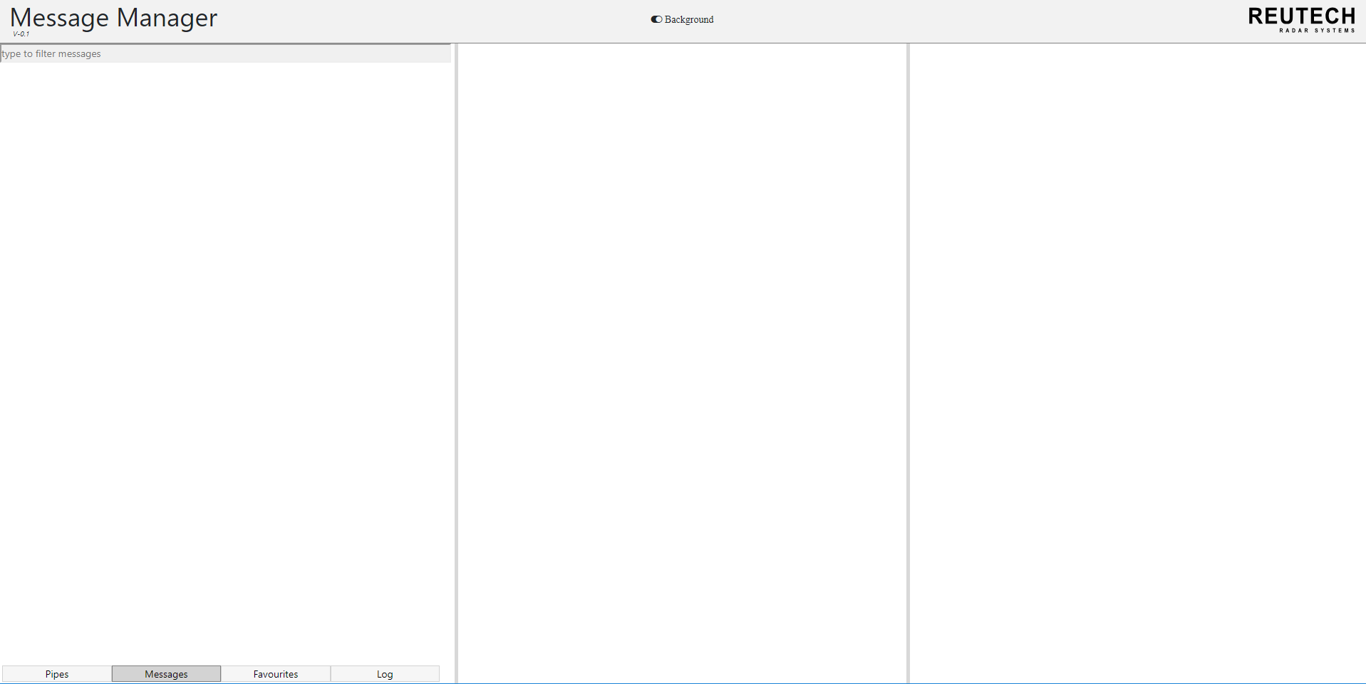

When the user connects to the Message Manager server, the above page will open up (this is the initial MMS page).

1. **MMS interface background colour change**

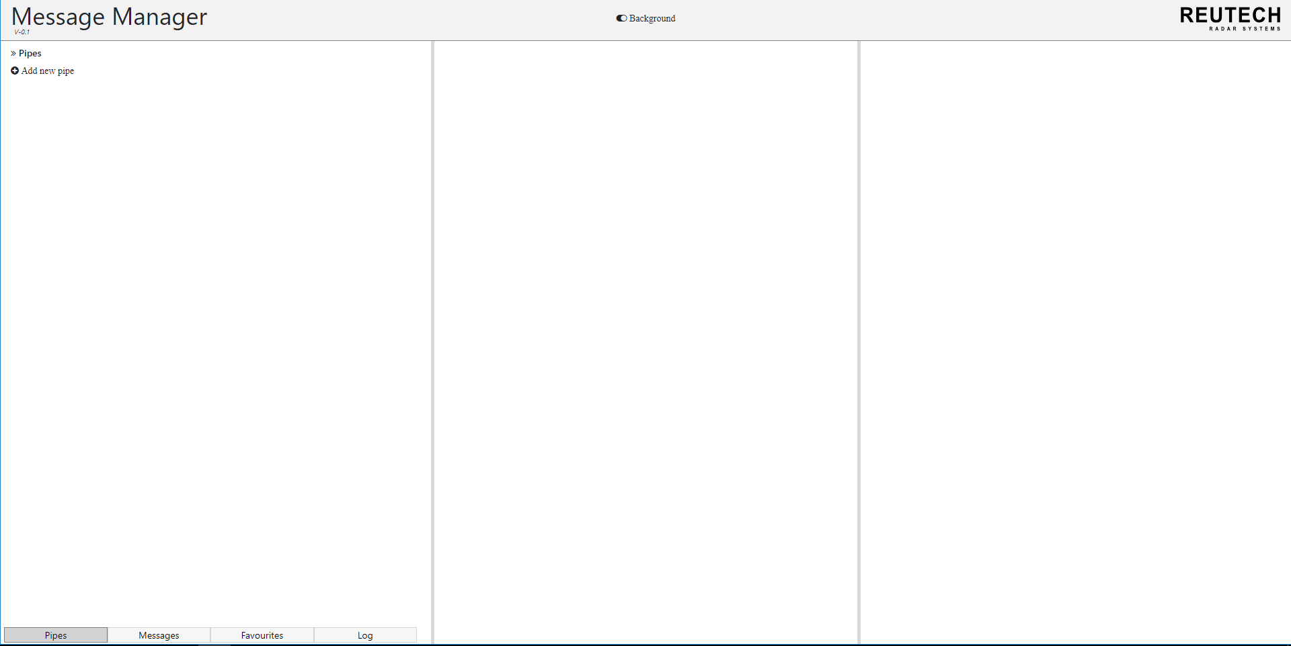

Change background of MMS interface

The background of the MMS interface can be changed by clicking the icon indicated by the figure above

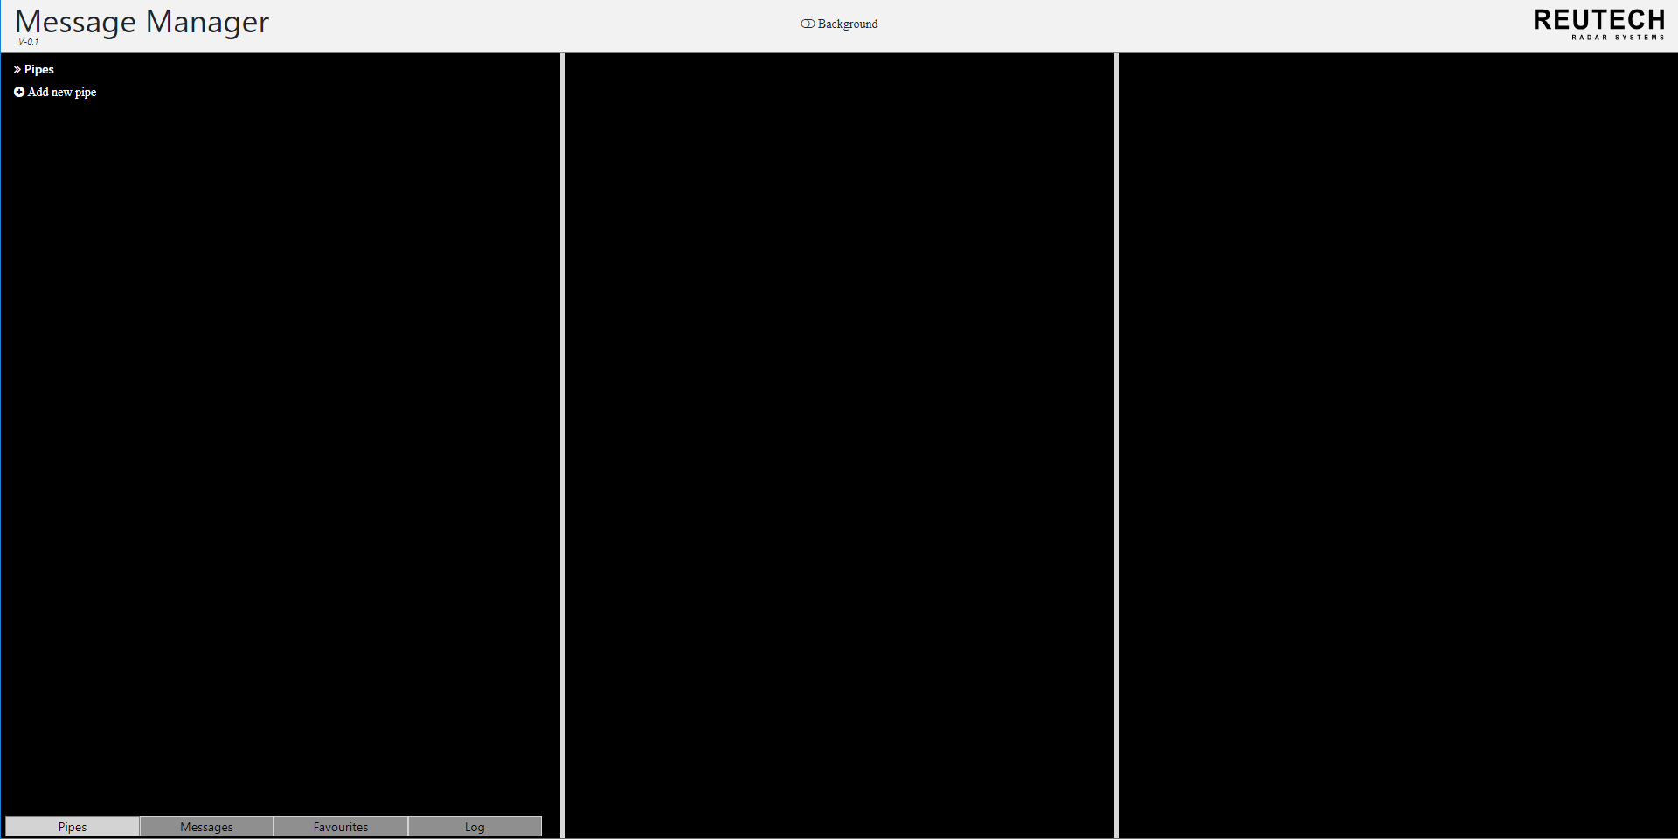

The background of the MMS can be changed to a black or white colour. The above shows that by clicking the “Background” icon the black background can be selected. When the user clicks ctrl + refresh, the default background will appear (white background).

1. **Connecting a pipe**



Click to add new pipe. This gives you a page to fill information about the pipe connection

To add a new pipe select “Add new pipe” under ‘Pipes’ tab as shown above. This will direct you to a section to fill out information about the pipe connection.

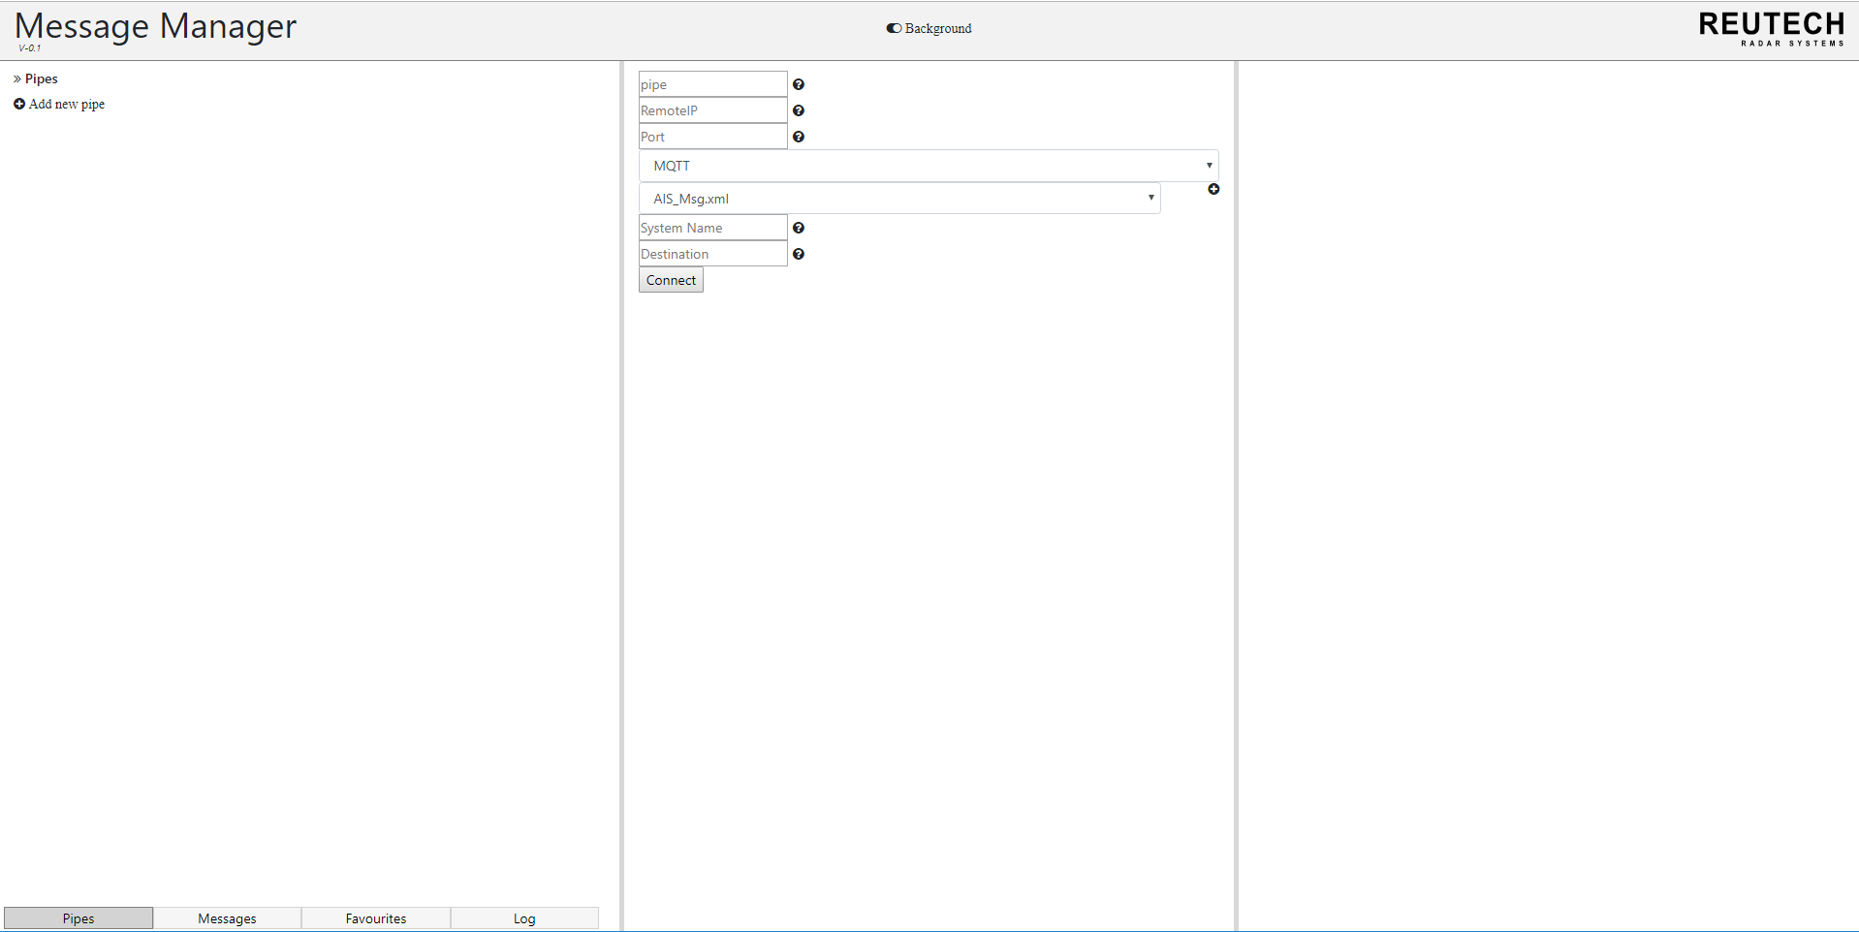

Click connect, to connect the pipe

The information is shown in figure and it includes the system name, IP and Port of a system broker, the destination name, XML file and a pipe name that is defined by the user.

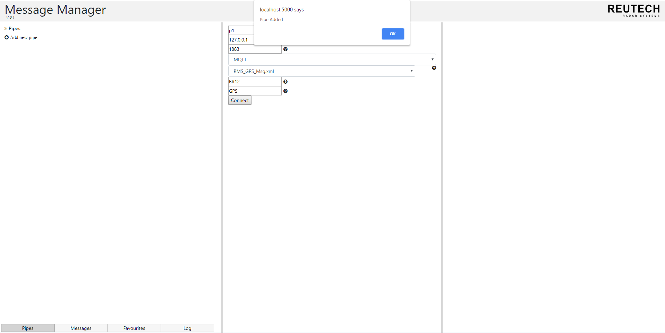

Pipe has been officially added

Pipe has been officially added

Pipe has been officially added

Once the pipe information has been entered successfully a message will appear that indicates that the pipe has been added.

1. **View XML and its messages**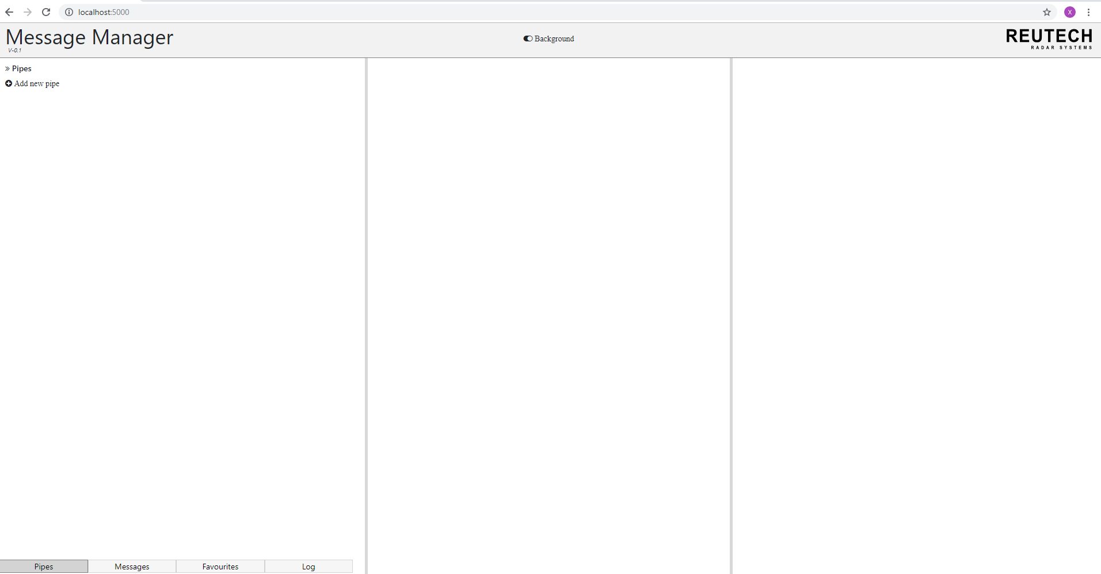

Press ctrl + refresh to get XML name for pipe connection

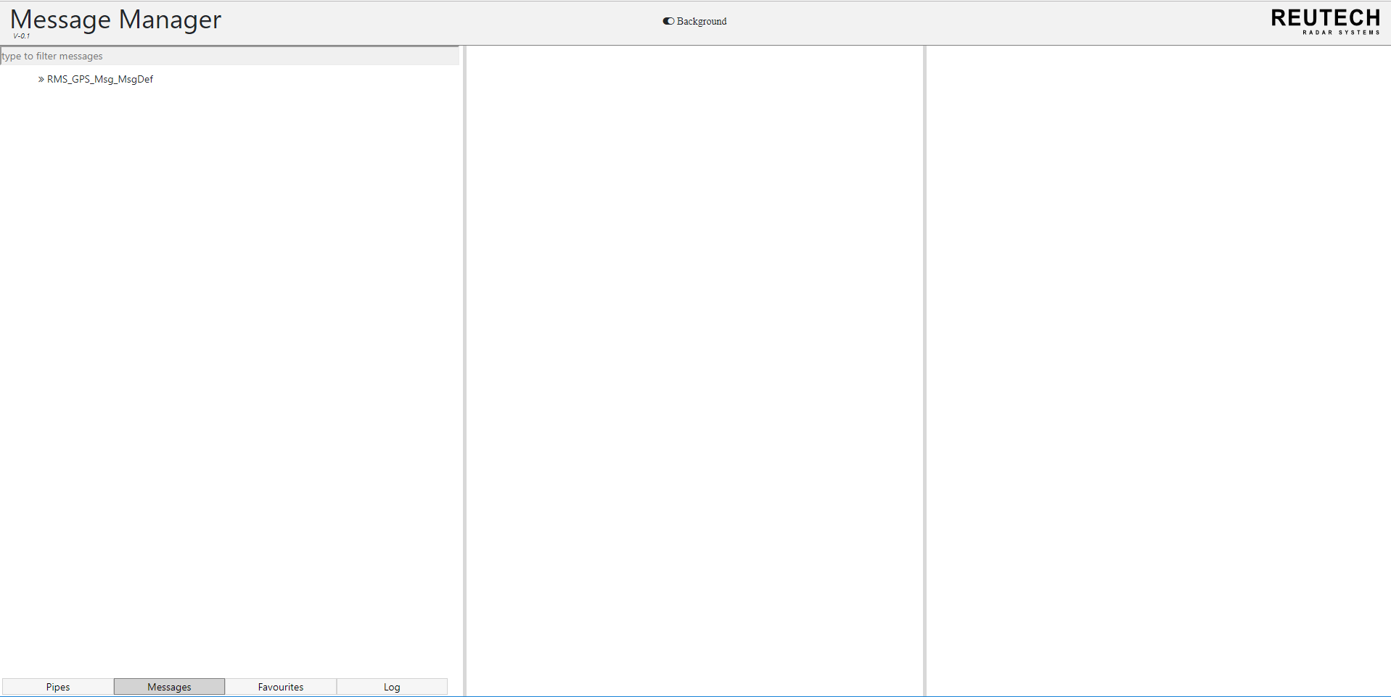

Click the XML name to get the messages for the XML

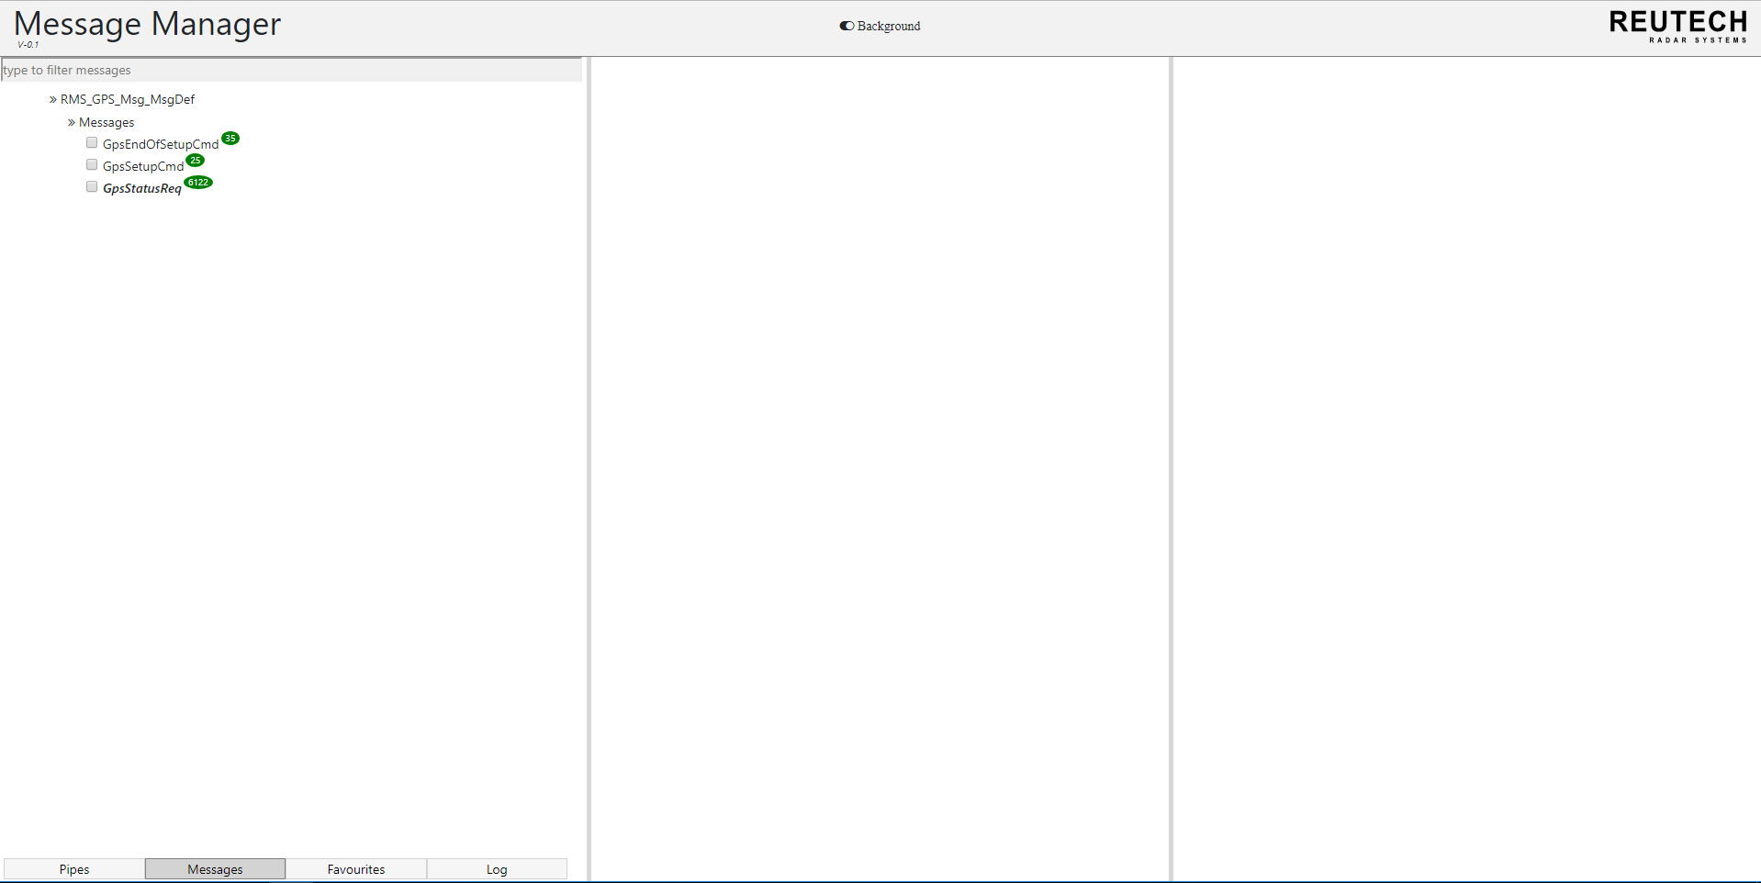

This is the messages for the XML. Click one message to get information about the message

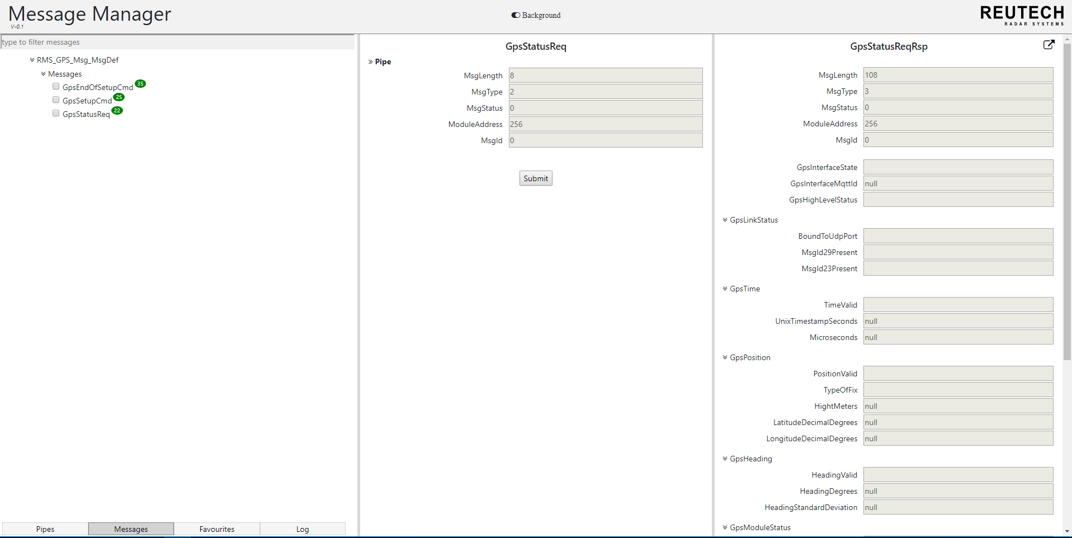

Click submit to get the response of this message

To get the XML name under the messages tab for that XML, press ctrl + refresh. To select a message click on one of the messages. This will populate the two tabs with information about the message like the message commands and requests and their default responses.

1. **Sending a message**

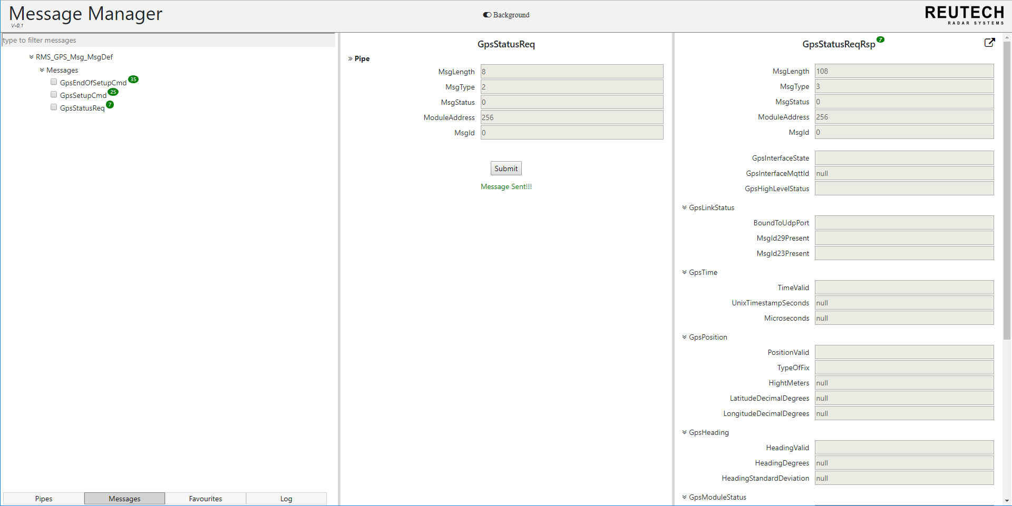

Shows message was sent successfully

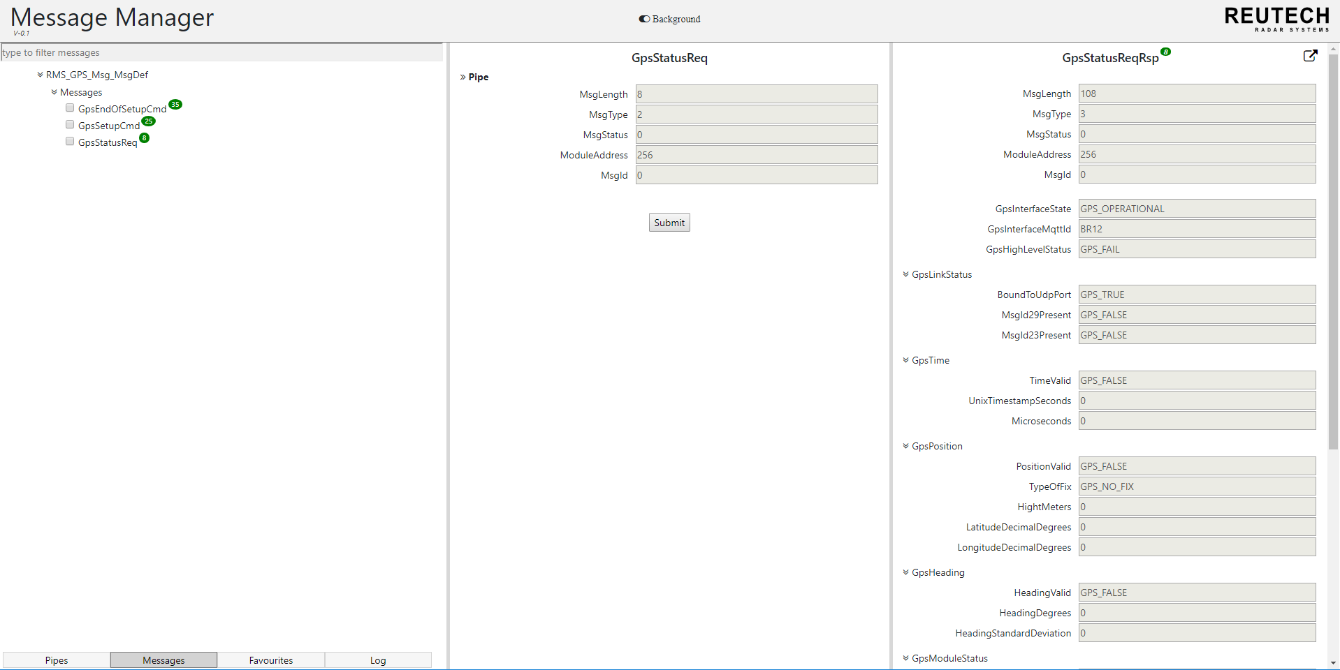

Click on the message name again to get the response information

When you click the submit button the message will be sent to the node (indicated by a green “Message Sent” message). To get the updated response of that message sent, click on the message name again and the right view will be populated with the response.

1. **Favourite list**

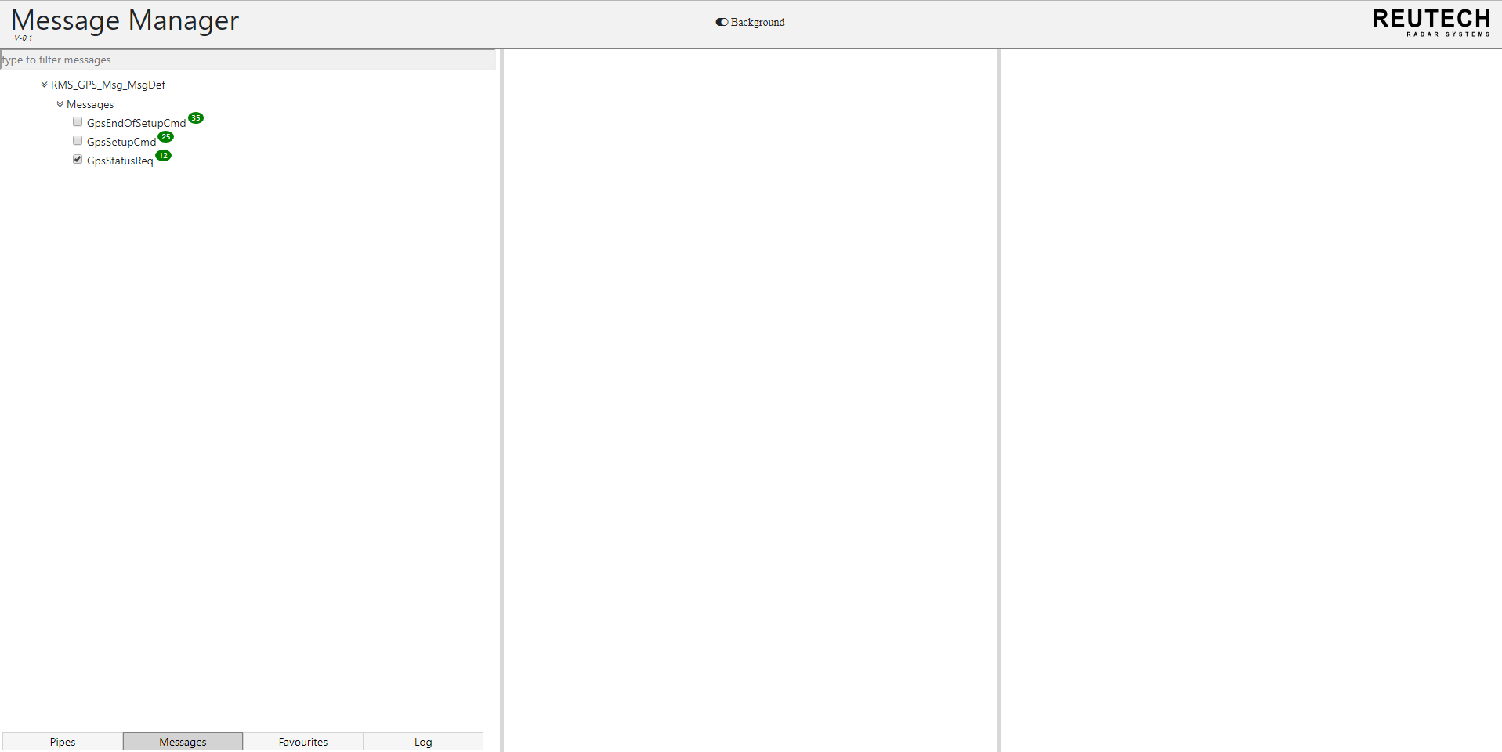

Check the checkbox to add the message to the favourites list.

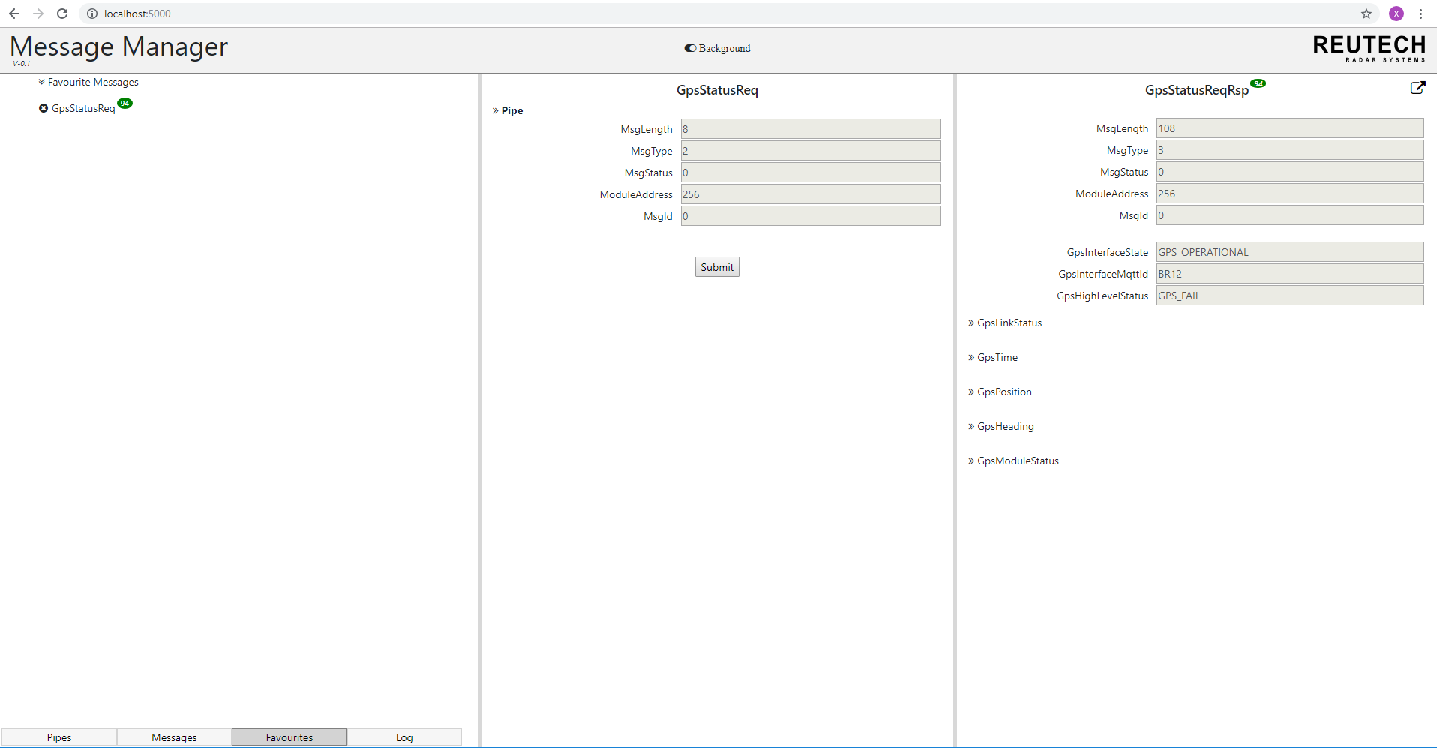

Press ctrl + refresh to view the message in favourite list. Click on the message to get the message information

To add a message to a favourites list, tick the checkbox of that message. When you select favourites the message will not appear under that section, as the user needs to press ctrl + refresh to load the ticked message in their favourite list.