Journal

Programming & Problem Solving

With Jacob Van Silfhout – Level 5

# Start of Semester 2

Introduction to the course outline of what we are to gain, achieve, produce and collaborate.

Weekly structure of course subjects that we will cover through to End of November. Including assessment and test dates.

Started off with GitHub. Online cloud storage and networking of programming and coding projects that we will be producing throughout the semester.

We started creating a GitHub account to push our codes, and any files and folders to, as well as pull them back to our computers when want.

I previously created an account in semester 1 Level 4, but forgot the user name and password, So I had to create another account using my own personal email address and new username.

I had to familiarize myself with using GitHub again, as well as Git Bash to push and pull code.

Creating new repository folders, using Git Bash to pull the repository to my desktop creating a folder for my work to be saved to, and to push this work back to Git Hub account to be stored and accessed.

The one part I was stuck on was “how to push a different folder up to Git Hub. The solution I found was to type into Git Bash: “cd” (change directory), and hit enter. This is what reset Git Bash to begin to accept pushing a new folder to Git Hub. I was pushing a folder into another folder without changing the directory. (Nesting)

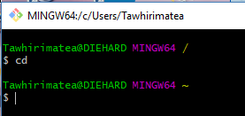 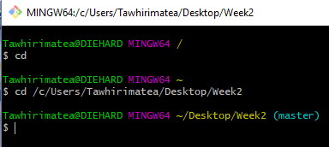

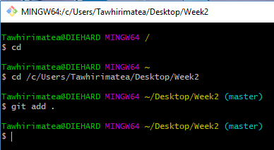 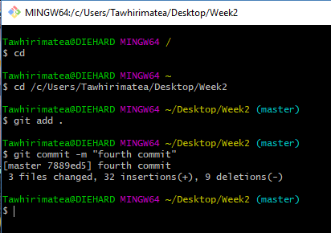

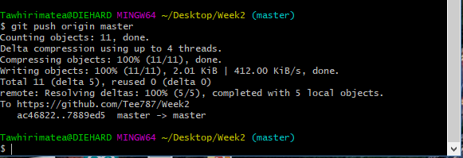

Checking the “status” of the folder I pushed up to my GitHub account

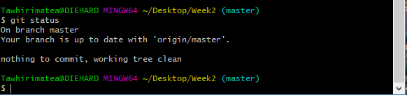

Also learnt how to check the directory path typing in: “pwd” and the status of whether your work was pushed successfully to GitHub.

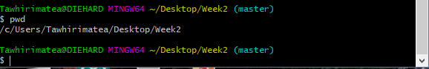

Given task exercises to attempt to develop a basic programming code.

First task was to develop a program asking the user for their “name, age, agenda and address”. Then had to display as all the information gathered on the console window.

Here is what my code looked like:

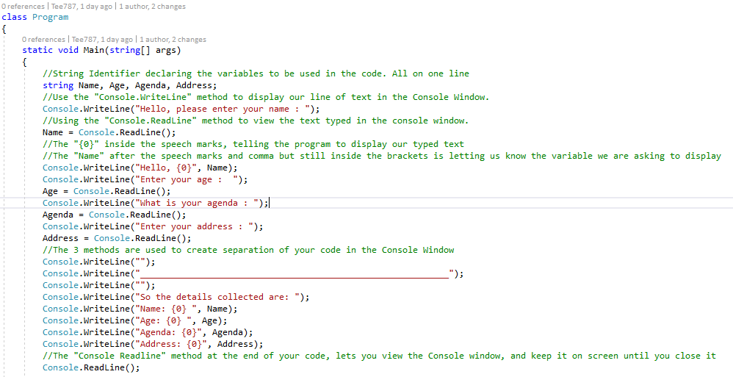

Task 2 we had to develop a code for mathematical equations. Using the “Convert.ToInt32” method, along with the “if” and “else” methods, along with “==” characters.

Here are some snippets of these methods used, and the full code.

Convert.ToInt32 function used to convert the string to a integer, number



If statement



Else if Statement



Next Exercises:

Task.1

Full working code:

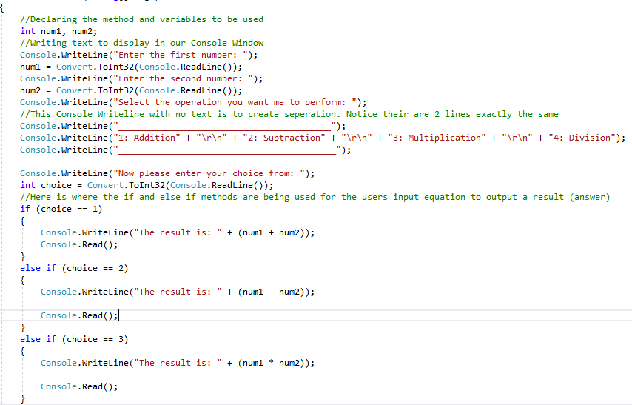

Task 3 we had to develop a code asking the user for the first and last name, and then displaying their full name in the console window.

I used the “Convert.ToString” method to convert the variable string to variable the full text variable function. E.g. Fname and Lname = First name and Last name

There was a section in the code that stumped me. I was trying to separate the first and last name with a space between the instead of one whole word.

e.g.

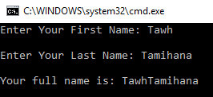 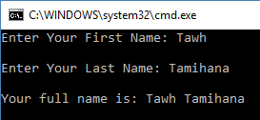

As you can see in the 1st image, there is no space between the First and Last name

But in the 2nd image there finally is.

With a lot of determination and not giving up, I finally found out how to achieve the final result without browsing the internet for the answer.

I was relieved and happy to have found the solution by myself

 As you can see in this image, it was only something minor that had to be added. A space between the speech marks inside the brackets was all it took.

Here is the full working code:

