Loops | Exercises

Task 1

Output a table showing multiple of numbers (x 10, X100 and x1000) in a range from a beginning set number to another end set number. Use a “for”, while” and a “do while” loop.

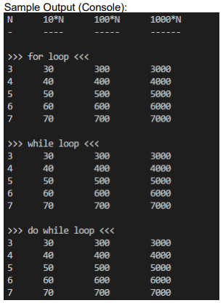

Task 2

Output a times table (to the browser console) for a number input from the user (input via a web page prompt). Use a “for”, while” and a “do while” loop.

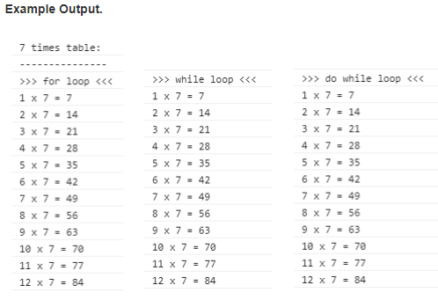

Task 3

Write a program that calculates the squares and cubes of the numbers from 0 to 10 and displays the resulting values in table format, as shown below. Use a “for”, while” and a “do while” loop. All calculations should be done in terms of a variable “x”. Research how to use “exponents” (ie. power of) – do not use the “Math” object and its methods.

