

UCDF2007ICT(ITR) / UCDF2007ICT(SE) / UCDF2007ICT(DI) / UCDF2007ICT

HAND OUT DATE : 16th 2022

HAND IN DATE : 9th 2022

WEIGHTAGE :

**INSTRUCTIONS TO CANDIDATES:**

**1 Students are advised to underpin their answers with the use of references (cited using the Harvard Name System of Referencing).**

**2 Late submissions will be awarded zero (0) unless Extenuating Circumstances (EC) are upheld.**

**3 Cases of plagiarism will be penalised.**

**4 The assignment should be bound in an appropriate style (comb bound or stapled).**

**5 Where the assignment should be submitted in both hardcopy and softcopy, the softcopy of the written assignment and source code (where appropriate) should be on a CD in an envelope / CD cover and attached to the hardcopy.**

Table of Contents

Sample Outputs 2

main.java 2

Login.java 2

User.java 4

Admin.java 6

Object-Oriented Concepts & Features Used in System 9

Object-Oriented Concepts 9

Classes and Objects 9

Inheritance 9

Constructors 11

Encapsulation 12

Polymorphism 12

Abstraction 13

Features Used in System 15

Close Window Feature 15

Login 15

Save Item into Text File 16

Show Items in table 17

Additional Features 18

Remove item 18

Enabled Button 18

Clear Text Field 19

Select Item From table 19

Assumptions 20

References 21

# Sample Outputs

## main.java

The first thing that user will see when they open this program is a warm welcome message. User will need to click the START button to continue, or they can click the exit button to close the program.

## Login.java

Next, system will request user to enter Username and Password. There is a note provided for general user, they will need to enter the ‘user’ for Username and ‘123’ for Password to access the vending machine and make purchase. For Administrator, they need to enter the ‘admin’ for Username and ‘123’ for Password to access the management system and make changes. Exit button allow user return to main page.

User enter wrong Username or Password.

User successfully logged in by enter correct Username or Password.

Admin successfully logged in by enter correct Username or Password.

## User.java

First, User will need to click ‘Click to Show Item’ button to display the items. User can select the item they want from the table, and system will show item details on the right side. Next user needs to enter the amount of money they want to insert and click purchase. Or user can click 'Clear' button to remove the item they selected. Exit button allow user return to main page.

If user click ‘Purchase’ without selecting an item, system will show a message to ask user to select item.

If user click ‘Purchase’ without entering number in ‘Insert Money’, system will show a message to ask user to enter it.

If the money that user inserted is not enough to buy the item, system will show Purchase Unsuccessful.

If user insert enough money, system will show Purchase Successful.

After Purchase Successful, user can view their Change. And user can click ‘Clear’ button if they want to make another purchase.

## Admin.java

First, Admin can click ‘Refresh Table’ button to display the items. Exit button allow user return to main page. If Admin want to add item into database, they will need to enter all the item details and click ‘Insert’ button. If want to clear text field, admin can click 'Clear' button to remove the details they entered.

If Admin want to remove an item from database, they need to enter all the item details of that item or they can easily click the item in table to select it. Next, admins need to enter ‘Yes’ in text field to enable the button and to achieve the role of confirmation, then click ‘Remove Item’ button to remove it from database.

Admins need to enter all details before ‘Insert’ or ‘Remove the item. If Admin do not have enter one of the details into text field, system will show message and ask admin to enter the specify details.

# Object-Oriented Concepts & Features Used in System

## Object-Oriented Concepts

Object-oriented Programming is a paradigm that provides many concepts like inheritance, abstraction, encapsulation, polymorphism and others. It can improve Java code readability and reusability by defining how to structure Java program efficiently. (Monus, 2022)

### Classes and Objects

In object-oriented programming, Classes and objects are the two main aspects. Class can be known as a template for objects. And in other hand, object can be known as an instance of a class.   
Class is a collection of objects and a logical entity, it can be described as a blueprint that includes all the data, Class contains variables and methods to define the behaviour of an object which can create an individual object. (Chand, 2021)

Object is a major element in a class, any entity that had a state and behaviour can be known as object. It can be defined as an instance of a class which can access to the data. The keyword ‘new’ can be used to create the object. (Chand, 2021)

### Inheritance

Inheritance has the ability to derive new classes from existing classes. Allows to inherit the properties and functionalities from base class. There are five types of inheritance supported by Java. (Chand, 2021)

Single Inheritance

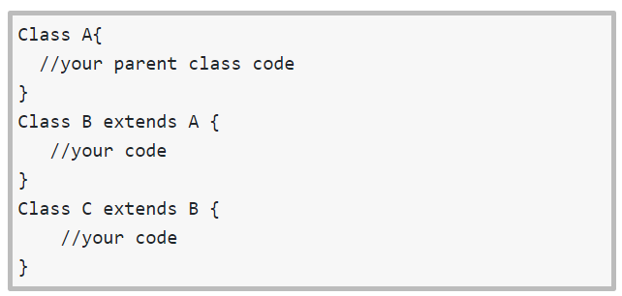  
Multi-Level Inheritance

Hierarchical Inheritance

Hybrid Inheritance

Multiple Inheritance

### Constructors

Constructors is a block of code to initializes an object that newly created. It is like a method in Java but do not have any return type and the name is same with class name. Constructors can be divided into few types. (Chand, 2021)

Default Constructor is created by the default java compiler when class creation and if no other constructor is declared in the class. (Chand, 2021)

Parameterized Constructor contains one or more parameters, it can be used to provide several values to distinct objects when the creation. (Chand, 2021)

### Encapsulation

Encapsulation has the ability to provide user with a well-defined interface to a set of functions in a way to hide their internal workings. And it is a process for binding the code and data together so that can be a single unit to use getter and setter methods. (Chand, 2021)

### Polymorphism

Polymorphism is describing a situation that something happens in different forms. There are two types of Polymorphism. (Chand, 2021)

Compile Time Polymorphism

Runtime Polymorphism

### Abstraction

Abstraction is to simplify the complex, for example only show the important things to user. There are two ways to achieve it. (Chand, 2021)

Abstract class, which is a class declared as abstract. It can have abstract and non-abstract methods, constructors and static method. It cannot be instantiated. (Chand, 2021)

Interface, respresnts the subsumption relationship between abstractions. Use its constants or methods will need to implement and interface first. (Chand, 2021)

## Features Used in System

### Close Window Feature

WindowEvent is to indicates the window has changed its status. Whenever its opened, closed, activated, deactivated, iconified, or decodified, or when focus is transferred into or out of the Window, this event will be generated by a Window object. (oracle, 2022)

The "WINDOW_CLOSING" event in code line 25. When the user attempts to close the window from the window's system menu, this event will be delivered. If the program does not explicitly hide or dispose the window while processing this event, the window close operation will be cancelled.

The goal for this close() object is to close the window. In this case, close the running window and open main() instead of running window keep running and open main() in another window.

### Login

Java conditions and if statement. By using the ‘if’ statement to specify a block of code to be executed when the condition is true. Next, ‘else if’ statement to specify a new condition when last condition is false. Lastly, ‘else’ statement to executes when all the conditions is false.

This code is for user to login as different role. First, if administrators want to be logged in as their role which is admin, they need to provide correct username and password to the system, so that they can enter Admin page. And since system do not have registration for different customers, so all the user will be sharing one role by using same username and password so that they can enter to User page.

### Save Item into Text File

From line 411 to line 423 is for system to show a dialog message and to prevent user proceed to next step if the text field is empty.

Java FileWriter class is used to write character-oriented data to a file which is used for file handling.

In this case, after system get the details of an items. System will write data to file which the data is provided from several text field and add a ‘:’ between data from these text field. Then system will show a dialog message to tell user item is added.

### Show Items in table

Line 380, make the button only can be click once so that the table will not repeat reading same data and show in table.  
Line 383, is to point a file on file system. If the file exists, it will not create a new file.  
Line 387, BufferedReader is to read text from a character-based input stream.  
Next, get first line data from text file, because first row in text file is schema of the items.  
Then extract data from line and set data to table after getting lines from text file.

# Additional Features

## Remove item

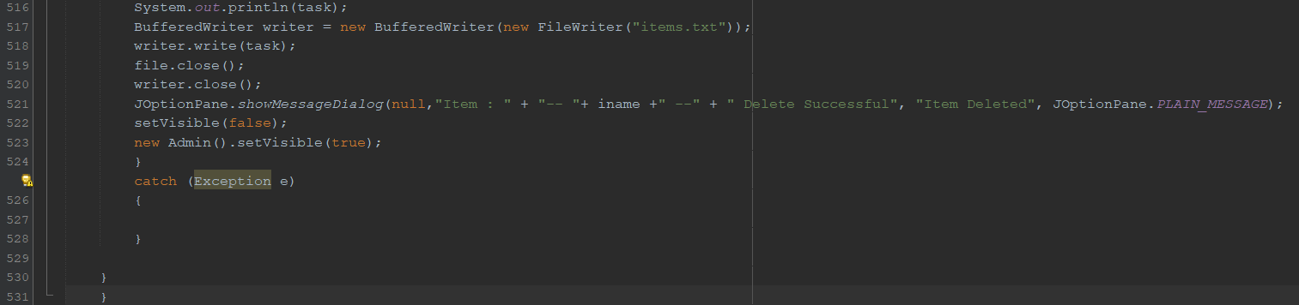

This code is for remove item. First, from line 490 to line 503 is to make sure user have enter all the details before they proceed to the Remove item. Next from line 504 to line 530, after system have read the details, system will write the file which is delete item, and show a dialog to tell user the item have deleted.

## Enabled Button

This code is to enables button only if user have entered ‘Yes' in text field, otherwise the button will be disabled.

## Clear Text Field

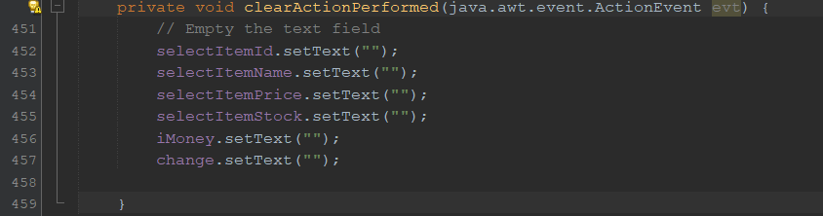

This code is to empty the text field, which by using ‘setText’ and provide empty for values.

## Select Item From table

This code to allow system read data from table and put it into text field. Make ‘i’ as the row that user selected. Line 477, getModel() is to returns information on the current data model during the processing of a personalized reverse engineering. And from line 478 to line 481 is set up the data into text field according to sequence of data in table.  
And for line 483 is to make the table be not editable.

# Assumptions

1. Stock status will become unavailable according to number of times that item have been purchased.
2. If item stock status unavailable, user cannot make purchase on that item.
3. Add a feedback feature to allow user to enter their comment and review after using the vending machine.
4. Provide a help centre to help use solve the problem they face when using the vending machine.
5. Add a confirmation feature whenever user want to purchase item or exit the vending machine.
6. Registration feature, so that user can have their own account. User can view purchase history after they make purchase successfully.
7. Having other forms of payment like using e-wallet, payment card, online bank, and others.

# References

Chand, S. (2021, June 17). *Java OOP Cheat Sheet – A Quick Guide to Object Oriented Programming in Java*. Retrieved from edureka: https://www.edureka.co/blog/cheatsheets/java-oop-cheat-sheet/

Monus, A. (2022, February 23). *Using OOP concepts to write high-performance Java code*. Retrieved from RAYGUN: https://raygun.com/blog/oop-concepts-java/

oracle. (2022, May 1). *Class WindowEvent*. Retrieved from oracle: https://docs.oracle.com/javase/7/docs/api/java/awt/event/WindowEvent.html