📑 SQL Test Notes – DATA6222 (Intermediate)

1️⃣ Database & Table Creation
-- Create Database
CREATE DATABASE DBName;
USE DBName;

-- Create Table (with PK & FK)
CREATE TABLE TableName (
ColumnName DataType PRIMARY KEY,
ColumnName2 DataType NOT NULL,
ForeignKeyCol INT FOREIGN KEY REFERENCES OtherTable(PrimaryKey)
);

Example (Past Paper – TutorialSessions)
CREATE TABLE TUTOR (
TUTOR_ID VARCHAR(10) PRIMARY KEY,
TUTOR_NAME VARCHAR(100) NOT NULL
);

CREATE TABLE SCHOOL (
SCHOOL_ID VARCHAR(10) PRIMARY KEY,
SCHOOL_NAME VARCHAR(100) NOT NULL,
SCHOOL_ADDRESS VARCHAR(200)
);

CREATE TABLE SESSIONS (
TUTOR_ID VARCHAR(10),
SCHOOL_ID VARCHAR(10),
SEATS_AVAILABLE INT,
PRIMARY KEY (TUTOR_ID, SCHOOL_ID),
FOREIGN KEY (TUTOR_ID) REFERENCES TUTOR(TUTOR_ID),
FOREIGN KEY (SCHOOL_ID) REFERENCES SCHOOL(SCHOOL_ID)
);

Example (Assignment – ArtGalleryDB)
CREATE TABLE Artist (
ArtistID INT PRIMARY KEY,
Name VARCHAR(50) NOT NULL,
Surname VARCHAR(50) NOT NULL
);

CREATE TABLE Genre (
GenreID INT PRIMARY KEY,
Description VARCHAR(100) NOT NULL
);

CREATE TABLE Artwork (
ArtworkID INT PRIMARY KEY,
Title VARCHAR(100) NOT NULL,
GenreID INT NOT NULL FOREIGN KEY REFERENCES Genre(GenreID),
ArtistID INT NOT NULL FOREIGN KEY REFERENCES Artist(ArtistID)
);

CREATE TABLE Exhibition (
ExhibitionID INT PRIMARY KEY,
Description VARCHAR(100) NOT NULL
);

CREATE TABLE Entry (
EntryID INT PRIMARY KEY,
ArtworkID INT NOT NULL FOREIGN KEY REFERENCES Artwork(ArtworkID),
ExhibitionID INT NOT NULL FOREIGN KEY REFERENCES Exhibition(ExhibitionID)
);

2️⃣ Insert Data
INSERT INTO TableName VALUES (...);

Example
INSERT INTO TUTOR VALUES ('A001', 'Mia Phillips');
INSERT INTO Genre VALUES (1, 'Abstract');

3️⃣ Update & Delete
-- Update
UPDATE TableName
SET ColumnName = NewValue
WHERE Condition;

-- Delete
DELETE FROM TableName
WHERE Condition;

Example
-- Past Paper
UPDATE SESSIONS
SET SEATS_BOOKED = 35
WHERE TUTOR_ID = 'A004' AND SCHOOL_ID = 'C001';

-- Assignment
DELETE FROM Entry WHERE EntryID = 3;
DELETE FROM Artwork WHERE ArtworkID = 3;

4️⃣ Alter Table
ALTER TABLE TableName
ADD NewColumn DataType;

ALTER TABLE SESSIONS
DROP COLUMN SEATS_BOOKED;

ALTER TABLE – Add Primary Key
-- General syntax
ALTER TABLE TableName
ADD CONSTRAINT ConstraintName PRIMARY KEY (ColumnName);

Example
ALTER TABLE TUTOR
ADD CONSTRAINT PK_Tutor PRIMARY KEY (TUTOR_ID);

🔹 ALTER TABLE – Add Foreign Key
-- General syntax
ALTER TABLE ChildTable
ADD CONSTRAINT ConstraintName FOREIGN KEY (ChildColumn)
REFERENCES ParentTable(ParentColumn);

Modifying a Column
Syntax Example (Conceptual - syntax varies widely):
SQL
-- PostgreSQL / Oracle
ALTER TABLE table_name
ALTER COLUMN column_name SET data_type;

-- SQL Server
ALTER TABLE table_name
ALTER COLUMN column_name new_data_type;

5️⃣ Select Queries

Simple Select
SELECT Column1, Column2
FROM TableName
WHERE Condition;

Joins

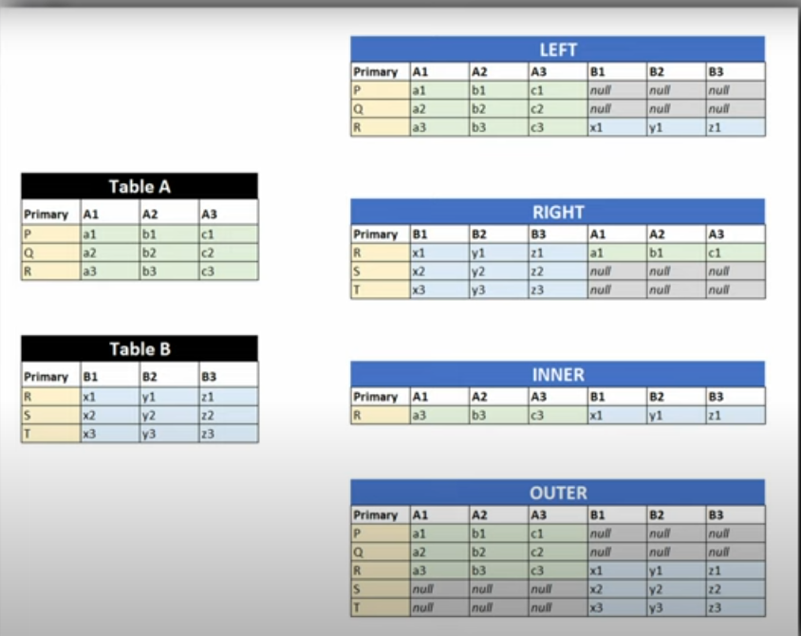

- Customers table (simplified):
CustomerID | CustomerName | City
1 | Alfreds Futterkiste | Berlin
2 | Ana Trujillo Emparedados | México DF
3 | Antonio Moreno Taquería | México DF
- Orders table (selection):
OrderID | CustomerID | OrderDate
10308 | 2 | 1996-09-18
10309 | 37 | 1996-09-19
10310 | 3 | 1996-09-20

🔹 1. INNER JOIN
➡ Returns rows where there is a match in both tables.
Example:
SELECT Customers.CustomerName, Orders.OrderID
FROM Customers
INNER JOIN Orders ON Customers.CustomerID = Orders.CustomerID
ORDER BY Customers.CustomerName;
Result:
- Only customers with matching orders appear.
- Alfreds (ID=1) is excluded (no orders).
- Ana Trujillo (ID=2) → Order 10308
- Antonio Moreno (ID=3) → Order 10310

🔹 2. LEFT JOIN
➡ Returns all rows from the left table (Customers), plus matches from the right (Orders). If no match, shows NULL.
Your example:
SELECT Customers.CustomerName, Orders.OrderID
FROM Customers
LEFT JOIN Orders ON Customers.CustomerID = Orders.CustomerID
ORDER BY Customers.CustomerName;
Result:
- Alfreds (ID=1) → NULL (no order)
- Ana Trujillo (ID=2) → Order 10308
- Antonio Moreno (ID=3) → Order 10310

🔹 3. RIGHT JOIN
➡ Returns all rows from the right table (Orders), and matching customers from left. If no match, customer fields show NULL.
SELECT Customers.CustomerName, Orders.OrderID
FROM Customers
RIGHT JOIN Orders ON Customers.CustomerID = Orders.CustomerID
ORDER BY Customers.CustomerName;
Result:
- Order 10308 → Ana Trujillo
- Order 10310 → Antonio Moreno
- Order 10309 (CustomerID=37, doesn’t exist in Customers) → NULL

🔹 4. FULL OUTER JOIN
➡ Returns all rows from both tables. Matches where possible, otherwise NULL.
(Some SQL engines like MySQL don’t support FULL OUTER JOIN, but SQL Server & PostgreSQL do.)
SELECT Customers.CustomerName, Orders.OrderID
FROM Customers
FULL OUTER JOIN Orders ON Customers.CustomerID = Orders.CustomerID
ORDER BY Customers.CustomerName;
Result:
- Alfreds → NULL
- Ana Trujillo → Order 10308
- Antonio Moreno → Order 10310
- Order 10309 → NULL (no matching customer)

🔹 5. CROSS JOIN
➡ Returns the Cartesian product: every customer paired with every order.
SELECT Customers.CustomerName, Orders.OrderID
FROM Customers
CROSS JOIN Orders;
Result:
If 3 customers × 3 orders = 9 rows total, regardless of match.

🔹 6. SELF JOIN

Example Table: TUTOR
TUTOR_ID | TUTOR_NAME
A001 | Mia Phillips
A002 | James Scott
A003 | Sarah Johnson
A004 | James Smith

Scenario
Suppose we want to find tutors that share the same first name (so we compare tutors with tutors inside the same table).

SQL Self Join
SELECT A.TUTOR_NAME AS Tutor1,
B.TUTOR_NAME AS Tutor2
FROM TUTOR A
INNER JOIN TUTOR B
ON LEFT(A.TUTOR_NAME, CHARINDEX(' ', A.TUTOR_NAME)-1)
= LEFT(B.TUTOR_NAME, CHARINDEX(' ', B.TUTOR_NAME)-1)
AND A.TUTOR_ID <> B.TUTOR_ID;

Explanation
- A and B are aliases for the same TUTOR table.
- We compare the first name part of TUTOR_NAME using string functions.
- A.TUTOR_ID <> B.TUTOR_ID ensures we don’t match a tutor with themselves.

Result
Tutor1 | Tutor2
James Scott | James Smith
James Smith | James Scott

Group By & Having
SELECT Column, COUNT(*) AS Total
FROM TableName
GROUP BY Column;

-- With HAVING (filter groups)
HAVING COUNT(*) > 1;
✅ Example:
SELECT G.Description, COUNT(*) AS TotalArtworks
FROM Genre G
JOIN Artwork A ON G.GenreID = A.GenreID
GROUP BY G.Description
HAVING COUNT(*) > 1;

6️⃣ Test-Style Queries

Tutors not booked (Past Paper Q2.1)
SELECT T.TUTOR_NAME
FROM TUTOR T
LEFT JOIN SESSIONS S ON T.TUTOR_ID = S.TUTOR_ID
WHERE S.TUTOR_ID IS NULL;

Total seats per tutor (Past Paper Q2.2)
SELECT T.TUTOR_NAME, SUM(S.SEATS_AVAILABLE) AS TOTAL_SEATS
FROM TUTOR T
LEFT JOIN SESSIONS S ON T.TUTOR_ID = S.TUTOR_ID
GROUP BY T.TUTOR_NAME
ORDER BY T.TUTOR_NAME;

School with most seats for A004 (Past Paper Q2.3)
SELECT T.TUTOR_NAME, C.SCHOOL_NAME, S.SEATS_AVAILABLE
FROM SESSIONS S
JOIN TUTOR T ON S.TUTOR_ID = T.TUTOR_ID
JOIN SCHOOL C ON S.SCHOOL_ID = C.SCHOOL_ID
WHERE S.TUTOR_ID = 'A004'
ORDER BY S.SEATS_AVAILABLE DESC
LIMIT 1;

🔹 Chapter 1 – RDBMS Basics (Extras)
- Transaction Log – keeps record of all database changes; used for recovery after crashes.
- Filegroups – logical grouping of data files for organizing large databases.
- Roles & Users – define database security; roles group permissions.
- Sequences – database object that generates sequential numbers (like auto-increment but reusable across tables).
- Rules & Defaults – older style constraints; defaults assign values if none provided.
- Other objects: Views, Stored Procedures, User-Defined Functions (UDFs).

🔹 Chapter 2 – Tools of the Trade
- SSMS (SQL Server Management Studio) – main GUI to manage DBs, run queries.
- SQL Server Configuration Manager – manage services and network settings.
- sqlcmd – command-line tool to run scripts.
- Profiler – monitors SQL activity for performance/debugging.
- BCP (Bulk Copy Program) – import/export large data.
- PowerShell – scripting automation for SQL Server.

🔹 Chapter 3 – Foundation Statements (Extras)
- DISTINCT – removes duplicate rows.
- SELECT DISTINCT City FROM Customers;
- ALL – default, returns all rows (even duplicates).
- FOR XML – outputs query results as XML.
- OPTION (hints) – provides optimizer hints. Example:
- SELECT * FROM Orders OPTION (MAXDOP 1);
- Multirow INSERT –
- INSERT INTO Genre (GenreID, Description)
- VALUES (1,'Abstract'), (2,'Modern'), (3,'Classic');

🔹 Chapter 4 – UNION
- UNION – combines results of two queries (removes duplicates).
- SELECT City FROM Customers
- UNION
- SELECT City FROM Suppliers;
- UNION ALL – keeps duplicates.

🔹 Chapter 5 – Schema & Naming
- Schema – logical container (e.g., dbo, sales).
  - Full object name: Database.Schema.Table.
  - Example: SchoolDB.dbo.TUTOR.

🔹 Chapter 6 – Advanced Constraints
- Disabling Constraints – temporarily turn off constraint for bulk inserts.
- Rules & Defaults – older style, less common, replaced by CHECK/DEFAULT constraints.
- Triggers for Integrity – can enforce rules beyond standard constraints.

🔹 Chapter 8 – Normalization
- 1NF (First Normal Form) – remove repeating groups; each cell holds atomic value.
- 2NF (Second Normal Form) – must be in 1NF + all non-key attributes fully depend on the whole PK.
- 3NF (Third Normal Form) – must be in 2NF + remove transitive dependencies (non-key depending on non-key).
- Denormalization – intentionally storing redundant data for performance.
- Example:
  - Unnormalized: Order table with multiple products in one row.
  - 1NF: Split products into separate rows.
  - 2NF: Move product details to a Product table.
  - 3NF: Remove derived info (e.g., total price) into separate calculation.

🔹 Chapter 11 – Scripts & Batches
- USE – select database context.
- Variables –
- DECLARE @Total INT;
- SET @Total = 100;
- Control-of-Flow:
  - IF…ELSE – conditional execution.
  - CASE – inline conditional.
  - WHILE – loops.
- Batches – groups of statements sent to server (use GO).
- TRY…CATCH – error handling.
- BEGIN TRY
- INSERT INTO Orders VALUES(...);
- END TRY
- BEGIN CATCH
- PRINT 'Error occurred';
END CATCH

