STB SETUP GUIDE

Quick setup guide for install alongside iptv subscription

1- Once youve downloaded the app using firedl/web browser open it. Long press ok or press the menu button on your remote. Then click settings.

2 - Once your in settings the next step is to click on profiles

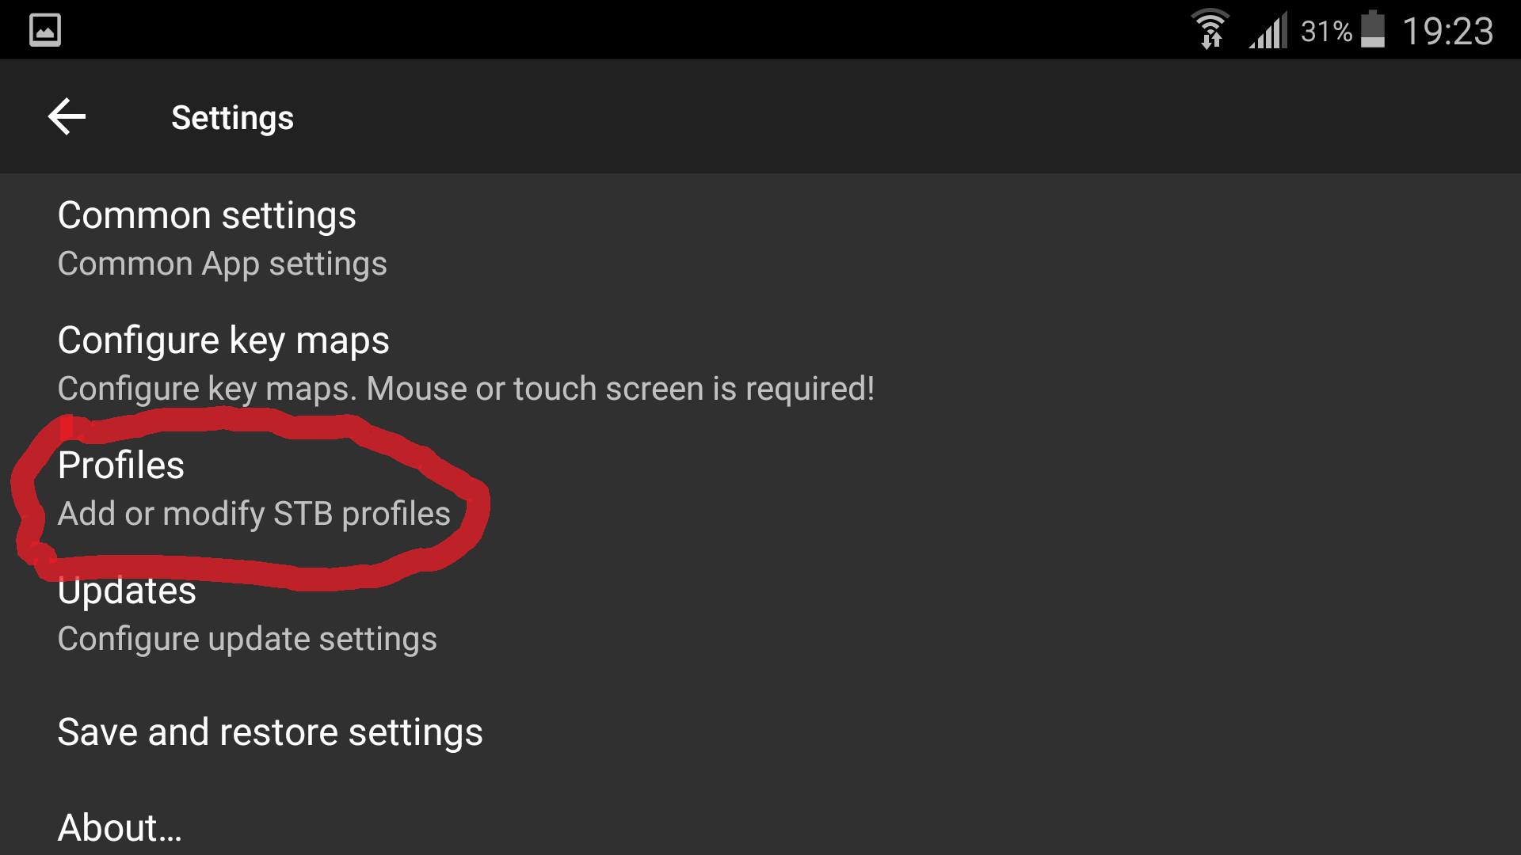

3 - then click on the profile that you see there already

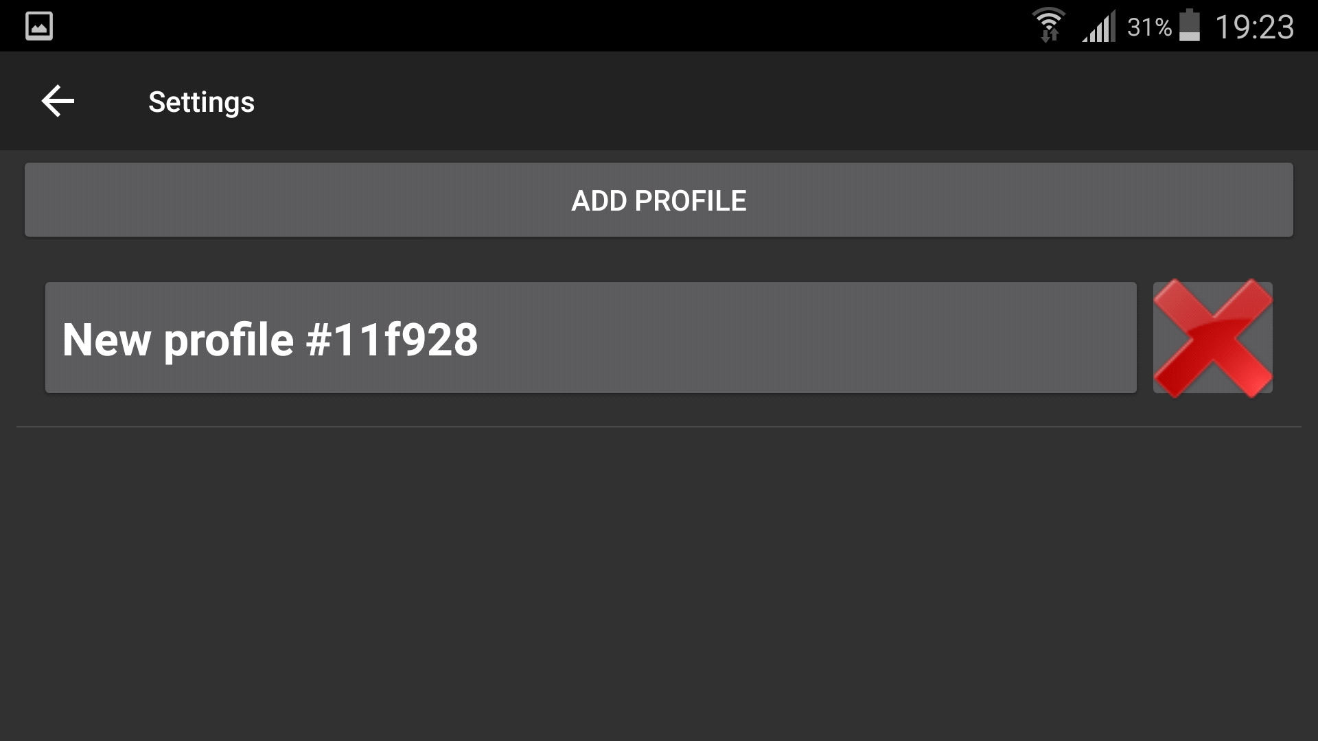

4- Once into profile the next step is to click portal settings

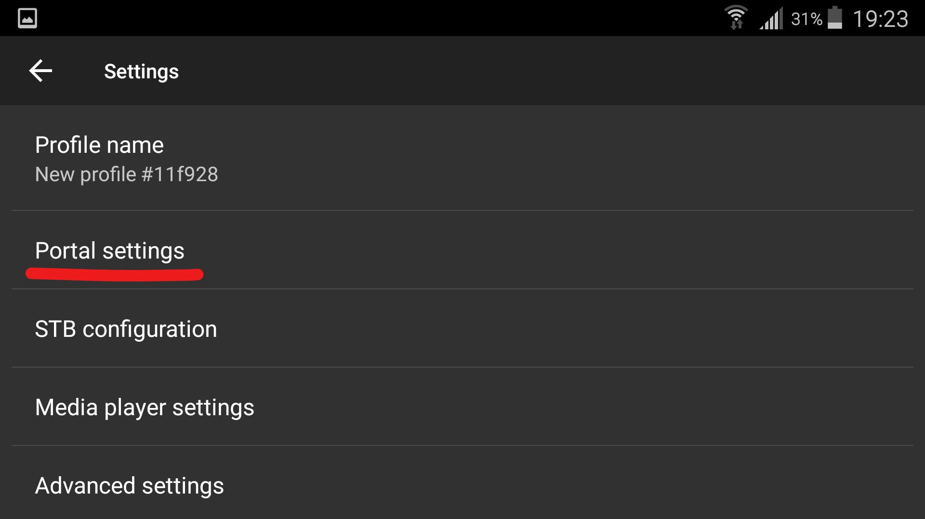

5- Then click portal url and type in <http://teevanhosting.ddns.net:4545/c> and then click ok

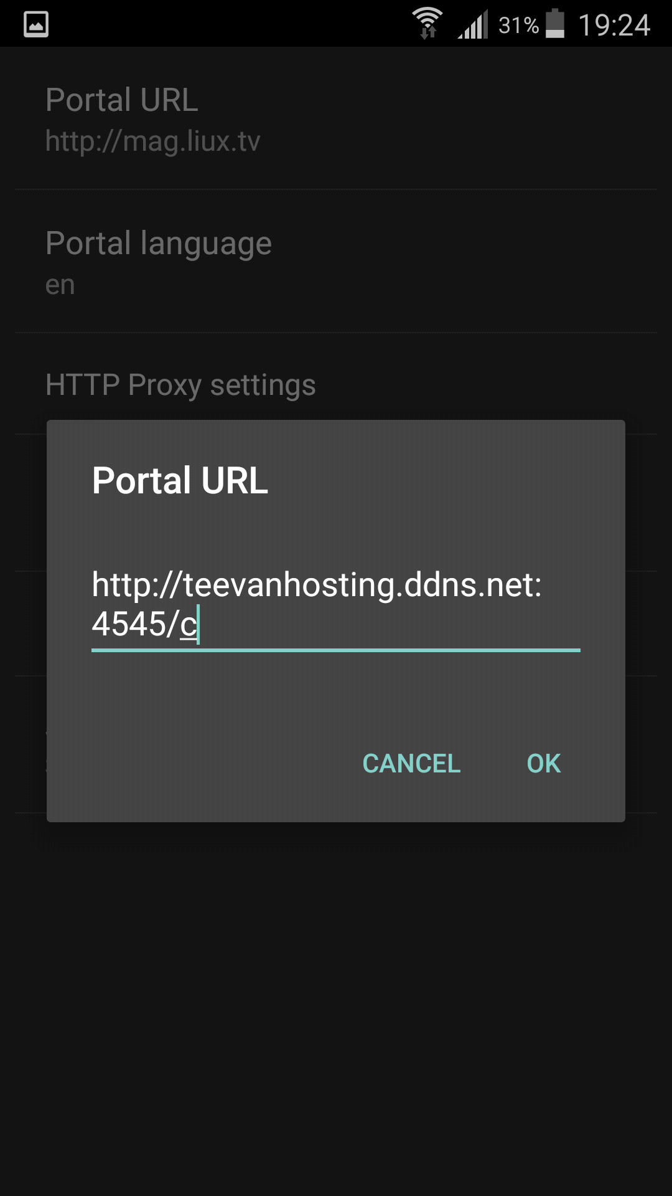

6 - Press back to come out of the portal settings and then click stb configuration and then scroll down and get your mac address. Send this to me so i can add you to my panel.

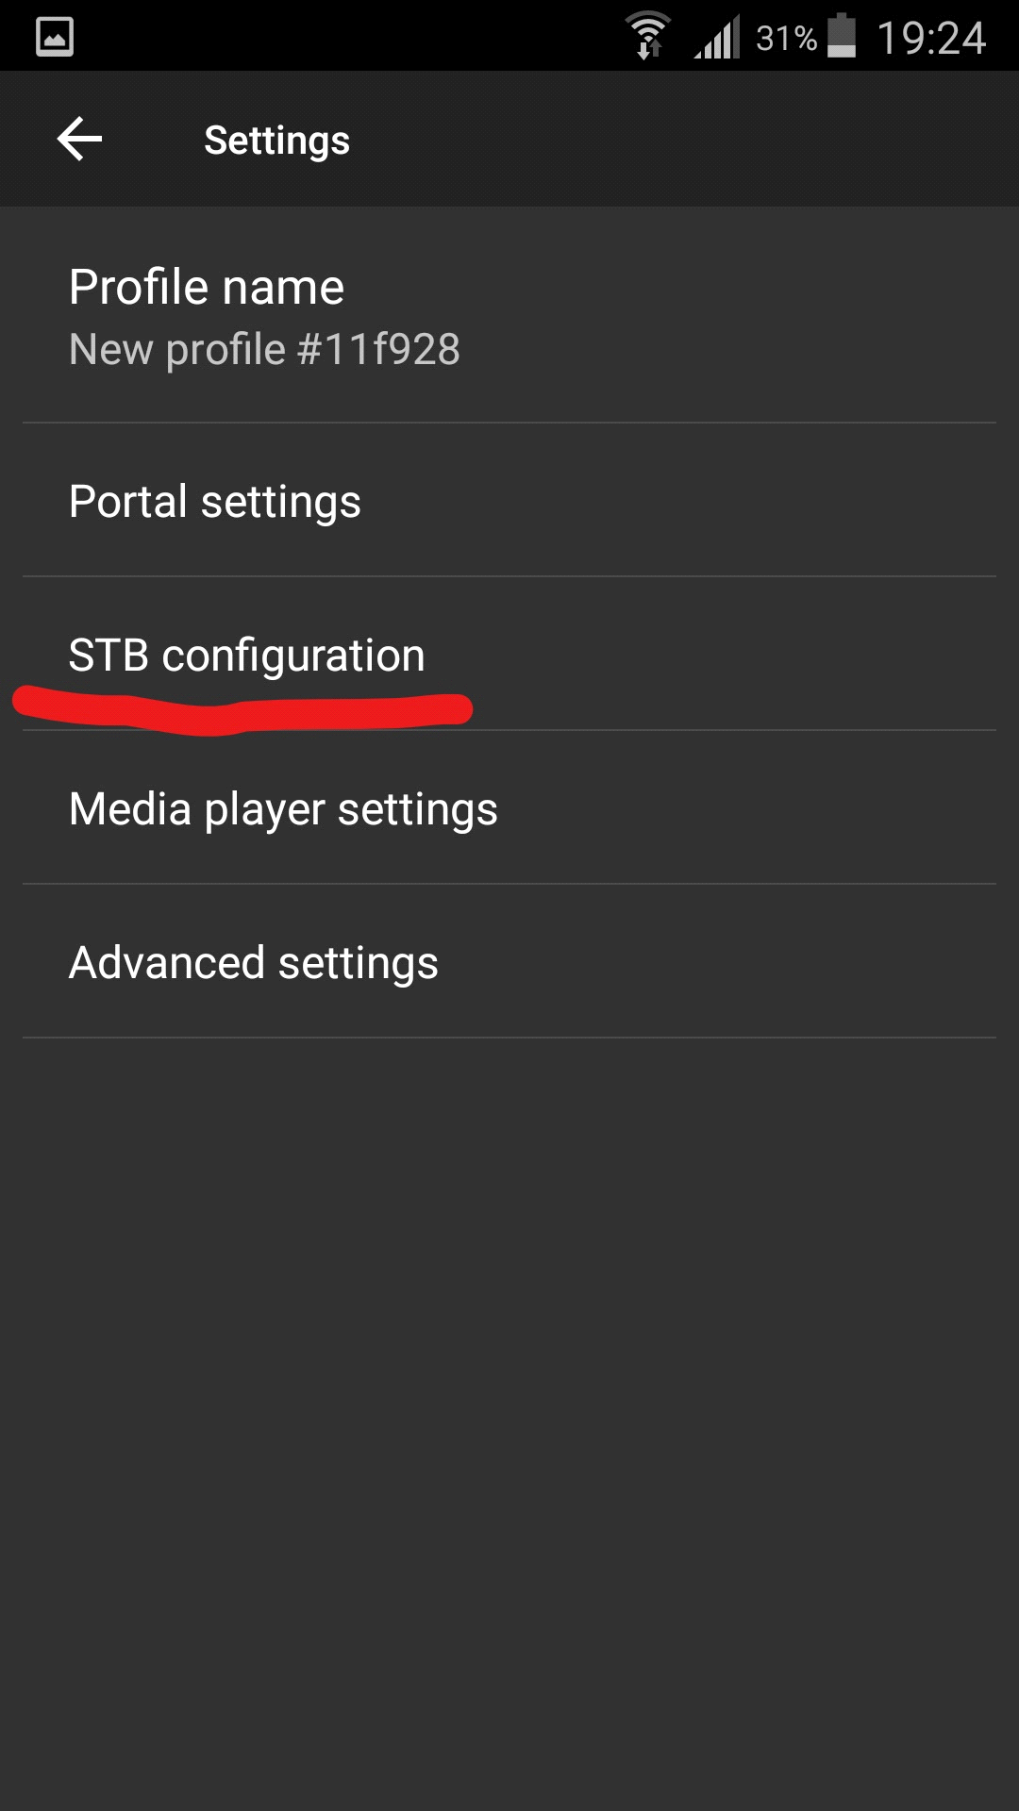

7 - Once youve done that then press the back button until you come out to the blue screen on stb emulator. Then press the menu button and go down and click profile. Then click the profile that you see there.

