Cartet

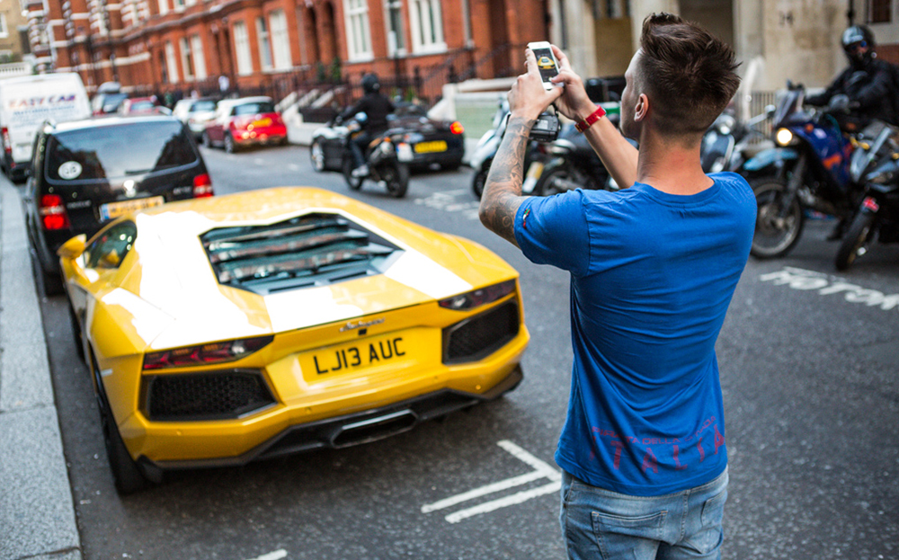


Timo Jansen
SM41

Introduction
After the start of the assignment to make my own application I started thinking about possible concepts. After a while I came up with my concept of scanning vehicles and adding them to collections in my app. This concept would tempt the users to go outside to make all sorts of collections of vehicles that they like, be it cool flashy cars or old-timers. Additionally, the user would be presented with all sorts of information about the cars they collected ranging from the brand and type of the car to the color and length of the vehicle.

Features
The application already has a couple of features:
- Spotting cars by scanning their license plate
- Adding cars to different collections
- Getting information about the cars you collected
I have also thought about some yet unimplemented features:
- Editing collections
- Provide external links to websites where even more information is
available like the price of a new or secondhand model
- Being able to share your collections and challenge your friends
to complete specific collections

Back-end

Scanning
To be able to scan a vehicle I make use of the phone’s camera hardware and an external text recognizing library. This library works by taking all the data that the camera sees and parsing that data to strings in the program. To make this work in my application I had to make some adjustments so that only text in the format of a dutch license plate can be read by the camera.

Fetching data
After my scanning activity has recognized a readable license plate the string containing said license plate is passed to a new activity which then in its place makes a connection to the publicly available database of the dutch vehicle registration services (RDW). All information about the car that the license plate belongs to is fetched from the API and is then parsed into a Car class and then in turn gets placed into a firebase database for later use.

Collections
In firebase collections will be stored after a user has scanned a new vehicle. Currently the data is separated by the unique device id of the android device that is used by the user, but in the future it will be stored under unique user ids that the user can register themselves. When the user wants to see their collections all the data under their unique id is taken from the firebase database and converted to Car classes again which will in turn be showed in the collections activity by an expandable list of cars.

Interface
My application currently counts three different interfaces: Spot, Car Information and Collections.

Spot

In this picture the area in the middle is black, but in reality this area shows what the camera sees. This way it’s easy to point your camera to the right place to scan license plates.

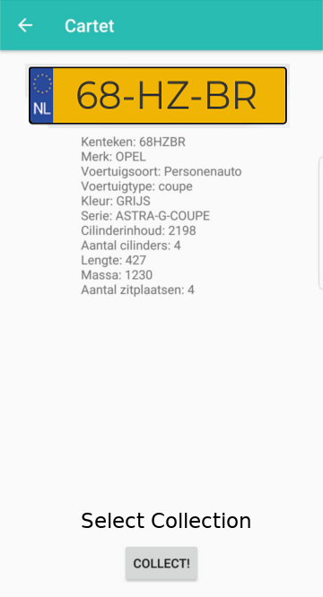

Textrecognizer recognizes a license plate

In this activity the information of the scanned car is shown and you will be able to select a collection in which you want to store the car you spotted
(The image of the license plate and the selection of collection is not currently implemented)

Collections
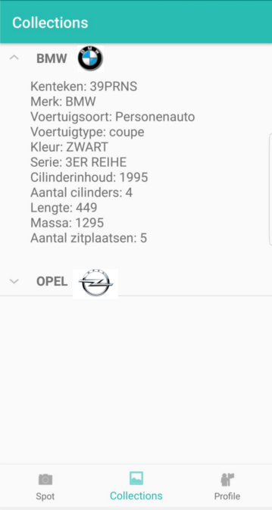
Here the user will be presented with their own collections and can in this way check information about all the cars they have collected just like when they just scanned a car.
(The logos of the collections have not yet been implemented)

The profile fragment is as of now empty, this activity will give the user some settings to adjust and maybe some information about themselves in regards of how many collections they have, how many cars, achievements, etc.

Conclusion
I think I have learned a lot about android application development and Java in general. In my opinion my application came out pretty nice and I feel like I can look back at it at some point in the near future and develop more features for it and maybe even publish it on the appstore.

