A review of techniques used in Recognition & Verification of handwritten signatures
Tejas Jadhav
M. Tech in Computer Science,
Mukesh Patel School of Technology Management & Engineering,
NMIMS University, Mumbai, India
tjadhav95@gmail.com
Abstract
Handwritten signature has been critical person identification technique for decades. Whether one signs a petition, work documents, contract, or wants to approve payment of a check, he/she uses personal signature to do all those things. The objective of this paper is to survey some of the best biometric signature recognition techniques The paper intends to give away information all about the application of biometrics i.e. signature detection and also about the various algorithms that are necessary to be studied by a designer while creating an application that will use it. The algorithms listed here are either implemented and being used or are a part of someone’s research work and haven’t been still implemented. In this paper there are a total of 40 different signature recognition approaches listed here that are been taken from different research papers. The output obtained is evaluated in the papers itself by performing experimental analysis and can be compared with each other in this paper.
Keywords: Biometrics, Image, signature, binarization, fuzzy, support vector machine, normalization

Introduction
Biometrics is currently perceived as a vital technology for setting up secure access control. It utilizes physiological qualities of humans for recognizing individual, and signature is one of the characteristics usable for biometrics. Singular recognizable proof technology utilizing human countenances, more often than not called confront acknowledgment technology, has been concentrated primarily in western nations since 1990s. It has been the most widespread tool for paper documents verification for many decades. In real life the human-expert can verify handwritten signatures easily, but it is a complicated task for doing by machines today.
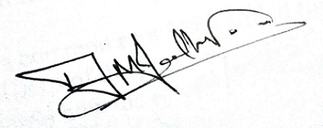
Figure 1: Sample signature of writer
In this review paper, there are a total of 40 different approaches used in 40 different research papers. These use not just image processing tools but also some level of machine learning. The approaches listed use feature extraction and classification techniques such as radon transforms, altitude and direction of pen movement, fuzzy logic, adaptive variance reduction, artificial neural network, support vector machine, Euclidian distances. Thus a comparison can be made based on the techniques used, which will allow us to differentiate and compare their efficiency.

Real life applications [1]
- Finance: IT-Processing centres of German savings banks are offering their customers solutions to embed dynamic signatures securely into electronic documents in an Adobe Live Cycle environment
- Insurance: Signing an insurance contract and documenting the consulting process that is required by EU legislation have caused several insurance companies to go paperless with either signature capturing tablets connected to a notebook or a tablet PC.
- Real Estate: Increasingly popular among real estate agents in USA are options of paperless contracting through signing on Tablet PCs.
- Health: The hospital of Ingolstadt is capturing and verifying the signatures of their doctors that fill electronic patient records on tablet PCs. The “National Health Service” organization in the UK has started such an implementation.
- Telecom: Signing phone and DSL contracts in the telecom shops is another emerging market.

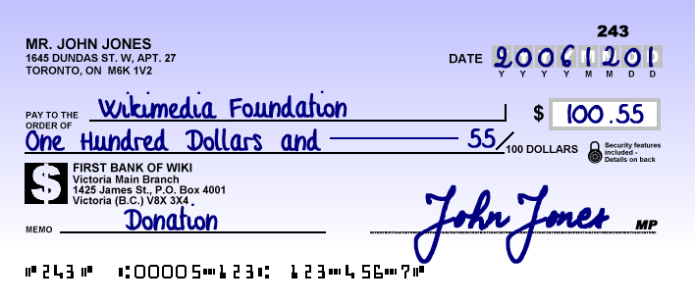
Figure 2: A bank cheque with signature

Types & methods of Signature Verification [1]
There are two types of signature verification methods:
- Offline Signature Verification Methods:
In this method, system makes use of a simple scanner or a camera that can take in image having signature & process the image further with whatever features it gets. This method can be seen useful in many applications such as banking cheques, medical certificates & prescriptions etc.
- Online Signature Verification Methods:
Here the system makes use of special acquisition devices like stylus pens and tablets that can take in signature features in real time and may give better accuracy

Performance evaluation parameters
- FAR – False Acceptance Rate
Rate of falsely accepted signatures
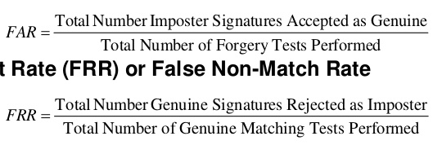
- FRR – False Recognition Rate
Rate of falsely rejected signatures
- EER – Equal Error Rate
The Equal Error Rate (EER) corresponds to the error value for which false acceptance rate is equal to false rejection rate. These rates determine the quality of an authentication system, but the acceptable values depend on the level of security desired for a specific application.

- PI – Performance Index
PI = 100 - EER
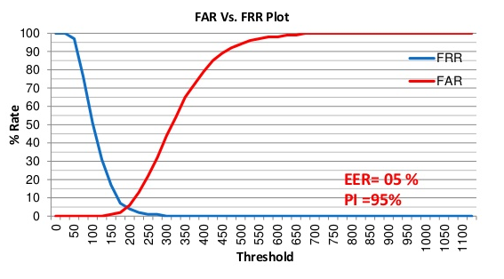
Figure 3: Performance evaluation graph

About the domain
To understand the in depth concepts of the different approaches, that are listed and explained in the later part, we might require some basic pre-requisite knowledge of the domain they work under.

Image processing
Image processing [41] is working on images using mathematical operations by form of signal processing for which the input is an image, a series of images, or a video, such as photographs or video frame; the output of image processing could be either an image or a set of characteristics or parameters related to an image. Most image-processing techniques involve treating the image as a two-dimensional signal and applying standard signal-processing techniques to it.

Biometrics
Biometrics [42] is the measurement or statistical analysis of people's physical/behavioural characteristics. The technology is mainly used for identification and access control, or for identifying individuals that are under surveillance. The basic premise of biometric authentication is that everyone is unique and an individual can be identified by his or her intrinsic physical or behavioural traits. The term "biometrics" is derived from the Greek words "bio" meaning life and "metric" meaning to measure.
Authentication made by biometric verification is becoming increasingly common in corporate and public security systems, consumer electronics, and applications. In addition to security, the driving force behind biometric verification has been convenience, as there are no passwords to remember or security tokens to carry. Measuring someone’s gait doesn’t even require a contact with the person.

Artificial Intelligence
Artificial Intelligence [43] is a way of making a computer, a computer-controlled robot, or a software think intelligently, in the similar manner the intelligent humans think. This is accomplished by studying how human brain thinks and how humans learn, decide, and work while trying to solve a problem, and then using the outcomes of this study as a basis of developing intelligent software and systems. AI is used in many systems such as gaming, NLP, expert systems, recognition systems and robotics, etc.

Machine Learning
Machine learning [44] is a branch of science that deals with programming the systems in such a way that they on their own learn and improve with experience. Here, learning means recognizing and understanding the input data and making wise decisions based on the supplied data. It is very difficult to cater to all the decisions based on all possible inputs. To tackle this problem, algorithms are developed that build knowledge from specific data and past experience with the principles of statistics, probability theory, logic, combinatorial optimization, search, reinforcement learning, and control theory.
Machine learning is a vast area and it is quite beyond the scope of this tutorial to cover all its features. There are several ways to implement machine learning techniques, however the most commonly used ones are supervised and unsupervised learning.

Literature Review
This section lists down the various algorithms that we are to study. Most of them work in 3 stages, which are pre-processing, main processing i.e. feature extraction and then post-processing stage which includes decision making or classification. There are a high number of algorithms that can be implemented for recognition of handwritten signatures these days, but following are the algorithms which give other newly formulated algorithms a backbone.
In paper [1] the researchers are considering some simple parameters like speed, acceleration, pen down time, distance, etc and based on the literature studies they discuss how these features can be used in the Image processing environment to improve the performance of handwritten signature. The approach provides a PI of 97.5 %.
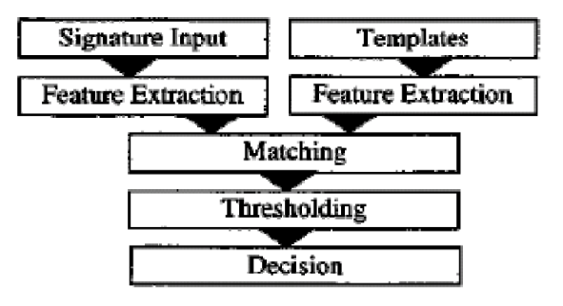
Figure 4: Flowchart of paper [1]
Features extracted and used for comparison include total Euclidian distance D of the pen travelled, Speed Vx and Vy express the functions of time, Acceleration Ax and Ay, Total time taken Tk, Length-to-width ratio, Amount of zero speed in direction x and y directions Nvx and Nvy , Amount of zero acceleration in direction x and y directions Nax and Nay

The paper [2] presents a crowdsourcing experiment to establish the human baseline performance for signature recognition tasks and a novel attribute-based semi-automatic signature verification system inspired in FDE analysis. It combines the DTW algorithm with Attribute based algorithm to obtain better accuracy and increase the recognition rate. With EER of 5%, we can say that recognition rate is 95%. Attribute based recognition features include Shape, Proportionality, Text-loops, Order, Punctuation, Flourish-characteristics, Hesitation, Alignment to the baseline, Slant of the strokes, Strokes-length, Character spacing
The dynamic time warping algorithm finds an optimal match between two sequences of feature vectors which allows for streached and compressed sections of the sequence.

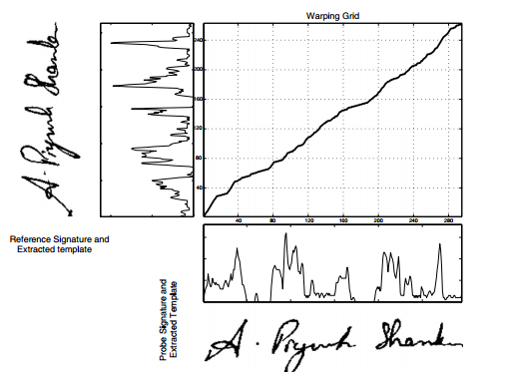
Figure 5: Dynamic Time warping
The proposed system in paper [3] functions in three stages. Pre-processing stage; this consists of gray scale conversion, binarization and fitting boundary box. Feature extraction stage where total 16 radon transform based projection features are extracted which are used to distinguish the different signatures. Finally in the classification stage; an efficient BPNN, Back Propagation Neural Network is prepared and trained with 16 extracted features. The average recognition accuracy of this system ranges from 87% - 97% with the training set of 10–40 persons. Global features include Height of the signature, Width of the signature, and Centroid along both X axis, Centroid along both Y axis
The radon transform derives projections of the image matrix along predefined directions. A projection of a two dimensional function f(x,y) is a group of line integrals. The radon transform calculates the line integrals from multiple sources along parallel paths, or beams, in a predefined direction. The beams are spaced one pixel unit apart. To represent an image, the radon transform takes multiple, parallel-beam projections of the image from different angles by rotating the source around the centre of the image. Radon transform of a signature image I for the angles specified in the vector ‘theta’ is computed using the matlab function radon().
It returns a vector ‘r’ for each angle in theta containing the Radon Transform. Mean and standard deviation of all the vectors ‘r’ are calculated and taken as a local features.
The number of neurons in the first layer is n (n=16 in this work) which is equal to the dimensionality of the input pattern vectors (Number of input nodes equals number of input features used). The number of neurons in the output layer is 5 which are equal to the number of pattern classes.
The developed BPNN is trained with signature from different persons. Large numbers of images are required to ensure proper training of the NN.
Table 1: Local radon transform features
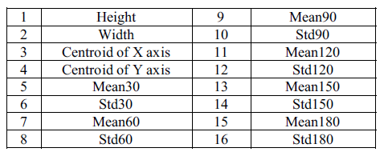
In paper [4], researchers propose a new on-line writer authentication system using the pen altitude, pen azimuth, shape of signature, and writing pressure in real time. It is well expected that altitude and the azimuth of gripped pen under signing depends on the shape of writer's hand and the habit of writing. The data set prepared is based on the following Features to be calculated dynamically at every instance of time: X-coordinate: x(t), Y-coordinate: y(t), Pressure: p(t), Azimuth: θ(t), Altitude: φ(t). After individuality in the altitude and the azimuth of gripped pen under signing is explained, the experimental result with writing information by 24 writers is shown. It is found that the authentication rate of 98.2% is obtained.
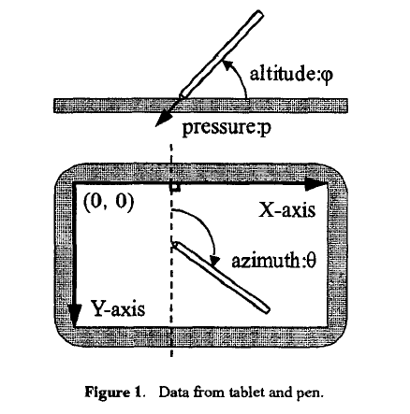
Figure 6: Data from tablet and pen.
In paper [5], researchers propose a new on-line writer authentication system that uses the pen azimuth, point positions of signature, and writing pressure in real time for creating 7 fuzzy characteristics. The stability of the altitude and the azimuth under signing is also compared with the bit-mapped data and the pen pressure along time for one writer. Researchers used collection of signatures for testing this system. Signature verification experiment has been conducted with 100 users across 25 original and 25 fake signatures for each user. The recognition rate shown was 99.8%. A 28-dimensional feature vector for the signature is formed.
In this paper [6] researchers present an off-line signature verification and recognition system using the global, directional and grid features of signatures. Support Vector Machine (SVM) was used to classify & verify the signatures and a classification ratio of 0.95 was obtained. Thus 95% accuracy is obtained As the recognition of signatures represents a multiclass problem SVM's one-against-all method was used.
The system researchers introduced is divided into two major sections: (i) Training signatures, (ii) Verification or recognition of given signature.
Features used were Signature area, Signature height-to-width ratio, Maximum horizontal histogram and maximum horizontal histogram, Maximum vertical histogram and maximum vertical histogram, Horizontal and vertical center of the signature are calculated using the formulas
In this system, a multi class system is constructed by combining two class SVMs, radial basis function is used which gave the best results. In the training phase, for each person 8 positive (genuine) and 82 (39 x 2 + 4) negative (forgery) examples are taken.
The proposed system of paper [7] functions in three stages. Pre-processing stage consists of four steps namely gray scale conversion, binarization, thinning and fitting boundary box process in order to make signatures ready for the important feature extraction. Feature extraction stage consists total 59 global and local wavelet based energy features to be extracted which are used to classify the different signatures. Finally in classification, a simple Euclidean distance classifier is used as decision tool. The average recognition accuracy obtained using this model ranges from 90% to 100% with the training set of images of 10 to 30 persons.
The proposed method in paper [8] is based on the hypothesis; reducing the variability of signatures leads to boost up the recognition rate. Therefore, the variance reduction technique is applied to normalize offline handwritten signatures by means of an adaptive dilation operator. Then the variability of signatures is analysed in terms of coefficient of variation (CV). The optimal CV is obtained and used as a threshold limit value to be acceptable variance reduction. The average recognition rate after experimental analysis is found to be 94.87%.
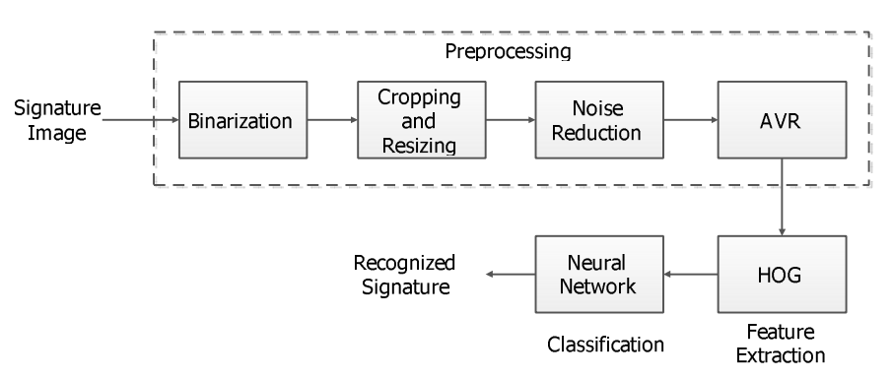
Figure 7: Flowchart for paper[8]
The paper [9] proposed a SIFT and a SURF algorithm which is used for enhanced offline signature recognition. This process, Bag-of-word features, was operated by making vector quantization technique, which outlined the key points for each training image inside a unified dimensional histogram. They put features of bag-of-word inside multiclass Support Vector Machine (SVM) classifier established upon the radial basis function (RBF) for a training and testing. They used Open CV C++ as an image processing tool and tool for feature extraction. In this paper, researchers compare the performance of SIFT on SVM based RBF kernel with SURF on SVM based RBF kernel. It was found out that the use of SIFT with SVM-RBF kernel system, it has an accuracy of 98.75% compared that of SURF with SVM-RBF kernel it has an accuracy of 96.25%. The SURF algorithm (speeded up robust transform) is composed mainly two parts. In the first part, locate the interest point in the image. The surf features are calculated and points are matched between the input and out signatures. The surf features are computed and points are matched across the input and out signatures. SURF detectors are looked in the significant points in the image, and descriptors are used to get the feature from vectors at each interest point just as in the SIFT. Hessian-matrix approximation consists of SURF to put through and locate the key points rather than variant aspects of the Gaussians (DOG) filter prepared in SIFT. This algorithm is very much similar to SIFT algorithm. But, it is actually three times faster than SIFT. About 64 dimensions can be used in SURF to save the time consumption for the two traits which are the matching and the computation.
Scale Invariant Feature Transform is one of several computer vision algorithms which is clearly aimed at extracting distinctive and invariant features from images. Features are extracted by making the SIFT algorithm invariant to image scale, rotation, and partially robust to modifying viewpoints and changes in illumination.
In paper [10], the researchers proposed and implemented an innovative approach based on upper and lower envelope and Eigen values techniques. Envelope represents the shape of the signature. The feature set consists of features such as large and small Eigen values computed from upper envelope and lower envelope and its union values. Both the envelopes are combined by performing union operation and their covariance is calculated. The ratios and the differences of high and low points of both these envelopes are calculated. Lastly average values of both the envelopes are obtained. These features set are coupled with support vector machine classifier that lead to 98.5% of accuracy.
In the paper [11] researchers, use this daily based biometric characteristic for identification and classification of students' papers and various exam documents used at University of Mostar. Paper uses a number of Global features, Grid Features, SIFT features. For classification, Support Vector Machine is used and the accuracy obtained is of 88.97%. Global features includes Aspect ratio, number of pixels that belong to the signature, Baseline shift, Global Slant Angle, Number of Edge Points, Number of Cross-Points and Spatial Symbols, Horizontal and vertical Center of gravity, Length name, Length surname, Maximal horizontal and vertical histogram, the length and ratio of Adjacency Columns, Heaviness of signature, Ratio of first vertical pixel to height, Number of Closed Loops.
In paper [12], a bank cheque is taken and the signature is collected from the bank cheque by taking it out by cropping the area of interest. The image is then trained and stored into the trained database using an efficient Feed forward artificial neural network. Then signatures to be tested are compared with the signatures that are stored into the test database. The accuracy of the system is tested out to be 85.00%. In pre-processing, Otsu’s thresholding or binarization algorithm is used which is one of the finest one, allows image object to be separated from its background and later Gaussian low pass filter is applied to remove unwanted noise.
Fuzzy Logic and Artificial Neural Network Based Off-line Signature Verification and Forgery Detection System is presented in paper [13]. As there are distinct and necessary variations in the feature set of each signature, so in order to match a particular signature image with the database image, the structural features of the signatures and also the local feature variations in the signature characteristics are used. The paper suggests that, variation in personality of signatures, because of age, sickness, geographic location and emotional state of the person actuates the problem
A new approach to document image retrieval based on signature is described in paper [14]. The database consists of document images with English text combined with headlines, logo, ruling lines, trade mark and signature. In searching a particular repository of business documents, the actual work to be done is using a query signature image to retrieve from a database. DT-RCWF and DT-CWT are used for extraction features and recognition rate of images is of 79.32%.
This paper [15] focuses on the pre-processing phase, which is an alternative way to improve the accuracy and to make such factors stable. This research is basically based on the hypothesis that, a table signature size is able to boost up the efficiency which means the recognition rate. Polar Scale Normalization, Adaptive Variance Reduction, Histogram of Oriented Gradients are the techniques used in the system and 98.39% of accuracy is shown.
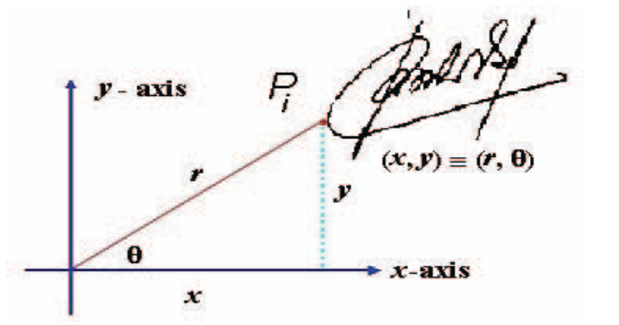
Figure 8: Polar scale normalization
The pre-processing techniques include Binarization, Complementation, Cropping, Resizing. The classification of the test data is done using an efficient artificial neural network.
A signature verification system based on Dynamic Time Warping (DTW) is proposed in paper [16]. Pre-processing techniques have Maximum Length Vertical Projection (MLVP) method, Minimum Length Horizontal Projection (MLHP) method. The technique basically works by extracting the vertical projection based features from signature images and by comparing probe and reference feature templates using elastic matching classification. A 98% accuracy is gained and show promising results.

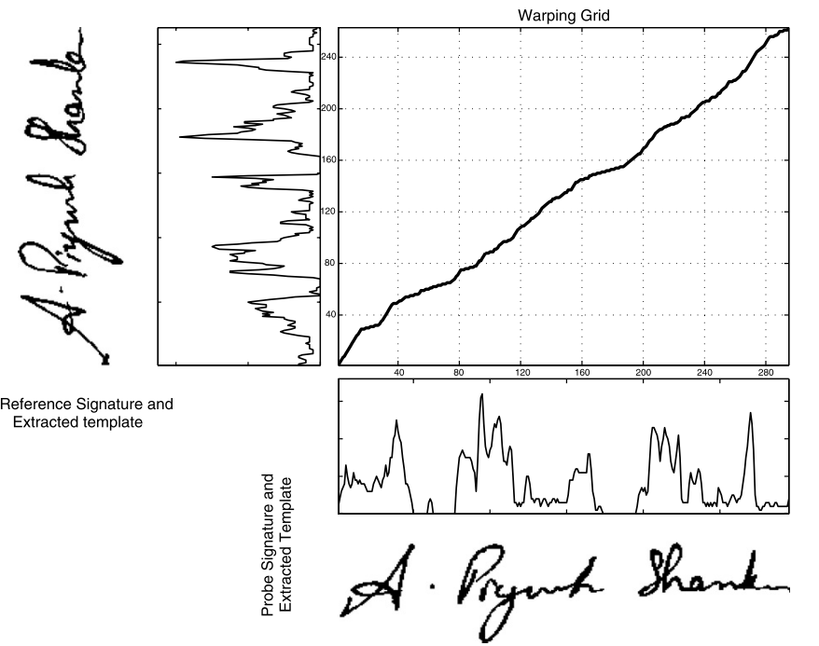
Figure 9: DTW algorithm
Paper [17] focuses on different steps including browsing a bank cheque, pre-processing, feature extraction, recognition. The paper extracts and uses features such as Contrast, Homogeneity, Energy and Entropy for comparing two signature images.
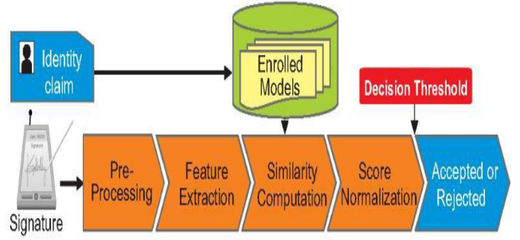
Figure 10: Flowchart of paper [17]
SIFT and a SURF algorithm which is used for enhanced offline signature recognition is used in paper [18]. This process, Bag-of-word features, was operated by making vector quantization technique, which outlined the key points for each training image inside a unified dimensional histogram. Accuracy obtained is 98.75%. SVM classification has limitations in speed and size while both phase of try and test of the algorithm and the chosen of the kernel function parameters.
A writer independent offline handwritten signature verification model, also known as global model, for signature verification is proposed in the paper [19]. Otsu’s thresholding is used for pre-processing the image. System uses Local Binary Pattern based feature vector extraction along with its variants and classifies the images using SVM. An accuracy of 95.75% is received and the results shown are promising.
An offline signature verification using neural network is projected in paper number [20], where the signature is written on a paper are obtained using a scanner or a camera captured and presented in an image format. In pre-processing, colour to grayscale, and finally to black and white, Resizing the image, thinning. Features extracted include Eccentricity, Skewness, Kurtois, Orientation Entropy, Euler number, Solidity, Mean, Standard deviation. The classification is done using a Cascaded feed-forward back-propagation networks and recognition rate of 92.5% is obtained.
System converts a scanned signature to a shape form and eigen-signature construction is proposed for extracting the feature vector from a shape formed signature. The test feature vector is said to belong to i^{th} class, if it possess minimum distance with i^{th} class sample when compared to other class samples Thus paper [21] shows accuracy of 91.40%. The pre-processing techniques include binarizing or thresholding. Noise is eliminated using a simple morphological filter, thinned. The test feature vector is said to belong to i^{th} class, if it possess minimum distance with i^{th} class sample when compared to other class samples.
The purpose in paper number [22] is to select relevant features from those features set. For doing that, researchers compute the importance score of each features using two methods: Information Gain Ratio and Correlation. Over 440 Histogram features, 550 Fresh features, 220 DCT features were extracted an accuracy obtained was 95.5%. Limitations seen are rotation normalization and time normalization. Once all the global features are extracted well, the next trick is ranking these features. Ranking score is obtained from Information Gain Ratio and Correlation. So the result obtained are two list of 1210 features set ranked in order of their Gain. From each list, the features set are then divided into sub features set having 10 first ranked features, 20 first ranked features, 30 first ranked features, and up to 1210 features. So each ranked list will produce sub features set of 121 features.
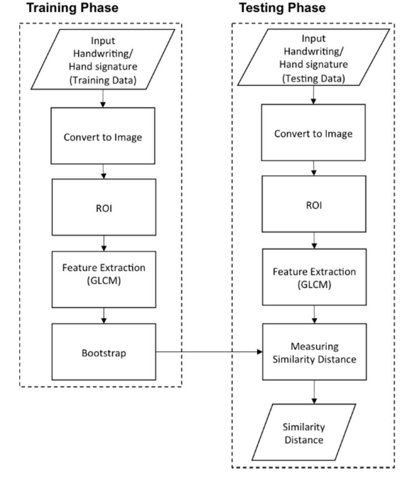
Figure 11: Flow Diagram for Paper [23]

Signature and handwriting recognition on a mobile device using the Gray Level Co-occurrence Matrix (GLCM) for texture-based feature extraction and the bootstrap for performing single classifier model is proposed in the paper [23]. The accuracy obtained is 88.46%.
The paper [24] examines authentication systems based on handwritten signature and the main informative parameters of signature such as size, shape, velocity, pressure, etc along with DCT, DFT. System using K-Nearest neighbours’ algorithm and Random forest algorithm for classification and the accuracy of 95% is shown.
An offline signature recognition system which uses histogram of oriented gradients is presented. Pre-processing techniques used are colour normalization, median filtering, angle normalization and exact bounding box, resized into 256×512 pixels. Feature extraction is done with Gradient Computation, Gradient Vote, Normalization Computation. A three layered feedforward backpropagation neural network is used for classification and the recognition rate of paper [25] is 96.87%
In this paper [26], the trace transform based affine invariant features are applied for signature verification. The diametric and trace functions are appropriately chosen to compute a set of circus functions from each signature image. Recognition rate of 76% is obtained. Low accuracy, more invariant functional will be designed for usefulness in signature verification.
This paper [27], deals with the analysis of discriminative powers of the features that can be extracted from an on-line signature, how it's possible to increase those discriminative powers by Dynamic Time Warping as a step in the pre-processing of the signal coming from the tablet. The accuracy obtained is 99.7%. Pre-processing is done using Filtering, equi-spacing by Linear Interpolation, Normalization, DTW Alignment, Derived Signals: Speed and Acceleration The main processing includes init minus min End minus min Average Root Square Average Time over 0 Crossing 0 Mean over 0 Standard deviation Number of traces, Time of signature, Writing Time of signature / Time of Signature, Height / Width, Area, Length.
Paper [28] uses a texture base approach called the Local binary Pattern algorithm along with SVM, The signature models are trained with genuine signatures on white background and tested with other genuine and forgeries mixed with different backgrounds. Results depict that a basic version of local binary patterns (LBP) or local directional and derivative patterns are more robust than others like GLCM features to the grey level distortion with SVM with histogram oriented kernels as a classifier or rotation invariant uniform LBP. The proposed configurations are checked and evaluated under different situations and conditions: changing the number of training signature images, database with different inks, multiple signing sessions, increasing the number of signers and combining different features Results have also been provided when looking for the signature in the check and segmenting it automatically. In all these cases, the best results were obtained with the LDerivP feature set, which improve the results obtained in the predefined baseline, showing quite significant improvements with fictitious signature images.
Paper [29] uses Conic section function neural network (CSFNN) circuitry was designed for offline signature recognition. CSFNN is a unified framework for multilayer perceptron (MLP) and radial basis function (RBF) networks and the size of feature vectors was not suitable for designed CSFNN chip structure owing to the input limitations of the circuit. Pre-processing is done using noise reduction algorithm, skeletonization. The few main disadvantages of analog systems include its sensitivity to ambient noise and to temperature. Accuracy shown is 95.5%.
This paper [30] explores the usefulness of local binary pattern (LBP) and local directional pattern (LDP) texture measures to discriminate off-line signatures. Comparison between these several texture normalizations is generated in order to look for reducing pen dependence. The recognition rate is 91.92%. The pre-processing techniques include binarized, cropped, or-exclusive operation, Texture histogram normalization. Least Squares Support Vector Machine (LS-SVM) is applied for classification.
The goal of this study [31] is to investigate the effect of combining transform features to authenticate signatures. Due to genuine human error and lack of consistency, comparing signatures requires pre-processing to assist with standardization. An EER of 2.46% which means a recognition rate of 99.40% is shown by the system. The features extracted include x coordinate, y coordinate, pen pressure, azimuth, altitude, DFT, DCT and DWT. Classification is done with Fast Dynamic Time Warping (FastDTW) algorithm
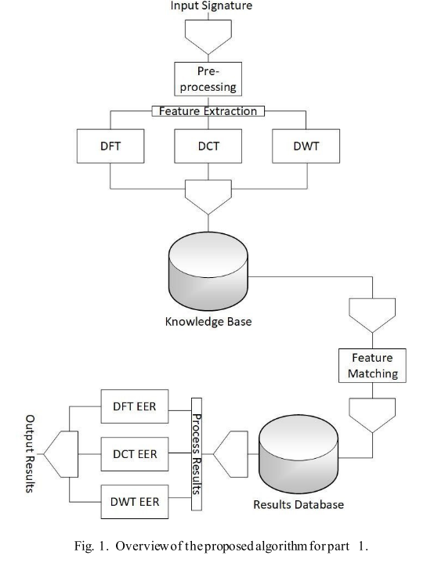
Figure 12: Flow chart of paper [31]
In this paper [32], gender discrimination has been proposed by feature extraction method. The proposed framework considers handwritten Hindi signature of each individuals as an input for gender detection. Recognition rate obtained is 92.90%.
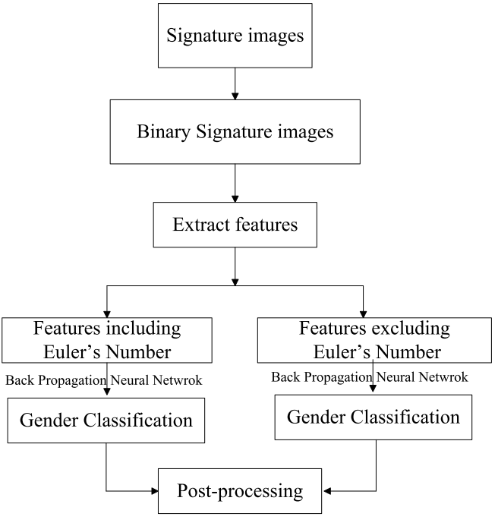
Figure 13: Flowchart of system in paper [32]
In order to solve the shortcomings of manual identification in technical accuracy and subjectivity, this paper [33] proposed an off-line signature identification method based on Support Vector Machine (SVM). Accuracy shown here is 85.00%. Dataset are stained by useless border. Other pre-processing techniques used in the system include Image binarization, denoising, removing blank margins. Features include global feature like height, width, area and slant angle and sum of black pixels. Identification rates within and between writing systems is prone to swing in some degree under different partitioning strategy.
This paper [34] titled presents a set of geometric signature features for offline automatic Signature verification based on the description of the signature envelope and the interior stroke distribution in polar and Cartesian coordinates. Feature extraction method includes Outline Detection and Representation, Feature Vector Based on Polar Coordinates, Feature Vector Based on Cartesian Coordinates. Classification is performed using The HMM Signature Model, Support Vector Machine Signature Model and Euclidean Distance-Based Signature Model.
The proposed system [35] segments each signature curve based on pen’s velocity value. The signature curve, would be decomposed in low or high partition according to velocity’s value. For each partition, hand movement direction between two consequent point Extracted. 95.10%. Pre-processing technique here are removing noise, translation invariance, rotation 7 scale invariance. Signature features extracted and used shape of signature would be partitioned based on dynamic feature such as velocity or pressure. Classification is done using Hidden Markov Model.

Optical flow is used to define a stability model of the genuine signatures for each signer in paper [36]. Stability between the unknown signature and reference signatures is estimated and consistency with the stability model of the signer is evaluated. Accuracy obtained is 96.00%. In pre-processing, signature image size was adjusted to a fixed area. Optical flow vectors were used for the analysis of the local stability of a signer to detect the stable regions in the signature. Optical flow vectors are for the analysis of the local stability of a signer to detect the stable regions in the signature.
In this paper [37] an efficient off-line signature verification method based on an interval symbolic representation and a fuzzy similarity measure is proposed. 88.26% Local Binary Pattern, interval-valued symbolic model. A histogram-based threshold technique, mean filter for noise removal, minimum bounding boxes. Classification of the signature image is done based on the similarity value, an adaptive writer-dependent acceptance threshold
A new approach of showing online signatures by interval-valued symbolic features. The online signature also gives global features that are to be extracted and used to form an interval-valued feature vectors. Methods for signature verification and recognition based on the symbolic representation are also proposed in paper [38] Recognition rate is 95.40%.
This paper [39] explores the utility of information derived from the dynamic time warping (DTW) cost matrix for the problem of online signature verification. The prior research and experimentations in literature primarily utilize only the DTW scores to authenticate a test signature. Accuracy measured is 97.24%. As the paper itself suggests local features & histogram representation shall be an interesting extension.
This paper [40] presents a new approach for online signature verification that exploits the potential of local stability information in handwritten signatures. Different from previous models, this approach classifies a signature using a multi domain strategy. Accuracy obtained is 97.90%. Both variable and stable regions of a signature image object could be considered for supporting the advanced personalized techniques in signature verification and recognition, since probably, from a behavioural point of view, a variability model of a signer/author could also be very complementary and informative to a stability model.

Future work
The research allowed us to learn more and more about the domain and the problem of signature recognition and verification. The research work having 40 different research papers on the problem of signature recognition/verification was done and presented here in this paper allowed to prepare and plan for a signature verification system to be designed.
The system work will work in 3 stages very similar to most of the systems. Pre-processing stage would have steps like grey-scaling, resizing (without disturbing the aspect ratio), noise reduction filters, Otsu thresholding and binarization algorithm and in the end fitting boundary box cropping. The feature extraction includes simple shape based features like aspect ratio, centre of gravity, normalised area, baseline-shift and GLCM features like contrast, dissimilarity, homogeneity, energy, correlation and ASM. The Local binary Pattern algorithm which will allow us to extract texture based features. The final stage would have KNN and SVM algorithms to classify the test image based on the training image dataset.

Conclusion
We can conclude by stating that the remarkable work done by the researchers in the 40 research papers described in this paper are stated with clear ideas and also with the accuracy of the system approached by them. We provide full credits to all the authors of these papers for sharing their knowledge and their astonishing work they have put forward that led us to our study. By looking at them and comparing, we can say which one is good by merely looking at their recognition rates. But choosing a system does not just depends on the systems efficiency, there are many other aspects that must be considered while designing a system such as application of the system, time requirements, space requirements of the system, complexity of the algorithms and cost of setting up the application and so on. There are still many approaches out there that may be better than what are listed here and thus the work does not end here.

References

