**Faculty of Computer Science and Engineering**

**Computer Science Department**



[Blood Bank Management System]

**Introduction to Software Engineering Course**

**CS 281**

**Fall 2021**

Team Members

Name of Group Member 1 Teef Khadeer Alzulfi – 3950489

Name of Group Member 2 Alanoud Saleh Alakhdeer – 3951671

Name of Group Member 3 Roaa Wajdi Senior –3953488

Contents

**Abstract** 4

**Chapter One: Introduction** 4

1.1 Overview 4

1.2 Problem Definition 4

1.3 Description of Proposed System 4

1.4 Scope of the System 4

**Chapter Two: System Analysis** 4

2.1 Domain Analysis 4

2.2 The Environment 4

2.3 Customers and Users 4

2.4 Existing Systems 4

2.5 Use Case Model 4

2.5.1 Actors of the system 4

2.5.2 Use Case Diagram 4

2.5.3 Use Case Descriptions 4

2.5.4 Functional Requirements 4

2.5.5 Non-Functional Requirements 4

**Chapter Three: System Design** 5

3.1 System Architecture 5

3.2 Sequence Diagrams 5

3.3 Activity Diagram 5

3.4 Class Diagram 5

**Chapter Six: Conclusion** 5

6.1 Summary 5

6.2 Lessons Learnt 5

6.3 Challenges and Limitations 5

6.4 Future Work 5

**Abstract**

blood donation is a process whereby a person voluntarily has blood drawn to be used for future transfusions when in need at hospitals for treatment procedures that require them. Donation may be of whole blood (blood drawn directly from the body) or of specific components of the blood; such as red blood cells, white blood cells, plasma, and platelets. Blood banks often participate in the process of collecting blood and other procedures such as managing stocks, approving blood requests and updating donation information.

# **Chapter One: Introduction**

# Overview

BBMS is a management system that is developed to manage blood bank . This is to make sure that the management of the blood stock became effective, systematic and meeting user requirements, the BBMS is to simplify and automate the process of searching for blood in case of emergency and maintain the records of blood donors, recipients, blood donation programs and blood stocks in the bank.

# Problem Definition

In some hospitals, especially in the emergency department, we need a lot of blood for operations that require blood transfusion or for people who have lost a lot of blood, so there may be a shortage in the blood stock in the hospital, or it is difficult to find blood donors whose blood type matches that of the recipients, which leads to the death of some people, so we designed this system.

# Description of Proposed System

This SRS describes the functional and nonfunctional requirements for software release of the Blood Donation Management System (BDMS). This document is intended to be used by the end users organization administration and members of the project team who will implement and verify the correct functioning of the system. Unless otherwise noted, all requirements specified here are committed for release.

# Scope of the System

The BDMS provide short way to find blood quickly. The system is web-based system which will connect the patients and donors in one virtual place. So, a hospital -where the patient in- can search for a blood group in the web site then request the quantity needed. Any hospital can fill emergent request in emergent situations, the system send messages to all donors by SMS to donate as a

response of the emergent request.

# 

# **Chapter Two: System Analysis**

# 2.1 Domain Analysis

In this system, we will do the "management of blood donation". Hospital staff, blood donors and recipients can use this website. What can be done in this system?

It connects blood donors and recipients who need this blood in one place

You can find or request blood for emergency cases quickly and easily You can also keep the names of blood donors on the website and book an appointment to donate again

# 2.2 The Environment

* patient management System
* patient Reception System
* admission System
* Report system

# 2.3 Customers and Users

* hospital
* Donor
* Employee
* admin

# 2.4 Existing Systems

website It connects blood donors and recipients who need this blood in one place where You can find or request blood for emergency cases quickly and easily

Suggestions

There is a special icon just for emergency cases in the website asking for help from all nearby hospitals. So that if there is not enough blood or there are no donors alerts are sent to them about the presence of a critical condition with patient data attached for rapid response

# 2.5 Use Case Model

## 2.5.1 Actors of the system

**1**.Medical laboratories: After the donation process, the blood is saved in bags with a sterile and encapsulated system. The blood units are transferred to the laboratory for the necessary tests and to ensure that the blood is free of infectious diseases.

**2**. Large hospitals and clinics that are located within neighborhoods or where the emergency department is located, which in turn receive blood from medical laboratories after it has been tested and ensured its safety.

## 2.5.2 Use Case Diagram

## 

2.5.3 Use Case Descriptions

|  |  |  |  |
| --- | --- | --- | --- |
| UC ID | 1 | Created date | DD/MM/YYYY |
| UC Name | Search Blood | Updated Date | DD/MM/YYYY |
| Actor | | Hospital Staff | |
| Description | | Allow hospital staff to search for a blood. | |
| Preconditions | | Staff is logged in to the system | |
| postconditions | | Result is displayed | |
| Normal Flow | | 1. the staff navigate to the search page . 2. staff type the information he search for e.g blood group 3. the staff click the search button.E1 4. The system should return the search results if, there is a corresponding in the database. 5. The system then should provide filtering options e.g (blood group, address, donation date..etc). 6. The system should filter the results upon the selected options from the staff. | |
| Alternative flow | |  | |
| Exceptions | | E1   1. If the staff doesn’t type words in the search field    1. the system should ask from him to insert search data.    2. Go to step 2 in normal flow. | |

|  |  |  |  |
| --- | --- | --- | --- |
| UC ID | 2 | Created date | DD/MM/YYYY |
| UC Name | Request Blood | Updated Date | DD/MM/YYYY |
| Actor | | Hospital Staff | |
| Description | | Allow hospital staff to request a blood. | |
| Preconditions | | Log in | |
| postconditions | | New request is created and saved to the database. | |
| Normal Flow | | 1. The staff go to request page . 2. The system display the form of requesting blood. 3. The staff fill out all the needed data (blood group, quantity, patient diagnostic ).E1 4. The staff click save button to save request. 5. The system should automatically send massages to the donors who has the sane blood group of the request. | |
| Alternative flow | |  | |
| Exceptions | | E1 | |
|  | | 1. If the staff doesn’t fill all needed data    1. the system should ask from him to insert required data.    2. Go to step 3 in normal flow. | |

|  |  |  |  |
| --- | --- | --- | --- |
| UC ID | 3 | Created date | DD/MM/YYYY |
| UC Name | Blood donation | Updated Date | DD/MM/YYYY |
| Actor | | Employee | |
| Description | | To allow employee to create donation for a donor | |
| Preconditions | | Log in | |
| postconditions | | Donor has been donated. | |
| Normal Flow | | 1. the employee check if the donor has appointment or not. 2. If he has, the employee must check the blood test for the donor. 3. If tests success the employee enter the donation details (donor number, date, number of bags…). After that the system should print confirmation of the donor to donate. | |
| Alternative flow | |  | |
| Exceptions | |  | |

|  |  |  |  |
| --- | --- | --- | --- |
| UC ID | 4 | Created date | DD/MM/YYYY |
| UC Name | Book appointment | Updated Date | DD/MM/YYYY |
| Actor | | Donor | |
| Description | | Allow donor to book appointment to donate | |
| Preconditions | | Log in | |
| postconditions | | Donor has an appointment | |
| Normal Flow | | 1. The donor navigates to the booking page. 2. Then he fills the required details such as date and time. 3. The system should check if the date is available or not. 4. If it available the system must send notification to the bank employee to confirm the appointment. 5. If confirmation done the system inform donor that his booking is success and ask him to come two hours earlier in the bank before the donation time to make the blood test and finish the donation procedures. | |
| Alternative flow | |  | |
| Exceptions | |  | |

## 2.5.4 Functional Requirements

* The system should allow user to register and create account.
* Any user should log in to the system to use system services.
* The system should allow hospital staff to request blood.
* The doner should be able to make appointment to donate.
* The employee should be able to confirm all appointments and requested

## 2.5.5 Non-Functional Requirements

### Usability Requirements:

* 1-the users should use the BDMS after watching video of who to use it
* .2- all hospitals’ staff should be able to request blood from the first time.

### Performance Requirements:

* 1-the BDMS should be able to perform 100 – 400 requests from users in the peak time which from the 10:00 Am to 12:00Pm.

# **Chapter Three: System Design**

# 3.1 System Architecture

# 3.2 Sequence Diagrams

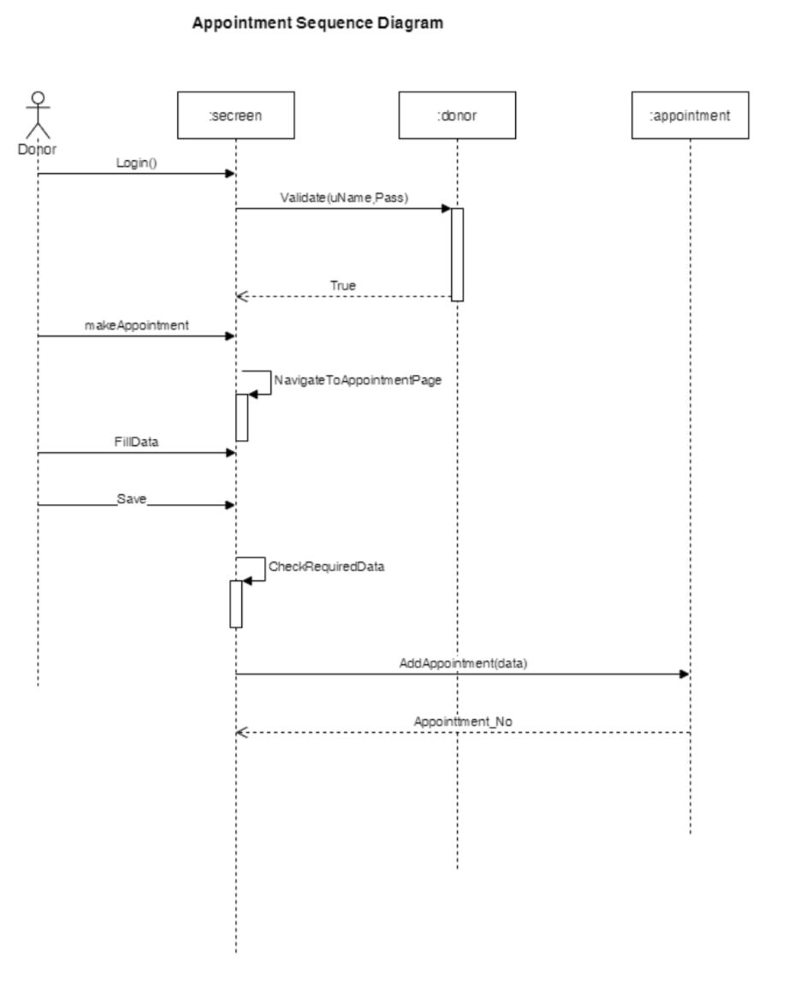

# 

# 

# 3.3 Activity Diagrams

صورة تحتوي على نص, ساعة حائط, أبعاد

تم إنشاء الوصف تلقائياً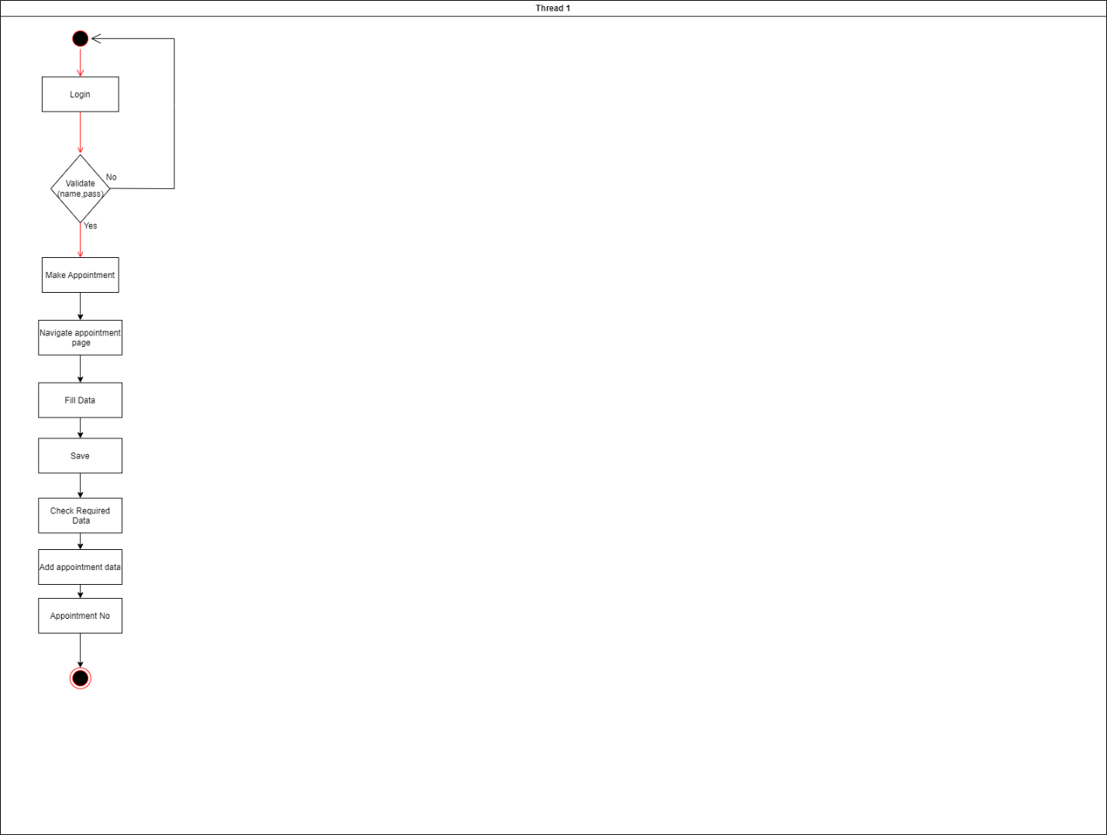

# 

# **Chapter Six: Conclusion**

# 6.1 Summary

Benefits of donating blood: Increasing the activity of the bone marrow to produce new blood cells (red cells, white blood cells, and platelets).

Increase the activity of blood circulation.

Donating blood helps reduce iron in the blood because it is one of the causes of heart disease and arterial blockage.

The best features offered by this system:

Facilitate obtaining blood for emergency or other cases as soon as possible.

Ease of donating blood.

Preserve the information of the donor previously, in order to facilitate the donation later.

# 6.2 Lessons Learnt

During the development of this system we practice most of the software development process and activities. It really was a good chance to practice what we learned in the collage and we see how software systems are developed and how the process is managed and controlled. Also we learned how to use some helping tools that facilitate the development process

# 6.3 Challenges and Limitations

The size of the database increases day-by-day, increasing the load on the database back up and data maintenance activity. Training for simple computer operations is necessary for the users working on the system

# 6.4 Future Work

It has been a great pleasure for me to work on this exciting and challenging project. This project proved good for me as it provided practical knowledge also about all handling procedure related with “Emergency Blood Bank Management System”. It also provides knowledge about the latest technology used in developing web enabled application and client server technology that will be great demand in future. This will provide better opportunities and guidance in future in developing projects independently.

6.5 Reference

* <https://itsourcecode.com/>
* <https://www.freeprojectz.com/>
* <https://www.tutorialspoint.com/index.htm/>