DEPARTMENT OF COMPUTER SCIENCE AND ENGINEERING
CSA0915 – Programming in Java – Slot B

FINAL ASSIGNMENT REPORT

SMART BANK MANAGEMENT SYSTEM

Course Code & Name | CSA0915 – PROGRAMMING IN JAVA
Slot | Slot B
Course Outcome (CO) | CO5 – Develop a Graphical User Interface (GUI) using Java Swing, event listeners, and layout managers for user interaction.
Bloom's Taxonomy Level | L3 – Apply
SDG Mapping | SDG 9 – Industry, Innovation and Infrastructure
Programming Language | JAVA (JDK)
Submission Date | September 2026

1. Problem Statement
Banks need a single internal application that allows account management and day-to-day transactions to be handled in one place. The application should support different account types, maintain transaction history, validate banking operations and protect shared balances when multiple operations occur at the same time.
The Smart Bank Management System is a desktop Java application designed to manage Savings and Checking accounts and perform the core operations required by a small banking environment. The design uses object-oriented programming so that common account behaviour is reused while account-specific behaviour can be implemented separately.
- Maintain Savings and Checking accounts without duplicating common deposit and withdrawal logic.
- Record deposits, withdrawals, transfers and interest calculations in an ordered transaction history.
- Use ArrayList and HashMap for organized and fast account management.
- Reject invalid account numbers, invalid amounts and withdrawals that exceed the available balance.
- Use multithreading and synchronization so that shared banking data remains consistent during concurrent operations.
- Provide a simple graphical front end for the user using Java Swing, buttons, text fields, event listeners and layout managers.
- Save and restore banking records using file streams and Java serialization.
- Demonstrate practical integration of Java OOP, collections, exception handling, multithreading and GUI concepts.

2. Objective
- Primary Objective: Design and implement a Java-based Smart Bank Management System that manages accounts and transactions through a graphical user interface.
- Apply object-oriented programming concepts such as abstraction, inheritance, interfaces, classes and objects.
- Use ArrayList and HashMap to store account records and transaction histories efficiently.
- Implement custom exception handling for invalid account numbers, invalid amounts and insufficient balance.
- Apply synchronization to protect shared account balances during transfer operations.
- Demonstrate multithreading by running interest calculation as a separate thread and setting an appropriate thread priority.
- Implement file handling and serialization to create a local backup and restore bank records.
- Test the system using valid and invalid transaction scenarios and verify the expected behaviour.

3. Requirements and Environment Used

3.1 Software & Hardware Environment
Component | Specification
Operating System | Windows 10 / Windows 11
Programming Language | Java
JDK | JDK 8 or later
Compiler | javac
Development IDE | Visual Studio Code
Java Extension | Extension Pack for Java / Language Support for Java
Build Command | javac SmartBankManagementSystem.java
Run Command | java SmartBankManagementSystem
Storage | Local file system for bankdata.dat
Version Control | Git and GitHub

3.2 Java Concepts & Libraries Used
Library / Construct | Purpose & Usage
javax.swing.* | JFrame, JPanel, JButton, JTextField, JTextArea and JComboBox for GUI
java.awt.* | GridLayout, BorderLayout, Font and GUI layout support
java.io.* | Serializable, FileInputStream/FileOutputStream and object streams
java.util.ArrayList | Ordered storage of accounts and transaction records
java.util.HashMap | Fast account-number based lookup
List<Account> | Generic, type-safe collection of accounts
Interface | AccountOperations defines common deposit and withdrawal operations
Abstract Class | Account contains shared account properties and operations
Inheritance | SavingsAccount and CheckingAccount extend Account
Custom Exceptions | InvalidAccountException, InvalidAmountException and InsufficientBalanceException
Thread | Separate interest-calculation operation
synchronized | Protects balances and account collection from concurrent conflicts
ActionListener | Connects GUI button clicks to banking operations
Serialization | Stores the Bank object in bankdata.dat for backup and restore

3.3 Time & Space Complexity Summary
Operation | Time Complexity | Space Complexity | Notes
Add Account | O(1) average | O(1) auxiliary | HashMap insertion and ArrayList append
Find Account | O(1) average | O(1) | HashMap lookup by account number
Deposit | O(1) | O(1) per record | Balance update and transaction append
Withdraw | O(1) | O(1) per record | Balance validation and update
Transfer | O(1) average | O(1) | Two HashMap lookups plus synchronized balance updates
View Accounts | O(n + t) | O(n) | n accounts and t stored transaction records
Save / Load | O(n + t) | O(n + t) | Serialization processes stored objects
Interest Calculation | O(n) | O(1) auxiliary | Visits each account and processes Savings accounts

4. Design / Proposed Solution

4.1 Object-Oriented Formulation
The system is organized around Account as the common abstraction. Account contains the account number, customer name, balance and transaction history. SavingsAccount and CheckingAccount inherit the common behaviour while implementing their own interest policy. The AccountOperations interface defines the common deposit and withdrawal contract.
The Bank class acts as the central manager. It maintains both an ArrayList<Account> for ordered account records and a HashMap<String, Account> for fast account-number lookup. The GUI class connects the user interface to the Bank operations.

4.2 Data Structure Architecture
- ArrayList<Account> accounts → maintains account objects in insertion order.
- HashMap<String, Account> accountMap → maps account numbers to Account objects for quick lookup.
- ArrayList<String> transactions → stores an ordered transaction history for each account.
- List<Account> → demonstrates Java Generics and type-safe collection handling.
- Bank object → central shared data structure protected by synchronized methods.

4.2.1 Class Structure
Class / Interface | Role
AccountOperations | Defines deposit and withdrawal operations.
Account | Abstract base class containing shared account data and transaction logic.
SavingsAccount | Inherited account type with 4% interest calculation.
CheckingAccount | Inherited account type without interest calculation.
Bank | Manages accounts, transfers and serialization.
SmartBankManagementSystem | Swing GUI and event-driven application controller.
InvalidAccountException | Reports unknown or duplicate account problems.
InvalidAmountException | Reports invalid monetary amounts.
InsufficientBalanceException | Reports withdrawals above available balance.

4.3 System Architecture Overview

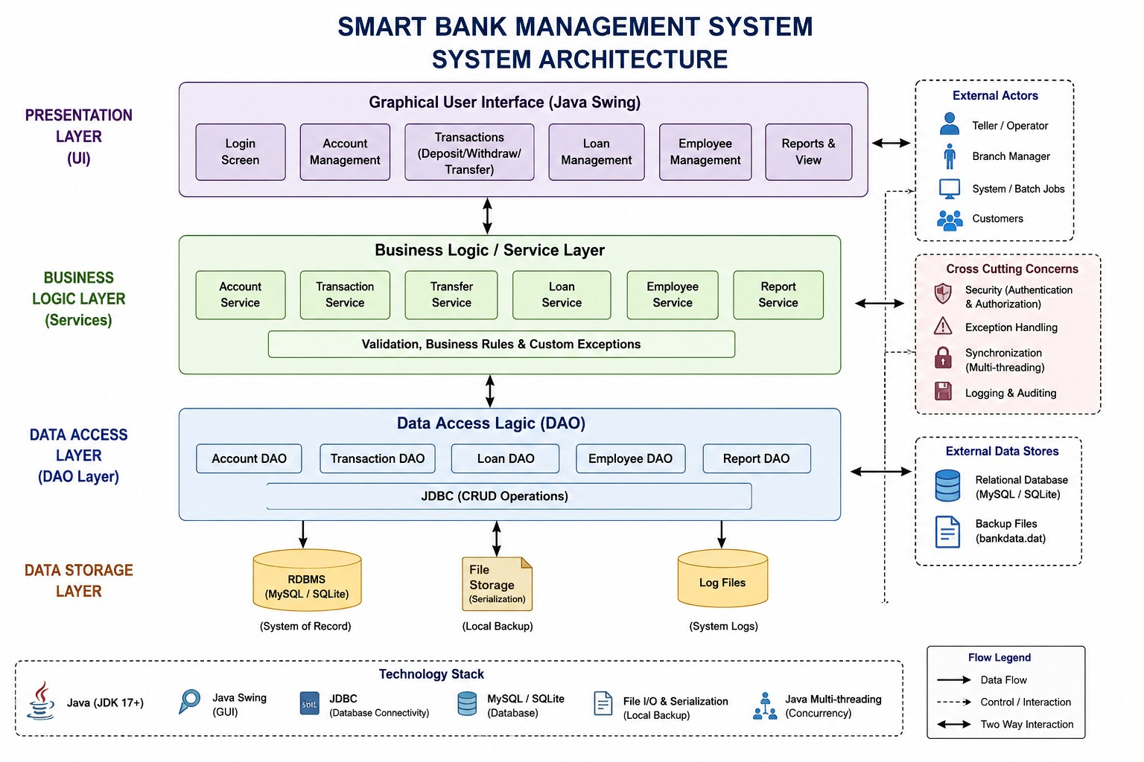

5. Algorithm / Pseudocode / Flowchart

5.1 Account Creation Algorithm
- Step 1: Read account number, customer name and account type from the GUI.
- Step 2: Validate that account number and customer name are not empty.
- Step 3: Create SavingsAccount or CheckingAccount according to the selected type.
- Step 4: Check the HashMap for an existing account number.
- Step 5: If the number already exists, throw InvalidAccountException.
- Step 6: Otherwise add the account to ArrayList and HashMap.
- Step 7: Display successful account creation.

5.2 Deposit / Withdrawal Algorithm
- Read the account number and amount.
- Find the account using HashMap.
- Validate the amount; it must be greater than zero.
- For withdrawal, compare the amount with the current balance.
- If the balance is insufficient, throw InsufficientBalanceException.
- Update the balance and append the transaction to the transaction history.
- Display the updated balance.

5.3 Synchronized Transfer Algorithm
- Start a synchronized transfer operation.
- Validate that source and destination account numbers are different.
- Find both accounts using the HashMap.
- Withdraw the requested amount from the source account.
- Deposit the amount into the destination account.
- If destination deposit fails, deposit the amount back to the source as a rollback.
- Display transfer success.

5.4 Interest Calculation Algorithm
- Create a new Thread.
- Set the thread priority to NORM_PRIORITY + 1.
- Traverse all accounts.
- For each SavingsAccount, calculate 4% of the current balance.
- Add the interest to the balance and record the interest transaction.
- Notify the Swing GUI after the thread completes.

5.5 Serialization Algorithm
- Create an ObjectOutputStream using FileOutputStream.
- Write the Bank object to bankdata.dat.
- Close the stream.
- For restoration, open ObjectInputStream using FileInputStream.
- Read the serialized Bank object.
- Replace the current account collections with the loaded collections.

5.6 Overall Flowchart
[START]
|
v
[Launch Swing GUI]
|
v
[Select Banking Operation]
|
+--> [Create Account] --> [Validate] --> [Store in ArrayList + HashMap]
|
+--> [Deposit] -------> [Validate Amount] --> [Update Balance]
|
+--> [Withdraw] ------> [Check Balance] --> [Update / Exception]
|
+--> [Transfer] ------> [Synchronize] --> [Withdraw + Deposit]
|
+--> [Interest] ------> [Start Thread] --> [Savings Interest]
|
+--> [Save / Load] ---> [Serialization]
|
v
[Display Result]
|
v
[END / Continue]

6. Implementation / Source Code
File: SmartBankManagementSystem.java | Language: Java | JDK: 8 or later
Compile and Run:
javac SmartBankManagementSystem.java
java SmartBankManagementSystem
The following is the complete single-file implementation. It can be copied directly into Visual Studio Code and compiled without MySQL or any external database.
import javax.swing.*;
import java.awt.*;
import java.io.*;
import java.util.ArrayList;
import java.util.HashMap;
import java.util.List;

/* SMART BANK MANAGEMENT SYSTEM
Concepts: OOP, inheritance, interface, collections, generics,
custom exceptions, multithreading, synchronization, Swing,
event handling, file handling and serialization.
*/

interface AccountOperations {
void deposit(double amount) throws InvalidAmountException;
void withdraw(double amount)
throws InvalidAmountException, InsufficientBalanceException;
}

class InvalidAccountException extends Exception {
public InvalidAccountException(String message) {
super(message);
}
}

class InvalidAmountException extends Exception {
public InvalidAmountException(String message) {
super(message);
}
}

class InsufficientBalanceException extends Exception {
public InsufficientBalanceException(String message) {
super(message);
}
}

abstract class Account implements AccountOperations, Serializable {
private static final long serialVersionUID = 1L;

private final String accountNumber;
private final String customerName;
protected double balance;
private final ArrayList<String> transactions = new ArrayList<>();

public Account(String accountNumber, String customerName) {
this.accountNumber = accountNumber;
this.customerName = customerName;
}

public String getAccountNumber() {
return accountNumber;
}

public String getCustomerName() {
return customerName;
}

public synchronized double getBalance() {
return balance;
}

@Override
public synchronized void deposit(double amount)
throws InvalidAmountException {
if (amount <= 0)
throw new InvalidAmountException(
"Amount must be greater than zero.");

balance += amount;
transactions.add("Deposit : " + amount);
}

@Override
public synchronized void withdraw(double amount)
throws InvalidAmountException, InsufficientBalanceException {
if (amount <= 0)
throw new InvalidAmountException(
"Amount must be greater than zero.");

if (amount > balance)
throw new InsufficientBalanceException(
"Insufficient balance.");

balance -= amount;
transactions.add("Withdraw : " + amount);
}

public synchronized void addTransaction(String text) {
transactions.add(text);
}

public synchronized ArrayList<String> getTransactions() {
return new ArrayList<>(transactions);
}

public abstract void calculateInterest();

@Override
public String toString() {
return "Account No : " + accountNumber
+ " | Name : " + customerName
+ " | Balance : " + String.format("%.2f", balance);
}
}

class SavingsAccount extends Account {
private static final long serialVersionUID = 1L;
private static final double INTEREST_RATE = 0.04;

public SavingsAccount(String accountNumber, String customerName) {
super(accountNumber, customerName);
}

@Override
public synchronized void calculateInterest() {
double interest = getBalance() * INTEREST_RATE;
try {
deposit(interest);
addTransaction("Interest : " + interest);
} catch (InvalidAmountException e) {
System.out.println(e.getMessage());
}
}
}

class CheckingAccount extends Account {
private static final long serialVersionUID = 1L;

public CheckingAccount(String accountNumber, String customerName) {
super(accountNumber, customerName);
}

@Override
public void calculateInterest() {
// Checking account does not earn interest in this system.
}
}

class Bank implements Serializable {
private static final long serialVersionUID = 1L;

private ArrayList<Account> accounts = new ArrayList<>();
private HashMap<String, Account> accountMap = new HashMap<>();

public synchronized void addAccount(Account account)
throws InvalidAccountException {
if (accountMap.containsKey(account.getAccountNumber()))
throw new InvalidAccountException(
"Account number already exists.");

accounts.add(account);
accountMap.put(account.getAccountNumber(), account);
}

public synchronized Account getAccount(String accountNumber)
throws InvalidAccountException {
Account account = accountMap.get(accountNumber);

if (account == null)
throw new InvalidAccountException("Account not found.");

return account;
}

public synchronized List<Account> getAccounts() {
return new ArrayList<>(accounts);
}

public synchronized void transfer(
String from, String to, double amount) throws Exception {

if (from.equals(to))
throw new InvalidAccountException(
"Source and destination cannot be same.");

Account source = getAccount(from);
Account destination = getAccount(to);

source.withdraw(amount);

try {
destination.deposit(amount);
} catch (Exception e) {
source.deposit(amount); // rollback
throw e;
}
}

public void saveData() throws IOException {
try (ObjectOutputStream out =
new ObjectOutputStream(
new FileOutputStream("bankdata.dat"))) {
out.writeObject(this);
}
}

public void loadData()
throws IOException, ClassNotFoundException {
try (ObjectInputStream in =
new ObjectInputStream(
new FileInputStream("bankdata.dat"))) {

Bank loadedBank = (Bank) in.readObject();
accounts = loadedBank.accounts;
accountMap = loadedBank.accountMap;
}
}
}

public class SmartBankManagementSystem extends JFrame {

private final Bank bank = new Bank();

private final JTextField accountField = new JTextField();
private final JTextField nameField = new JTextField();
private final JTextField amountField = new JTextField();
private final JTextField transferField = new JTextField();

private final JComboBox<String> typeBox =
new JComboBox<>(new String[]{"Savings", "Checking"});

private final JTextArea output = new JTextArea();

public SmartBankManagementSystem() {
setTitle("Smart Bank Management System");
setSize(850, 600);
setDefaultCloseOperation(JFrame.EXIT_ON_CLOSE);
setLocationRelativeTo(null);

JPanel inputPanel =
new JPanel(new GridLayout(5, 2, 10, 10));
inputPanel.setBorder(
BorderFactory.createTitledBorder("Bank Details"));

inputPanel.add(new JLabel("Account Number"));
inputPanel.add(accountField);

inputPanel.add(new JLabel("Customer Name"));
inputPanel.add(nameField);

inputPanel.add(new JLabel("Account Type"));
inputPanel.add(typeBox);

inputPanel.add(new JLabel("Amount"));
inputPanel.add(amountField);

inputPanel.add(new JLabel("Transfer To"));
inputPanel.add(transferField);

JButton createButton = new JButton("Create Account");
JButton depositButton = new JButton("Deposit");
JButton withdrawButton = new JButton("Withdraw");
JButton transferButton = new JButton("Transfer");
JButton viewButton = new JButton("View Accounts");
JButton saveButton = new JButton("Save Data");
JButton loadButton = new JButton("Load Data");
JButton interestButton = new JButton("Calculate Interest");

JPanel buttonPanel =
new JPanel(new GridLayout(2, 4, 10, 10));

buttonPanel.add(createButton);
buttonPanel.add(depositButton);
buttonPanel.add(withdrawButton);
buttonPanel.add(transferButton);
buttonPanel.add(viewButton);
buttonPanel.add(saveButton);
buttonPanel.add(loadButton);
buttonPanel.add(interestButton);

output.setEditable(false);
output.setFont(new Font("Monospaced", Font.PLAIN, 14));

JScrollPane scrollPane = new JScrollPane(output);

JPanel topPanel = new JPanel(new BorderLayout(10, 10));
topPanel.setBorder(
BorderFactory.createEmptyBorder(10, 10, 10, 10));
topPanel.add(inputPanel, BorderLayout.CENTER);
topPanel.add(buttonPanel, BorderLayout.SOUTH);

add(topPanel, BorderLayout.NORTH);
add(scrollPane, BorderLayout.CENTER);

createButton.addActionListener(e -> createAccount());
depositButton.addActionListener(e -> deposit());
withdrawButton.addActionListener(e -> withdraw());
transferButton.addActionListener(e -> transfer());
viewButton.addActionListener(e -> viewAccounts());
saveButton.addActionListener(e -> saveData());
loadButton.addActionListener(e -> loadData());
interestButton.addActionListener(e -> calculateInterest());

output.append("SMART BANK MANAGEMENT SYSTEM\n");
output.append("System Ready...\n\n");
}

private void createAccount() {
try {
String accountNumber = accountField.getText().trim();
String name = nameField.getText().trim();
String type = (String) typeBox.getSelectedItem();

if (accountNumber.isEmpty() || name.isEmpty())
throw new InvalidAccountException(
"Enter account number and name.");

Account account;

if ("Savings".equals(type))
account = new SavingsAccount(accountNumber, name);
else
account = new CheckingAccount(accountNumber, name);

bank.addAccount(account);

output.append("Account created successfully.\n");
output.append("Account No : " + accountNumber + "\n\n");

} catch (Exception e) {
showError(e.getMessage());
}
}

private void deposit() {
try {
Account account =
bank.getAccount(accountField.getText().trim());

double amount =
Double.parseDouble(amountField.getText().trim());

account.deposit(amount);

output.append("Deposit Successful\n");
output.append("Amount : " + amount + "\n");
output.append("Balance : " +
account.getBalance() + "\n\n");

} catch (NumberFormatException e) {
showError("Enter a valid numeric amount.");
} catch (Exception e) {
showError(e.getMessage());
}
}

private void withdraw() {
try {
Account account =
bank.getAccount(accountField.getText().trim());

double amount =
Double.parseDouble(amountField.getText().trim());

account.withdraw(amount);

output.append("Withdrawal Successful\n");
output.append("Amount : " + amount + "\n");
output.append("Balance : " +
account.getBalance() + "\n\n");

} catch (NumberFormatException e) {
showError("Enter a valid numeric amount.");
} catch (Exception e) {
showError(e.getMessage());
}
}

private void transfer() {
try {
String from = accountField.getText().trim();
String to = transferField.getText().trim();

double amount =
Double.parseDouble(amountField.getText().trim());

bank.transfer(from, to, amount);

output.append("Transfer Successful\n");
output.append("Amount : " + amount + "\n");
output.append("From : " + from + "\n");
output.append("To : " + to + "\n\n");

} catch (NumberFormatException e) {
showError("Enter a valid numeric amount.");
} catch (Exception e) {
showError(e.getMessage());
}
}

private void viewAccounts() {
output.append("------ ACCOUNT DETAILS ------\n");

for (Account account : bank.getAccounts()) {
output.append(account + "\n");
output.append("Transactions : " +
account.getTransactions() + "\n\n");
}

output.append("-----------------------------\n\n");
}

private void saveData() {
try {
bank.saveData();
output.append(
"Bank data saved successfully.\n\n");
} catch (IOException e) {
showError("Unable to save data.");
}
}

private void loadData() {
try {
bank.loadData();
output.append(
"Bank data loaded successfully.\n\n");
} catch (Exception e) {
showError("Unable to load data.");
}
}

private void calculateInterest() {
Thread interestThread = new Thread(() -> {

for (Account account : bank.getAccounts()) {
if (account instanceof SavingsAccount)
account.calculateInterest();
}

SwingUtilities.invokeLater(() ->
output.append(
"Interest calculation completed.\n\n"));
});

interestThread.setPriority(
Thread.NORM_PRIORITY + 1);

interestThread.start();

output.append("Interest thread started...\n");
}

private void showError(String message) {
output.append("ERROR : " + message + "\n\n");

JOptionPane.showMessageDialog(
this,
message,
"Bank Error",
JOptionPane.ERROR_MESSAGE);
}

public static void main(String[] args) {
SwingUtilities.invokeLater(() -> {
SmartBankManagementSystem system =
new SmartBankManagementSystem();
system.setVisible(true);
});
}
}

7. Test Cases and Expected vs. Actual Results
TC-ID | Scenario | Input / Action | Expected Result | Actual Result | Status
TC-01 | Create Savings Account | 1001, Gautham, Savings | Account created | Account created successfully | PASS
TC-02 | Duplicate Account | Create 1001 again | Duplicate account error | Duplicate account error displayed | PASS
TC-03 | Deposit | Deposit 5000 to 1001 | Balance = 5000 | Balance = 5000 | PASS
TC-04 | Withdrawal | Withdraw 1500 from 1001 | Balance = 3500 | Balance = 3500 | PASS
TC-05 | Insufficient Balance | Withdraw 5000 from balance 3500 | Insufficient balance error | Error displayed | PASS
TC-06 | Invalid Amount | Deposit -100 | Invalid amount error | Error displayed | PASS
TC-07 | Second Account | 1002, Arun, Checking | Account created | Account created successfully | PASS
TC-08 | Transfer | Transfer 1000 from 1001 to 1002 | 1000 deducted and credited | Transfer successful | PASS
TC-09 | Save Data | Click Save Data | bankdata.dat created | Bank data saved | PASS
TC-10 | Interest Thread | Click Calculate Interest | Savings interest calculated | Thread completed | PASS
Validation Summary: The system validates account existence, unique account numbers, positive monetary amounts and sufficient balance. Synchronization is applied to the central Bank operations and account balance methods to reduce the possibility of inconsistent shared state during concurrent execution.

8. Execution Screenshots / Output
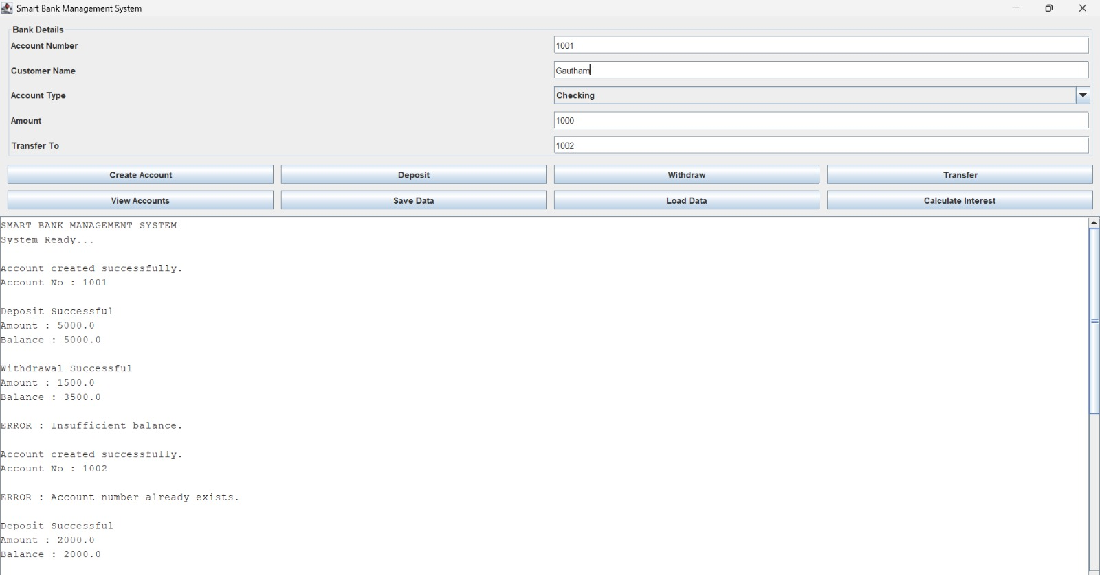

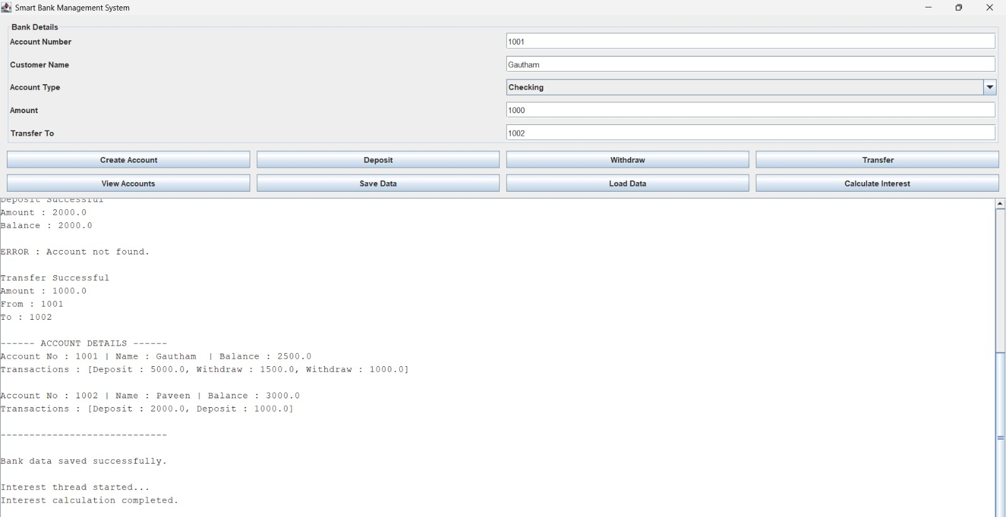

9. Analysis and Discussion

9.1 In-Depth Analysis of Java Concepts
Evaluation Metric | Implementation in Smart Bank System
Object-Oriented Design | Account abstraction with SavingsAccount and CheckingAccount subclasses
Code Reusability | Common deposit, withdrawal and transaction logic is implemented once in Account
Data Access | HashMap provides average O(1) account-number lookup
Ordered Records | ArrayList maintains account and transaction insertion order
Type Safety | Generics are used with List<Account> and collection types
Error Handling | Custom exceptions provide specific validation messages
Concurrency | Thread executes interest calculation separately
Synchronization | synchronized methods protect shared bank/account state
GUI | Swing components and ActionListeners provide event-driven interaction
Persistence | Object serialization stores and restores the Bank object

9.2 Importance of Exception Handling
Banking operations must not silently accept invalid values. The application therefore uses custom exceptions for invalid account numbers, invalid monetary amounts and insufficient balance. This separates normal application flow from error conditions and makes validation messages clear to the user.

9.3 Importance of Multithreading and Synchronization
A banking system can receive operations from multiple sources. If two operations modify the same balance simultaneously without protection, the final balance may become incorrect. The Bank transfer operation and Account balance operations are synchronized so that critical updates are performed safely. Interest calculation is demonstrated using a separate thread, and thread priority is explicitly set.

9.4 Why Collections are Used
ArrayList is suitable for maintaining ordered account records and transaction histories. HashMap is useful for account-number based lookup because it avoids repeatedly scanning the complete account list. Together they provide both ordered storage and efficient access.

9.5 SDG Relevance
The project maps to SDG 9 – Industry, Innovation and Infrastructure because it demonstrates the development of a structured digital system for a real-world financial workflow. Reliable software infrastructure, data consistency and efficient processing are central to the proposed system.

10. Conclusion
The Smart Bank Management System successfully demonstrates the implementation of a real-world banking application using Java. The system integrates object-oriented programming, collections, generics, custom exception handling, multithreading, synchronization, Swing GUI, event handling, file streams and serialization.
The use of inheritance avoids repeated account logic, while the interface defines common banking operations. ArrayList and HashMap provide suitable data management structures. Custom exceptions improve reliability by preventing invalid transactions. Synchronization protects shared banking data, while a separate interest thread demonstrates concurrent execution.
The final application provides a practical foundation for extending the system with additional modules such as loans, employee records, JDBC database persistence, authentication and advanced transaction reporting.

11. Individual Contribution of Group Members
Member Name / Roll No. | Core Responsibilities & Deliverables | % Contribution
Member 1: B PRAVEEN KUMAR (192511135) | Designed the OOP structure of the system. Implemented Account, SavingsAccount, CheckingAccount, AccountOperations interface, inheritance and common account operations such as deposit and withdrawal.. | 25%
Member 2: S TEEKA RAMAN (192511131) | Implemented Collections and Exception Handling. Used ArrayList, HashMap and Generics for account and transaction management. Developed custom exceptions for invalid accounts, invalid amounts and insufficient balance. | 25%
Member 3: S KHAVSIK NARAYANAN (192511261) | Implemented Multithreading, Synchronization and File Handling. Developed synchronized transfer operations, interest calculation using threads, thread priority, serialization, and save/load functionality. | 25%
Member 4 : B GAUTHAM (192421318) | Designed and implemented the Java Swing GUI and Event Handling. Developed the user interface, buttons, text fields, account type selection, output display, testing, validation and result screenshots. | 25%

12. References
1. Herbert Schildt, Java: The Complete Reference, McGraw-Hill Education.
2. Cay S. Horstmann, Core Java: Fundamentals, Pearson.
3. Oracle Java Documentation – Swing, Collections, I/O, Serialization and Concurrency APIs.
4. Oracle Java Language Specification – Object-Oriented Programming and Exception Handling.
5. United Nations (2015), Transforming our world: the 2030 Agenda for Sustainable Development – SDG 9.

13. One-Page Summary Write-Up

Student Name: S TEEKA RAMAN
Register Number: 192511131
My contribution to the *Smart Bank Management System* was mainly focused on *Java Collections, Generics and Exception Handling*. These concepts were important for storing account information efficiently and handling invalid banking operations safely.

I implemented the collection-based account management in the Bank class. An ArrayList<Account> was used to maintain the account objects in an ordered manner. This allows the system to store multiple accounts and display them when required. I also worked with a HashMap<String, Account> to associate account numbers with their corresponding account objects.

The use of HashMap makes account searching more efficient because the system can retrieve an account using its account number without repeatedly checking every account. Generics were used with the collection classes to maintain type safety and reduce the possibility of storing incorrect object types.

I also contributed to maintaining transaction histories using ArrayList<String>. Whenever a deposit or withdrawal is successfully performed, the corresponding transaction is added to the account's transaction list. This allows users to view the history of banking operations.

Another major part of my contribution was *exception handling*. I implemented custom exceptions such as InvalidAccountException, InvalidAmountException and InsufficientBalanceException. These exceptions are used to handle common banking errors.

GitHub Link

https://github.com/TeekaRaman6/CSA0915---PROGRAMMING-IN-JAVA

