Object-Oriented Analysis and UML-Based Design of an Intelligent Food Waste Reduction and Redistribution System (IFWRRS)
CSA11 – Object Oriented Analysis and Design
Table of Contents

1. Problem Analysis and Requirement Summary

1.1 Problem Overview
Large quantities of edible surplus food generated daily by restaurants, hotels, supermarkets, and food suppliers go to waste while charitable organizations, shelters, and community kitchens face food shortages. The Intelligent Food Waste Reduction and Redistribution System (IFWRRS) is proposed to bridge this gap by digitally connecting food providers, recipient organizations, delivery partners, and administrators, enabling timely, traceable, and efficient redistribution of surplus food before it expires.

1.2 Functional Requirements (derived from the scenario)
ID | Requirement
FR1 | Registered food providers shall record surplus food with quantity, type, preparation time, expiry period, storage requirement, and pickup location.
FR2 | The system shall identify suitable recipient organizations based on food requirement, location, quantity, and urgency (intelligent matching).
FR3 | Recipient organizations shall view available donations, request items, confirm collection, and update distribution status.
FR4 | Delivery partners shall receive pickup/delivery assignments and update transportation status.
FR5 | Administrators shall monitor donations, organizations, deliveries, users, and generate reports.
FR6 | The system shall generate notifications when surplus food is approaching expiry.
FR7 | The system shall support user registration, authentication, and role-based access.

1.3 Non-Functional Requirements
- Reliability: Consistent state transitions for donation and delivery status.
- Scalability: Ability to add new providers, organizations, and regions without redesign.
- Usability: Simple interfaces for providers and NGOs with limited technical expertise.
- Timeliness: Near real-time matching and notification before food expiry.
- Data consistency & transaction management: Concurrent requests for the same donation must be handled safely.

1.4 Domain Summary
The domain centers on four stakeholder roles (Provider, Recipient Organization, Delivery Partner, Administrator) interacting around a central artifact — the FoodDonation — whose lifecycle (posted → matched → requested → confirmed → delivered → closed) drives most system behaviour.

2. Actor Identification
Actor | Type | Description
Food Provider | Primary, Human | Restaurant, hotel, supermarket, or supplier that posts surplus food donations.
Recipient Organization | Primary, Human | Charity, NGO, or shelter that requests and collects donations.
Delivery Partner | Primary, Human | Individual/agency that transports food from provider to recipient.
Administrator | Primary, Human | Oversees users, donations, deliveries, and system reports.
Matching Engine | Secondary, System | Automated component that matches donations to suitable recipients.
Notification System | Secondary, System | Automated component that issues expiry and status alerts.

3. Use Case Descriptions

UC-01: Post Surplus Food Donation
- Actor: Food Provider
- Precondition: Provider is registered and logged in.
- Main Flow: Provider enters food type, quantity, preparation time, expiry period, storage requirement, and pickup location → system validates data → system triggers Matching Engine (include) → donation status set to Posted.
- Postcondition: Donation is visible to matching recipient organizations.
- Alternate Flow: Invalid data → system prompts correction.

UC-02: Perform Intelligent Matching
- Actor: Matching Engine (system)
- Trigger: New donation posted, or periodic re-scan.
- Main Flow: Engine filters recipient organizations by food type, quantity capacity, location proximity, and urgency → ranks candidates → notifies top matches.

UC-03: Request Food Donation
- Actor: Recipient Organization
- Precondition: Donation is visible/matched.
- Main Flow: Organization views donation details → submits request → system notifies provider → includes UC-02 outcome as trigger context.

UC-04: Confirm Collection
- Actor: Recipient Organization, Food Provider
- Main Flow: Provider confirms the request → system creates a delivery assignment (include UC receive assignment) → recipient later confirms physical collection, closing the donation.

UC-05: Update Distribution Status
- Actor: Recipient Organization
- Main Flow: Organization marks donation as collected/distributed to end beneficiaries for reporting purposes.

UC-06: Receive Pickup/Delivery Assignment
- Actor: Delivery Partner
- Main Flow: System assigns nearest available partner → partner accepts → partner receives pickup and delivery location details.

UC-07: Update Transport Status
- Actor: Delivery Partner
- Main Flow: Partner updates status (Picked Up → In Transit → Delivered) as the delivery progresses; system notifies provider and recipient at each change.

UC-08: Monitor Donations, Organizations, Deliveries, Users
- Actor: Administrator
- Main Flow: Administrator views dashboards of all active/past donations, registered users, and ongoing deliveries; can suspend/approve accounts.

UC-09: Generate System Reports
- Actor: Administrator
- Main Flow: Administrator requests a report (e.g., waste reduced, donations per region) → system compiles and exports data.

UC-10: Send Expiry Notification
- Actor: Notification System (system), extends UC-01/UC-02
- Main Flow: When a posted donation nears its expiry threshold without being matched/collected, the system automatically alerts the provider and nearby recipient organizations.

UC-11: Register / Login
- Actor: All human actors
- Main Flow: New users register with role-specific details; returning users authenticate via credentials.

4. Use Case Diagram
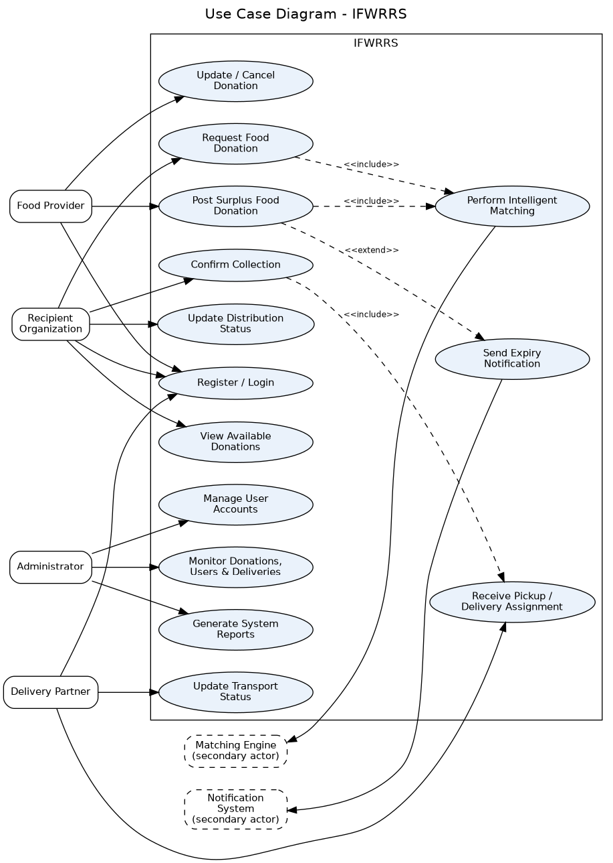
Use Case Diagram
The diagram shows four primary human actors interacting with the system boundary and two secondary system actors (Matching Engine, Notification System) that automate matching and alerting. <<include>> relationships capture mandatory sub-behaviour (e.g., posting a donation always includes matching); <<extend>> captures optional/conditional behaviour (expiry notification only fires under a condition).

5. Object and Class Identification

5.1 Candidate Objects (from noun analysis of the scenario)
Food provider, restaurant/hotel/supermarket/supplier, recipient organization, delivery partner, administrator, surplus food, quantity, food type, preparation time, expiry period, storage requirement, pickup location, recipient requirement, urgency, availability, donation request, collection, distribution status, delivery assignment, transportation status, notification, report.

5.2 Classification of Objects into Classes
Applying object classification (behaviour + attribute clustering, and eliminating redundant/irrelevant candidates such as “quantity” which becomes an attribute, not a class), the following classes were identified:
Class | Category | Justification
User (abstract) | Entity | Common identity/auth attributes shared by all roles — supports inheritance and polymorphism.
FoodProvider, RecipientOrganization, DeliveryPartner, Administrator | Entity | Role-specialized behaviour that differs from the base User.
FoodDonation | Entity | Central business object; owns the lifecycle state machine.
FoodItem | Entity | Line-item detail when a donation bundles multiple food items.
Address | Entity/Value | Reusable location value object for pickup/delivery.
MatchingEngine | Control | Encapsulates matching algorithm — a control class, not persisted as a normal entity.
Notification | Entity/Boundary | Represents a message dispatched to a user.
DeliveryAssignment | Entity | Associates a donation with a delivery partner and tracks transport status.
Report | Entity | Administrator-facing aggregated output.

6. Class Diagram
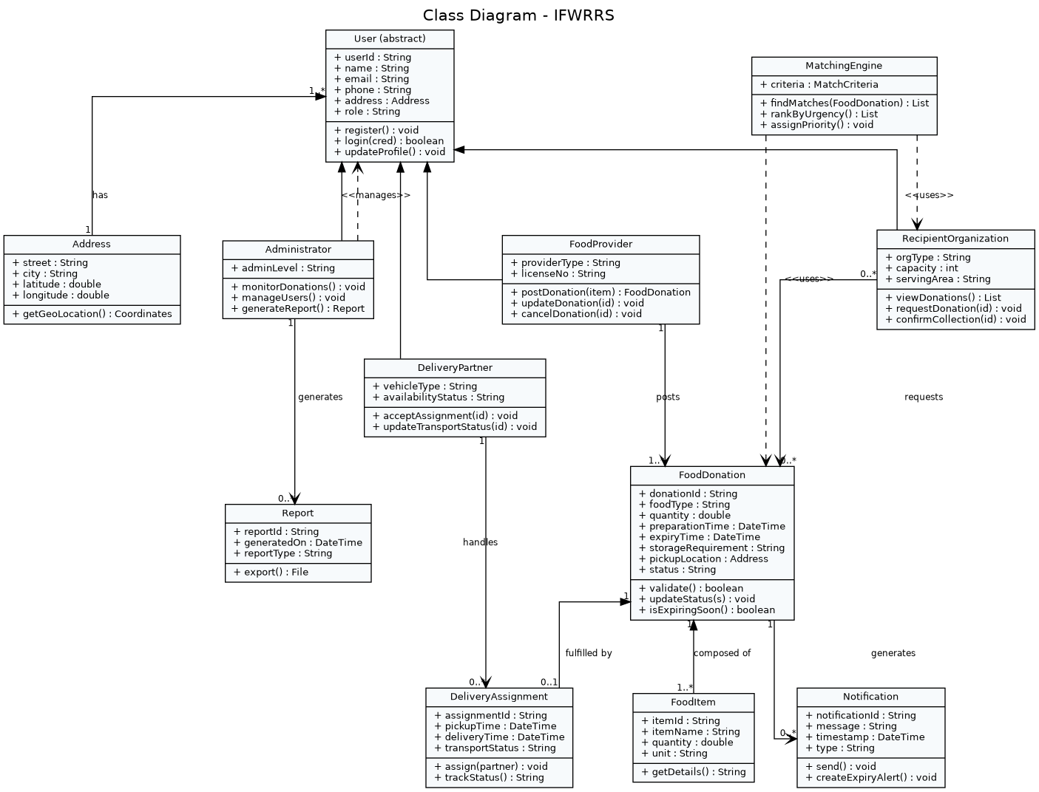
Class Diagram
Key relationships: - Inheritance (generalization): FoodProvider, RecipientOrganization, DeliveryPartner, Administrator all generalize from abstract User. - Composition: FoodDonation owns one or more FoodItems — items cannot exist without the donation (filled diamond). - Aggregation: User has one or more Address — an address can conceptually be reused/exist independent of the user record (hollow diamond). - Association: FoodProvider posts FoodDonation; RecipientOrganization requests FoodDonation; DeliveryPartner handles DeliveryAssignment. - Dependency (<<uses>>): MatchingEngine depends on FoodDonation and RecipientOrganization data without owning them.

7. Sequence / Interaction Diagram
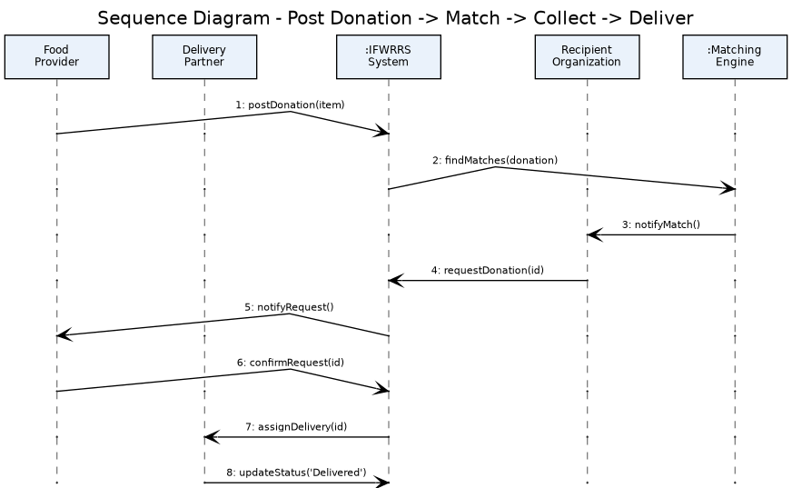
Sequence Diagram
This interaction diagram traces the primary success scenario for UC-01 → UC-02 → UC-03 → UC-04 → UC-06 → UC-07: a provider posts a donation, the system validates and triggers matching, the recipient organization requests it, the provider confirms, and the delivery partner is assigned and updates transport status through to delivery.

8. Activity Diagram
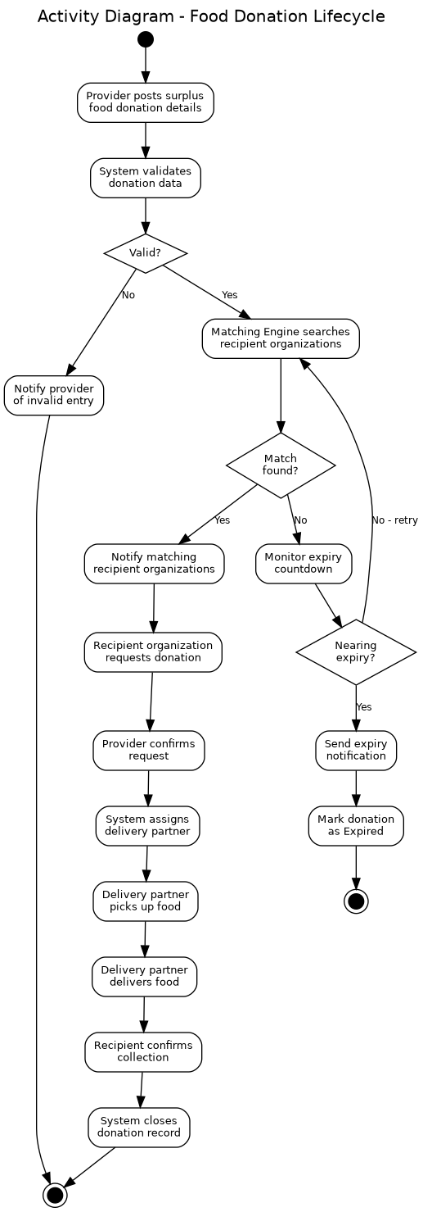
Activity Diagram
The activity diagram models the complete FoodDonation lifecycle, including the decision points for data validity, match availability, and expiry monitoring — showing both the happy path (posted → delivered → closed) and the expiry path (posted → unmatched → expired).

9. State Transition Diagram
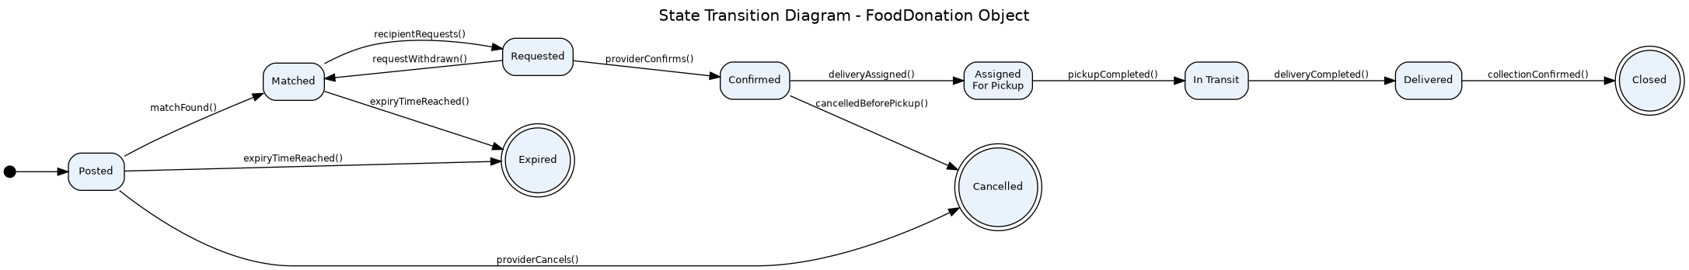
State Transition Diagram
The FoodDonation object exhibits nine distinct states. Guard conditions (e.g., expiryTimeReached()) ensure a donation cannot silently remain active past its safe consumption window, directly satisfying the constraint on food-expiry handling.

10. Package Diagram
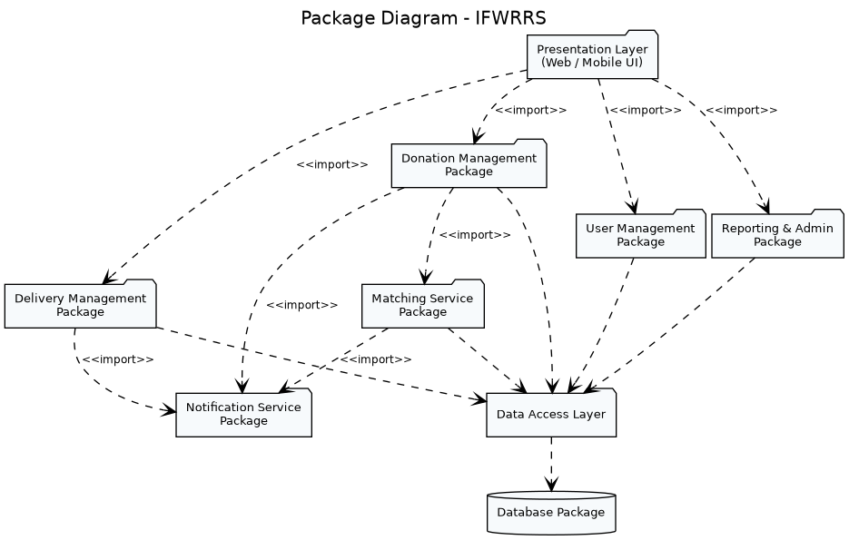
Package Diagram
The system is organized into a layered architecture: a Presentation layer, four cohesive business-logic packages (User Management, Donation Management, Matching Service, Delivery Management, Notification Service, Reporting & Admin), and a Data Access layer over a single Database package. Dependencies flow strictly downward, minimizing coupling between the UI and persistence concerns.

11. Component Diagram
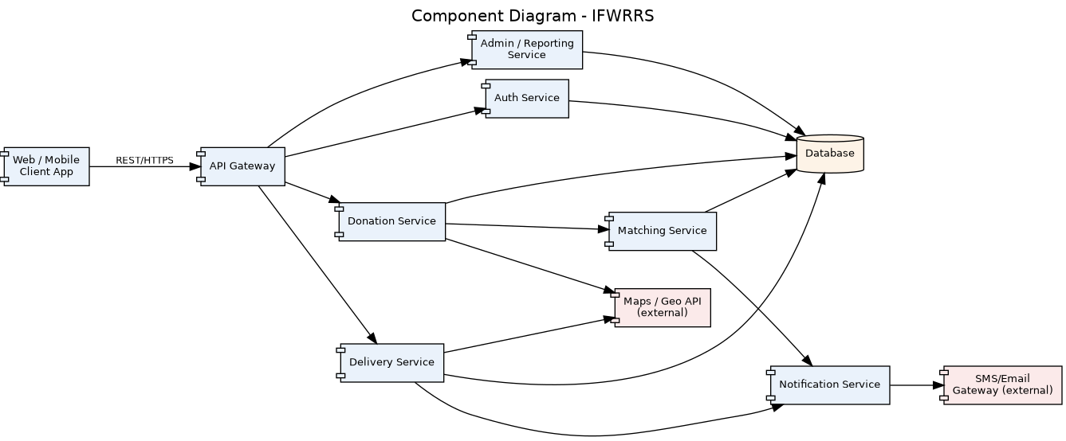
Component Diagram
Each business package is realized as an independently deployable service component behind an API Gateway, communicating over REST/HTTPS. External dependencies (SMS/Email Gateway, Maps/Geo API) are isolated behind the Notification and Donation/Delivery services respectively, so they can be replaced without affecting core logic.

12. Deployment Diagram
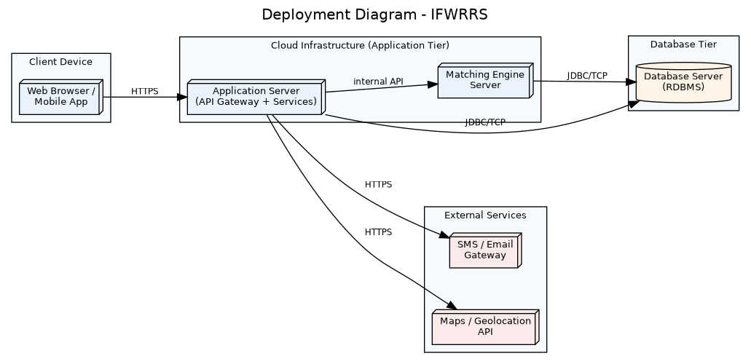
Deployment Diagram
Client devices communicate with a cloud-hosted application-server tier (API Gateway + services) over HTTPS. The Matching Engine is deployed as a separate node to allow independent scaling of computationally heavier matching jobs. A dedicated database server and external SMS/Maps services complete the physical topology.

13. Object Responsibility Analysis (CRC Cards)
Class | Responsibilities | Collaborators
FoodProvider | Post/update/cancel donations; maintain profile | FoodDonation, Notification
RecipientOrganization | Browse donations; request; confirm collection | FoodDonation, MatchingEngine, Notification
DeliveryPartner | Accept assignment; report transport status | DeliveryAssignment, Notification
Administrator | Monitor entities; manage accounts; generate reports | User, FoodDonation, Report
FoodDonation | Hold donation data; enforce valid status transitions; detect nearing expiry | FoodItem, Notification, DeliveryAssignment
MatchingEngine | Filter and rank recipient organizations for a donation | FoodDonation, RecipientOrganization
DeliveryAssignment | Link a donation to a delivery partner; track transport progress | FoodDonation, DeliveryPartner
Notification | Compose and dispatch a message to the relevant user(s) | User
Report | Aggregate and export operational data | FoodDonation, DeliveryAssignment
Responsibility assignment follows the GRASP principles: Information Expert (FoodDonation owns its own status-transition logic because it holds the state), Creator (FoodProvider creates FoodDonation instances since it supplies the data), Controller (MatchingEngine acts as a use-case controller rather than embedding matching logic inside entity classes), and Low Coupling / High Cohesion (Notification is a single-purpose class reused by every other component instead of each class emailing/SMS-ing directly).

14. Design Axioms, Principles and Design Pattern Justification

14.1 Design Axioms (Suh’s Axiomatic Design, applied conceptually)
- Independence Axiom: Each package (User Management, Donation Management, Matching, Notification, Delivery, Reporting) maps to an independent functional requirement, so a change to matching logic does not ripple into delivery tracking.
- Information Axiom: Among designs satisfying the independence axiom, the simplest one (fewest classes/relationships) was preferred — e.g., a single Notification class serves all alert types instead of one subclass per alert type.

14.2 Object-Oriented Design Principles Applied
- High Cohesion: FoodDonation only manages donation data and its own lifecycle; delivery tracking is delegated to DeliveryAssignment.
- Low Coupling: UI/Presentation never talks to the database directly — always via service packages, per the layered Package Diagram.
- Encapsulation: State transition rules are private to FoodDonation.update_status(); no external class mutates status directly.
- Abstraction: User is an abstract class exposing a common contract (register(), role()), hiding role-specific implementation details.
- Open/Closed Principle: New provider or organization sub-types can be added by extending User without modifying existing matching or notification logic.

14.3 Design Patterns Justified
Pattern | Where Applied | Justification
State Pattern | FoodDonation status lifecycle | Encapsulates legal transitions (Posted→Matched→…→Closed) and prevents invalid states, directly satisfying the “data consistency” constraint.
Strategy Pattern | MatchingEngine | The matching algorithm (proximity, urgency, capacity) can be swapped without changing the classes that call it.
Observer Pattern | Notification dispatch | Providers, recipients, and delivery partners “subscribe” to status changes on a donation and are notified automatically.
Factory Method | User registration | Creates the correct User subclass (FoodProvider, RecipientOrganization, etc.) based on the selected role at registration.
Singleton (candidate) | Database connection manager | Ensures a single shared connection pool across all service components, avoiding resource duplication.
MVC (architectural) | Overall layering | Presentation (View), Service packages (Controller), Entity classes (Model) — supports the Package/Component diagrams.

15. Assumptions and Constraints

15.1 Assumptions
- All actors access the system through a single web/mobile client; no offline mode is required.
- A donation is assumed to be collected by exactly one recipient organization (no partial-quantity splitting in this iteration).
- Delivery partners are either gig-workers or NGO-affiliated volunteers, already onboarded with basic verification.
- Expiry threshold for triggering alerts is configurable but defaults to 30 minutes before expiryTime.
- Location data (latitude/longitude) is available for all providers, organizations, and pickup points.

15.2 Constraints
- All classes, attributes, and operations must trace back to at least one use case (Section 16).
- UML diagrams must remain mutually consistent — e.g., every message in the Sequence Diagram corresponds to an operation in the Class Diagram.
- The design must account for food expiry, notification timing, matching criteria, delivery status, user roles, data consistency, and transaction management, per the assignment brief.
- The system must distinguish stakeholder responsibilities clearly (no shared/God classes).

16. Requirement-to-Use Case/Class Traceability Matrix
Requirement | Use Case(s) | Primary Class(es)
FR1 – Record surplus food | UC-01 | FoodProvider, FoodDonation, FoodItem
FR2 – Intelligent matching | UC-02 | MatchingEngine, FoodDonation, RecipientOrganization
FR3 – View/request/confirm | UC-03, UC-04, UC-05 | RecipientOrganization, FoodDonation
FR4 – Pickup/delivery & status | UC-06, UC-07 | DeliveryPartner, DeliveryAssignment
FR5 – Admin monitoring & reports | UC-08, UC-09 | Administrator, Report, User
FR6 – Expiry notifications | UC-10 | Notification, FoodDonation
FR7 – Registration/auth | UC-11 | User (and subclasses)

17. Implementation / Prototype and Results
A console-based Python prototype was implemented to validate the core object model — the User inheritance hierarchy, the FoodDonation state machine, and the MatchingEngine strategy — before full UI/database implementation. The prototype enforces valid state transitions exactly as modelled in the State Transition Diagram (Section 9), raising an error on any illegal transition attempt.
Sample execution output:
======================================================================
IFWRRS PROTOTYPE DEMONSTRATION
======================================================================
FoodProvider 'Green Leaf Hotel' registered with id USR0001
RecipientOrganization 'Hope Shelter' registered with id USR0002
DeliveryPartner 'Ravi Kumar' registered with id USR0003
Administrator 'System Admin' registered with id USR0004
Green Leaf Hotel posted donation DNT0005: 40 kg of Cooked Rice & Curry (expires in 120 min)
[Notification -> INFO] Donation DNT0005 status changed to 'Matched'
MatchingEngine found 1 match(es) for DNT0005: ['Hope Shelter']
[Notification -> INFO] Donation DNT0005 status changed to 'Requested'
Hope Shelter requested donation DNT0005
[Notification -> INFO] Donation DNT0005 status changed to 'Confirmed'
[Notification -> INFO] Donation DNT0005 status changed to 'AssignedForPickup'
Ravi Kumar updated assignment DLV0009 -> Picked Up
[Notification -> INFO] Donation DNT0005 status changed to 'InTransit'
Ravi Kumar updated assignment DLV0009 -> Delivered
[Notification -> INFO] Donation DNT0005 status changed to 'Delivered'
[Notification -> INFO] Donation DNT0005 status changed to 'Closed'
Admin System Admin monitoring 1 donation(s):
- DNT0005: Closed
Final status of DNT0005: Closed
Result: The donation object transitioned correctly through all nine lifecycle states with no invalid transitions, and every status change automatically generated a Notification, confirming that the Observer-style notification design and the State-pattern-based lifecycle work as modelled.

18. Reflection on Design Decisions and Learning Outcomes
Modelling IFWRRS reinforced how object identification (Section 5) is rarely a one-pass exercise — several early candidate classes (e.g., “Urgency”, “Availability”) were correctly demoted to attributes or matching criteria rather than standalone classes, which sharpened the distinction between entity, attribute, and control responsibilities. Choosing the State pattern for FoodDonation was the most consequential design decision: centralising transition rules directly satisfies the assignment’s data-consistency constraint and made the Activity, Sequence, and State diagrams naturally consistent with one another, since every diagram references the same fixed vocabulary of statuses.
The exercise also clarified the practical value of GRASP and SOLID principles beyond theory — e.g., delegating matching logic to a dedicated MatchingEngine (Controller/Strategy) rather than embedding it inside FoodDonation kept that class cohesive and made the algorithm independently testable and replaceable.
Relevance to selected SDGs: IFWRRS directly supports SDG 2 (Zero Hunger) by redirecting edible surplus to those in need, SDG 12 (Responsible Consumption and Production) by reducing avoidable food waste at the source, SDG 11 (Sustainable Cities and Communities) by strengthening local food-redistribution networks, and SDG 13 (Climate Action) indirectly, since diverting food from disposal reduces the methane emissions associated with landfill decomposition.

19. GitHub Upload Checklist
- ☐ Create a repository named IFWRRS-OOAD-Assignment.
- ☐ Add README.md summarizing the problem statement and this document’s structure.
- ☐ Upload all .dot/PlantUML diagram sources under /diagrams/src and rendered .png files under /diagrams/img.
- ☐ Upload prototype.py under /prototype.
- ☐ Upload this report (.docx/.pdf) under /docs.
- ☐ Commit with a descriptive message, e.g. "Add OOAD analysis, UML diagrams, and prototype for IFWRRS".
- ☐ Share the repository link in the final submission.

