ZOO TIME

[Document subtitle]

**Name: ID;**

**Mahamood alrashdi 131423**

**Abdulaziz lmamari 136463**

**Ahmed alajmi 134607**

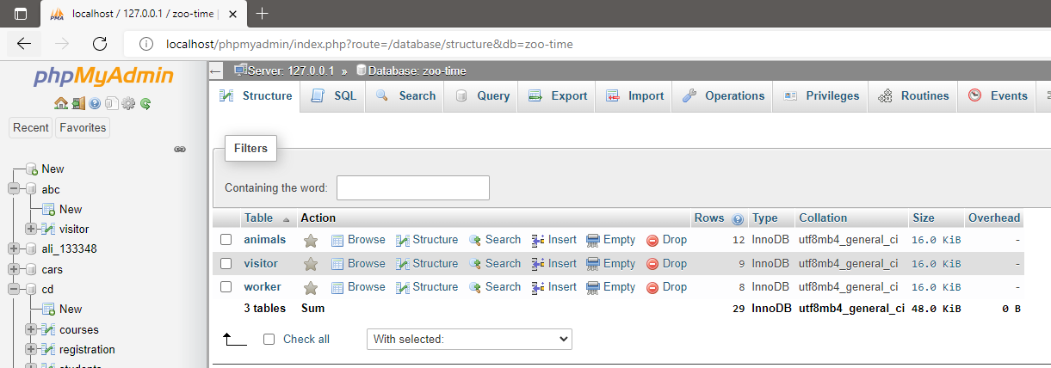

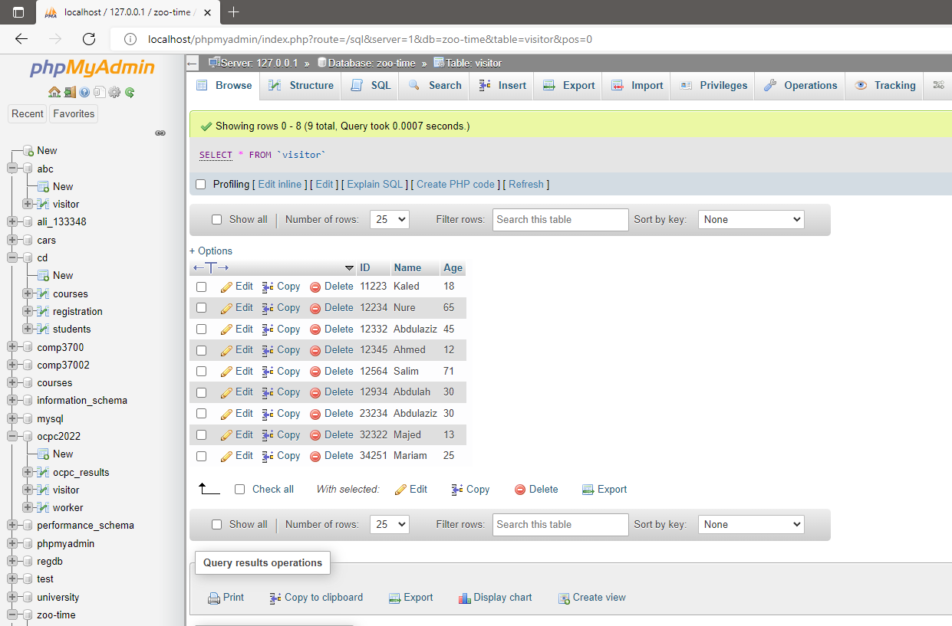

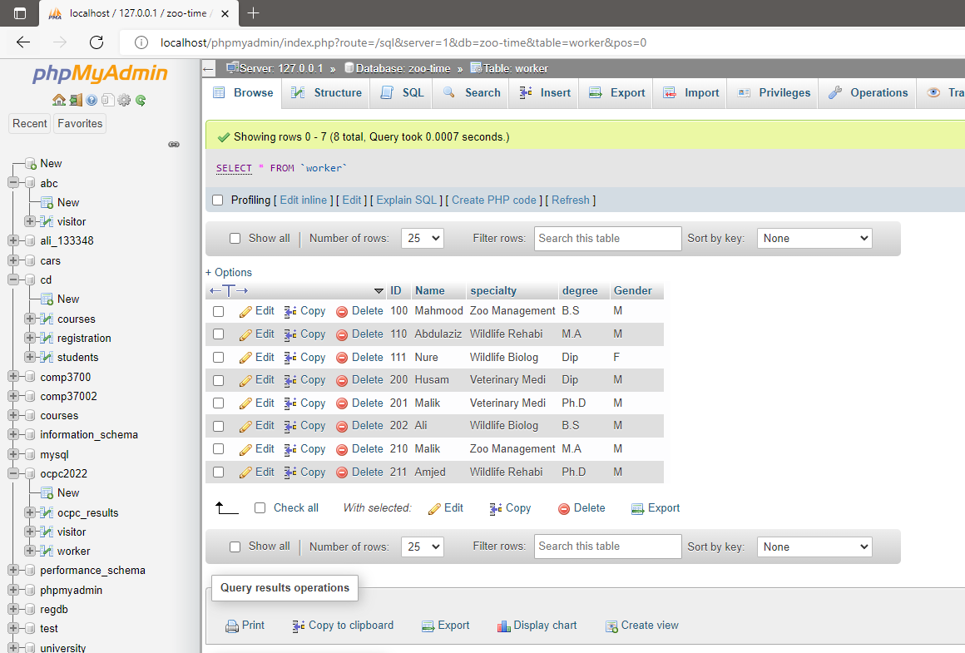

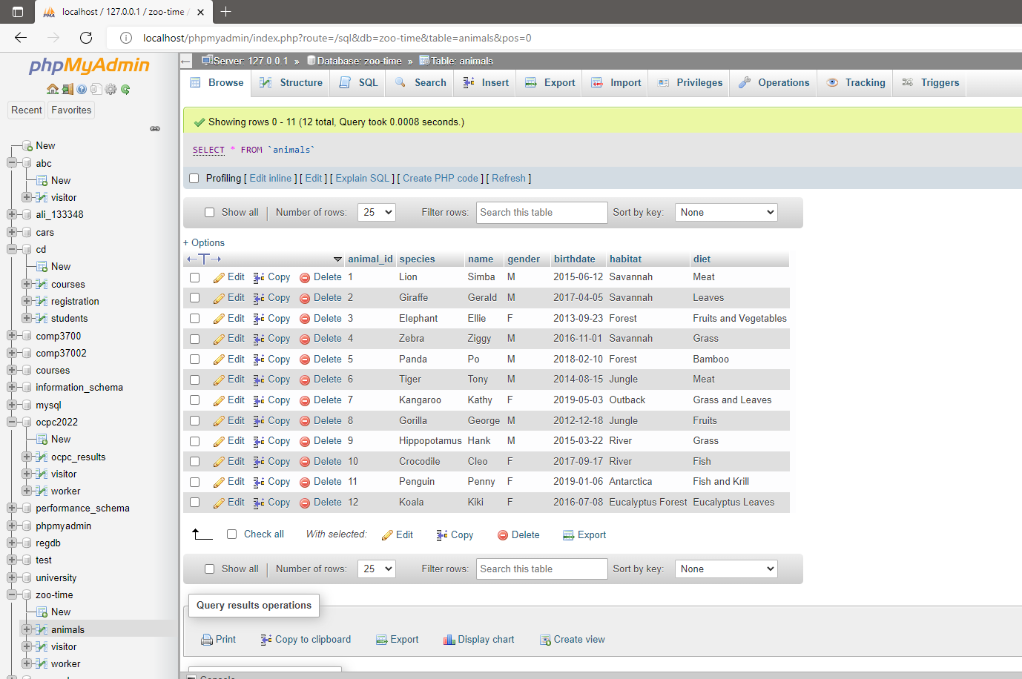

Table code :

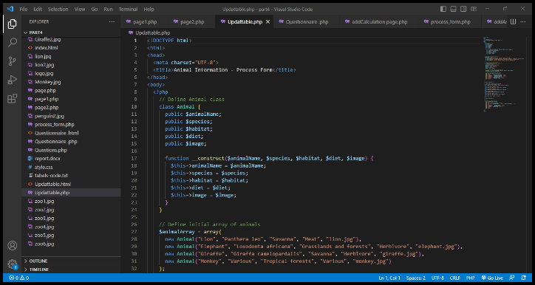**(In text file in the folder)**

Update:

This is an HTML page that displays animal information in a table. It has two forms: one to add animals to the table, and another to search for animals in the table. The animal data is stored in an array of objects, and the table is dynamically updated with the array data using JavaScript.

Questions:

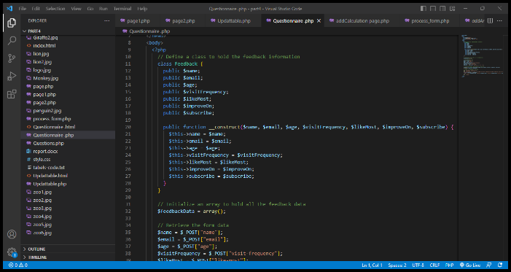This code defines a PHP class called Feedback, which has properties for a name, email, age, visit frequency, what the user liked most about a particular service or product, what they think can be improved, and whether they want to subscribe to a newsletter. The class has a constructor method that accepts arguments for each of these properties.The code also creates an empty array called $feedbackArray.The code then checks if the server request method is "POST", and if it is, it retrieves form data submitted by the user and assigns it to variables. It then creates a new instance of the Feedback class with these values and pushes it onto the $feedbackArray.Finally, there is a function called test_input which is used to sanitize user input by removing any unnecessary whitespace and escaping special characters.

Calculations:

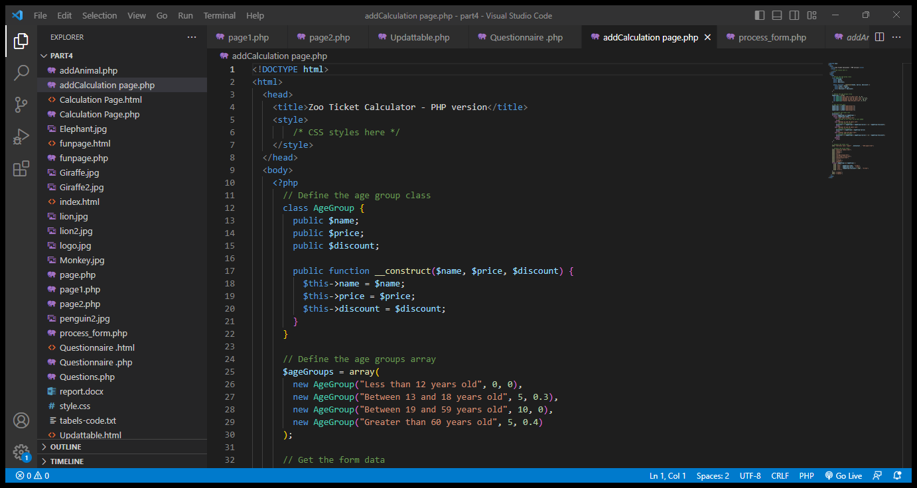This is a PHP code that generates an HTML page with a zoo ticket calculator. The code defines an AgeGroup class that stores the name of the age group, the ticket price, and the discount percentage. The code also defines an array of AgeGroup objects that represent the different age groups and their respective prices and discounts.The code retrieves data from a form submitted via the HTTP POST method. The form contains four fields, each representing the number of visitors in a specific age group. The code then calculates the total cost of the tickets by looping through the AgeGroup objects and applying the appropriate discount percentage based on the age group.The HTML page generated by the code displays the total cost of the tickets, as well as a price table that shows the ticket price and discount percentage for each age group. The code uses PHP's echo statement to output the HTML code to the browser.

FUNPAGE:

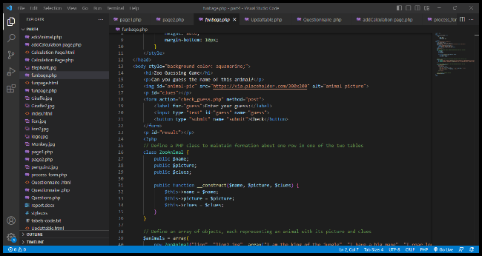In this code, the form is modified to send the entered information to the "check_guess.php" page using the "POST" method. The button also has a "name" attribute, which can be used to check if the form has been submitted in the PHP code.The PHP class "ZooAnimal" is defined to maintain information about one row in one of the two tables in part 3 of the project. An array of objects is then created using this class to maintain information about all rows in the specified table.A function "displayTable" is defined to display the content of the table using table format from the array. This function takes an array as an argument and iterates

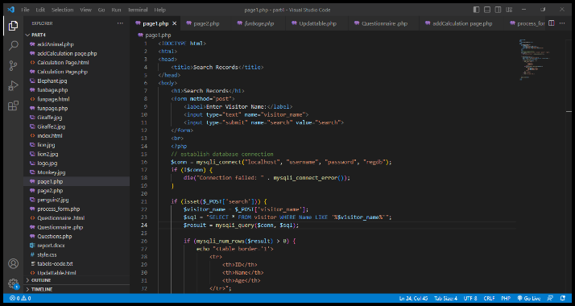

The provided code is an HTML document with a search form that allows users to search for visitor records. When the user submits the form, the PHP code establishes a connection to a MySQL database and executes a query to retrieve records matching the entered visitor name. If any records are found, they are displayed in a table format with columns for ID, Name, and Age. If no records are found, a message is displayed indicating that no records were found.

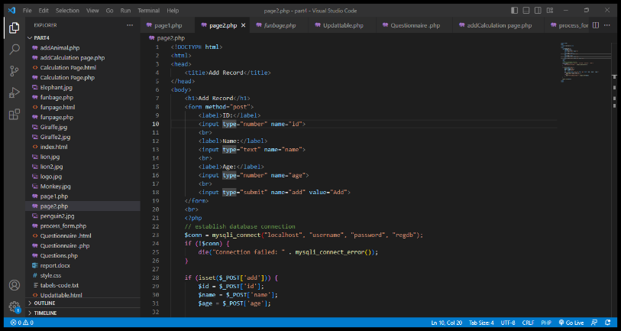

The provided code is an HTML document that includes a form allowing users to add a record. When the user submits the form, the PHP code establishes a connection to a MySQL database and inserts the entered ID, name, and age values into a table called "visitor." If the record is successfully added, a success message is displayed; otherwise, an error message is shown.

* The live website is hosted on GitHub pages at the following URL:
* <https://teemzoo.github.io/Project-part2/index.html>
* The GitHub project can be found at the following URL:
* <https://github.com/TeemZoo/Project-Part2>

|  |  |  |  |
| --- | --- | --- | --- |
| NAME | ID | Task | contribution |
| Abdulaziz said Almamary | 136463 | Squl part and the report | 40% |
| Mahmood Khalid alrashdi | 131423 | GitHub account and the update | 30% |
| Ahmed Abdulamir Alajmi | 134607 | Php part | 30% |