**ReportProject Title: Zoo Time Website**

[Company name] | [Company address]

Team Members:

1. Abdulaziz said Almamary 136463
2. Mahmood Khalid alrashdi 131423
3. Ahmed Abdulamir Alajmi 134607

[Year]

Photo Gallery Page:

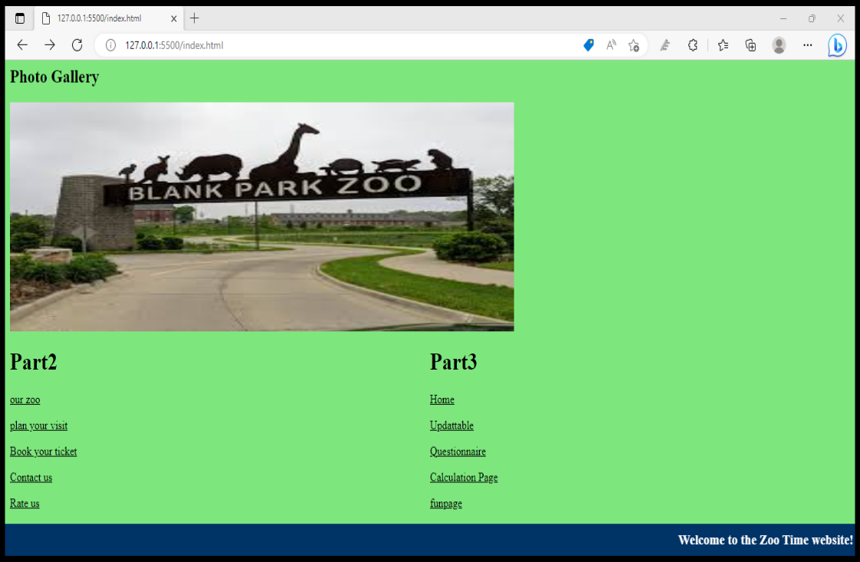

JavaScript code

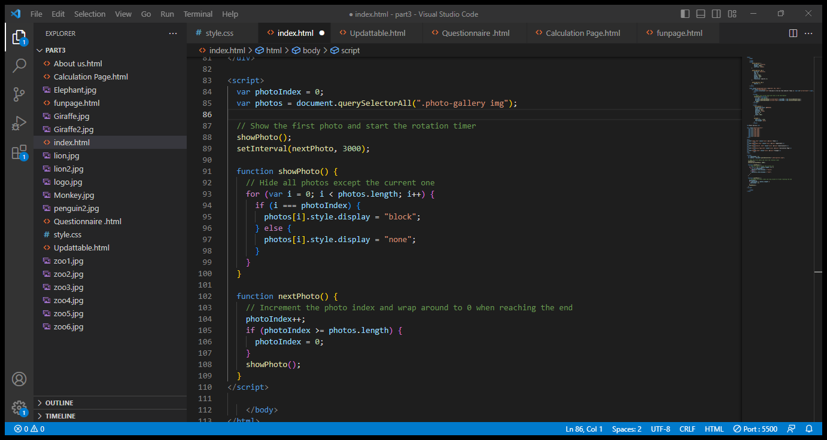

Updattable:

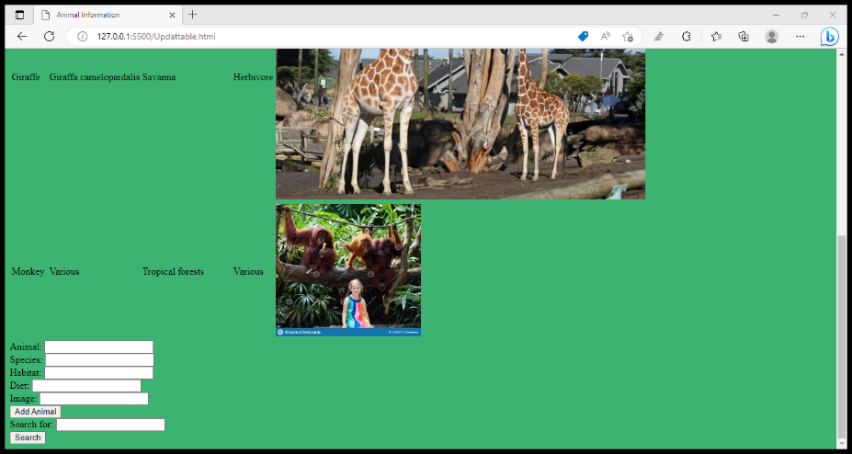

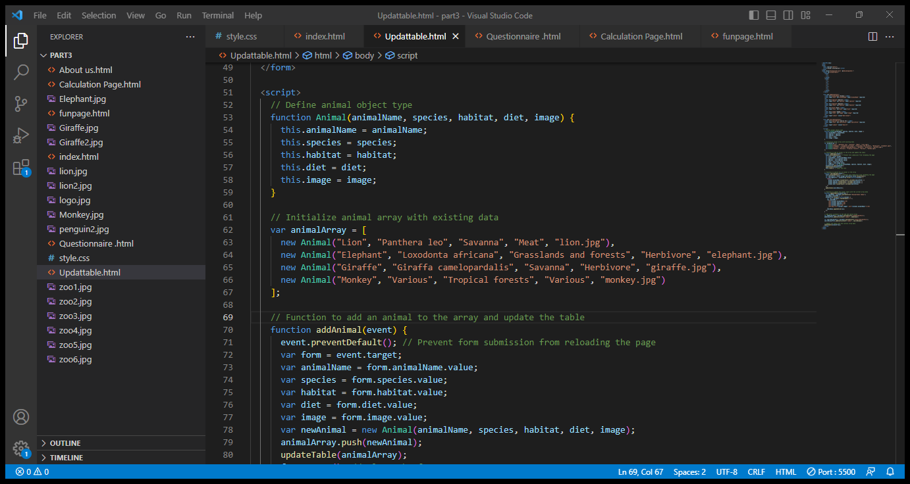

Questionnaire:

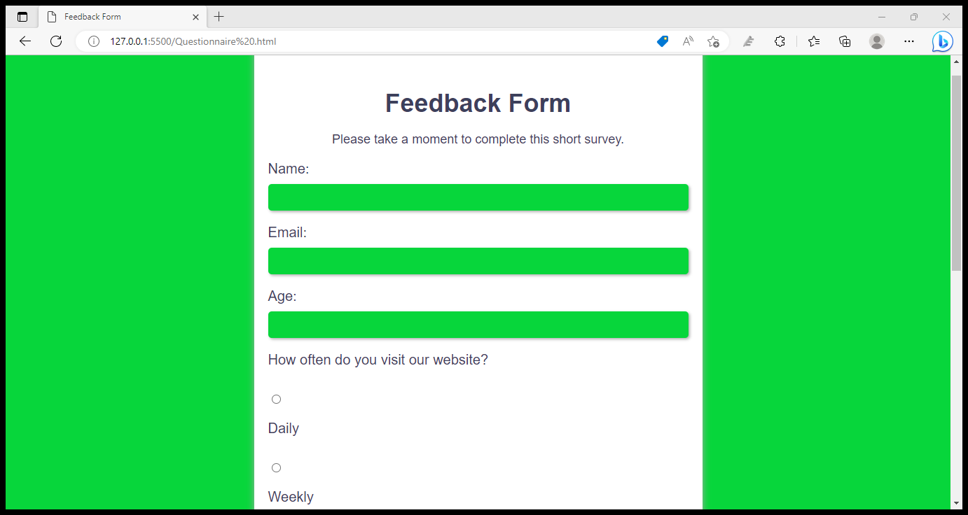

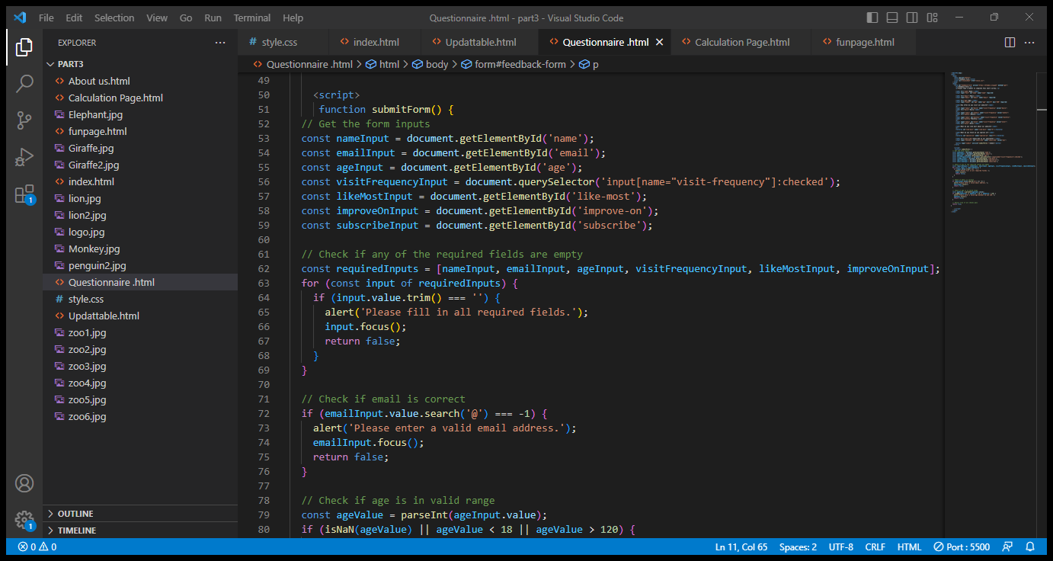

Calculation:

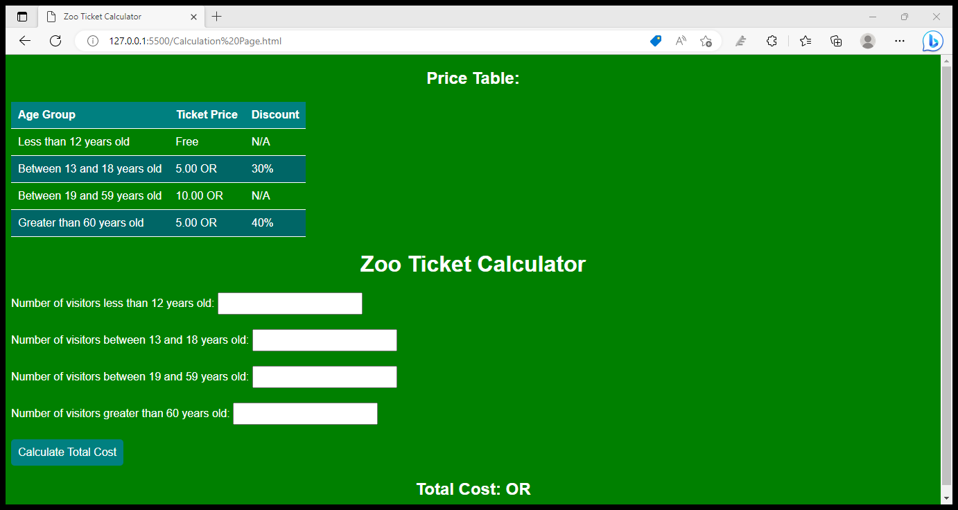

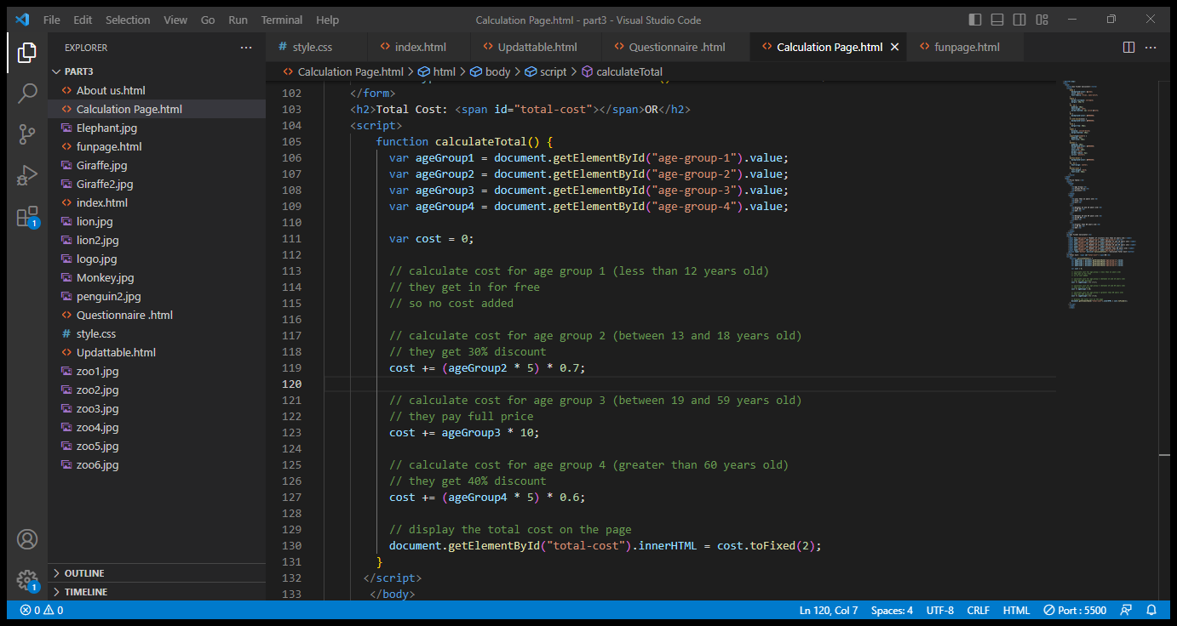

Funpage:

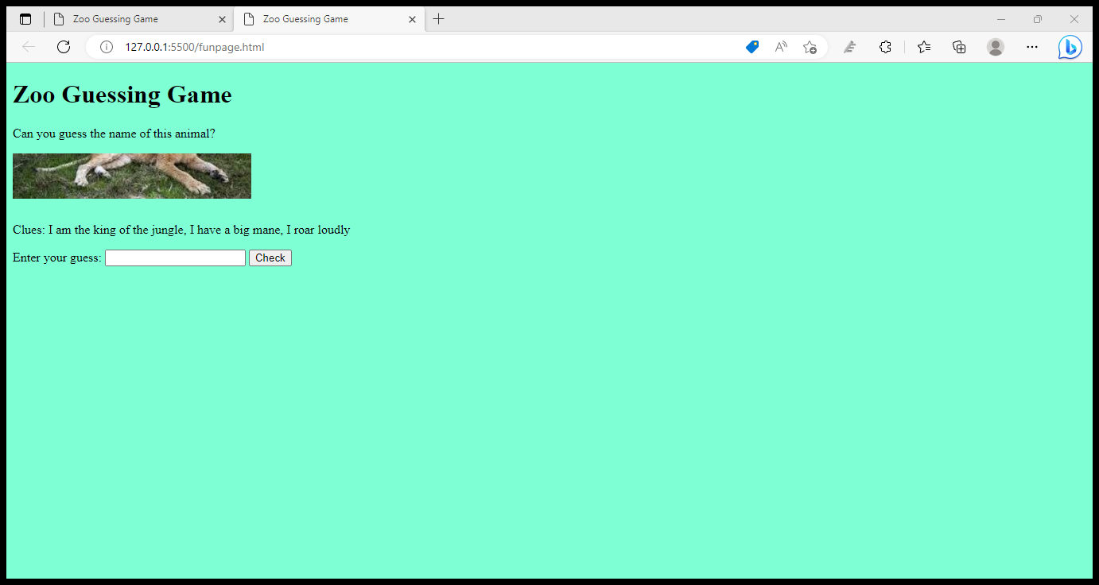

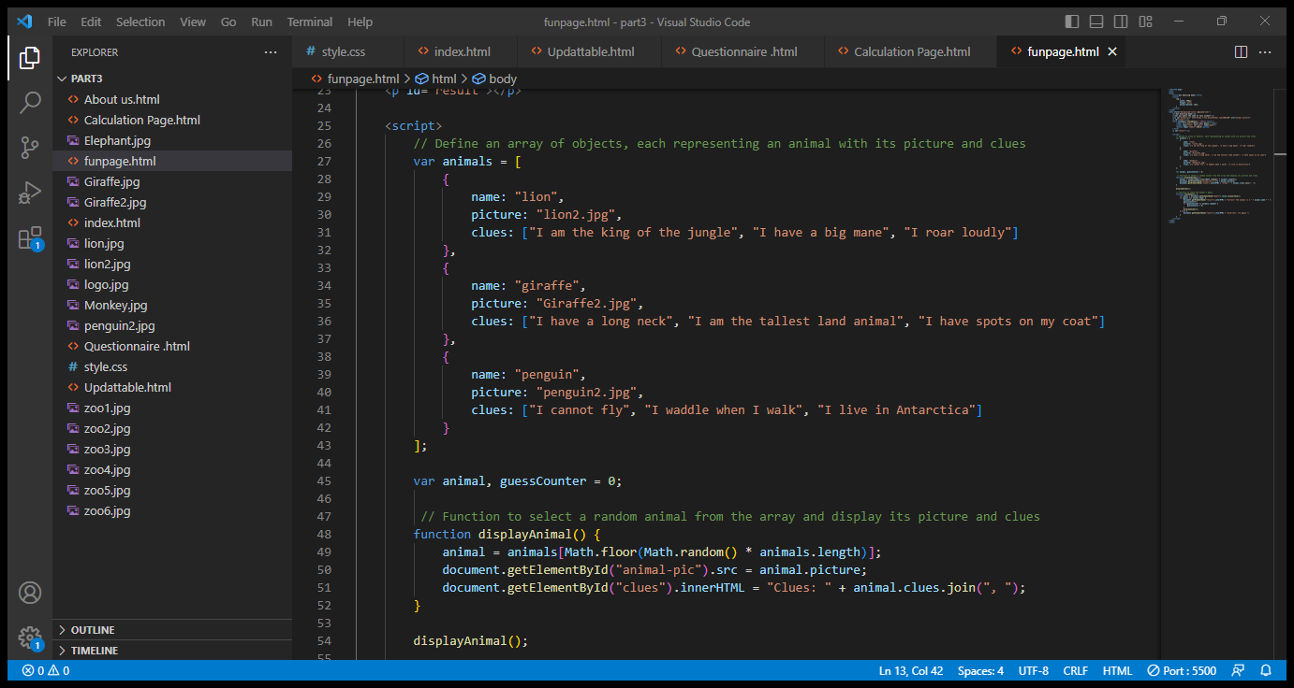

Contribution Table:

|  |  |  |  |
| --- | --- | --- | --- |
| Team Member | ID | Components | Percentage |
| Abdulaziz said Almamary | 136463 | index.html / report  funpage.html | 40% |
| Mahmood Khalid alrashdi | 131423 | Updattable.html  Questionnaire .html | 30% |
| Ahmed Abdulamir Alajmi | 134607 | Calculation Page.html | 30% |

Conclusion

In this project, our team successfully designed and implemented two pages on the Zoo Time website. John was responsible for the Photo Gallery page, Maria designed the Feedback Form page, Ahmed created the Navigation Bar, and Sara designed the Text Banner. We used JavaScript to implement the dynamic features of the pages, such as the Photo Gallery slideshow and the real-time updating of the date and time on the Text Banner. Overall, we are satisfied with the outcome of the project and we believe that we have achieved our goals.