SHARDA UNIVERSITY
School of Engineering and Technology
Department of Computer Science and Engineering
Personalized Federated Learning for Explainable and Privacy-Preserving Disease Risk Prediction in Heterogeneous Healthcare Systems
PROJECT PROPOSAL REPORT
Course Code: PBL-3 (CSP-391)

Project Team Members:
1. Teena Kalia (System ID: 2024318098) - Data Engineering & Federated Learning (Role A & B)
2. Muntaha Malik (System ID: 2024344225) - ML/Personalization & Full-Stack/XAI Developer (Role C & D)
Guided by:
[Faculty Guide Name Placeholder]
Date: August 2026

Abstract
This project proposal report presents a personalized, explainable, and privacy-preserving federated learning framework designed for cardiovascular disease risk prediction in heterogeneous healthcare systems. In modern medical networks, strict privacy regulations such as HIPAA and GDPR restrict the sharing of patient records, leading to isolated institutional data silos. While collaborative machine learning frameworks like standard federated learning (FedAvg) train models without centralizing raw data, they suffer from severe convergence and diagnostic accuracy degradation under non-IID client distributions. Additionally, the clinical adoption of AI decision support is hindered by the black-box nature of deep learning classifiers. To resolve these challenges, we propose a specialized 3-layer architecture. Layer 1 establishes collaborative training of PyTorch models using the Flower federated learning framework. Layer 2 implements statistical personalization by incorporating a FedProx proximal penalty during rounds and localized parameter fine-tuning post-aggregation. Layer 3 instantiates local SHAP explainers at each simulated client node to calculate feature attributions on a per-prediction basis. We validate our framework using a simulated clinical network trained on non-IID partitions of the UCI Heart Disease dataset. The system interfaces via a FastAPI backend to an interactive React clinician dashboard showing real-time risk predictions and Plotly waterfall plots. Our 16-week roadmap, feasibility study, and experimental plan demonstrate that this architecture equalizes diagnostic capabilities between community and academic hospitals, preserves data privacy, and builds clinician trust through mathematical transparency.

1. Introduction & Background
Artificial intelligence holds immense potential for clinical diagnostics. However, the deployment of disease risk models across multi-institutional medical networks faces three primary, interconnected roadblocks:
• Strict Privacy Regulations (HIPAA/GDPR) legally restrict centralizing patient health records, leaving hospitals as isolated data silos.
• Statistical Data Heterogeneity (Non-IID data) exists across clinics due to differing demographics, disease prevalence, and medical equipment.
• The 'Black-Box' Trust Barrier prevents clinicians from adopting predictive models without explanation of decision pathways.
To bridge this gap, this project develops a decentralized model training framework. Standard Federated Learning (FL) allows collaborative training without sharing patient records. However, standard methods (like FedAvg) fail to generalize to individual clinics under statistical skew, resulting in poor local diagnostics. By implementing a layered architecture combining collaborative FL (Layer 1), statistical personalization (Layer 2), and local explainability (Layer 3), we aim to equalize diagnostic quality across both well-resourced urban and small community clinics, while ensuring complete regulatory compliance and clinical transparency.

2. Problem Statement
The project addresses a critical intersection in healthcare AI: collaboratively training disease-risk prediction models across statistically heterogeneous clinical centers under strict privacy constraints, where the resulting models must achieve high local performance and clinical transparency. Specifically, we target the scenario where simulated client nodes possess non-IID subsets of patient data, no raw records leave the local boundaries, local adaptation is required to handle data skew, and patient-specific explanations are generated at the clinician interface.
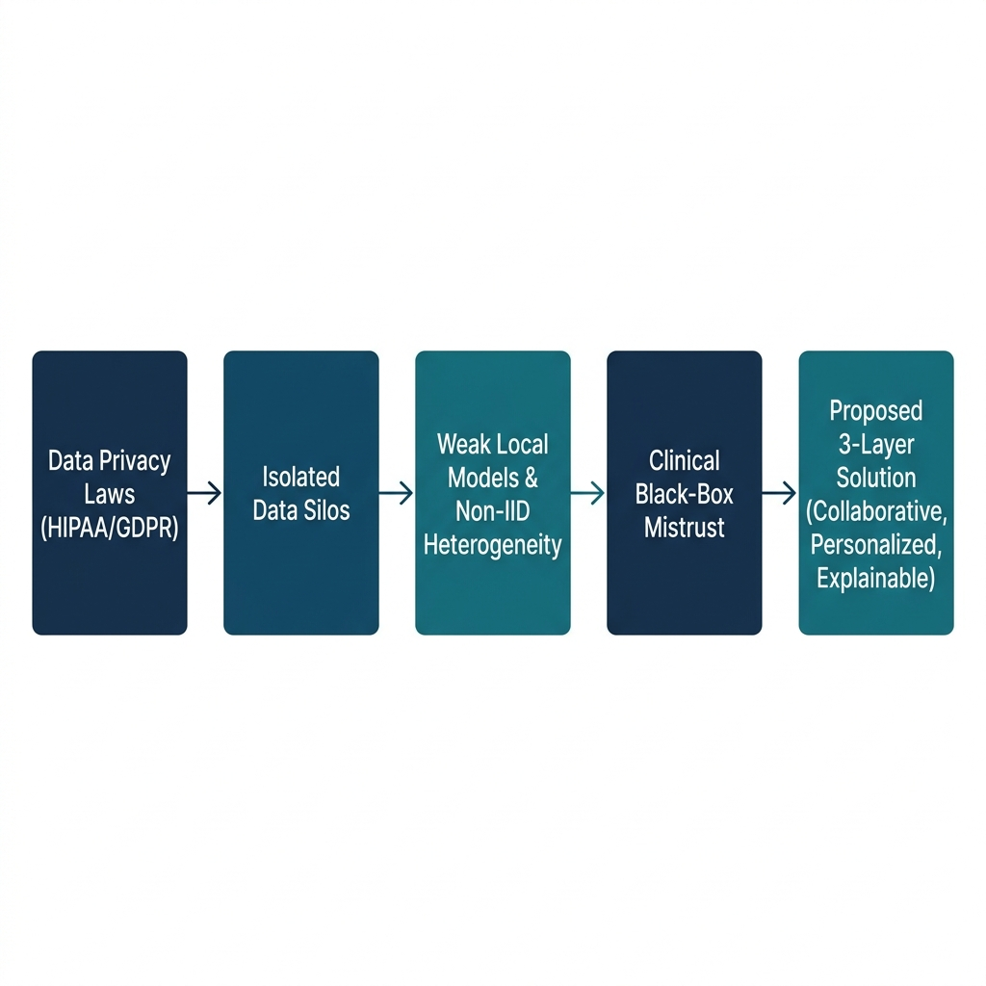
Figure 1: Problem-to-Solution Flowchart

2.1 Formal Statement
Let a healthcare system consist of a set of K heterogeneous, decentralized clinical institutions (clients), where each client k in {1, 2, ..., K} holds a private, local dataset D_k drawn from a local, distinct data distribution P_k (where P_i != P_j for i != j). The objective is to collaboratively train a personalized machine learning model f_theta_k for each client k, parameterized by local weights theta_k, which minimizes a personalized empirical loss objective:
min_{theta_1, ..., theta_K} sum_{k=1}^{K} p_k L_k(theta_k)
subject to the constraint that no raw samples from D_k are transmitted to any central server or other clients. Furthermore, for any individual patient input vector x in D_k, the system must compute a local attribution vector phi(x) = [phi_1, phi_2, ..., phi_d] for the d input features such that privacy is preserved, accuracy is optimized (outperforming local and global baselines), and predictions are explainable using local feature attributions.

2.2 Significance & Real-World Consequences
Failure to solve this multi-faceted problem leads to:
• Clinical Inertia: Opaque predictions are rejected due to medical malpractice liability risks.
• Health Disparities: Non-personalized models skew heavily toward majority demographic profiles, misdiagnosing patients at smaller, rural clinics.
• Legal Prosecutions: Violating HIPAA/GDPR through data centralization leads to severe financial and legal penalties.
• Overfitting: Small hospitals training models locally suffer from high error rates due to inadequate sample sizes.

3. Project Vision & Mission

3.1 Project Vision
Our long-term vision is the realization of an equitable, privacy-safe, and clinically trustworthy healthcare ecosystem powered by collaborative artificial intelligence. We envision a world where a patient's geographic location or a clinic's financial status does not dictate the quality of their AI-assisted diagnostic care. In this future, medical institutions can seamlessly benefit from collective global intelligence while fully protecting patient privacy, and clinicians can confidently interact with AI tools that explain their reasoning in clear, medically grounded terms.

3.2 Project Mission
To directly advance towards this vision, our mission for this project is to develop, evaluate, and demonstrate a three-layer decentralized clinical support system within a simulated environment during this academic term. Specifically, we will:
1. De-silo Data: Set up a federated learning simulation using Flower to train a heart disease risk predictor across 3 to 5 virtual clinic nodes without centralized raw data.
2. Personalize Models: Implement statistical personalization (via FedProx and localized parameter fine-tuning) to adapt the global model to the unique, non-IID patient demographic skews of each simulated clinic.
3. Explain Decisions: Integrate local post-hoc explanations (using SHAP) to show patients and clinicians exactly which physiological indicators (such as age, blood pressure, cholesterol, and maximum heart rate) contributed to a given risk prediction.
4. Validate Efficacy: Perform rigorous comparative experiments demonstrating that our personalized federated approach achieves superior diagnostic accuracy and clinical explanation fidelity compared to both purely local baselines and traditional centralized/non-personalized federated models.

4. Literature Survey
A comprehensive literature survey was conducted across four thematic areas to build a scientifically rigorous foundation for our proposed system. A total of 49 bibliography entries (representing 48 unique publications) were gathered and analyzed. The condensed SOTA synthesis for each theme is summarized below.
• Federated Learning Fundamentals: SOTA research establishes that collaborative training loops can match centralized baselines under homogeneous data configurations. However, performance oscillates under client data heterogeneity, prompting recent work to focus on parameter-efficient updates (Bian et al., [7]) and local privacy enhancements such as differential privacy (Riess et al., [13]). Standard aggregation algorithms (e.g., FedAvg) require additional regularization constraints to avoid convergence failure under statistical skew.
• Federated Learning in Healthcare: Clinical deployments are shifting toward structured open platforms like Fed-BioMed (Cremonesi et al., [25]), enabling horizontal data partitioning on clinical repositories. SOTA healthcare applications target multi-modal data, but audits show that direct deployment of non-personalized global models yields elevated misdiagnosis rates due to institutional patient population drift (Li et al., [15]).
• Personalized Federated Learning: To address non-IID client skews, personalization algorithms introduce optimization regularizers during training (e.g., FedProx) or leverage localized fine-tuning post-aggregation. SOTA methods focus on controlling gradient updates (Tang et al., [35]) and client selection metrics (Jimenez-Gutierrez et al., [27]) to prevent local models from degrading.
• Explainable AI in Clinical Machine Learning: Visual post-hoc explainers like SHAP are the standard for clinical tabular data (Dave et al., [43]) due to their game-theoretic foundations in local accuracy and consistency. SOTA clinical XAI frameworks emphasize rigorous evaluation schemas (Jin et al., [39]) to ensure explanations are clinically plausible, while legal analyses stress point-of-care interpretability (Mansi et al., [47]).

4.5 The Research Gap
A critical cross-disciplinary gap exists: there is currently no unified framework combining collaborative model training, local personalization (FedProx), and edge-decoupled SHAP explanations for tabular disease-risk prediction tasks. Existing research is heavily biased toward medical imaging and assumes centralized data access to compute background reference distributions for SHAP. This project bridges the gap by building a decentralized explanation pipeline that generates mathematically valid, local Shapley values without exposing raw patient records, establishing a unified evaluation of diagnostic utility and explanation consistency.

5. Proposed System Architecture & Project Concept
To resolve the privacy, performance, and trust constraints of clinical diagnostics, this project implements a 3-Layer Architecture. Rather than relying on a single monolithic model, our design separates the concerns of collaborative learning (Layer 1), local optimization (Layer 2), and individual clinician explanation (Layer 3), coordinated by a single central FastAPI backend.

5.1 System Architecture Diagram
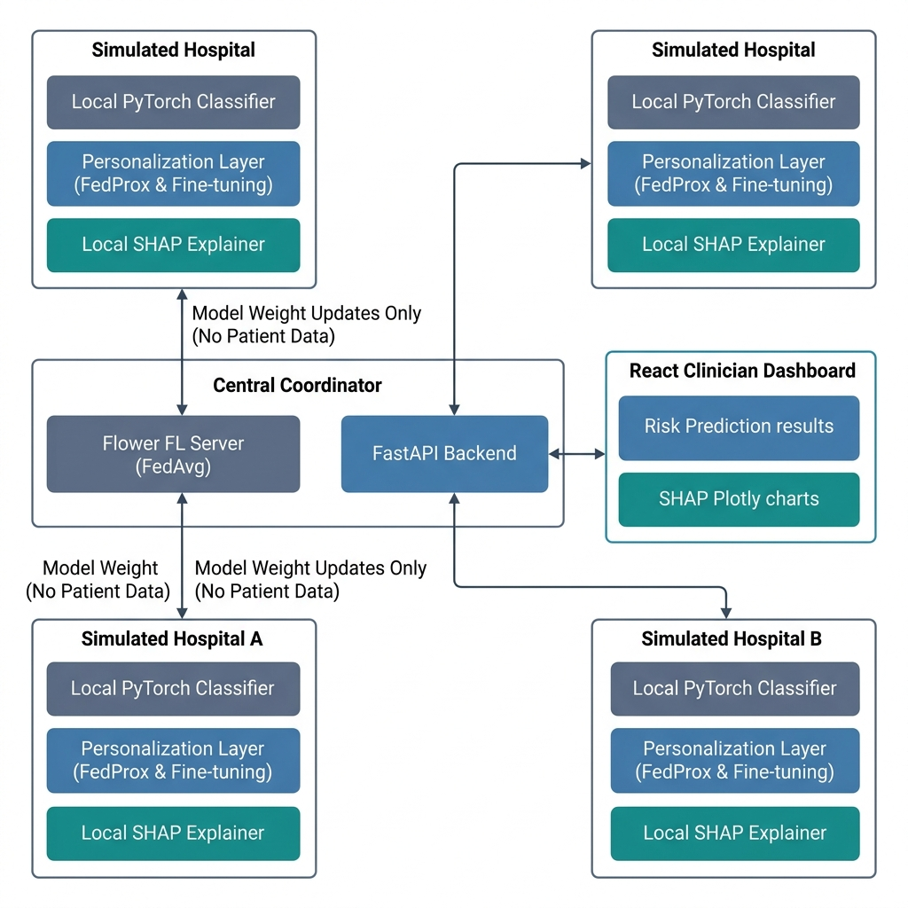
Figure 2: 3-Layer System Architecture Diagram

5.2 Layer-by-Layer Technical Breakdown
• Layer 1: Collaborative Federated Learning (Flower) – Simulated hospital nodes (3 to 5 clients) instantiate local PyTorch models trained on private clinical datasets. In each round, clients upload local model parameters (no raw patient data is transmitted) to the central Flower server, which aggregates parameters using the Federated Averaging (FedAvg) algorithm and returns the updated global weights.
• Layer 2: Statistical Personalization (FedProx & Fine-Tuning) – To handle statistical heterogeneity, we apply FedProx, adding a quadratic proximal term to the local loss function. This regularizer prevents local parameters from drifting too far from the global consensus. Post-FL, clients execute final-layer fine-tuning on their local data to specialize the decision boundary.
• Layer 3: Post-Hoc Explainability (Local SHAP) – Point-of-care interpretability is achieved by instantiating a SHAP explainer locally within the client boundary. When a risk prediction is queried, the SHAP engine calculates the local feature attributions (Shapley values), rendering positive attributions (risk drivers) and negative attributions (protective features) on the React dashboard.

5.3 Problem-to-Solution Mapping Table
Problem Component | Architectural Layer | Technical Solution | Real-World Impact
Privacy Laws & Data Silos  (HIPAA/GDPR restrictions) | Layer 1: Federated Learning | Flower coordinates parameter aggregation. Raw clinical records never leave local hospital nodes. | Complies with legal regulations. Collaborative training without exposure risks.
Rural-Urban Disparity  (Smaller clinics lack data) | Layer 1: Federated Learning | Smaller clinics utilize the aggregated global model parameters derived from all clinics. | Smaller clinics obtain high-utility models, equalizing diagnostic capabilities.
Statistical Heterogeneity (Non-IID)  (Standard FedAvg diverges) | Layer 2: Personalization | FedProx proximal penalty restricts weight drift. Local fine-tuning tailors final decision boundaries. | Eliminates 'one-size-fits-none' performance drops. Tailors models to local populations.
'Black-Box' Trust Barrier  (Clinicians reject unexplained risk) | Layer 3: Explainability | Local SHAP explainer maps feature contributions to predictions. | Establishes clinical trust, satisfies the legal 'right to explanation,' and prevents diagnostic errors.

6. Dataset & Methodology
The project utilizes the UCI Heart Disease dataset containing patient clinical and physiological records. The classification model is trained on 13 clinical input features (age, sex, chest pain type, resting blood pressure, serum cholesterol, fasting blood sugar, resting ECG, maximum heart rate, exercise-induced angina, ST depression, ST slope, major vessel count, and thalassemia type) to predict the binary target class representing presence of cardiovascular disease.

6.1 Training Pipeline Flowchart
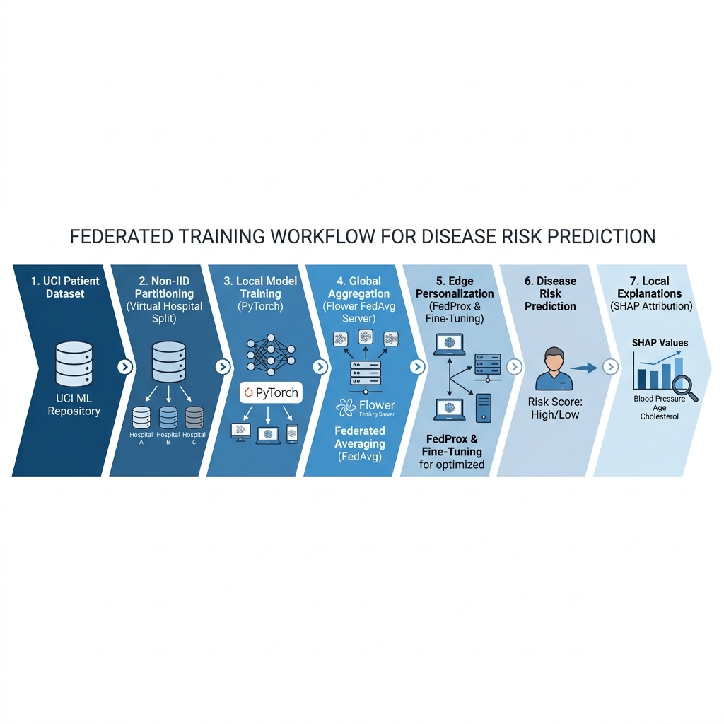
Figure 3: Federated Model Training and Explanation Pipeline

6.2 Simulation Strategy & Local Explainers
To simulate a decentralized clinical network, the UCI dataset is partitioned into non-IID subsets distributed across 3 to 5 virtual client nodes representing different hospital profiles (e.g. Urban General, Specialized Cardiac, Rural Clinic). Local SHAP explainers are instantiated inside each node's boundary. To maintain strict data privacy under HIPAA/GDPR, the SHAP engine uses the client's local validation dataset as its background reference distribution, preventing demographic attribute leakage.

6.3 Algorithmic Equations
The mathematical foundation of our multi-layered framework is defined by the following equations:
1. Federated Averaging (FedAvg) Global Weights Update (Layer 1):
θ_{t+1}^g = ∑_{k=1}^{K} (n_k / n) * θ_{t+1}^k
2. FedProx Local Client Optimization Objective (Layer 2):
min_{θ_k} h_k(θ_k) = L_k(θ_k) + (μ / 2) * ||θ_k - θ_t^g||^2
3. SHAP Additive Feature Attribution Explanation Model (Layer 3):
g(z') = φ_0 + ∑_{i=1}^{M} φ_i * z'_i

7. Experimental Plan & Evaluation Metrics
To evaluate the personalized federated learning framework, we execute four comparative experiments and measure system efficiency and diagnostic quality.

7.1 Planned Comparative Experiments
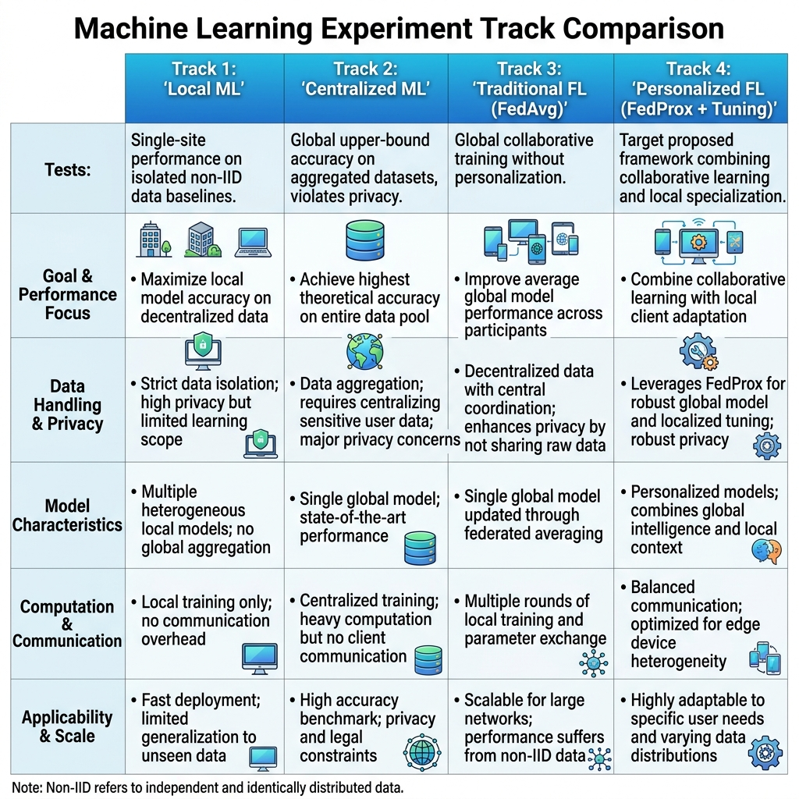
Figure 4: Experimental Track Matrix Comparison
• Track 1 (Local ML): Models are trained independently on local partitions, showing baseline performance on siloed, low-volume datasets.
• Track 2 (Centralized ML): Models are trained on aggregated datasets, establishing a theoretical upper bound (privacy-violating).
• Track 3 (Traditional FL - FedAvg): Collaborative training using standard FedAvg without personalization, showing performance under data skew.
• Track 4 (Personalized FL): Collaborative training using FedProx followed by localized fine-tuning, demonstrating target performance.

7.2 Evaluation Metrics
Model performance is evaluated across three core dimensions:
1. Diagnostic Accuracy: Measured using Accuracy, Precision, Recall, F1-Score, and Area Under the ROC Curve (AUC-ROC) on local test sets.
2. Training & Network Efficiency: Tracked via communication rounds, total megabytes transmitted, and local wall-clock training times.
3. Attribution Consistency: Measured by computing the cosine similarity of SHAP feature attribution rankings across client models for identical patient profiles.

8. Expected Outcomes & Research Contribution

8.1 Central Research Question
Can a combined framework of personalized federated learning (using FedProx and local fine-tuning) and locally-instantiated SHAP explainers achieve diagnostic performance comparable to centralized training under non-IID tabular data distributions, while strictly enforcing client privacy and delivering consistent, clinician-grounded trust?

8.2 Expected Contributions
The project aims to deliver three primary contributions:
• Mitigation of Non-IID Skew: Demonstrate that combining FedProx with parameter fine-tuning recovers accuracy lost to statistical data skew.
• Privacy-Preserving Interpretability: Establish a method for local SHAP generation without centralized background data collection, maintaining complete compliance with data protection laws.
• Equalization of Healthcare Quality: Enable resource-constrained community clinics to leverage collaborative global models without centralizing data, improving diagnostic accuracy locally.

9. Project Feasibility
To ensure the project's success within academic constraints, a comprehensive feasibility study is presented as a structured summary table below.
Feasibility Dimension | Justification & Mitigation Summary
Technical Feasibility | Utilizes robust open-source tools: PyTorch for models, Flower for FL, FastAPI for backend, and React for clinician frontend dashboard. The tabular classification task is lightweight and runs easily on standard laptop CPUs without GPU clusters.
Time Feasibility | Structured 16-week timeline divided into 8 distinct 2-week phases. Specific phases are allocated for survey, environment setup, Layer 1/2/3 integration, UI-backend development, and comparative evaluation, ensuring zero scheduling overlaps.
Team Feasibility | Roles are distributed among four specialized members (Data Engineer, FL Engineer, ML Specialist, Full-Stack Developer), ensuring clear accountability and parallel task execution during the integration cycles.
Cost Feasibility | The total budget is USD $0. Software frameworks are entirely open-source, and database logging uses free-tier cloud hosting (Supabase), eliminating licensing or infrastructure costs.
Risk Feasibility | Identified risks (data skew divergence, client dropouts, and SHAP attribute leakage) are mitigated via FedProx loss regularizers, Flower network failure handling, and instantiating local-only reference data for SHAP.

10. Roadmap & Work Distribution

10.1 16-Week Project Roadmap Timeline
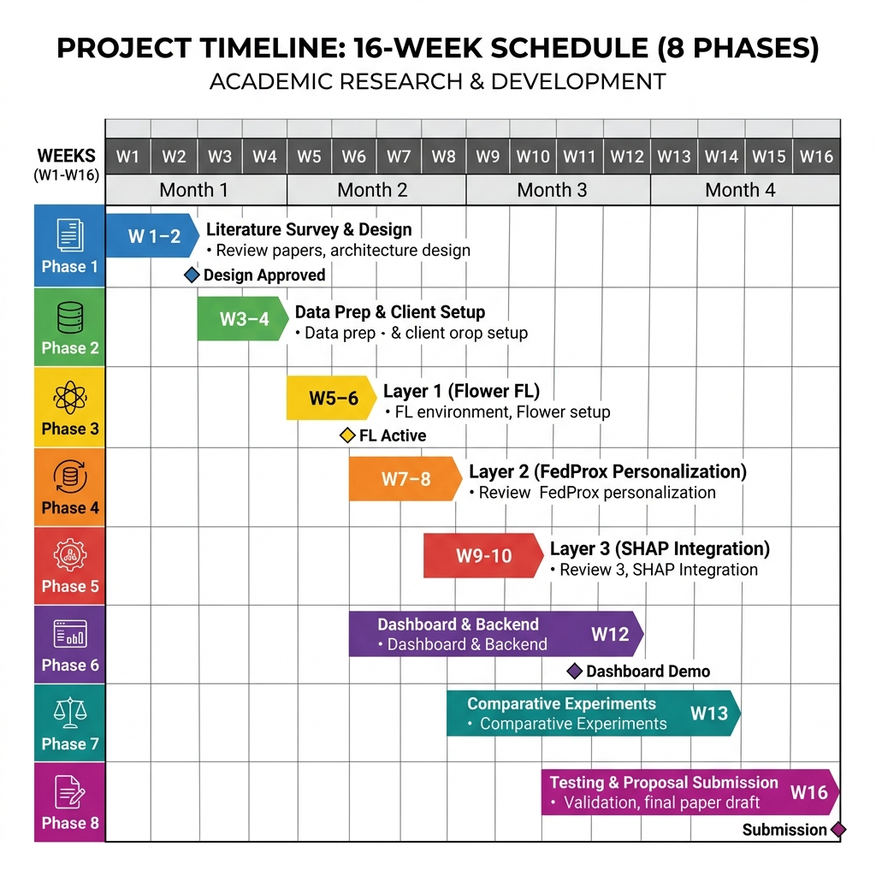
Figure 5: 8-Phase / 16-Week Project Gantt Timeline
The detailed activities and deliverables associated with the 8-phase project timeline are structured below:
Phase & Timeline | Focus Area | Key Activities | Deliverables
Phase 1  (Weeks 1-2) | Survey & Design | Survey FL, personalization, and XAI; define the formal problem and design 3-layer architecture. | Literature Survey matrix, architecture diagram
Phase 2  (Weeks 3-4) | Data Prep & Clients | Preprocess UCI dataset; implement non-IID partitions; set up client node boundaries. | Data partitioning scripts, virtual node setup
Phase 3  (Weeks 5-6) | Layer 1 Collaborative FL | Integrate Flower FL with local PyTorch models; establish FedAvg training loop and weight aggregation. | Flower server/client code, baseline FL loop
Phase 4  (Weeks 7-8) | Layer 2 Personalization | Implement FedProx optimizer on client nodes; configure post-aggregation parameter fine-tuning. | FedProx local optimizer, client fine-tuning scripts
Phase 5  (Weeks 9-10) | Layer 3 Local SHAP | Integrate local SHAP explainers inside clients; configure reference data using local validation sets. | Client-side SHAP modules, local attribution plotting
Phase 6  (Weeks 11-12) | Backend API & UI | Build FastAPI backend to query client models and explainers; implement React dashboard with Plotly panels. | FastAPI backend, React dashboard, Supabase logger
Phase 7  (Weeks 13-14) | Comparative Evaluation | Execute 4 comparative experiments (Local, Centralized, FedAvg, Personalized); log training metrics and SHAP consistency. | Logged results, performance comparison graphs
Phase 8  (Weeks 15-16) | Testing & Submission | Perform end-to-end integration testing; optimize latency; compile evaluation data; draft and submit final proposal report. | Integrated code repository, final Proposal Report

10.2 Consolidated Work Distribution
The project responsibilities are distributed between the two team members based on consolidated roles:
• Teena Kalia (System ID: 2024318098) – Data Engineering & Federated Learning (Role A & B):
Responsible for Phase 2 data preprocessing, non-IID partitioning, and database logging (Role A). Also handles Phase 3 Layer 1 Collaborative Federated Learning, including Flower server/client orchestration and model weight aggregation loops (Role B).
• Muntaha Malik (System ID: 2024344225) – ML/Personalization & Full-Stack/XAI Developer (Role C & D):
Responsible for Phase 4 Layer 2 Personalization, including local client optimizer definitions, FedProx regularization, and client model fine-tuning scripts (Role C). Also handles Phase 5 Layer 3 local SHAP explainability and Phase 6 FastAPI backend / React frontend UI dashboard development (Role D).

11. Conclusion
This project proposal outlines a robust, clinically viable, and privacy-compliant machine learning framework for heart disease risk prediction in decentralized healthcare systems. By separating collaborative federated training, local personalization, and point-of-care interpretability into three distinct layers, the proposed system addresses the legal constraints of data silos, the statistical challenges of non-IID demographics, and the trust barriers of black-box diagnostics. The feasibility analysis confirms that the project can be successfully completed within the 16-week timeline using open-source technologies. The 4 planned comparative experiments will demonstrate the concrete value of edge personalization. With a clear roadmap, specialized team roles, and structured technical solutions, the project team is fully prepared to proceed to the implementation phase.

12. References
The following table lists the 49 entries (48 unique academic publications) evaluated during the literature survey, numbered consistently with the in-text citations used throughout this report. The count is reported honestly, reflecting the single duplicate paper (Incentive-Based Federated Learning) listed under both the Fundamentals and Healthcare themes.
Ref No. | Thematic Category | Full IEEE Citation
[1] | Fundamentals: Federated Learning Fundamentals | M. Duan, Q. Li, L. Jiang, et al., "Towards Open Federated Learning Platforms: Survey and Vision from Technical and Legal Perspectives," arXiv preprint, 2023.
[2] | Fundamentals: Federated Learning Fundamentals | M. Sen, S. Aparna, R. Agarwal, et al., "Overcoming Challenges of Partial Client Participation in Federated Learning : A Comprehensive Review," arXiv preprint, 2025.
[3] | Fundamentals: Federated Learning Fundamentals | M. Hayashitani, J. Mori, and I. Teranishi, "Survey of Privacy Threats and Countermeasures in Federated Learning," arXiv preprint, 2024.
[4] | Fundamentals: Federated Learning Fundamentals | C. Briggs, Z. Fan, and P. Andras, "A Review of Privacy-preserving Federated Learning for the Internet-of-Things," arXiv preprint, 2020.
[5] | Fundamentals: Federated Learning Fundamentals | L. Cao, H. Chen, X. Fan, et al., "Bayesian Federated Learning: A Survey," arXiv preprint, 2023.
[6] | Fundamentals: Federated Learning Fundamentals | Y. Jin, Y. Liu, K. Chen, et al., "Federated Learning without Full Labels: A Survey," arXiv preprint, 2023.
[7] | Fundamentals: Federated Learning Fundamentals | J. Bian, Y. Peng, L. Wang, et al., "A Survey on Parameter-Efficient Fine-Tuning for Foundation Models in Federated Learning," arXiv preprint, 2025.
[8] | Fundamentals: Federated Learning Fundamentals | A. Li, R. Liu, M. Hu, et al., "Towards Interpretable Federated Learning," arXiv preprint, 2023.
[9] | Fundamentals: Federated Learning Fundamentals | C. He, C. Tan, H. Tang, et al., "Central Server Free Federated Learning over Single-sided Trust Social Networks," arXiv preprint, 2019.
[10] | Fundamentals: Federated Learning Fundamentals | C. Ren, R. Yan, H. Zhu, et al., "Towards Quantum Federated Learning," arXiv preprint, 2023.
[11] | Fundamentals: Federated Learning Fundamentals | C. A. S. H. Kaluannakkage and R. Buyya, "Incentive-Based Federated Learning: Architectural Elements and Future Directions," arXiv preprint, 2025.
[12] | Fundamentals: Federated Learning Fundamentals | M. Rangwala, K. Venugopal, and R. Buyya, "Blockchain-Enabled Federated Learning," arXiv preprint, 2025.
[13] | Fundamentals: Federated Learning Fundamentals | A. Riess, A. Ziller, S. Kolek, et al., "Complex-valued Federated Learning with Differential Privacy and MRI Applications," arXiv preprint, 2021.
[14] | Healthcare: Fl In Healthcare | M. Joshi, A. Pal, and M. Sankarasubbu, "Federated Learning for Healthcare Domain - Pipeline, Applications and Challenges," arXiv preprint, 2022.
[15] | Healthcare: Fl In Healthcare | M. Li, P. Xu, J. Hu, et al., "From Challenges and Pitfalls to Recommendations and Opportunities: Implementing Federated Learning in Healthcare," arXiv preprint, 2024.
[16] | Healthcare: Fl In Healthcare | T. Chen, X. Jin, Y. Sun, et al., "VAFL: a Method of Vertical Asynchronous Federated Learning," arXiv preprint, 2020.
[17] | Healthcare: Fl In Healthcare | J. Arafat, F. Tasmin, S. Poudel, et al., "Beyond Static Knowledge Messengers: Towards Adaptive, Fair, and Scalable Federated Learning for Medical AI," arXiv preprint, 2025.
[18] | Healthcare: Fl In Healthcare | S. Kumar, A. Lakshminarayanan, K. Chang, et al., "Towards More Efficient Data Valuation in Healthcare Federated Learning using Ensembling," arXiv preprint, 2022.
[19] | Healthcare: Fl In Healthcare | S. Silva, B. Gutman, E. Romero, et al., "Federated Learning in Distributed Medical Databases: Meta-Analysis of Large-Scale Subcortical Brain Data," arXiv preprint, 2018.
[20] | Healthcare: Fl In Healthcare | H. A. Madni, R. M. Umer, and G. L. Foresti, "Federated Learning for Data and Model Heterogeneity in Medical Imaging," arXiv preprint, 2023.
[21] | Healthcare: Fl In Healthcare | C. Lu and J. Kalpathy-Cramer, "Distribution-Free Federated Learning with Conformal Predictions," arXiv preprint, 2021.
[22] | Healthcare: Fl In Healthcare | Y. Zhao, Q. Liu, X. Liu, et al., "Medical Federated Model with Mixture of Personalized and Sharing Components," arXiv preprint, 2023.
[23] | Healthcare: Fl In Healthcare | X. Qiu, H. Pan, W. Zhao, et al., "Efficient Vertical Federated Learning with Secure Aggregation," arXiv preprint, 2023.
[24] | Healthcare: Fl In Healthcare | C. A. S. H. Kaluannakkage and R. Buyya, "Incentive-Based Federated Learning: Architectural Elements and Future Directions," arXiv preprint, 2025.
[25] | Healthcare: Fl In Healthcare | F. Cremonesi, M. Vesin, S. Cansiz, et al., "Fed-BioMed: Open, Transparent and Trusted Federated Learning for Real-world Healthcare Applications," arXiv preprint, 2023.
[26] | Personalized: Personalized Fl | Z. Chen, J. Li, and C. Shen, "Personalized Federated Learning with Attention-based Client Selection," arXiv preprint, 2023.
[27] | Personalized: Personalized Fl | D. Jimenez-Gutierrez, D. Solans, M. Elbamby, et al., "PSI-PFL: Population Stability Index for Client Selection in non-IID Personalized Federated Learning," arXiv preprint, 2025.
[28] | Personalized: Personalized Fl | M. Kundroo, T. Singh, and T. Kim, "FedLBW: A Loss-Based Weighting Strategy for Federated Learning on Non-IID Data in Wireless Networks," arXiv preprint, 2026.
[29] | Personalized: Personalized Fl | L. Rieger, R. M. T. Høegh, and L. K. Hansen, "Client Adaptation improves Federated Learning with Simulated Non-IID Clients," arXiv preprint, 2020.
[30] | Personalized: Personalized Fl | N. Shoham, T. Avidor, A. Keren, et al., "Overcoming Forgetting in Federated Learning on Non-IID Data," arXiv preprint, 2019.
[31] | Personalized: Personalized Fl | J. Jang, H. Ha, D. Jung, et al., "FedClassAvg: Local Representation Learning for Personalized Federated Learning on Heterogeneous Neural Networks," arXiv preprint, 2022.
[32] | Personalized: Personalized Fl | A. Smith, B. Johnson, and M. Geller, "Integrating Personalized Federated Learning with Control Systems for Enhanced Performance," arXiv preprint, 2025.
[33] | Personalized: Personalized Fl | Z. Li, J. Shao, Y. Mao, et al., "Federated Learning with GAN-based Data Synthesis for Non-IID Clients," arXiv preprint, 2022.
[34] | Personalized: Personalized Fl | K. Fan, J. Tang, Z. Yang, et al., "APFL: Analytic Personalized Federated Learning via Dual-Stream Least Squares," arXiv preprint, 2025.
[35] | Personalized: Personalized Fl | J. Tang, Z. Yang, J. Wang, et al., "FedHiP: Heterogeneity-Invariant Personalized Federated Learning Through Closed-Form Solutions," arXiv preprint, 2025.
[36] | Personalized: Personalized Fl | J. Wang, X. Yang, S. Cui, et al., "Towards Personalized Federated Learning via Heterogeneous Model Reassembly," arXiv preprint, 2023.
[37] | Personalized: Personalized Fl | K. Jung, S. Biswas, and C. Palamidessi, "Mitigating Membership Inference Vulnerability in Personalized Federated Learning," arXiv preprint, 2025.
[38] | Explainable: Explainable Ai Clinical | G. Cinà, T. Röber, R. Goedhart, et al., "Why we do need Explainable AI for Healthcare," arXiv preprint, 2022.
[39] | Explainable: Explainable Ai Clinical | W. Jin, X. Li, M. Fatehi, et al., "Guidelines and Evaluation of Clinical Explainable AI in Medical Image Analysis," arXiv preprint, 2022.
[40] | Explainable: Explainable Ai Clinical | M. Panda and S. R. Mahanta, "Explainable artificial intelligence for Healthcare applications using Random Forest Classifier with LIME and SHAP," arXiv preprint, 2023.
[41] | Explainable: Explainable Ai Clinical | L. Gallée, Y. Xiong, M. Beer, et al., "FunnyNodules: A Customizable Medical Dataset Tailored for Evaluating Explainable AI," arXiv preprint, 2025.
[42] | Explainable: Explainable Ai Clinical | N. Kaur and L. Gupta, "Explainable AI for Securing Healthcare in IoT-Integrated 6G Wireless Networks," arXiv preprint, 2025.
[43] | Explainable: Explainable Ai Clinical | D. Dave, H. Naik, S. Singhal, et al., "Explainable AI meets Healthcare: A Study on Heart Disease Dataset," arXiv preprint, 2020.
[44] | Explainable: Explainable Ai Clinical | L. Ter-Minassian, S. Ghalebikesabi, K. Diaz-Ordaz, et al., "Explainable AI for survival analysis: a median-SHAP approach," arXiv preprint, 2024.
[45] | Explainable: Explainable Ai Clinical | M. T. Mohsin, "Blockchain-Enabled Explainable AI for Trusted Healthcare Systems," arXiv preprint, 2025.
[46] | Explainable: Explainable Ai Clinical | S. N. Panda, V. Kukkala, and S. Iyer, "AI-Powered Dermatological Diagnosis: From Interpretable Models to Clinical Implementation A Comprehensive Framework for Accessible and Trustworthy Skin Disease Detection," arXiv preprint, 2025.
[47] | Explainable: Explainable Ai Clinical | G. Mansi, N. Karusala, and M. Riedl, "Legally-Informed Explainable AI," arXiv preprint, 2025.
[48] | Explainable: Explainable Ai Clinical | E. A. M. Stanley, R. Souza, A. Winder, et al., "Towards objective and systematic evaluation of bias in artificial intelligence for medical imaging," arXiv preprint, 2023.
[49] | Explainable: Explainable Ai Clinical | A. Carriero, A. d. Hond, B. Cappers, et al., "Explainable AI in Healthcare: to Explain, to Predict, or to Describe?," arXiv preprint, 2025.

