NAME:-RANGA TEENAMRUTHA

EMAIL ID: [rangateenamrutha10@gmail.com](mailto:rangateenamrutha10@gmail.com) Phone:-7989012373

ROLL NUMBER:-20NN1A2B4 (IT)

COLLEGE:-Vignan’s Nirula Institute Of Technology and Science For Women

Code:

Card.js:

import React from 'react';

import './Card.css'; // Import CSS file for styling

const Card = ({ title, description, imageUrl }) => {

  return (

    <div className="card">

      {imageUrl && <img src={imageUrl} alt="Card" />}

      <div className="card-content">

        <h2>{title}</h2>

        <p>{description}</p>

      </div>

    </div>

  );

};

export default Card;

Card.css:

.card {

    border: 1px solid #ddd;

    border-radius: 5px;

    overflow: hidden;

    margin: 10px;

    box-shadow: 0 0 5px rgba(0, 0, 0, 0.1);

  }

  .card img {

    width: 100%;

    height: auto;

  }

  .card-content {

    padding: 15px;

  }

Button.js:

import React from 'react';

import './Button.css'; // Import CSS file for styling

const Button = ({ text, onClick }) => {

  return (

    <button className="button" onClick={onClick}>

      {text}

    </button>

  );

};

export default Button;

Button.css:

.button {

    background-color: #007bff;

    color: #fff;

    border: none;

    border-radius: 5px;

    padding: 10px 20px;

    cursor: pointer;

    transition: background-color 0.3s ease;

  }

  .button:hover {

    background-color: #0056b3;

  }

App.js:

import React from 'react';

import Card from './Card';

import Button from './Button';

import './App.css'; // Import CSS file for styling

const App = () => {

  const cardsData = [

    {

      title: 'Card 1',

      description: 'Description for Card 1',

      imageUrl: 'image1.jpg',

    },

    {

      title: 'Card 2',

      description: 'Description for Card 2',

      imageUrl: 'image2.jpg',

    },

  ];

  const handleClick = () => {

    alert('Button clicked!');

  };

  return (

    <div className="app">

      <h1>Sample React App with Card and Button Components</h1>

      <div className="card-container">

        {cardsData.map((card, index) => (

          <Card key={index} {...card} />

        ))}

      </div>

      <Button text="Click Me" onClick={handleClick} />

    </div>

  );

};

export default App;

App.css:

.app {

  text-align: center;

  margin-top: 50px;

}

.card-container {

  display: flex;

  flex-wrap: wrap;

  justify-content: center;

}

OUTPUT:  
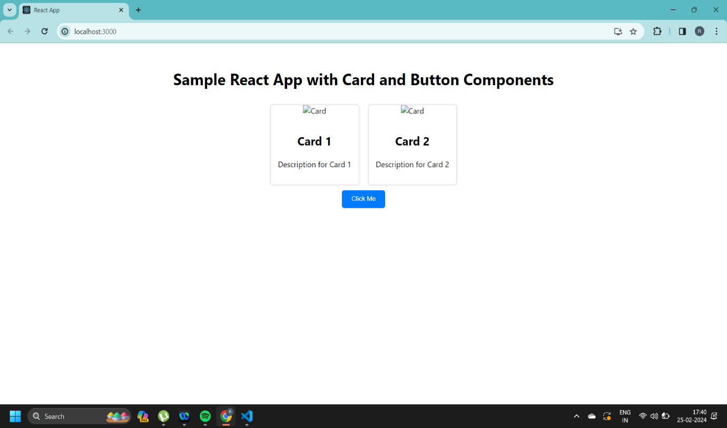

Approaching the assignment involved breaking down the requirements into smaller tasks:

1.Component Creation: I started by creating the `Card` and `Button` components as functional components in separate files. Each component received props to display dynamic data and handle events.

2.Styling: I used CSS files (`Card.css` and `Button.css`) to style the components. The styles were kept simple to ensure clarity and reusability.

3.Integration: Next, I integrated the components into the main `App` component. I created sample data for the cards and added a button to demonstrate functionality.

4.Testing: After integrating the components, I tested the application to ensure that the components rendered correctly and that the button click event worked as expected.

Challenges encountered:

1.Styling Consistency: Ensuring consistent styling across components and making them visually appealing while keeping the CSS manageable was a challenge. I opted for a simple and clean design to maintain clarity.

2.Data Handling: Managing dynamic data for the cards and passing it as props to the components required careful attention to ensure that the components remained reusable and customizable.

3.Event Handling: Implementing event handling for the button component to trigger an alert when clicked was straightforward. However, ensuring that the event handling was done efficiently and accurately required some consideration.

Overall, the assignment provided a good opportunity to practice React.js fundamentals, including component creation, styling, and event handling, while focusing on reusability and customization.