Week 7:

1a,b,c> In q1.cpp

d> The code is also in q1.cpp. The graph is in figure1.png. We can see that Lomuto is better than Hoare’s implementation, and the Median implementaion is between the Lomuto and Hoare’s implementation.

2a> In q2.cpp.

b> The be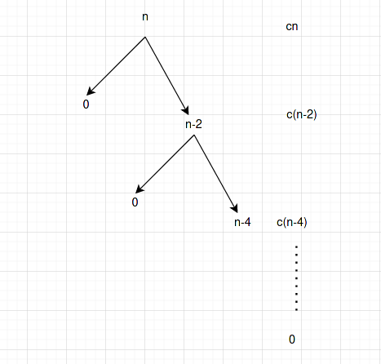st case would be when len is < 27 and the array is sorted. This will cause our best case to be dependent on the best case of InsertionSort, which is O(n), therefore, the best case of quicksort with 2 pivots is O(n).

The worst case is O(n^2) because if the pivots are already in their designated positions.

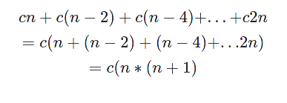Hence worst case is O(n^2)

c>

The solution is in q2.cpp under the function name randomdualQuickSort();