[Figure 1 : Architecture of a video game using conceptual AI 2](file:///C:\Users\yanns\Desktop\State%20of%20the%20Art.docx#_Toc102738154)

[Figure 2: Basic illustration of reinforcement learning 3](file:///C:\Users\yanns\Desktop\State%20of%20the%20Art.docx#_Toc102738155)

Artificial intelligence is helpful in a lot of games. It can be present in two main domains. Context AI and game AI. A game one is an AI whose purpose is to help the player to solve problems like defeating opponent in combat or navigating in a maze as example. Context specific AI would be oriented to react to the player choices. In Forza Horizon 4, we can find multiple type of AI. The Drivatar is one whose main goal is to reproduce the player behaviour in order to learn how players act in different situations. The main goal with that is to add human aspect to an artificial player. We also find other types of AI like an autopilot or assisted controls in the game.

The field of study in artificial intelligence in video games is large and progress made in this domain is important. The Artificial Intelligence in Video Games: Towards a Unified Framework article is about the evolution of AI in games. The games became more complex and sophisticated with specific AI for each of them. The problem here is that there is a lot of similarities between them and the exploitation of complex environment for each video game is not efficient, thus a specific AI is developed for specific game. This document focuses on this problematic with the proposition of a unified framework that will help the development of AI behaviour in a unified way by the usage in an unified AI framework during development phase. This is call conceptual AI and it can be implemented in a similar way in numerous games.

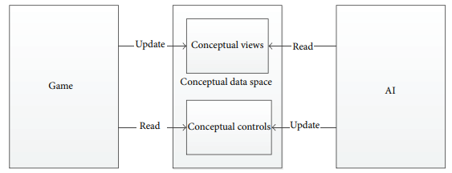

Figure 1 : Architecture of a video game using conceptual AI

The help of artificial intelligence in video games can be present with another type. Indeed, it’s possible to implement algorithms that will try to learn how to play the game in an almost perfect way. The algorithm that can be used for that are called “by reinforcement”. The Asynchronous Methods for Deep Reinforcement Learning article describe well this type of AI. This article is related to the Q-learning type of AI and it describes the operations that bring an AI to learn how to play a game, based on observation of the game environment by an agent and the implementation of the way to use the game controls. Based on a neural network, the AI will automatically learn how to play by the using of a reward function (or Q function). If this function is constantly increasing, the AI player is better than other ones and he will be selected to be reproduced with other ones. Thus, each generation is better than the previous and after a certain number of generations, the AI player has learnt how to play the game effectively. The AI that is train on a specific level can also acquire the knowledge on how to react in a similar 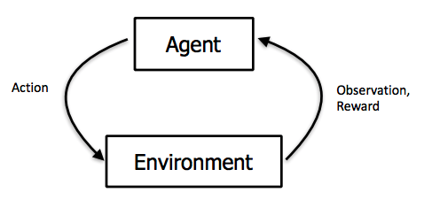environment but in another level.

Figure 2: Basic illustration of reinforcement learning

An example of Q-learning is the implementation done by SethBling named MarI/O. This program follows the principles explained above. At first the Neural Network don’t even know how the controls work; he will learn by getting a reward which is given to him when he goes deeper into the level. The closer he will get to the end flag; the more reward will be given to the Neural Network. The environmental observation is done by reading every byte in the flash memory, each block is seen as a white cube, entities as a black cube and Mario is the red line.

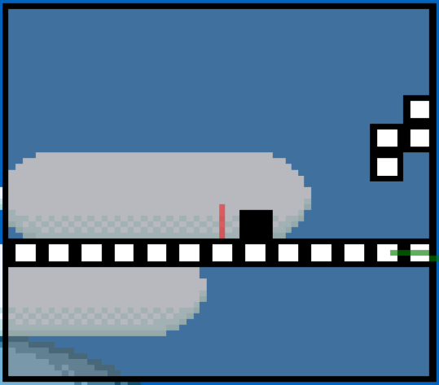

Figure : Environment observation of MarI/O

The agent will learn by linking the environment to different action, the simplest example is to jump when there is an enemy just in front of Mario. After multiple generation when can see what the reproduction and random mutation developed the Neural Network.

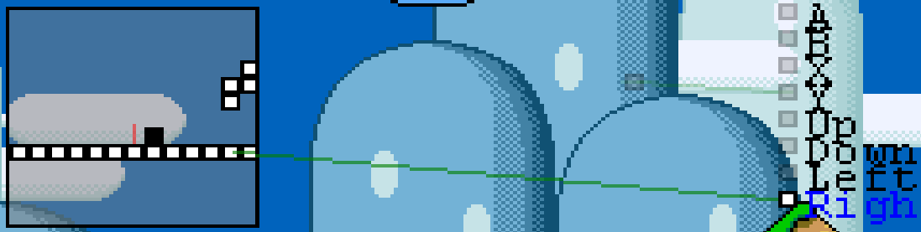

Figure : Generation 0 of MarI/O

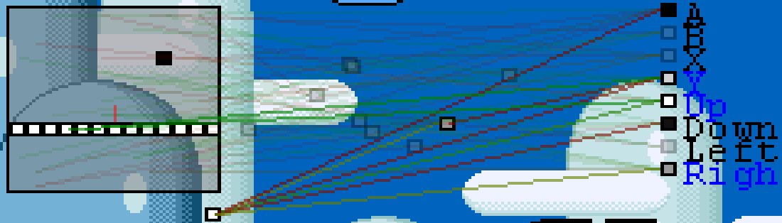

Figure : Generation 51 of MarI/O

References:

https://dl.acm.org/doi/abs/10.1155/2015/271296

https://arxiv.org/pdf/1602.01783.pdf