- Enter the following MATLAB commands and describe what each step does
Syntax | What it does
Adding noises using imnoise(img,’type’)
>> t = imread(‘trees.tif’); | Read the image tree.tif into variable t
>> t2 = t + 120; imtool(t2); | 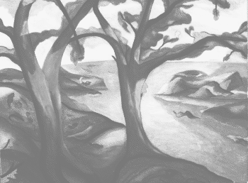
>> sp1 = imnoise(t, ‘salt & pepper’);  >> imtool(sp1); | 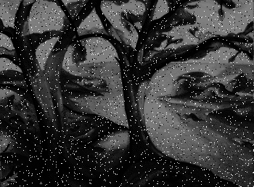
>> sp2 = imnoise(t, ‘salt & pepper’, 0.2);  >> figure; imtool(sp2); | 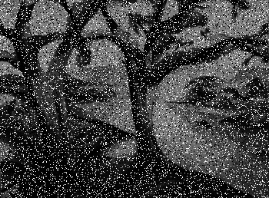
Compare sp1 and sp2, what do you notice?
What does the parameter 0.2 do?
Find out its default value.
>> ga1 = imnoise(t, ‘gaussian’); imtool(ga1); | 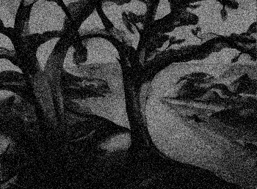
>> ga2 = imnoise(t, ‘gaussian’, 0.5, 0.3);  >> figure; imtool(ga2); | 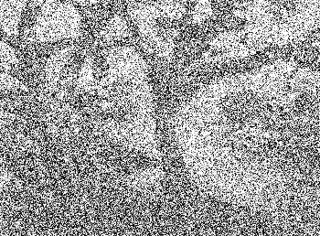
Compare ga1 and ga2, what do you notice?
What does the first parameter 0.5 refer to?
What does the second parameter 0.3 refer to?
Find out the default values of these parameters.
>> spk = imnoise(t2, ‘speckle’); imtool(spk); | 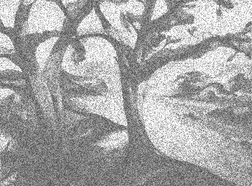
Filtering
>> a7 = fspecial(‘average’, [7 7]) | 0.0204 0.0204 0.0204 0.0204 0.0204 0.0204 0.0204  0.0204 0.0204 0.0204 0.0204 0.0204 0.0204 0.0204  0.0204 0.0204 0.0204 0.0204 0.0204 0.0204 0.0204  0.0204 0.0204 0.0204 0.0204 0.0204 0.0204 0.0204  0.0204 0.0204 0.0204 0.0204 0.0204 0.0204 0.0204  0.0204 0.0204 0.0204 0.0204 0.0204 0.0204 0.0204  0.0204 0.0204 0.0204 0.0204 0.0204 0.0204 0.0204
>> sp = im2double(sp1);  >> sp_a7 = filter2(a7, sp); imtool(sp_a7); | 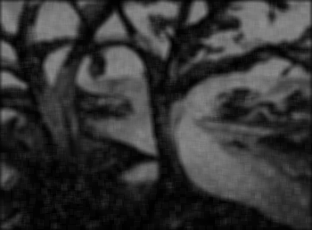
>> a = fspecial(‘average’) | 0.1111 0.1111 0.1111  0.1111 0.1111 0.1111  0.1111 0.1111 0.1111
What is the default filter size?
>> sp_a = filter2(a, sp); figure; imtool(sp_a); | 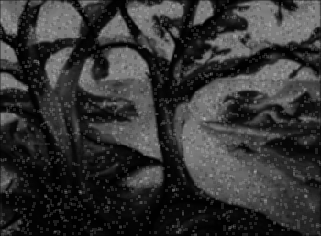
Compare sp_a7 and sp_a, which one is better?
>> sp_m = medfilt2(sp); figure; imtool(sp_m); | 
>> sp2_m = medfilt2(sp2, [5 5]); imtool(sp2_m) | 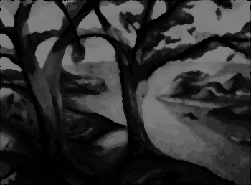
>> sp2_o = ordfilt2( sp2, 3, [0 1 0; 1 1 1; 0 1 0] );
What does the parameter 3 refer to?
 | Perform a max filter on ga1
 | Perform a min filter on ga2

- Removing periodic noise
Syntax | What it does
>> I = im2double(imread(‘cameraman.tif’)); | Load ‘cameraman.tif’ into variable im
>> sz = size(I) | 256 256
>> [x y] = meshgrid(1:sz (2),1:sz(1));  >> N = sin(x + y / 1.5) ; imtool(N); | 
>> J = I + N; imtool(J); | 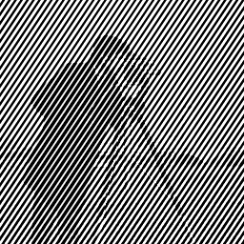
>> FJ = fftshift ( fft2(J) );  >> figure; imagesc(abs(FJ));  >> figure; imagesc(log(1+abs(FJ))); | Compare the 2 displaying images. Why do you need the log function?
>> impixelinfo;  >> ns = [ 88 102; 102 88]; | Enter the coordinate of the noise spikes
>> D1 = sqrt((x-ns(1,1)).^2 + (y-ns(1,2)).^2);  >> D2 = sqrt((x-ns(2,1)).^2 + (y-ns(2,2)).^2);  >> r = 5;  >> H = (D1 > r & D2 > r); imtool(H); | 
>> FK = FJ.*H;
>> figure; imagesc(log(1+abs(FK)));
>> K = real(ifft2(FK)); imtool(K) | 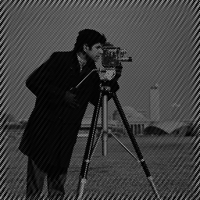
Repeat to filtering with a larger value of r and compare the outputs.

- Image Averaging is another method to reduce zero-mean Gaussian noise if we have several corrupted images at hand.
Syntax | What it does
Io = im2double(imread(‘cameraman.tif’)); | Load an image into a variable Io
for k = 1:10
I(:, :, k) = imnoise(Io,‘gaussian’, 0, 0.05);
end
imtool(I(:, :, 1)); imtool(I(:, :, 2));
J = mean(I, 3); imtool(J);
MSE = mean(mean((J - Io).^2)) | Calculate the mean square error (MSE)
 | Display the averaged image and compare it to the original.
>> I = im2double(imread(‘cameraman.tif’));
>> FI = fft2(I);
>> sz = size(FI);
>> [u v] = meshgrid(1:sz(2), 1:sz(1));
>> a = 0.1, b = 0.1, T = 10,
>> m = pi*(a*u + b*v);
>> H = (T./m).*sin(m).*exp(-j*m);
>> FJ = H.*FI;
>> J = real(ifft2(FJ));
>> G = J;
>> FG = fft2(G);
>> FK = FG./H;
>> K = real(ifft2(FK));

