Use Case Description.

The below use case description was completed based on the following user story:

* As an ADMIN I want to ALLOCATE TIME SLOTS so that the hackers can know when to start presenting.

|  |  |
| --- | --- |
| Use case | Allocate time slots |
| Actor | Admin |
| Pre-conditions | Hacker is logged into the system. |
| Basic flow of events | 1. The actor logs into the system. 2. System authenticates the actor’s credentials and starts a session. 3. The actor views available time slots. 4. The actor is guided by the system to view time slots. 5. The actor allocates times slots 6. The system acknowledges that the actor the actor allocated a time slot. 7. The actor leaves the system. |
| Extensions | 1a. The system fails to authenticate the actor.  -The system inform the actor and doesn’t allow them to proceed.  3b. The system fails to allocate time slots  -The system informs the actor and starts the session again. |
| Post-conditions | Time slots allocated |
| Special requirements | The actor must be registered and logged in. |

Functional Requirements

* The system must allow the admin to allocate hackers time slots.
* The system must allow the admin to check for available time slots.
* The system must display filled and available time slots.

Non-Functional Requirements

* The system shall display the time slot in hh:mm.
* The system shall display the available time slots in green.
* Configuration time for Allocating of time slots must display within 10 seconds.

Use case diagram

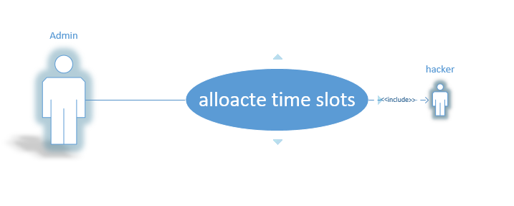

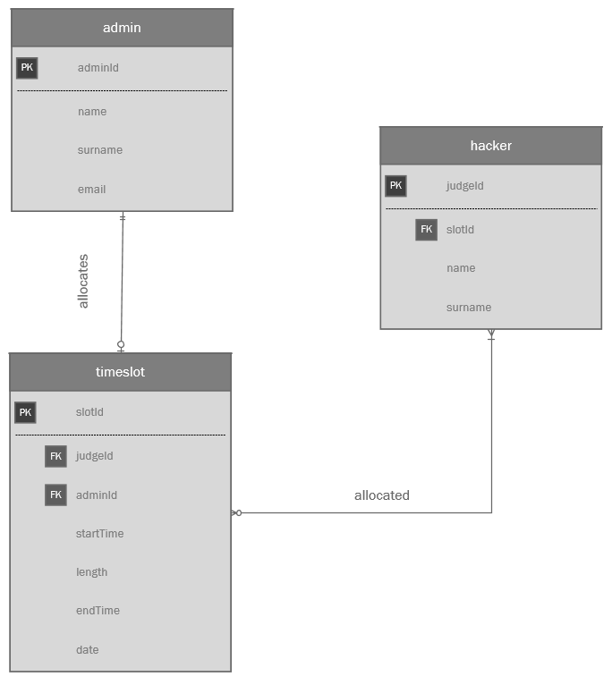 Entity Relation Diagram

Business Rules

Admin/timeslots/hackers

1. One to many ADMIN can allocate one to many TIME SLOTS.
2. One to many TIME SLOTS are allocated by one to many ADMIN.
3. One to many TIME SLOTS are allocated to one to many HACKERS.
4. One to many HACKERS can be allocate one to many TIME SLOTS.