Use Case Description.

The below use case description was completed based on the following user story:

* As an admin I want to login so that I can access the system.

|  |  |
| --- | --- |
| Use case | login |
| Actor | Admin |
| Pre-conditions | 1. A valid username or email address associated with the account. 2. A valid password that meets the system's password requirements (such as minimum length, complexity, etc.). 3. A working internet connection to access the login page. 4. The account being in good standing (not suspended or deactivated). 5. The user having appropriate access permissions for the level of access they are attempting to gain. 6. The user agreeing to any terms and conditions or privacy policies associated with the platform. |
| Basic flow of events | 1. The actor logs into the system. 2. System authenticates the actor’s credentials and the system redirect the user to the appropriate page or dashboard after successful login. |
| Extensions | 1. The system fails to authenticate the actor.   -The system informs the actor and restarts the session. |
| Post-conditions | 1. The user is authenticated and authorized to access the system or application. 2. The user is redirected to the appropriate page or dashboard. 3. The user's session is established, and a session ID is generated. 4. The user's account information, such as name and email address, is displayed on the page. 5. The system logs the user's activity, including the login time and IP address, for security and auditing purposes. 6. The user can access all the features and functionalities that are available to them based on their role and permissions. 7. The user can log out of the system or application when they are done. 8. If the user enters invalid login credentials, they are prompted to enter the correct information or reset their password. 9. The system displays appropriate error messages if the user encounters any errors during the login process. |
| Special requirements | None |

Functional Requirements

1. The system should verify the user's credentials (username and password) before allowing access to the account.
2. The system should provide an option to recover the password in case the user forgets it.
3. The system should allow the user to change their password.
4. The system should redirect the user to the appropriate page or dashboard after successful login.

Non-Functional Requirements

1. Security: The system should have appropriate security measures to protect user credentials and prevent unauthorized access.
2. Usability: The login process should be easy to understand and use, with clear instructions and error messages.
3. Availability: The login system should be available and responsive at all times, with minimal downtime or maintenance.
4. Performance: The login process should be fast and efficient, with minimal waiting time for the user.
5. Compatibility: The login system should be compatible with different devices and browsers to ensure a consistent user experience.

Use case diagram

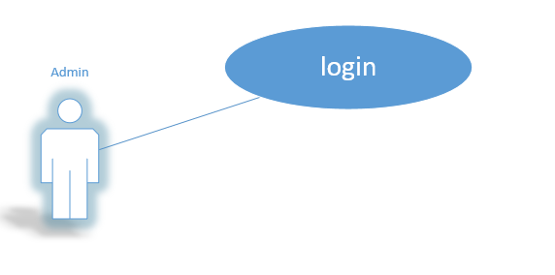

Entity Relation Diagram

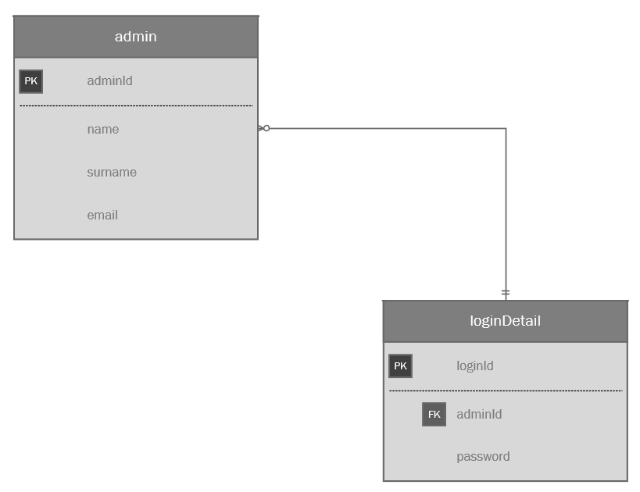

Business Rules