# **User story Description**

|  |  |  |
| --- | --- | --- |
| Use case name | View presentation | |
| Actor | Judge, Hacker | |
| Pre-conditions | Must log in to the system | |
| Post­-conditions | Rate the presentation | |
| Typical courses of event | | |
| Judge   * Login * View presentation | | Hacker   * Uploads the file * Shares the screen |

# **Functional requirements**

* Hacker must be able to share the screen to the Judge
* Voice record (speaker and microphone)
* Judge should have a profile to view the presentation
* Judge should have internet to view the presentation

# **Non-functional requirements**

* Reliability – system works to the user at any given time.
* You can interact with other users.
* Availability - The network has to be available 24 hours a day.
* Performance – The system should give good quality image whilst the hacker shares the screen.
* Response time should be less, the judge can communicate instantly for feedback.
* Dependability - If system loses the connection to the internet, user should be informed.

# **Use case Diagram**

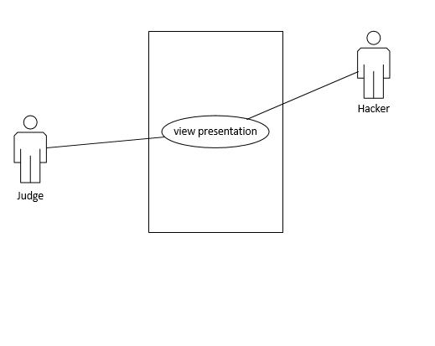

# **Entity Relation Diagram**

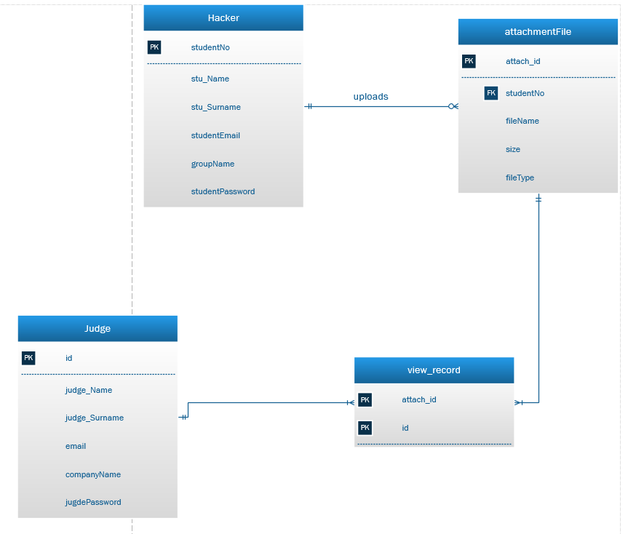

## **Business rules**

HACKER can upload many ATTACHMENTFILES

Some HACKERS may not upload ATTACHMENTFILES

An ATTACHMENTFILES is uploaded by one and only one HACKER

JUDGE can view one or more ATTACHMENTFILES

ATTACHMENT file can be viewed by one or many JUGDES