Peer-To-Peer Lending ER-Model Explanation

The ER diagram consists of the following features :

* In the model, every borrower and lender registers as a user, each with a unique User ID. A user can both be a borrower and lender at the same time but can register once with a unique ID only.
* Each user also has a nominee to itself, which holds an identifying relationship with the user. The nominee has to itself:

1. First name
2. Last name
3. Email ID
4. ParentID

* The attributes of a User are as follows :

1. UserID
2. Email
3. Password
4. First name
5. Last name
6. Phone number
7. Address

* As an investor/lender, the user can make a proposal to provide a loan with its own specifications and conditions for a certain duration of time. The specifications include the amount he/she holds to lend, the interest rate, duration and EMI if required. Each proposal has a unique proposal ID. The Proposal ID here is the primary key for the proposal made.
* As a borrower, the user can specify his/her requirements of money with its own specifications and requirements. The specifications include the amount he/she requires to borrow, the requested interest rate, duration and EMI he/she would be able to pay. Each request has a unique request ID. The Request ID is the primary key for the request put up.
* Whenever a request or a proposal is accepted, the ID of the proposal/request along with the InvestorID (UserID of the investor) and the RequestID (UserID of the borrower) is stored.
* Each ongoing or fulfilled/closed transaction is kept track of and the ‘Status’ attribute is updated whenever the transaction is successfully done.

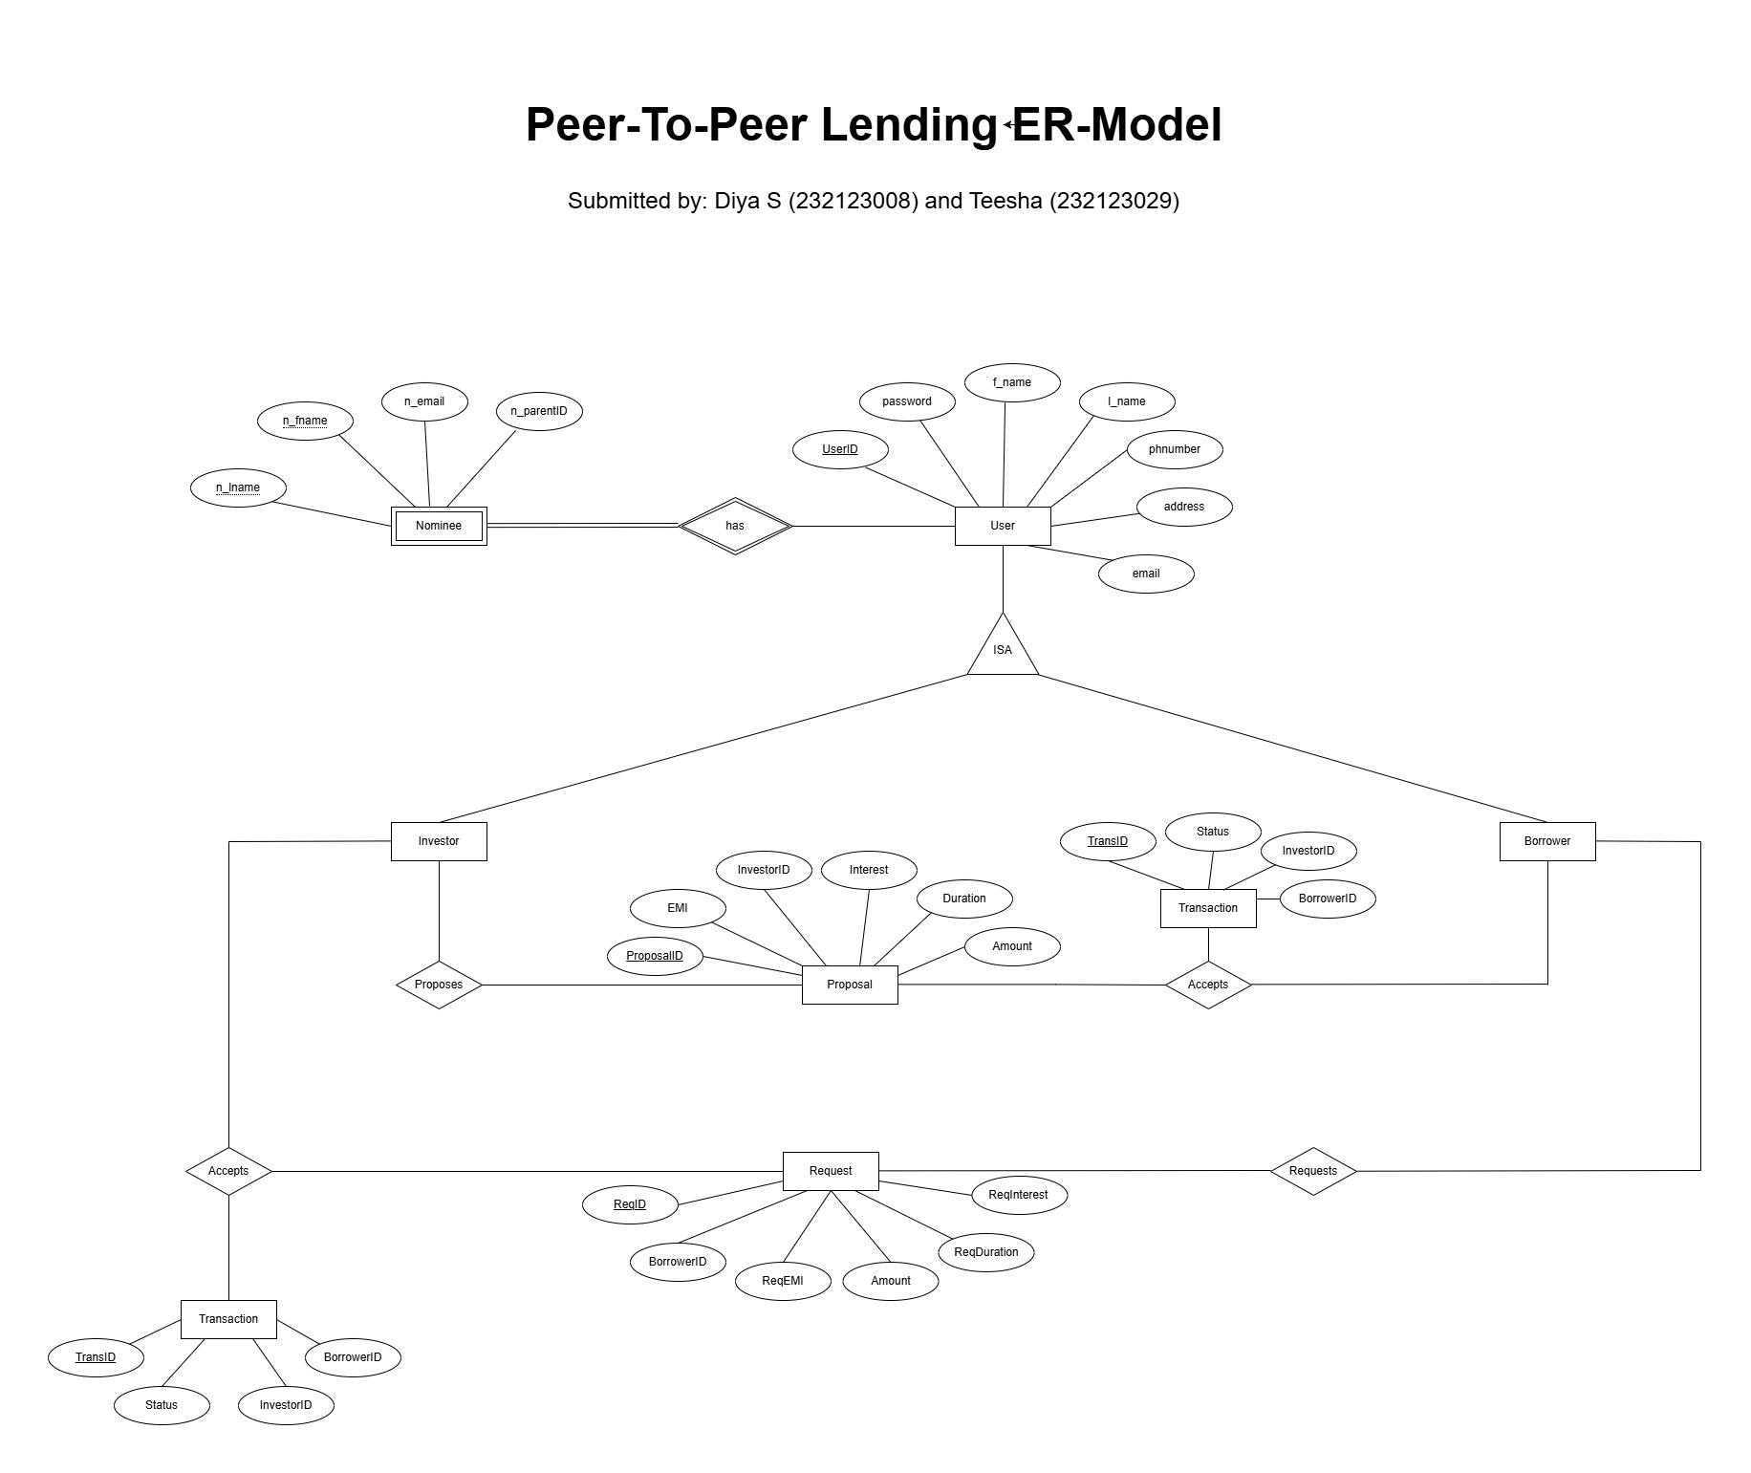

Submitted by Teesha, Diya