**SOFTWARE DEVELOPMENT LIFE CYCLE(SDLC)**

**Waterfall Framework**

**REQUIREMENTS AND ANALYSIS**

### Requirements:

1. RESOURCES

* Think Java TextBook
* Java 11 on computer systems
* Deck of cards to play game
* 3 team members with assigned task

1. BACKGROUND AND INFORMATION

War is an internationally recognized card game that is played with a full deck of 52 cards (the jokers are not included). There is no clear representation on how the game started but it is said to have spread around the world in the middle ages when people were confined to their homes during the plague. As they were indoors, ways of entertainment were playing cards thus the birth of ‘War’ (Natania, 2017)

The two-player game starts with a deck of cards split into half (26 each) and each player gets a set of cards all facing downwards. At the same time, each player turns up a card and the player with the higher card takes both cards and puts them at the bottom of his stack face down. The cards are ranked from highest to lowest where ace is the highest followed by king, queen, jack and ten through 2. The game continues in that manner until the player’s turnover cards are of the same value. At this point war has been declared. Each player then turns up one card (face up) and the other card facing downwards then the player with the highest card takes both piles and reshuffling takes place (Bicycle, 2019) If the cards had the same value, you repeat the previous step and the highest-values card collects the set. When a player runs out of cards they lose and the game is complete

This game can also be played with three or four players as long as the cards are equally divided between the group. War will be declared when at least two people have similar value cards then all the members battle for the pile. There are many variations to this game and a popular one is called ‘Casino War’ where the player deals with the house (the casino) and the winner gets money if they get a higher valued card. (McLeod, 1995)

1. PERFORMANCE

Easy to learn quick game to entertain people of all age ranges.

1. FUNCTIONALITY

The game functions well.

1. TO ANALYSE
   1. EFFECTIVENESS- effective
   2. UTILIZATION- easy for anyone to use
   3. PERFORMANCE – it performs well
   4. DEVELOPMENT
   5. MISSION SCENARIO – we can make it more attractive and complex

DESIGN

1. Risks:
2. Technologies:
   * 1. Classes and subclasses
     2. Arrays and array lists
     3. Scanners
     4. Interface representation(Storyboard presentation)
3. Timeline and budget: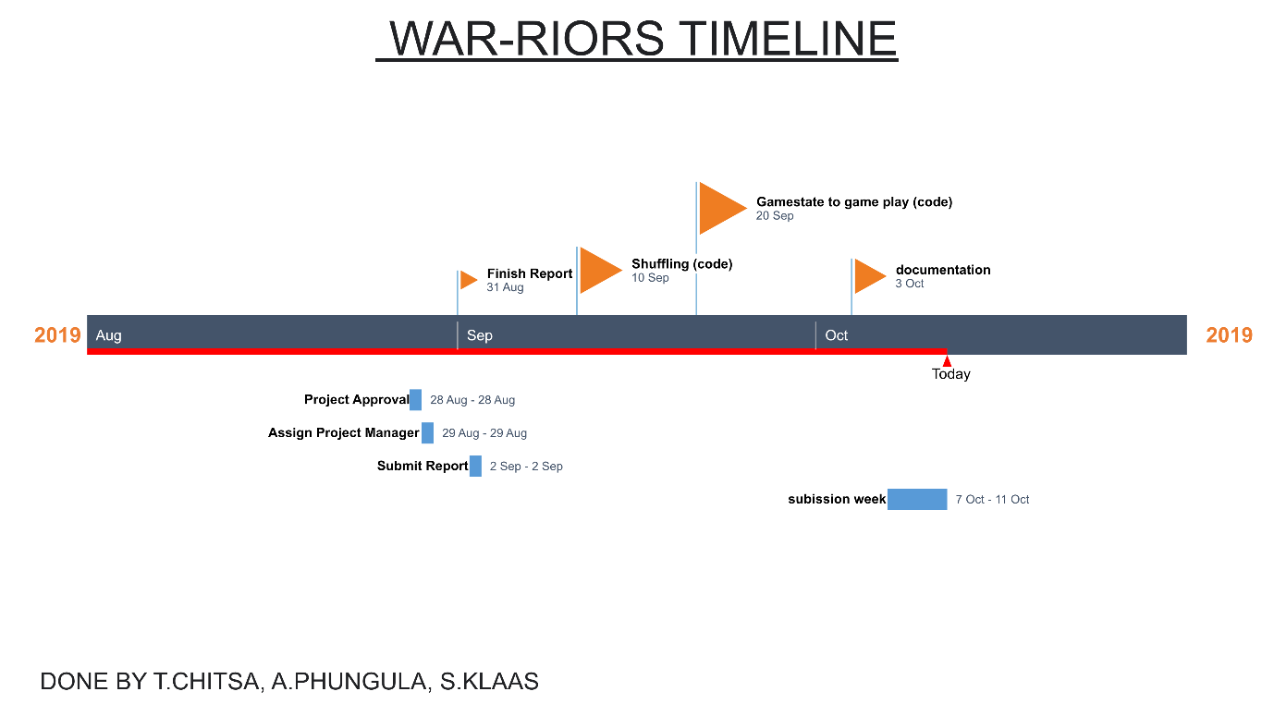

**IMPLEMENTATION**

Storyboard has been uploaded with all the necessary details on the implementation of the game.

# References

Bicycle. (2019). *Bicycle Cards*. Retrieved from bicyclecards.com: https://bicyclecards.com/how-to-play/war/

McLeod, J. (1995). *Pagat*. Retrieved from www.pagat.com: https://www.pagat.com/war/war.html#tod_und_leben

Natania, C. (2017, February 14). *All Jackpots Casino*. Retrieved from www.alljackpotscasino.com: https://www.alljackpotscasino.com/blog/history-casino-war/