COMP603 / ENSE600
Program Design & Construction / Software Construction
2026 CJLU
Assignment 1 (Project 1)
Project Report
System Design and Java CUI Implementation with Generative AI — 40% of the course
Project title | [ ]
Group ID (from Canvas) | [ ]
Student 1 — name and ID | [ ]
Student 2 — name and ID (if any) | [ ]

How to use this template
GUIDANCE — Blue boxes like this one are instructions. Delete every blue box before you submit.
Grey text in square brackets is a placeholder — replace it with your own content.
Keep all numbered headings. If a section does not apply to your project, keep the heading and write “Not applicable” with a one-line reason.
Each section states the marking component and its weight, so you can check your report against the marking rubric before submitting.
Sections 2.6 and 3.7 are Student-Authored Critical Reflections. They must contain NO AI-generated text. Each has a declaration you must sign.
Submit this report as Word or PDF inside your single ZIP file, together with the source code folder and the demonstration video.
Table of contents
GUIDANCE — The table of contents below is a field. In Word, press Ctrl+A then F9 (or right-click → Update Field) to fill it in once you have finished writing.
Update this field in Word (Ctrl+A, then F9)

1. Project Setup
GUIDANCE — The marker must be able to build and run your project without any manual configuration.
State exactly how to build and run it, and list any account credentials needed to log in.
Your project must be a standard Maven or Gradle project.

How to build and run
[e.g. Open a terminal in the project folder and run: mvn clean javafx:run — or — mvn clean compile exec:java. State the build tool you used (Maven or Gradle) and the main class.]

2. Requirement Generation and Analysis (Component 1.1 — 20%)
GUIDANCE — Propose a topic that is neither too simple nor too complex for your team size.
Define the core functionalities, the system scope, and the user interactions.
Section 2.6 must be written entirely by you, with no AI-generated text.

2.1 Project topic and scope justification
GUIDANCE — Describe what the system does and who it is for. Then justify the size: why is this topic big enough to be interesting, but small enough to finish?
[Describe your chosen topic, the problem it solves, and justify that its scope suits an individual / two-person team.]
1.Topic: Conference Management System with Reviewer Assignment
2.The problem it solves: Academic conferences receive a large number of research paper submissions every year. Managing the review process manually can become inefficient and error-prone, especially when assigning appropriate reviewers to papers while considering constraints such as research expertise, conflicts of interest, and reviewer workload.
3. Why its scope suits two-person team:
why is this topic big enough to be interesting: The project scope is designed to be large enough to demonstrate meaningful object-oriented design concepts while remaining achievable for a two-person development team within the project timeframe. The system includes multiple interacting entities, such as users, papers, reviews, assignments, and decisions, which provide opportunities to apply abstraction, encapsulation, inheritance, polymorphism, interfaces, collections, and file-based persistence.
why is this topic small enough to finish :several advanced features that exist in real conference management platforms are intentionally excluded from this project scope. These include real-time email notifications, online paper file processing, reviewer bidding systems, external authentication services, and discussion forums. These features may provide additional value in a production system but introduce significant complexity that is beyond the learning objectives and implementation scope of this project.
conclusion: this project focuses on implementing the essential conference review workflow and a constraint-based reviewer assignment mechanism while maintaining a manageable scope suitable for a two-person software development team.

2.2 Core functional requirements
GUIDANCE — Number every requirement (FR-1, FR-2, ...) so you can refer to them from the design and implementation sections. Mark each one Essential or Desirable — Section 2.6 asks you to justify these choices.
ID | Requirement | Description / acceptance criteria | Priority
FR-1 | User and role management | The system shall allow users to create and access user accounts containing basic information such as name, email and institution. A user shall be able to hold one or more conference roles, including Author, Reviewer and Chair, and the system shall provide functions appropriate to each role. | Essential
FR-2 |  | The Chair shall be able to configure the required number of reviewers per paper, maximum reviewer workload, acceptance threshold and disagreement threshold. The Chair shall also be able to change the conference phase between Submission, Review and Decision, and the system shall prevent operations that are not permitted in the current phase. | Essential
  Conference
  configuration and phase
  control
FR-3 |  | Authors shall be able to submit paper information including title, abstract, research topics, co-authors and affiliations. The system shall assign a unique paper ID and maintain its status. Authors shall be able to view the status of their own submissions. | Essential
  Paper submission and
  lifecycle management
FR-4 | Reviewer expertise and conflict management | Reviewers shall be able to maintain research expertise topics and declare conflicts of interest. The system shall also detect applicable conflicts such as shared institutional affiliation and shall prevent conflicted reviewers from being considered eligible for assignment. | Desirable
FR-5 |  | The Chair shall be able to assign reviewers automatically or manually. For automatic assignment, the system shall exclude reviewers with conflicts of interest or reviewers who have reached their workload limit, calculate topic matching between eligible reviewers and papers, rank suitable reviewers using topic relevance and workload, and assign the required number of reviewers where possible. Manual assignments shall be subject to the same eligibility constraints. | Essential
  Reviewer assignment
FR-6 |  | Reviewers shall be able to view only papers assigned to them through an anonymised paper view that does not expose author identities. Reviewers shall be able to submit one review per assigned paper containing a score, confidence level and review comments. The system shall reject invalid or duplicate review submissions. | Desirable
  Double-blind review
  management
FR-7 | Review monitoring and decision management | The system shall track review completion for each paper. When the required reviews have been submitted, it shall calculate review results, identify significant score disagreement using the configured threshold, and generate an acceptance or rejection recommendation. The Chair shall make the final decision and shall provide a reason when overriding the system recommendation. Authors shall be able to view anonymised review feedback after the decision is released. | Essential
FR-8 | Persistent data storage and audit trail | The system shall save and reload essential conference data, including users, papers, reviewer assignments, reviews, conference configuration and decisions, so that data remains available after the application is restarted. Important actions such as reviewer assignments and final decision overrides shall be recorded in an audit log. | Essential
FR-9 |  | The system shall send email notifications to users when important events occur, such as successful paper submission, reviewer assignment, review completion reminders, and decision announcements. | Desirable
  Automatic email
  notification
FR-10 |  | The system shall provide additional support for the review process, including comparing review scores, displaying disagreement information between reviewers, and allowing the Chair to record discussion notes before making final decisions. This feature improves decision-making quality . | Desirable
  Advanced review
  analysis and discussion support
FR-11 | Paper file upload and validation | The system shall allow authors to upload paper files and perform basic validation, such as checking file format and size requirements before submission. | Desirable
FR-12 |  | Reviewers shall be able to indicate preferred research topics or papers they would like to review. The system may consider reviewer preferences when generating reviewer assignments. | Desirable
  Reviewer bidding
  and preference
  management
(Add or remove rows as needed. The example row in grey should be deleted.)

2.6 Critical Reflection — Student-Authored (No AI-Generated Text)
GUIDANCE — This is the part that carries the marks for critical judgement. Write it in your own words.
Do not paste GenAI text here. If GenAI suggested a requirement and you want to discuss it, quote it clearly as a quotation and then give YOUR analysis of it.
Answer all three questions below with concrete reference to your FR-numbers.

2.6.1 Which features and requirements are essential for the system, and why?
[Refer to your FR-numbers. Explain what makes each one essential — what breaks if you remove it?]
1. FR-1 User and role management: The system need people, the only way that human can access this system is through logging in. if this core requirement removed, no one can use this system, which make the thing we build useless. Additionally, users can have different roles, for example, author, reviewer and chair, to do different jobs. So managing this changing well can make system more convenient to use, and different people can get their specific tools to finish their work.
2. FR-3 Paper submission and lifecycle management: The core task of our system is reviewing paper. However, if we do not have paper, how can we review it? Therefore, Paper submitting is an essential task that our system should have. Additionally, managing a paper's lifecycle well is necessary, too. It is our responsibility to make the submitted paper go to a reasonable cycle to let reviewers judge it correctly. Without this, the system has no data source at all, and authors cannot track whether their work is under review or finished.
3. FR-5 Reviewer assignment: This matches the right papers with the right reviewers based on their research fields. If this requirement is removed, a paper may be assigned to an expert who knows nothing about it, which is a huge mistake. It ensures fairness and quality by putting the paper into the hands of the most suitable person who can actually understand and evaluate the research.
4. FR-7 Review monitoring and decision management: It is an essential part of giving the right score to a paper. If this requirement is removed, we cannot track if reviews are finished, check for score disagreements, or help the chair make the final accept or reject decision, making the whole review process incomplete. Additionally, without this tracking and management tool, the conference would lose its final judgment step. The chair would have no review feedback to decide which paper gets accepted or rejected, which means all the review efforts would mean nothing.
5 FR-2 Conference configuration and phase control：This is an essential tool for the chair to manage the whole system well. If this is removed, the chair cannot set rules, for example, max workload or score limits, or change conference stages, and wrong actions might happen at the wrong time. It is a controller to make sure people only do the right thing during the correct phase, like submitting during submission phase and reviewing during review phase.

2.6.2 Which features are unnecessary or unrealistic, and why did you exclude them?
[Include features GenAI proposed that you rejected. Say why they were out of scope, unrealistic for the time available, or not valuable to the user.]
1. Automatic email notification: It is a normal feature in the real life. However, as an assignment project, we decide to make it focus on showing the core function of Conference Management System, which are users management, paper submitting, review management and so on. Additionally, we believe that the exiting functions can completely show what we have leant in the class. That why we decide to abandon it.
2. Paper file upload and validation: Paper storage is an important feature in the real life Conference Management System. However, as a demo, we decided to merge it into "Persistent data storage and audit trail", which store use data and paper together, in the project1. Additionally, as for validation, we need to do a lot of complex work which does not relate to our core tasks to implment it. So may we will do it in the project2.
3. Reviewer bidding and preference management: In Reviewer assignment, the chair or the system will assign the paper to the right reviewer. Before that, the interest of reviewers will be collected. Therefore, it is no need to implement a feature which only focus on this task.
4. Reviewer expertise and conflict management: In Reviewer assignment, we make system to automatically assign paper to reviewers according to their research fields. what's more, chair will also manually assign paper to insure the right reviewer get the right paper. So there is no need to implement this function.

2.6.3 Why were these design decisions made?
[Explain the reasoning and trade-offs behind your final requirement set.]
1. We want to make a good use of the knowledge we learnt in class: We believe one of the purpose of building this project is to apply what we leant in the class. So we keep the feature that match this aim and reject unnecessary requirements.
2. Project size limitation: project1 is like a demo, so we just make sure every core task can work well, and abandon extra function.
3. Balance between realism and feasibility: There is some feature that exit in the real world Conference Management System, like email but we don not shixian However, lacking these function does not make our system break, so we just leave it and hope finish these complex but not enssitial in the project2.

DECLARATION — I/We declare that Section 2.6 was written entirely by the student author(s) named below, in our own words, without using GenAI to generate the text. GenAI output quoted for analysis is clearly marked as a quotation.
Student name | Student ID | Signature | Date

3. Software Design (Component 1.2 — 30%)
GUIDANCE — You must show at least TWO design iterations and how the architecture evolved between them.
Insert your diagrams as images (PNG/JPG). Make sure the text in them is readable when printed.
Section 3.7 must be written entirely by you, with no AI-generated text.

3.1 Use case diagram
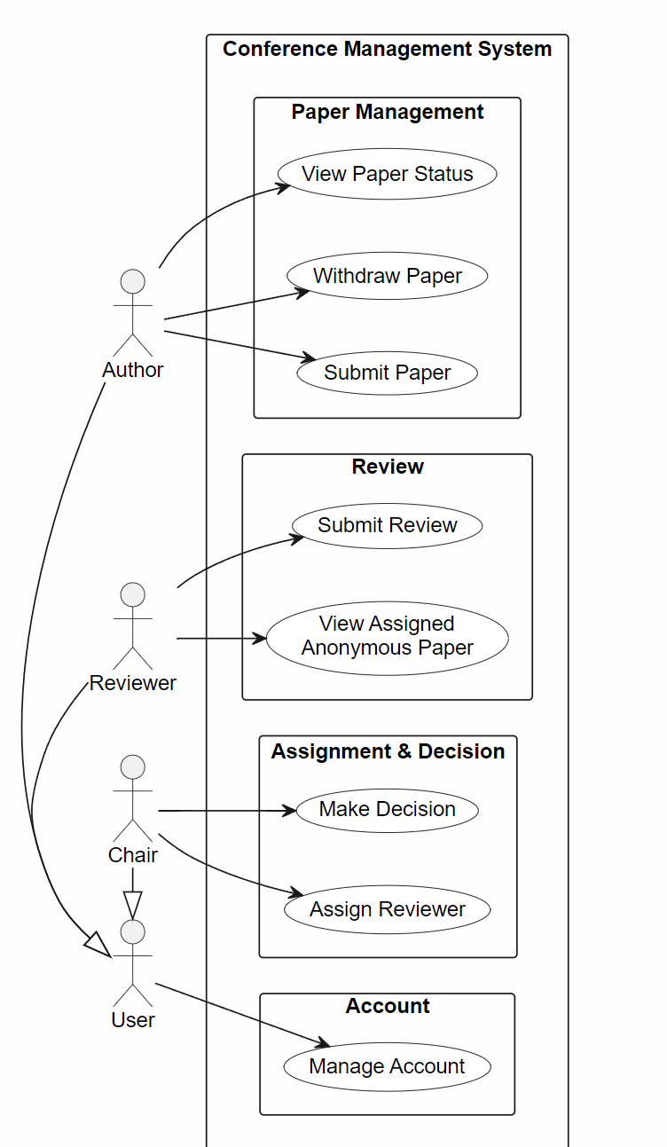
Figure 1: Use case diagram

3.2 System scope, constraints and assumptions reflected in the design
[Explain the boundary of the system as drawn in your use case diagram.]

3.3 Class diagram — Iteration 1 (initial design)
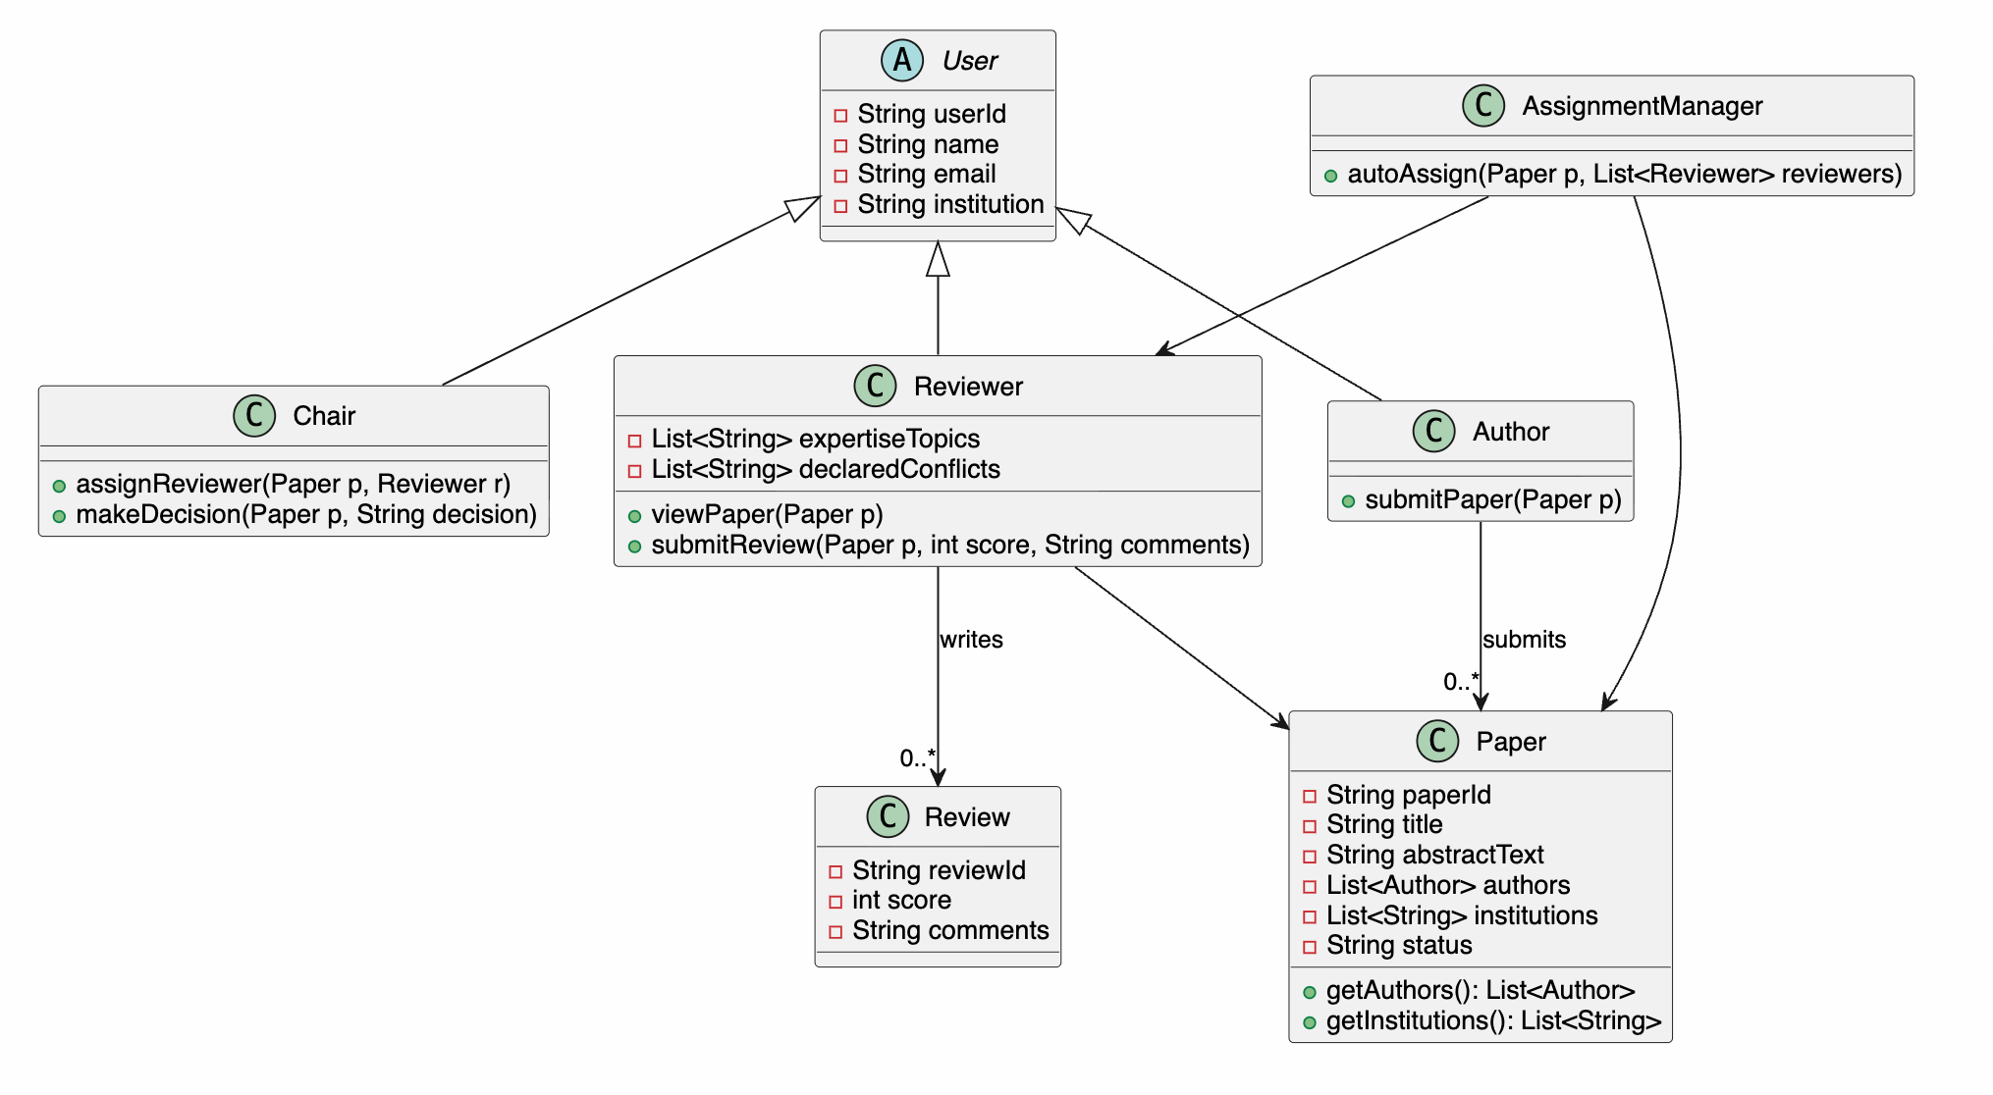
Figure 2: Class diagram — Iteration 1
In Iteration 1, our primary objective was to build an intuitive, baseline object-oriented model by directly mapping real-world conference roles and operational domain entities into Java classes:
- Subclass Inheritance (User, Author, Reviewer, Chair): Since Authors, Reviewers, and Chairs are all conference participants sharing core personal attributes (userId, name, email, institution), modeling them as concrete subclasses extending an abstract User class to achieve code reuse and logical hierarchy.
- Core Data Entities (Paper, Review): The Paper class encapsulates submission details including paperId, title, abstractText, authors, institutions, and status. The Review class stores numerical score and textual comments. Reviewer references the target Paper object through viewPaper(Paper p) to read submission content
- Separation of Assignment Logic (AssignmentManager): we created a dedicated AssignmentManager containing autoAssign(Paper p, List<Reviewer> reviewers). This controller evaluates reviewer workloads and topic relevance to handle paper assignments centrally.

3.4 GenAI analysis of Iteration 1
GUIDANCE — Ask GenAI to critique your design. Record what it suggested and — crucially — whether you accepted or rejected each suggestion, and why.
Rejecting a bad AI suggestion with a good reason earns more marks than accepting everything.
# | Prompt used (summary) | GenAI suggestion | Accepted / Rejected | Reason for your decision
1 | Critique the inheritance structure of User, Author, Reviewer, and Chair. | Replace subclass inheritance with a Role Composition Pattern (UserAccount has-a Set<ConferenceRole>). | Accepted | Class inheritance leads to mutually exclusive user types, creating an identity vs. role conflict. Composition allows a single user identity to dynamically hold multiple roles
2 | Does the paper review process have any issues ? | It does. Passing Paper to Reviewer exposes paper.getAuthors(), breaking Double-Blind. Introduce an AnonymousPaperView DTO or wrapper. | Accepted | There is a risk of leaking real information.The type system itself should structurally prevent access to sensitive data.
3 | Does the reviewer assignment process in AssignmentService have any issues? | Yes. The COI (Conflict of Interest) checking logic uses hardcoded if-else blocks, which violates the Open/Closed Principle (OCP). Extract it into a ConflictRule interface and use a ConflictChecker holding a rule list. | Accepted | AI identified a Conflict of Interest design flaw I had not initially considered. Enables Open/Closed Principle. Adding a new conflict rule only requires creating a new class, without modifying the existing AssignmentService.
4 | Does the class diagram support the full paper lifecycle (FR-3)? | No. Author lacks a withdrawPaper(String paperId) method. | Accepted | R-3 explicitly requires authors to be able to withdraw a paper where permitted. This method is missing from the initial design.
5 | Critique the controller structure for Chair actions. | Merge AssignmentManager, Chair, and the decision workflow into one ConferenceController. | Rejected | Merging them makes one class do too many things. That is hard to maintain and extend.Keeping them separate is better.
(Add or remove rows as needed. The example row in grey should be deleted.)

3.5 Class diagram — Iteration 2 (final design)
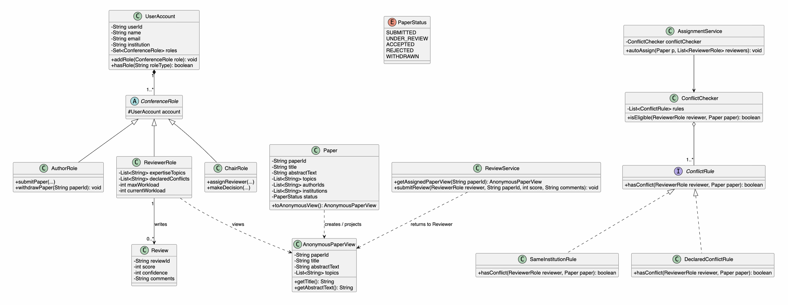
Figure 3: Class diagram — Iteration 2 (final)
The Iteration 2 class diagram resolves the design flaws identified in Section 3.4 by applying core Object-Oriented and SOLID principles:
- Role Composition Pattern (UserAccount and ConferenceRole): We replaced the concrete subclass inheritance (User -> Author/Reviewer/Chair) with the Role Composition Pattern. A single UserAccount holds a Set<ConferenceRole>. This solves the identity vs. role conflict, allowing a user to simultaneously act as an Author and Reviewer in the same conference.
- Double-Blind Encapsulation via DTO (AnonymousPaperView): To strictly fulfill FR-6 without leaking author identities, ReviewerRole no longer receives raw Paper objects. Instead, the system projects the Paper into an AnonymousPaperView DTO that physically excludes authors and institutions. Reviewers can only inspect content through this anonymised view.
- Open/Closed Principle for Conflict Checking (ConflictRule & ConflictChecker): The hardcoded conflict checking logic in AssignmentManager has been refactored into a ConflictRule interface and a ConflictChecker strategy chain. New conflict of interest rules (e.g., co-author history) can be added by implementing ConflictRule without altering existing assignment service logic.
- Paper Lifecycle Enhancement (AuthorRole.withdrawPaper): Added the withdrawPaper(String paperId) method to AuthorRole to satisfy FR-3, completing the paper submission lifecycle management.

3.6 Summary of design evolution
Change | Iteration 1 | Iteration 2 | Reason for the change
User & Role Architecture | Concrete subclass inheritance (User -> Author, Reviewer, Chair). | Role Composition Pattern (UserAccount holds Set<ConferenceRole>). | Eliminates identity vs. role conflict; allows a single user account to hold multiple conference roles simultaneously
Double-Blind Review Protection | Reviewer directly holds Paper object, exposing getAuthors(). | Reviewer accesses AnonymousPaperView DTO created by Paper.toAnonymousView(). | Enforces FR-6 double-blind privacy at the type-system level, preventing reviewers from accessing sensitive author details.
Conflict of Interest Logic | Procedural if-else blocks embedded inside AssignmentManager | Strategy pattern with ConflictRule interface and ConflictChecker manager | Satisfies Open/Closed Principle (OCP); enables adding new conflict types without changing core assignment logic
Paper Lifecycle Management | Author only supports submitPaper() | AuthorRole includes both submitPaper() and withdrawPaper(paperId). | Fully satisfies FR-3 requirements for author paper withdrawal operations.

3.7 Critical Reflection — Student-Authored (No AI-Generated Text)
GUIDANCE — Answer all four questions. Be specific — name the class, the relationship or the pattern you are talking about. Generic statements such as “AI was helpful” earn no marks.

3.7.1 What design suggestions did GenAI generate?
[Summarise the substantive design suggestions you received.]

3.7.2 What errors, limitations or poor design decisions did GenAI make?
[Give concrete examples: a God class, a missing relationship, an inappropriate inheritance hierarchy, a hallucinated Java feature, etc.]

3.7.3 How did you correct or improve these designs?
[Describe what you changed and how you decided on the correction.]

3.7.4 Why is the final design more appropriate?
[Argue for your final design in terms of OOP principles, SOLID, maintainability and how well it fits your requirements.]

DECLARATION — I/We declare that Section 3.7 was written entirely by the student author(s) named below, in our own words, without using GenAI to generate the text. GenAI output quoted for analysis is clearly marked as a quotation.
Student name | Student ID

Appendix A: AI Usage Log (Component 1.4 — 20%)
GUIDANCE — This appendix is mandatory. Failure to document your AI usage transparently will lose marks.
Record the main prompts you used — not every prompt, but enough for the marker to see how you worked with GenAI at each stage.
The most important column is the last one: what you changed, rejected or corrected. That is the evidence of your own engineering judgement.

A.1 GenAI tools used
Tool | Model / version | Mainly used for
ChatGPT | GPT-6 | Requirement brainstorming
(Add or remove rows as needed. The example row in grey should be deleted.)

A.2 Prompt log
# | Stage | Tool | Main prompt (summary) | What GenAI produced | What you changed / rejected and why
1 | topic | ChatGPT | help refine the problem statement for our topic and justifies why its scope is suitable for a two-person team. | the polished text which is ... | 改变了一些措辞，同时保留了我们topic的核心内容
2 | Requirement  ananlysis | ChatGPT | help brainstorm and polish the text | the polished text which is ... | add a few reasonable  Requirements
(Add or remove rows as needed. The example row in grey should be deleted.)

A.3 Human vs AI contribution summary
GUIDANCE — State clearly which parts of the work were mainly your own design decisions and which parts started from GenAI output.
Part of the project | Mainly human-designed | Mainly AI-generated (then reviewed) | Notes
Class structure / relationships | Yes | No | AI suggestions were rejected twice
(Add or remove rows as needed. The example row in grey should be deleted.)

Appendix B: Contribution Report (Component 1.4)
GUIDANCE — Required for group projects only. If you worked individually, write “Individual project” below and delete the table.
Every member must state their individual contribution. A member contributing less than 40% has their mark capped at 60% of the total project mark; a member making no contribution receives zero.
The percentages must add up to 100%.
Member name | Student ID | Main contributions (design, code, testing, report, video) | Contribution %

If you worked individually:
[Individual project — all work completed by the named student.]

