COMP603 / ENSE600
Program Design & Construction / Software Construction
2026 CJLU
Assignment 1 (Project 1)
Project Report
System Design and Java CUI Implementation with Generative AI — 40% of the course
Project title | Conference Management System
Group ID (from Canvas) | Group 2
Student 1 — name and ID | Yuzheng Wu - 26365742
Student 2 — name and ID (if any) | Yuxiao Huang - 26365747

Table of contents
1. Project Setup 2
How to build and run 2
2. Requirement Generation and Analysis (Component 1.1 — 20%) 2
2.1 Project topic and scope justification 2
2.2 Core functional requirements 3
2.6 Critical Reflection — Student-Authored (No AI-Generated Text) 5
3. Software Design (Component 1.2 — 30%) 8
3.1 Use case diagram 8
3.2 System scope, constraints and assumptions reflected in the design 9
3.3 Class diagram — Iteration 1 (initial design) 10
3.4 GenAI analysis of Iteration 1 10
3.5 Class diagram — Iteration 2 (final design) 12
3.6 Summary of design evolution 13
3.7 Critical Reflection — Student-Authored (No AI-Generated Text) 13
Appendix A: AI Usage Log (Component 1.4 — 20%) 16
A.1 GenAI tools used 16
A.2 Prompt log 16
A.3 Human vs AI contribution summary 21
Appendix B: Contribution Report (Component 1.4) 24

1. Project Setup

How to build and run
This project is a standard Maven project and runs as a Command-Line Interface (CUI). No manual configuration is required. To build and run the project, ensure that JDK 17 (or higher) and Apache Maven are installed on your machine. Open a terminal in the project root folder (where the pom.xml is located) and execute the following command to clean, compile, and run the application directly:
mvn clean compile exec:java -Dexec.mainClass="com.conference.Main"
The build tool used is Maven, and the main class is com.conference.Main.
Upon the first run, the system will automatically create a local data file at data/conference-data.ser and populate it with demo data. To test the system without registering new accounts, please use the following pre-configured accounts. The default password for all accounts is 123456. You can log in using either the Email or the User ID:
User ID | Name | Email | Role(s)
U001 | Alice Chen | alice@cityu.edu.hk | Author
U002 | Bob Li | bob@hku.hk | Author
U003 | Carol Wong | carol@polyu.hk | Reviewer
U004 | Dave Smith | dave@ust.hk | Reviewer
U005 | Erin Zhang | erin@cityu.edu.hk | Reviewer
U006 | Prof. Lee | lee@cuhk.edu.hk | Chair

2. Requirement Generation and Analysis (Component 1.1 — 20%)

2.1 Project topic and scope justification
1.Topic: Conference Management System
2.The problem it solves: Managing conference submissions manually can lead to unsuitable reviewer assignments, overlooked conflicts of interest, uneven reviewer workloads, and difficulty tracking review completion and final decisions. The proposed system supports Authors, Reviewers, and the Chair in managing these activities through a local Java CUI application. It is intended for a single small academic conference and covers paper metadata submission, reviewer assignment, anonymous review submission, final decisions, and author feedback.
3. Why its scope suits two-person team:
why is this topic big enough to be interesting: The system involves interacting entities, including user accounts, conference roles, papers, reviewer assignments, reviews, and decisions. Its core workflow requires more than storing and retrieving records: reviewer assignments must consider expertise, conflicts of interest, and workload; operations must follow conference phases; and final decisions depend on completed reviews. These requirements provide practical opportunities to apply object-oriented modelling, abstraction, encapsulation, inheritance, polymorphism, interfaces, Java Collections, and File I/O.
why is this topic small enough to finish: The scope is limited to one conference, a local CUI, a single round of reviewing, and file-based persistence. Papers are represented by metadata, including titles, abstracts, topics, authors, and affiliations, rather than uploaded manuscript files. Reviewer assignment uses explicit topic-matching and workload rules rather than global optimisation. Basic review summaries, disagreement detection, and decision recommendations are included, while richer review analysis, recorded discussions, reviewer bidding, automatic email notifications, and paper file upload and validation are deferred beyond Project 1. Multi-conference management, external authentication, and real-time online collaboration are outside the current scope.
conclusion: The project focuses on a complete and appropriately bounded conference review workflow: submission, constrained reviewer assignment, anonymous review submission, final decision-making, and feedback. This scope provides sufficient business logic and interaction to demonstrate the concepts studied in the course while remaining manageable for a two-person team.

2.2 Core functional requirements
ID | Requirement | Description / acceptance criteria | Priority
FR-1 | User and role management | The system shall allow users to create and access accounts containing their name, email, and institution. A user shall be able to hold one or more distinct conference roles, including Author, Reviewer, and Chair. The system shall provide functions appropriate to the user's authorised roles. | Essential
FR-2 |  | The Chair shall be able to configure the required number of reviewers per paper, maximum reviewer workload, acceptance threshold, and disagreement threshold. The Chair shall also be able to change the conference phase between Submission, Review, and Decision. The system shall prevent operations that are not permitted in the current phase. | Essential
  Conference
  configuration and phase
  control
FR-3 |  | lifecycle managementAuthors shall be able to submit paper metadata, including a title, abstract, research topics, author and co-author information, and affiliations. The system shall assign a unique paper ID and maintain its status. Authors shall be able to view the status of their own submissions. The submitting Author shall be able to withdraw a paper during the Submission or Review phase, provided that no final decision has been recorded. Withdrawn papers shall not receive further reviewer assignments or review submissions. | Essential
  Paper submission and
  lifecycle management
FR-4 | Reviewer expertise and conflict management | Reviewers shall be able to maintain their research expertise topics and declare conflicts of interest involving papers or authors. The system shall use this information when checking assignment eligibility. It shall also detect conflicts involving a paper's authors or co-authors and shared institutional affiliations, and prevent conflicted reviewers from being assigned. | Essential
FR-5 |  | The Chair shall be able to assign reviewers automatically or manually. Automatic assignment shall exclude reviewers with conflicts of interest, reviewers who have reached their workload limit, and reviewers already assigned to the paper. It shall calculate topic matching between eligible reviewers and the paper, rank candidates by topic relevance and workload, and assign the required number of reviewers where possible. If there are insufficient eligible reviewers, the system shall report the shortfall. Manual assignments shall apply the same conflict, workload, duplicate-assignment, and paper-status checks. | Essential
  Reviewer assignment
FR-6 |  | Reviewers shall be able to view only papers assigned to them through an anonymised paper view that excludes author and affiliation fields. Each assigned Reviewer shall be able to submit one review per paper during the Review phase, containing a score, confidence level, and review comments. The system shall reject invalid, duplicate, or unassigned review submissions. Reviewer identities shall not be included in the feedback released to Authors under FR-7. | Essential
  Double-blind review
  management
FR-7 | Review monitoring and decision management | The system shall track review completion for each paper. Once the required reviews have been submitted, it shall calculate the average score, flag significant score disagreement using the configured threshold, and generate an acceptance or rejection recommendation using the configured acceptance threshold. The Chair shall be able to record the final decision only after the required reviews are complete and shall provide a reason when overriding the recommendation. Authors shall be able to view the final decision and anonymised review feedback for their own papers after release. | Essential
FR-8 | Persistent data storage and audit trail | The system shall save and reload essential conference data, including users, papers, reviewer assignments, reviews, conference configuration, final decisions, and override reasons, so that the data remains available after restarting the application. Important actions, including reviewer assignments, paper withdrawals, and final decisions, shall be recorded in a persistent audit log identifying the action, responsible user, target paper, and time. | Essential
FR-9 |  | The system could send email notifications for events such as successful paper submission, reviewer assignment, review reminders, and decision announcements. | Desirable
  Automatic email
  notification
FR-10 |  | Beyond the basic average score, disagreement flag, and recommendation required by FR-7, the system could provide richer comparisons of review scores and comments and allow the Chair to record discussion notes and the resolution of reviewer disagreements. | Desirable
  Advanced review
  analysis and discussion support
FR-11 | Paper file upload and validation | The system could allow Authors to upload manuscript files and validate their format and size. This is separate from storing paper metadata under FR-3 . | Desirable

2.6 Critical Reflection — Student-Authored (No AI-Generated Text)

2.6.1 Which features and requirements are essential for the system, and why?
1. FR-1 User and role management: The system need people, the only way that human can access this system is through logging in. if this core requirement removed, no one can use this system, which make the thing we build useless. Additionally, users can have different roles, for example, author, reviewer and chair, to do different jobs. So managing this changing well can make system more convenient to use, and different people can get their specific tools to finish their work.
2.FR-2 Conference configuration and phase control: This is an essential tool for the chair to manage the whole system well. If this is removed, the chair cannot set rules. For example, max workload or score limits, or change conference stages, and wrong actions might happen at the wrong time. It is a controller to make sure people only do the right thing during the correct phase, like submitting during submission phase and reviewing during review phase.
3. FR-3 Paper submission and lifecycle management: The core task of our system is reviewing paper. However, if we do not have paper, how can we review it? Therefore, Paper submitting is an essential task that our system should have. Additionally, managing a paper's lifecycle well is necessary, too. It is our responsibility to make the submitted paper go to a reasonable cycle to let reviewers judge it correctly. Without this, the system has no data source at all, and authors cannot track whether their work is under review or finished.
4. FR-4 Reviewer expertise and conflict management: It is an essential part of assigning the right papers to the right reviewers. In our system, we use reviewers' research topics to find suitable reviewers, and use different conflict rules to check whether they can review a paper. If we remove this requirement, FR-5 cannot know which reviewer is suitable and which reviewer should be excluded.
5. FR-5 Reviewer assignment: This matches the right papers with the right reviewers according to their research fields. If this requirement is removed, a paper may be assigned to an expert who knows nothing about it, which is a huge mistake. It ensures fairness and quality by giving paper to suitable person who can understand the research.
6. FR-6 Double-blind review management: The main purpose of assigning reviewers is to let them review papers and give their opinions. If we remove this requirement, reviewers cannot submit scores and comments, and FR-7 will have no review results to use for making recommendations.
7. FR-7 Review monitoring and decision management: It is an important part of giving the right score to a paper. If this requirement is removed, we cannot know if reviews have been finished, making the whole review process incomplete. Additionally, without this function, the conference will lose its final judgment step and the chair will have no review feedback to decide which paper gets accepted or rejected, which means all the review efforts will mean nothing.
8. FR-8 Persistent data storage and audit trail: This function save and reload important data. If we can not persistently save data, we will loss data every time we restart system. Additionally, whole process(from the author submitting the paper, to the reviewer submitting the evaluation, and then to the chair making a decision ) is an ongoing process, which means system must keep data from earlier stages for later stages to work properly.

2.6.2 Which features are unnecessary or unrealistic, and why did you exclude them?
1. FR-9 Automatic email notification: It is a normal feature in the real life. However, as an assignment project, we decide to make it focus on showing the core function of Conference Management System, which are users management, paper submitting, review management and so on. Additionally, we believe that the exiting functions can completely show what we have leant in the class. That is why we decide to abandon it.
2. FR-10 Advanced review analysis and discussion: FR-7 can already check score disagreements, and help the Chair make decisions. Some analysis parts in FR-10 is as same as existing function. What's more, even without advanced analysis and discussion, the chair can still make the decision using scores and review comments. Therefore, the review process can still work.
3. FR-11 Paper file upload and validation: Paper file upload is an important feature in a real Conference Management System. However, in Project 1, we decide to focus on making the paper review process rather than using real paper files. We think existing paper information is enough to show our basic function. Therefore, we decide not to include this feature in Project 1, so that we can spend more time on our core functions.

2.6.3 Why were these design decisions made?
1. We want to make a good use of the knowledge we learnt in class: We believe one of the purposes of building this project is to apply what we leant in the class. So we keep the feature that match this aim and reject unnecessary requirements. For example, in FR-1, we apply the OOP knowledge such as abstraction, encapsulation and inheritance we learnt in class to manage different user roles. As for the function we rejected, we think removing these features help us focus more on applying OOP, Collections, File I/O and SOLID principles in our project. For example, we decide to remove FR-11 Paper file upload and validation. Uploading real paper files and checking their formats and sizes need more work, which is not necessary for practicing the File I/O knowledge we have learnt.
2. Make sure the system can work: The main purpose of our system is to finish the whole paper review process. So the reason we regard a feature as a necessary feature is it has huge impact to the whole process . For example, if authors can submit papers but the system cannot assign reviewers, no one will know who should review these papers. Therefore, we believe it is more important to make sure every core function can work well rather than adding too many extra functions.
3. Leaving space for project2's improvement: Project 1 is a demo. If we include too many functions, we may not have enough time to check our code and have less space to improve our system in the project2. We want to leave some features for Project 2, so that we can continue improving our system. For example, FR-10 can be added in Project 2. Therefore, we decide to focus on the core functions in Project 1 and leave some advanced features for project2.
DECLARATION — I/We declare that Section 2.6 was written entirely by the student author(s) named below, in our own words, without using GenAI to generate the text. GenAI output quoted for analysis is clearly marked as a quotation.
Student name | Student ID | Signature | Date
Yuzheng Wu | 26365742 | 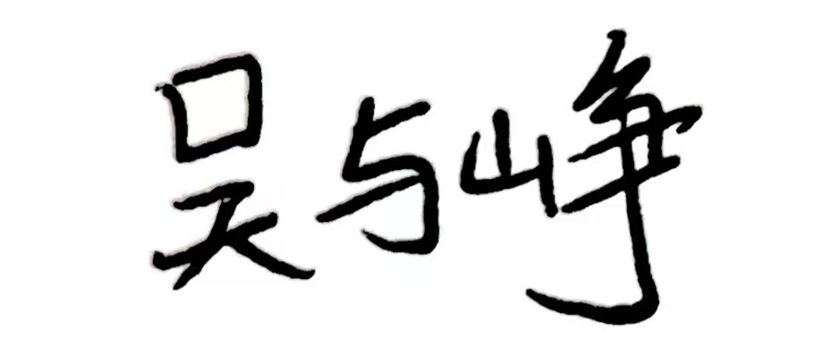 | 2026.10.12
Yuxiao Huang | 26365747 | 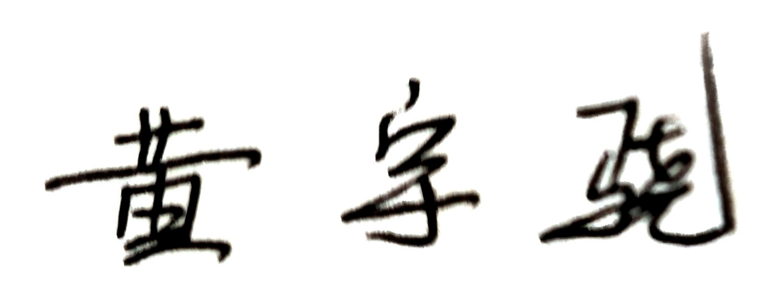 | 2026.10.12

3. Software Design (Component 1.2 — 30%)

3.1 Use case diagram
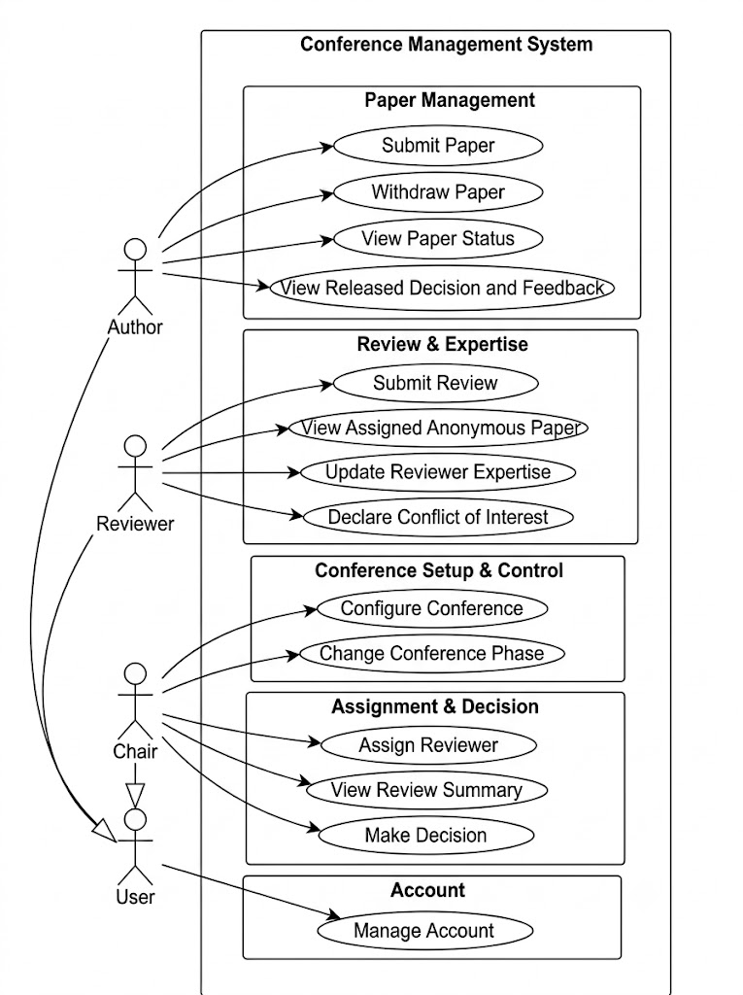
Figure 1: Use case diagram

3.2 System scope, constraints and assumptions reflected in the design
1. System Scope: As shown in the use case diagram, our Conference Management System includes four main modules: Paper Management, Review, Assignment & Decision, and Account Management. There are four actors in the system: User, Author, Reviewer, and Chair. Author, Reviewer, and Chair are special roles of User, and each role has its own functions. In the Paper Management module, authors can submit papers, withdraw papers, and view their paper status. In the Review module, reviewers can view assigned anonymous papers and submit reviews. In the Assignment & Decision module, the Chair can assign reviewers to papers and make final decisions. Additionally, all users can manage their accounts through the Account Management module. These functions form the main workflow of our system, from paper submission to the final decision.
2. Constraints: First, different users have different permissions. For example, only the Chair can assign reviewers and make final decisions, while authors can only manage their own submissions. Reviewers can only access papers assigned to them, and the paper information shown to reviewers must not expose author identities. Second, Project 1 is developed as a Java CUI application, so users interact with the system through text-based menus rather than a graphical interface. Third, the system must follow the conference phase rules. For example, authors can submit papers during the Submission phase, while reviewers submit reviews during the Review phase. The system also uses file-based storage to save and reload important information, rather than relying on an external database, which is the constraint of the data storage.
3. Assumptions: First, we assume that users have valid accounts and the appropriate conference roles before using the corresponding functions. A user may have more than one role, but the available functions depend on the role being used. Second, we assume that papers have already been submitted before they can be assigned to reviewers. Reviewers can only submit reviews for papers assigned to them, and the Chair makes final decisions based on the available review results. Third, we assume that the basic paper information, such as title, abstract, and research topics, is sufficient for the paper submission and reviewer assignment process in Project 1. Therefore, uploading actual paper files is not required for the current version of the system.

3.3 Class diagram — Iteration 1 (initial design)
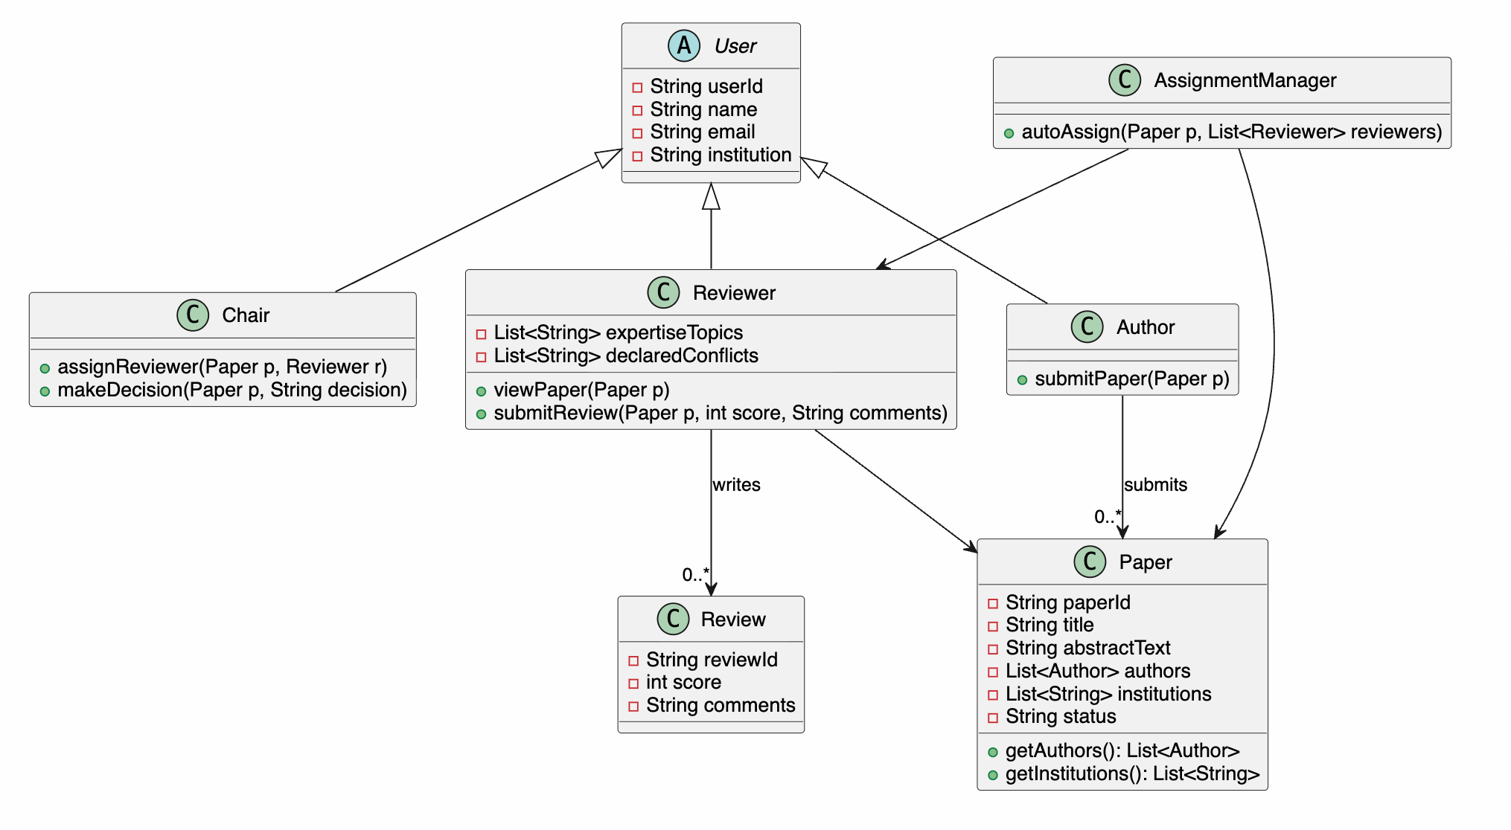
Figure 2: Class diagram — Iteration 1
In Iteration 1, our primary objective was to build an intuitive, baseline object-oriented model by directly mapping real-world conference roles and operational domain entities into Java classes:
- Subclass Inheritance (User, Author, Reviewer, Chair): Since Authors, Reviewers, and Chairs are all conference participants sharing core personal attributes (userId, name, email, institution), modeling them as concrete subclasses extending an abstract User class to achieve code reuse and logical hierarchy.
- Core Data Entities (Paper, Review): The Paper class encapsulates submission details including paperId, title, abstractText, authors, institutions, and status. The Review class stores numerical score and textual comments. Reviewer references the target Paper object through viewPaper(Paper p) to read submission content
- Separation of Assignment Logic (AssignmentManagement): we created a dedicated AssignmentManagement containing autoAssign(Paper p, List<Reviewer> reviewers). This controller evaluates reviewer workloads and topic relevance to handle paper assignments centrally.

3.4 GenAI analysis of Iteration 1
# | Prompt used (summary) | GenAI suggestion | Accepted / Rejected | Reason for your decision
1 | Critique the inheritance structure of User, Author, Reviewer, and Chair. | Replace subclass inheritance with a Role Composition Pattern (UserAccount has-a Set<ConferenceRole>). | Accepted | Class inheritance leads to mutually exclusive user types, creating an identity vs. role conflict. Composition allows a single user identity to dynamically hold multiple roles
2 | Does the paper review process have any issues ? | It does. Passing Paper to Reviewer exposes paper.getAuthors(), breaking Double-Blind. Introduce an AnonymousPaperView DTO or wrapper. | Accepted | There is a risk of leaking real information.The type system itself should structurally prevent access to sensitive data.
3 | Does the reviewer assignment process in AssignmentService have any issues? | Yes. The COI (Conflict of Interest) checking logic uses hardcoded if-else blocks, which violates the Open/Closed Principle (OCP). Extract it into a ConflictRule interface and use a ConflictChecker holding a rule list. | Accepted | AI identified a Conflict of Interest design flaw I had not initially considered. Enables Open/Closed Principle. Adding a new conflict rule only requires creating a new class, without modifying the existing AssignmentService.
4 | Does the class diagram support the full paper lifecycle (FR-3)? | No. Author lacks a withdrawPaper(String paperId) method. | Accepted | R-3 explicitly requires authors to be able to withdraw a paper where permitted. This method is missing from the initial design.
5 | Critique the controller structure for Chair actions. | Merge AssignmentService, Chair, and the decision workflow into one ConferenceController. | Rejected | Merging them makes one class do too many things. That is hard to maintain and extend.Keeping them separate is better.

3.5 Class diagram — Iteration 2 (final design)
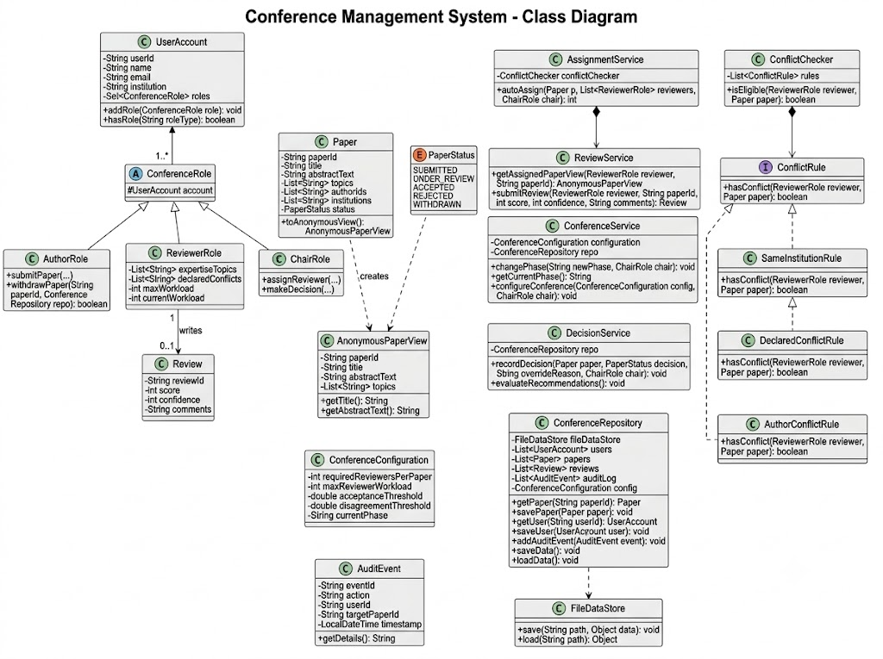
Figure 3: Class diagram — Iteration 2 (final)
The Iteration 2 class diagram resolves the design flaws identified in Section 3.4 by applying core Object-Oriented and SOLID principles:
- Role Composition Pattern (UserAccount and ConferenceRole): We replaced the concrete subclass inheritance (User -> Author/Reviewer/Chair) with the Role Composition Pattern. A single UserAccount holds a Set<ConferenceRole>. This solves the identity vs. role conflict, allowing a user to simultaneously act as an Author and Reviewer in the same conference.
- Double-Blind Encapsulation via DTO (AnonymousPaperView): To strictly fulfill FR-6 without leaking author identities, ReviewerRole no longer receives raw Paper objects. Instead, the system projects the Paper into an AnonymousPaperView DTO that physically excludes authors and institutions. Reviewers can only inspect content through this anonymised view.
- Open/Closed Principle for Conflict Checking (ConflictRule & ConflictChecker): The hardcoded conflict checking logic in AssignmentService has been refactored into a ConflictRule interface and a ConflictChecker strategy chain. New conflict of interest rules (e.g., co-author history) can be added by implementing ConflictRule without altering existing assignment service logic.
- Paper Lifecycle Enhancement (AuthorRole.withdrawPaper): Added the withdrawPaper(String paperId) method to AuthorRole to satisfy FR-3, completing the paper submission lifecycle management.

3.6 Summary of design evolution
Change | Iteration 1 | Iteration 2 | Reason for the change
User & Role Architecture | Concrete subclass inheritance (User -> Author, Reviewer, Chair). | Role Composition Pattern (UserAccount holds Set<ConferenceRole>). | Eliminates identity vs. role conflict; allows a single user account to hold multiple conference roles simultaneously
Double-Blind Review Protection | Reviewer directly holds Paper object, exposing getAuthors(). | Reviewer accesses AnonymousPaperView DTO created by Paper.toAnonymousView(). | Enforces FR-6 double-blind privacy at the type-system level, preventing reviewers from accessing sensitive author details.
Conflict of Interest Logic | Procedural if-else blocks embedded inside AssignmentService | Strategy pattern with ConflictRule interface and ConflictChecker manager | Satisfies Open/Closed Principle (OCP); enables adding new conflict types without changing core assignment logic
Paper Lifecycle Management | Author only supports submitPaper() | AuthorRole includes both submitPaper() and withdrawPaper(paperId). | Fully satisfies FR-3 requirements for author paper withdrawal operations.

3.7 Critical Reflection — Student-Authored (No AI-Generated Text)

3.7.1 What design suggestions did GenAI generate?
- GenAI find if we just let class Author, Reviewer, Chair to extend abstract class User, each person can just be one of these roles. In other words, it means someone need to create several accounts if he has more than one role. It suggests us to create class Useraccount which can have several Conference roles and class Author, Reviewer, Chair just to extend abstract class Conference role.

- GenAI tells us we just let reviewer to access paper entity. although reviewer doesn’t have the method getAuthor, he has paper entity. It has a risk for reviewer to get the name of Author, GenAI suggests us to create class AnonymousPaperView whose entity it’s created by paper, so there is less risk to leak the information of author.

- GenAI suggest us to make Conflict of Interest checking independent. Initially, we plan to put this module into method autoAssign in the class Assignment management using if-else blocks, but if we need to change the rules, it will be very hard. So GenAI lets us create the class Conflictchecker, which has several ConflictRules. ConflictRule is an interface, which is implemented by SameInstitutionRule and DeclaredConflictRule. It is easy to add or remove the rules.

- GenAI advises us to add the method withdrawPaper. At the beginning, we don’t think of the paper needs to be withdraw, AI reminds us to add this key method.

3.7.2 What errors, limitations or poor design decisions did GenAI make?
1. GenAI suggests us to merge AssignmentService, Chair, and the decision workflow into one ConferenceController. Because it thinks these classes can be merge into a unit to control all the system, which can be easy to implement. But it violates the prinple of Single Responsbility. It can be hard to extend.
2. Initially, GenAI suggests us to use if-else checks to addressing Conflict of Interest. But if we want to add or remove the rules, we need to change this method. It violates the Open/Closed principle. After that, we ask some advises for GenAI again, and give us proper advice.
3. GenAI suggests us to include a list of reviewers in the paper entity and include a list of papers in the reviewer entity. But if you do that, it will violate Single Responsibility Principle. Also, if reviewer has a list of paper, it will lead to the information leakage.
4. GenAI thinks we need to add Paperfactory and UserFactory classes to create Paper entity and User Entity. But we think it is unnecessary to add them, because the contructor in Paper and User classes is sufficient for our requirements.

3.7.3 How did you correct or improve these designs?
- What we have changed: We create class Useraccount which can have several Conference roles and class Author, Reviewer, Chair just to extend abstract class Conference role. So person who only has several roles can use one account to call all methods.
How we decided: if we let class Author, Reviewer, Chair to extend abstract class User just as what we have done, each person can just be one of these roles. In other words, It means someone need to create several accounts if he has more than one role. It doesn’t achieves the requirement that we have proposed.

- What we have changed: we create class AnonymousPaperView whose entity it’s created by paper. Reviewer views paper through the instance of class AnonymousPaperView which has all the information that Reviewer need.
How we decided: Reviewer doesn’t have the method getAuthor, but he has paper entity. It has a risk for reviewer to get the name of Author by calling the public method getAuthor. If Reviewer doesn’t have right to get the name, we need to eliminate the possibility.

- What we have changed: We create the class Conflictchecker, which has several ConflictRules. ConflictRule is an interface, which is implemented by SameInstitutionRule and DeclaredConflictRule. We change the name Assignment Manager into Assignment service.
How we decided: Initially, we plan to put this module into method autoAssign in the class AssignmentService using if-else blocks, but if we need to change the the class Assignment manager. Also, if we want to add or remove the rules, we need to change this method. It violates the Open/Closed principle. As for the reason why we change the name, because we add the class
ReviewService, we want to unify the name.

- What we have changed: We add the method withdrawPaper in the Author.
How we decided: At the beginning, we don’t think of the paper needs to be withdraw. But it is a key method to satisfy FR-3.

3.7.4 Why is the final design more appropriate?
- We change from Class Inheritance to Role Composition. Initially, we just let class Author, Reviewer, Chair to extend abstract class User, so each person can take one role. But someone can have several roles. This violates the Object-Oriented principle of favoring composition over inheritance and makes extension harder when multi-role support becomes a requirement, which weakens Open-Closed Principle(OCP) compliance. if someone has more than one role, he needs to create several accounts. Therefore, we create class Useraccount which can have several Conference roles and class Author, Reviewer, Chair just to extend abstract class Conference role. This change satisfies the Single Responsibility Principle (SRP) by separating the user's basic identity from their conference roles. UserAccount depends on the abstract ConferenceRole rather than concrete implementations, it satisfies the Dependency Inversion Principle (DIP).
- We change from directly accessing Paper to using AnonymousPaperView. At the beginning, we just let Reviewer access the Paper entity directly. Even if Reviewer doesn't have the getAuthor method, he still holds the Paper object and can call its public methods to get the author's name. This mainly violates information hiding requirement, because Reviewer may see some private information he shouldn't see. After we create the AnonymousPaperView which only contains the information Reviewer needs and removes author details. It reduces risks of leaking author information. It makes the system fits our requirement FR-6 (Double-blind review)
- We achieve the Conflict of Interest (COI) checking by adding ConflictChecker and a ConflictRule interface rather than using if-else blocks in the AssignmentService. If we use if-else blocks, it can be really hard to modify and retest this entire class, which is a weakening of the Open-Closed Principle (OCP). Now, we create a ConflictChecker and a ConflictRule interface. Also, SameInstitutionRule and DeclaredConflictRule are separate classes. Adding a new rule just means adding a new class without changing the old code. This fixes the Open-Closed Principle (OCP) violation and satisfies our requirements FR-4 and FR-5.
- We added the withdrawPaper method to the Author. Before GenAI pointed it out, we only thought about submitting papers and forgot that authors might need to withdraw them. Our design was incomplete and missed the full paper lifecycle required by FR-3. After adding this method, it covers a missing part of the paper lifecycle and helps meet FR-3.
- We rejected GenAI's idea of merging everything into a ConferenceController. GenAI suggested combining AssignmentService, the Chair role, and the decision workflow into one large ConferenceController because it thought it was easy to implement. We rejected this. This would likely violate the Single Responsibility Principle (SRP) because assignment rules, reviewer coordination, chair decisions, and workflow state changes would all become reasons to change the same class. It would also weaken the Open-Closed Principle (OCP), since adding a new assignment rule or decision step would require modifying the controller. By keeping AssignmentService, ReviewService, and the Chair's tasks separate, each class has only one job, which makes makes the system easier to test and maintain.
DECLARATION — I/We declare that Section 3.7 was written entirely by the student author(s) named below, in our own words, without using GenAI to generate the text. GenAI output quoted for analysis is clearly marked as a quotation.
Student name | Student ID
Yuzheng Wu | 26365742
Yuxiao Huang | 26365747

Appendix A: AI Usage Log (Component 1.4 — 20%)

A.1 GenAI tools used
Tool | Model / version | Mainly used for
Claude Code | sonnet 5.5 | Initial project brainstorming, exploring possible system features, identifying the main conference review workflow, evaluating the project scope for a two-person team, and providing suggestions on software architecture.
DeepSeek | V4.1 flash | Generating the initial functional requirements based on our brainstorming results, suggesting essential and desirable features, and providing an initial description of system functions and user interactions.
ChatGPT | GPT-6 | Refining functional requirements and acceptance criteria, analysing dependencies between requirements, reviewing use case and class diagrams, identifying design problems, suggesting OOP and SOLID improvements, developing testing scenarios, debugging Java code, and checking consistency between requirements, design and implementation.
Kimi Code | K3 | Generating the first version of the Java CUI application, implementing the core classes and business logic, developing reviewer assignment and review management functions, implementing file-based data persistence, and assisting with code revisions based on the final design.

A.2 Prompt log
# | Stage | Tool | Main prompt (summary) | What GenAI produced | What you changed / rejected and why
1 | Project brainstorming | Claude Code | Suggest suitable Java CUI project topics for a two-person software engineering team. The project should demonstrate OOP, SOLID, collections, and file persistence without becoming excessively complex. | Proposed candidate systems and discussed their core workflows, entities, technical complexity, and suitability for two-person development. Conference management was identified as a possible topic involving user roles, papers, review assignments, and decisions. | We selected the Conference Management System and limited it to a single academic conference. We focused on a complete paper-review workflow rather than adding unrelated features. This decision was intended to provide sufficient business complexity while keeping the implementation manageable, as explained in Section 2.1.
2 | Scope and architecture exploration | Claude Code | For a conference review management system, identify the essential workflow, the main domain entities, and possible architectural approaches suitable for a Java command-line application. | Suggested a workflow covering account management, paper submission, reviewer assignment, review submission, and final decisions. It also discussed potential entities and architectural responsibilities for managing users, papers, reviews, and assignments. | We adopted the end-to-end conference workflow as the project's focus. We excluded multi-conference management, external authentication, online collaboration, and full manuscript processing because these were outside the intended Project 1 scope. The initial architecture was treated as a starting point for subsequent UML design rather than a final solution.
3 | Initial requirement generation | DeepSeek | Based on the proposed conference management workflow, generate functional requirements, distinguish essential features from desirable enhancements, and describe the main user interactions. | Produced an initial requirement draft covering account and role management, conference settings, paper submission, reviewer expertise and conflicts, reviewer assignment, anonymous reviews, decision management, persistence, and possible optional enhancements. | We organised and reviewed the resulting requirements as FR-1 to FR-11. We retained FR-1 to FR-8 as essential for the core workflow and classified email notification, advanced review discussion, paper file upload, and reviewer bidding (FR-9 to FR-11) as desirable features outside the current implementation scope. The final priorities were selected by the students rather than accepted automatically.
4 | Requirement refinement | ChatGPT | Review FR-1 to FR-11 for ambiguity, missing constraints, dependencies, and testability. Refine the acceptance criteria while preserving a feasible two-person Project 1 scope. | Suggested more precise rules for multi-role accounts, conference phase restrictions, paper withdrawal, author and co-author conflicts, assignment eligibility, duplicate reviews, decision readiness, and persisted audit information. | We incorporated explicit acceptance criteria into Section 2.2. In particular, FR-3 specifies when withdrawal is permitted; FR-5 specifies eligibility, ranking, and shortfall handling; FR-6 specifies anonymous access and review validation; and FR-7 specifies recommendation and decision conditions. We retained the distinction between basic review analysis in FR-7 and optional advanced analysis in FR-10.
5 | Use case and initial design review | ChatGPT | Check whether the use case diagram and initial class diagram represent the essential requirements, system actors, major interactions, and appropriate responsibilities. | Analysed the User, Author, Reviewer, and Chair actors and the principal submission, review, assignment, decision, and account-management interactions. It also highlighted relationships between requirements, role permissions, and the initial object-oriented model. | We used the feedback to evaluate the coverage of our diagrams against FR-1 to FR-8. The diagrams were reviewed as descriptions of the same conference workflow, with particular attention to actor permissions, the distinction between user identity and conference roles, and consistency with the selected scope.
6 | UML design iteration: role architecture | ChatGPT | Critique the initial inheritance structure in which Author, Reviewer, and Chair extend an abstract User class. Does this design support one user holding multiple conference roles? | Identified the identity-versus-role limitation of representing different conference roles as separate User subclasses. Suggested replacing that structure with UserAccount containing a Set<ConferenceRole>, where ConferenceRole is an abstract class extended by AuthorRole, ReviewerRole, and ChairRole. | We accepted the proposed role-composition structure because FR-1 allows one account to hold multiple roles. The final Java implementation uses UserAccount.addRole(), getRole(), and getRoles() to manage role objects. This change is documented in Sections 3.4–3.6.
7 | UML design iteration: double-blind review | ChatGPT | Review the design in which a Reviewer receives a Paper object directly. Could this expose authors or institutions? Suggest an appropriate design for FR-6. | Identified that direct access to a Paper object could expose structured author information through its public methods. Proposed an AnonymousPaperView data-transfer object containing only the paper information needed for review. | We accepted the DTO-based design. The final Paper.toAnonymousView() creates an AnonymousPaperView, and ReviewService.getAssignedPaperView() returns that view after checking reviewer eligibility and assignment. This prevents author and affiliation fields from being included in the structured reviewer view. The design does not claim to automatically remove identities voluntarily included in free-text content.
8 | UML design iteration: conflict checking | ChatGPT | Evaluate hardcoded conflict-of-interest checks in the original assignment design. How could these checks be structured to support additional rules without repeatedly changing assignment logic? | Recommended extracting conflict checks into a ConflictRule interface and a ConflictChecker that evaluates registered rule implementations. This separates eligibility rules from reviewer-selection logic and supports the Open/Closed Principle. | We adopted this structure in the final design. The code contains ConflictRule, ConflictChecker, SameInstitutionRule, DeclaredConflictRule, and AuthorConflictRule. AssignmentService.isEligible() consults ConflictChecker instead of implementing all conflict types directly. This supports FR-4 and FR-5 while keeping the assignment logic focused on eligibility and selection.
9 | UML design iteration: paper lifecycle | ChatGPT | Compare the initial Author class with FR-3. Does it support all required paper lifecycle operations, including withdrawal? | Identified that the initial design supported submission but did not explicitly represent paper withdrawal. Suggested adding a withdrawal operation and enforcing the appropriate phase, ownership, and paper-status restrictions. | We accepted the recommendation. The implemented method AuthorRole.withdrawPaper(String paperId, ConferenceRepository repo) restricts withdrawal to the submitting author before the Decision phase and prevents withdrawal after an incompatible paper-status transition. It removes active reviewer assignments and records a PAPER_WITHDRAWN audit event. This addresses the missing operation discussed in Sections 3.4–3.6.
10 | UML design critique: rejected suggestion | ChatGPT | Critique the separation of the assignment controller, Chair responsibilities, and decision-making workflow. Would merging them into one controller improve the architecture? | Suggested combining assignment management, Chair-related operations, and decision coordination into a single ConferenceController to centralise the workflow. | We rejected the proposed large controller because assignment, conference configuration, review processing, and final decision-making have different reasons to change. The implementation instead maintains separate responsibilities in AssignmentService, ConferenceService, ReviewService, and DecisionService, with ChairRole delegating operations to the appropriate services. This decision supports the responsibility separation explained in Section 3.4.
11 | Initial Java implementation | Kimi Code | Generate the initial Java Maven CUI application from the selected functional requirements and revised class design. Implement the core user, role, paper, review, and conference entities. | Provided an initial application structure with the com.conference package hierarchy and domain classes such as UserAccount, ConferenceRole, AuthorRole, ReviewerRole, ChairRole, Paper, and Review, together with a Main entry point and console interaction structure. | We reviewed the generated class responsibilities and compared them with the final class diagram. The resulting implementation separates domain models, services, persistence, and UI code. We retained the role-composition design and the anonymous paper representation rather than reverting to direct inheritance from separate user types.
12 | Core business logic implementation | Kimi Code | Implement the main reviewer assignment and review management functions. Enforce conflicts of interest, reviewer capacity, duplicate-assignment restrictions, paper status, and anonymous review access. | Assisted with implementation of AssignmentService, ConflictChecker, ReviewService, and related domain operations. The resulting code provides automatic and manual assignment, review submission, declared conflicts, and anonymous paper views. | We reviewed the implementation against FR-4, FR-5, and FR-6. The final AssignmentService ranks automatically eligible reviewers by topic-match count, then current workload, then reviewer ID. Manual assignment uses the same eligibility checks, although it does not require a positive topic match. Review submission is handled by ReviewService.submitReview(), which checks assignment, phase, score, confidence, comments, and duplicate submissions.
13 | Decision workflow and CUI implementation | Kimi Code | Implement conference configuration, review summaries, final decision handling, and role-specific console menus consistent with the essential requirements. | Assisted with the business workflow and CUI structure. The final application includes ConferenceService, DecisionService, WorkflowRules, and ConsoleApp. The console provides Author, Reviewer, and Chair menus for their permitted operations. | We checked that the final design separates menu interaction from the service methods that enforce business rules. ConferenceService manages configuration and phases, while DecisionService calculates review summaries, checks readiness, records decisions, and prepares author feedback. ConsoleApp connects these functions to role-specific menus.
14 | File persistence and audit implementation | Kimi Code | Implement local file-based persistence for the conference system so that users, papers, assignments, reviews, configuration, decisions, and audit records survive application restarts. | Assisted with the persistence layer, including ConferenceRepository, DataStore, and FileDataStore. The implementation serialises conference state to a local file and supports audit-event storage. | We retained file-based persistence rather than introducing an external database, consistent with FR-8 and the limited Project 1 scope. The final FileDataStore includes transactional updates, snapshot replacement, backup handling, and validation of saved state. AuditEvent records important workflow actions.
15 | Debugging: duplicate role types | ChatGPT | Inspect UserAccount.addRole() for duplicate-role and ownership problems. What should happen if the same account receives two AuthorRole objects or a role belonging to another account? | Highlighted the difference between set membership and uniqueness by role type. Suggested checking that a role belongs to the target account and that an account does not receive multiple instances of the same concrete role class. | The current implementation validates ownership and returns without adding a duplicate role type. The earlier Git version did not contain these explicit guards. WorkflowRegressionTest.roleTypesAreUniqueAndOwnershipIsChecked() verifies that adding a second AuthorRole does not increase the role count, rejects a role belonging to another account, and checks that Chair authorisation requires a valid Chair.
16 | Debugging: assignment ranking and limits | ChatGPT | Check whether automatic reviewer assignment follows FR-5. Test zero topic matches, ranking ties, reviewer workload, duplicate assignments, and the configured reviewer count. | Suggested testing candidate filtering and ranking independently of the CUI, including cases where a reviewer has no matching expertise, a paper already has its required reviewers, or multiple candidates have the same relevance score. | The final AssignmentService.topicMatch() counts distinct normalised topic matches. autoAssign() excludes zero-match candidates and ranks eligible reviewers by relevance, workload, and reviewer ID. Both assignment routes respect the configured reviewer count and the absolute two-reviewer limit. Relevant regression methods include automaticAssignmentUsesRelevanceAndStableTieBreaks(), automaticAssignmentBalancesWorkloadAndReportsShortfall(), manualAndAutomaticAssignmentsNeverExceedTwo(), and configuredOneReviewerLimitAlsoAppliesToManualAssignments().
17 | Debugging: phases and decisions | ChatGPT | Verify the conference phase restrictions and FR-7 decision prerequisites. Can the Chair enter the Decision phase with incomplete reviews, make a decision before readiness, or override a recommendation without a reason? | Suggested negative test scenarios for illegal phase transitions, incomplete reviews, unauthorised decisions, and missing override reasons. Also recommended using the same definition of valid reviews for completion checks, averages, disagreement detection, and recommendations. | The final ConferenceService.changePhase() permits only forward phase transitions and checks that non-withdrawn papers have completed reviews before entering Decision. DecisionService.isReady() checks the required number of valid reviews, while makeDecision() requires a non-empty reason when the final choice differs from the recommendation. Regression coverage includes phaseGuardsAreEnforcedOutsideTheCui(), zeroAndIncompleteReviewsCannotEnterDecisionOrBeDecided(), and summariesOverrideReasonAndAuthorFeedbackAreConsistent().
18 | Debugging: review integrity and withdrawal | ChatGPT | Test whether the review workflow prevents invalid and duplicate submissions. Also check what happens to assignments, reviewer workload, and review visibility when a paper is withdrawn or a reviewer declares a new conflict. | Suggested testing score and confidence boundaries, blank comments, unassigned reviewers, duplicate reviews, withdrawal after assignment, and conflicts declared after an earlier review. | The final ReviewService.submitReview() rejects unassigned, duplicate, or invalid reviews. AuthorRole.withdrawPaper() removes active assignments and blocks future reviews of withdrawn papers. ReviewService.declareConflict() can remove affected assignments before Decision, while DecisionService.validReviews() excludes reviews that no longer meet assignment and conflict requirements. Regression methods include reviewsRejectUnassignedDuplicateInvalidScoreAndBlankComment(), withdrawalHidesPaperAndReviewHistoryAndReleasesBothSides(), and lateConflictInvalidatesReviewAndAllowsReplacement().
19 | Debugging: persistence and transaction failures | ChatGPT | Review FileDataStore for data-loss risks. Test corrupted or null snapshots, failed writes, rollback behaviour, backup recovery, and consistency between persisted conference data and audit events. | Suggested failure-oriented persistence tests rather than checking successful saves alone. The scenarios included loading invalid saved objects, obstructed storage paths, transaction exceptions, and write failures after previously committed data existed. | The final persistence implementation rejects malformed or null existing snapshots rather than silently overwriting them. It uses transaction rollback to restore in-memory state when an operation fails, and retains the previous committed snapshot as a backup. Regression methods include malformedAndNullSnapshotsAreNeverOverwritten(), obstructedPathFailsInsteadOfReportingFirstRunSuccess(), transactionFailureRollsBackDataAndAudit(), and writeFailureRollsBackAndPreservesCommittedBytes().
20 | Final testing and consistency review | ChatGPT | Review the complete Java CUI implementation and regression tests against FR-1 to FR-8 and Sections 3.4–3.6. Check input validation, graceful cancellation, role permissions, persistence, and whether the implementation matches the final design. | Suggested a final requirements-to-code review and tests for invalid inputs, role permissions, review completion, workload restoration, and data persistence. It also identified areas where documentation should use the actual implementation class and method names. | The final ConsoleApp supports role-specific menus and cancellation or exit controls, including /cancel, q, /exit, and end-of-input handling. WorkflowRegressionTest contains 31 regression tests covering accounts, assignments, conflict rules, review validity, phase control, decisions, persistence, and rollback. The submitted archive contains a test report showing 31 tests with no failures or errors. We used the code-level checks to identify terminology requiring alignment in the final report, including the distinction between ReviewService and the non-existent ReviewerService.

A.3 Human vs AI contribution summary
Part of the project | Mainly human-designed | Mainly AI-generated (then reviewed) | Notes
1. Project topic and overall scope | Final topic selection, project boundaries, and the decision to support one local conference and one review round. | Claude Code contributed initial brainstorming, candidate features, workflow analysis, and architectural suggestions. | The students selected Conference Management System as the project topic and limited its scope to an achievable Java CUI implementation. Advanced optional features were excluded from Project 1. Corresponds to A.2 entries 1–2 and Section 2.1.
2. Initial functional requirements | Review of the initial requirement draft and assessment of whether the suggested features matched the intended project. | DeepSeek generated the initial functional requirement descriptions, candidate user interactions, and essential/desirable feature suggestions. | The draft was organised into FR-1 to FR-11. It was not treated as a final specification without human review. Corresponds to A.2 entry 3 and Section 2.2.
3. Final requirements and priorities | Final selection of FR-1 to FR-8 as Essential and FR-9 to FR-11 as Desirable, including the reasoning behind the selected scope. | ChatGPT assisted with refining acceptance criteria, reviewing requirement dependencies, and identifying missing constraints. | The final requirements specify withdrawal conditions, assignment rules, reviewer anonymity, decision readiness, and persistence. The selection and justification of requirements remained human decisions. Corresponds to A.2 entry 4 and Section 2.6.
4. Use case diagram and system boundaries | Final selection and organisation of actors, major use cases, system scope, constraints, and assumptions. | ChatGPT provided feedback on functional coverage, actors, interaction consistency, and diagram interpretation. | The use case design represents User, Author, Reviewer, and Chair interactions. The students retained responsibility for the final diagram and its consistency with the selected requirements. Corresponds to A.2 entry 5 and Sections 3.1–3.2.
5. Initial and final class diagrams | Initial design decisions, evaluation of AI feedback, acceptance or rejection of suggestions, and approval of the final architecture. | ChatGPT analysed inheritance, role composition, anonymous views, conflict rules, missing lifecycle operations, and controller responsibilities. | Sections 3.3–3.6 document the movement from the initial design to the revised architecture. The rejected ConferenceController proposal illustrates a case where students did not adopt AI advice automatically. Corresponds to A.2 entries 6–10.
6. User account and role architecture | Validation of multi-role requirements, role ownership, duplicate-role restrictions, and role-based access expectations. | Kimi Code assisted with the initial Java domain implementation; ChatGPT assisted with role-architecture analysis and subsequent validation. | The final implementation uses UserAccount, abstract ConferenceRole, and concrete AuthorRole, ReviewerRole, and ChairRole classes. UserAccount.addRole() prevents duplicate concrete role types. Corresponds to A.2 entries 6, 11, and 15.
7. Paper lifecycle and anonymous views | Selection of withdrawal permissions and review-privacy rules, together with validation against FR-3 and FR-6. | ChatGPT suggested the missing withdrawal operation and DTO-based anonymisation; Kimi Code assisted with implementing the relevant domain and service classes. | AuthorRole.withdrawPaper() enforces withdrawal constraints, while Paper.toAnonymousView() and ReviewService.getAssignedPaperView() provide an anonymous reviewer-facing view. No automatic anonymisation of arbitrary free-text content is claimed. Corresponds to A.2 entries 7, 9, and 18.
8. Reviewer assignment and conflict management | Selection and validation of assignment eligibility, ranking rules, workload behaviour, and conflict restrictions. | ChatGPT proposed the extensible conflict-checking approach and testing scenarios; Kimi Code assisted with the initial reviewer assignment implementation. | AssignmentService handles assignment eligibility and ranking. ConflictChecker evaluates ConflictRule implementations, including author, institution, and declared conflicts. The final implementation was reviewed against FR-4 and FR-5. Corresponds to A.2 entries 8, 12, and 16.
9. Review submission and management | Review of score boundaries, duplicate prevention, reviewer permissions, review validity, and review-completion conditions. | Kimi Code assisted with implementation of the review workflow; ChatGPT contributed review validation and edge-case testing suggestions. | ReviewService.submitReview() enforces review submission rules. DecisionService.validReviews() selects reviews that remain valid for completion and decision calculations. Corresponds to A.2 entries 12, 13, and 18.
10. Conference configuration and decision workflow | Final judgement on conference phase constraints, decision prerequisites, recommendation interpretation, and override-reason requirements. | Kimi Code assisted with the initial workflow implementation and later code revisions; ChatGPT assisted with testing and debugging the phase and decision rules. | ConferenceService handles configuration and phase transitions. DecisionService calculates averages, disagreement flags, recommendations, and final decisions. The final workflow follows FR-2 and FR-7. Corresponds to A.2 entries 13 and 17.
11. File persistence and audit trail | Selection of local file persistence, verification of data recovery expectations, and evaluation of failure-handling behaviour. | Kimi Code assisted with the persistence layer; ChatGPT contributed failure-case analysis and testing suggestions. | ConferenceRepository, DataStore, FileDataStore, and AuditEvent support the storage architecture. The implementation preserves conference state, records audit events, and provides backup and rollback behaviour. Corresponds to A.2 entries 14 and 19.
12. CUI implementation, testing, and debugging | Evaluation of user interactions, identification and correction of implementation defects, review of regression cases, and validation of final code behaviour. | Kimi Code assisted with the first CUI and subsequent implementation revisions; ChatGPT assisted with debugging, test-case suggestions, and requirements-to-code consistency analysis. | ConsoleApp provides role-specific operations, input handling, cancellation, and exit controls. WorkflowRegressionTest contains 31 automated regression tests. Human review was used to assess which AI suggestions were appropriate for the final system. Corresponds to A.2 entries 15–20.
13. Critical reflection and engineering judgement | Sections 2.6 and 3.7 were independently authored by the students, including requirement-selection reasoning, evaluation of AI design suggestions, and justification of accepted or rejected changes. | No AI-generated prose was used for the student-authored critical reflection sections. AI suggestions discussed in these sections form part of the design evidence, not the authorship of the reflection itself. | The students remain responsible for the arguments and conclusions in Sections 2.6 and 3.7. The AI Usage Log separately records AI-assisted work and should be checked against actual conversation history and the submitted implementation.

Appendix B: Contribution Report (Component 1.4)
Member name | Student ID | Main contributions (design, code, testing, report, video) | Contribution %
Yuzheng Wu | 26365742 | design, testing, report | 50%
Yuxiao Huang | 26365747 | design, code, video | 50%

