Issues founded in FRD
1) Issue : Hero section is not properly responsive in the ipad pro size ( 1024 × 1366 px)
Description : The hero image appears oversized on the ipad view port , causing the layout unbalanced , also the buttons are getting over flowing (“Get in Quote”)
Expected : properly responsive and balanced layout
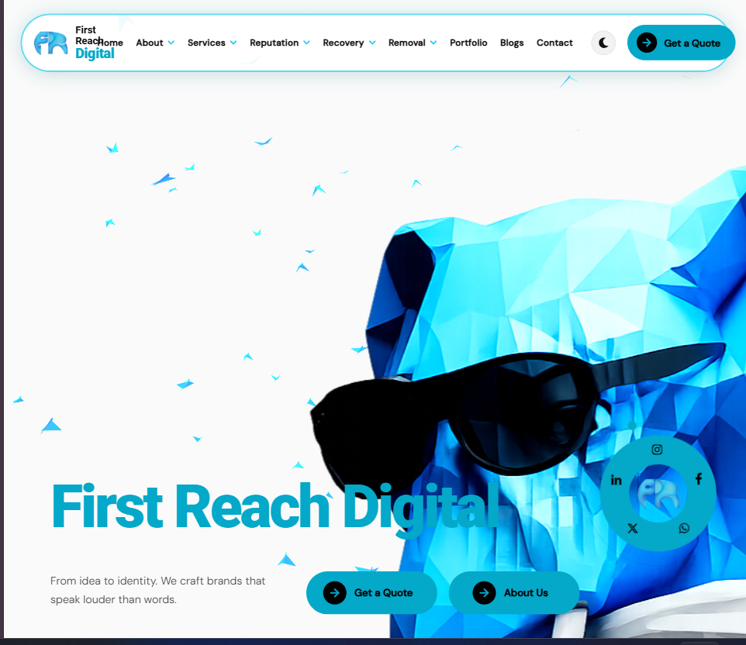
2) Issue : Navbar is not properly optimised for tablet / ipad pro viewport
Description : The navbar in the desktop layout on the ipad/tablet viewport . Navigation items are closely packed together , resulted a crowding appearance
Expected : The navbar should adapt appropriately to tablet screen sizes . Navigation items have the proper spacing
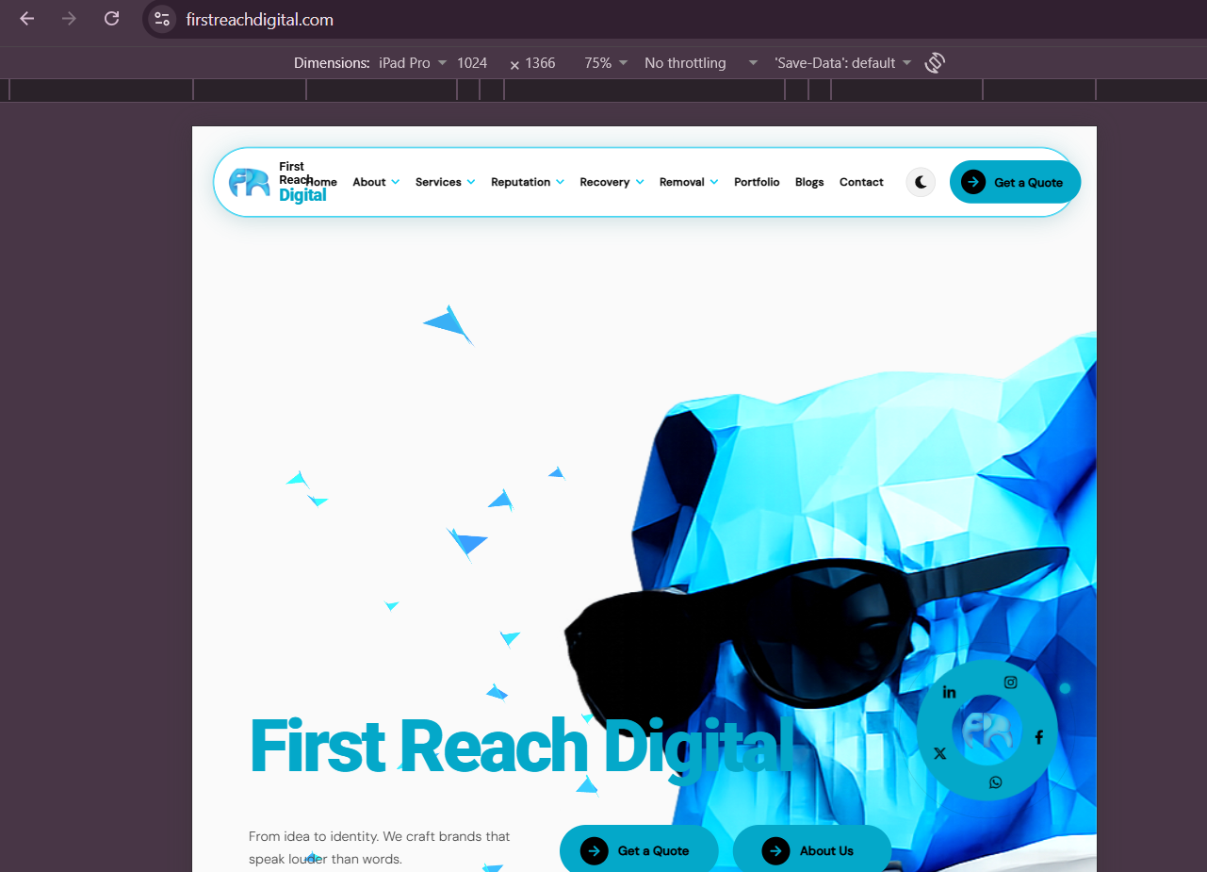
3) Issue : Contact page - “Get in Touch” Button navigation issue
Description : The Get in Touch button on the contact page is not redirecting to specific path , Most of the “Get in Touch” buttons are not working well
Expected : Clicking the button should redirect the user to the appropriate page or designated page (when its in the dark mode while clicking Its getting white background
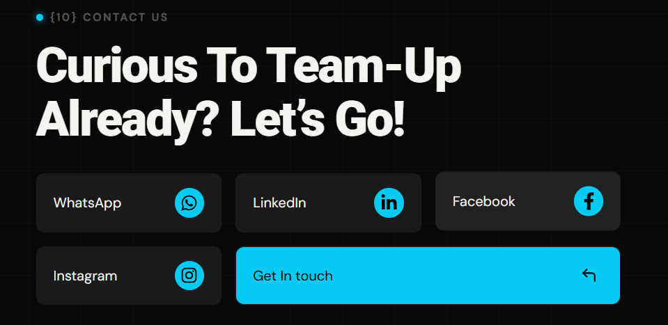
4) Issue : Career page alignment issue
Description There is an alignment issue on the career page
Expected : All elements should be properly aligned and responsive across different screen sizes
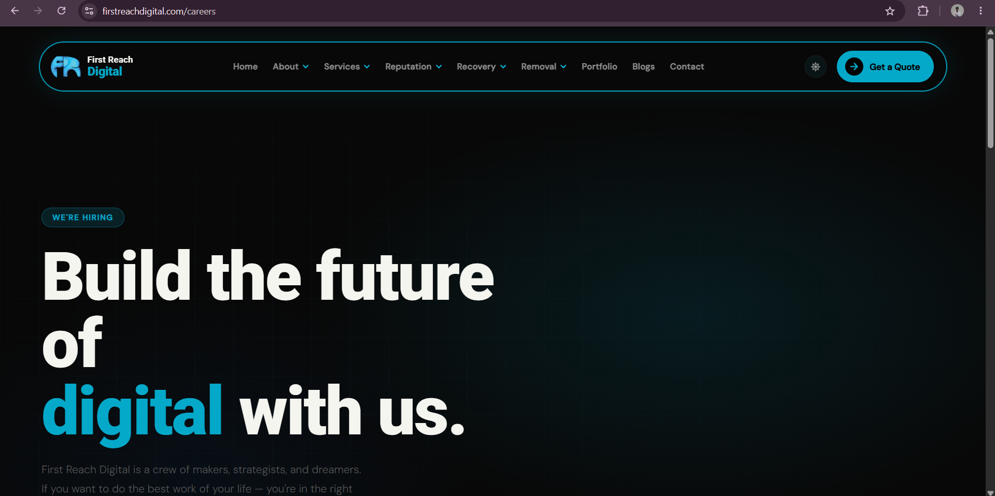
5) Issue : Missing 404 page / Not found page
Description When accessing a URL or route that does not exist on the website , a proper 404 page is not displayed
Expected : User should see a user-friendly 404 – page not found when they access an invalid or unmatched routes
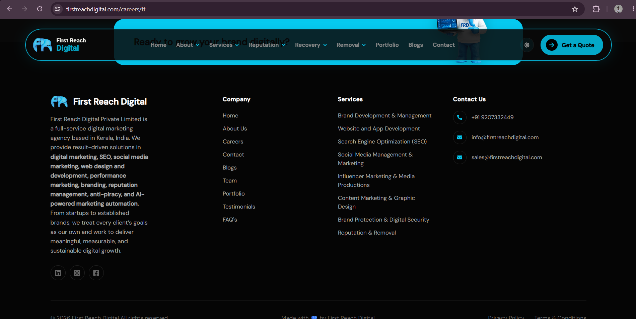
Here I have used the (https://firstreachdigital.com/careers/tt) /tt unspecified path but it not rendering a 404 page

