Story ID | Requirement | Role–goal–benefit user story
US01 | FR01 | As a route coordinator, I want to record delivery requests as provisional or confirmed so that I can distinguish requests that are not yet fully confirmed from those ready for planning.
US02 | FR02 | As a route coordinator, I want to split an order into multiple consignments and combine goods from different orders into a consignment so that deliveries can be organised according to operational requirements.
US03 | FR03 | As a fleet planner, I want to consider vehicle availability and driver suitability together so that I can assign a workable vehicle and driver combination to a route.
US04 | FR04 | As a route coordinator, I want to be alerted when planned goods exceed the suitable vehicle capacity so that I can resolve capacity conflicts before dispatch.
US05 | FR05 | As a driver, I want to access the current version of my route so that I do not rely on an outdated manifest after changes are made.
US06 | FR06 | As a depot worker, I want to record receipt, checking and route assignment as separate consignment statuses so that goods at the depot are not confused with goods that have been checked and assigned.
US07 | FR07 | As a route coordinator, I want to confirm the vehicle, driver, route, load and required documents before dispatch so that only operationally ready routes are dispatched.
US08 | FR08 | As a driver, I want to record delivery outcomes such as delivery, partial delivery, refusal, damage or failed attempt so that the organisation has an accurate record of what happened.
US09 | FR09 | As a customer or producer, I want to receive information when a delivery is delayed, transferred or returning to the depot so that I know what is happening with the delivery.
US10 | FR10 | As a route coordinator, I want to generate information about capacity conflicts, late collections, route readiness, failed deliveries and returned goods so that I can monitor and coordinate operations effectively.
Task 9: User Stories

Task 10: Acceptance Criteria
Selected Story 1: US03
Story
“As a fleet planner, I want to consider vehicle availability and driver suitability together so that I can assign a workable vehicle and driver combination to a route.”
Criterion | Observable acceptance condition
1 | The system provides the availability information for vehicles relevant to the planned route.
2 | The system provides the availability and suitability information for drivers relevant to the planned route.
3 | A vehicle is only identified as suitable when its capacity, access and temperature capabilities meet the requirements of the planned goods.
4 | A driver is only identified as suitable when the driver's availability, licence and relevant local-access constraints are satisfied.
5 | The system identifies when a suitable vehicle is available, but no suitable driver is available.
6 | The coordinator can identify a vehicle-and-driver combination that satisfies the known planning constraints.
7 | The system does not represent an unsuitable vehicle or driver combination as a confirmed workable assignment.

Given-When-Then example
- Given a route has known goods, access and temperature requirements
And a vehicle is available with suitable capacity and capabilities
And a driver is available with the required licence and access suitability
- When the coordinator plans the route

- Then the vehicle and driver can be considered as a suitable combination
And the route is not assigned an unsuitable vehicle or driver

Questions revealed
- What exact vehicle capacity information must be available before planning?
- Which driver licence restrictions apply to each vehicle?
- What constitutes a suitable local-access qualification?
- Can a driver be assigned to more than one route on the same day?
Selected Story 2: US05
Story
“As a driver, I want to access the current version of my route so that I do not rely on an outdated manifest after changes are made.”
Criterion | Observable acceptance condition
1 | Each published route has an identifiable version.
2 | When a route is republished, a new route version is created.
3 | The current published version can be identified by the driver.
4 | A driver can distinguish the current route version from an earlier version.
5 | Changes to quantities, addresses, timing or stop sequence included in a new version are reflected in the current route information.
6 | The system records when a route version was published.
7 | The system does not represent an older route version as the current published version.

Given-When-Then example
- Given a route has been published as version 1
And the coordinator changes the delivery sequence
- When the coordinator republishes the route
- Then a new route version is created
And the new version is identified as the current version
And the driver can identify that the previous version is no longer current
Questions revealed
- How should drivers be notified that a route has changed?
- Must a driver acknowledge a new route version?
- What happens if the driver is offline when a route is republished?
- Can a route be changed after the driver has departed?
- Who is authorised to publish a new route version?

Selected Story 3: US06
Story
“As a depot worker, I want to record receipt, checking and route assignment as separate consignment statuses so that goods at the depot are not confused with goods that have been checked and assigned.”
Criterion | Observable acceptance condition
1 | A consignment can be recorded as received at the depot.
2 | Receipt at the depot does not automatically mark the consignment as checked.
3 | The checking status can be recorded separately from the receipt status.
4 | A consignment can be identified as assigned to a route separately from being received or checked.
5 | Quantity, condition and label checks can be recorded for a received consignment.
6 | A quantity or condition difference can be recorded as accepted, held for clarification or rejected.
7 | The current consignment status can be identified by authorised staff.

Given-When-Then example
- Given a consignment has arrived at the depot
- When the depot worker records its receipt
- Then the consignment is recorded as received
And it is not automatically recorded as checked
And it is not automatically recorded as assigned to a route
Questions revealed
- Who may accept quantity or condition differences?
- What information must be recorded when a consignment is rejected?
- Can a consignment be assigned to a route before checking is complete?
- What happens to goods held for clarification?
Task 11: Identify Actors and Use Cases
Actor and stakeholder catalogue
Actor or stakeholder | Type | Goal or interest | Direct interaction?
Route Coordinator | Primary actor | Coordinate requests, routes, capacity, readiness and disruptions | Yes
Driver | Primary actor | Access an accurate route and record delivery outcomes | Yes
Depot Worker | Primary actor | Receive, check and assign consignments correctly | Yes
Fleet Planner | Primary actor | Match suitable vehicles with suitable drivers | Yes
Producer | Supporting / external stakeholder | Provide goods information and receive collection/delivery status | Yes, where the system supports these interactions
Customer | Supporting / external stakeholder | Receive accurate information about delivery status | Yes, where the system supports these interactions
Vehicle / Fleet availability source | Supporting actor, if external | Provide vehicle availability information | Potentially
External notification service | Supporting actor, if external | Deliver customer or producer notifications | Potentially

Task 12: Use-case catalogue
Use case | Primary actor | Meaningful outcome | Source requirement
Record Delivery Request | Route Coordinator | A provisional or confirmed delivery request is recorded | FR01
Manage Consignments | Route Coordinator / Depot Worker | Orders and consignments are organised according to delivery requirements | FR02
Plan Vehicle and Driver Assignment | Fleet Planner | A suitable vehicle and driver combination is identified | FR03
Check Vehicle Capacity | Route Coordinator | Capacity conflicts are identified before dispatch | FR04
Manage Route Version | Route Coordinator | A current route version is published and identifiable | FR05
Record Consignment Status | Depot Worker | Receipt, checking and route assignment statuses are recorded separately | FR06
Confirm Dispatch Readiness | Route Coordinator | Vehicle, driver, route, load and documents are confirmed before dispatch | FR07
Record Delivery Outcome | Driver | Delivery, partial delivery, refusal, damage or failed attempt is recorded | FR08
Communicate Delivery Status | Route Coordinator | Customers and producers receive relevant delay, transfer or return information | FR09
Generate Operational Report | Route Coordinator | Operational information about conflicts, delays, readiness and failed/returned goods is produced | FR10

Task 13: Use-case diagram
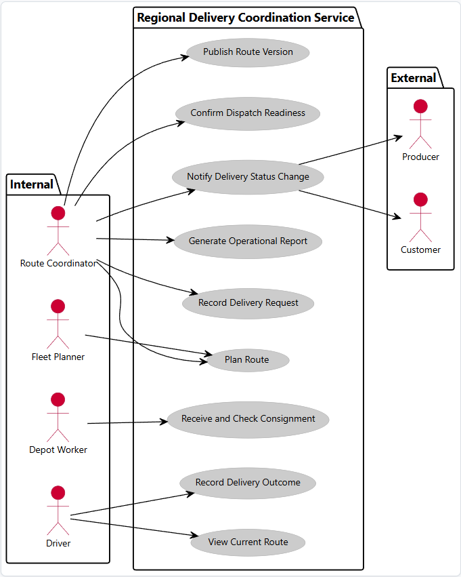

Task 14: Traceability
Business problem / stakeholder goal | Requirement | User story | Acceptance evidence | Use case | Domain concepts
Delivery requests are inconsistent and may not be fully confirmed | FR01 | US01 | Request can be recorded as provisional or confirmed | Record Delivery Request | DeliveryRequest, Customer, CollectionPoint, Destination
Orders and consignments have a complex relationship | FR02 | US02 | An order can produce several consignments, and a consignment can contain goods from several orders | Manage Consignments | Order, Consignment, Goods
Vehicle availability and driver suitability must be considered together | FR03 | US03 | Only workable vehicle/driver combinations are considered suitable | Plan Vehicle and Driver Assignment | Vehicle, Driver, Route
Planned goods may exceed suitable vehicle capacity | FR04 | US04 | Capacity conflict is identified when planned goods exceed suitable capacity | Check Vehicle Capacity | Goods, Vehicle, Consignment
Drivers may retain outdated printed manifests | FR05 | US05 | Current route version is identifiable and older versions are not shown as current | Manage Route Version | Route, RouteVersion
Goods at the depot may not yet be checked or assigned | FR06 | US06 | Receipt, checking and route assignment are recorded separately | Record Consignment Status | Consignment, Depot, Route
A planned route may not be ready for dispatch | FR07 | US07 | Vehicle, driver, route, load and required documents must be confirmed before readiness | Confirm Dispatch Readiness | Route, Vehicle, Driver, Load, Document
Delivery outcomes need to be recorded consistently | FR08 | US08 | Delivery, partial delivery, refusal, damage and failed attempt can be recorded | Record Delivery Outcome | Delivery, DeliveryOutcome, Consignment
Customers and producers need consistent disruption information | FR09 | US09 | Delay, transfer and return status can be communicated | Communicate Delivery Status | Customer, Producer, Delivery, DeliveryStatus
Coordinator needs visibility of operational problems | FR10 | US10 | Reports provide information on capacity conflicts, late collections, readiness, failures and returns | Generate Operational Report | Route, Collection, Delivery, Consignment

Task 15: Class Diagram
