**Lab 5. Reversing and Repacking**

* **Task 1**

(1) Your Answer

POREporePoREpOre

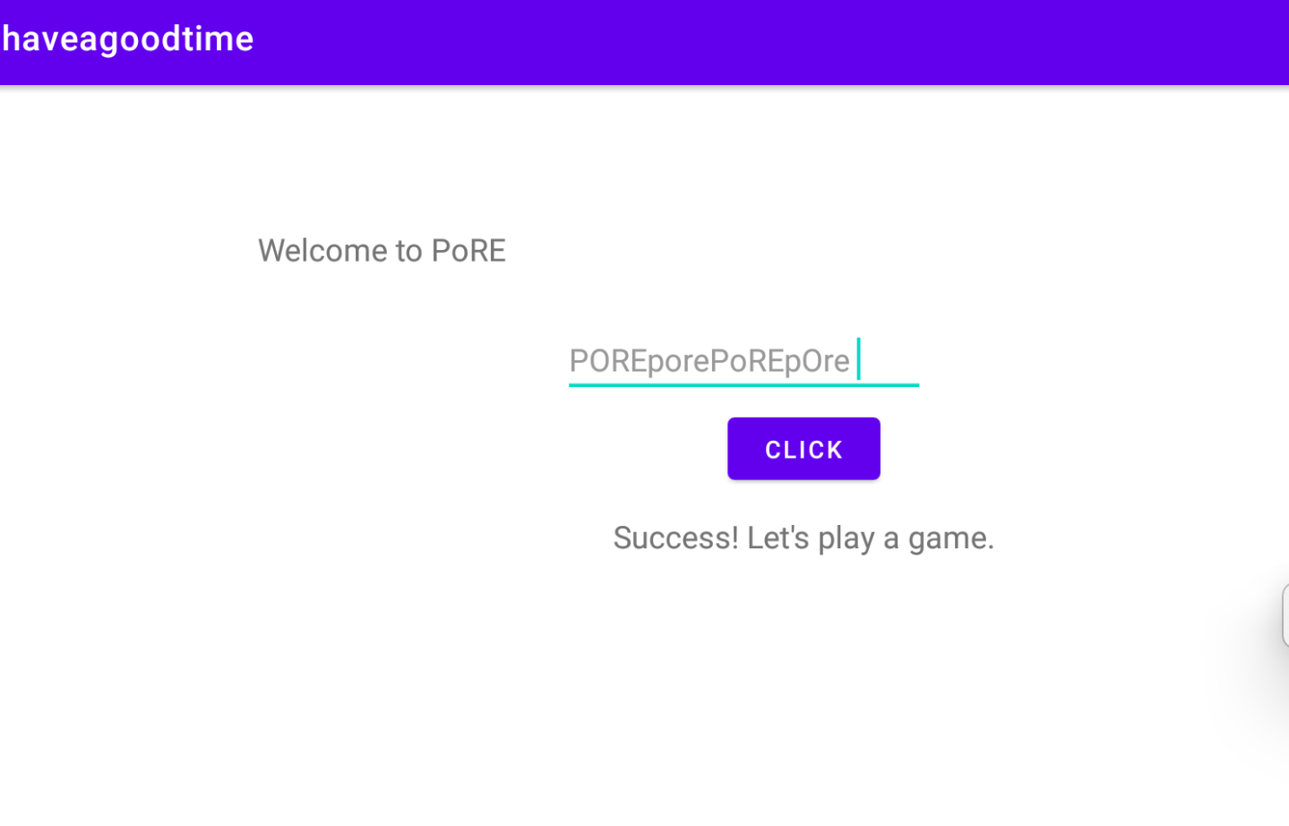

(2) Writeup

[Record how you solve this task here.]

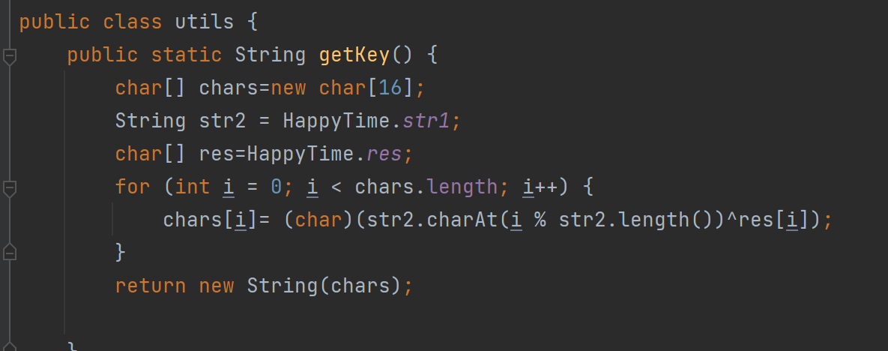

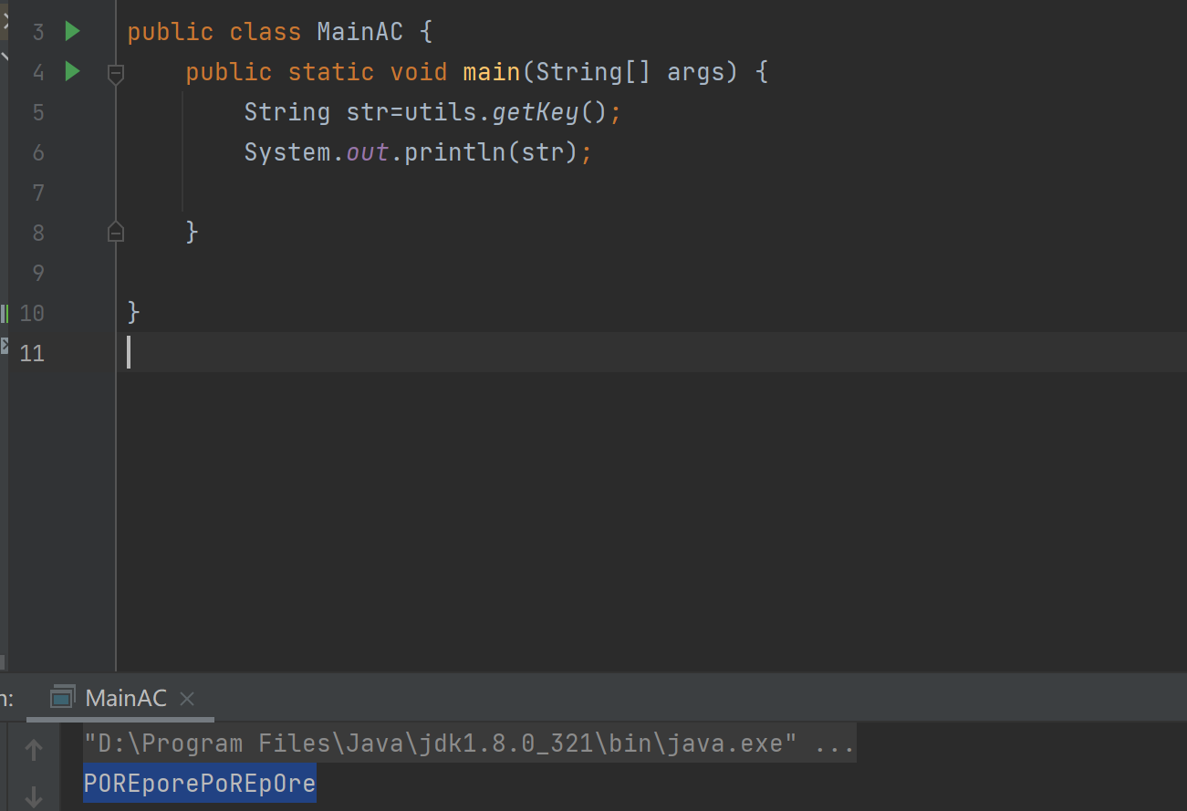

* **Task 2**

(1) Writeup

[Record how you solve this task here.]

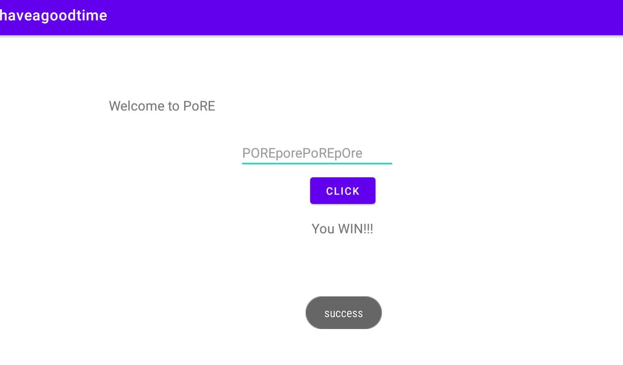

将if-eqz改成if-nez即可

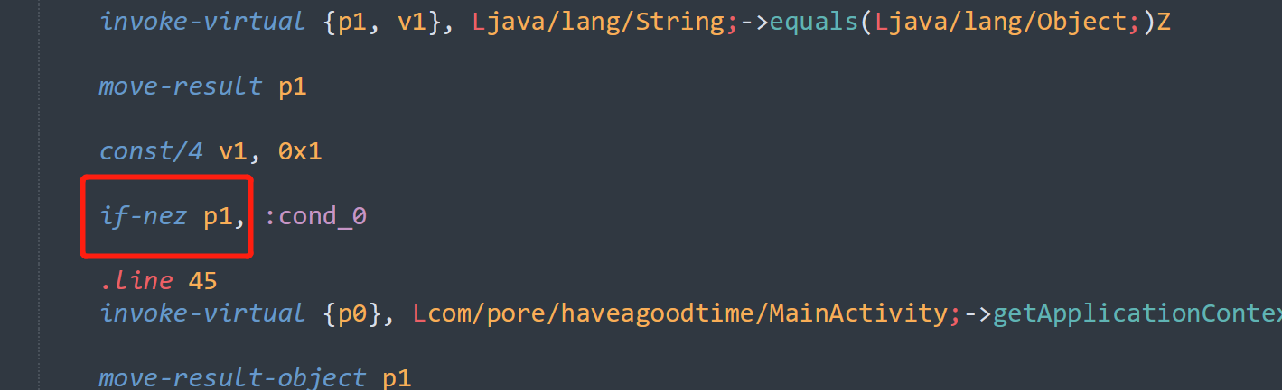

将if-eqz改成if-nez即可

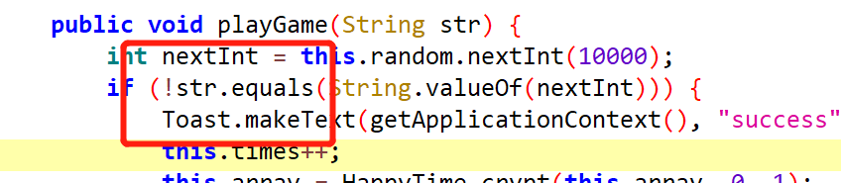

* **Task3**

(1) Your Answer

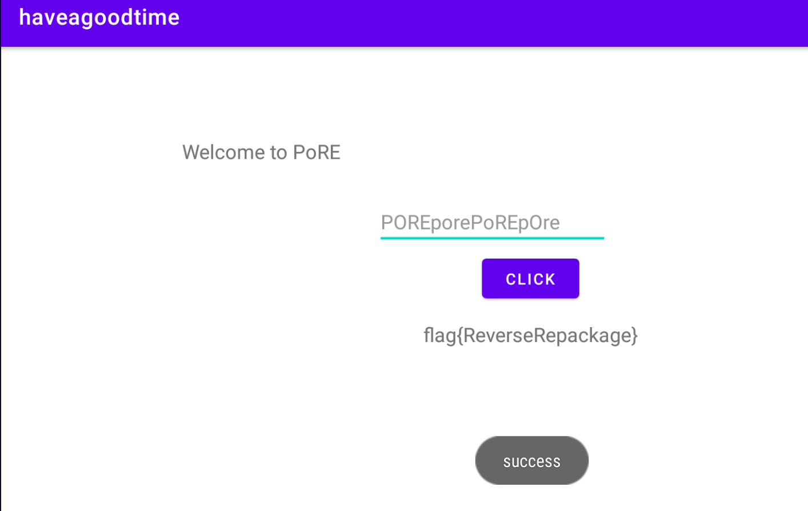

(2) Writeup

[Record how you solve this task here.]

在buttonClick函数最后的if函数中调用show函数

