RENTWHEEL: A CLIENT-SERVER CAR RENTAL INFORMATION SYSTEM WITH REST API USING LARAVEL AND FLUTTER
M. Teguh Gabita (200102078), Luthfi Rizalul Fikri (230102066), Fauzi Ardiansyah (230102048), Fahmy Muhammad Nurfadilah (230102043) Wijdan Fakhri Syauqi (230102126)
Department of Informatics Engineering, Faculty of Science and Technology
Universitas Muhammadiyah Bandung

teguhgabita00@gmail.com, luthfirizalul@gmail.com, ardiansyahfauzi900@gmail.com, fahminuhammadnurfadilah@gmail.com
Course: Client-Server Mobile Programming — Lecturer: Vitradisa Pratama, S.ST., M.T.

Abstract—Conventional car rental processes often cause problems such as duplicated data, incorrect vehicle status records, and a lack of transparency for customers. This paper discusses RentWheel, a car rental information system built on a client-server architecture consisting of a mobile application (Flutter) as the client side and a server application (Laravel) that provides a REST API and manages a MySQL database. Communication between the client and the server is carried out through JSON data exchange with token-based authentication using Laravel Sanctum, while user role management (admin and customer) is handled using Spatie Laravel Permission. Based on analysis of the source code, the system has implemented registration, login, browsing and booking of cars, payment with proof-of-transfer upload, booking history, notifications, profile management, and a web-based admin panel for managing cars, categories, users, and transaction reports. The analysis shows that applying a client-server architecture with a REST API clearly separates the user interface from the business logic and data layer, thereby supporting a centralized, consistent car rental transaction process that can be accessed from multiple types of clients.
Keywords—client-server, REST API, Laravel, Flutter, car rental, information system
I. INTRODUCTION
Information and communication technology has developed very rapidly over the last two decades, particularly internet technology and mobile devices, whose penetration keeps increasing among the public. This condition has driven the transformation of almost every service sector from a conventional model toward a digital model. One of the main foundations of this transformation is the client-server architecture, a software architecture pattern in which a client application—whether web-based or mobile—communicates with a server through a standard protocol such as HTTP to exchange data in a structured, real-time manner.
The client-server architecture plays an important role because it allows a clear separation of concerns between the user interface (presentation layer) and the business logic and data management (business and data layer). With this pattern, a single server application can serve more than one type of client at a time, as long as data communication is carried out through a consistent Application Programming Interface (API), generally a REST API with JSON as the data exchange format. This approach provides flexibility, ease of maintenance, and scalability compared to a monolithic application that combines all logic on a single platform.
On the other hand, the car rental business process at many service providers is still carried out manually, such as recording customer and vehicle data on physical files or spreadsheets, confirming vehicle availability by phone or in person, and recording payments manually. Such working methods are prone to causing various problems, including data duplication, errors in recording vehicle status (available, rented, or under service), difficulty for customers in tracking booking status and transaction history, and slow recapitulation of data for the management side.
These problems underlie the need to digitalize car rental services through an information system that integrates the management side (admin) and the customer side within a single, centralized database. This digitalization is expected to speed up the transaction process, reduce data-recording errors, and provide transparent information regarding vehicle availability, booking status, and payment status directly to customers through the application.
Based on the above discussion, RentWheel was built as a client-server-based car rental information system consisting of a mobile application developed using the Flutter framework as the user interface, and a backend server developed using the Laravel framework to provide a REST API service while managing the database. This application is designed to support the core car rental business processes, from user registration and authentication, browsing and booking vehicles, payment processing, to data management by the admin through a web-based administration panel.
II. PROPOSED SOLUTION
RentWheel offers a solution in the form of a clear separation between the client application and the server through a client-server architecture connected via a REST API. The mobile application built with Flutter acts as the interface for customers to register, log in, search for and book cars, make payments, and track booking history and notifications, without needing to know the implementation details on the server side.
All requests from the mobile application are sent to the Laravel server in JSON format through the REST API endpoints provided (routes/api.php). Every request that requires authentication—except registration and login—must include an access token issued by Laravel Sanctum, so that only logged-in users can access the data. The distinction in access rights between customers and administrators is managed using the Spatie Laravel Permission package, with new users automatically assigned the "user" role upon registration.
With this approach, all data—ranging from car data, categories, bookings, to payments—is stored centrally in a single MySQL database accessed both by the mobile application (through the REST API) and the web-based admin panel (Laravel Blade). This data centralization guarantees consistency of information between what the customer sees on the mobile application and what the admin manages through the web panel, while also simplifying the overall transaction reporting process.
III. SYSTEM ARCHITECTURE
In general, the RentWheel architecture consists of four main components: the Mobile Application (Client), the REST API, the Server, and the Database, which communicate with one another through a request-and-response mechanism. An overview of this architecture is presented in Fig. 1.

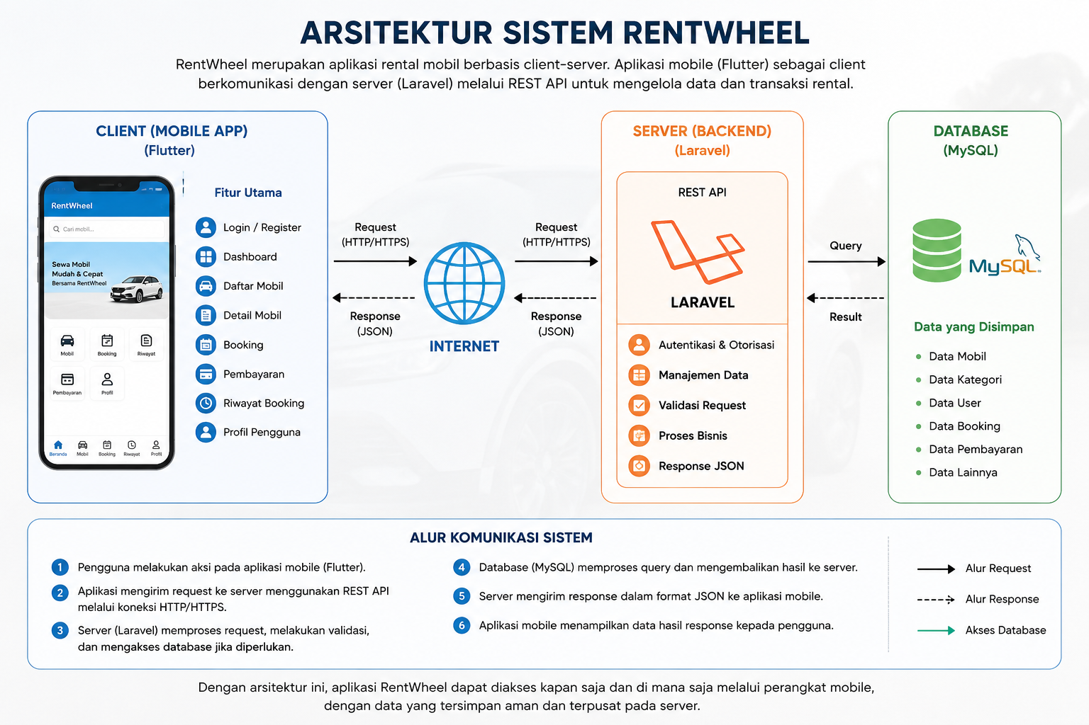
Fig. 1. RentWheel System Architecture

A. Mobile Application (Client)
The mobile application is built using Flutter and acts as the interface used by users to interact with the system. Every user action, such as logging in, searching for cars, or creating a booking, is handled by a service layer (ApiService, AuthService, MobilService, BookingService, PembayaranService) that sends HTTP requests to the server using the http package, accompanied by Content-Type and Accept headers set to application/json, as well as an Authorization header containing a Bearer token for requests that require authentication. The token and the user data obtained after login are stored locally on the device using SharedPreferences so that the session persists without requiring the user to log in again.
B. REST API and Server
Requests from the mobile application are received by the Laravel server through the routes defined in routes/api.php. Public routes such as registration and login can be accessed without a token, while all other routes fall under the auth:sanctum middleware group and can only be accessed after the user has successfully logged in. Each route is directed to the corresponding Controller (for example AuthController, MobilController, BookingController, PembayaranController, UserController, LaporanController, NotifikasiController), which is responsible for validating the input data, executing the business logic, and interacting with the Model through the Eloquent ORM.
C. Database
Data is stored in a MySQL database with main tables such as users, kategoris, mobils, bookings, and pembayarans, which are related to one another through foreign keys (for example, a booking is linked to the car and the user who made the reservation, while a payment is linked to its corresponding booking). This structure ensures that every rental transaction is recorded relationally and can be traced back to the car data, the customer, and the payment status.
D. Request and Response Flow
The communication flow begins when the mobile application sends an HTTP request (GET, POST, PUT, or DELETE) to one of the REST API endpoints. The server receives the request, validates the data, checks the authentication status through the Sanctum token, and then executes a query against the MySQL database through the relevant Eloquent Model. The query result is processed by the Controller into a JSON data structure and returned as a response to the mobile application together with the appropriate HTTP status code (for example, 200 for success, 201 for data successfully created, 404 when data is not found, 409 in case of a data conflict, or 422 when validation fails). The mobile application then reads this response to update the user interface or store relevant data locally.
IV. SYSTEM IMPLEMENTATION
A. Registration and Login
New users register through the mobile application by filling in their name, email, password, and additional data such as ID card number, phone number, and address, which is sent to the POST /register endpoint. The AuthController validates the data, stores the user with a hashed password, automatically assigns the "user" role through Spatie Laravel Permission, and then issues an access token using Laravel Sanctum. The login process (POST /login) validates the email and password combination, then issues a new token if the credentials are correct.
B. Dashboard
The GET /dashboard endpoint provides a statistical summary consisting of the total number of cars, users, bookings, payments, the number of bookings with "ongoing" and "completed" status, and the total revenue calculated from the accumulation of all payment data.
C. Categories and Car Listings
Vehicle data is grouped by car category, which is managed through the /kategori-mobil endpoints (index, store, show, update, destroy). The car list is displayed through GET /mobil along with its category relation, while the details of a single car unit are accessed through GET /mobil/{id}. Each car record stores attributes such as car name, brand, license plate, daily rental price, status (available, rented, or under service), and a photo of the vehicle.
D. Booking
The booking feature is accessed through the POST /booking endpoint. Users select a car along with the rental start and end dates, and the system automatically calculates the total price based on the number of days multiplied by the daily rental price of the selected car. The GET /booking endpoint displays the booking history belonging to the currently logged-in user, while a user with the admin role can view all booking data from every customer.
E. Payment
After a booking is created, users can submit payment data through the POST /pembayaran endpoint, including uploading a proof-of-transfer file (image or PDF) using a multipart/form-data mechanism. The payment status is initially "pending" until confirmed by the admin through the admin panel as either "paid" or "failed". The system also prevents a single booking from having more than one payment record.
F. Booking History and Profile
The mobile application provides a Booking History page that displays booking data along with its payment status, as well as a Profile page that displays and allows users to update their personal data (name, email, phone number, ID card number, address) and change their password through the PUT /profile and PUT /profile/password endpoints.
G. Notifications
The system provides a GET /notifikasi endpoint to display the list of notifications belonging to a user along with the number of unread notifications, as well as endpoints to mark a single notification or all notifications as read.
H. Admin Panel
In addition to the mobile application, admins can access a web-based administration panel (Laravel Blade) that covers user data management (User CRUD based on Spatie Laravel Permission), car and category data management, payment data management, and a Reports page that displays a recapitulation of all booking transactions along with total revenue, and allows the admin to update booking status and payment status directly.
V. CONCLUSION
Based on the analysis of the source code, RentWheel has successfully implemented a car rental information system based on a client-server architecture, with the Flutter mobile application as the client side and Laravel as the server side that provides a REST API service and manages a MySQL database. Data communication between the client and the server is carried out in a structured manner through the JSON format with token-based authentication (Laravel Sanctum) and user role management (Spatie Laravel Permission), so that access to customer features and administrative features can be clearly distinguished.
This system covers the entire car rental business flow, from registration and login, browsing and booking cars, automatic calculation of total rental cost, payment management with proof-of-transfer upload, booking history, notifications, user profile management, to an admin panel for managing car data, categories, users, and transaction reports. The application of a client-server architecture with a REST API in RentWheel has proven capable of clearly separating the user interface from the business logic/data layer, supporting data centralization, and enabling the system to be accessed consistently from both the mobile application and the web-based admin panel.
REFERENCES
[1] R. Subagia, “Sistem Informasi Rental Mobil Berbasis Web,” Jurnal Perangkat Lunak, vol. 2, no. 2, pp. 94–100, 2020, doi: 10.32520/jupel.v2i2.1121.
[2] B. Ragil Pangestu and A. Voutama, “Rancang Bangun Sistem Informasi Rental Mobil Berbasis Website,” JATI (Jurnal Mahasiswa Teknik Informatika), vol. 8, no. 3, pp. 2586–2592, 2024, doi: 10.36040/jati.v8i3.9497.
[3] Pradana, “Sistem Informasi Rental Mobil dan Monitoring Kepuasan Pelanggan Menggunakan Metode Servqual pada Penyu Mobil Berbasis Web dengan Notifikasi WhatsApp,” Jurnal Nasional Komputasi dan Teknologi Informasi (JNKTI), vol. 8, no. 2, 2025, doi: 10.32672/jnkti.v8i2.8850.
[4] F. T. Dewantoro and A. F. Waluyo, “Penerapan Rest Api Dalam Perancangan Aplikasi Reservasi Perawatan dan Penitipan Hewan Berbasis Android,” KLIK: Kajian Ilmiah Informatika dan Komputer, vol. 4, no. 2, 2023.
[5] V. Y. P. Ardhana, M. T. Hidayat, M. Jannah, S. Sumiati, P. Rini, and N. Sari, “Implementasi RESTful API Pada Laravel dan Simulator IoT Wokwi Untuk Pengukuran Suhu dan Kelembaban Menggunakan Metode Waterfall,” Arcitech Journal of Computer Science and Artificial Intelligence, vol. 3, no. 2, p. 93, 2023, doi: 10.29240/arcitech.v3i2.9334.
[6] I. Sommerville, Software Engineering, 10th ed. Boston, MA, USA: Pearson, 2016.
[7] Laravel LLC, “Laravel 12.x Documentation.” [Online]. Available: https://laravel.com/docs
[8] Laravel LLC, “Laravel Sanctum Documentation.” [Online]. Available: https://laravel.com/docs/sanctum
[9] Spatie, “Laravel Permission Documentation.” [Online]. Available: https://spatie.be/docs/laravel-permission
[10] Google, “Flutter Documentation.” [Online]. Available: https://docs.flutter.dev
[11] Oracle Corporation, “MySQL 8.0 Reference Manual.” [Online]. Available: https://dev.mysql.com/doc/

