ERF Paper

Tegveer Ghura

2023-02-10

# df import and subset  
df <- read_csv('Data/REKT_Database_Clean_Python.csv')   
df <- subset(df, select = -c(...1, token_name, description, name_categories))  
#df <- df %>% filter(funds_lost!=0)

# Removing dictionary values from the scam_type column  
df$scam_type <- gsub("[^:]*,[^:]*", "",df$scam_type)  
df$scam_type <- gsub("'id'::", "",df$scam_type)  
df$scam_type <- gsub("\\{|\\}", "",df$scam_type)  
df$scam_type <- gsub("'", "",df$scam_type)  
df$scam_type <- gsub("type: ", "",df$scam_type)  
df$scam_type <- gsub(" ", "",df$scam_type)  
  
# Removing list brackets from the scamNetworks column  
df$scamNetworks <- gsub("\\[|\\]", "", df$scamNetworks)  
df$scamNetworks <- gsub("'", '', df$scamNetworks)  
df$scamNetworks <- gsub(", +", ",", df$scamNetworks) # remove whitespace after comma for grouping later

# pooling together scam types into respective types   
df <- df %>%   
 mutate(scam_type_grouped = if_else(scam_type=="Honeypot" | scam_type=="Rugpull" | scam_type=="Abandoned" | project_name=="Kronos Dao" | project_name=="Genesis" | project_name=="Celsius Network" | project_name=="Voyager" | project_name=="BlockFi" | project_name=="FTX Group" | project_name=="Bitcoin Sheikh" | project_name=="Trade Coin Club" | project_name=="EmpiresX" | project_name=="Vauld", "Exit Scam", "Exploit"))  
df <- subset(df, select = -c(scam_type, day_of_week_of_attack, day_of_year_of_attack, date, project_name))  
table(df$scam_type_grouped)

##   
## Exit Scam Exploit   
## 2677 486

#only month_of_attack has NA's (1873 of them), we can impute "unknown" for them or get rid of the column. Let's first see the performance from imputation  
df$month_of_attack=month.name[df$month_of_attack]  
df$month_of_attack[is.na(df$month_of_attack)] <- "Unknown"  
#df <- na.omit(df)

# pooling scamNetworks into 5 levels (Eth, binance, polygon, other centralized, other decentralized)  
df <- separate_rows(df,scamNetworks,sep = ",")  
df <- df %>%   
 mutate(scam_networks_grouped = if_else(scamNetworks == "Avax" | scamNetworks == "Algorand" | scamNetworks == "Arbitrum" | scamNetworks == "Cosmos" | scamNetworks == "Cronos" | scamNetworks == "Elastos" | scamNetworks == "Elrond" | scamNetworks == "EOS" | scamNetworks == "Fantom" | scamNetworks == "Fuse" | scamNetworks == "Gnosis" | scamNetworks == "Harmony" | scamNetworks == "Heco" | scamNetworks == "Klaytn" | scamNetworks == "KuCoin" | scamNetworks == "Moonriver" | scamNetworks == "Near" | scamNetworks == "OKExChain" | scamNetworks == "Optimism" | scamNetworks == "Ronin" | scamNetworks == "RSK" | scamNetworks == "Solana" | scamNetworks == "TRON" | scamNetworks == "Polkadot" | scamNetworks == "Other" | scamNetworks == "Terra Classic", "Other Decentralized", scamNetworks))   
df <- df %>% filter(scam_networks_grouped != "") # remove empty string level  
df <- subset(df, select = -c(scamNetworks))

# specify dtypes before train test split  
  
df$scam_networks_grouped <- as.factor(df$scam_networks_grouped)  
df$scam_type_grouped <-as.factor(df$scam_type_grouped)  
df$month_of_attack <-as.factor(df$month_of_attack)  
  
# add +1 because we have zeros in funds_returned and helps avoid negative inf values  
  
df$log_funds_lost <- log(df$funds_lost + 1)  
df$log_funds_returned <- log(df$funds_returned + 1)   
df <- subset(df, select = -c(funds_lost, funds_returned))

library(caret)  
  
set.seed(3738)  
  
df <- df[sample(1:nrow(df)), ] # shuffle rows  
  
train.index <- createDataPartition(df$scam_networks_grouped,   
 p = .8, list = FALSE)  
train <- df[ train.index,]  
test <- df[-train.index,]  
  
x_train <- train %>% select(log_funds_lost, log_funds_returned,   
 scam_networks_grouped)  
y_train <- train$scam_type_grouped  
  
x_test <- test %>% select(log_funds_lost, log_funds_returned,   
 scam_networks_grouped)  
y_test <- test$scam_type_grouped  
  
classifier_RF <- randomForest(x = x_train,  
 y = y_train,  
 ntree = 500)  
  
classifier_RF

##   
## Call:  
## randomForest(x = x_train, y = y_train, ntree = 500)   
## Type of random forest: classification  
## Number of trees: 500  
## No. of variables tried at each split: 1  
##   
## OOB estimate of error rate: 7.53%  
## Confusion matrix:  
## Exit Scam Exploit class.error  
## Exit Scam 2052 98 0.0455814  
## Exploit 95 318 0.2300242

# Predicting the Test set results  
y_pred = predict(classifier_RF, newdata = x_test)  
  
# Confusion Matrix  
confusion_mtx = table(y_test, y_pred)  
confusion_mtx

## y_pred  
## y_test Exit Scam Exploit  
## Exit Scam 504 23  
## Exploit 37 73

#Evaluate variable importance  
importance(classifier_RF)

## MeanDecreaseGini  
## log_funds_lost 240.56063  
## log_funds_returned 39.59532  
## scam_networks_grouped 71.51662

varImpPlot(classifier_RF)

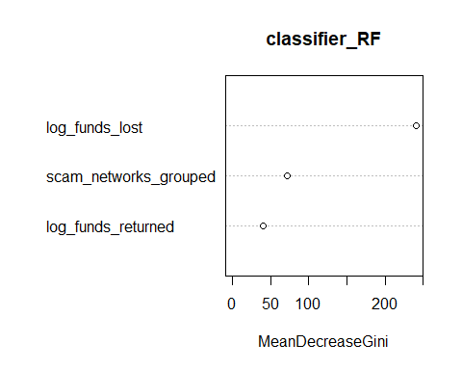

library(caret)  
set.seed(2377)  
train.index <- createDataPartition(df$scam_networks_grouped,   
 p = .8, list = FALSE)  
train <- df[ train.index,]  
test <- df[-train.index,]  
  
train$scam_type_grouped = ifelse(train$scam_type_grouped == "Exploit", 1, 0)  
test$scam_type_grouped = ifelse(test$scam_type_grouped == "Exploit", 1, 0)  
logistic_model <- glm(scam_type_grouped ~ ., data = train, family = binomial(link = "logit"))

# logistic_model_summary <- summary(logistic_model)  
# logistic_model_summary  
stargazer::stargazer(logistic_model,type='html',report = "vc*stp",  
 ci = TRUE)

Dependent variable:

scam_type_grouped

month_of_attackAugust

-1.153**

(-2.240, -0.066)

t = -2.078

p = 0.038

month_of_attackDecember

-1.396**

(-2.466, -0.326)

t = -2.557

p = 0.011

month_of_attackFebruary

-0.707

(-1.839, 0.424)

t = -1.225

p = 0.221

month_of_attackJanuary

-2.012***

(-3.149, -0.875)

t = -3.468

p = 0.001

month_of_attackJuly

-0.318

(-1.414, 0.777)

t = -0.569

p = 0.570

month_of_attackJune

-0.479

(-1.581, 0.624)

t = -0.851

p = 0.395

month_of_attackMarch

-0.800

(-1.907, 0.307)

t = -1.416

p = 0.157

month_of_attackMay

-0.554

(-1.666, 0.558)

t = -0.976

p = 0.330

month_of_attackNovember

-1.260**

(-2.316, -0.204)

t = -2.339

p = 0.020

month_of_attackOctober

-0.834

(-1.889, 0.220)

t = -1.550

p = 0.122

month_of_attackSeptember

-1.214**

(-2.303, -0.125)

t = -2.185

p = 0.029

month_of_attackUnknown

-2.399***

(-3.631, -1.167)

t = -3.816

p = 0.0002

scam_networks_groupedCentralized

0.978***

(0.450, 1.506)

t = 3.627

p = 0.0003

scam_networks_groupedEthereum

0.784***

(0.411, 1.158)

t = 4.113

p = 0.00004

scam_networks_groupedOther Decentralized

1.414***

(0.780, 2.049)

t = 4.367

p = 0.00002

scam_networks_groupedPolygon

0.997**

(0.206, 1.787)

t = 2.471

p = 0.014

log_funds_lost

0.235***

(0.192, 0.277)

t = 10.918

p = 0.000

log_funds_returned

0.113***

(0.045, 0.182)

t = 3.233

p = 0.002

Constant

-2.725***

(-3.841, -1.608)

t = -4.785

p = 0.00001

Observations

2,563

Log Likelihood

-532.387

Akaike Inf. Crit.

1,102.774

Note:

*p<0.1;* ***p<0.05;*** p<0.01

train_prob_pred <- predict(logistic_model, type = 'response', newdata = train)  
test_prob_pred <- predict(logistic_model, type = 'response', newdata = test)  
#y_pred = ifelse(prob_pred > 0.5, "Exploit", "Exit Scam")  
  
# Train Confusion Matrix  
y_train_pred = ifelse(train_prob_pred > 0.5, 1, 0)  
y_train_pred<- as.factor(y_train_pred)  
train$scam_type_grouped <- as.factor(train$scam_type_grouped)  
(cm = table(train$scam_type_grouped, y_train_pred))

## y_train_pred  
## 0 1  
## 0 2068 87  
## 1 128 280

# Test Confusion Matrix  
y_test_pred = ifelse(test_prob_pred > 0.5, 1, 0)  
y_test_pred<- as.factor(y_test_pred)  
test$scam_type_grouped <- as.factor(test$scam_type_grouped)  
(cm = table(test$scam_type_grouped, y_test_pred)) # NAs ignored

## y_test_pred  
## 0 1  
## 0 508 14  
## 1 38 77

#y_pred <- as.factor(unname(y_pred)) # for cfm plot

# 1. Open jpeg file  
#jpeg("Train_CFM.jpg", width = 350, height = 350)  
  
library(scales)

##   
## Attaching package: 'scales'

## The following object is masked from 'package:purrr':  
##   
## discard

## The following object is masked from 'package:readr':  
##   
## col_factor

ggplotConfusionMatrix <- function(m){  
 mytitle <- paste("Train Accuracy", percent_format()(m$overall[1]))  
 p <-  
 ggplot(data = as.data.frame(m$table) ,  
 aes(x = Prediction, y = Reference)) +  
 geom_tile(aes(fill = log(Freq)),   
 colour = "white", show.legend = FALSE) +  
 scale_fill_gradient(low = "white", high = "#56B1F7") +  
 geom_text(aes(x = Prediction, y = Reference,   
 label = Freq)) +  
 ggtitle(mytitle) +   
 scale_x_discrete(limits = rev) +  
 theme_minimal() +   
 theme(panel.grid.major = element_blank(),   
 panel.grid.minor = element_blank())  
 return(p)  
}  
cfm_train <- confusionMatrix(train$scam_type_grouped, y_train_pred)  
ggplotConfusionMatrix(cfm_train)

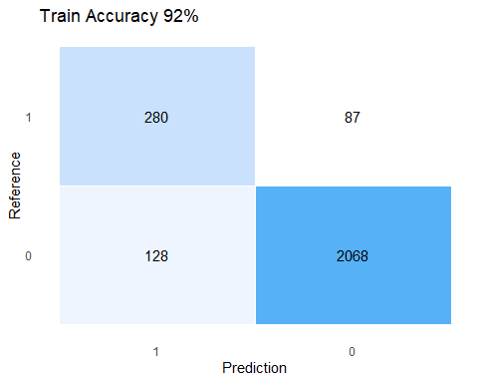

# Close the jpeg file  
#dev.off()

# Open jpeg file  
#jpeg("Test_CFM.jpg", width = 350, height = 350)  
  
library(scales)  
ggplotConfusionMatrix <- function(m){  
 mytitle <- paste("Test Accuracy", percent_format()(m$overall[1]))  
 p <-  
 ggplot(data = as.data.frame(m$table) ,  
 aes(x = Prediction, y = Reference)) +  
 geom_tile(aes(fill = log(Freq)),   
 colour = "white", show.legend = FALSE) +  
 scale_fill_gradient(low = "white", high = "#56B1F7") +  
 geom_text(aes(x = Prediction, y = Reference,   
 label = Freq)) +  
 ggtitle(mytitle) +   
 scale_x_discrete(limits = rev) +  
 theme_minimal() +   
 theme(panel.grid.major = element_blank(),   
 panel.grid.minor = element_blank())  
 return(p)  
}  
cfm_test <- confusionMatrix(test$scam_type_grouped, y_test_pred)  
ggplotConfusionMatrix(cfm_test)

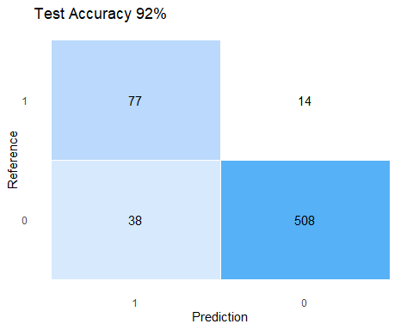

# Close the jpeg file  
#dev.off()

# Train and Test Data ROC-AUC Curve  
train_pred <- prediction(train_prob_pred, train$scam_type_grouped)  
test_pred <- prediction(test_prob_pred, test$scam_type_grouped)  
  
# Create an ROC curve  
perf_train <- performance(train_pred, measure = "tpr", x.measure = "fpr")  
perf_test <- performance(test_pred, measure = "tpr", x.measure = "fpr")  
  
# Open a pdf and jpeg file  
#pdf("ROC.pdf", width = 6.5, height = 4.24)   
#jpeg("ROC.jpg", width = 700, height = 350)  
  
  
# Plot the ROC curve  
plot(perf_train, main = "Logistic Regression AUC-ROC Curve",  
 col = "#009ECE")  
plot(perf_test, add = T, col = "#FF9E00", lwd = 1.5)  
legend(0.32, 0.25, c("Train Data", "Test Data"),   
 col = c("#009ECE", "#FF9E00"),   
 bty = "n", lwd = 1.2, cex = 0.75)  
abline(0, 1, lty = 2, col = "gray") # Add y=x line

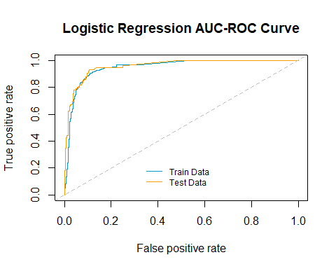

# Close the pdf/jpeg file  
#dev.off()

auc.train <- auc(train$scam_type_grouped, train_prob_pred)  
cat("Area under the curve for Logistic Regression Train Set is: ", auc.train)

## Area under the curve for Logistic Regression Train Set is: 0.9500398

auc.test <- auc(train$scam_type_grouped, train_prob_pred)  
cat("\nArea under the curve for Logistic Regressio Test Set is: ", auc.test)

##   
## Area under the curve for Logistic Regressio Test Set is: 0.9500398