GRS MA681 Final Project

Analysing Inceptive Municipal Efforts to Achieve Carbon Neutrality by 2050 in Boston

Tegveer Ghura

# Abstract

In 2017, Mayor Martin J. Walsh fortified existing GHG (short for greenhouse gas) emissions reduction goals to achieve carbon neutrality (no net carbon emissions released into the atmosphere) by the year 2050 in the City of Boston.[1] This research paper aims to analyse the significance of the changes in GHG emissions generated by municipal operations in the City of Boston from the year 2005 to 2018. The City had pledged in the year 2000, when it enlisted itself in the Cities for Climate Protection Campaign of ICLEI (Local Governments for Sustainability) network, to take an active, leading role in advancing climate action.[2] Therefore, a statistical examination of the local government’s progress of combating global warming would help us benchmark their successes against claims laid out in updated versions of the Climate Action Plan (CAP) and other documents. To test these claims, the main tools used were hypothesis testing, general linear models, including ANCOVA, and an Autoregressive model, assuming an Autoregressive (Lag 1) correlation structure. The results obtained from my methods and EDA were largely different from the statistics reported in the CAP and Boston GHG Inventory reports, with major trends of Yearly GHG Emissions differing among the Fuels, Departments, and Facilities groups.

# Introduction

Initially in 2007, Mayor Thomas Menino signed an executive order for the City of Boston to meet or exceed the goal of reducing its annual greenhouse gas emissions 7% below 1990 levels by 2012 (referring to Kyoto Protocol targets), and to begin releasing and updating a Climate Action Plan (CAP) that laid out strategies to reduce greenhouse gas emissions by 80 percent by 2050 in both municipal operations and in the entire Boston community.[3] Later, in 2017, Mayor Walsh set a more ambitious goal of making Boston carbon neutral by 2050 and highlighted the steps to do so in the 2019 CAP Report. The reason to undertake this responsibility was to fulfill Boston’s commitment to the Paris Climate Agreement and to keep global warming under 1.5 degrees Celsius. [4]

Between the years 2005 and 2019, numerous policies, results, and goals were presented to the Boston public in different versions of the CAP reports as well as in the City of Boston Greenhouse Gas (GHG) Emissions Inventory. In this project, I assess select information from these reports and sources to compare it to my analysis, given the capacity of my dataset. To explain in more detail, we first need to understand the differences between the community and Local Government Operations (LGO) or municipal GHG inventories. Emissions reporting for the annual GHG inventory for the City is separated into community-wide and local government (municipal) operations inventories.[5] Emissions from the Boston Housing Authority, the Massachusetts Water Resources Authority (MWRA), and the Boston Planning and Development Agency (BPDA) are not included in the municipal GHG inventory, but those from the Boston Public Health Commission (BPHC), and the Boston Water and Sewer Commission (BWSC) are.[6] Moreover, LGO’s should be considered to be largely overlapping, but not completely contained within the Citywide inventory.[7]

The LGO inventory calculates all GHG emissions generated by municipal operations of the City. This includes the burning of fuels in the City’s facilities and vehicles, and the energy used in municipal buildings, vehicles, parks, street lights, and traffic signals.[8] As we shall see in the next section, the dataset used corresponds to the data collected from this inventory from the years 2005-2018.

To iterate again, it should be noted that all the results and data of my research are only part of the municipal operations inventories. The main problem to analyse in this research paper is to validate the results of GHG reduction efforts of municipal operations present in the 4 versions of the CAP and in the City of Boston GHG Emissions Inventory Report (2005-2017). A significant claim is that emissions from LGO’s in 2017 were 41 per cent less than they were in 2005, hence exceeding Boston’s goal to reduce municipal GHG emissions by 25% from 2005 to 2020.[9] In fact, in the 2011 CAP, it was highlighted that because GHG emissions are approximately proportional to energy use, successful completion of the Energy Reduction Plan meant that the goal of 25% GHG reductions for municipal operations will be met by 2015 or 2016.[10] The Energy Reduction Plan specified a 40-percent reduction in the energy use of street lights from 2011 to 2016 and laid out additional measures to reduce energy use for municipal transportation to 20% between 2010 and 2015, a claim that shall be investigated in my analysis.[11] Even better news came out when the 2014 CAP reported that LGO emissions had been reduced by almost 25 percent since 2005, saving Boston an additional year.[12]

Boston’s LGO emissions are mainly comprised by building energy consumption.[13] Electricity and natural gas consumption, by these buildings, each comprise of about a third of total GHG emissions.[14] Fuels used for transportation, including diesel and gasoline together, make up a fourth of total municipal GHG emissions. [15]

As the department with the largest building inevtory, and the second largest vehicle inventory (after Boston Police Department), Boston Public Schools (BPS) are the largest source of municipal emissions.[16] BPS owns and operates approximately 12 million of the City’s 16 million square feet of building space with these buildings comprising of approximately a third of municipal electricity consumption and two thirds of municipal natural gas consumption.[17] BPS Department of Transportation (DOT) fleet of over 700 vehicles uses diesel consumption, which is continuing to decrease as BPS switched its fleets from diesel to propane-powered school buses.[18]

Public Works Department’s street lights is another large contributor of GHG emissions in terms of street lights use. Boston’s 66,000 electric street lights and 2,800 natural gas street lights account for 9% of total municipal GHG emissions.[19] Earlier, street lighting constituted largely to the City’s GHG emissions portfolio; however, ardent conversion of these electric street lights to LEDs, dating back to 2010, have cut emissions from street lights in half.[20]

Boston is a coastal city and, therefore, is vulnerable to sea level rise as well as other effects of climate change, such as extreme temperatures (both hot and cold) and precipitation.[21] These climate changes disproportionately affect communities of color, women, youth, disabled people, elderly people, and people with limited English proficiency.[22] According to the 2011 CAP, after accounting for initial costs, residents, businesses, and institutions will have total net savings of $2 billion in energy costs by 2020 by reducing GHG emissions.[23] Additionally, the City benefits from improved public health and reduced health care costs from reductions in air pollution and traffic congestion.[24] In the following Main Sections portion of the paper, under the EDA and Methods section, I shall evaluate and present my findings of these municipal operations GHG reduction results.

# Data

The dataset was obtained from the data.boston.gov website. The dataset contains the total GHG emissions by municipal department, facility (asset use), fuel type, and fiscal year for all LGOs. Originally, the dataset had 7 variables, 5 of which were used for analysis. The 2 variables not of use were “Department”, which was the acronym for department responsible for energy use, and “Protocol”, indicating the protocol used for data reporting. The renamed variables of interest include: “Department” (full name of the department), “Facility” (GHG producing asset), “Fuel Type” (Type of energy producing GHGs), “Year” (Fiscal period of energy consumed from 2005- 2018), and “Emission” (Numeric quantity of GHGs produced in tons of carbon dioxide equivalents, tCO2e). The original data had 1014 observations with all 159 NA’s being removed during data cleaning. Initially after reading in the data, the “Emission” column was read in as a factor; hence, its datatype was changed to numeric.

Boston’s GHG inventory includes carbon dioxide (CO2), methane (CH4), and nitrous oxide (N2O). The formula used to determine the CO2e from a given energy use is:

Activity Data * Emissions Factor = GHG Emissions from the Activity[25]

# Exploratory Data Analysis

Table 1: Summary Statistics of tCO2e Emission

|  |  |  |  |  |  |
| --- | --- | --- | --- | --- | --- |
| Min. | 1st Qu. | Median | Mean | 3rd Qu. | Max. |
| 1.0 | 183.5 | 344.0 | 347.9 | 512.5 | 696.0 |

Table 2: Summary Statistics of tCO2e Emission by Fuel Type

|  |  |  |  |  |  |
| --- | --- | --- | --- | --- | --- |
| Fuel Type | Observations | Mean | Std Deviation | Minimum | Maximum |
| Biodiesel | 3 | 379.667 | 224.014 | 121 | 389 |
| Diesel | 133 | 352.376 | 211.152 | 2 | 687 |
| Electricity | 228 | 300.684 | 194.586 | 16 | 676 |
| Fuel Oil | 108 | 340.593 | 163.475 | 1 | 689 |
| Gasoline | 155 | 425.110 | 190.264 | 4 | 690 |
| Natural Gas | 197 | 349.056 | 181.447 | 3 | 692 |
| Propane | 3 | 409.000 | 187.832 | 193 | 341 |
| Steam | 28 | 293.286 | 201.891 | 7 | 689 |

Table 3: Summary Statistics of tCO2e Emission by Year

|  |  |  |  |  |  |
| --- | --- | --- | --- | --- | --- |
| Fiscal Year | Observations | Mean | Std Deviation | Minimum | Maximum |
| 2005 | 52 | 379.577 | 180.378 | 43 | 686 |
| 2006 | 53 | 364.075 | 192.700 | 53 | 682 |
| 2007 | 54 | 353.167 | 189.518 | 3 | 662 |
| 2008 | 68 | 344.250 | 198.413 | 2 | 691 |
| 2009 | 70 | 372.714 | 189.071 | 50 | 694 |
| 2010 | 69 | 325.884 | 196.590 | 4 | 689 |
| 2011 | 70 | 333.343 | 193.797 | 8 | 685 |
| 2012 | 71 | 338.859 | 200.558 | 9 | 696 |
| 2013 | 69 | 300.029 | 193.310 | 5 | 661 |
| 2014 | 65 | 326.338 | 202.240 | 14 | 692 |
| 2015 | 55 | 306.836 | 196.223 | 1 | 695 |
| 2016 | 51 | 367.176 | 210.160 | 20 | 693 |
| 2017 | 52 | 385.173 | 178.833 | 105 | 690 |
| 2018 | 56 | 400.214 | 179.693 | 116 | 678 |

Table 4: Summary Statistics of Dependent Variable, Emission, by Department

|  |  |  |  |  |  |
| --- | --- | --- | --- | --- | --- |
| Department | Observations | Mean | Std Deviation | Minimum | Maximum |
| Library | 61 | 454.475 | 170.744 | 43 | 686 |
| Boston Public Schools | 70 | 330.129 | 155.148 | 53 | 682 |
| Fire | 70 | 292.043 | 173.793 | 3 | 662 |
| Parks and Recreation | 71 | 372.775 | 186.345 | 2 | 691 |
| Police | 67 | 440.254 | 139.686 | 50 | 694 |
| Water and Sewer Commission | 57 | 451.825 | 234.234 | 4 | 689 |
| Transportation | 67 | 407.896 | 211.901 | 8 | 685 |
| Property & Construction Mgmt | 66 | 356.182 | 222.215 | 9 | 696 |
| Public Works | 99 | 234.485 | 193.255 | 5 | 661 |

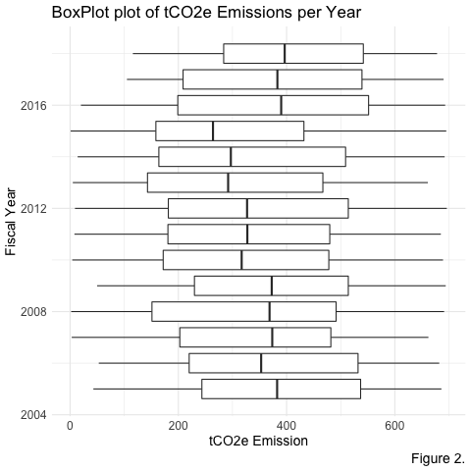Plots and Figures

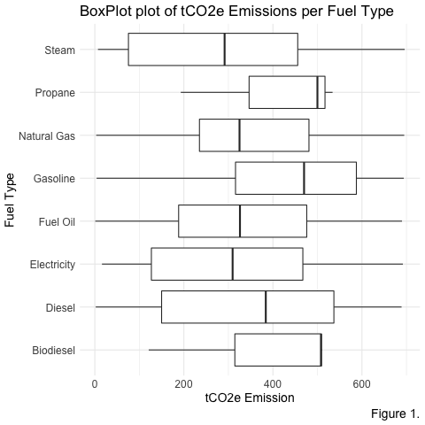

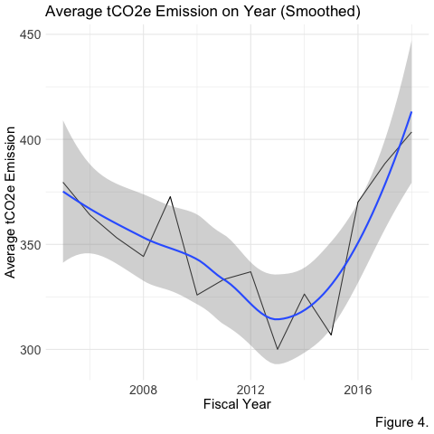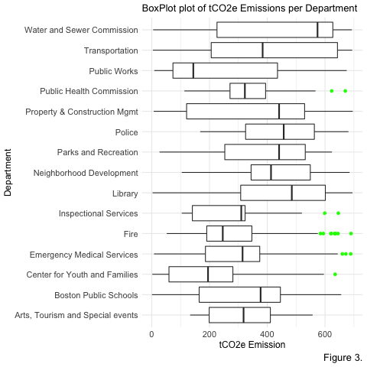

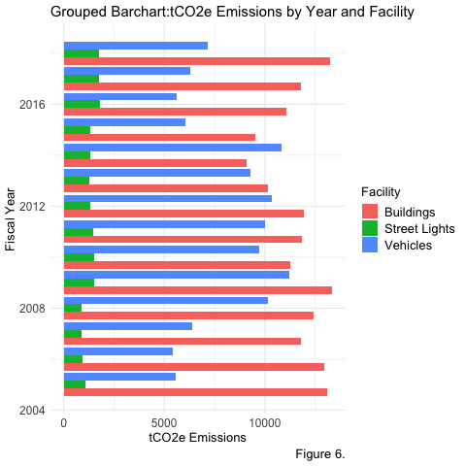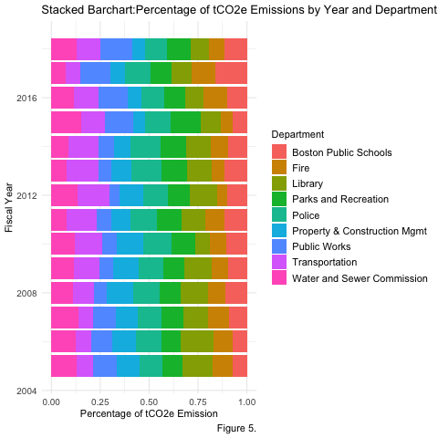

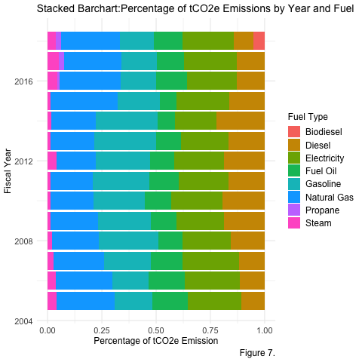Recall that according to the 2014 CAP, LGO emissions had been reduced by almost 25 percent since 2005. This claim does, to a large extent, agree with figures 2 and 4 on pages 5 and 6 respectively, as we observe a downward trend in tCO2e Emissions until its minimum point corresponding to year 2013. However, our data then paints a wholly different picture after 2014 with respect to GHG emissions. Recall that the GHG Inventory Report had claimed that emissions from LGO’s in 2017 were 41% less than they were in 2005. However, from the same figures 2 and 4, we see that overall trend in tCO2e Emissions increases after 2014 and, actually, reaches the point where it crosses 2005 levels in 2017. This discrepancy between the claims of the reports and our EDA is worth diving deeper into in our Methods section, where we model and test for significance the tCO2e Emissions values.

We only used 9 out of the 15 Departments in the dataset in Figure 5 for convenience of visualization and these were selected if their respective total tCO2e Emissions across 2005-2018 was greater than 20,000 tCO2e. Our analysis, from Table 4 and Figure 3, also agrees with the claim stated by the GHG Inventory Report that Boston Public Schools (BPS), Public Works, and Boston Police Department are among the largest Departments of GHG contributors. It should also be observed that the Fuel Biodiesel, a renewable source of energy, first got used in 2018 and Propane first got used in the year 2016, as BPS switched its fleets from diesel to cleaner propane-powered school buses.

Analysing tCO2e Emissions by facility in Figure 6, we again observe discrepancy between the claims made in the GHG Inventory Report and our findings. Recall that the report also states that due to converting electric street lights to LEDs, more than half GHG Emissions have been reduced since 2010. From Figure 6, the opposite is observed that from 2005-2008, street lights constituted the least to emissions, but saw an increase after and stayed constant at that value. Moreover, the Energy Reduction Plan specified a 40% reduction in energy use of street lights from 2011 to 2016, but, again, we see that emissions stayed pretty much constant between 2011 and 2015 and then, surprisingly, increased in 2016.

Therefore, our EDA resulted in rather startling results when compared to those published in CAP reports and in the GHG Inventory. However, only EDA is not sufficient to answer our main questions, but helpful in identifying them. In the next Methods section, we delve deeper and try to infer the significance of these claims by using hypothesis testing, ANCOVA, and General Linear Mixed Models using an Autoregressive (Lag 1 or AR1) structure of correlation.

# Methods

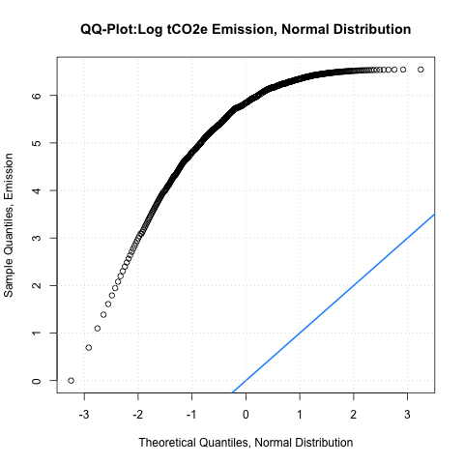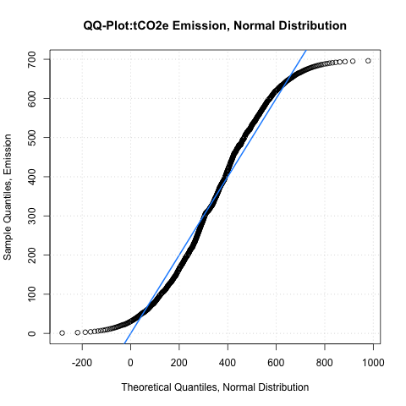 The only assumption I have used in regression and hypothesis testing is that of normality so that our dependent variable, tCO2e Emission, satisfies the assumptions for linear regression, for example homoscedasticity (variance of Y at every X is the same) and normality (at every X, distribution of Y follows a normal distribution). A QQ-Plot of the variable tCO2e Emission and its log is helpful to assess which variable to use for regression too. Hence, raw values of the dependent variable will be more suited to a standard linear regression model as shown below.

The first method used is that of a two sample one-tailed t-test to test the following null and alternative hypothesis at a 0.05 level of significance (95% confidence level): *H0:* *µ2005* *<= µ*2015 vs *H1:* *µ*2005 *> µ*2015, where *µ2005* and *µ*2015 correspond to the mean tCO2e Emission for the years 2005 and 2015 respectively.

The second method is also is that of a two sample one-tailed t-test to test the following null and alternative hypothesis at a 0.05 level of significance (95% confidence level): *H0:* *µ2005* *<= µ*2017 vs *H1:* *µ*2005 *> µ*2017, where *µ2005* and *µ*2017 correspond to the mean tCO2e Emission for the years 2005 and 2017 respectively.

The third method is an ANCOVA model with Fuel Type as the grouping variable, Year as the covariate, and tCO2e Emission as the dependent variable. Also, a two sample one-tailed t-test is also used to test the following null and alternative hypothesis at a 0.05 level of significance (95% confidence level): *H0:* *µDiesel* *<= µ*Propane vs *H1:* *µ*Diesel *> µ*Propane, where *µDiesel* and *µ*Propane correspond to the mean tCO2e Emission for the fuels Diesel and Propane respectively.

The fourth method is also an ANCOVA model with Facility as the grouping variable, Year as the covariate, and tCO2e Emission as the dependent variable. Along with this, a two sample one-tailed t-test is conducted to test the following null and alternative hypothesis at a 0.05 level of significance (95% confidence level): *H0:* *µ2010* *<= µ*2017 vs *H1:* *µ*2010 *> µ*2017, where *µ2010* and *µ*2017 correspond to the mean tCO2e Emission for the Street Light Facility for years 2010 and 2017 respectively.

The last method used is an Autoregressive (Lag 1) model for tCO2e Emission. I used this methodology to gain more information on whether tCO2e Emission observations across time are independent or not. The estimate of the correlation, if closer to 1, would mean that tCO2e Emission observations are not independent.

# Results

# The first method’s one-tailed t-test yielded a p-value of 0.02443 < alpha = 0.05, which means we reject the null hypothesis and, therefore, conclude that mean tCO2e Emission for 2005 was significantly greater than that of 2015. Hence, our statistical test does agree with the claims of the 2011 and 2014 CAP that tCO2e Emissions did, in fact, decrease significantly by 2015. However, in the second method, when the year is changed to 2017 instead of 2015 for the same t-test, we obtain p-value of 0.5982 > alpha = 0.05, which means we don’t reject the null hypothesis and, therefore, do not have enough evidence to conclude that mean tCO2e Emission for 2005 was significantly greater than that of 2017. Therefore, this statistical analysis does agree with Figure 2 in the EDA section, but does not agree with the GHG Inventory Report statistic that emissions from LGO’s in 2017 were 41 per cent less than they were in 2005.

# For the ANCOVA model specified in the third method, I obtained a significant p-value of 6.365e-07 < alpha = 0.05, so we reject the null hypothesis and, therefore, conclude that Fuel Type is important to determining tCO2e Emissions, after taking into account Year. The one-tailed t-test yielded a p-value of 0.6691 > alpha = 0.05, which means we don’t reject the null hypothesis and, therefore, do not have enough evidence to conclude that mean tCO2e Emission for Propane was significantly lesser than that of Diesel. Hence, our statistical test does not agree with the claims that although Diesel consumption by Boston Public Schools may have decreased for their fleet of buses, average tCO2e Emission of Propane and Diesel are not significantly different, which means that we do not have enough evidence to conclude that Propane-powered buses are cleaner than Diesel consuming buses.

# For the ANCOVA model specified in the fourth method, I obtained a significant p-value of 6.364e-10 < alpha = 0.05, so we reject the null hypothesis and, therefore, conclude that Facility is important to determining tCO2e Emissions, after taking into account Year. The one-tailed t-test yielded a p-value of 0.7452 > alpha = 0.05, which means we don’t reject the null hypothesis and, therefore, do not have enough evidence to conclude that mean tCO2e Emissions for Street Lights in 2017 were significantly lesser than that of 2010. Hence, our statistical test does not agree with the claim of the GHG Inventory Report that converting electric street lights to LEDs, dating back to 2010, led to a cut in emissions from street lights in half.

# Lastly, from the Autoregressive model, the estimate of the correlation in the data at a time lag of 1 is 6.017e-01 or 0.6017, which signifies a strong correlation (correlation close to 1), and, also, the estimate is statistically significant too as its p-value < 2e-16. Therefore, the observations are not independent.

# Discussion/Conclusion

In conclusion, the results obtained from our analyses differs by a large extent to what the various claims in the GHG Inventory Report as well as the 2014 and 2019 CAP reports suggest. The reason of this discrepancy is still unknown, but it could potentially be tracked back to maybe drawbacks in data cleaning and/or collection. Maybe the removal of 160 odd NA’s out of a dataset of 1000 odd observations was not the best method and, hence, could have possibly lead to loss of crucial information. However, practically, the NA values would not have made a large impact to affect our analyses in such a significant manner that our EDA and methods give different results altogether. Therefore, the potential drawback of data cleaning can be nullified. On the other hand, data collection from the municipal perspective could be a reason here and maybe data used to generate the CAP and GHG Inventory reports might be different from what was posted on the website.

In terms of methods used, hypothesis tests are always vulnerable to drawbacks, such as generating unrealistic null hypotheses that stem from our “goal” of rejecting the null that we had already concluded was true initially. Moreover, the ASA Statement on p-values applies to most methods described above and the main drawback is that the conclusions stated in the results were attained by setting a significance threshold and, hence, other robust ways of testing the claims could be used. Next steps to work in this area of research would be to attain a larger, more representative dataset from a government source and use models/simulations that do not suffer from the drawbacks of p-values or hypothesis tests.

**Bibliography**

“The City of Boston’s Climate Action Plan December 2007.” Climate: Change, [www.cityofboston.gov/climate/pdfs/CAPJan08.pdf.](http://www.cityofboston.gov/climate/pdfs/CAPJan08.pdf.)

Services, Environment and Energy, and ees_boston. “A Climate of Progress: City of Boston Climate Action Plan Update 2011.” Issuu, issuu.com/ees_boston/docs/a_climate_of_progress_- *cap_update*.

“GREENOVATE BOSTON 2014 CLIMATE ACTION PLAN UPDATE .” Greenovate Boston 2014 CAP Update Summary, [www.cityofboston.gov/images_documents/Greenovate%20Boston%202014%20CAP%20Update](http://www.cityofboston.gov/images_documents/Greenovate%20Boston%202014%20CAP%20Update)

_Summary_tcm3-49733.pdf.

“CITY OF BOSTON CLIMATE ACTION PLAN 2019 UPDATE.” City of Boston, Oct. 2019, [www.boston.gov/sites/default/files/embed/file/2019-](http://www.boston.gov/sites/default/files/embed/file/2019-) 10/city_of_boston_2019_climate_action_plan_update_4.pdf.

“CITY OF BOSTON GREENHOUSE GAS EMISSIONS INVENTORY (2005-2017).” City of

Boston, [www.boston.gov/sites/default/files/imce-uploads/2019 07/boston_ghg_inventory_2005- 2017.pdf](http://www.boston.gov/sites/default/files/imce-uploads/2019%2007/boston_ghg_inventory_2005-%202017.pdf).

“Boston’s Climate Plan Update Targets Major Source of Emissions – Buildings.” Smart Cities World, [www.smartcitiesworld.net/news/news/bostons-climate-plan-update-targets-major-source-](http://www.smartcitiesworld.net/news/news/bostons-climate-plan-update-targets-major-source-)of-emissions–buildings-4672

*Boston.gov*, 15 Dec. 1970, www.boston.gov/.

1. City of Boston Climate Action Plan Update 2019
2. City of Boston Climate Action Plan Update 2014
3. City of Boston Climate Action Plan Update 2007, 2011
4. City of Boston Climate Action Plan Update 2019
5. City of Boston Greenhouse Gas Emissions Inventory (2005-2017)
6. City of Boston Greenhouse Gas Emissions Inventory (2005-2017)
7. City of Boston Greenhouse Gas Emissions Inventory (2005-2017)
8. City of Boston Greenhouse Gas Emissions Inventory (2005-2017)
9. City of Boston Greenhouse Gas Emissions Inventory (2005-2017)
10. City of Boston Climate Action Plan Update 2011
11. City of Boston Climate Action Plan Update 2011
12. City of Boston Climate Action Plan Update 2014
13. City of Boston Greenhouse Gas Emissions Inventory (2005-2017)
14. City of Boston Greenhouse Gas Emissions Inventory (2005-2017)
15. City of Boston Greenhouse Gas Emissions Inventory (2005-2017)
16. City of Boston Greenhouse Gas Emissions Inventory (2005-2017)
17. City of Boston Greenhouse Gas Emissions Inventory (2005-2017)
18. City of Boston Greenhouse Gas Emissions Inventory (2005-2017)
19. City of Boston Greenhouse Gas Emissions Inventory (2005-2017)
20. City of Boston Greenhouse Gas Emissions Inventory (2005-2017)
21. *Boston.gov*, 15 Dec. 1970, www.boston.gov/.
22. City of Boston Climate Action Plan Update 2019
23. City of Boston Climate Action Plan Update 2011
24. City of Boston Climate Action Plan Update 2011
25. City of Boston Greenhouse Gas Emissions Inventory (2005-2017)