**SRS Document  
Coesy Inventory  
*An Inventory Management System***(Group 6)

Group 6:

* Nguyễn Minh Khôi
* Dương Hải Minh
* Đỗ Quý Thịnh
* Nguyễn Quốc Trung
* Bùi Tiến Đạt
* Đào Tiến Dũng

1. **Introduction**More and more organizations are off-loading their inventory management duties from paperworks to electronic solutions. Our Inventory Management System aim to provide a solid, fast and reliable system to tackle: How to manage my organization’s inventory online?
2. **Overall description**Web-based application with a local database that helps managing an organization’s inventory, with detailed statistics and overview tools.
3. **Feature Specification**

|  |  |  |
| --- | --- | --- |
| **#** | **Main Features** | **Description** |
| **1** | Register, Sign In / Out | Guests will be able to register a new account in the system, and use it to manage the organization’s inventory |
| **2** | Forgot password | (Early Versions) Provide a randomly-generated password for the user who forgot his/her password |
| **3** | Full listing of items | - |
| **4** | Comprehensive search / sort functions | All the search / sort functions that you need to effectively manage your inventories |
| Search by name / pricing / … |
| Sort by date imported / pricing / type / … |
| **5** | “Exporting” items | Allow exporting items from the inventory, either to staff from the same organization or another organization |
| Listing of items that are exported |
| Reminder for export’s due dates |
| **6** | Input / Output items | Easy way to input / output items into inventory |
| Items delivery due dates listing |
| **7** | Receipt / Voucher printing | (Extra feature) |

1. **Technologies:**

|  |  |  |
| --- | --- | --- |
|  | **HTML5** | **Building the skeleton of a Website** |
| **CSS3** | **Designing the skeleton made with HTML** |
| **JavaScript** | **Interacting with the user in a website** |
| **Bootstrap4** | **Building Mobile Responsive websites** |
| **JQuery** | **Doing some animations** |
|  | **NodeJS** | **Performing operations with our database** |
|  | **MySQL** | **Connecting databases to our Website** |
|  | **WordPress** | **Building introductory Websites, beautifully** |

1. **Use-cases model:**

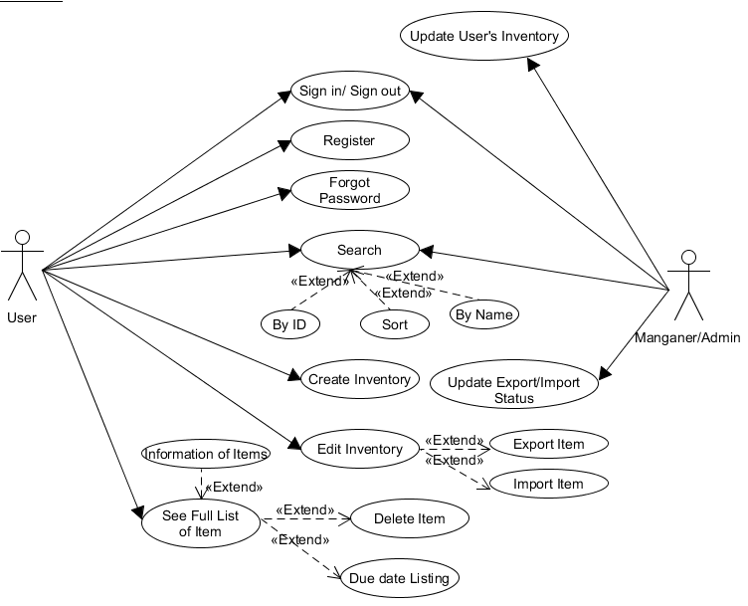

1. **Business Process model:**

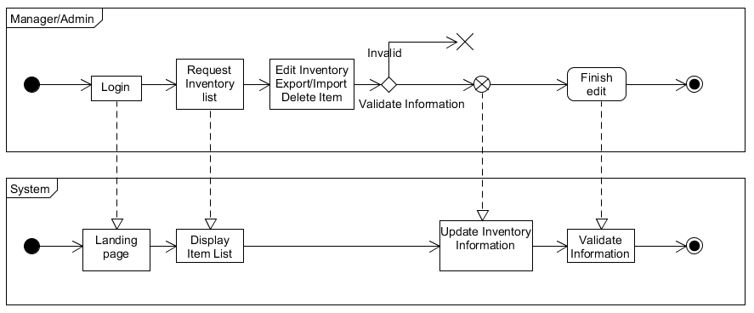

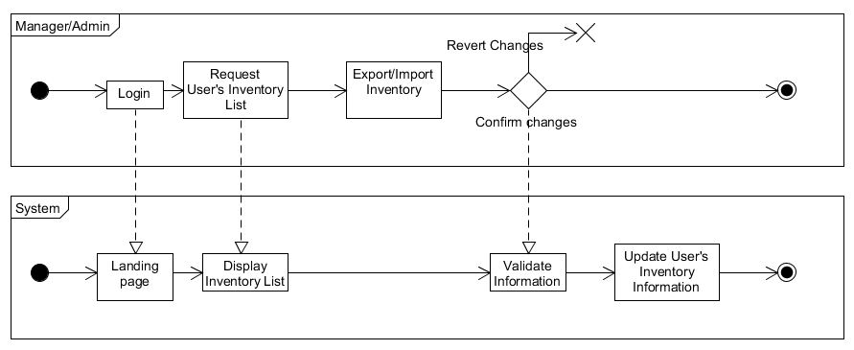

1. **Design:**
   1. **Interface design:**

* 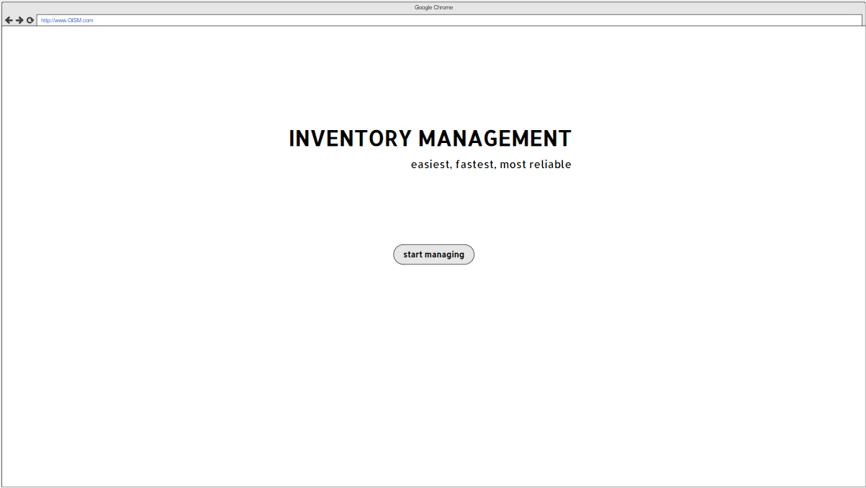**Landing Page**
* 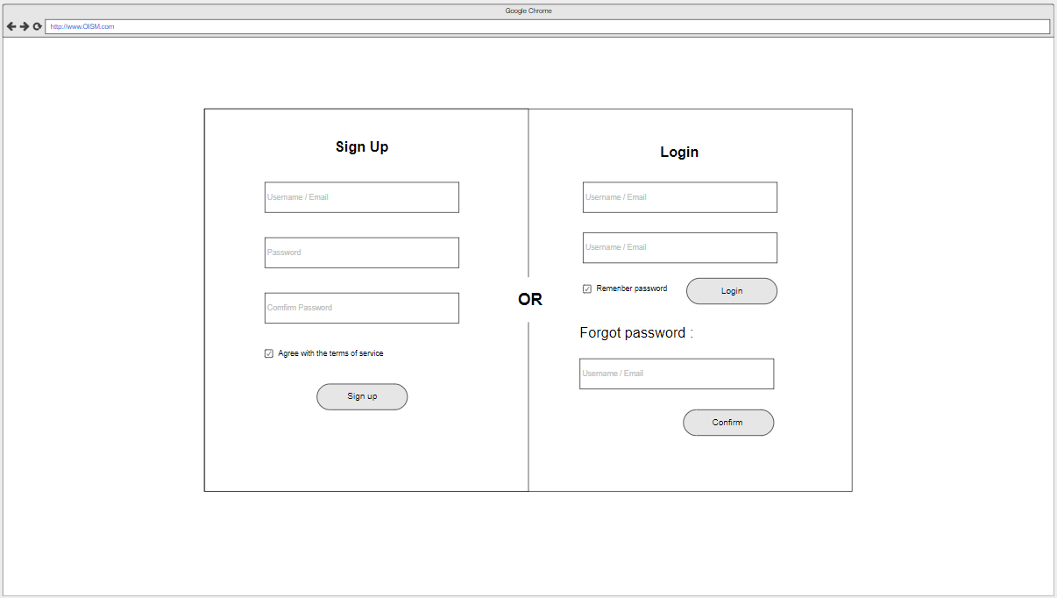**Login / Register Page:**
* 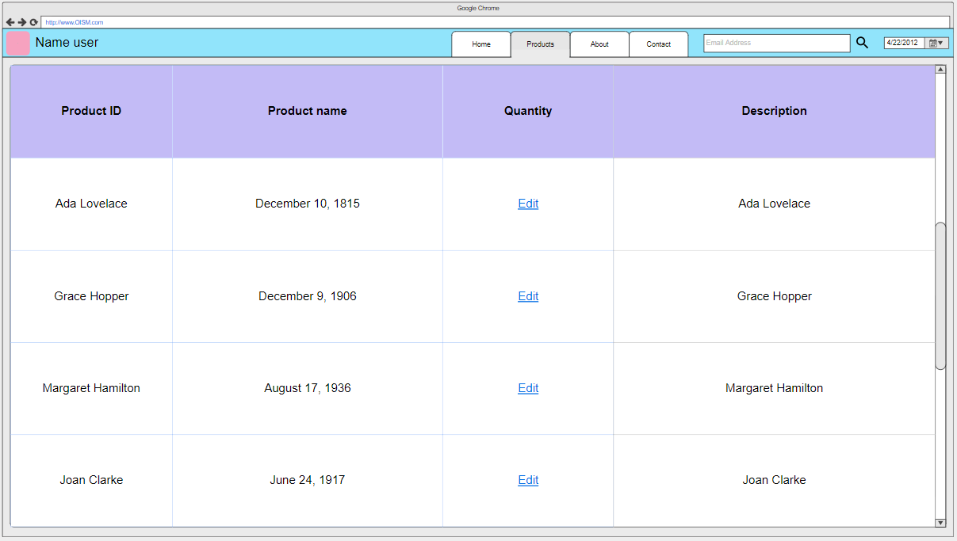**Inventory Page:**

|  |  |  |  |
| --- | --- | --- | --- |
| **ID** | **Page** | **Page Description** | **Features** |
| **P1** | **Splash Page** | **First page a guest sees, convey the application’s moto and name.** | * **Divert to Login Page** |
| **P2** | **Login Page** | **With this page a guest can register an account, or login with an existing account. Also included is “Forgot Password”** | * **Input credentials + Login** * **Input user’s info + Register** * **Forgot Password** |
| **P3** | **Home Page** | **Main page of an user. Displays and allow the user to use the multiple functions of the application.** | * **Sees user’s basic informations** * **Use inventory management (Divert to P4)** |
| **P4** | **Inventory Page** | **Main inventory management page.** | * **Add / Delete / Modify items** |
|  |  |  |  |
|  |  |  |  |

* 1. 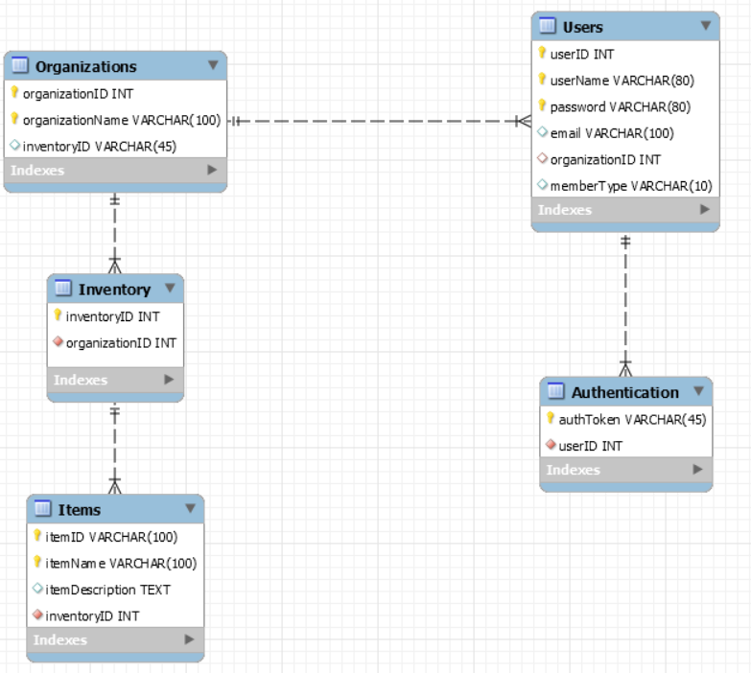**Database:**