Activitat 2. Portes lògiques

1. Obté les taules de veritat i les funcions dels següents circuits:

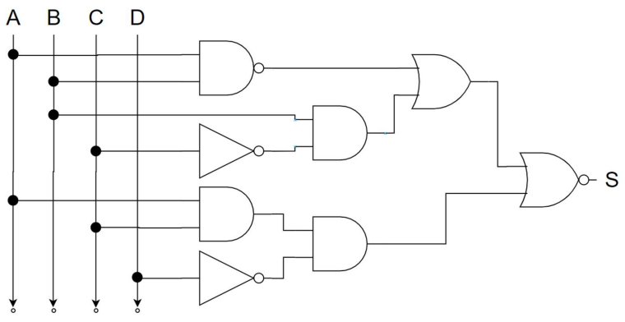

S1

S3

S2

S6

S4

S5

**Taula de veritat**

|  |  |  |  |  |  |  |  |  |  |  |  |  |  |  |  |
| --- | --- | --- | --- | --- | --- | --- | --- | --- | --- | --- | --- | --- | --- | --- | --- |
|  |  |  |  |  |  |  |  |  |  | S1 | S2 | S3 | S4 | S5 | S6 |
| A | **B** | **C** | **D** |  | **A'** | **B'** | **C'** | **D'** |  | **(A · B)'** | **B · C'** | **S1 + S2** | **A · C** | **S4 · D'** | **(S3 + S5)'** |
| 0 | 0 | 0 | 0 |  | 1 | 1 | 1 | 1 |  | 1 | 0 | 1 | 0 | 0 | 0 |
| 0 | 0 | 0 | 1 |  | 1 | 1 | 1 | 0 |  | 1 | 0 | 1 | 0 | 0 | 0 |
| 0 | 0 | 1 | 0 |  | 1 | 1 | 0 | 1 |  | 1 | 0 | 1 | 0 | 0 | 0 |
| 0 | 0 | 1 | 1 |  | 1 | 1 | 0 | 0 |  | 1 | 0 | 1 | 0 | 0 | 0 |
| 0 | 1 | 0 | 0 |  | 1 | 0 | 1 | 1 |  | 1 | 1 | 1 | 0 | 0 | 0 |
| 0 | 1 | 0 | 1 |  | 1 | 0 | 1 | 0 |  | 1 | 1 | 1 | 0 | 0 | 0 |
| 0 | 1 | 1 | 0 |  | 1 | 0 | 0 | 1 |  | 1 | 0 | 1 | 0 | 0 | 0 |
| 0 | 1 | 1 | 1 |  | 1 | 0 | 0 | 0 |  | 1 | 0 | 1 | 0 | 0 | 0 |
| 1 | 0 | 0 | 0 |  | 0 | 1 | 1 | 1 |  | 1 | 0 | 1 | 0 | 0 | 0 |
| 1 | 0 | 0 | 1 |  | 0 | 1 | 1 | 0 |  | 1 | 0 | 1 | 0 | 0 | 0 |
| 1 | 0 | 1 | 0 |  | 0 | 1 | 0 | 1 |  | 1 | 0 | 1 | 1 | 1 | 0 |
| 1 | 0 | 1 | 1 |  | 0 | 1 | 0 | 0 |  | 1 | 0 | 1 | 1 | 0 | 0 |
| 1 | 1 | 0 | 0 |  | 0 | 0 | 1 | 1 |  | 0 | 1 | 1 | 0 | 0 | 0 |
| 1 | 1 | 0 | 1 |  | 0 | 0 | 1 | 0 |  | 0 | 1 | 1 | 0 | 0 | 0 |
| 1 | 1 | 1 | 0 |  | 0 | 0 | 0 | 1 |  | 0 | 0 | 0 | 1 | 1 | 0 |
| 1 | 1 | 1 | 1 |  | 0 | 0 | 0 | 0 |  | 0 | 0 | 0 | 1 | 0 | 1 |

**Funció del circuit**

(A · B)’ + B · C’ + A · C · D’

1. 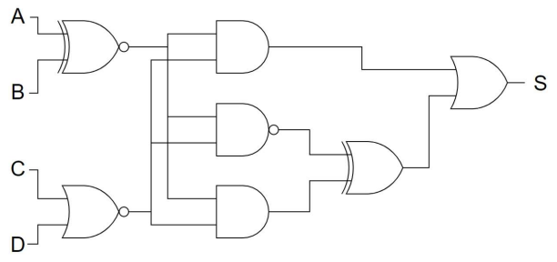

S3

S1

S7

S4

S6

S5

S2

**Taula de veritat**

|  |  |  |  |  |  |  |  |  |  |  |  |  |  |  |  |  |
| --- | --- | --- | --- | --- | --- | --- | --- | --- | --- | --- | --- | --- | --- | --- | --- | --- |
|  |  |  |  |  |  |  |  |  |  | S1 | S2 | S3 | S4 | S5 | S6 | S7 |
| A | **B** | **C** | **D** |  | **A'** | **B'** | **C'** | **D'** |  | **A ⊙ B** | **(C + D)'** | **S1 · S2** | **(S1 · S2)'** | **S1 · S2** | **S4 ⊕ S5** | **S3 + S6** |
| 0 | 0 | 0 | 0 |  | 1 | 1 | 1 | 1 |  | 1 | 1 | 1 | 0 | 1 | 1 | 1 |
| 0 | 0 | 0 | 1 |  | 1 | 1 | 1 | 0 |  | 1 | 0 | 0 | 1 | 0 | 1 | 1 |
| 0 | 0 | 1 | 0 |  | 1 | 1 | 0 | 1 |  | 1 | 0 | 0 | 1 | 0 | 1 | 1 |
| 0 | 0 | 1 | 1 |  | 1 | 1 | 0 | 0 |  | 1 | 0 | 0 | 1 | 0 | 1 | 1 |
| 0 | 1 | 0 | 0 |  | 1 | 0 | 1 | 1 |  | 0 | 1 | 0 | 1 | 0 | 1 | 1 |
| 0 | 1 | 0 | 1 |  | 1 | 0 | 1 | 0 |  | 0 | 0 | 0 | 1 | 0 | 1 | 1 |
| 0 | 1 | 1 | 0 |  | 1 | 0 | 0 | 1 |  | 0 | 0 | 0 | 1 | 0 | 1 | 1 |
| 0 | 1 | 1 | 1 |  | 1 | 0 | 0 | 0 |  | 0 | 0 | 0 | 1 | 0 | 1 | 1 |
| 1 | 0 | 0 | 0 |  | 0 | 1 | 1 | 1 |  | 0 | 1 | 0 | 1 | 0 | 1 | 1 |
| 1 | 0 | 0 | 1 |  | 0 | 1 | 1 | 0 |  | 0 | 0 | 0 | 1 | 0 | 1 | 1 |
| 1 | 0 | 1 | 0 |  | 0 | 1 | 0 | 1 |  | 0 | 0 | 0 | 1 | 0 | 1 | 1 |
| 1 | 0 | 1 | 1 |  | 0 | 1 | 0 | 0 |  | 0 | 0 | 0 | 1 | 0 | 1 | 1 |
| 1 | 1 | 0 | 0 |  | 0 | 0 | 1 | 1 |  | 1 | 1 | 1 | 0 | 1 | 1 | 1 |
| 1 | 1 | 0 | 1 |  | 0 | 0 | 1 | 0 |  | 1 | 0 | 0 | 1 | 0 | 1 | 1 |
| 1 | 1 | 1 | 0 |  | 0 | 0 | 0 | 1 |  | 1 | 0 | 0 | 1 | 0 | 1 | 1 |
| 1 | 1 | 1 | 1 |  | 0 | 0 | 0 | 0 |  | 1 | 0 | 0 | 1 | 0 | 1 | 1 |

**Funció del circuit**

(A ⊙ B) · (C + D)' + ((A ⊙ B) · (C + D)')' ⊕ (A ⊙ B) · (C + D)'

1. 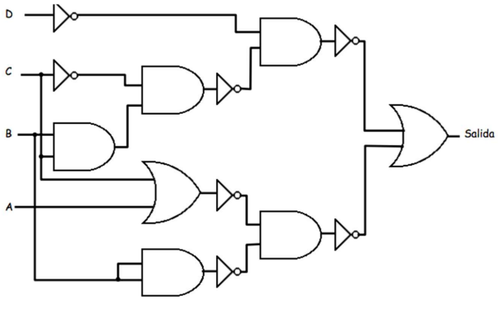

S3

S2

S7

S1

S4

S6

S5

**Taula de veritat**

|  |  |  |  |  |  |  |  |  |  |  |  |  |  |  |  |  |
| --- | --- | --- | --- | --- | --- | --- | --- | --- | --- | --- | --- | --- | --- | --- | --- | --- |
|  |  |  |  |  |  |  |  |  |  | S1 | S2 | S3 | S4 | S5 | S6 | S7 |
| A | **B** | **C** | **D** |  | **A'** | **B'** | **C'** | **D'** |  | **B · C** | **(C' · S1)'** | **(D' · S2)'** | **(C + A)'** | **(B · B)'** | **(S4 · S5)'** | **S3 + S6** |
| 0 | 0 | 0 | 0 |  | 1 | 1 | 1 | 1 |  | 0 | 1 | 0 | 1 | 1 | 0 | 0 |
| 0 | 0 | 0 | 1 |  | 1 | 1 | 1 | 0 |  | 0 | 1 | 1 | 1 | 1 | 0 | 1 |
| 0 | 0 | 1 | 0 |  | 1 | 1 | 0 | 1 |  | 0 | 1 | 0 | 0 | 1 | 1 | 1 |
| 0 | 0 | 1 | 1 |  | 1 | 1 | 0 | 0 |  | 0 | 1 | 1 | 0 | 1 | 1 | 1 |
| 0 | 1 | 0 | 0 |  | 1 | 0 | 1 | 1 |  | 0 | 1 | 0 | 1 | 0 | 1 | 1 |
| 0 | 1 | 0 | 1 |  | 1 | 0 | 1 | 0 |  | 0 | 1 | 1 | 1 | 0 | 1 | 1 |
| 0 | 1 | 1 | 0 |  | 1 | 0 | 0 | 1 |  | 1 | 1 | 0 | 0 | 0 | 1 | 1 |
| 0 | 1 | 1 | 1 |  | 1 | 0 | 0 | 0 |  | 1 | 1 | 1 | 0 | 0 | 1 | 1 |
| 1 | 0 | 0 | 0 |  | 0 | 1 | 1 | 1 |  | 0 | 1 | 0 | 0 | 1 | 1 | 1 |
| 1 | 0 | 0 | 1 |  | 0 | 1 | 1 | 0 |  | 0 | 1 | 1 | 0 | 1 | 1 | 1 |
| 1 | 0 | 1 | 0 |  | 0 | 1 | 0 | 1 |  | 0 | 1 | 0 | 0 | 1 | 1 | 1 |
| 1 | 0 | 1 | 1 |  | 0 | 1 | 0 | 0 |  | 0 | 1 | 1 | 0 | 1 | 1 | 1 |
| 1 | 1 | 0 | 0 |  | 0 | 0 | 1 | 1 |  | 0 | 1 | 0 | 0 | 0 | 1 | 1 |
| 1 | 1 | 0 | 1 |  | 0 | 0 | 1 | 0 |  | 0 | 1 | 1 | 0 | 0 | 1 | 1 |
| 1 | 1 | 1 | 0 |  | 0 | 0 | 0 | 1 |  | 1 | 1 | 0 | 0 | 0 | 1 | 1 |
| 1 | 1 | 1 | 1 |  | 0 | 0 | 0 | 0 |  | 1 | 1 | 1 | 0 | 0 | 1 | 1 |

**Funció del circuit**

(D' · (C' · B · C)')' + ((C + A)' · (B · B))'

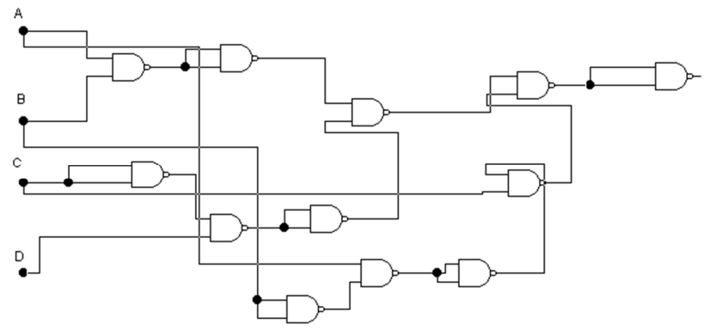d)

S12

S2

S1

S11

S6

S10

S3

S5

S4

S9

S8

S7

**Taula de veritat (pt. 1)**

|  |  |  |  |  |  |  |  |  |  |  |  |  |  |  |
| --- | --- | --- | --- | --- | --- | --- | --- | --- | --- | --- | --- | --- | --- | --- |
|  |  |  |  |  |  |  |  |  |  | S1 | S2 | S3 | S4 | S5 |
| A | **B** | **C** | **D** |  | **A'** | **B'** | **C'** | **D'** |  | **(A · B)'** | **(S1 · S1)'** | **(C · C)'** | **(S3 · D)'** | **(S4 · S4)'** |
| 0 | 0 | 0 | 0 |  | 1 | 1 | 1 | 1 |  | 1 | 0 | 1 | 1 | 0 |
| 0 | 0 | 0 | 1 |  | 1 | 1 | 1 | 0 |  | 1 | 0 | 1 | 0 | 1 |
| 0 | 0 | 1 | 0 |  | 1 | 1 | 0 | 1 |  | 1 | 0 | 0 | 1 | 0 |
| 0 | 0 | 1 | 1 |  | 1 | 1 | 0 | 0 |  | 1 | 0 | 0 | 1 | 0 |
| 0 | 1 | 0 | 0 |  | 1 | 0 | 1 | 1 |  | 1 | 0 | 1 | 1 | 0 |
| 0 | 1 | 0 | 1 |  | 1 | 0 | 1 | 0 |  | 1 | 0 | 1 | 0 | 1 |
| 0 | 1 | 1 | 0 |  | 1 | 0 | 0 | 1 |  | 1 | 0 | 0 | 1 | 0 |
| 0 | 1 | 1 | 1 |  | 1 | 0 | 0 | 0 |  | 1 | 0 | 0 | 1 | 0 |
| 1 | 0 | 0 | 0 |  | 0 | 1 | 1 | 1 |  | 1 | 0 | 1 | 1 | 0 |
| 1 | 0 | 0 | 1 |  | 0 | 1 | 1 | 0 |  | 1 | 0 | 1 | 0 | 1 |
| 1 | 0 | 1 | 0 |  | 0 | 1 | 0 | 1 |  | 1 | 0 | 0 | 1 | 0 |
| 1 | 0 | 1 | 1 |  | 0 | 1 | 0 | 0 |  | 1 | 0 | 0 | 1 | 0 |
| 1 | 1 | 0 | 0 |  | 0 | 0 | 1 | 1 |  | 0 | 1 | 1 | 1 | 0 |
| 1 | 1 | 0 | 1 |  | 0 | 0 | 1 | 0 |  | 0 | 1 | 1 | 0 | 1 |
| 1 | 1 | 1 | 0 |  | 0 | 0 | 0 | 1 |  | 0 | 1 | 0 | 1 | 0 |
| 1 | 1 | 1 | 1 |  | 0 | 0 | 0 | 0 |  | 0 | 1 | 0 | 1 | 0 |

**Taula de veritat (pt. 2)**

|  |  |  |  |  |  |  |
| --- | --- | --- | --- | --- | --- | --- |
| S6 | S7 | S8 | S9 | S10 | S11 | S12 |
| (S2 · S5)' | **(B · B)'** | **(A · S7)'** | **(S8 · S8)'** | **(S9 · C)'** | **(S6 · S10)'** | **(S11 · S11)'** |
| 1 | 1 | 1 | 0 | 1 | 0 | 1 |
| 1 | 1 | 1 | 0 | 1 | 0 | 1 |
| 1 | 1 | 1 | 0 | 1 | 0 | 1 |
| 1 | 1 | 1 | 0 | 1 | 0 | 1 |
| 1 | 0 | 1 | 0 | 1 | 0 | 1 |
| 1 | 0 | 1 | 0 | 1 | 0 | 1 |
| 1 | 0 | 1 | 0 | 1 | 0 | 1 |
| 1 | 0 | 1 | 0 | 1 | 0 | 1 |
| 1 | 1 | 0 | 1 | 1 | 0 | 1 |
| 1 | 1 | 0 | 1 | 1 | 0 | 1 |
| 1 | 1 | 0 | 1 | 0 | 1 | 0 |
| 1 | 1 | 0 | 1 | 0 | 1 | 0 |
| 1 | 0 | 1 | 0 | 1 | 0 | 1 |
| 0 | 0 | 1 | 0 | 1 | 1 | 0 |
| 1 | 0 | 1 | 0 | 1 | 0 | 1 |
| 1 | 0 | 1 | 0 | 1 | 0 | 1 |

**Funció del circuit**

**(((((A · B)' · (A · B)')' · (((C · C)' · D)' · ((C · C)' · D)')')' · (((A · (B · B)')' · (A · (B · B)')')'· C)')'**

**·**

**((((A · B)'· (A · B)')' · (((C · C)' · D)' · ((C · C)' · D)')')' · (((A · (B · B)')' · (A · (B · B)')')'· C)')')'**

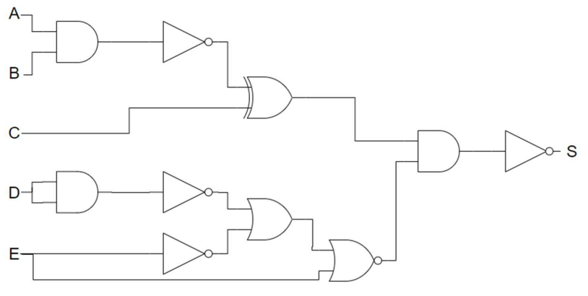e)

S1

S2

S6

S3

S4

S5

**Taula de veritat**

|  |  |  |  |  |  |  |  |  |  |  |  |  |  |  |  |  |  |
| --- | --- | --- | --- | --- | --- | --- | --- | --- | --- | --- | --- | --- | --- | --- | --- | --- | --- |
|  |  |  |  |  |  |  |  |  |  |  |  | S1 | S2 | S3 | S4 | S5 | S6 |
| A | **B** | **C** | **D** | **E** |  | **A'** | **B'** | **C'** | **D'** | **E'** |  | **(A · B)'** | **S1 ⊕ C** | **(D · D)'** | **S3 + E'** | **(S4 + E)'** | **(S2 · S5)'** |
| 0 | 0 | 0 | 0 | 0 |  | 1 | 1 | 1 | 1 | 1 |  | 1 | 1 | 1 | 1 | 0 | 1 |
| 0 | 0 | 0 | 0 | 1 |  | 1 | 1 | 1 | 1 | 0 |  | 1 | 1 | 1 | 1 | 0 | 1 |
| 0 | 0 | 0 | 1 | 0 |  | 1 | 1 | 1 | 0 | 1 |  | 1 | 1 | 0 | 1 | 0 | 1 |
| 0 | 0 | 0 | 1 | 1 |  | 1 | 1 | 1 | 0 | 0 |  | 1 | 1 | 0 | 0 | 0 | 1 |
| 0 | 0 | 1 | 0 | 0 |  | 1 | 1 | 0 | 1 | 1 |  | 1 | 0 | 1 | 1 | 0 | 1 |
| 0 | 0 | 1 | 0 | 1 |  | 1 | 1 | 0 | 1 | 0 |  | 1 | 0 | 1 | 1 | 0 | 1 |
| 0 | 0 | 1 | 1 | 0 |  | 1 | 1 | 0 | 0 | 1 |  | 1 | 0 | 0 | 1 | 0 | 1 |
| 0 | 0 | 1 | 1 | 1 |  | 1 | 1 | 0 | 0 | 0 |  | 1 | 0 | 0 | 0 | 0 | 1 |
| 0 | 1 | 0 | 0 | 0 |  | 1 | 0 | 1 | 1 | 1 |  | 1 | 1 | 1 | 1 | 0 | 1 |
| 0 | 1 | 0 | 0 | 1 |  | 1 | 0 | 1 | 1 | 0 |  | 1 | 1 | 1 | 1 | 0 | 1 |
| 0 | 1 | 0 | 1 | 0 |  | 1 | 0 | 1 | 0 | 1 |  | 1 | 1 | 0 | 1 | 0 | 1 |
| 0 | 1 | 0 | 1 | 1 |  | 1 | 0 | 1 | 0 | 0 |  | 1 | 1 | 0 | 0 | 0 | 1 |
| 0 | 1 | 1 | 0 | 0 |  | 1 | 0 | 0 | 1 | 1 |  | 1 | 0 | 1 | 1 | 0 | 1 |
| 0 | 1 | 1 | 0 | 1 |  | 1 | 0 | 0 | 1 | 0 |  | 1 | 0 | 1 | 1 | 0 | 1 |
| 0 | 1 | 1 | 1 | 0 |  | 1 | 0 | 0 | 0 | 1 |  | 1 | 0 | 0 | 1 | 0 | 1 |
| 0 | 1 | 1 | 1 | 1 |  | 1 | 0 | 0 | 0 | 0 |  | 1 | 0 | 0 | 0 | 0 | 1 |
| 1 | 0 | 0 | 0 | 0 |  | 0 | 1 | 1 | 1 | 1 |  | 1 | 1 | 1 | 1 | 0 | 1 |
| 1 | 0 | 0 | 0 | 1 |  | 0 | 1 | 1 | 1 | 0 |  | 1 | 1 | 1 | 1 | 0 | 1 |
| 1 | 0 | 0 | 1 | 0 |  | 0 | 1 | 1 | 0 | 1 |  | 1 | 1 | 0 | 1 | 0 | 1 |
| 1 | 0 | 0 | 1 | 1 |  | 0 | 1 | 1 | 0 | 0 |  | 1 | 1 | 0 | 0 | 0 | 1 |
| 1 | 0 | 1 | 0 | 0 |  | 0 | 1 | 0 | 1 | 1 |  | 1 | 0 | 1 | 1 | 0 | 1 |
| 1 | 0 | 1 | 0 | 1 |  | 0 | 1 | 0 | 1 | 0 |  | 1 | 0 | 1 | 1 | 0 | 1 |
| 1 | 0 | 1 | 1 | 0 |  | 0 | 1 | 0 | 0 | 1 |  | 1 | 0 | 0 | 1 | 0 | 1 |
| 1 | 0 | 1 | 1 | 1 |  | 0 | 1 | 0 | 0 | 0 |  | 1 | 0 | 0 | 0 | 0 | 1 |
| 1 | 1 | 0 | 0 | 0 |  | 0 | 0 | 1 | 1 | 1 |  | 0 | 0 | 1 | 1 | 0 | 1 |
| 1 | 1 | 0 | 0 | 1 |  | 0 | 0 | 1 | 1 | 0 |  | 0 | 0 | 1 | 1 | 0 | 1 |
| 1 | 1 | 0 | 1 | 0 |  | 0 | 0 | 1 | 0 | 1 |  | 0 | 0 | 0 | 1 | 0 | 1 |
| 1 | 1 | 0 | 1 | 1 |  | 0 | 0 | 1 | 0 | 0 |  | 0 | 0 | 0 | 0 | 0 | 1 |
| 1 | 1 | 1 | 0 | 0 |  | 0 | 0 | 0 | 1 | 1 |  | 0 | 1 | 1 | 1 | 0 | 1 |
| 1 | 1 | 1 | 0 | 1 |  | 0 | 0 | 0 | 1 | 0 |  | 0 | 1 | 1 | 1 | 0 | 1 |
| 1 | 1 | 1 | 1 | 0 |  | 0 | 0 | 0 | 0 | 1 |  | 0 | 1 | 0 | 1 | 0 | 1 |
| 1 | 1 | 1 | 1 | 1 |  | 0 | 0 | 0 | 0 | 0 |  | 0 | 1 | 0 | 0 | 0 | 1 |

**Funció del circuit**

**(((A · B)' ⊕ C) · (((D · D)' + E') + E)')'**