Activitat 1: Taules de veritat

1. Obté les taules de veritat i les funcions dels següents circuits:
2. 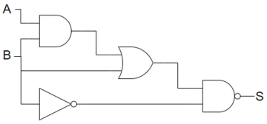

**Taula de veritat**

|  |  |  |  |  |  |  |  |  |
| --- | --- | --- | --- | --- | --- | --- | --- | --- |
|  |  |  |  |  |  | S1 | S2 | S3 |
| A | **B** |  | **A’** | **B’** |  | A · B | S1 + B | (S2 · B’)’ |
| 0 | 0 |  | 1 | 1 |  | 0 | 0 | 1 |
| 0 | 1 |  | 1 | 0 |  | 0 | 1 | 1 |
| 1 | 0 |  | 0 | 1 |  | 0 | 0 | 1 |
| 1 | 1 |  | 0 | 0 |  | 1 | 1 | 1 |

1. 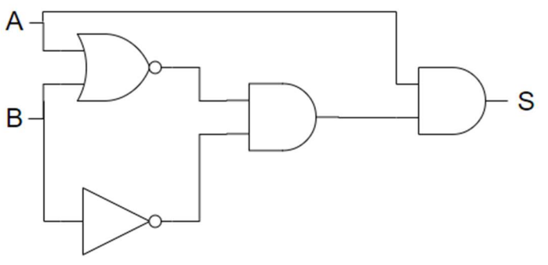

**Taula de veritat**

|  |  |  |  |  |  |  |  |  |
| --- | --- | --- | --- | --- | --- | --- | --- | --- |
|  |  |  |  |  |  | S1 | S2 | S3 |
| A | **B** |  | **A’** | **B’** |  | (A + B)’ | S1 · B’ | S2 · A |
| 0 | 0 |  | 1 | 1 |  | 1 | 1 | 0 |
| 0 | 1 |  | 1 | 0 |  | 0 | 0 | 0 |
| 1 | 0 |  | 0 | 1 |  | 0 | 0 | 0 |
| 1 | 1 |  | 0 | 0 |  | 0 | 0 | 0 |

1. 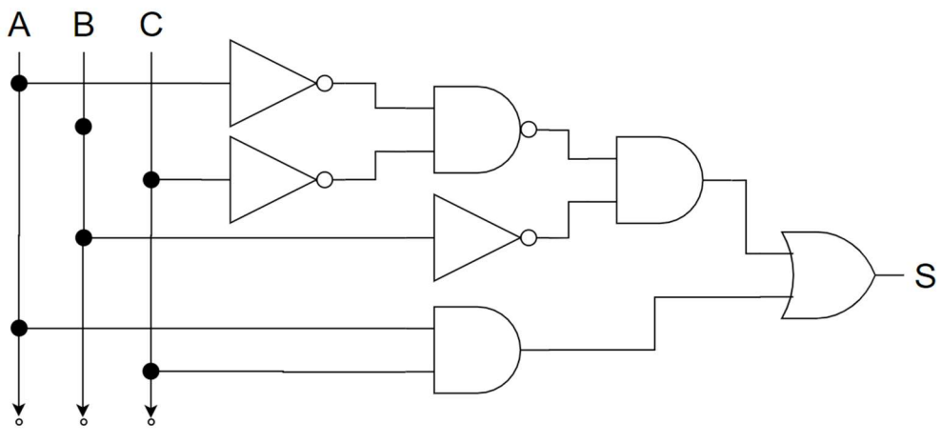

**Taula de veritat**

|  |  |  |  |  |  |  |  |  |  |  |  |
| --- | --- | --- | --- | --- | --- | --- | --- | --- | --- | --- | --- |
|  |  |  |  |  |  |  |  | **S1** | **S2** | **S3** | **S4** |
| A | **B** | **C** |  | **A’** | **B’** | **C’** |  | (A’ · C’)’ | S1 · B’ | A · C | S2 + S3 |
| 0 | 0 | 0 |  | 1 | 1 | 1 |  | 0 | 0 | 0 | 0 |
| 0 | 0 | 1 |  | 1 | 1 | 0 |  | 1 | 1 | 0 | 1 |
| 0 | 1 | 0 |  | 1 | 0 | 1 |  | 0 | 0 | 0 | 0 |
| 0 | 1 | 1 |  | 1 | 0 | 0 |  | 1 | 0 | 0 | 0 |
| 1 | 0 | 0 |  | 0 | 1 | 1 |  | 1 | 1 | 0 | 1 |
| 1 | 0 | 1 |  | 0 | 1 | 0 |  | 1 | 1 | 1 | 1 |
| 1 | 1 | 0 |  | 0 | 0 | 1 |  | 1 | 0 | 0 | 0 |
| 1 | 1 | 1 |  | 0 | 0 | 0 |  | 1 | 0 | 1 | 1 |