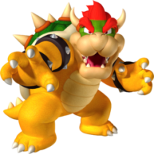[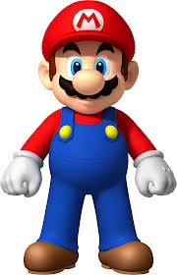](http://www.google.ca/imgres?q=mario+bros&hl=en&biw=953&bih=564&tbm=isch&tbnid=0tJ-wcC590Sa7M:&imgrefurl=http://www.fanpop.com/clubs/super-mario-bros/images/32901984/title/big-mario-photo&docid=DwuMTCTRU8f1UM&imgurl=http://images6.fanpop.com/image/photos/32900000/Big-Mario-super-mario-bros-32901984-1586-2462.png&w=1586&h=2462&ei=d0VUUZHTMKjhyQGI_YC4Cg&zoom=1&iact=hc&vpx=731&vpy=42&dur=499&hovh=280&hovw=180&tx=133&ty=172&page=1&tbnh=149&tbnw=96&start=0&ndsp=15&ved=1t:429,r:4,s:0,i:157)

Your job is to create the popular scene at the end of most super Mario levels. All resources have been provided. Below is the starting point for the program:

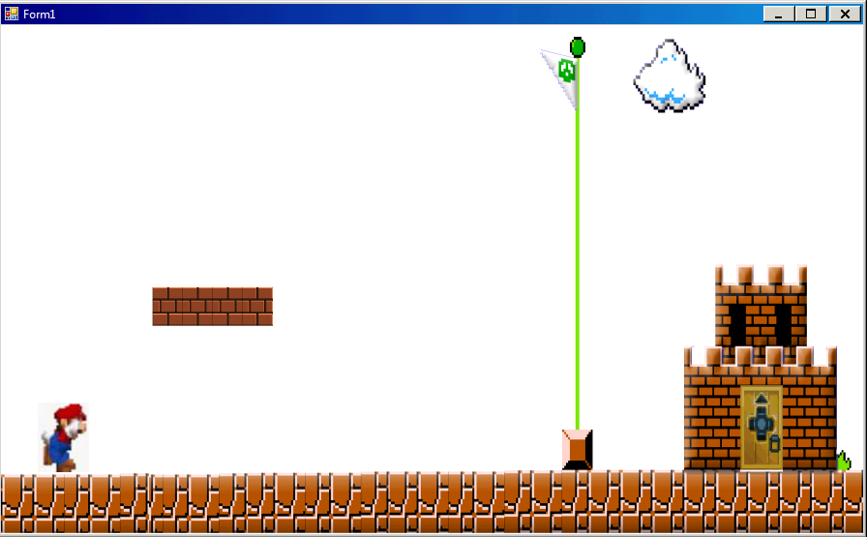

The scene consists of e parts: **Running, Jumping,** and **Going through the door.**

**Running:** Mario should run towards the flag until he gets past the bricks overhead. Use the mariorun series of sprites to cycle through.

**Jumping:** Mario should jump to the top of the flag using the jump sequence of sprites. Once he gets to the top, just use the one sprite (marioholdflag) and have him fall slowly down the flag. Once he gets to the bottom, simply copy some code from the running part and have him move to the door.

**Going Through The Door:** When Mario gets to the door, have the program cycle through some of the door pictures. Use as many as you need to code the door opening and Mario going inside (you don’t have to use all of them).

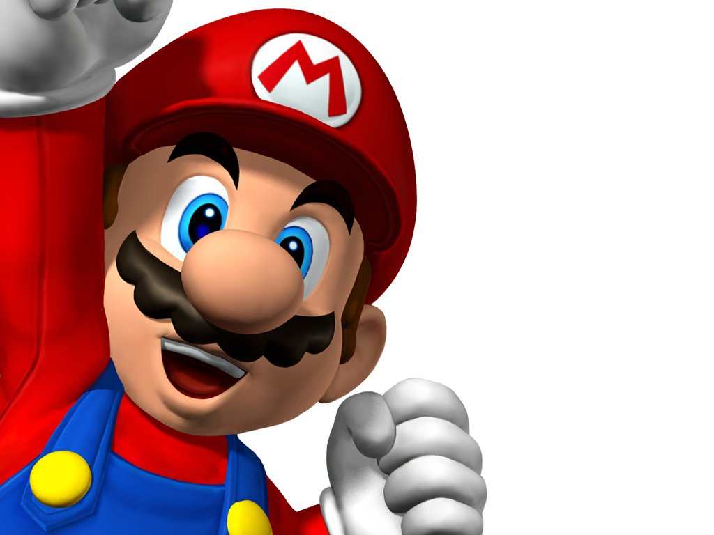

Here are some things to consider throughout your animation.

* Try to make your animation as smooth as possible
* Try to make the characters appear to scale.
* Make sure your timing allows for me to see the animation in order.
* Marks will be given for efficient code