**A Portfolio**

**to enhance my skills**

**Application on**

**Innovation Smart Systems - ISS, Innovative and Secure IoT systems – MSIoT, Réseaux Embarqués et Objets Connectés - REOC**

Table of contents

Part A: GENERALITY 2

Part B: DESCRIPTIVE PART 4

Part D: ANALYTICAL PART 6

Annexes 6

# Part A: GENERALITY

A.I. PRESENTATION of PORTFOLIO

This document must make explicit with reference to the competency framework of this training, the knowledge and skills acquired by your experiences. It revolves around three modes of demonstration of your experience:

1. a descriptive part about your experiences connected to this training; the expected level of description is not a simple enumeration of tasks or facts but a real appreciation of the context in which you carried out these activities.

2. a technical part based on the presentation of problem situations demonstrating all of your knowledge in the field of this training

3. an analytical part that will be the result of the work carried out and which will present all the skills acquired.

In addition to the supporting documents requested, any other document that you consider relevant may be attached to the portfolio

The portfolio will be submitted to the jury. An oral defense of your portfolio and an exchange will be held with the same jury that will seek the adequacy between your achievements and the requirements of this training.

The construction of this portfolio, through the work of explanation, taking back and projection it requires, is a real training project.

*We hope that this new experience is for you the most interesting possible.*

**A-II Some recommendations:**

The elements of this portfolio are recorded over time, they are the result of a process that is consistent throughout the training but may incorporate earlier elements.

Be specific and append significant documents.

Focus on the diversity of the documents presented (media, publication, observation report, etc.) and the multiplicity of sources of information (peers, training managers, etc.).

The points listed constitute a possible frame but can be adapted to the situation of each one.

Do not hesitate to seek advice and support from your teachers to formalize this portfolio.

**A.III. GLOSSARY**

This glossary is provided to help you identify the relevance of certain concepts to your learning.

* **Acquired experience:** various types of resources (theoretical and technological knowledge, knowledge of the professional context, operational know-how, intellectual approaches ...) that have been acquired through the exercise of activities during your career. The term "acquired" means that they result from learning and are not innate dispositions or personality traits.
* **Theoretical and technological knowledge:** knowledge (concepts, laws, theories, operating modes ...) to understand, analyze or interpret a situation, a phenomenon, a problem and to communicate with a specialist in the field. It may be the knowledge of operating modes but not the ability to implement them. This knowledge is expressed in terms of content.

Examples: electronic circuits, resistance of materials, construction technology, genetic engineering, differential equations, technical regulations ...

* **Operational skills:** ability to use instruments, techniques, methods or procedures. They express themselves with action verbs.

Examples: designing a heat exchanger for a given application, using a CAD software, defining a network configuration, performing a microbial count, conducting a problem study meeting, giving a presentation explaining a research project, working in a team and in network ...

* **Relational skills:** the different ways of being, specific to a personality, adapted to a given situation in order to cooperate effectively with others. This know-how is expressed by the verbs "to be or to have" or by verbs of the relational field.

Examples: being communicative, being creative, having a team spirit, having a sense of listening ...

* **Competences:** set of resources acquired by a subject to act appropriately in a field of constraints and resources (technical, human, financial, logistical, temporal, ..) for a specific issue.
* **Tasks:** sequence of manual and intellectual operations constituting a basic unit of work. An activity groups together several tasks for a given mission. A job is described from a list of activities.

Examples: employment: production manager; mission: to ensure the manufacture of a product; activity: driving a production line; tasks: establish the chronology of the production steps / write the data sheets / manage the supply of production / ensure the operational safety of the production system.

A.IV. PRESENTATION OF Your CURRICULUM

*A.III.1. IDENTIFICATION*

**Personal Information:**

Last name First Name:

Age

Maill:

*A.III.2. CURRICULUM VITAE*

It is a question of adding in the body of the file your synthetic CV (1 page) allowing a global vision of your course.

*A.III.3. YOUR ACQUIRED TRAINING*

This part must explain in as much detail as possible your training course.

**Quote trainings or lessons most related to the PTP**

|  |  |  |  |
| --- | --- | --- | --- |
| **Entitled** | **Organism** | **Year** | **Duration (in number of hours)** |
| **Smart Devices** | **INSA** | **2018 – 2019** | **60.25** |
| Sensors introduction |  |  | 11.25 |
| Microcontrollers and Open Source-Hardware (M&OSH) |  |  | 27.5 |
| Optical Sensors |  |  | 7.5 |
| CAD, manufacturing and integration of nanotechnology sensors |  |  | 14 |
| **Communication** | **INSA** | **2018 – 2019** | **63.75** |
| Protocols for connected objects |  |  | 33.25 |
| Digital Wireless Communications for connected objects |  |  | 5 |
| Energy for connected objects (recovery, transfer) |  |  | 7.5 |
| Security for network of connected object |  |  | 7.5 |
| Emerging network (SDN, NGN) |  |  | 10.5 |
| **Middleware and Service** | **INSA** | **2018 – 2019** | **62** |
| Service architecture |  |  | 31 |
| Middleware of Internet of Things |  |  | 14.75 |
| Adaptability: cloud and autonomic management |  |  | 16.75 |
| **Analysis and Data Processing, Business Applications** | **INSA** | **2018 – 2019** | **37.5** |
| Software Engineering |  |  | 6.25 |
| Semantic Data |  |  | 8 |
| Big Data |  |  | 15 |
| SPOC/Hackathon/Seminaries |  |  | 8.25 |
| **Innovative project** | **INSA** | **2018 – 2019** | **80.75** |
| Innovative project |  |  | 37.5 |
| Portfolio |  |  | 8.25 |
| English |  |  | 35 |
| **Innovation and humanity** | **INSA** | **2018 – 2019** | **95.5** |
| Innovation / Social Acceptability / Business development |  |  | 20 |
| Creativity methods / TRIZ method |  |  | 20.5 |
| Team Management |  |  | 20 |
| Sport |  |  | 25 |
| Individualized Professional Development |  |  | 10 |

# Part B: DESCRIPTIVE PART

**B.I. PRESENTATION OF EXPERIENCES LINKED TO THE TRAINING**

You will present ALL of your possible experiences (internships, projects, ...). This is to mention only the date, duration, frame and role occupied.

In the next section (B.II), you will describe the experiences that you think highlight the knowledge and skills of the training.

The purpose of this descriptive part is to understand in what context (s) you have evolved and how the development of your skills within this particular context (s) has occurred.

Please mention the experience (s) that will be the object of your development:

|  |  |  |  |
| --- | --- | --- | --- |
| **Summary table of the whole course** | | | |
| **DATE** | **DURATION** | **CONTEXT** | **FUNCTION(S)** |
| 10/04/2018 to 01/22/2019 | 4 months | Innovative project: realization of a platform for the measurement of the air quality of a big city. This project is in collaboration with the University of Wollongong. | Development of a web interface including data analysis and data visualization through a map and graphs. |
| 10/01/2018 to 11/30/2018 | 2 months | Smart devices: conception of an Arduino Uno board | Conception of the PCB, schematics and routing |
| 11/26/2018 to 12/22/2018 | 1 month | Big Data: analysis of a dataset about the Olympic Games | Implementation and interpretation of 4 graphs in order to deduce which parameters impact on the winning of a medal |
| 11/08/2018 to 11/09/2018 | 2 days | Hackathon: This project was |  |
| 12/18/2018 to |  | Service architecture: |  |

**B.II. Innovative project**

*The description of the experience should not be an enumeration of your activities but a descriptive and detailed study of your functions and tasks in a given context. For each of these experiences, we ask you to describe successively:*

*B.II.1. The environment and context*

*Specify the economic environment in which you have evolved, the organization, its sector and field of activity,*

*Explain the assigned missions, your contribution to the overall production.*

*B.II.2. your function*

*Analyze in a few lines your function in terms of missions or activities.*

**B.II. Innovative project**

*B.II.1. The environment and context*

Nowadays, big cities have various nuisance which impact on the health and the comfort of citizen. The University of Wollongong, based in Australia, has proposed a project on designing an embedded sensor platform to be deployed by non-scientific people. This platform has to collect data about the quality of the air in a city, analyze these data and display them on a user interface as a website.

This project is the main project for the Innovative Smart System training as it combines electronic and computer science skills. For this project, our team is composed of five students: two from electronic domain and three from the computer science domain. We divided the project into two parts: an electronic part and a software part.

*B.II.2. your function*

As I am a computer science student, I was part of the computer science team. Our missions were to develop the web interface and to analyze data measured by the air quality sensor in order to interpret them and show them on the interface through graphs and a map. One member of the team has already developed a website using Angular, so we decide to use this technology to develop our website.

**B.III. Smart Devices**

*B.II.1. The environment and context*

The “Smart Devices” module includes diverse notions as sensors, microcontrollers and design documents of electronic cards using KiCad. The aim of the course is to have a first experience with microcontrollers and their architecture, and their use with sensors in order to collect data from these sensors and send these data on a low power wide area network as LoRa. As a student coming from computer science domain, it was my first time working on an Arduino microcontroller and designing electronical circuits.

We had to make a project in pair which consists of designing an Arduino shield in order to connect a gas sensor to an Arduino Uno. The Arduino collects data from the sensor and send them to a LoRa module which communicates them on The Things Network.

*B.II.2. your function*

To realize this project, me and my partners worked on the same tasks. Firstly, we had to make the schematic of the impedance adaptation circuit using KiCad. Some components are not present initially in KiCad, so we had to draw the symbol of a LTC1050 amplifier and a RN_Breakout2483 module regarding their datasheet. Then, we have drawn the schematic of the impedance adaptation circuit.

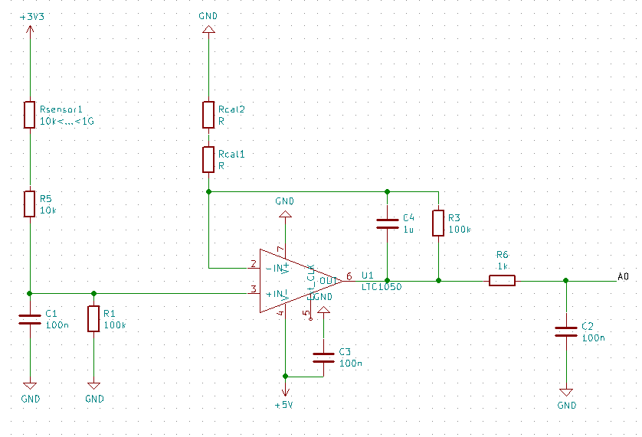

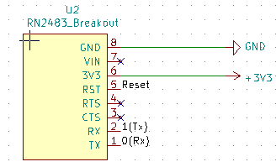

Secondly, we made the layout of the PCB from the schematic by arranging components on the board and routing them.

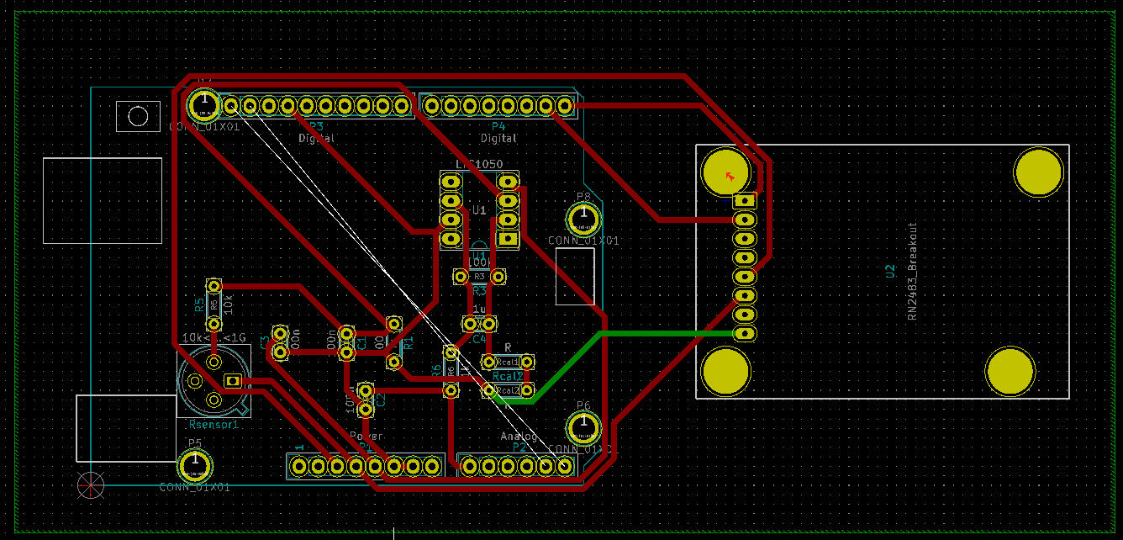

**B.IV. Big Data**

*B.II.1. The environment and context*

*Specify the economic environment in which you have evolved, the organization, its sector and field of activity,*

*Explain the assigned missions, your contribution to the overall production.*

*B.II.2. your function*

*Analyze in a few lines your function in terms of missions or activities.*

**Part C: TECHNICAL PART**

**NOTES (to be deleted later)**

During your journey, you were confronted with problem situations (technical problem solving, strategic choices ...) during which you had to implement a relevant practice to achieve a desired result.

We propose to describe these situations that you had to solve. The chosen problem situations must highlight the technical knowledge you have developed in direct relation to the Training.

Express yourself in terms of "I": "I started with, I searched, I tried to". You will reproduce -the proposed frame for each problem situation developed:

**C.I.1 Presentation**

Present the situation by specifying the context, the field of responsibilities, the actor (s), the objectives to be reached, the resources and the constraints (human, material, financial, informational ...), the duration and the dates.

**C.I.2. Resolution of problem**

Explain the chosen solution by answering the following three questions:

"What": the description of the solution; "How": the way to go about it and "Why": the justification of your choice

**C.I.3.The knowledge and skills mobilized**

What new skills did you have to mobilize and develop to solve this problem? How did you acquire them (reading, training, peers)?

**C.1.4. Summary and Review**

Make a synthetic summary of the situation-problem. To conclude, it is a question of taking stock by answering the following questions: what lessons have you learned from this experience? Today with hindsight, what analysis of the proposed solution do you make?

**END OF INSTRUCTIONS (to be deleted later)**

During my training, I was confronted with many problems through the projects. I will present in this part all situations where I was confronted to these problems and how I solve them.

**C.I. Innovative project (TODO)**

**C.II. Smart Devices**

C.II.1. Presentation

The purpose of this project is to conceive the schematic impedance adaptation circuit in order to connect a gas sensor to the Arduino Uno. Me and my partner were from the computer science department, so it was the first time we designed an electronic circuit using KiCad. The first problem was to get familiar with the software and to understand electronic concepts.

C.II.2. Resolution of problem

C.II.3. The knowledge and skill mobilized

C.II.4. Summary and Review

# Part D: ANALYTICAL PART

D.I. ANALYSIS OF SKILLS

You have presented the significant experiences related to the training. You also presented several problem situations where you explained the acquired knowledge and the skills mobilized to solve these problems.

In this last part, it is for you to make an exhaustive analysis of all the knowledge and skills acquired during these different experiences.

In the table below, for each activity, specify your level of execution corresponding to the appropriate figure using the following criteria:

Sma

**AP- level of application:** follow-up of instructions or procedures

**AN- level of analysis:** improvement or optimization of solutions or proposals

**M - level of proficiency:** program design or specification definitions

**EX - level of expertise:** definition of orientations or strategies

|  |  |  |  |
| --- | --- | --- | --- |
| **Activities** | **Acquired experience in terms of**  1. theoretical, technological knowledge,  2. operational know-how, and relational,  3. intellectual steps  4. other skills related to a given position | **Modes[1]** | **Level**  **(AP to EX)** |
|  |  |  |  |

**D.II. SELF EVALUATION**

* Make a summary of the skills you think you can use with the training.

............................................................................................................ ...

* Possibly what skills are still missing?

............................................................................................................ ...

**D.III. BALANCE SHEET**

* What contributions do you draw from the in-depth analysis of your experiences in building your portfolio?

............................................................................................................ ...

**D.IV. COMPLEMENTARY ELEMENTS**

* Are there additional elements that you wish to communicate to the jury?

…………………………………………………………………………………………….......

# Annexes

1. Main acquisition methods: Initial training (IT), peer exchange (PE), self-training (ST), professional practice (PP)