Database Management System Project Report and Docs
Smart Pickup System for Kids

Submitted by: Tehman Hassan 23-CP-11
Submitted to: Dr Abdur Rehman



Department of Computer Engineering University of Engineering and Technology Taxila

1. Project Overview
NANI 2.0 is a full-stack Smart School Pickup Management System built to eliminate the unorganized and unsafe process of collecting students from school gates. Parents schedule pickups in advance through a web interface, a real-time queue is formed and broadcast live to the responsible teacher, and the teacher marks each child as "Picked Up" when the parent arrives. The entire interaction is tracked in a relational MySQL database, authenticated with JSON Web Tokens, and updated in real-time through Redis-backed WebSockets.
1.1 Project Purpose
Traditional school dismissal is chaotic — teachers must recognize parents by face, queues form randomly, and no audit trail exists. NANI 2.0 solves this by:
• Giving every student a unique QR code that a teacher can scan to confirm identity
• Letting parents pre-book a pickup slot, which auto-inserts them into a prioritized queue
• Displaying the live queue on both the parent dashboard and the teacher screen simultaneously
• Logging every booking with a timestamp, status, and priority score in the database
• Providing an admin panel for full oversight of users, students, and bookings
1.2 Technology Stack
Component | Technology | Version / Detail
Backend Framework | FastAPI (Python) | 0.115+
ORM | SQLAlchemy | 2.0+
Database Migrations | Alembic | 1.13+
Relational Database | MySQL | 8.0
Password Hashing | passlib / bcrypt | 1.7.4
JWT Authentication | python-jose | 3.3.0
Real-time Messaging | Redis (Pub/Sub) | 5.0+
WebSocket | FastAPI WebSocket (ASGI) | Built-in
Frontend Framework | React | 18
Frontend Build Tool | Vite | 5
CSS Framework | Tailwind CSS | 3
Routing (Frontend) | React Router DOM | 6
Database Driver | PyMySQL | 1.1.1

1.3 System Architecture
The system follows a classic three-tier architecture. The Browser (React SPA) communicates with the FastAPI backend over HTTP REST for data operations and over WebSocket for live queue updates. The backend connects to MySQL 8.0 via SQLAlchemy for persistent storage and to Redis via redis-py for the real-time publish/subscribe message channel. JWT tokens are stored in browser localStorage and sent on every HTTP request inside an Authorization: Bearer header.
2. Database Design
The NANI 2.0 database (named nani2) is a normalized MySQL 8.0 relational database consisting of nine tables. All primary keys are UUID v4 strings (VARCHAR 36) rather than auto-incremented integers — this prevents enumerable ID attacks and makes distributed inserts safe. ENUM types are used for status and role columns to enforce valid values at the database level.
2.1 Entity-Relationship Model
The ER diagram below shows all nine entities, their attributes (with PK/FK markers), and the cardinality of every relationship. The four denormalized columns in the students entity are visible as plain attributes without a corresponding FK arrow.
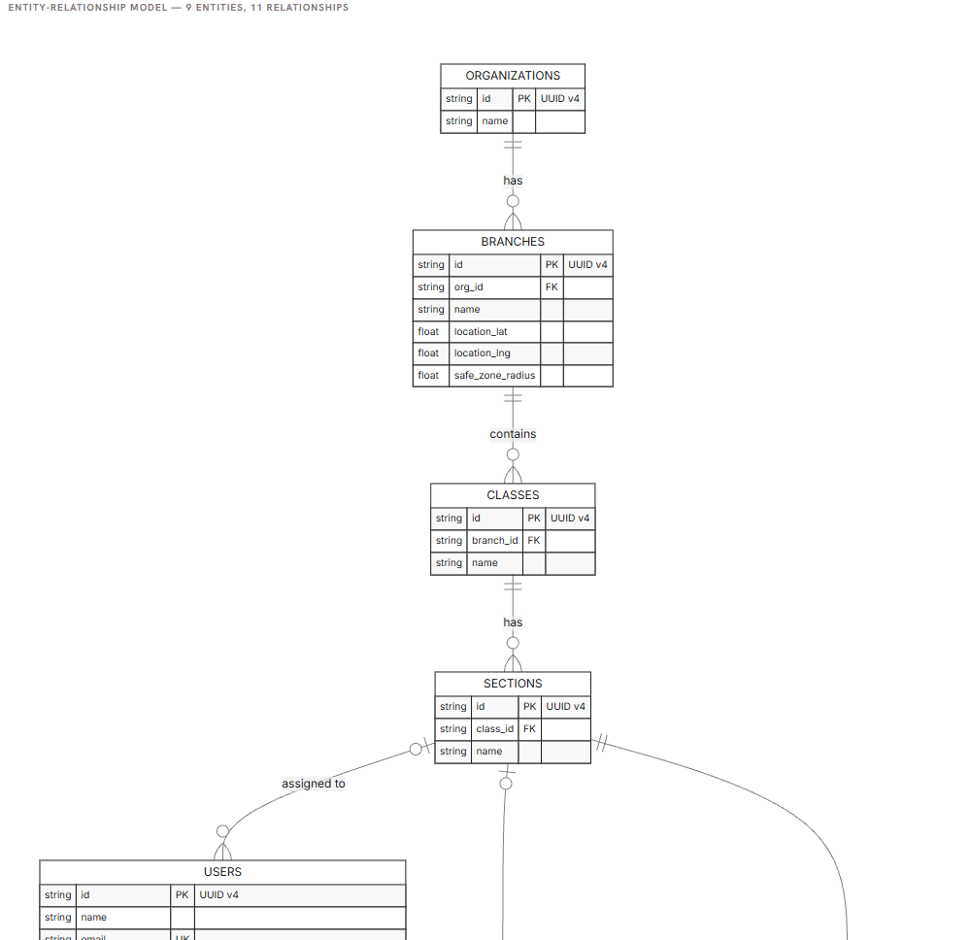
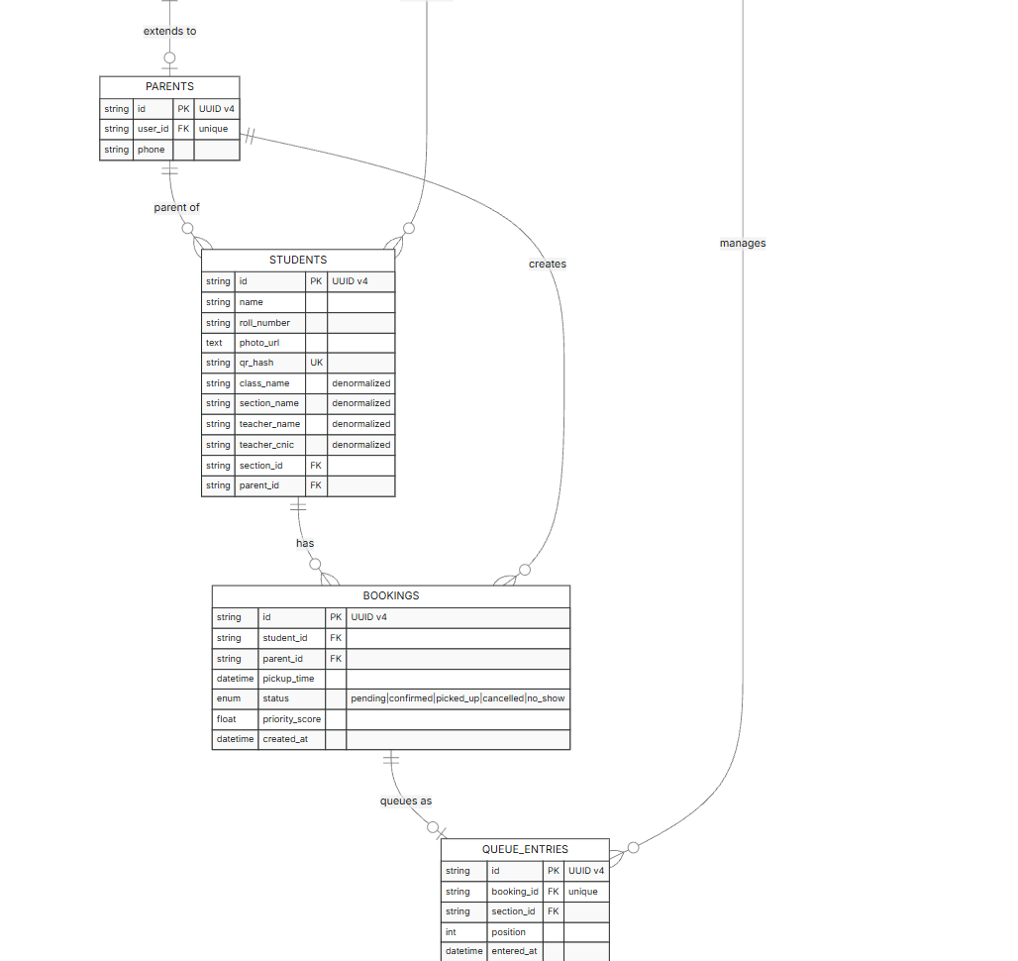
2.2 Relational Schema
The relational schema below maps each entity to its formal relation, showing column names, data types, primary key (underlined), and foreign key (italic) notations.
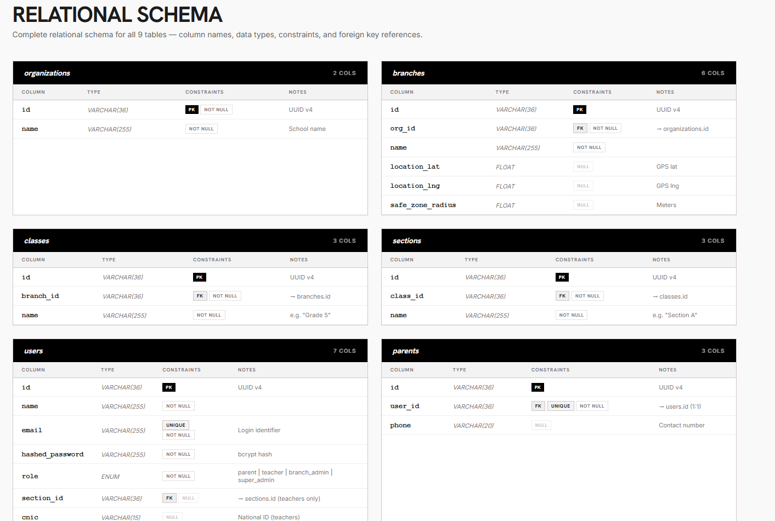
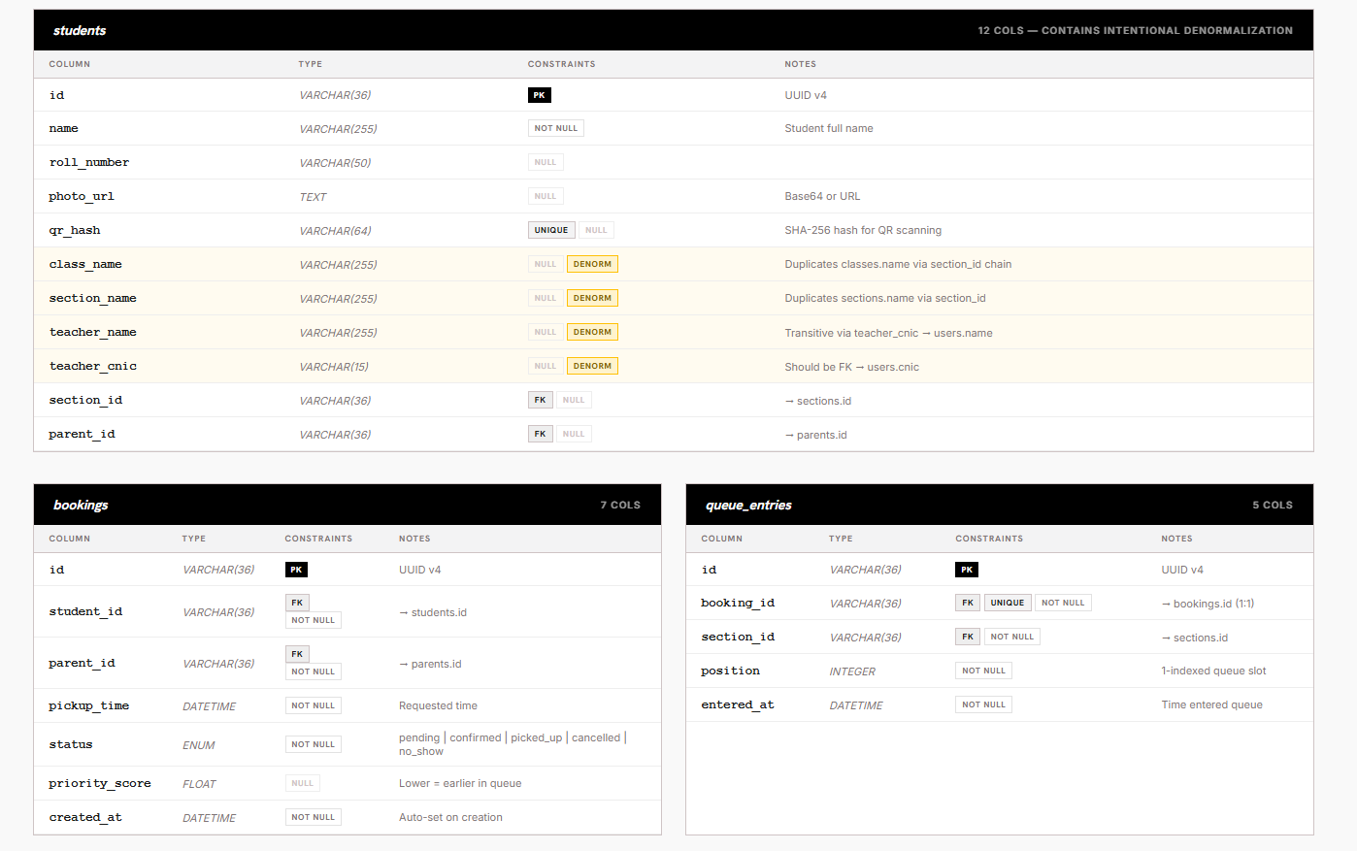
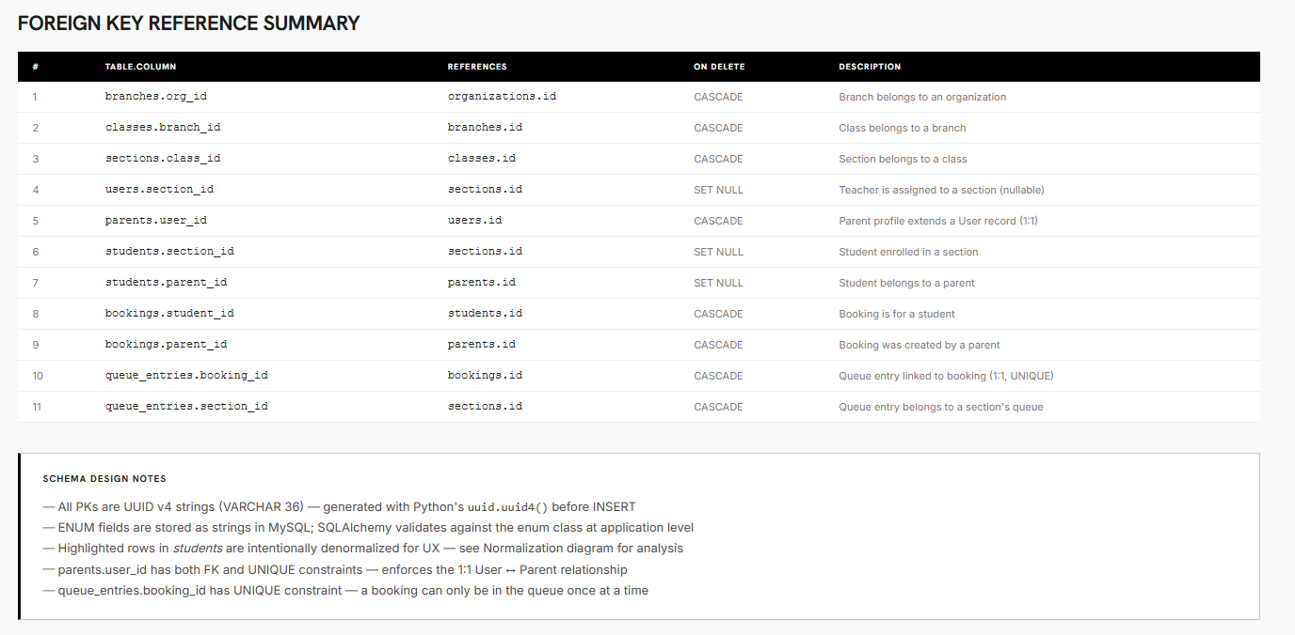
2.3 Table Descriptions
2.3.1 organizations
Stores the top-level school organization. All branches belong to one organization. Designed to support multi-school deployments in future.
Column | Type | Constraints | Description
id | VARCHAR(36) | PRIMARY KEY | UUID v4 — generated in Python
name | VARCHAR(255) | NOT NULL | Full name of the organization

2.3.2 branches
A physical campus or branch location belonging to an organization. Stores optional GPS coordinates and a safe-zone radius used by the location proximity feature.
Column | Type | Constraints | Description
id | VARCHAR(36) | PRIMARY KEY | UUID v4
org_id | VARCHAR(36) | FK → organizations.id NOT NULL | Parent organization
name | VARCHAR(255) | NOT NULL | Branch name
location_lat | FLOAT | NULL | GPS latitude
location_lng | FLOAT | NULL | GPS longitude
safe_zone_radius | FLOAT | NULL | Radius in metres for safe-zone detection

2.3.3 classes
A grade-level class (e.g., "Grade 5") within a branch. Classes group sections.
Column | Type | Constraints | Description
id | VARCHAR(36) | PRIMARY KEY | UUID v4
branch_id | VARCHAR(36) | FK → branches.id NOT NULL | Owning branch
name | VARCHAR(255) | NOT NULL | Class label, e.g. "Grade 5"

2.3.4 sections
A section within a class (e.g., "Section A"). Each section has one assigned teacher and its own pickup queue. This is the central organizing unit of the queue system.
Column | Type | Constraints | Description
id | VARCHAR(36) | PRIMARY KEY | UUID v4
class_id | VARCHAR(36) | FK → classes.id NOT NULL | Parent class
name | VARCHAR(255) | NOT NULL | Section label, e.g. "Section A"

2.3.5 users
Central identity table for all system users — parents, teachers, branch admins, and super admins. Email is unique across the system and serves as the login identifier. Passwords are stored as bcrypt hashes, never in plain text.
Column | Type | Constraints | Description
id | VARCHAR(36) | PRIMARY KEY | UUID v4
name | VARCHAR(255) | NOT NULL | Full name
email | VARCHAR(255) | UNIQUE NOT NULL | Login email address
hashed_password | VARCHAR(255) | NOT NULL | bcrypt password hash
role | ENUM | NOT NULL | parent | teacher | branch_admin | super_admin
section_id | VARCHAR(36) | FK → sections.id NULL | Assigned section (teachers only)
cnic | VARCHAR(15) | NULL | National ID number (teachers)

2.3.6 parents
An extension profile for users whose role is "parent". Follows the Role-Extension pattern — every parent User has exactly one Parent record linked via user_id. The UNIQUE constraint on user_id enforces the 1:1 relationship.
Column | Type | Constraints | Description
id | VARCHAR(36) | PRIMARY KEY | UUID v4
user_id | VARCHAR(36) | FK → users.id UNIQUE NOT NULL | Linked user (1:1)
phone | VARCHAR(20) | NULL | Contact phone number

2.3.7 students
Stores child profiles registered by parents. Contains both properly normalized FK columns (section_id, parent_id) and four intentionally denormalized plain-text columns (class_name, section_name, teacher_name, teacher_cnic) entered by the parent at registration time. See Section 3 for normalization analysis.
Column | Type | Constraints | Description
id | VARCHAR(36) | PRIMARY KEY | UUID v4
name | VARCHAR(255) | NOT NULL | Student full name
roll_number | VARCHAR(50) | NULL | School roll number
photo_url | TEXT | NULL | Base64-encoded photo or URL
qr_hash | VARCHAR(64) | UNIQUE NULL | SHA-256 hash for QR code scanning
class_name | VARCHAR(255) | NULL — DENORMALIZED | Stores classes.name redundantly
section_name | VARCHAR(255) | NULL — DENORMALIZED | Stores sections.name redundantly
teacher_name | VARCHAR(255) | NULL — DENORMALIZED | Stores users.name (teacher) redundantly
teacher_cnic | VARCHAR(15) | NULL — DENORMALIZED | Teacher CNIC entered by parent (no FK)
section_id | VARCHAR(36) | FK → sections.id NULL | Normalized section reference
parent_id | VARCHAR(36) | FK → parents.id NULL | Owning parent

2.3.8 bookings
A pickup request created by a parent for a specific student. Holds the requested pickup time, the calculated priority score, and the current status. A student can have at most one active booking at any time (enforced in application logic).
Column | Type | Constraints | Description
id | VARCHAR(36) | PRIMARY KEY | UUID v4
student_id | VARCHAR(36) | FK → students.id NOT NULL | Booked student
parent_id | VARCHAR(36) | FK → parents.id NOT NULL | Booking parent
pickup_time | DATETIME | NOT NULL | Requested pickup date-time
status | ENUM | NOT NULL | pending | confirmed | picked_up | cancelled | no_show
priority_score | FLOAT | NULL | Unix timestamp of pickup_time ± bonuses/penalties
created_at | DATETIME | NOT NULL | Auto-set at creation time

2.3.9 queue_entries
Represents a booking's position inside a section's live pickup queue. Created automatically when a booking is created. The UNIQUE constraint on booking_id guarantees a booking appears in the queue at most once.
Column | Type | Constraints | Description
id | VARCHAR(36) | PRIMARY KEY | UUID v4
booking_id | VARCHAR(36) | FK → bookings.id UNIQUE NOT NULL | Linked booking (1:1)
section_id | VARCHAR(36) | FK → sections.id NOT NULL | Section whose queue this entry belongs to
position | INTEGER | NOT NULL | 1-indexed queue slot, reordered after each change
entered_at | DATETIME | NOT NULL | Timestamp when entry was added to queue

2.4 Foreign Key Relationships
# | Table.Column | References | On Delete | Purpose
1 | branches.org_id | organizations.id | CASCADE | Branch belongs to an organization
2 | classes.branch_id | branches.id | CASCADE | Class belongs to a branch
3 | sections.class_id | classes.id | CASCADE | Section belongs to a class
4 | users.section_id | sections.id | SET NULL | Teacher optionally assigned to section
5 | parents.user_id | users.id | CASCADE | 1:1 parent profile for a user
6 | students.section_id | sections.id | SET NULL | Student enrolled in a section
7 | students.parent_id | parents.id | SET NULL | Student belongs to a parent
8 | bookings.student_id | students.id | CASCADE | Booking is for a student
9 | bookings.parent_id | parents.id | CASCADE | Booking created by a parent
10 | queue_entries.booking_id | bookings.id | CASCADE | Queue entry linked to a booking (1:1)
11 | queue_entries.section_id | sections.id | CASCADE | Queue entry belongs to section's queue

3. Normalization Analysis
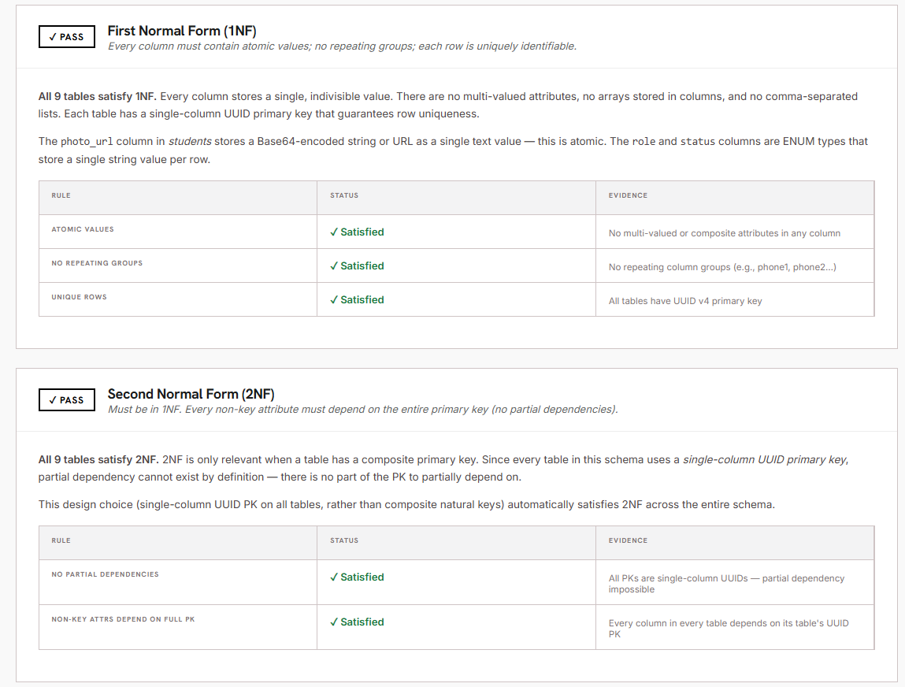
3.1 First Normal Form (1NF)
All nine tables satisfy 1NF. Every column in every table stores a single atomic value — there are no repeating groups, no multi-valued attributes, and no comma-separated lists stored in a column. Each row is uniquely identifiable by its UUID primary key.
• Atomic values: photo_url stores one Base64 string; role stores one ENUM string; status stores one ENUM string
• No repeating groups: there are no phone1, phone2 style columns anywhere in the schema
• Unique rows: every table has a single-column UUID v4 primary key guaranteeing row uniqueness
3.2 Second Normal Form (2NF)
All nine tables satisfy 2NF. Since every table in this schema uses a single-column UUID primary key, partial dependency cannot exist by definition — there is no part of a composite key to partially depend on. This design choice (UUID PKs over composite natural keys) automatically satisfies 2NF across the entire database.
3.3 Note on Denormalization in the students Table
The students table contains four columns that technically violate 3NF through transitive dependency: class_name, section_name, teacher_name, and teacher_cnic. This was an intentional design decision made for the following reasons:
• Parents register their children by typing class, section, and teacher information manually during sign-up — not by selecting from system-managed dropdowns
• Storing class_name and section_name locally avoids requiring parents to know internal UUIDs
• teacher_cnic is entered by the parent to loosely link their child to a teacher without a hard FK dependency
• The section_id FK still exists as the normalized reference, established by admin workflows after registration
• This pattern is commonly called denormalization for write-side simplicity and is accepted in production systems when the trade-off is clearly justified
4. Use Case Analysis
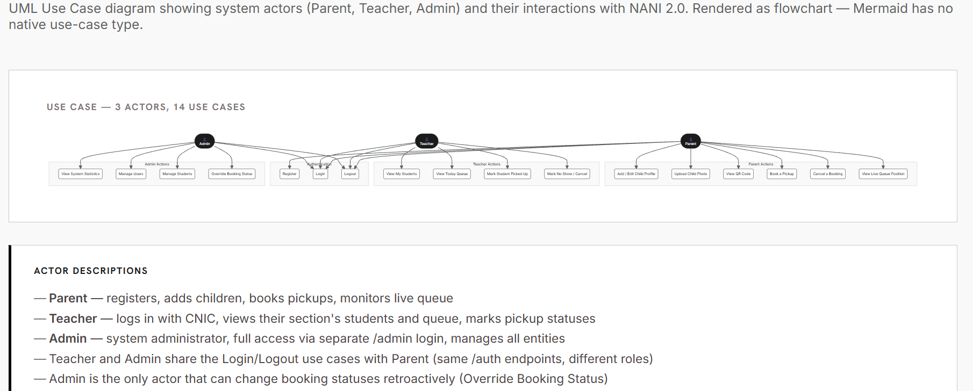

4.1 System Actors
Actor | Role | Description
Parent | Registered user (role = parent) | Registers children, books pickups, monitors live queue and QR codes
Teacher | Registered user (role = teacher) | Logs in with CNIC, views section students and daily queue, marks pickup statuses
Admin | Registered user (role = super_admin) | Full system access via /admin-login, manages all entities and overrides bookings
System | Backend (automated) | Calculates priority scores, inserts queue entries, broadcasts live updates via WebSocket

4.2 Use Case Table
Actor | Use Case | Description
Parent | Register | Create an account with name, email, password, and role selection
Parent | Login | Authenticate with email and password, receive JWT token
Parent | Add Child Profile | Enter student details including class, section, and teacher CNIC
Parent | Upload Child Photo | Upload a Base64-encoded photo stored in students.photo_url
Parent | View QR Code | View or download the child's unique SHA-256 QR code for gate scanning
Parent | Book a Pickup | Select a child, date, and time; system inserts booking and queue entry
Parent | Cancel a Booking | Cancel a pending or confirmed booking; queue reorders automatically
Parent | View Live Queue | See the real-time queue position via WebSocket broadcast
Teacher | Login | Authenticate using email and password (same /auth/login endpoint)
Teacher | View My Students | See all students assigned to the teacher's section
Teacher | View Today's Queue | See the live ordered queue for their section for the current day
Teacher | Mark Picked Up | Update booking status to picked_up; queue reorders and parent is notified
Teacher | Mark No Show / Cancel | Update status to no_show or cancelled; affects queue ordering
Admin | View System Stats | See total counts of users, students, and bookings
Admin | Manage Users | View, edit, and delete user accounts
Admin | Manage Students | View and update student records
Admin | Override Booking Status | Change any booking's status regardless of current state

5. System Flow
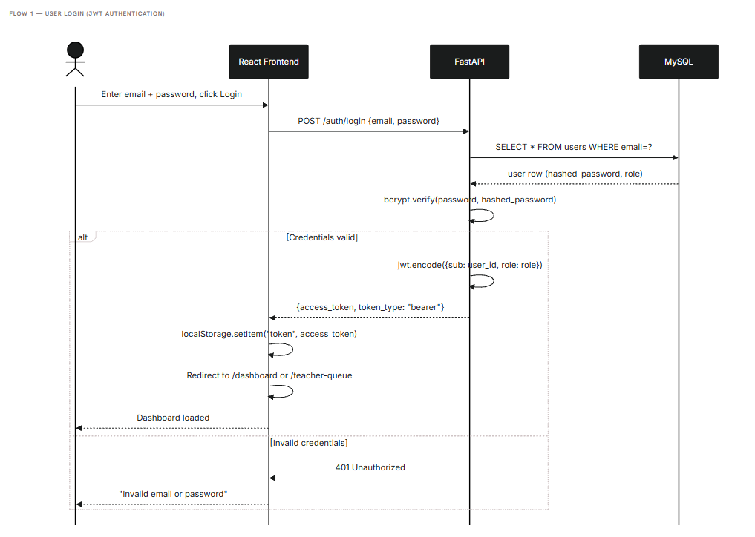
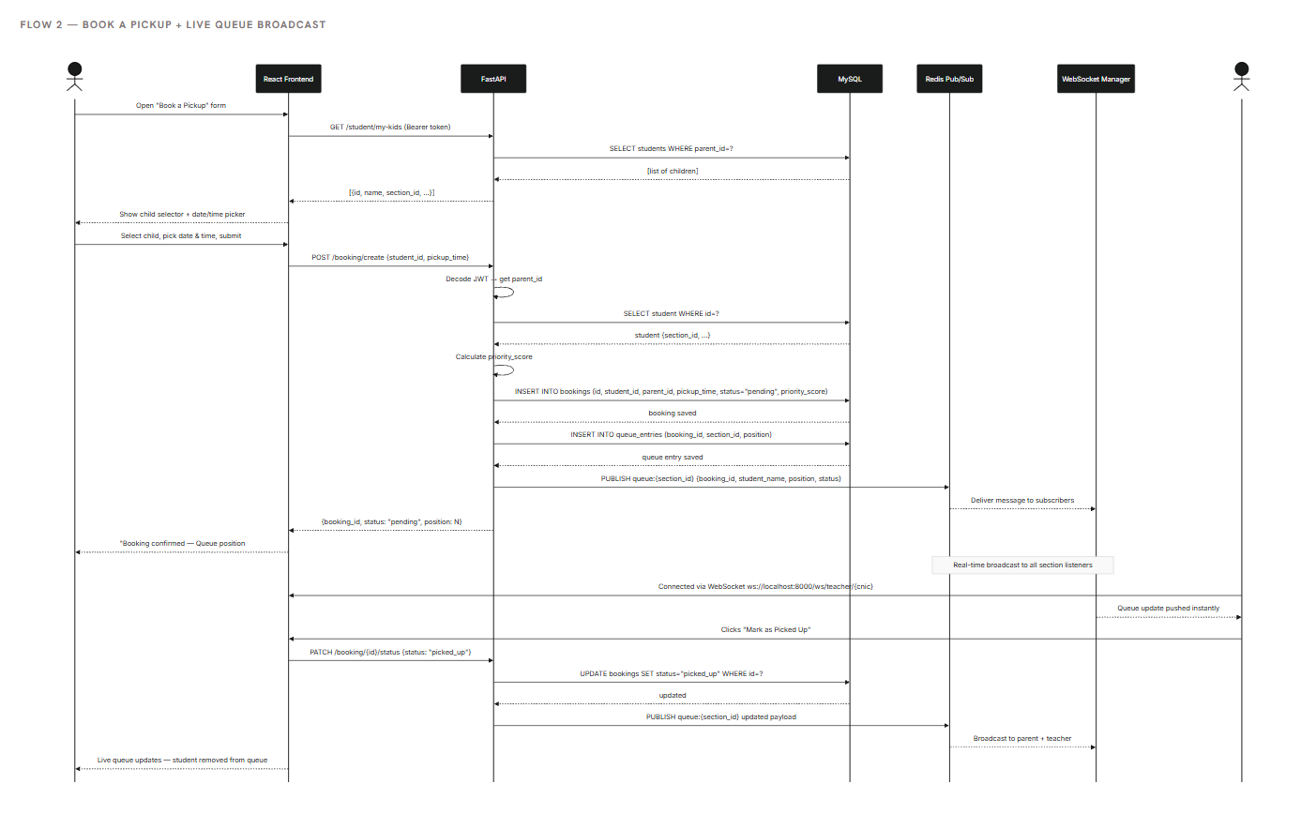
5.1 User Registration and Login Flow
The authentication flow follows a stateless JWT pattern:
• Step 1: Parent opens /register, fills in name, email, password, and selects role "parent"
• Step 2: Frontend sends POST /auth/register with the registration payload
• Step 3: Backend hashes the password with bcrypt and inserts a row into users
• Step 4: If role = parent, backend also inserts a row into parents (user_id FK)
• Step 5: Backend encodes a JWT (HS256) with sub = user.id and role = user.role, returns token
• Step 6: Frontend stores the token in localStorage under the key "token"
• Step 7: All subsequent API requests include Authorization: Bearer <token> in the header
• Step 8: Backend Depends(get_current_user) decodes the token and resolves the User object on each request
5.2 Booking a Pickup Flow
When a parent books a pickup, the following database and real-time operations occur:
• Step 1: Parent opens the dashboard and clicks "Book a Pickup"
• Step 2: Frontend sends GET /student/my-kids (JWT required) to fetch the parent's children
• Step 3: Parent selects a child, chooses a date and time, and submits the form
• Step 4: Frontend sends POST /booking/create {student_id, pickup_time}
• Step 5: Backend verifies the student belongs to the logged-in parent
• Step 6: Backend checks no active booking already exists for that student
• Step 7: Backend calculates priority_score = pickup_time.timestamp() ± zone bonuses
• Step 8: Backend inserts a row into bookings (status = "pending")
• Step 9: Backend inserts a row into queue_entries (booking_id, section_id, position)
• Step 10: Backend calls reorder_queue() — re-numbers all queue positions by priority_score ASC
• Step 11: Backend calls emit_queue_update() — publishes payload to Redis channel queue:{section_id}
• Step 12: WebSocket Manager broadcasts the updated queue JSON to all connected clients on that channel
• Step 13: Teacher's and parent's screens update instantly without any page refresh
5.3 Live Queue Update Mechanism
The real-time queue system uses a Redis Pub/Sub channel as the message bus. When any booking status changes (create, cancel, mark picked_up, mark no_show), the backend publishes a fresh queue payload to the Redis channel. The WebSocket Manager, which subscribes to that channel, immediately pushes the update to all connected browser clients. Two WebSocket channels are maintained:
• queue:{section_id} — subscribed by the parent queue page; shows the parent their current queue position
• teacher:{cnic} — subscribed by the teacher queue page; shows the teacher the ordered list for their section
• No frontend polling is used anywhere — all updates are server-push through WebSocket
• Redis is optional: if Redis is unavailable, the app continues working but live broadcasts are silently skipped
6. Module Descriptions
The backend is organized into routers (HTTP endpoints), services (business logic), core utilities (database, security, WebSocket), and models (SQLAlchemy ORM). Each module is described below with its key code and explanation.
6.1 Authentication Module (app/routers/auth.py)
Handles user registration, login, and identity verification. On registration, the password is bcrypt-hashed and a Parent profile row is automatically created if the user's role is "parent". On login, the bcrypt hash is verified and a signed JWT is returned.
Code (POST /auth/register)
@router.post("/register", response_model=TokenResponse, status_code=201)
def register(body: RegisterRequest, db: Session = Depends(get_db)):
if db.query(User).filter(User.email == body.email).first():
raise HTTPException(status_code=409, detail="Email already registered")
user = User(
name=body.name, email=body.email,
hashed_password=hash_password(body.password),
role=body.role, section_id=body.section_id, cnic=body.cnic,
)
db.add(user)
db.flush()
if user.role.value == "parent":
db.add(Parent(user_id=user.id))
db.commit()
return TokenResponse(access_token=create_access_token(user), ...)
Explanation
• db.flush() writes the user row to the transaction without committing, making user.id available for the Parent FK
• hash_password() calls passlib's bcrypt handler — the plain password is never stored
• create_access_token() calls python-jose to sign a JWT with sub=user.id, role=user.role, exp=24h
• A 409 Conflict is returned if the email is already registered — email uniqueness is enforced at both DB (UNIQUE constraint) and application level
6.2 Booking Module (app/routers/booking.py)
Handles creating, cancelling, and status-updating bookings. All write operations trigger a queue reorder and a live broadcast to all connected WebSocket clients on the relevant channels.
Code (POST /booking/create)
@router.post("/create", response_model=BookingResponse, status_code=201)
async def create_booking(body: CreateBookingRequest, db=Depends(get_db),
current_user=Depends(require_role("parent"))):
parent = _require_parent(db, current_user)
student = db.query(Student).filter(
Student.id == body.student_id,
Student.parent_id == parent.id).first()
# check no active booking exists for this student
priority_score = queue_engine.calculate_priority_score(body.pickup_time)
booking = Booking(student_id=body.student_id, parent_id=parent.id,
pickup_time=body.pickup_time, status=BookingStatus.pending,
priority_score=priority_score)
db.add(booking); db.flush()
queue_engine.insert_into_queue(db, booking, student.section_id)
queue_engine.reorder_queue(db, student.section_id)
db.commit()
await queue_engine.emit_queue_update(db, student.section_id)
await queue_engine.emit_teacher_update(db, student.teacher_cnic)
Explanation
• require_role("parent") is a FastAPI dependency that decodes the JWT and raises 403 if the role does not match
• _require_parent() queries the parents table by user_id to obtain the Parent object and its FK-linked id
• priority_score is a Unix float timestamp of the requested pickup_time — lower values appear earlier in the queue
• insert_into_queue() creates a queue_entries row; reorder_queue() re-numbers all active positions by priority_score ASC
• emit_queue_update() and emit_teacher_update() call manager.broadcast() which pushes JSON to all WebSocket subscribers
6.3 Queue Engine (app/services/queue_engine.py)
The queue engine is the core business-logic service of the system. It calculates priority scores, manages queue entry insertion and reordering, caches the queue state in Redis, and emits live broadcasts.
Code (priority_score calculation)
SAFE_ZONE_BONUS = 300.0 # seconds — pulls booking 5 min earlier
NO_SHOW_PENALTY = 600.0 # seconds — pushes booking 10 min later
def calculate_priority_score(pickup_time, within_safe_zone=False,
apply_penalty=False) -> float:
score = pickup_time.timestamp()
if within_safe_zone:
score -= SAFE_ZONE_BONUS
if apply_penalty:
score += NO_SHOW_PENALTY
return score
Explanation
• Base score = Unix timestamp of pickup_time — a parent who books an earlier slot naturally gets a lower (better) score
• SAFE_ZONE_BONUS: if the parent's GPS location is within the school's safe_zone_radius, their score is reduced by 300 seconds (moves them up in queue)
• NO_SHOW_PENALTY: if a parent has previously been a no-show, their score is increased by 600 seconds (moves them down)
• reorder_queue() re-numbers all queue_entries rows for the section by ordering on Booking.priority_score ASC after every change
• _cache_queue() stores the current queue in a Redis sorted set (ZADD) for fast read access, with a 1-hour TTL
6.4 WebSocket Manager (app/core/ws_manager.py)
A single shared ConnectionManager instance holds all active WebSocket connections organized by channel name. Any module can broadcast to a channel without knowing which clients are connected. Dead connections are automatically pruned on each broadcast attempt.
Code (ConnectionManager)
class ConnectionManager:
def __init__(self):
self._channels: dict[str, list[WebSocket]] = defaultdict(list)
async def connect(self, channel: str, websocket: WebSocket):
await websocket.accept()
self._channels[channel].append(websocket)
async def broadcast(self, channel: str, data: dict):
connections = list(self._channels.get(channel, []))
dead = []
for ws in connections:
try:
await ws.send_json(data)
except Exception:
dead.append(ws)
for ws in dead:
self.disconnect(channel, ws)
manager = ConnectionManager() # single shared instance
Explanation
• _channels is a defaultdict(list) keyed by channel string (e.g., "queue:abc123" or "teacher:35202-1234567")
• connect() accepts the WebSocket handshake and appends the connection object to the correct channel list
• broadcast() iterates all connections on a channel, sends JSON data to each, and collects any failed sends
• Dead connections (client disconnected) are removed after each broadcast — no stale references accumulate
• manager is a module-level singleton — imported and used directly by queue_engine and the WS router
7. API Reference
All endpoints are served at http://localhost:8000. Interactive docs are available at http://localhost:8000/docs (Swagger UI). JWT token must be sent as Authorization: Bearer <token> on all protected routes.
7.1 Authentication Endpoints
Method | Endpoint | Auth | Description
POST | /auth/register | None | Register a new user; returns JWT token
POST | /auth/login | None | Login with email and password; returns JWT token
GET | /auth/me | JWT | Return the currently authenticated user's profile

7.2 Student Endpoints
Method | Endpoint | Auth | Description
GET | /student/my-kids | Parent JWT | List all children registered to the logged-in parent
POST | /student/add | Parent JWT | Register a new child under the logged-in parent
PUT | /student/{id} | Parent JWT | Update a child's profile data
DELETE | /student/{id} | Parent JWT | Delete a child profile
GET | /student/{id}/qr | Parent JWT | Generate and return the QR code for a child

7.3 Booking Endpoints
Method | Endpoint | Auth | Description
POST | /booking/create | Parent JWT | Create a new booking and insert into queue
POST | /booking/cancel | Parent JWT | Cancel a pending or confirmed booking
GET | /booking/my-bookings | Parent JWT | List all bookings for the logged-in parent
PATCH | /booking/{id}/status | Teacher/Admin JWT | Update booking status (confirmed, picked_up, no_show)

7.4 Queue Endpoints
Method | Endpoint | Auth | Description
GET | /queue/{section_id} | JWT | Fetch the current live queue for a section
WS | /ws/queue/{section_id} | None (WS) | WebSocket channel for live parent queue updates
WS | /ws/teacher/{cnic} | None (WS) | WebSocket channel for live teacher queue updates

7.5 Teacher Endpoints
Method | Endpoint | Auth | Description
GET | /teacher/my-students | Teacher JWT | List all students in the teacher's section
GET | /teacher/queue/today | Teacher JWT | Fetch today's queue for the teacher's section

7.6 Admin Endpoints
Method | Endpoint | Auth | Description
GET | /admin/stats | Admin JWT | System summary — total users, students, bookings
GET | /admin/users | Admin JWT | List all users in the system
DELETE | /admin/users/{id} | Admin JWT | Delete a user account
GET | /admin/students | Admin JWT | List all students
GET | /admin/bookings | Admin JWT | List all bookings with status
PATCH | /admin/bookings/{id} | Admin JWT | Override any booking's status

8. Key Design Decisions
Decision | Rationale
UUID v4 strings as primary keys (VARCHAR 36) instead of AUTO_INCREMENT integers | Prevents enumerable ID attacks, allows IDs to be generated client-side before INSERT, safer in distributed systems
Role-Extension pattern for Parent (separate parents table rather than adding columns to users) | Keeps the users table clean; not all users are parents; makes querying role-specific data simpler
Intentional 3NF denormalization in students (class_name, section_name, teacher_name, teacher_cnic) | Parents register children manually without system knowledge; storing free-text simplifies the registration UX at the cost of potential stale data
ENUM stored as VARCHAR in MySQL, validated by SQLAlchemy at application level | MySQL ENUMs are rigid to alter; SQLAlchemy Enum type provides validation before reaching the DB while keeping the schema portable
Stateless JWT authentication (no sessions or refresh tokens) | Stateless tokens remove the need for a session store, simplify horizontal scaling, and work naturally with SPAs
Redis as optional message bus (graceful degradation if Redis is down) | Redis failure should not take down the entire application; bookings and queue state are still persisted in MySQL and the system continues, just without live push notifications
Single shared ConnectionManager singleton for WebSockets | Avoids the overhead of a separate pub/sub library for the WebSocket layer; clean channel-keyed design scales to hundreds of concurrent connections on a single ASGI process
Alembic for schema migrations rather than SQLAlchemy create_all() | Provides version-controlled, incremental schema changes that can be rolled back; create_all() cannot alter existing tables
priority_score = Unix timestamp of pickup_time | A monotonically increasing float that naturally orders earlier pickups first; float arithmetic also allows bonus/penalty adjustments without needing a separate sorting column

