Style Guidelines for Final Year Project ReportsFreelance Marketplace Application

Final Year Project Proposal

Session 2021-2025

A 4th Year Student

A project submitted in partial fulfilment of the

COMSATS University Degree

of

BSc. (Hons.)BS in Computer Science / Software Engineering (CUI)



Department of Computer Science

COMSATS University Islamabad, Lahore Campus

30 July 2024

Table of Contents

Freelance Marketplace Application 1

Final Year Project Proposal 1

Session 2021-2025 1

Plagiarism Free Certificate 4

1 Introduction 5

1.1 Core Functionality 5

1.1.1 Job Posting & Management: 5

1.1.2 Proposal Submission: 5

1.1.3 Communication & Collaboration: 6

1.1.4 Secure Payment System: 6

1.2 Evolving Requirements 6

2 Success Criterion 6

3 Related work 6

3.1 Historical background: 6

3.2 Related Achievement in Existing Freelance Market Place 7

3.3 General Freelance Marketplace Overview: 7

3.4 Freelance Economy: 8

4 Project Rationale 8

4.1 Aims and Objectives 9

4.1.1 Client Functionalities 9

4.1.2 Freelancer Functionalities 9

4.1.3 Shared Functionalities 10

4.2 Scope of the Project 10

4.2.1 Future Enhancements 10

5 Proposed Methodology and Architecture 11

5.1 Frontend 11

5.1.1 Next.js: 12

5.2 Backend 12

5.2.1 NestJS: 12

5.3 Database 12

5.4 Cloud Platform 12

5.5 Bird Eye View 12

6 Individual Tasks 12

7 Gantt Chart 13

8 Tools and Technologies 14

8.1 Frontend: 14

8.2 Backend: 14

8.3 Database: 14

9 References 14

**Project Registration**

|  |  |  |  |  |  |  |  |
| --- | --- | --- | --- | --- | --- | --- | --- |
| Project ID (for office use) | | |  | | | | |
| Type of project | | | [ ] Traditional **[ ] Industrial** [ ] Continuing | | | | |
| Nature of project | | | [ ] **D**evelopment [ ] **R**esearch **[ ] R&D** | | | | |
| Area of specialisation | | |  | | | | |
| **Project Group Members** | | | | | | | |
| Sr.# | Reg. # | Student Name | | CGPA | Email ID | Phone # | Signature |
| (i) | Sp21-bcs-022 | Tehmina Saleem | | 2.36 | Sp21-bcs-022@cuilahore.edu.pk | 03406869101 |  |
| (ii) | Sp21-bcs-090 | Sammar Zahra | | 2.70 | Sp21-bcs-090@cuilahore.edu.pk | 03480640880 |  |
| (iii) | Sp21-bcs-102 | Laiba Mir | | 3.05 | Sp21-bcs-102@cuilahore.edu.pk | 03095000497 |  |
| **Declaration:** FYP group members have cleared all prerequisites courses For FYP-I as per their degree requirements.  For BS(Computer Science)  (CSC241 Object Oriented Programming, CSC291 Software Engineering Concepts, CSC371 Database Systems-I, HUM102 Report Writing Skills)  For BS(Software Engineering)  (CSC241 Object Oriented Programming, CSE291 Introduction to Software Engineering , CSC371 Database Systems-I , HUM102 Report Writing Skills) | | | | | | | |

# Plagiarism Free Certificate

This is to certify that, I am __Tehmina Saleem______________________ S/D/o ____Muhammad Saleem___________________, group leader of FYP under registration no CIIT/_sp21-bcs-022________________/LHR at Computer Science Department, COMSATS Institute of Information Technology, Lahore. I declare that my FYP proposal is checked by my supervisor and the similarity index is ________% that is less than 20%, an acceptable limit by HEC. Report is attached herewith as Appendix A.

Date: 11-March-2024____________ Name of Group Leader: ___Tehmina Saleem_____________________ Signature: _____________

Name of Supervisor: _____________________ Co-Supervisor (if any):____________________

Designation: _____________________ Designation: _____________________

Signature: _____________________ Signature: _____________________

**Project Abstract**

This document outlines the high-level scope for a freelance marketplace application built using the MERN stack (MongoDB, Express.js, React.js, and Node.js). The application aims to connect clients seeking freelance services with skilled professionals for project-based work.

The core functionalities include job posting and management, proposal submission, secure communication channels with integrated video and audio calling options (ideally with Google Meet, Zoom, Skype), a secure payment system with withdrawal to bank accounts, a dispute resolution system, and a customer support ticketing system. Additionally, KYC (Know Your Customer) verification can be implemented for enhanced security.

While the core requirements can evolve based on user feedback and market demands, this document serves as a road map, outlining user types (clients and freelancers), functional breakdown, technical considerations, and potential future enhancements. The application's success will be measured by user growth, project management efficiency, financial performance, user satisfaction, and customer support effectiveness.

This high-level scope document provides a foundation for the development process, paving the way for a thriving freelance marketplace application.

# Introduction

This project outlines the high-level scope for a freelance marketplace application built using the MERN stack. The application, envisioned as a one-stop solution for project-based work, will connect freelancers with clients seeking their expertise. This application serves as a roadmap for the application's development, outlining its core functionalities, user types, and user stories.

## 1.1 Core Functionality

The freelance marketplace application will provide a feature-rich environment for both clients and freelancers. Here's an overview of its core functionalities:

### Job Posting & Management:

Clients can post jobs with detailed descriptions outlining their project requirements, budget, and desired skills. They can manage job postings, set expiration dates, and review proposals submitted by interested freelancers.

### Proposal Submission:

Freelancers can browse posted jobs that align with their skills and experience. They can submit compelling proposals outlining their qualifications, proposed approach, and rates for the project.

### Communication & Collaboration:

Integrated communication features are essential for seamless project execution. The application will offer in-app chat functionality for real-time text communication. Additionally, video calling and audio calling functionalities will enhance collaboration and facilitate discussions. Integrations with existing meeting platforms like Google Meet, Zoom, and Skype would be ideal, allowing users to leverage familiar tools within the application. Slack integration might also be considered in the future to provide more robust communication options for project teams.

### Secure Payment System:

A secure payment system is paramount for trust and transparency within the platform. The application will facilitate secure transactions between clients and freelancers, supporting various payment methods for user convenience.

## 1.2 Evolving Requirements

It is important to acknowledge that the core requirements outlined above can be subject to change throughout the development process. This flexibility allows us to adapt to user feedback, market demands, and technological advancements. While this document serves as a high-level roadmap, the specific functionalities will be further refined based on ongoing analysis and stakeholder input..

# Success Criterion

The success criterion for the freelance marketplace application can be summarized as follows:

The success criterion for the freelance marketplace application is to

* Deliver a platform that connects clients with freelancers.
* Job posting and management.
* ⁠Communication and Collaboration with clients and freelancers.
* ⁠User feedback and usage metrics.

# Related work

## Historical background:

During the Middle Ages, freelancers were akin to soldiers who offered their services to kings in exchange for payment. Often, these individuals were soldiers who had lost their allegiance to their own kings in battle and now fought for whomever they chose. The prevalence of these hired soldiers surged after 1000 A.D. In English, they were commonly referred to as condottieri, denoting the leaders of bands of mercenary soldiers. Latin records indicate that initially, these soldiers were known as stipendiaries, reflecting their status as soldiers who worked for stipends.

[1]

## Related Achievement in Existing Freelance Market Place

The global Freelance Platforms market, valued at USD 4530.44 million in 2022, is anticipated to grow at a CAGR of 13.66% through the forecast period, reaching USD 9765.33 million by 2028. These platforms serve as a meeting ground for businesses and freelance professionals worldwide, generating revenue by extracting a portion of transactions from both employers and freelancers. They streamline the process, offering convenience and efficiency to all parties involved. The report encompasses comprehensive quantitative and qualitative analyses, covering macro to micro aspects of the market, including industry dynamics, segment markets, and regional perspectives. It provides insights into market players, market share, and concentration ratios, facilitating a deeper understanding of the competitive landscape. Additionally, it addresses factors such as mergers & acquisitions, emerging trends, and the impact of events like COVID-19 and regional conflicts. This report is essential reading for industry stakeholders, investors, researchers, consultants, and strategists looking to navigate or invest in the freelance platforms market. [2]

In 2019, the United States was ranked as the largest freelance market in the world, with a 78% yearon.73% of freelancers turn to online marketplaces to look for work. [3]

## General Freelance Marketplace Overview:

The primary freelance marketplaces stand as the most extensive and seasoned platforms available. They cater to a myriad of needs spanning from web development, design, marketing, content creation, management, to operations. Pioneers in their field, these marketplaces swiftly garnered brand recognition, amassing a sizable user base that caught the attention of investors. [4]

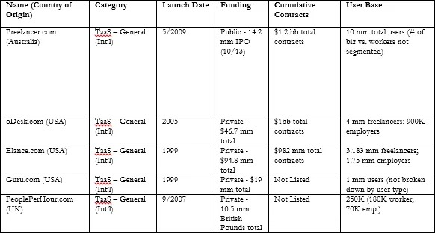

Table 1 Freelance Marketplace Overview

## Freelance Economy:

To grasp the current trends in the freelance economy, it's crucial to analyze the pivotal role played by platforms in its evolution. Since the late 1990s, a diverse array of digital platforms has emerged, triggering a profound economic transformation and restructuring of markets, work dynamics, and the creation and capture of value in today's economy (Kenney and Zysman, 2016). These platforms, intertwined with technological advancements, constitute what is known as the platform economy, constantly reshaping the landscape of work. Digital platforms serve as facilitators for interactions between disparate parties, enabling exchanges that may not have been feasible otherwise, or at least not as efficiently achievable through bilateral relationships (Eisenmann et al., 2006; Evans, 2003; Gawer, 2014; Kenney and Zysman, 2017). Consequently, they have ushered in a more streamlined approach to direct transactions among various stakeholders, a fundamental aspect of their value-creating capabilities (Hagiu, 2014). [5]

# Project Rationale

With the rise of the gig economy and remote work, there's a growing need for platforms that connect freelancers with clients. A freelance marketplace serves as a bridge between these two parties, facilitating work arrangements that are flexible and adaptive to the modern workforce's needs. Freelance marketplaces create opportunities for individuals to leverage their skills and expertise for income generation.

As a developer or entrepreneur, taking on a freelance marketplace project offers numerous opportunities for learning and growth. We can delve into areas such as platform development, user experience design, payment integration, and community building

By embarking on a freelance marketplace project, I aim to contribute to the ecosystem of remote work and entrepreneurship while honing my skills in software development, business strategy, and user-centric design. I hope to learn about the intricacies of building a successful platform that balances the needs of different stakeholders while fostering trust, transparency, and efficiency in the freelance economy. Ultimately, I aspire to create a meaningful impact by empowering individuals and businesses to thrive in the digital age.

## Aims and Objectives

The key functionalities of the freelance marketplace application categorized by user type is given as.

### Client Functionalities

#### Job Posting & Management:

* Create and edit job postings
* Set project details including title, description, budget, skills required, and deadline
* Manage job visibility
* Review and manage proposals submitted by freelancers

#### Freelancer Search & Management:

* Search for freelancers based on skills, experience, and ratings
* View freelancer profiles including skills, portfolio, and experience
* Communicate with shortlisted freelancers through in-app chat

#### Project Management & Communication:

* Manage ongoing projects with assigned freelancers
* Track project progress and milestones
* Secure communication channels with freelancers (chat, video calls, audio calls) (Ideally integrated with existing platforms like Google Meet)

#### Secure Payment System:

* Initiate secure payments to freelancers for completed projects

### Freelancer Functionalities

#### Profile Management:

* Create and maintain a comprehensive profile showcasing skills, experience, and portfolio
* Set hourly rates or project rates
* Manage profile visibility (public, private)

#### Job Search & Proposals:

* Search for relevant job postings based on skills and interests
* View detailed job descriptions and apply for suitable projects
* Submit compelling proposals outlining qualifications, approach, and proposed rates

#### Project Management & Communication:

* Manage ongoing projects with assigned clients
* Track project progress and milestones
* Secure communication channels with clients (chat, video calls, audio calls) (Ideally integrated with existing platforms like Google Meet)

#### Payment System:

* View and track earnings for completed projects
* Withdraw earnings to a connected bank account

### Shared Functionalities

#### Search & Discovery:

* Robust search functionality to find relevant jobs and freelancers based on keywords, skills, and categories

#### Security & Trust:

* Secure communication channel

## Scope of the Project

The main goal of the project is to achieve all the features of already available market places in one place. We would Foster a sense of community among freelancers on our platform by providing an opportunity to make teams, forums, groups, and networking events. Encourage collaboration, knowledge sharing, and mentorship opportunities. A strong sense of community would not only enhance engagements but will also promote loyalty and retention among users. With the advancements in Artificial Intelligence our project would evolve with time.

### Future Enhancements

As the freelance marketplace application evolves, several features can be considered for future implementation:

#### Advanced Search & Filtering:

Granular search filters based on location, project type, freelancer skills, and experience level.

#### Freelancer Ratings & Reviews:

A reputation system allowing clients to rate and review freelancers, and vice versa, fostering trust and accountability.

#### Project Milestones & Time Tracking:

Features to define project milestones, track time spent, and facilitate progress monitoring for both clients and freelancers.

#### Escrow System:

An optional escrow system holding client payments until project milestones are met, ensuring security for both parties.

#### Team Collaboration Features:

Functionality for clients to create project teams with multiple freelancers for complex projects.

#### Mobile App Development:

Develop a mobile application for on-the-go access to the platform for both clients and freelancers.

#### AI-powered Job Matching:

Implement AI algorithms to recommend relevant job postings to freelancers and suggest suitable freelancers to clients based on skills and project requirements.

#### Specialized Project Categories:

Create specialized project categories to cater to different industries and niche skill sets.

#### Freelancer Membership Tiers:

Introduce optional paid membership tiers for freelancers offering benefits like increased profile visibility and priority project recommendations.

#### Freelance Learning & Development Resources:

Integrate learning resources and skill development opportunities for freelancers to enhance their skills and marketability.

#### Paid Expert Review:

Client can ask for paid expert review before marking the product as delivered or completed in case he does not have a team for that or he wants it generally.

These are just a few potential enhancements to consider for the future. Continuously gathering user feedback and analyzing platform usage patterns will guide the prioritization of future development efforts.

The core functionalities and features can be subject to change based on further analysis and stakeholder feedback. As the project progresses, this project can be refined and updated to reflect the evolving vision for the freelance marketplace application.

# Proposed Methodology and Architecture

The freelance marketplace application will be built using the MERN stack, leveraging the following technologies:

## Frontend

We will be using Next.js for frontend development

### Next.js:

Next.js is a React framework that builds on top of React. It offers additional features like server-side rendering (SSR) and static site generation (SSG) which can improve performance and SEO.

## Backend

We will use express or nest.js for backend development

### NestJS:

A progressive Node.js framework built on top of Express. NestJS provides a more structured and scalable approach to building backend applications.

## Database

MongoDB - A NoSQL document database offering flexibility and scalability for data storage.

## Cloud Platform

A cloud platform like Amazon Web Services (AWS) will be considered for hosting the application to ensure scalability, security, and global reach.

## Bird Eye View

The bird eye view of the whole project is shown in Fig. 1.

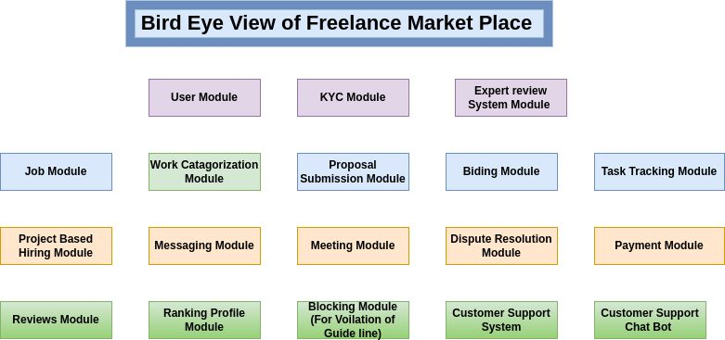

Figure 1 Bird eye view

# Individual Tasks

The table referring to the individual tasks is given below see Table. 1.

Table 2 Individual tasks of group members

|  |  |  |
| --- | --- | --- |
| **Team Member** | **Activity** | **Tentative Date** |
| <Sammar,Tehmina,Laiba> | Requirement Analysis | <11th March to 11th April> |
| <Sammar,Laiba,Tehmina> | Project Plaining &Designing | <11st April to 20th May> |
| <Laiba,Sammar,Tehmina> | Front End Development | <20th May to 25th July> |
| <Sammar,Laiba,Tehmina> | Backend End Development | <25thth July to 25th october> |
| <Sammar,Tehmina,Laiba> | Testing And Maintenance | <25th October to 10th December> |

# Gantt Chart

The Gantt chart graphically representing which tasks would be done in which duration, i.e., starting date, end date is shown in the Fig. 2.

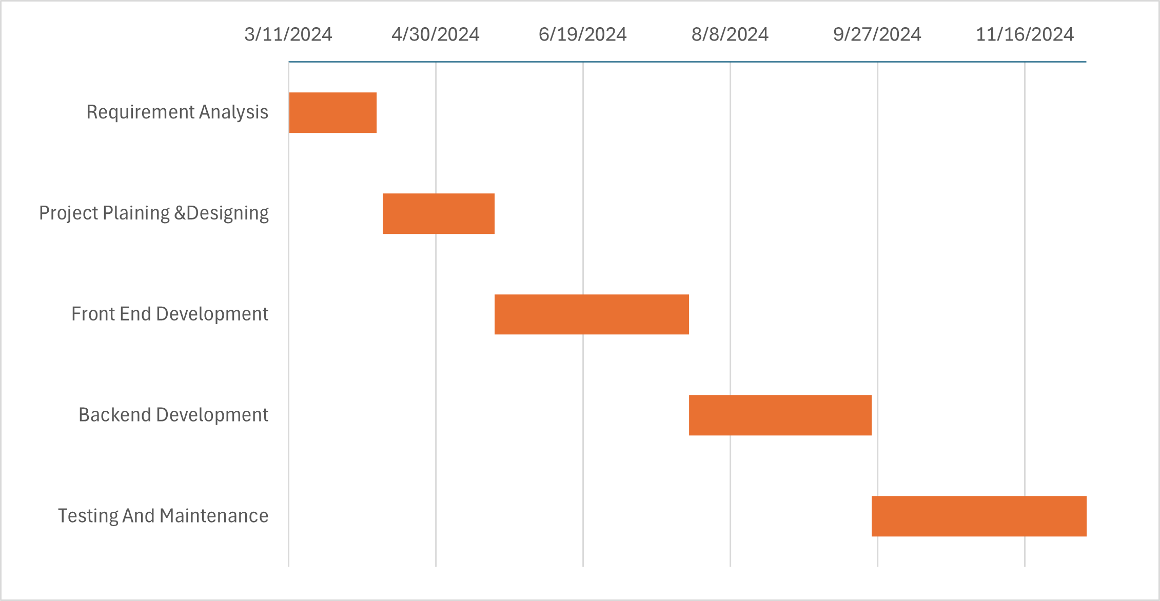

Figure 2 Gannt Chart

# Tools and Technologies

The freelance marketplace application will be built using following technologies:

## Frontend:

Next.js: Next.js is a React framework that builds on top of React. It offers additional features like server-side rendering (SSR) and static site generation (SSG) which can improve performance and SEO.

## Backend:

NestJS: A progressive Node.js framework built on top of Express. NestJS provides a more structured and scalable approach to building backend applications.

## Database:

MongoDB - A NoSQL document database offering flexibility and scalability for data storage

# References

|  |  |
| --- | --- |
| [1] | [Online]. Available: https://blog.truelancer.com/history-of-freelancing/. |
| [2] | “Linkedin,” [Online]. Available: https://www.linkedin.com/pulse/freelance-platforms-market-size-unveiling-new-avenues/. [Accessed 11 March 2024]. |
| [3] | “Webinarcare,” [Online]. Available: https://webinarcare.com/best-freelance-platforms/freelance-platforms-statistics/#8. [Accessed 11 march 2024]. |
| [4] | [Online]. Available: https://medium.com/@kevmack12/freelance-marketplace-industry-competitive-analysis-5cfa6ce431a5. |
| [5] | [Online]. Available: https://core.ac.uk/download/pdf/162136426.pdf. |