EWP WEEK -6
Aim: To study JavaScript arrays, functions, alert boxes, console output and DOM manipulation by creating an interactive Employee Management webpage.
Objective:
- To create and use JavaScript arrays.
- To display array elements using alert().
- To display data using console.log().
- To use JavaScript functions with buttons.
- To manipulate HTML elements using the DOM.
- To navigate between multiple webpages.
Code:
Home Page:
<!DOCTYPE html>
<html>
<head><title>Employee Home</title></head>
<body style="font-family:Arial;text-align:center;background-color:lightblue;">
<h1>Employee Management</h1>
<button onclick="location.href='webpage.html'">Display Employees</button><br><br>
<button onclick="location.href='alert.html'">Show Employees in Alert</button><br><br>
<button onclick="location.href='console.html'">Show Employees in Console</button>
</body>
</html>
Display Employees:
<!DOCTYPE html>
<html>
<head><title>Employees</title></head>
<body style="font-family:Courier New;font-size:30px;text-align:center;background-color:rgb(186,186,252);">
<h2>Employee List</h2>
<p id="emp"></p>
<br>
<button onclick="location.href='index.html'">Home</button>
<script>
const employees=["Rahul","Priya","Amit","Sneha","Kiran"];
document.getElementById("emp").innerHTML="<b>Employees:</b> "+employees.join(", ");
</script>
</body>
</html>
Alert Output:
<!DOCTYPE html>
<html>
<head><title>Alert Example</title></head>
<body style="font-family:Courier New;font-size:30px;text-align:center;background-color:lightpink;">
<h2>Employee Alert</h2>
<button onclick="showEmployees()">Show Employees</button><br><br>
<button onclick="location.href='index.html'">Home</button>
<script>
const employees=["Rahul","Priya","Amit","Sneha","Kiran"];
function showEmployees(){alert("Employees:\n"+employees.join("\n"));}
</script>
</body>
</html>
Console Output:
<!DOCTYPE html>
<html>
<head><title>Console Example</title></head>
<body style="font-family:Courier New;font-size:30px;text-align:center;background-color:lightgreen;">
<h2>Console Output</h2>
<button onclick="showConsole()">Show Employees</button><br><br>
<button onclick="location.href='index.html'">Home</button>
<script>
const employees=["Rahul","Priya","Amit","Sneha","Kiran"];
function showConsole(){
console.clear();
console.log("Employee Names");
for(let i=0;i<employees.length;i++){console.log(employees[i]);}
}
</script>
</body>
</html>

Output :
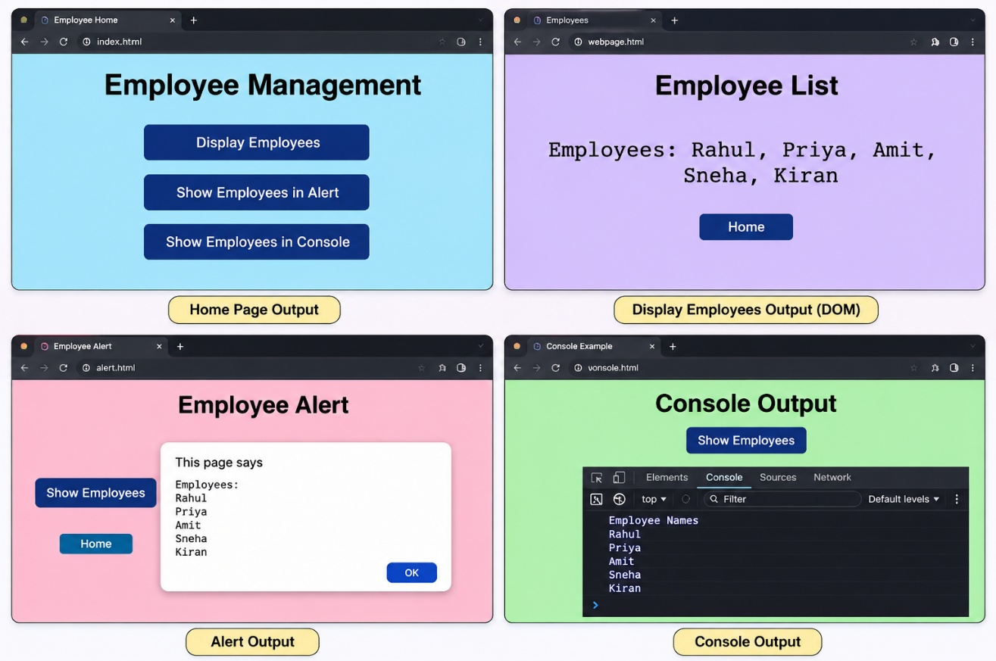

Concepts Used:
• JavaScript Array – Stores multiple employee names.
• const – Declares the employee array.
• Functions – Performs actions when buttons are clicked.
• alert() – Displays employee names in a popup.
• console.log() – Displays employee names in the browser console.
• for Loop – Iterates through the employee array.
• join() – Converts array elements into a string.
• DOM Manipulation – Displays data using getElementById().
• innerHTML – Inserts employee information into the webpage.
• onclick – Executes JavaScript when a button is clicked.
• Page Navigation – Uses location.href to move between pages.

Result:
A multi-page Employee Management website was created successfully using HTML and JavaScript. JavaScript arrays, functions, alert boxes, console output, loops, DOM manipulation, and page navigation were implemented successfully.

