EWP WEEK -7
Aim: To study HTML forms, CSS styling, JavaScript event handling, form controls, DOM manipulation and dynamic result calculation by creating an Online Admission Form and Online Examination Portal.
Objective:
- To create an Online Admission Form using HTML.
- To use text fields, radio buttons and dropdown lists.
- To apply CSS styling to HTML forms.
- To create an Online Examination Portal.
- To use JavaScript functions and event handling.
- To retrieve user input using the DOM.
- To calculate and display examination results dynamically.
Code:
Online Admission Form:
<!DOCTYPE html>
<html>
<head>
<title>Online Admission Form</title>
<style>
body {
font-family: Arial, sans-serif;
background-color: #f2f2f2;
}
.form-box {
width: 400px;
margin: 40px auto;
padding: 20px;
background-color: white;
border-radius: 10px;
box-shadow: 0 0 10px gray;
}
h2 {
text-align: center;
}
label {
display: block;
margin-top: 10px;
}
input, select {
width: 100%;
padding: 8px;
margin-top: 5px;
box-sizing: border-box;
}
.gender {
width: auto;
}
button {
width: 100%;
padding: 10px;
margin-top: 20px;
background-color: blue;
color: white;
border: none;
cursor: pointer;
}
button:hover {
background-color: darkblue;
}
</style>
</head>
<body>
<div class="form-box">
<h2>Online Admission Form</h2>
<form>
<label>Student Name:</label>
<input type="text" name="name" required>
<label>Gender:</label>
<input type="radio" name="gender" value="Male" class="gender"> Male
<input type="radio" name="gender" value="Female" class="gender"> Female
<label>Course Selection:</label>
<select name="course">
<option>B.Tech</option>
<option>B.Sc</option>
<option>B.Com</option>
<option>BBA</option>
</select>
<button type="submit">Submit</button>
</form>
</div>
</body>
</html>
Online Examination Portal:
<!DOCTYPE html>
<html>
<head>
<title>Online Examination Portal</title>
<style>
body {
font-family: Arial, sans-serif;
background-color: #f2f2f2;
margin: 0;
}
.container {
width: 600px;
margin: 30px auto;
padding: 25px;
background-color: white;
border-radius: 10px;
}
h1 {
text-align: center;
color: darkblue;
}
h3 {
color: #333;
}
nav {
background-color: darkblue;
padding: 15px;
text-align: center;
}
nav a {
color: white;
text-decoration: none;
margin: 20px;
}
nav a:hover {
color: yellow;
}
input {
padding: 8px;
margin: 5px;
}
input:focus {
border: 2px solid blue;
}
button {
padding: 10px 20px;
background-color: green;
color: white;
border: none;
border-radius: 5px;
cursor: pointer;
}
button:hover {
background-color: darkgreen;
}
#result {
margin-top: 20px;
font-size: 20px;
font-weight: bold;
color: darkgreen;
}
</style>
</head>
<body>
<nav>
<a href="#">Home</a>
<a href="#">Exam</a>
<a href="#">Results</a>
</nav>
<div class="container">
<h1>Online Examination Portal</h1>
<h3>Student Details</h3>
<label>Student Name:</label>
<input type="text" id="name" placeholder="Enter your name">
<h3>Question 1</h3>
<p>What is the capital of India?</p>
<input type="radio" name="q1" value="Delhi"> Delhi
<input type="radio" name="q1" value="Mumbai"> Mumbai
<input type="radio" name="q1" value="Chennai"> Chennai
<h3>Question 2</h3>
<p>Which language is used for web page structure?</p>
<input type="radio" name="q2" value="HTML"> HTML
<input type="radio" name="q2" value="Python"> Python
<input type="radio" name="q2" value="Java"> Java
<br><br>
<button onclick="calculateScore()">Submit Exam</button>
<div id="result"></div>
</div>
<script>
function calculateScore() {
let name = document.getElementById("name").value;
if (name == "") {
alert("Please enter your name");
return;
}
let score = 0;
let q1 = document.querySelector(
'input[name="q1"]:checked'
);
let q2 = document.querySelector(
'input[name="q2"]:checked'
);
if (q1 && q1.value == "Delhi") {
score++;
}
if (q2 && q2.value == "HTML") {
score++;
}
document.getElementById("result").innerHTML =
"Hello " + name + "! Your score is " + score + " / 2";
}
</script>
</body>
</html>
Output :
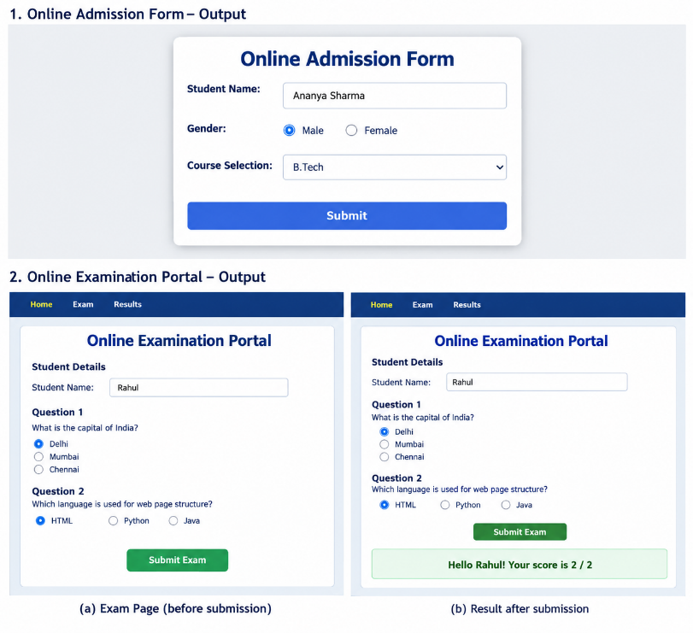

Concepts Used:
- HTML Form – Creates the admission form and collects student information.
- Text Input – Accepts the student's name.
- Radio Button – Allows selection of gender and examination answers.
- Select and Option – Provides course selection through a dropdown list.
- CSS Styling – Provides layout, colors, spacing, borders and hover effects.
- CSS Pseudo-class :hover – Changes the appearance of buttons and navigation links when the mouse is over them.
- CSS Pseudo-class :focus – Applies styling when an input field receives focus.
- JavaScript Function – calculateScore() performs the examination score calculation.
- DOM Manipulation – getElementById() retrieves HTML elements and their values.
- querySelector() – Finds the selected radio button.
- alert() – Displays a warning when the student name is not entered.
- Conditional Statements – Checks the selected answers and calculates the score.
- innerHTML – Displays the examination result dynamically.
- onclick – Executes the JavaScript function when the Submit Exam button is clicked.
- Form Validation – The required attribute ensures that the student name is entered in the admission form.

Result:
Two interactive webpages were created successfully using HTML, CSS and JavaScript. The Online Admission Form implements form controls such as text input, radio buttons and dropdown selection. The Online Examination Portal implements JavaScript functions, DOM manipulation, event handling, answer validation and dynamic score calculation successfully.

