EWP WEEK -8
Aim: To study JavaScript functions by creating an interactive webpage that demonstrates different types of functions and displays their code and output dynamically.
Objective:
- To understand different types of JavaScript functions.
- To use function declarations and function expressions.
- To use arrow functions and parameters with return values.
- To understand default and rest parameters.
- To implement callback and higher-order functions.
- To understand recursive functions and closures.
- To use object methods and asynchronous functions.
- To use IIFE, generator and anonymous functions.
- To display function code and output dynamically using the DOM.
Code:
<!DOCTYPE html>
<html lang="en">
<head>
<meta charset="UTF-8">
<meta name="viewport" content="width=device-width, initial-scale=1.0">
<title>JavaScript Functions</title>
<style>
* { box-sizing: border-box; }
body { margin: 0; font-family: Arial, sans-serif; background: #eef2ff; color: #1e293b; }
header { background: linear-gradient(135deg, #4f46e5, #7c3aed); color: white; text-align: center; padding: 22px; }
header h1 { margin: 0; font-size: 28px; }
header p { margin: 6px 0 0; }
.container { max-width: 1200px; margin: 25px auto; padding: 0 20px; }
.panel { display: grid; grid-template-columns: 260px 1fr; gap: 20px; background: white; padding: 20px; border-radius: 15px; box-shadow: 0 5px 20px #0002; }
.menu { height: 560px; overflow-y: auto; padding-right: 8px; }
.menu h2 { margin-top: 0; font-size: 20px; }
.function { padding: 13px; margin-bottom: 8px; border: 1px solid #ddd; border-radius: 8px; cursor: pointer; background: #f8fafc; transition: .2s; }
.function:hover { background: #e0e7ff; transform: translateX(3px); }
.function.active { background: #4f46e5; color: white; border-color: #4f46e5; }
.number { font-weight: bold; margin-right: 5px; }
.content { min-width: 0; }
.content h2 { margin-top: 0; color: #4f46e5; }
.box-title { font-weight: bold; margin: 18px 0 8px; }
pre { margin: 0; background: #111827; color: #a7f3d0; padding: 20px; border-radius: 10px; overflow-x: auto; min-height: 180px; font-family: Consolas, monospace; line-height: 1.5; }
.output { background: #0f172a; color: #22c55e; padding: 18px; border-radius: 10px; min-height: 80px; font-family: Consolas, monospace; white-space: pre-line; }
.run { margin-top: 15px; padding: 10px 25px; border: 0; border-radius: 7px; background: #4f46e5; color: white; font-weight: bold; cursor: pointer; }
.run:hover { background: #3730a3; }
@media (max-width: 700px) { .panel { grid-template-columns: 1fr; } .menu { height: 220px; } }
</style>
</head>
<body>
<header>
<h1>JavaScript Functions</h1>
<p>Interactive Function Demonstration</p>
</header>
<div class="container">
<div class="panel">
<div class="menu">
<h2>Functions</h2>
<div class="function active" onclick="select(0)">1. Function Declaration</div>
<div class="function" onclick="select(1)">2. Function Expression</div>
<div class="function" onclick="select(2)">3. Arrow Function</div>
<div class="function" onclick="select(3)">4. Parameters & Return</div>
<div class="function" onclick="select(4)">5. Default Parameter</div>
<div class="function" onclick="select(5)">6. Rest Parameter</div>
<div class="function" onclick="select(6)">7. Callback Function</div>
<div class="function" onclick="select(7)">8. Higher-Order Function</div>
<div class="function" onclick="select(8)">9. Recursive Function</div>
<div class="function" onclick="select(9)">10. Closure</div>
<div class="function" onclick="select(10)">11. Object Method</div>
<div class="function" onclick="select(11)">12. Async Function</div>
<div class="function" onclick="select(12)">13. IIFE</div>
<div class="function" onclick="select(13)">14. Generator Function</div>
<div class="function" onclick="select(14)">15. Anonymous Function</div>
</div>
<div class="content">
<h2 id="title">Function Declaration</h2>
<div class="box-title">Code</div>
<pre id="code"></pre>
<button class="run" onclick="runFunction()">▶ Run Function</button>
<div class="box-title">Output</div>
<div class="output" id="output">Select a function to run it.</div>
</div>
</div>
</div>
<script>
const functions = [
{ title: "Function Declaration", code: `function greet(name) { return "Hello, " + name + "!"; } greet("Boss");`, run: () => "Hello, Boss!" },
{ title: "Function Expression", code: `const add = function(a, b) { return a + b; }; add(10, 20);`, run: () => 30 },
{ title: "Arrow Function", code: `const square = n => n * n; square(6);`, run: () => 36 },
{ title: "Parameters and Return", code: `function multiply(a, b) { return a * b; } multiply(7, 8);`, run: () => 56 },
{ title: "Default Parameter", code: `function welcome(name = "Guest") { return "Welcome, " + name; } welcome();`, run: () => "Welcome, Guest" },
{ title: "Rest Parameter", code: `function total(...numbers) { return numbers.reduce((a, b) => a + b, 0); } total(10, 20, 30, 40);`, run: () => 100 },
{ title: "Callback Function", code: `function processUser(name, callback) { callback("User: " + name); } processUser("Alex", message => { return message; });`, run: () => "User: Alex" },
{ title: "Higher-Order Function", code: `function calculate(a, b, operation) { return operation(a, b); } calculate(10, 5, (a, b) => a - b);`, run: () => calculate(10, 5, (a, b) => a - b) },
{ title: "Recursive Function", code: `function factorial(n) { return n <= 1 ? 1 : n * factorial(n - 1); } factorial(5);`, run: () => factorial(5) },
{ title: "Closure", code: `function counter() { let count = 0; return () => ++count; } const c = counter(); c();`, run: (() => { let count = 0; return () => ++count; })() },
{ title: "Object Method", code: `const person = { name: "Alex", age: 21, introduce() { return this.name + " is " + this.age; } }; person.introduce();`, run: () => "Alex is 21" },
{ title: "Async Function", code: `async function getData() { return new Promise(resolve => { setTimeout(() => { resolve("Data received!"); }, 1000); }); } getData();`, run: async () => { showOutput("Fetching data..."); await new Promise(resolve => setTimeout(resolve, 1000)); return "Data received!"; } },
{ title: "IIFE", code: `(function() { return "IIFE executed!"; })();`, run: () => "IIFE executed!" },
{ title: "Generator Function", code: `function* numbers() { yield 10; yield 20; yield 30; } [...numbers()];`, run: () => [10, 20, 30].join("\n") },
{ title: "Anonymous Function", code: `const message = function() { return "Anonymous function!"; }; message();`, run: () => "Anonymous function!" }
];
let current = 0;
function select(index) {
current = index;
document.querySelectorAll(".function").forEach((item, i) => { item.classList.toggle("active", i === index); });
document.getElementById("title").textContent = functions[index].title;
document.getElementById("code").textContent = functions[index].code;
runFunction();
}
async function runFunction() { let result = await functions[current].run(); showOutput(result); }
function showOutput(value) { document.getElementById("output").textContent = value; }
function factorial(n) { return n <= 1 ? 1 : n * factorial(n - 1); }
function calculate(a, b, operation) { return operation(a, b); }
select(0);
</script>
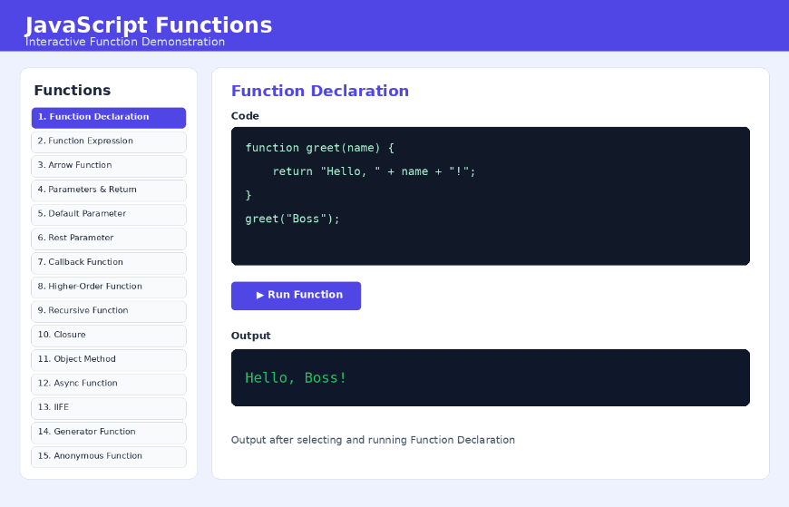
</body>
</html>
Output :

Concepts Used:
- JavaScript Functions
- Function Declaration
- Function Expression
- Arrow Function
- Parameters and Return
- Default Parameter
- Rest Parameter
- Callback Function
- Higher-Order Function
- Recursive Function
- Closure
- Object Method
- Async Function
- IIFE
- Generator Function
- Anonymous Function
- DOM Manipulation
- onclick event

Result:

An interactive JavaScript Functions webpage was created successfully. Different types of JavaScript functions were demonstrated, and their code and outputs were displayed dynamically.

