EWP WEEK -9
Aim: To study XML and XML namespaces by creating and displaying student and college information using XML, HTML and JavaScript.
Objective:
- To understand XML structure and syntax.
- To use XML namespaces.
- To create XML data for student and college information.
- To display XML data using HTML and JavaScript.
- To access and display information from XML elements.
- To understand the use of different namespace prefixes..
Code:
namespace.xml:
<?xml version="1.0"?>
<university
xmlns:s="https://www.geethanjaliinstitutions.com"
xmlns:c="https://www.anurag.edu.in">
<s:student>
<s:name>Rahul</s:name>
<s:department>Artificial Intelligence</s:department>
</s:student>
<c:college>
<c:name>Anurag University</c:name>
<c:department>AI Department</c:department>
</c:college>
</university>
student.html:
<pre id="xmlOutput"></pre>
<script>
const xml = `<student>
<name>Rahul</name>
<branch>CSE</branch>
<year>3</year>
</student>`;
document.getElementById("xmlOutput").textContent = xml;
</script>

student.xml
<?xml version="1.0" encoding="UTF-8"?>
<students>
<student>
<studentId>101</studentId>
<name>Tina</name>
<age>20</age>
<course>BCA</course>
<email>Tina@example.com</email>
</student>
</students>
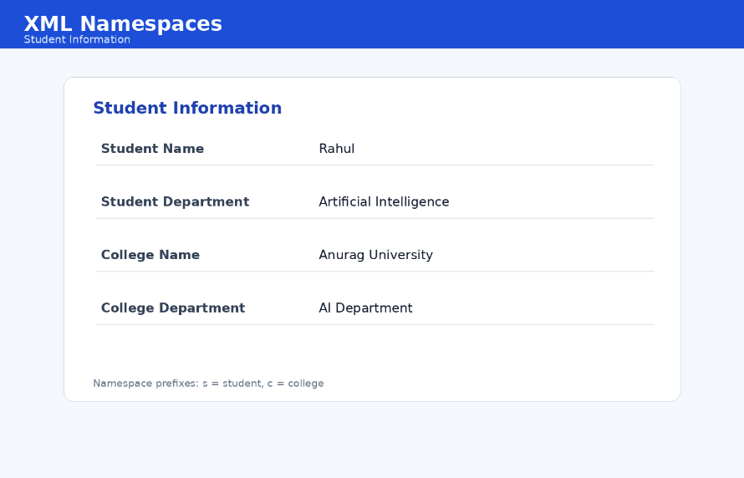
Output :

Concepts Used:
- XML
- XML Declaration
- XML Namespace
- Namespace Prefix
- XML Elements
- HTML <pre>
- JavaScript Template Literal
- DOM Manipulation
- getElementById()
- textContent

Result:

XML documents and XML namespaces were created successfully. Student and college information was represented using XML elements and namespace prefixes, and XML data was displayed using HTML and JavaScript.

