EWP WEEK -1
Aim: To study the fundamentals of HTML and create a basic web page using essential HTML tags and attributes.
Objective:
- To understand the structure of an HTML document.
- To learn the usage of basic HTML tags.
- To create headings, paragraphs, lists, hyperlinks, and images.
- To understand the purpose of commonly used HTML attributes.
- To develop a simple static web page.

Code:
<!DOCTYPE html> <!-- Declares the document as HTML5 -->
<html>
<head>
<!-- Title displayed on the browser tab -->
<title>HTML Basics</title>
</head>
<body>
<!-- ================= HEADING TAGS ================= -->
<h1>Heading 1</h1> <!-- Largest heading -->
<h2>Heading 2</h2> <!-- Second largest heading -->
<h3>Heading 3</h3> <!-- Third level heading -->
<h4>Heading 4</h4> <!-- Fourth level heading -->
<h5>Heading 5</h5> <!-- Fifth level heading -->
<h6>Heading 6</h6> <!-- Smallest heading -->
<hr> <!-- Horizontal line -->
<!-- ================= PARAGRAPH ================= -->
<p>
HTML stands for HyperText Markup Language.
It is used to create web pages.
</p>
<hr>

<!-- ================= LINE BREAK ================= -->
This is the first line.<br> <!-- Moves text to the next line -->
This is the second line.
<hr>
<!-- ================= HYPERLINKS ================= -->
<!-- Opens Google in the same browser tab -->
<a href="https://www.google.com">
Visit Google
</a>
<br><br>
<!-- Opens Wikipedia in a new browser tab -->
<a href="https://www.wikipedia.org" target="_blank">
Visit Wikipedia
</a>
<hr>
<!-- ================= IMAGES ================= -->
<!-- Displays an image from the project folder -->
<img src="image.jpg"
alt="Sample Image"
width="300"
height="200">
<br><br>
<!-- Displays an image from the local computer (Not recommended for websites) -->
<img src="C:\Users\HP\Pictures\sample.png"
alt="Local Image"
width="300"
height="200">
</body></html>

Output :
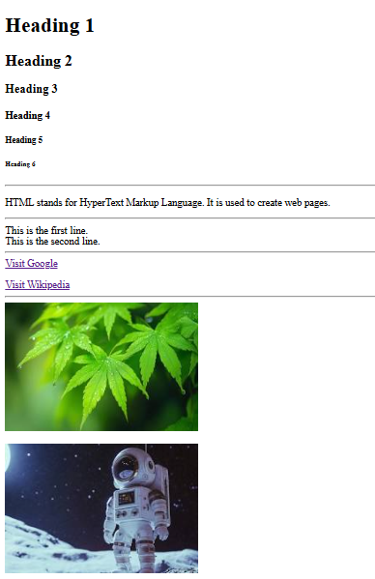

Concepts Used:
- Introduction to HTML
- Structure of an HTML document
- HTML Tags:
- <!DOCTYPE html> – Declares that the document is an HTML5 document.
- <html> – Defines the root element of an HTML document.
- <head> – Contains metadata and information about the webpage.
- <title> – Specifies the title displayed on the browser tab.
- <body> – Contains all the visible content of the webpage.
- <h1> – Defines the main (largest) heading of the webpage.
- <h2> – Defines a second-level heading.
- <h3> – Defines a third-level heading.
- <h4> – Defines a fourth-level heading.
- <h5> – Defines a fifth-level heading.
- <h6> – Defines the smallest heading.
- <p> – Defines a paragraph of text.
- <br> – Inserts a line break in the content.
- <hr> – Inserts a horizontal line to separate content.
- <ul> – Creates an unordered (bulleted) list.
- <ol> – Creates an ordered (numbered) list.
- <li> – Defines a list item within a list.
- <a> – Creates a hyperlink to another webpage or resource.
- <img> – Displays an image on the webpage.
- <div> – Defines a division or section in a webpage.
- <span> – Defines an inline container for text or other elements.
- HTML Attributes:
- href – Specifies the destination URL of a hyperlink.
- src – Specifies the location or path of the image file.
- alt – Specifies alternative text for an image if it cannot be displayed.
- width – Sets the width of an image in pixels.
- height – Sets the height of an image in pixels.
- style – Applies inline CSS styles to an HTML element.
- target – Specifies where to open the linked document (e.g., _blank opens in a new tab).
- id – Assigns a unique identifier to an HTML element.
- class – Assigns one or more class names to an HTML element.
- title – Displays additional information as a tooltip when the mouse pointer is placed over an element.

Result:
A basic HTML web page was created successfully using essential HTML tags and attributes. The webpage displayed headings, paragraphs, hyperlinks, images, and lists, demonstrating the fundamental structure of an HTML document.

