EWP WEEK - 2
Aim: To study and implement HTML formatting elements, images, hyperlinks, preformatted text, and tables to create a structured web page.
Objective:
- To understand the use of HTML formatting and text elements.
- To learn how to insert images into a webpage.
- To create hyperlinks between web pages.
- To display preformatted text using the <pre> tag.
- To design tables using HTML table elements.

Code:
<!DOCTYPE html>
<html>
<head>
<!-- Title displayed on the browser tab -->
<title>HTML Formatting, Images and Tables</title>
</head>
<!-- Background color of the webpage -->
<body bgcolor="pink">
<!-- Main Heading -->
<h1 align="center">HTML Formatting Elements</h1>
<!-- Paragraph -->
<p>HTML stands for HyperText Markup Language. It is used to create and structure web pages.</p>
<hr>
<!-- Preformatted Text -->
<pre>
This is a preformatted text.
It preserves spaces and line breaks exactly as written.
Useful for displaying poems, code snippets, and formatted text.
</pre>
<hr>
<!-- Images -->
<h2>Images</h2>
<img src="sample-1.jpeg" alt="Sample Image" width="300">

<hr>
<!-- Hyperlinks -->
<h2>Hyperlinks</h2>
<a href="https://www.google.com">Visit Google</a>
<br><br>
<a href="29-06-2026.html" target="_blank">Visit Week-1 Page</a>
<hr>
<!-- Table -->
<h2 align="center">Sample Image Gallery</h2>
<table border="2" align="center" cellpadding="10" cellspacing="5">
<!-- Table Header -->
<tr>
<th>Image 1</th>
<th>Image 2</th>
<th>Image 3</th>
</tr>
<!-- Images Row -->
<tr>
<td><img src="butterfly.jpeg" width="100" alt="Butterfly"></td>
<td><img src="moon.jpeg" width="100" alt="Moon"></td>
<td><img src="duck.jpeg" width="100" alt="Duck"></td>
</tr>
<!-- Names Row -->
<tr>
<td align="center">Butterfly</td>
<td align="center">Moon</td>
<td align="center">Duck</td>
</tr>
</table>
</body>
</html>

Output :
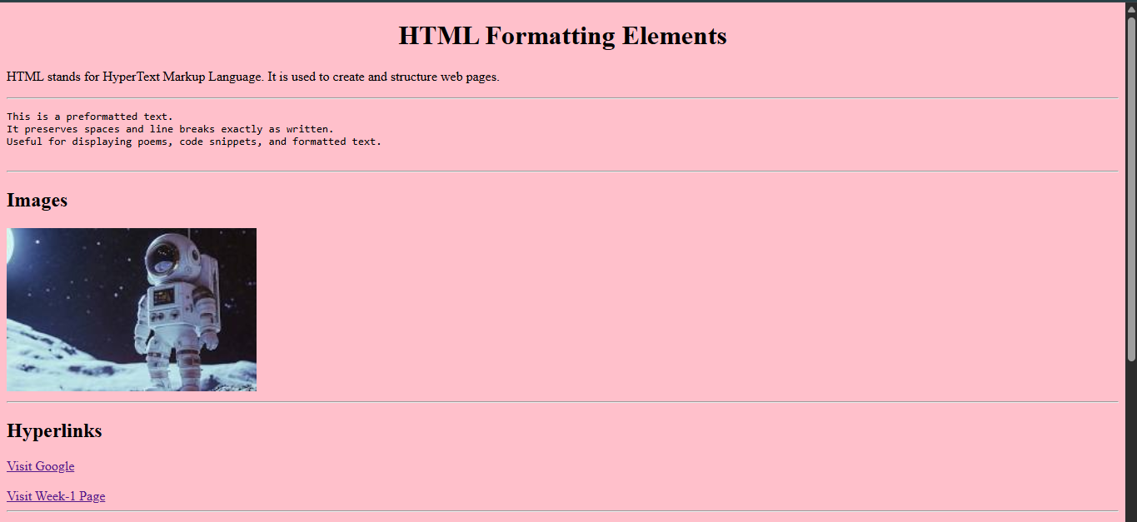
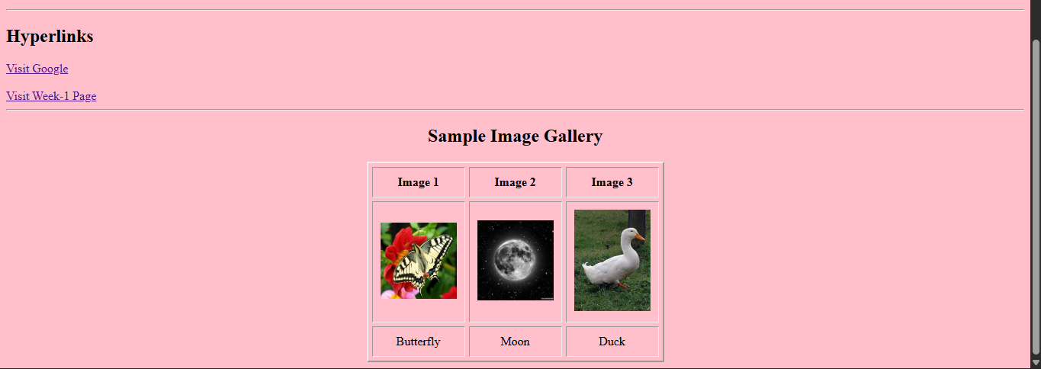

Concepts Used:
- HTML Formatting Elements
- Images and Hyperlinks
- HTML Tables
- HTML Tags:
- <html> – Defines the root element of an HTML document.
- <head> – Contains metadata and information about the webpage.
- <title> – Specifies the title displayed on the browser tab.
- <body> – Contains all the visible content of the webpage.
- <h1> – Defines the main heading.
- <h2> – Defines a second-level heading.
- <p> – Defines a paragraph.
- <pre> – Displays preformatted text while preserving spaces and line breaks.
- <img> – Displays an image on the webpage.
- <a> – Creates a hyperlink.
- <table> – Creates a table.
- <tr> – Defines a table row.
- <th> – Defines a table header cell.
- <td> – Defines a table data cell.

- HTML Attributes:
- bgcolor – Sets the background color of the webpage.
- href – Specifies the destination URL of a hyperlink.
- target – Specifies where to open the linked document.
- src – Specifies the image location.
- alt – Specifies alternative text for an image.
- width – Sets the image width.
- border – Sets the border thickness of a table.
- bordercolor – Sets the color of the table border.
- cellpadding – Specifies the space between cell content and border.
- cellspacing – Specifies the space between adjacent cells.
- align – Aligns the table on the webpage.

Result:
A web page was successfully developed using HTML formatting elements, preformatted text, images, hyperlinks, and tables. The output demonstrated the proper use of these HTML elements for organizing and presenting webpage content.

