EWP WEEK -3
Aim: To study HTML lists, forms, and hyperlinks by creating multiple web pages connected through navigation links.
Objective:
- To create ordered and unordered lists using HTML.
- To design login and registration forms using various HTML form elements.
- To understand webpage navigation using hyperlinks.
- To create multiple HTML pages and link them together.
- To use different HTML input controls such as text fields, password fields, radio buttons, checkboxes, drop-down lists, and text areas.
Code:
Home Page:
<!DOCTYPE html>
<html>
<head>
<title>Week-3 Home Page</title>
</head>
<body style="background-color:#EAF6F6; text-align:center; font-family:Arial;">
<h1 style="color:darkblue;">HTML Navigation Menu</h1>
<h3>Select a page to explore</h3>
<hr width="50%">
<p><a href="ordered.html">Ordered List</a></p>
<p><a href="unordered.html">Unordered List</a></p>
<p><a href="login.html">Login Page</a></p>
</body>
</html>
Ordered List:
<!DOCTYPE html>
<html>
<head>
<title>Ordered List</title>
</head>
<body style="background-color:#FFF8DC; text-align:center; font-family:Arial;">
<h1 style="color:brown;">Programming Languages</h1>
<ol style="display:inline-block; text-align:left; font-size:18px;">
<li>C</li>
<li>C++</li>
<li>Java</li>
<li>Python</li>
<li>JavaScript</li>
<li>PHP</li>
<li>HTML</li>
<li>CSS</li>
</ol>
<br><br>
<a href="index.html">Back to Home</a>
</body>
</html>
Unordered List:
<!DOCTYPE html>
<html>
<head>
<title>Unordered List</title>
</head>
<body style="background-color:#F0FFF0; text-align:center; font-family:Arial;">
<h1 style="color:darkgreen;">Computer Accessories</h1>
<ul style="display:inline-block; text-align:left; font-size:18px;">
<li>Keyboard</li>
<li>Mouse</li>
<li>Monitor</li>
<li>Printer</li>
<li>Web Camera</li>
<li>Speakers</li>
<li>USB Drive</li>
<li>Headphones</li>
</ul>
<br><br>
<a href="index.html">Back to Home</a>
</body>
</html>

Login Page:
<!DOCTYPE html>
<html>
<head>
<title>Login Page</title>
</head>
<body style="background-color:#EAF4FC; text-align:center; font-family:Arial;">
<h1 style="color:darkblue;">Student Login</h1>
<form>
Username<br>
<input type="text" placeholder="Enter Username" required>
<br><br>
Password<br>
<input type="password" placeholder="Enter Password" required>
<br><br>
<input type="checkbox"> Remember Me
<br><br>
<input type="submit" value="Login">
<input type="reset" value="Clear">
</form>
<br><br>
<p>New User?</p>
<a href="registration.html">Create an Account</a>
<br><br>
<a href="index.html">Back to Home</a>
</body>
</html>
Registration Page:
<!DOCTYPE html>
<html>
<head>
<title>Registration Page</title>
</head>
<body style="background-color:#F5F5FF; text-align:center; font-family:Arial;">
<h1 style="color:darkgreen;">Student Registration</h1>
<form>
Full Name<br>
<input type="text" placeholder="Enter Full Name" required>
<br><br>
Roll Number<br>
<input type="text" required>
<br><br>
Email<br>
<input type="email" required>
<br><br>
Password<br>
<input type="password" required>
<br><br>
Confirm Password<br>
<input type="password" required>
<br><br>
Gender<br>
<input type="radio" name="gender"> Male
<input type="radio" name="gender"> Female
<br><br>
Department<br>
<select>
<option>CSE</option>
<option>AI</option>
<option>AIML</option>
<option>ECE</option>
<option>EEE</option>
</select>
<br><br>
Skills<br>
<input type="checkbox"> HTML
<input type="checkbox"> CSS
<input type="checkbox"> JavaScript
<br><br>
Address<br>
<textarea rows="4" cols="30"></textarea>
<br><br>
<input type="submit" value="Register">
<input type="reset" value="Clear">
</form>
<br><br>
<a href="login.html">Go to Login</a>
<br><br>
<a href="index.html">Back to Home</a>
</body>
</html>

Output :
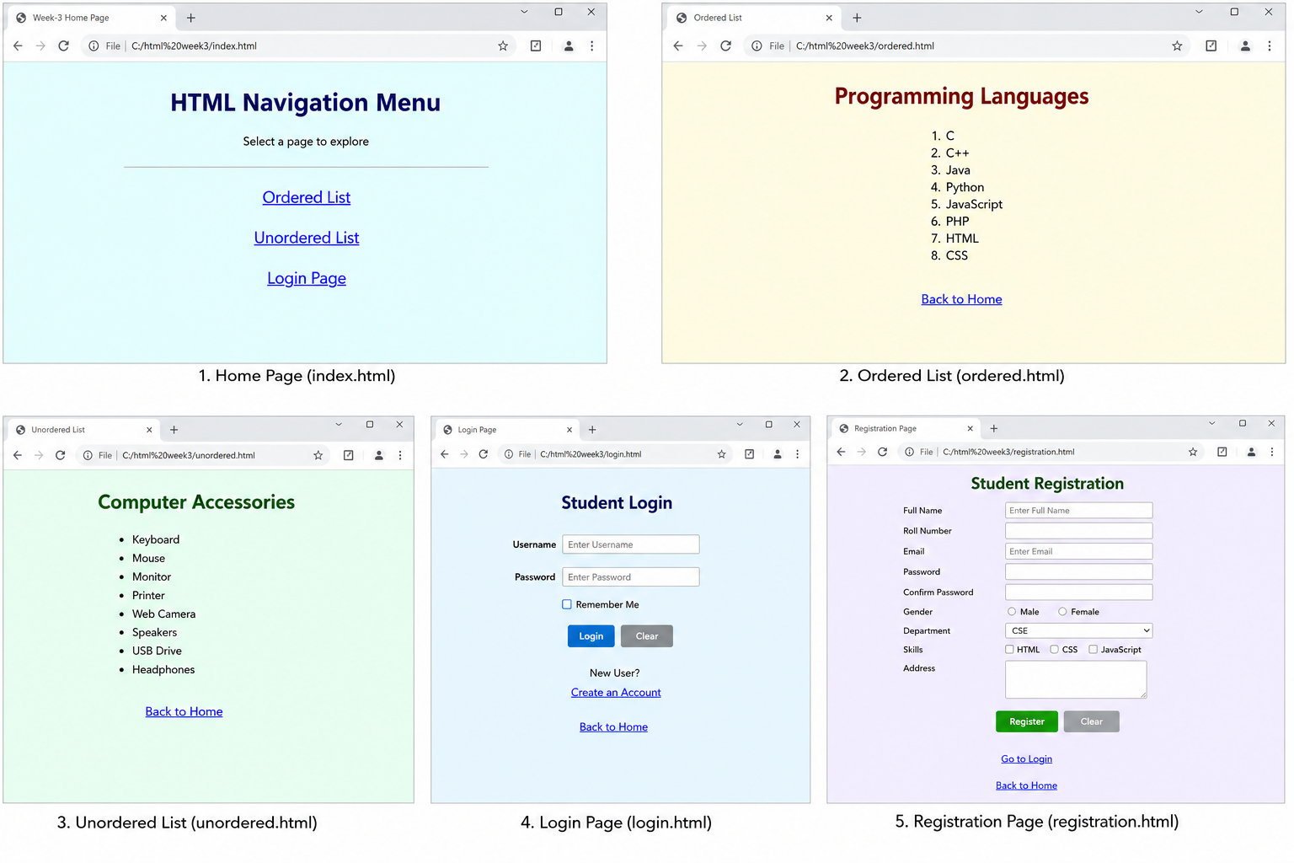

Concepts Used:

1. HTML Lists
- Ordered List (<ol>)
- Unordered List (<ul>)
- List Item (<li>)

2. HTML Forms
- Form (<form>)
- Label (<label>)
- Text Input (<input type="text">)
- Password Input (<input type="password">)
- Email Input (<input type="email">)
- Radio Button (<input type="radio">)
- Checkbox (<input type="checkbox">)
- Drop-down List (<select>, <option>)
- Text Area (<textarea>)
- Submit Button (<input type="submit">)
- Reset Button (<input type="reset">)

3. Hyperlinks
- <a> – Creates hyperlinks between web pages.

4. HTML Tags
- <html> – Defines the root element of an HTML document.
- <head> – Contains metadata about the webpage.
- <title> – Specifies the title displayed on the browser tab.
- <body> – Contains all visible webpage content.
- <h1> – Defines the main heading.
- <p> – Defines a paragraph.
- <ol> – Creates an ordered list.
- <ul> – Creates an unordered list.
- <li> – Defines a list item.
- <form> – Creates an HTML form.
- <input> – Accepts user input.
- <textarea> – Creates a multi-line text input.
- <select> – Creates a drop-down list.
- <option> – Defines an option in a drop-down list.
- <a> – Creates hyperlinks.
- <br> – Inserts a line break.

5. HTML Attributes
- href – Specifies the destination URL of a hyperlink.
- type – Specifies the type of an input element.
- name – Specifies the name of an input element.
- placeholder – Displays hint text inside an input field.
- required – Makes an input field mandatory.
- value – Specifies the value of an input element.
- style – Applies inline CSS styles.
- rows – Specifies the number of rows in a text area.
- cols – Specifies the number of columns in a text area.

Result:
A multi-page HTML website was created successfully. The website demonstrated navigation between pages using hyperlinks and included ordered lists, unordered lists, a login page, and a registration page using various HTML form controls such as text fields, password fields, radio buttons, checkboxes, drop-down lists, and text areas.

