EWP WEEK -4
Aim: To study different methods of applying CSS (Inline, Internal, and External CSS) and understand the use of classes, IDs, and <div> elements for designing attractive web pages.
Objective:
- To understand Inline CSS.
- To understand Internal CSS.
- To understand External CSS.
- To learn the use of CSS Classes.
- To learn the use of CSS IDs.
- To design webpages using <div> containers.
- To apply colors, fonts, borders, spacing, and alignment using CSS.
Code:
Home Page:
<!DOCTYPE html>
<html>
<head>
<title>Week-4 CSS Demo</title>
<link rel="stylesheet" href="style.css">
</head>
<body>
<div class="container">
<h1>CSS Demonstration</h1>
<p>Select any page to explore different CSS techniques.</p>
<div class="menu">
<a href="inline.html">Inline CSS</a>
<a href="internal.html">Internal CSS</a>
<a href="external.html">External CSS</a>
</div>
</div>
</body>
</html>

inline.html:
<!DOCTYPE html>
<html>
<head>
<title>Inline CSS</title>
</head>
<body style="background:#FFEFD5; text-align:center; font-family:Arial;">
<div style="width:500px; margin:auto; background:white;
padding:25px; border-radius:12px;
box-shadow:0 0 15px gray;">
<h1 style="color:darkred;">Inline CSS Example</h1>
<p style="font-size:20px; color:green;">
This page is completely styled using Inline CSS.
</p>
<button style="padding:12px 20px;
background:darkred;
color:white;
border:none;
border-radius:8px;">
Click Here
</button>
<br><br>
<a href="index.html">Back to Home</a>
</div>
</body>
</html>

internal.html:
<!DOCTYPE html>
<html>
<head>
<title>Internal CSS</title>
<style>
body{
background:#E6F7FF;
font-family:Arial;
text-align:center;
}
.card{
width:500px;
margin:auto;
background:white;
padding:25px;
border-radius:12px;
box-shadow:0px 0px 12px gray;
}
.heading{
color:navy;
}
.text{
font-size:18px;
color:#444;
}
.btn{
background:navy;
color:white;
padding:12px 20px;
border:none;
border-radius:8px;
}
</style>
</head>
<body>
<div class="card">
<h1 class="heading">Internal CSS Example</h1>
<p class="text">
This webpage uses Internal CSS inside the style tag.
</p>
<button class="btn">
Explore
</button>
<br><br>
<a href="index.html">Back to Home</a>
</div>
</body>
</html>

external.html:
<!DOCTYPE html>
<html>
<head>
<title>External CSS</title>
<link rel="stylesheet" href="style.css">
</head>
<body>
<div class="container">
<h1 id="mainHeading">
External CSS Example
</h1>
<p class="description">
This page is designed using an external stylesheet.
</p>
<div class="box">
<h2>Advantages</h2>
<ul>
<li>Reusable CSS</li>
<li>Cleaner HTML</li>
<li>Easy Maintenance</li>
<li>Professional Development</li>
</ul>
</div>
<a class="button" href="index.html">
Back to Home
</a>
</div>
</body>
</html>

style.css:
body{
background:linear-gradient(to right,#74ebd5,#ACB6E5);
font-family:Arial;
text-align:center;
margin:0;
padding:30px;
}
.container{
width:650px;
margin:auto;
background:white;
padding:30px;
border-radius:15px;
box-shadow:0 0 20px rgba(0,0,0,0.3);
}
h1{
color:#0B3D91;
}
.description{
font-size:18px;
color:#444;
}
.menu{
margin-top:30px;
}
.menu a{
display:block;
margin:15px;
padding:12px;
background:#0B3D91;
color:white;
text-decoration:none;
border-radius:8px;
font-size:18px;
}
.menu a:hover{
background:#1565C0;
}
.box{
margin-top:25px;
padding:20px;
background:#F5F5F5;
border-left:6px solid #0B3D91;
border-radius:10px;
text-align:left;
}
.button{
display:inline-block;
margin-top:20px;
padding:12px 20px;
background:#0B3D91
color:white;
text-decoration:none;
border-radius:8px;
}
.button:hover{
background:#1565C0;
}
#mainHeading{
color:darkgreen;
}

Output :
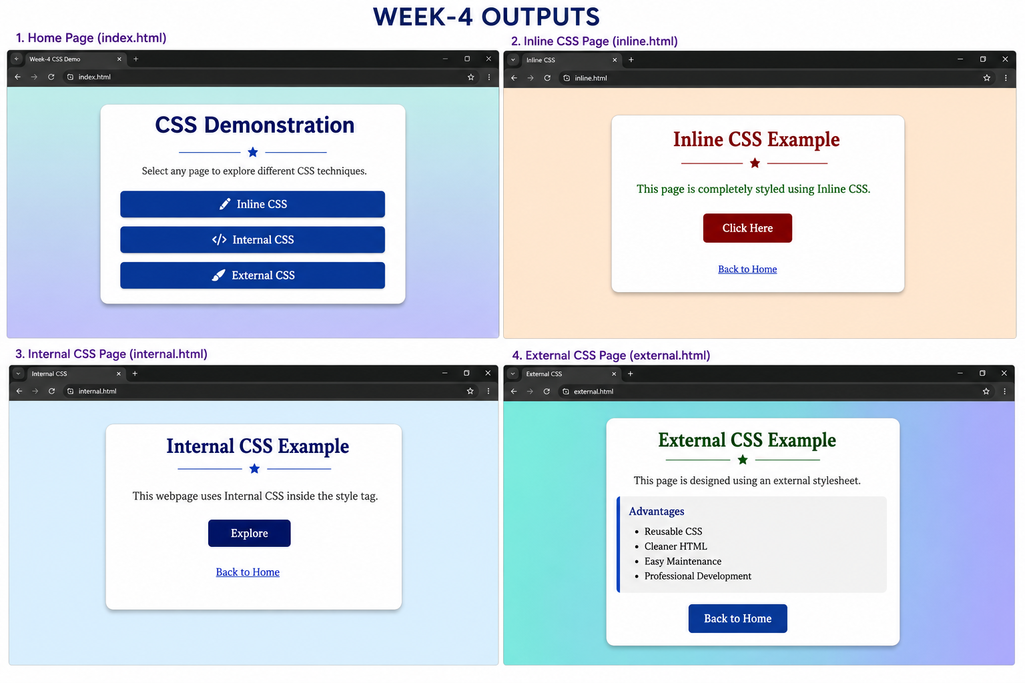

Concepts Used:

1. CSS Types
- Inline CSS
- Internal CSS
- External CSS

2. CSS Selectors
- Element Selector
- Class Selector (.)
- ID Selector (#)

3. CSS Properties
- background
- color
- font-family
- font-size
- text-align
- margin
- padding
- border
- border-radius
- box-shadow
- width
- display
- text-decoration

4. HTML Elements
- <html>
- <head>
- <title>
- <body>
- <div>
- <h1>
- <h2>
- <p>
- <ul>
- <li>
- <a>
- <button>
- <link>
- <style>

5. HTML Attributes
- class
- id
- href
- rel
- style

Result:
A multi-page website was created successfully to demonstrate the three methods of applying CSS: Inline, Internal, and External CSS. The experiment also illustrated the use of CSS classes, IDs, and <div> elements to create attractive and well-structured webpages. Different styling properties such as colors, fonts, backgrounds, borders, spacing, shadows, and hover effects were applied successfully, resulting in a responsive and visually appealing interface suitable for understanding the fundamentals of CSS.

