WEEK-5
Aim: To study various CSS properties such as Colors, Position, and Classes, and to understand different methods of integrating JavaScript (Inline, Internal, and External) by designing interactive and attractive web pages.
Objective:
- To understand different methods of specifying colors in CSS.
- To learn the use of background colors, border colors, and gradient colors.
- To study different CSS Position properties.
- To understand reusable CSS Classes.
- To apply Inline CSS wherever required.
- To understand Inline JavaScript.
- To understand Internal JavaScript.
- To understand External JavaScript.
- To perform arithmetic operations using JavaScript.
- To create attractive and responsive webpages.
Code:
Home Page:
<!DOCTYPE html>
<html>
<head>
<title>EWP Week-5</title>
<link rel="stylesheet" href="style.css">
</head>
<body>
<div class="container">
<h1>Week-5 CSS & JavaScript Demonstration</h1>
<p class="description">
Explore different CSS and JavaScript concepts.
</p>
<div class="menu">
<a href="colors.html">CSS Colors</a>
<a href="positions.html">CSS Position</a>
<a href="classes.html">CSS Classes</a>
<a href="javascript.html">JavaScript Integration</a>
</div>
</div>
</body>
</html>
Style.css:
/* Body */
body{
margin:0;
padding:30px;
font-family:Arial,Helvetica,sans-serif;
background:linear-gradient(135deg,#74ebd5,#ACB6E5);
}
/* Main Container */
.container{
width:900px;
margin:auto;
background:white;
padding:30px;
border-radius:15px;
box-shadow:0px 0px 20px rgba(0,0,0,0.3);
text-align:center;
}
/* Heading */
h1{
color:#0B3D91;
text-shadow:1px 1px 2px gray;
}
/* Description */
.description{
font-size:20px;
color:#555;
}
/* Navigation */
.menu{
margin-top:30px;
}
.menu a{
display:block;
width:250px;
margin:15px auto;
padding:14px;
background:#0B3D91;
color:white;
text-decoration:none;
border-radius:8px;
font-size:18px;
transition:0.3s;
}
.menu a:hover{
background:#1565C0;
transform:scale(1.05);
}
/* General Buttons */
button{
padding:12px 22px;
background:#0B3D91;
color:white;
border:none;
border-radius:6px;
cursor:pointer;
margin:8px;
font-size:16px;
}
button:hover{
background:#1565C0;
}
/* Input Boxes */
input{
padding:10px;
width:220px;
margin:8px;
font-size:16px;
border:2px solid #0B3D91;
border-radius:5px;
}
/* Tables */
table{

width:100%;
border-collapse:collapse;
margin-top:20px;
}
table,th,td{
border:2px solid gray;
}
th{
background:#1565C0;
color:white;
padding:10px;
}
td{
padding:10px;
background:#F5F5F5;
}
/* Lists */
ul{
text-align:left;
display:inline-block;
}
li{
padding:5px;
}
/* Cards */
.card{
background:#F8F9FA;
padding:20px;
margin:20px;
border-radius:10px;
box-shadow:0px 0px 10px gray;
}
/* Badge */
.badge{
background:#28A745;
color:white;
padding:5px 12px;
border-radius:15px;
}
/* Footer Links */
a{
color:#0B3D91;
font-weight:bold;
}
a:hover{
color:red;
}

Color.html:
<!DOCTYPE html>
<html>
<head>
<title>CSS Colors Demonstration</title>
<link rel="stylesheet" href="style.css">
</head>
<body>
<div class="container">
<h1>CSS Colors Demonstration</h1>
<p class="description">
This page demonstrates different methods of applying colors in CSS.
</p>
<hr>
<h2>1. Text Colors</h2>
<p class="named">Named Color - Red</p>
<p class="hex">HEX Color - #0066CC</p>
<p class="rgb">RGB Color - rgb(0,128,0)</p>
<p class="rgba">RGBA Color - rgba(255,0,0,0.6)</p>
<p class="hsl">HSL Color</p>
<p class="hsla">HSLA Color</p>
<hr>
<h2>2. Background Colors</h2>
<div class="bgBlue">
Blue Background
</div>
<br>
<div class="bgGreen">
Green Background
</div>
<br>
<div class="gradient">
Gradient Background
</div>
<hr>
<h2>3. Border Colors</h2>
<div class="borderRed">
Red Border
</div>
<br>
<div class="borderBlue">
Blue Border
</div>
<hr>
<h2>4. Colored Buttons</h2>
<button class="btnBlue">Blue Button</button>
<button class="btnGreen">Green Button</button>
<button class="btnRed">Red Button</button>
<hr>
<h2>5. Colored Links</h2>
<a class="link1" href="#">Blue Link</a>
<br><br>
<a class="link2" href="#">Red Link</a>
<hr>
<h2>6. Colored Input Boxes</h2>
<input class="inputBlue" placeholder="Blue Border">
<input class="inputGreen" placeholder="Green Border">
<hr>
<h2>7. Colored Table</h2>
<table>
<tr>
<th>Name</th>
<th>Color</th>
</tr>
<tr>
<td>Apple</td>
<td style="color:red;">Red</td>
</tr>
<tr>
<td>Leaf</td>
<td style="color:green;">Green</td>
</tr>
<tr>
<td>Sky</td>
<td style="color:blue;">Blue</td>
</tr>
</table>
<hr>
<h2>8. Colored List</h2>
<ul>
<li style="color:red;">Red Item</li>
<li style="color:green;">Green Item</li>
<li style="color:blue;">Blue Item</li>
<li style="color:purple;">Purple Item</li>
</ul>
<hr>
<h2>9. Inline CSS Example</h2>
<h3 style="color:darkorange;">
This Heading Uses Inline CSS
</h3>
<p style="background:lightyellow;
padding:15px;
color:darkblue;
border:2px solid orange;">
This paragraph is completely styled using Inline CSS.
</p>
<button style="background:purple;
color:white;
padding:12px;
border:none;
border-radius:6px;">
Inline Styled Button
</button>
<br><br>
<a href="index.html">
Back to Home
</a>
</div>
</body>
</html>

Posituons.html:
<!DOCTYPE html>
<html>
<head>
<title>CSS Position Demonstration</title>
<link rel="stylesheet" href="style.css">
</head>
<body>
<div class="container">
<h1>CSS Position Demonstration</h1>
<p class="description">
This page demonstrates all CSS Position properties.
</p>
<hr>
<h2>1. Static Position</h2>
<div class="staticBox">
Static Position (Default)
</div>
<hr>
<h2>2. Relative Position</h2>
<div class="relativeBox">
Relative Position
</div>
<hr>
<h2>3. Absolute Position</h2>
<div class="parent">
Parent Container
<div class="absoluteBox">
Absolute Position
</div>
</div>
<hr>
<h2>4. Fixed Position</h2>
<p>
A fixed box appears at the bottom-right corner of the browser window.
</p>
<div class="fixedBox">
Fixed Position
</div>
<hr>
<h2>5. Sticky Position</h2>
<div class="stickyBox">
Sticky Position (Scroll Down)
</div>
<div class="scrollArea">
<p>Scroll to observe the Sticky element.</p>
<p>Lorem ipsum dolor sit amet.</p>
<p>CSS makes webpages attractive.</p>
<p>HTML provides webpage structure.</p>
<p>JavaScript adds interactivity.</p>
<p>Sticky Position remains at the top while scrolling.</p>
<p>Continue Scrolling...</p>
<p>Continue Scrolling...</p>
<p>Continue Scrolling...</p>
<p>Continue Scrolling...</p>
<p>Continue Scrolling...</p>
<p>Continue Scrolling...</p>
<p>Continue Scrolling...</p>
<p>Continue Scrolling...</p>
<p>End of Demonstration.</p>
</div>
<hr>
<h2>6. Inline CSS Position Example</h2>
<div style="position:relative;
left:50px;
background:orange;
color:white;
padding:15px;
width:250px;
border-radius:8px;">
Inline CSS Relative Position
</div>
<br>
<a href="index.html">
Back to Home
</a>
</div>
</body>
</html>
Class.html:
<!DOCTYPE html>
<html>
<head>
<title>CSS Classes Demonstration</title>
<link rel="stylesheet" href="style.css">
</head>
<body>
<div class="container">
<h1>CSS Classes Demonstration</h1>
<p class="description">
This page demonstrates the use of reusable CSS classes.
</p>
<hr>
<h2>1. Alert Classes</h2>
<p class="success">
✔ Success! Data Saved Successfully.
</p>
<p class="warning">
⚠ Warning! Please Check Your Input.
</p>
<p class="danger">
✖ Error! Invalid Username or Password.
</p>
<p class="info">
ℹ Information! Welcome to CSS Classes Demo.
</p>
<hr>
<h2>2. Card Class</h2>
<div class="card">
<h3>Student Information</h3>
<p><b>Name :</b> John</p>
<p><b>Department :</b> AI</p>
<p><b>Semester :</b> V</p>
</div>
<hr>
<h2>3. Badge Class</h2>
<span class="badge">NEW</span>
<span class="badgeGreen">ACTIVE</span>
<span class="badgeRed">OFFLINE</span>
<hr>
<h2>4. Button Classes</h2>
<button class="btnBlue">Primary</button>
<button class="btnGreen">Success</button>
<button class="btnRed">Danger</button>
<button class="btnOrange">Warning</button>
<hr>
<h2>5. Table Using Classes</h2>
<table class="studentTable">
<tr>
<th>Name</th>
<th>Department</th>
<th>Grade</th>
</tr>
<tr>
<td>Rahul</td>
<td>AI</td>
<td>A</td>
</tr>
<tr>
<td>Sneha</td>
<td>CSE</td>
<td>A+</td>
</tr>
<tr>
<td>Ajay</td>
<td>ECE</td>
<td>B+</td>
</tr>
</table>
<hr>
<h2>6. List Using Classes</h2>
<ul class="courseList">
<li>HTML</li>
<li>CSS</li>
<li>JavaScript</li>
<li>Bootstrap</li>
<li>React</li>
</ul>
<hr>
<h2>7. Multiple Classes</h2>
<p class="card success">
This paragraph uses both <b>card</b> and <b>success</b> classes.
</p>
<hr>
<h2>8. Inline CSS with Class</h2>
<div class="card"
style="background:#FFF8DC;
border:3px dashed orange;">
This card uses a CSS class along with Inline CSS.
</div>
<br>
<a href="index.html">
Back to Home
</a>
</div>
</body>
</html>
Javascript.html:
<!DOCTYPE html>
<html>
<head>
<title>JavaScript Demonstration</title>
<link rel="stylesheet" href="style.css">
<!-- External JavaScript -->
<script src="script.js"></script>
<!-- Internal JavaScript -->
<script>
function showMessage()
{
alert("This message is from Internal JavaScript.");
}
</script>
</head>
<body>
<div class="container">
<h1>JavaScript Integration</h1>
<p class="description">
This page demonstrates Inline, Internal and External JavaScript.
</p>
<hr>
<h2>1. Inline JavaScript</h2>
<button onclick="alert('Hello! This is Inline JavaScript.')">
Click Me
</button>
<hr>
<h2>2. Internal JavaScript</h2>
<button onclick="showMessage()">
Show Internal JavaScript
</button>
<hr>

<h2>3. External JavaScript</h2>
<button onclick="externalMessage()">
Show External JavaScript
</button>
<hr>
<h2>4. JavaScript Calculator</h2>
<table class="studentTable">
<tr>
<td>First Number</td>
<td><input type="number" id="num1"></td>
</tr>
<tr>
<td>Second Number</td>
<td><input type="number" id="num2"></td>
</tr>
</table>
<br>
<button class="btnBlue" onclick="add()">Addition</button>
<button class="btnGreen" onclick="subtract()">Subtraction</button>
<button class="btnOrange" onclick="multiply()">Multiplication</button>
<button class="btnRed" onclick="divide()">Division</button>
<br><br>
<h2 id="result">
Result :
</h2>
<br>
<a href="index.html">
Back to Home
</a>
</div>
</body>
</html>
Script.js:
// External JavaScript
function externalMessage()
{
alert("This message is from External JavaScript.");
}
// Read Input Values
function getValues()
{
let num1 = Number(document.getElementById("num1").value);
let num2 = Number(document.getElementById("num2").value);
return { num1, num2 };
}
// Addition
function add()
{
let value = getValues();
document.getElementById("result").innerHTML =
"Result : " + (value.num1 + value.num2);
}
// Subtraction

function subtract()
{
let value = getValues();
document.getElementById("result").innerHTML =
"Result : " + (value.num1 - value.num2);
}
// Multiplication
function multiply()
{
let value = getValues();
document.getElementById("result").innerHTML =
"Result : " + (value.num1 * value.num2);
}
// Division
function divide()
{
let value = getValues();
if(value.num2==0)
{
document.getElementById("result").innerHTML =
"Result : Cannot Divide by Zero";
}
else
{
document.getElementById("result").innerHTML =
"Result : " + (value.num1 / value.num2);
}
}
Output :
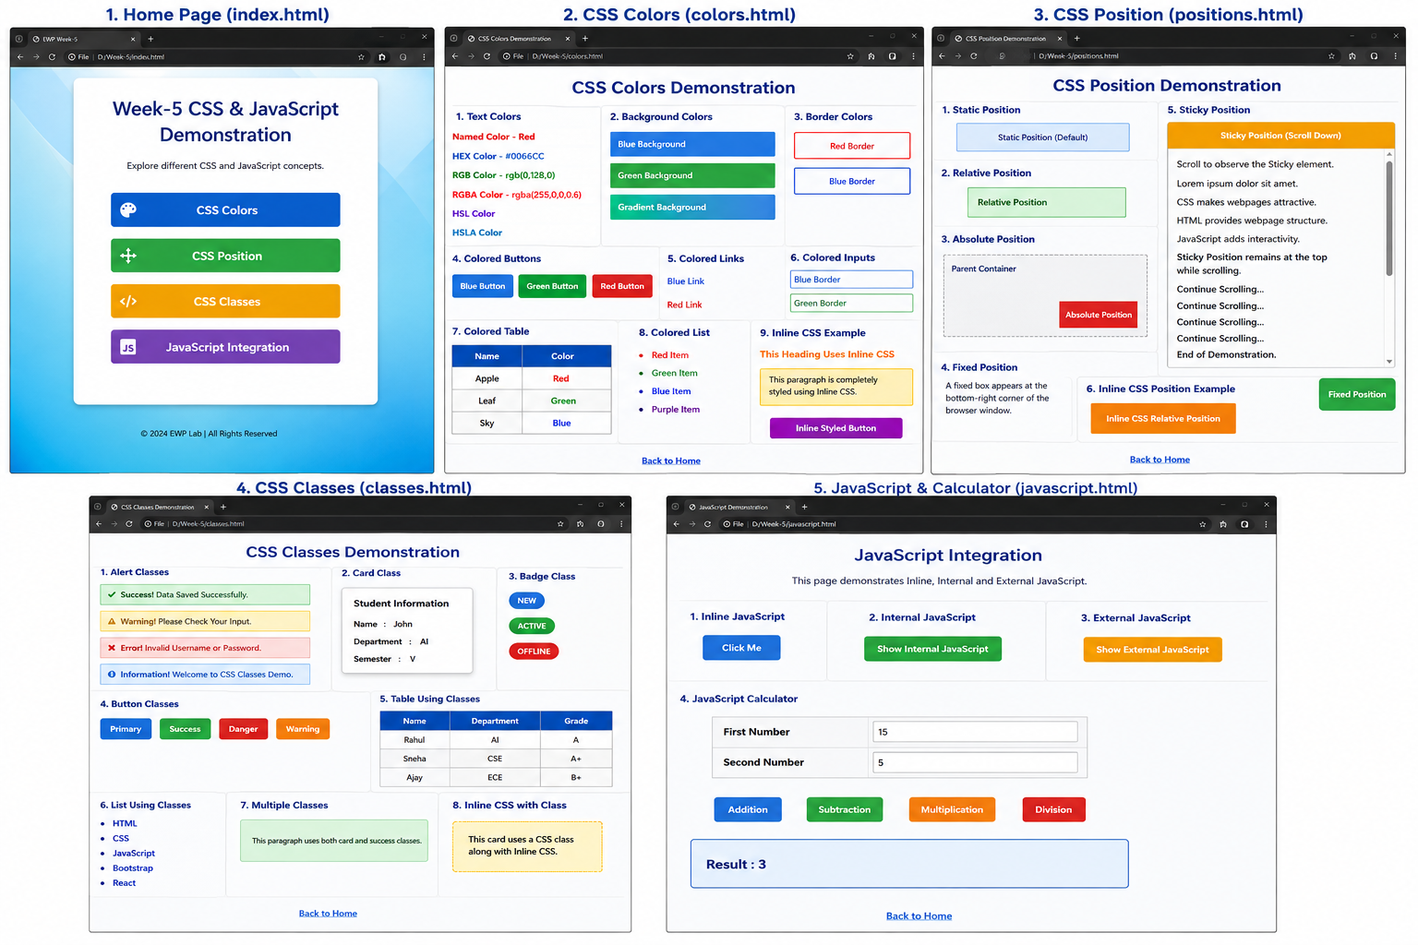

Concepts Used:

1. CSS Colors
- Named Colors
- HEX Colors
- RGB Colors
- RGBA Colors
- HSL Colors
- HSLA Colors
- Background Colors
- Border Colors
- Gradient Backgrounds
- Text Colors

2. CSS Position
- Static
- Relative
- Absolute
- Fixed
- Sticky

3. CSS Classes
- Class Selector (.)
- Reusable Classes
- Multiple Classes on One Element
- Alert Classes
- Card Class
- Badge Class
- Button Classes
- Table Classes
- List Classes

4. JavaScript Integration
- Inline JavaScript
- Internal JavaScript
- External JavaScript

5. JavaScript Concepts
- Variables
- Functions
- DOM Manipulation
- Event Handling
- Input Handling
- Arithmetic Operators
- Conditional Statements (if...else)
- Output using innerHTML

6. JavaScript Calculator
- Addition
- Subtraction
- Multiplication
- Division
- Division by Zero Validation

7. CSS Properties
- color
- background
- background-color
- background-image
- border
- border-radius
- box-shadow
- margin
- padding
- font-family
- font-size
- font-weight
- text-align
- text-decoration
- width
- height
- display
- position
- top
- right
- bottom
- left
- z-index
- transition
- transform

8. HTML Elements
- <html>
- <head>
- <title>
- <body>
- <div>
- <h1>
- <h2>
- <h3>
- <p>
- <a>
- <button>
- <input>
- <table>
- <tr>
- <th>
- <td>
- <ul>
- <li>
- <span>
- <hr>
- <script>
- <link>

9. HTML Attributes
- class
- id
- href
- src
- type
- onclick
- style
- rel
- placeholder

Result:
A multi-page website was created successfully to demonstrate various CSS concepts including Colors, Position properties, and reusable Classes. The experiment also illustrated the integration of JavaScript using Inline, Internal, and External methods. A JavaScript Calculator was implemented to perform Addition, Subtraction, Multiplication, and Division with input validation. Different CSS properties such as text colors, background colors, border colors, gradients, positioning techniques, shadows, hover effects, and reusable classes were applied to create an attractive, responsive, and interactive user interface, thereby strengthening the understanding of front-end web development fundamentals.

