
COMSATS University Islamabad,
Abbottabad Campus

SOFTWARE DESIGN DESCRIPTION
(SDD DOCUMENT)
for
INTELI-REHAB
A Smart Wearable Rehabilitation System
By
Tehreem Zaheer CIIT/SP23-BCS-131/ATD
Kashmala Zeb CIIT/SP23-BSE-048/ATD
Ahmed Irshad CIIT/SP23-BSE-045/ATD

Supervisor
Dr. Ahmed Khan

Bachelor of Science in Computer Science (2023-2027)

Table of Contents
1. Introduction 6
2. Design methodology and software process model 6
3. System overview 7
3.1 Architectural design 7
3.2 ARCHITECTURE DIAGRAM: 9
3.3 Process flow/Representation 9
3.3.1 Patient Activity Diagram: 10
3.3.2 Physiotherapist Activity Diagram: 11
3.3.3 Clinic Activity Diagram: 12
4. Design models 13
4.1 Class Diagram 13
4.2 Sequence Diagram 14
Patient Sequence Diagram 14
Physiotherpist Sequence Diagram 14
Clinic Sequence Diagram 15
7. Data design 18
5.2 DATABASE / STORAGE SOLUTIONS: 19
5.3 DATA DICTIONARY: 19
8. ALGORITHM AND IMPLEMENTATION: 27
6.1 WEARABLE PAIRING & BIOMETRIC CALIBRATION ALGORITHM: 27
6.2 SENSOR FUSION ALGORITHM: 28
6.3 EMG SIGNAL PROCESSING ALGORITHM: 29
6.4 MOVEMENT ANOMALY DETECTION ALGORITHM: 29
6.5 FATIGUE TREND DETECTION & ALERT ALGORITHM: 30
6.6 SESSION REPORT GENERATION & CLOUD SYNC ALGORITHM: 31
7. Software requirements traceability matrix 32
8. Human interface design 34
8.1. SCREEN IMAGES FOR MOBILE APP: 34
The Inteli-Rehab system includes: 34
Screen objects and actions for Patient Mobile App 37
8.2. SCREEN IMAGES FOR WEB PORTAL: 38
9. Appendix I 41

Revision History
Name | Date | Reason for changes | Version

Application Evaluation History

Comments (by committee)  *include the ones given at scope time both in doc and presentation | Action Taken
Comments for 10%: Task list for 30%: Verbally communicated as mentioned in presentation. | We have implemented UI for all three actors (Patient, Physiotherapist and Clinic) with user authentication and constructed the wearable prototype.

Supervised by
Dr. Ahmad Khan
Signature_____________
- Introduction
IntelliRehab is a smart wearable rehabilitation system designed to assist patients and physiotherapists in monitoring and improving upper-arm rehabilitation exercises. The system combines wearable sensor technology, a mobile application, AI-based movement analysis, and 3D digital twin visualization to provide an interactive and data-driven rehabilitation experience.
The system allows patients to perform assigned exercises while collecting real-time motion and muscle activity data through IMU and EMG sensors integrated with an ESP32-based wearable device. The collected data is processed to evaluate movement quality, detect abnormalities, monitor fatigue, and provide corrective feedback. Physiotherapists can manage patients, assign exercises, review progress, and monitor rehabilitation outcomes through a dedicated control interface.
This document presents the system design, architecture, major workflows, database structure, and interface designs completed so far. At the current stage, the system includes modules for patient and clinic onboarding, exercise management, wearable sensor connectivity, baseline calibration, movement tracking, digital twin visualization, AI-based assessment, and physiotherapist monitoring.

Design methodology and software process model
The design of Inteli-Rehab follows an Object-Oriented Design (OOD) methodology. This approach is selected because the system contains multiple modular components -- Onboarding, Exercise Protocol Management, Wearable Connectivity, Biometric Calibration, Movement Tracking, Digital Twin Visualization, AI Monitoring & Safety, Gamification, and Physiotherapist/Clinic Oversight -- each of which can be modelled as an independent class or service with clear responsibilities and well-defined interfaces.
Object-oriented principles such as encapsulation, modularity, inheritance, and reusability help ensure that the Flutter mobile application, the on-device intelligence layer, and the Supabase-backed cloud services maintain a clean, testable, and scalable structure. Shared behaviour between Patient, Physiotherapist, and Clinic Admin accounts is captured through a common User base class, while specialised responsibilities are pushed into their respective subclasses.
Inteli-Rehab is developed using the Incremental Development Model, matching the phased delivery plan set out in the project's Scope Document and Gantt chart (10%, 30%, 60%, and 100% milestones). Each increment delivers a working, demonstrable subset of the system -- starting with onboarding and wearable connectivity, then movement tracking and the digital twin, then AI monitoring and safety features, and finally the physiotherapist/clinic dashboards and cloud synchronisation -- allowing the design to be refined and validated against supervisor and committee feedback at every phase.

System overview
Inteli-Rehab is designed as a hybrid edge-cloud system that follows a layered, modular architecture. Time-critical sensing and feedback -- sensor fusion, EMG processing, AI inference, and 3D digital twin rendering -- run on-device inside the Flutter mobile application so that patients receive corrective and fatigue feedback with minimal latency during a live session. All clinical oversight, protocol management, and longitudinal progress data are synchronised to a Supabase cloud backend (PostgreSQL) and exposed to physiotherapists and clinic administrators through dedicated React.js web dashboards.
The system operates in an offline-first mode for the exercise session itself -- sensor streaming, movement tracking, and alerting continue to function without connectivity -- while account management, protocol assignment, and reporting require the mobile app or web dashboard to reach the cloud backend. Supabase (PostgreSQL) is used as the primary relational data store for all structured clinical and account data.

Architectural design
3.1.1 PERCEPTION / SENSING LAYER:
The hardware layer with dual IMU sensors (upper arm + forearm) and EMG electrodes (biceps + triceps). A BLE microcontroller streams raw sensor data to the mobile app.
3.1.2 COMMUNICATION LAYER:
Handles Bluetooth connection between wearable and mobile app. Manages pairing, data streaming, and sensor calibration.
3.1.3 INTELLIGENCE & PROCESSING LAYER:
Processes sensor data on the phone in real time:
- Sensor Fusion: Combines IMU data into joint angles
- EMG Processor: Calculates muscle activation and fatigue
- AI Engine: Detects movement errors and fatigue trends
- Digital Twin: Shows a live 3D arm model with color-coded feedback
3.1.4 APPLICATION LAYER:
The Flutter mobile app patients use. Handles onboarding, device pairing, live exercises, progress tracking, and gamified feedback.
3.1.5 DATA & SYNC LAYER:
Stores session data locally on the phone and syncs to the cloud when internet is available.
3.1.6 CLOUD & INFRASTRUCTURE LAYER:
Supabase backend for user login, database, live updates, and file storage.
3.1.7 PRESENTATION / MONITORING LAYER:
React.js web dashboards for physiotherapists (patient monitoring, reports) and clinic admins (staff management).
3.1.8 AI TRAINING PIPELINE:
Offline Python system that trains AI models on EMG datasets, then exports them to the mobile app.
3.1.9 INTER-LAYER RELATIONSHIPS:
- Wearable sends data → Mobile App
- Mobile App processes → AI Engine
- AI results → Live 3D model + alerts
- App saves data → Local storage → Cloud
- Cloud feeds → Web dashboards
- Training updates models → Mobile App (via app updates)

ARCHITECTURE DIAGRAM:
Figure 1 shows the full layered architecture of Inteli-Rehab, from the wearable hardware through on-device intelligence to the cloud backend and web dashboards.

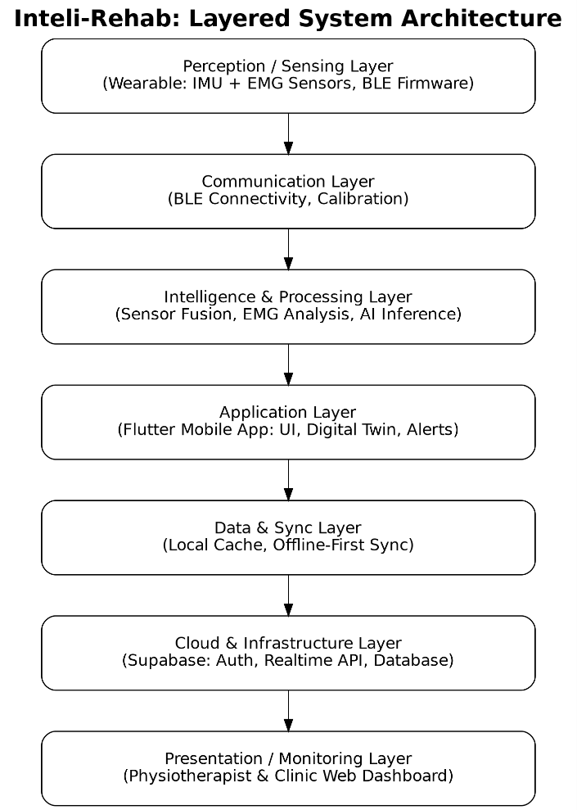
Figure 1 Architecture Diagram

Process flow/Representation
The following activity diagrams show the process flow of our system based upon three user perspectives, as given below:
- Patient Activity Diagram
- Physiotherapist Activity Diagram
- Clinic Activity Diagram

Patient Activity Diagram:
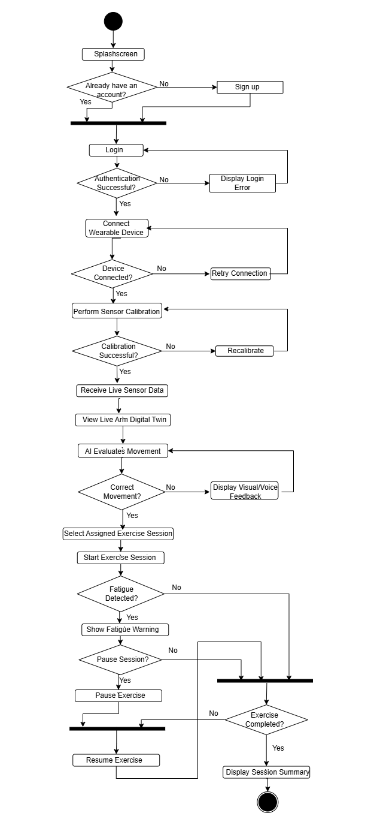
Figure 2 Patient Activity Diagram

Physiotherapist Activity Diagram:
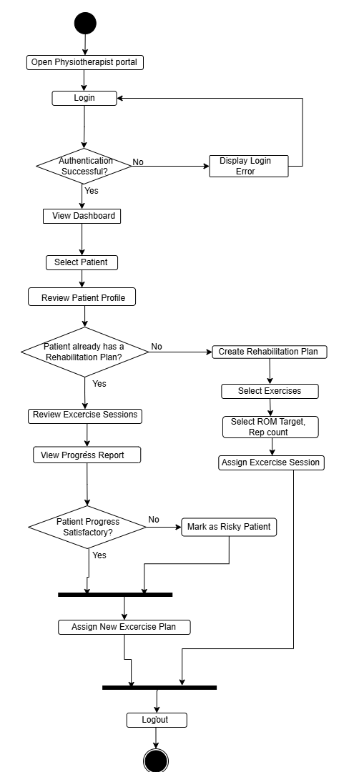

Figure 3 Physiotherapist Activity Diagram

Clinic Activity Diagram:

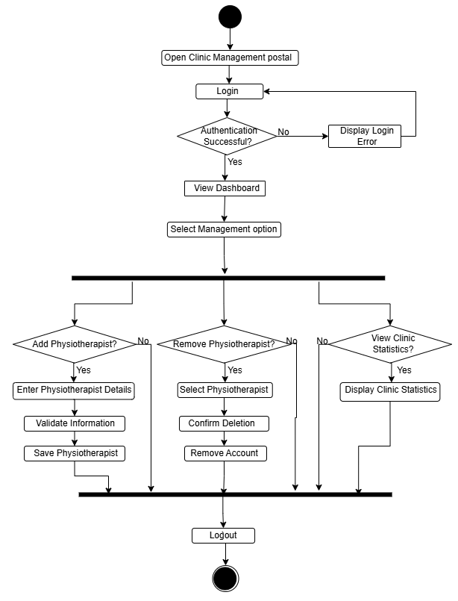
Figure 4 Clinic Activity Diagram

Design models

Class Diagram

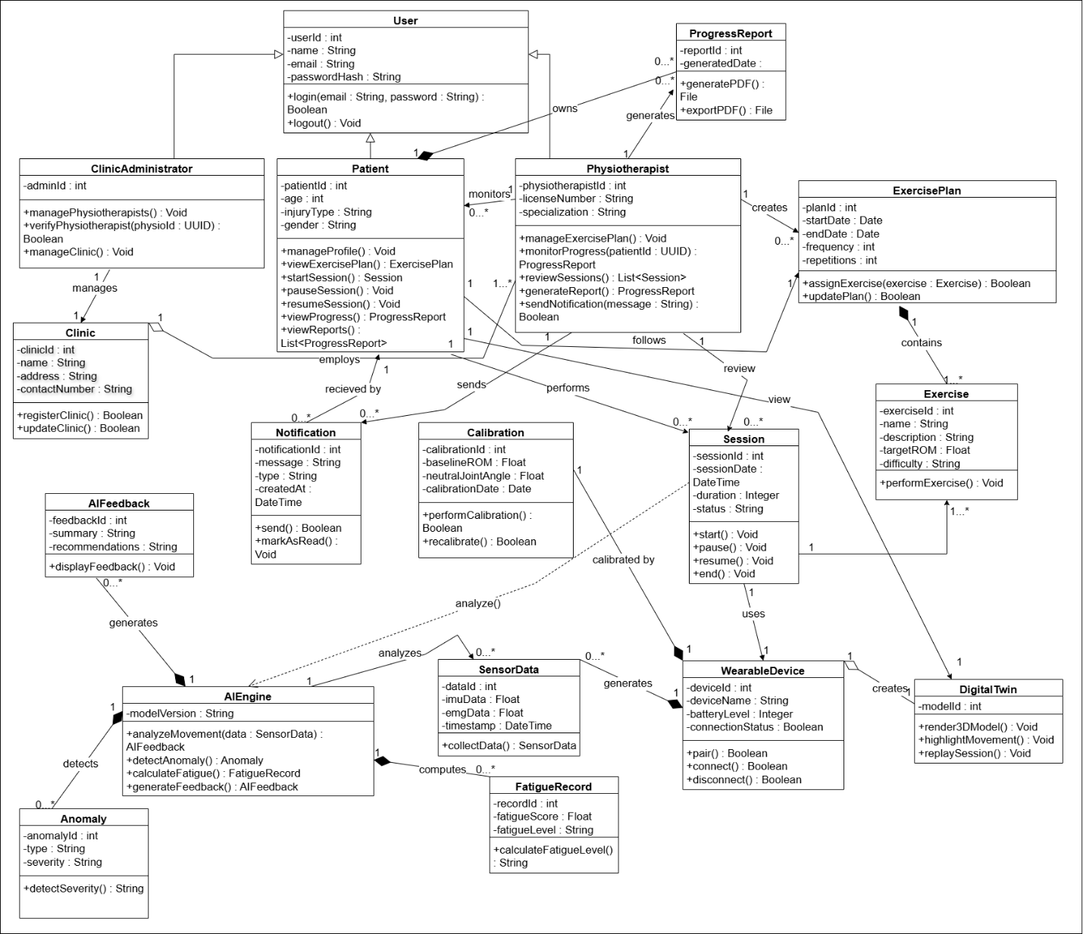
Figure 5 Class Diagram

Sequence Diagram
The following diagrams show the process sequence of our system based upon three user perspectives, as given below:

Patient Sequence Diagram
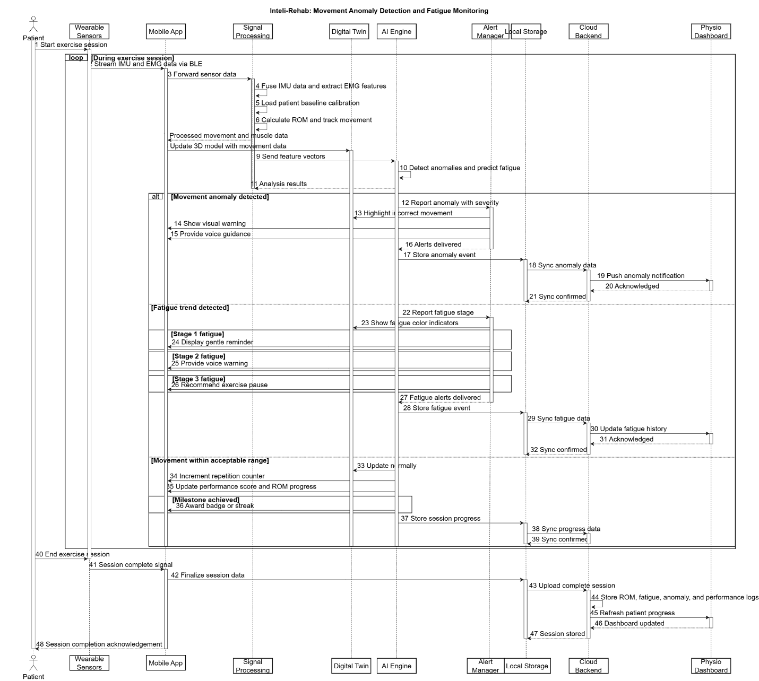
Figure 6 Patient Sequence Diagram

Physiotherpist Sequence Diagram
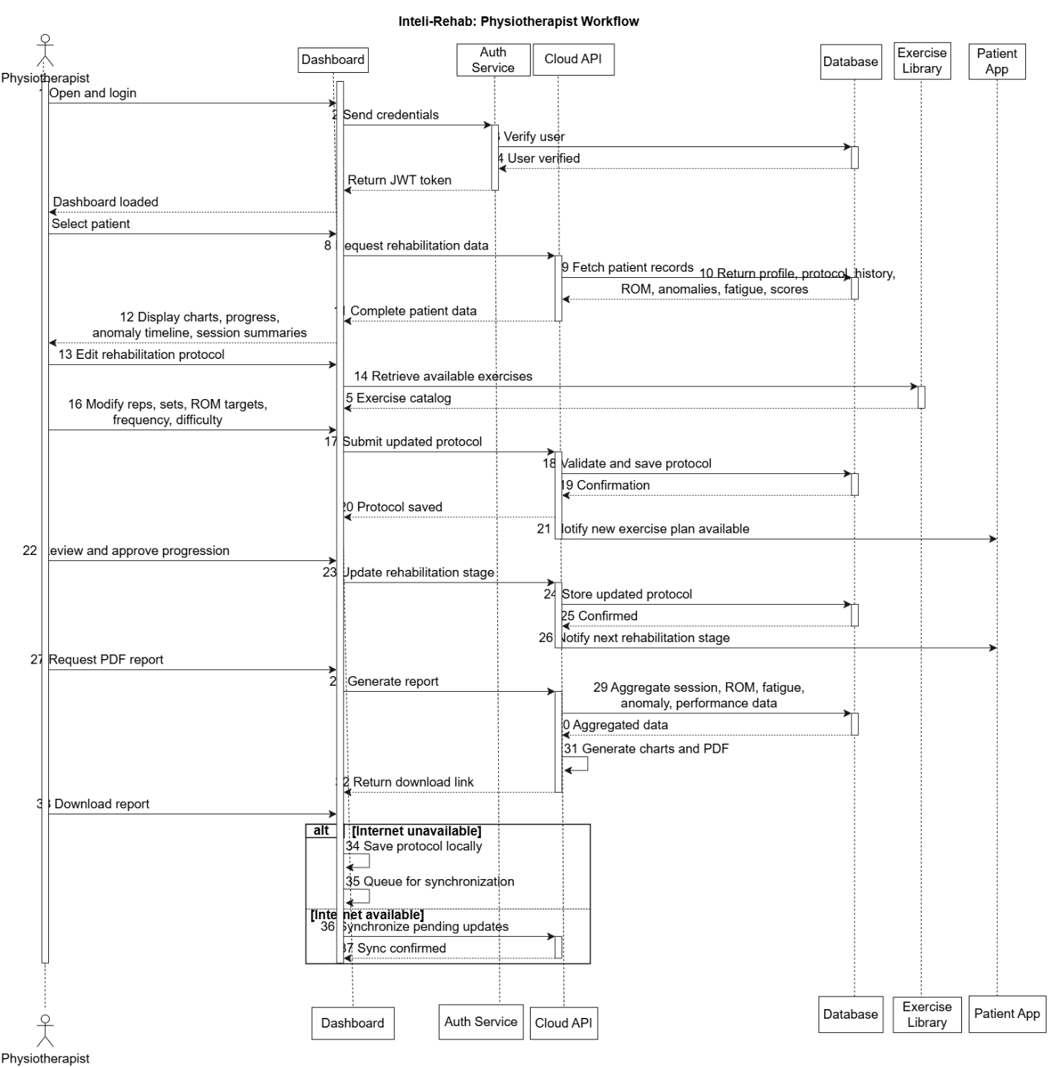
Figure 7 Physiotherapist Sequence Diagram

Clinic Sequence Diagram
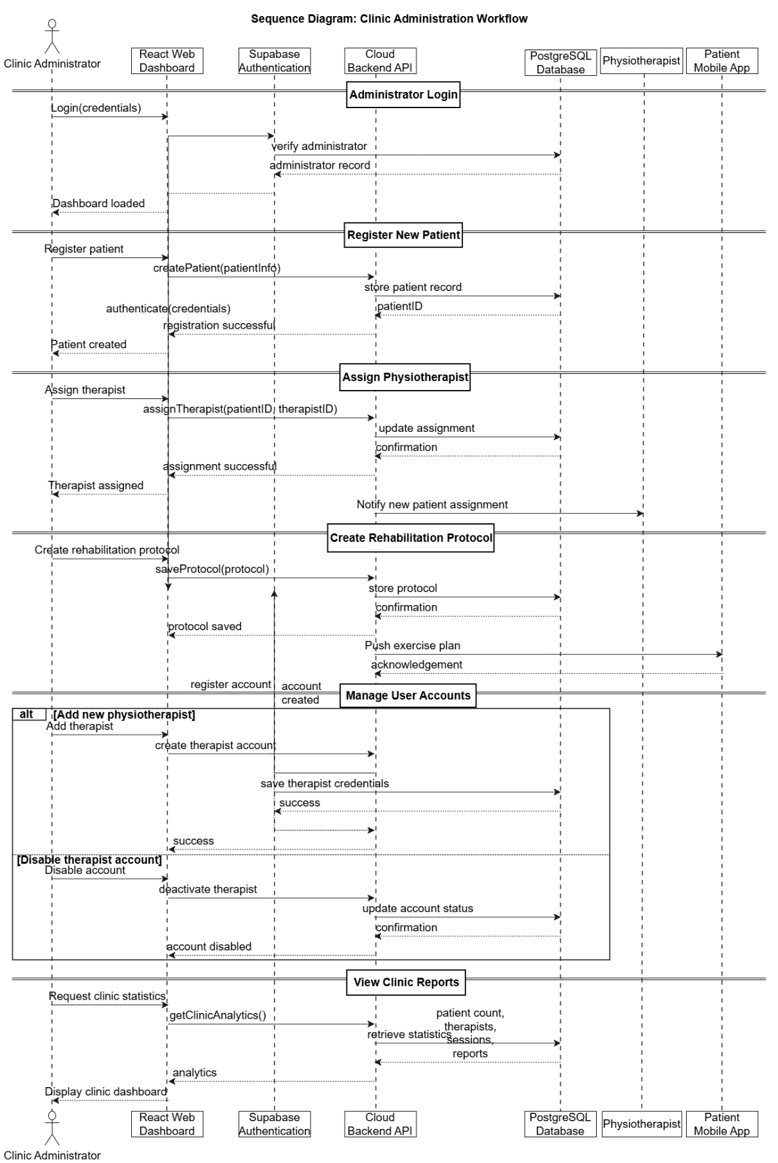
Figure 8 Clinic Sequence Diagram
- Schematic Diagram:

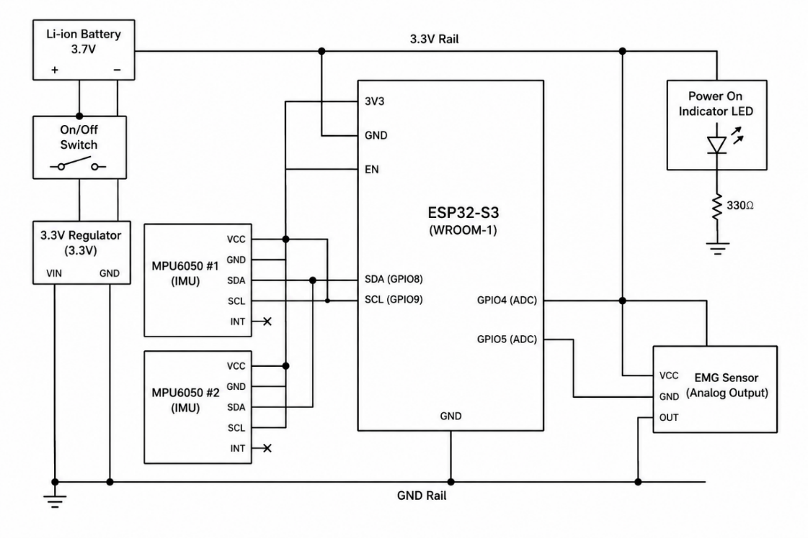
Figure 9 Schematic Block Diagram

- Timing Diagram
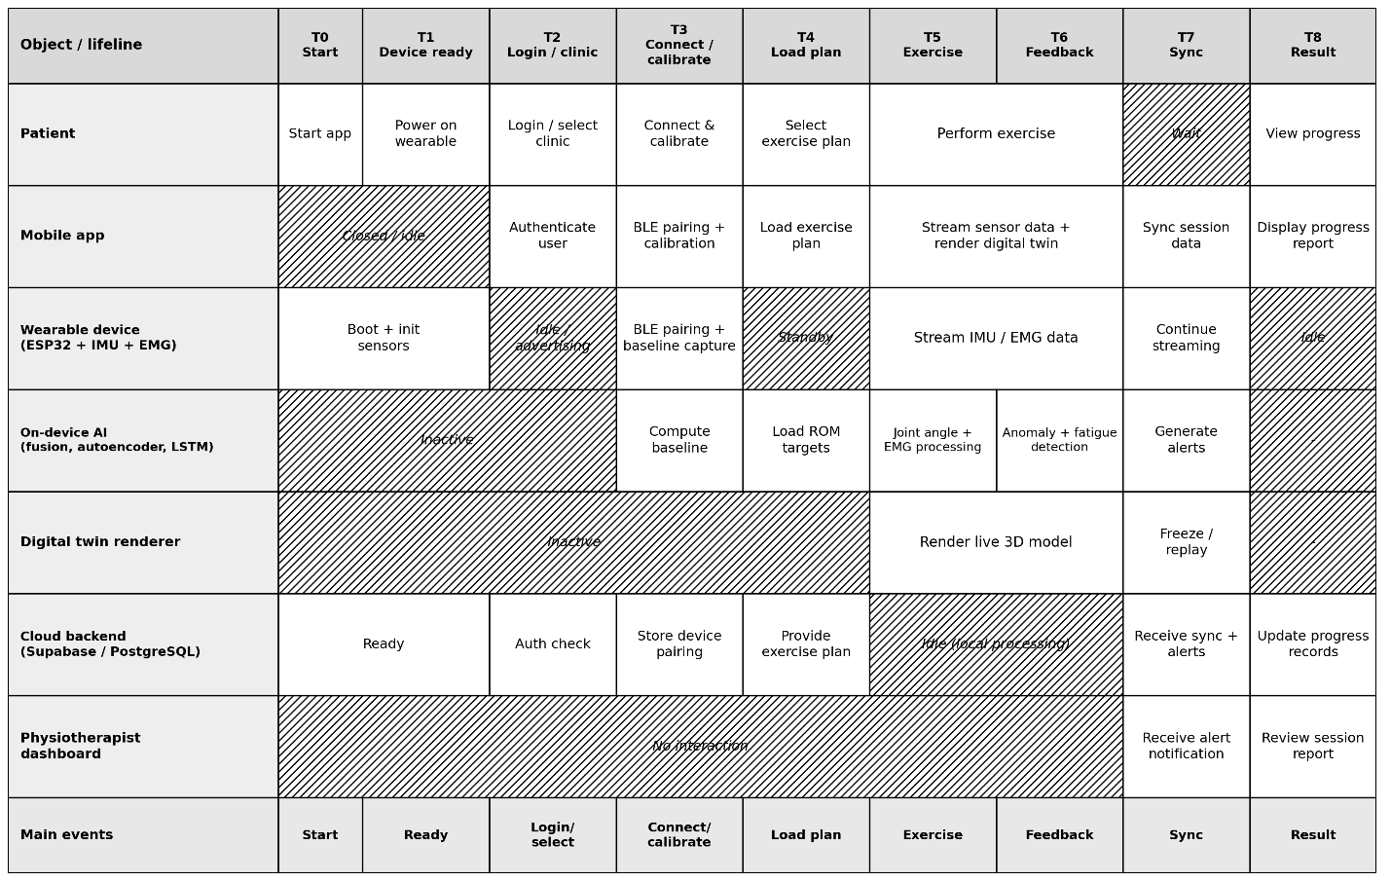
Figure 10 Timing Diagram

Data design
Inteli-Rehab's data design transforms the core information domain -- accounts, clinics, exercise protocols, live sessions, sensor readings, alerts, progress, and reports -- into a well-structured, scalable set of relational entities hosted in Supabase (PostgreSQL). The design supports offline-first session capture, clinician oversight, AI analysis logging, and patient motivation tracking.
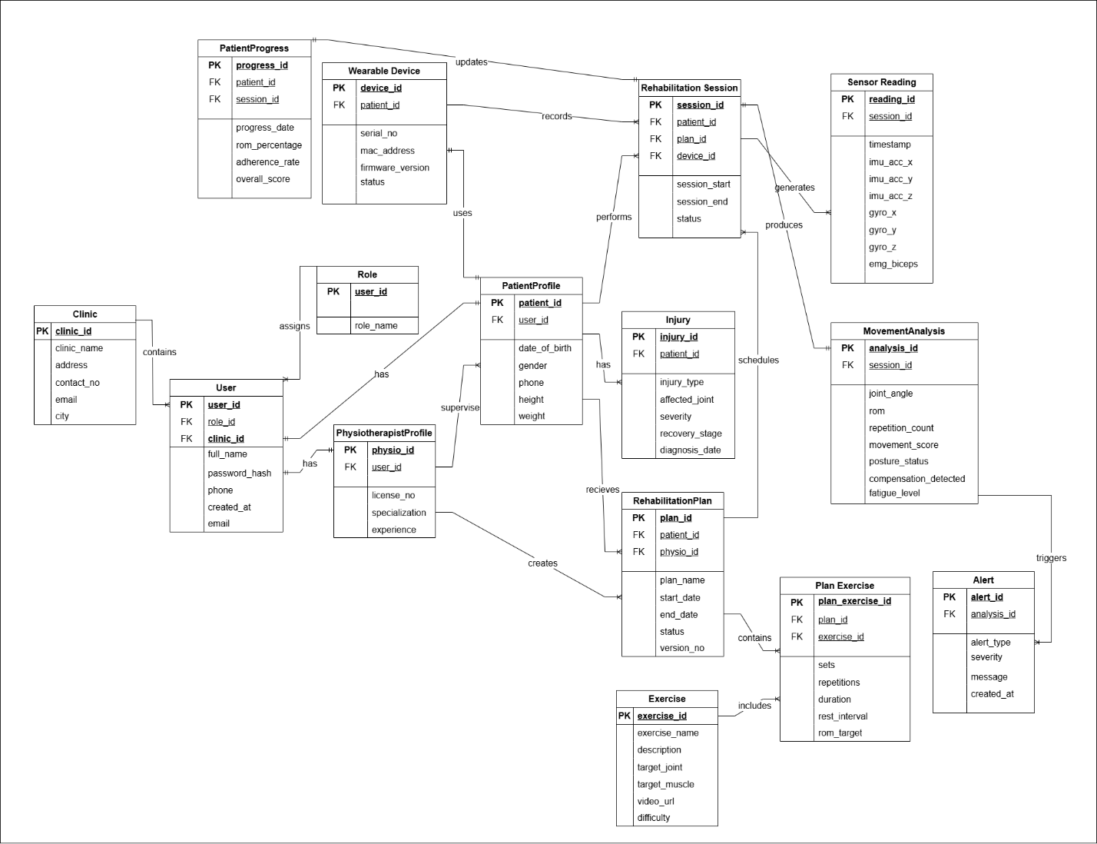
Figure 11 Inteli-Rehab ER Diagram

5.2 DATABASE / STORAGE SOLUTIONS:
Inteli-Rehab uses Supabase (managed PostgreSQL) as its primary relational data store for all account, clinical, protocol, session-summary, alert, progress, and report metadata. Supabase Auth handles authentication and role-based access control for Patient, Physiotherapist, and Clinic Admin accounts, and Supabase Storage holds generated PDF reports.
On the mobile device, a local SQLite cache stores the active protocol, in-progress session data, and any records queued by the offline-first sync engine, so that a live exercise session -- including movement tracking, digital-twin rendering, and safety alerts -- is never blocked by a lost network connection. High-frequency raw sensor frames are batched locally during a session and summarized before being persisted, rather than being streamed to the cloud row-by-row, to keep bandwidth and storage costs manageable.

5.3 DATA DICTIONARY:

ENTITY: CLINIC
Table 5.1 USER Data Dictionary
Attribute | Type | Description
clinic_id | int | Primary key, unique identifier for the clinic
clinic_name | string | Name of the clinic or hospital
address | string | Physical address of the clinic
contact_no | string | Phone number of the clinic
email | string | Email address of the clinic
city | string | City where the clinic is located

ENTITY: ROLE
Table 5.2 ROLE Data Dictionary
Attribute | Type | Description
user_id | int | Primary key; foreign key to User
role_name | string | Role assigned to the user

ENTITY: USER
Table 5.3 USER Data Dictionary
Attribute | Type | Description
user_id | INT | Primary key, unique identifier for the user
role_id | INT | Foreign key referencing ROLE
clinic_id | INT | Foreign key referencing CLINIC
full_name | VARCHAR | User's full name
password_hash | VARCHAR | Securely hashed password
phone | VARCHAR | User's contact number
created_at | DATETIME | Account creation timestamp

ENTITY: PATENT
Table 5.4 PATIENT Data Dictionary
Attribute | Type | Description
patient_id | INT | Primary key, unique identifier for the patient
user_id | INT | Foreign key referencing USER
date_of_birth | DATE | Patient's date of birth
gender | VARCHAR | Patient's gender
phone | VARCHAR | Patient's contact number
height | FLOAT | Height in centimeters
weight | FLOAT | Weight in kilograms

ENTITY: PHYSIOTHERAPIST_PROFILE
Table 5.5 PHYSIOTHERAPIST_PROFILE Data Dictionary
Attribute | Type | Description
physio_id | INT | Primary key, unique identifier for the physiotherapist
user_id | INT | Foreign key referencing USER
license_no | VARCHAR | Professional license number
specialization | VARCHAR | Area of specialization
experience | INT | Years of professional experience
email | VARCHAR | Professional email address

ENTITY: INJURY
Table 5.6 INJURY Data Dictionary
Attribute | Type | Description
injury_id | INT | Primary key, unique identifier for the injury
patient_id | INT | Foreign key referencing PATIENT_PROFILE
injury_type | VARCHAR | Type of injury
affected_joint | VARCHAR | Joint affected by the injury
severity | VARCHAR | Injury severity level
recovery_stage | VARCHAR | Current stage of recovery
diagnosis_date | DATE | Date of diagnosis

ENTITY: WEARABLE_DEVICE
Table 5.7 WEARABLE_DEVICE Data Dictionary
Attribute | Type | Description
device_id | INT | Primary key, unique identifier for the wearable device
patient_id | INT | Foreign key referencing PATIENT_PROFILE
serial_no | VARCHAR | Unique serial number
mac_address | VARCHAR | Bluetooth MAC address
firmware_version | VARCHAR | Installed firmware version
status | VARCHAR | Current device status

ENTITY: REHABILITATION_PLAN
Table 5.8 REHABILITATION_PLAN Data Dictionary
Attribute | Type | Description
plan_id | INT | Primary key, unique identifier for the rehabilitation plan
patient_id | INT | Foreign key referencing PATIENT_PROFILE
physio_id | INT | Foreign key referencing PHYSIOTHERAPIST_PROFILE
plan_name | VARCHAR | Rehabilitation plan name
start_date | DATE | Plan start date
end_date | DATE | Plan end date
status | VARCHAR | Current plan status
version_no | INT | Plan version number

ENTITY:EXERCISE
Table 5.9 EXERCISE Data Dictionary
Attribute | Type | Description
exercise_id | INT | Primary key, unique identifier for the exercise
exercise_name | VARCHAR | Exercise name
description | TEXT | Detailed exercise description
target_joint | VARCHAR | Target joint
target_muscle | VARCHAR | Target muscle group
video_url | VARCHAR | Instructional video URL
difficulty | VARCHAR | Exercise difficulty level

ENTITY: PLAN_EXERCISE
Table 5.10 PLAN_EXERCISE Data Dictionary
Attribute | Type | Description
plan_exercise_id | INT | Primary key, unique identifier for the record
plan_id | INT | Foreign key referencing REHABILITATION_PLAN
exercise_id | INT | Foreign key referencing EXERCISE
sets | INT | Number of prescribed sets
repetitions | INT | Number of repetitions
duration | INT | Duration in minutes
rest_interval | INT | Rest interval in seconds
rom_target | FLOAT | Target range of motion (degrees)

ENTITY: REHABILITATION_SESSION
Table 5.11 REHABILITATION_SESSION Data Dictionary
Attribute | Type | Description
session_id | INT | Primary key, unique identifier for the session
patient_id | INT | Foreign key referencing PATIENT_PROFILE
plan_id | INT | Foreign key referencing REHABILITATION_PLAN
device_id | INT | Foreign key referencing WEARABLE_DEVICE
session_start | DATETIME | Session start time
session_end | DATETIME | Session end time
status | VARCHAR | Current session status

ENTITY: SENSOR_READING
Table 5.12 SENSOR_READING Data Dictionary
Attribute | Type | Description
reading_id | INT | Primary key, unique identifier for the sensor reading
session_id | INT | Foreign key referencing REHABILITATION_SESSION
timestamp | DATETIME | Time the reading was captured
imu_acc_x | FLOAT | Accelerometer X-axis value
imu_acc_y | FLOAT | Accelerometer Y-axis value
imu_acc_z | FLOAT | Accelerometer Z-axis value
gyro_x | FLOAT | Gyroscope X-axis value
gyro_y | FLOAT | Gyroscope Y-axis value
gyro_z | FLOAT | Gyroscope Z-axis value
emg_biceps | FLOAT | EMG reading from biceps

ENTITY: MOVEMENT_ANALYSIS
Table 5.13 MOVEMENT_ANALYSIS Data Dictionary
Attribute | Type | Description
analysis_id | INT | Primary key, unique identifier for the analysis
session_id | INT | Foreign key referencing REHABILITATION_SESSION
joint_angle | FLOAT | Calculated joint angle (degrees)
rom | FLOAT | Achieved range of motion
repetition_count | INT | Number of completed repetitions
movement_score | FLOAT | Movement quality score (0–100)
posture_status | VARCHAR | Posture assessment
compensation_detected | BOOLEAN | Indicates compensatory movement detection
fatigue_level | VARCHAR | Detected fatigue level

ENTITY: ALERT
Table 5.14 ALERT Data Dictionary
Attribute | Type | Description
alert_id | INT | Primary key, unique identifier for the alert
analysis_id | INT | Foreign key referencing MOVEMENT_ANALYSIS
alert_type | VARCHAR | Alert category
severity | VARCHAR | Alert severity
message | TEXT | Alert description
created_at | DATETIME | Alert generation timestamp

ENTITY: PATIENT_PROGRESS
Table 5.15 PATIENT_PROGRESS Data Dictionary
Attribute | Type | Description
progress_id | INT | Primary key, unique identifier for the progress record
patient_id | INT | Foreign key referencing PATIENT_PROFILE
session_id | INT | Foreign key referencing REHABILITATION_SESSION
progress_date | DATE | Progress record date
rom_percentage | FLOAT | Range of motion improvement percentage
adherence_rate | FLOAT | Exercise adherence percentage
overall_score | FLOAT | Overall rehabilitation progress score

ALGORITHM AND IMPLEMENTATION:
This section presents the core algorithms of Inteli-Rehab in Program Design Language (PDL) pseudocode, covering the on-device pipeline from wearable pairing through AI-based safety monitoring to cloud synchronization.

6.1 WEARABLE PAIRING & BIOMETRIC CALIBRATION ALGORITHM:
This algorithm handles BLE pairing with the wearable band and establishes the patient's biometric baseline (neutral joint position and resting muscle level) used to normalize every later reading.
pairAndCalibrate(patientID, deviceMAC):
device = scanForBLEDevice(deviceMAC)
IF device NOT FOUND THEN
RETURN error "Device not found"
ENDIF
connection = connectBLE(device)
IF connection.status != "connected" THEN
RETURN error "Pairing failed"
ENDIF
registerDevice(patientID, device.macAddress)
displayInstruction("Hold arm still in neutral position")
neutralSamples = collectIMUSamples(duration = 5s)
neutralAngle = average(neutralSamples)
displayInstruction("Relax muscles")
restingEMGSamples = collectEMGSamples(duration = 5s)
restingEMGLevel = average(restingEMGSamples)
IF signalQuality(neutralSamples, restingEMGSamples) < THRESHOLD THEN
RETURN error "Poor signal quality, please reposition sensors"
ENDIF
baseline = saveBiometricBaseline(patientID, neutralAngle, restingEMGLevel)
RETURN baseline

6.2 SENSOR FUSION ALGORITHM:
This algorithm fuses the two IMUs into a single relative joint angle and uses that angle stream to count repetitions and track range-of-motion progress against the assigned protocol.
computeJointAngle(imu1Reading, imu2Reading, baseline):
q1 = madgwickUpdate(imu1Reading.accel, imu1Reading.gyro, imu1Reading.mag)
q2 = madgwickUpdate(imu2Reading.accel, imu2Reading.gyro, imu2Reading.mag)
relativeOrientation = quaternionDifference(q1, q2)
rawAngle = quaternionToEulerAngle(relativeOrientation)
jointAngle = rawAngle - baseline.neutralJointAngle
RETURN jointAngle
trackRepetition(session, jointAngle, protocol):
IF session.state == "extending" AND jointAngle >= EXTENSION_THRESHOLD THEN
session.state = "flexing"
ELSE IF session.state == "flexing" AND jointAngle <= FLEXION_THRESHOLD THEN
session.repsCompleted += 1
session.state = "extending"
ENDIF
session.currentROM = max(session.currentROM, jointAngle)
session.romPercentage = (session.currentROM / protocol.targetROM) * 100
RETURN session

6.3 EMG SIGNAL PROCESSING ALGORITHM:
This algorithm converts raw biceps/triceps EMG into a normalized activation level and a spectral fatigue index.
processEMGSignal(rawEMG, baseline, initialMedianFrequency):
filtered = bandpassFilter(rawEMG, low = 20Hz, high = 450Hz)
rectified = fullWaveRectify(filtered)
envelope = movingRMS(rectified, window = 100ms)
activationLevel = (envelope - baseline.restingEMGLevel) / MVC_REFERENCE
activationLevel = clamp(activationLevel, 0, 1)
spectrum = fastFourierTransform(filtered)
medianFrequency = computeMedianFrequency(spectrum)
fatigueIndex = (initialMedianFrequency - medianFrequency) / initialMedianFrequency
RETURN activationLevel, fatigueIndex

6.4 MOVEMENT ANOMALY DETECTION ALGORITHM:
This algorithm flags compensatory or incorrect movement patterns by measuring how well an autoencoder trained on correct-form data can reconstruct the current movement.
detectMovementAnomaly(featureVector):
// featureVector = [jointAngle, angularVelocity, activationLevel, ROM]
normalizedInput = normalize(featureVector)
reconstructed = autoencoder.forward(normalizedInput)
reconstructionError = meanSquaredError(normalizedInput, reconstructed)
IF reconstructionError > ANOMALY_THRESHOLD THEN
severity = classifySeverity(reconstructionError)
RETURN true, severity
ELSE
RETURN false, "none"
ENDIF

6.5 FATIGUE TREND DETECTION & ALERT ALGORITHM:
This algorithm looks at the recent temporal sequence of fatigue-index readings to detect a developing fatigue trend before it becomes unsafe.
detectFatigueTrend(sessionWindow):
// sessionWindow = sequence of last N fatigue-index readings
sequence = normalizeSequence(sessionWindow)
prediction = lstmModel.predict(sequence)
IF prediction.stage == "moderate" THEN
triggerAlert("fatigue_warning", severity = "mild")
ELSE IF prediction.stage == "critical" THEN
triggerAlert("fatigue_warning", severity = "critical")
recommendSessionPause()
ENDIF
RETURN prediction.stage

6.6 SESSION REPORT GENERATION & CLOUD SYNC ALGORITHM:
This algorithm consolidates a completed session's metrics and alerts into a report and reliably syncs it using the offline-first queue.
generateSessionReport(session):
report = initializeReport(session.patientID)
report.addMetric("Repetitions", session.repsCompleted)
report.addMetric("ROM Progress", session.romPercentage)
report.addMetric("Consistency Score", session.consistencyScore)
alerts = getAlertsForSession(session.sessionID)
FOR EACH alert IN alerts:
report.addSection("Alert", alert)
ENDFOR
badges = evaluateNewBadges(session)
report.setBadges(badges)
reportID = saveReportLocally(report)
IF networkAvailable() THEN
syncToCloud(session, report)
ELSE
queueForSync(session, report)
ENDIF
RETURN reportID

Software requirements traceability matrix
The table below maps each functional requirement identified for Inteli-Rehab to the design component(s) responsible for realizing it. Requirement numbering follows the module breakdown defined in the project's Scope Document; it should be reconciled with the formal SRS requirement IDs once that document is finalized.
Table 7.1 Requirements Traceability Matrix
Req # | Referenced Item | Design Component | Component Item(s)
FR-1 | Patient Registration & Clinic/Physiotherapist Selection | Class Diagram | Patient class, selectClinic method, OnboardingController
FR-2 | User Login (Patient / Physiotherapist / Admin) | Sequence Diagram | login method, AuthService
FR-3 | Physiotherapist Account Creation | Class Diagram | ClinicAdmin class, addPhysiotherapist method
FR-4 | Maintain Clinical Exercise Database | Class Diagram | Exercise class, ExerciseRepository
FR-5 | Assign Personalized Exercise Protocol | Class Diagram | ExerciseProtocol class, assign method
FR-6 | Pair Wearable Device via BLE | Sequence Diagram | BLE Client Manager, pairAndCalibrate method
FR-7 | Perform Biometric Calibration | Sequence Diagram | BiometricBaseline class, calibrate method
FR-8 | Start & Track Exercise Session | Sequence Diagram | ExerciseSession class, start, countRepetition methods
FR-9 | Compute Joint Angles & Muscle Activation | Class Diagram | SensorFusionEngine, EMGProcessor classes
FR-10 | Render Live 3D Digital Twin | Sequence Diagram | DigitalTwinRenderer class
FR-11 | Detect Movement Anomaly & Trigger Corrective Alert | Sequence Diagram | AIInferenceEngine (Autoencoder), AlertManager
FR-12 | Detect Fatigue Trend & Trigger Warning | Sequence Diagram | AIInferenceEngine (LSTM), AlertManager
FR-13 | View Progress, ROM Charts & Gamification | Class Diagram | ProgressRecord, Badge classes
FR-14 | Monitor Patient Progress Dashboard | Sequence Diagram | Physiotherapist Web Dashboard, getPatientProgress
FR-15 | Adjust Protocol & Approve Progression | Class Diagram | ExerciseProtocol class, adjust, approveProgression
FR-16 | Generate PDF Report | Sequence Diagram | Report class, requestReport method
FR-17 | Sync Session Data to Cloud (Offline-First) | Sequence Diagram | Offline-First Sync Queue, Cloud Backend API
FR-18 | Manage Physiotherapist Accounts (Clinic Panel) | Class Diagram | ClinicAdmin class, Clinic Admin Panel

Human interface design
IntelliRehab provides a simple and user-friendly interface designed for patients and physiotherapists to interact with the rehabilitation system efficiently.
Patients can log in, view assigned rehabilitation exercises, connect their wearable device, and perform exercises while receiving real-time feedback. The application displays movement progress, exercise performance, sensor status, and rehabilitation history through an interactive interface. Patients can also view assessment results and recommendations generated from their exercise sessions.
Physiotherapists can access patient records, assign personalized exercise plans, monitor rehabilitation sessions, and review performance reports. The interface presents sensor-based analysis, movement quality scores, and progress information to help physiotherapists evaluate recovery and make informed decisions.
The system provides feedback through visual indicators, progress reports, alerts, and exercise recommendations, allowing users to easily understand rehabilitation status and take appropriate actions.

8.1. SCREEN IMAGES FOR MOBILE APP:
These screens represent the core user interface of the Inteli-Rehab system, showing how users interact with key features such as Registration, Rehabilitation session, Progress Checking, session history viewing, Web Portal landing page, and administrative functions. The design ensures a consistent and intuitive experience across the web and mobile application. Each interface focuses on clarity, ease of use, and smooth access to primary system functions.

The Inteli-Rehab system includes:
- Inteli-Rehab Web Portal Landing Page
- Web Login Page & Web Dashboard for clinic and physiotherapist
- Login/Registration Page for Patient Mobile Application
- Patient Dashboard
- Patient Sensor Connection and Calibration Screens
- Exercise Review Screen
- Rehabilitation Session Summary Screen

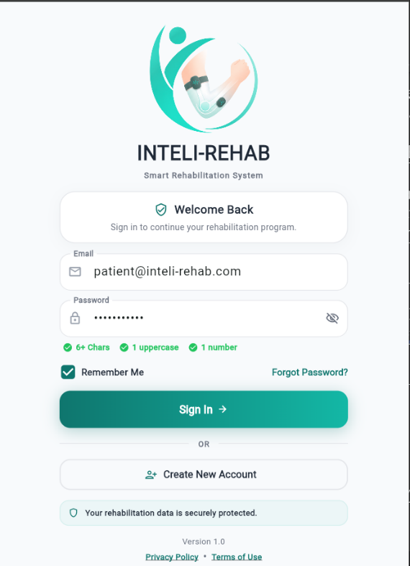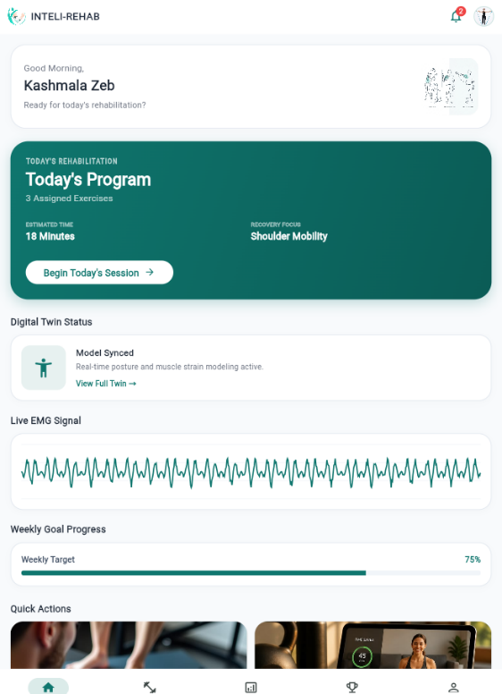

Figure 12 Sign in Screen Figure 13 Patient Dashboard

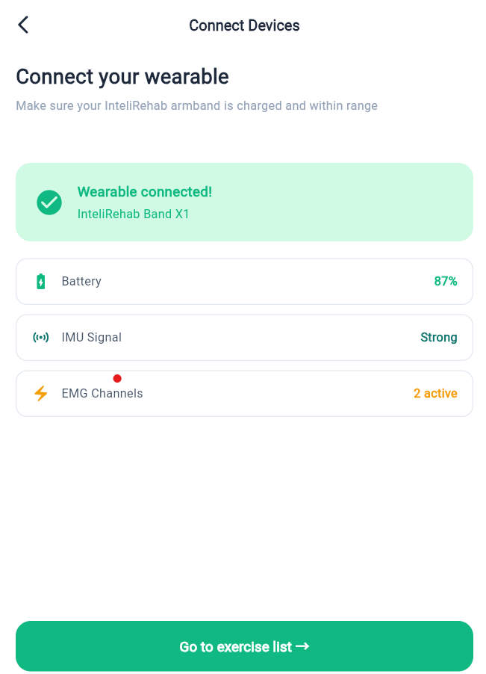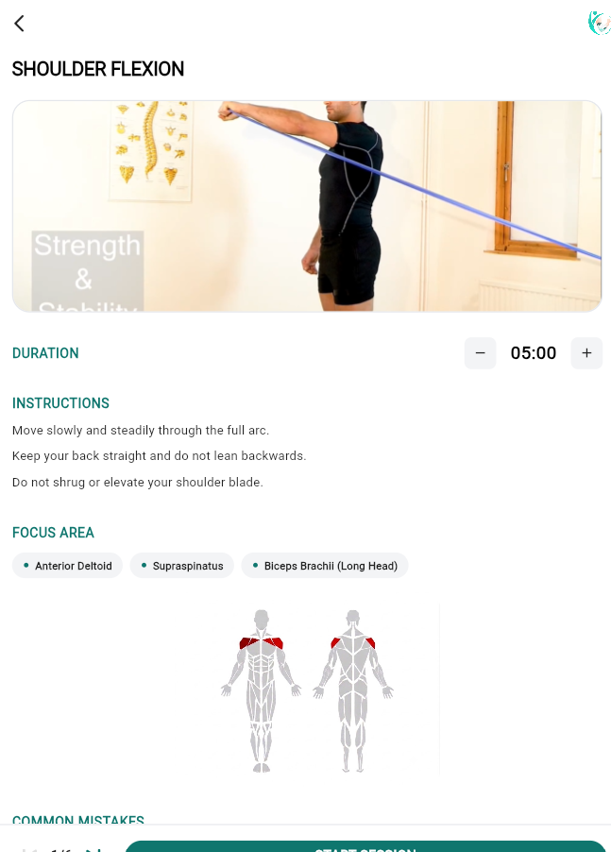
Figure 14 Wearable Connection Screen Figure 15Exercise Preview Screen

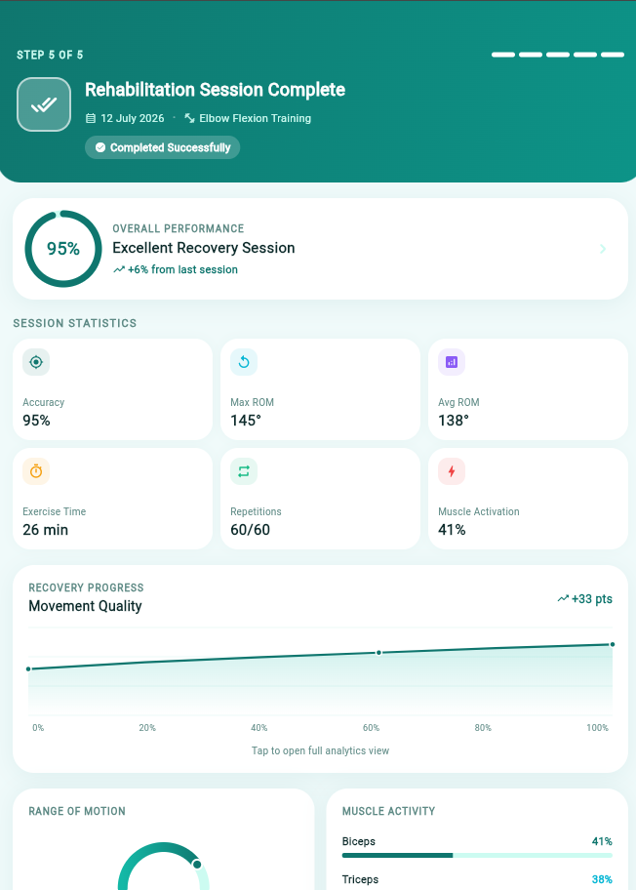
Figure 16 Rehabilitation Session Summary Screen

Screen objects and actions for Patient Mobile App
On the Website the patients interact with several screen objects that perform specific actions, allowing smooth and intuitive navigation. These objects can be categorized into buttons, text fields, image displays, and alerts. Each screen object has an associated action that drives the system's functionality.
1. Sign In
- Screen Object: Email field, password field with toggle, password strength indicators, Remember Me checkbox, Sign In button, Create New Account button
- Action: Enter credentials to sign in, toggle password visibility, and navigate to account creation
2. Sign Up
- Screen Object: Registration form fields, password strength indicators, terms checkbox, Create Account button
- Action: Register a new account by filling in details, meeting password requirements, and agreeing to terms
3. Connect Devices
- Screen Object: Connection status banner, device metrics (Battery, IMU Signal, EMG Channels), Go to exercise list button
- Action: Verify wearable connection, check device health, and proceed to exercises
4. Exercise Detail
- Screen Object: Exercise video/image, duration timer with controls, instructions, focus area tags, muscle diagram, Start Session button
- Action: Review exercise details, adjust duration, and begin the session
5. Session Summary
- Screen Object: Performance score, session statistics grid (Accuracy, ROM, Time, Reps, Muscle Activation), progress chart, ROM gauge, muscle activity bars
- Action: View session results, track recovery progress, and analyze performance metrics

SCREEN IMAGES FOR WEB PORTAL:

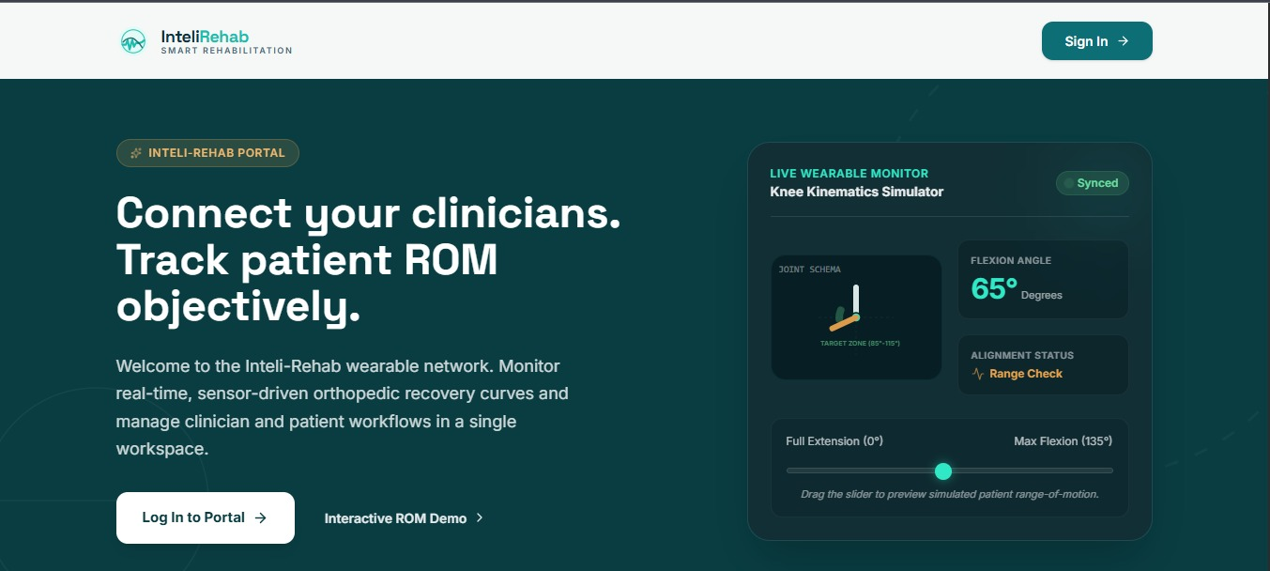
Figure 17 Web Portal Landing Page

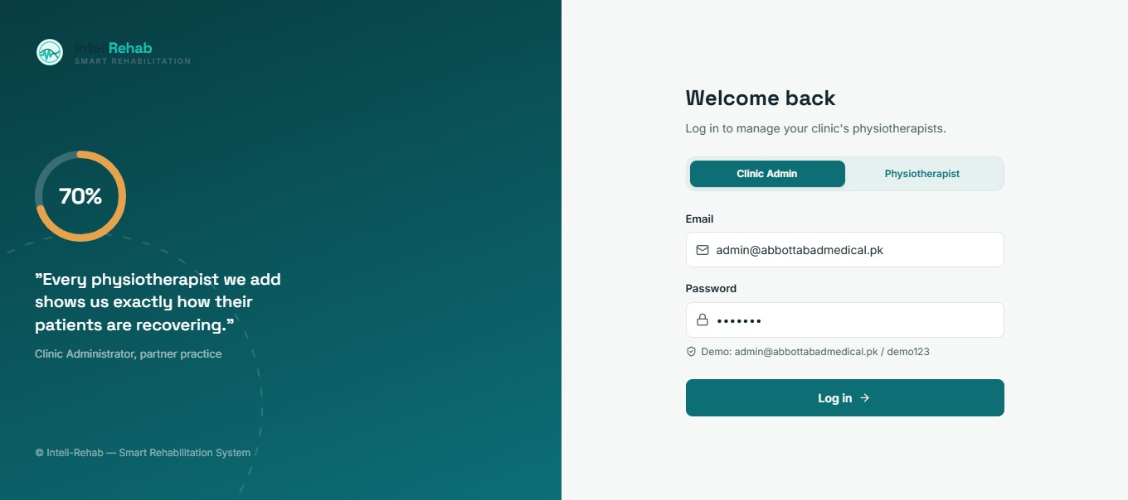
Figure 18 Role Based Login Page

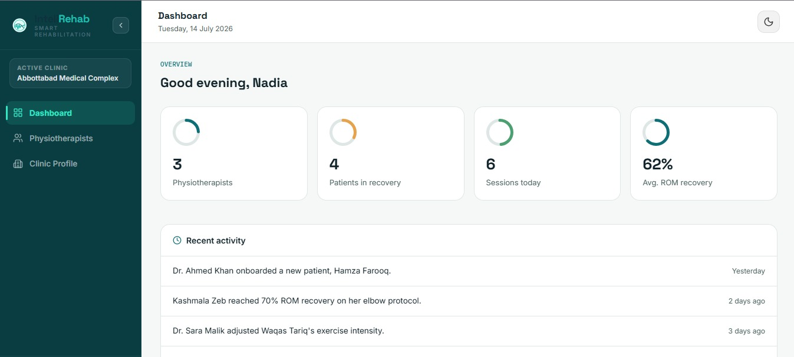
Figure 19 Clinic Administrator's Dashboard

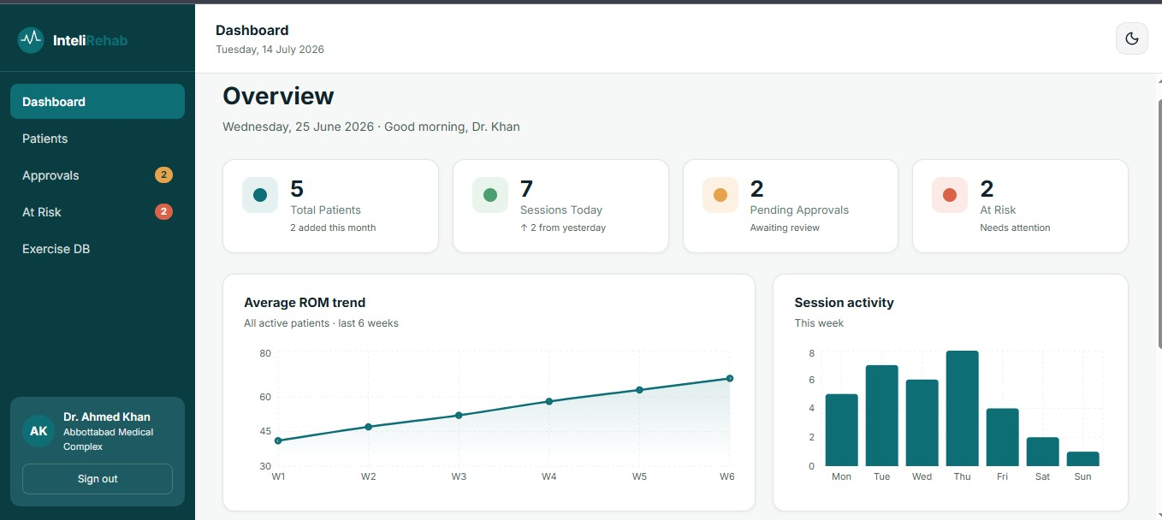
Figure 20 Physiotherapist Dashboard

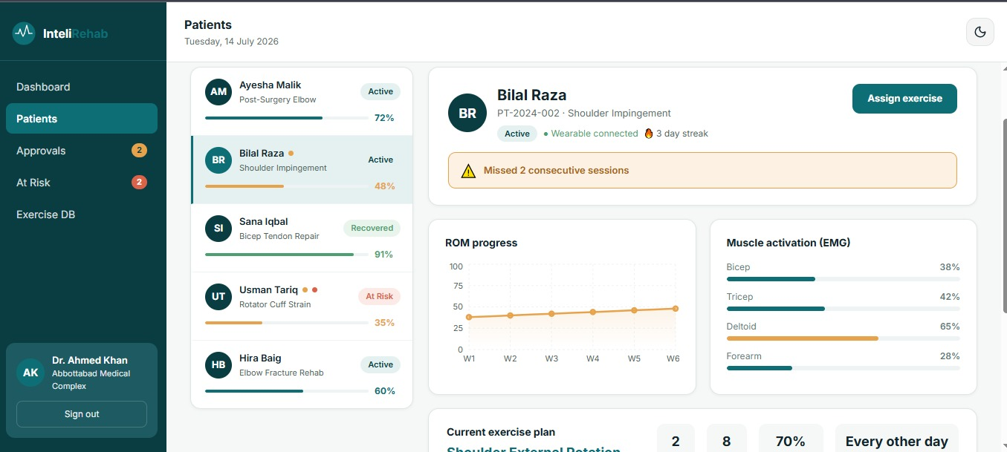
Figure 21 Patients Information Display Page

Screen objects and actions for Clinic Admin & Physiotherapist Portal
1. Landing Page
- Screen Object: Hero section, ROM simulator panel, Sign In button, Interactive ROM Demo link
- Action: Preview simulated patient ROM and navigate to portal login
2. Portal Sign In
- Screen Object: Role toggle, email field, password field, Log In button
- Action: Select role and sign in to manage clinic workflows
3. Clinic Admin Dashboard
- Screen Object: Stat cards, recent activity feed, sidebar navigation
- Action: View clinic metrics and track recent activity
4. Physiotherapist Dashboard
- Screen Object: Stat cards, ROM trend chart, session activity chart, sidebar navigation
- Action: Monitor patients, review approvals, identify at-risk cases, and track recovery trends
5. Patients Management
- Screen Object: Patient list, detail panel, ROM progress chart, EMG chart, Assign exercise button
- Action: View patient progress, check muscle activation data, and assign exercises

9. Appendix I
The following external resources and tools were referenced during the design of Inteli-Rehab:
Table 9.1 Appendix
Resource | Link
Flutter Documentation | https://docs.flutter.dev/
Unity Documentation | https://docs.unity3d.com/
Three.js Documentation | https://threejs.org/docs/
Supabase Documentation | https://supabase.com/docs
TensorFlow Lite (On-Device Inference) | https://www.tensorflow.org/lite
PyTorch Documentation | https://pytorch.org/docs/
Bluetooth Low Energy (BLE) Specifications | https://www.bluetooth.com/specifications/specs/
React.js Documentation | https://react.dev/
PostgreSQL Documentation | https://www.postgresql.org/docs/
UML Reference -- StarUML | https://staruml.io/
UML / Diagramming Reference -- diagrams.net | https://www.diagrams.net/
Incremental Modeling Guide | https://agilemodeling.com/essays/bestpractices.htm

