Dr. A. Q. Khan Institute of Computer Science & Information Technology



Lab no. 07
Artificial Intelligence (Lab)
Submitted to:
MAM HAJRA
Submitted by:
Tehzeeb (232101006)
Department:
BSCE-7.
Date:
Nov 1st , 2026

Coding/logic | Response | Data processing & visualization | Accuracy | Outcome/Result
04 | 04 | 04 | 04 | 04
LINK: https://github.com/Tehzeb/AI-LAB/tree/main/AILAB7

QUESTION:01
======================================================================
PART 1: IRIS DATASET LOADED SUCCESSFULLY
======================================================================

First Five Rows:
sepal_length sepal_width petal_length petal_width species
0 5.1 3.5 1.4 0.2 Iris-setosa
1 4.9 3.0 1.4 0.2 Iris-setosa
2 4.7 3.2 1.3 0.2 Iris-setosa
3 4.6 3.1 1.5 0.2 Iris-setosa
4 5.0 3.6 1.4 0.2 Iris-setosa

Dataset Shape: (150, 5)

Dataset Information:
<class 'pandas.core.frame.DataFrame'>
RangeIndex: 150 entries, 0 to 149
Data columns (total 5 columns):
# Column Non-Null Count Dtype
--- ------ -------------- -----
0 sepal_length 150 non-null float64
1 sepal_width 150 non-null float64
2 petal_length 150 non-null float64
3 petal_width 150 non-null float64
4 species 150 non-null object
dtypes: float64(4), object(1)
memory usage: 6.0+ KB

Statistical Description:
sepal_length sepal_width petal_length petal_width
count 150.000000 150.000000 150.000000 150.000000
mean 5.843333 3.054000 3.758667 1.198667
std 0.828066 0.433594 1.764420 0.763161
min 4.300000 2.000000 1.000000 0.100000
25% 5.100000 2.800000 1.600000 0.300000
50% 5.800000 3.000000 4.350000 1.300000
75% 6.400000 3.300000 5.100000 1.800000
max 7.900000 4.400000 6.900000 2.500000

====================================================================
PART 2: DATA QUALITY ANALYSIS
====================================================================

Missing Values:
sepal_length 0
sepal_width 0
petal_length 0
petal_width 0
species 0
dtype: int64
Total Missing Values: 0
Duplicate Rows: 3
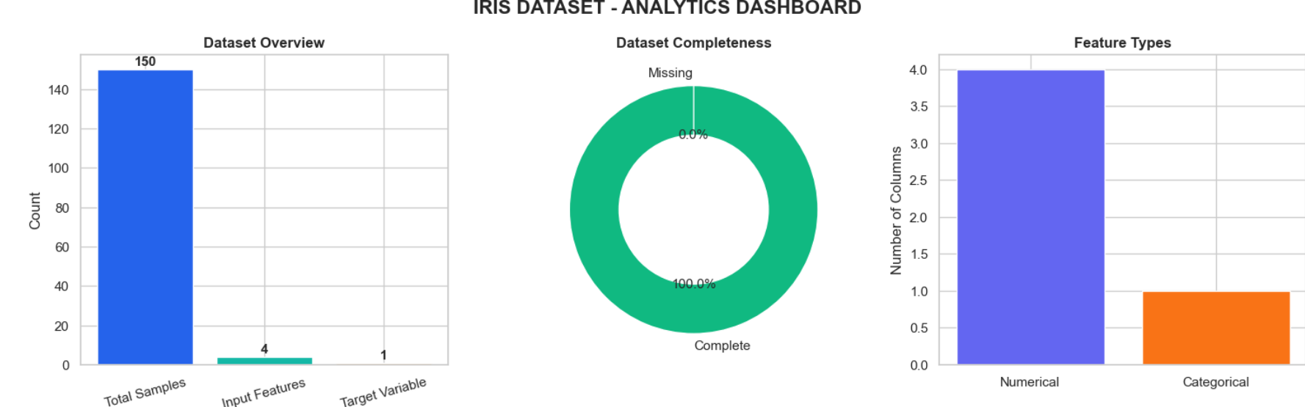
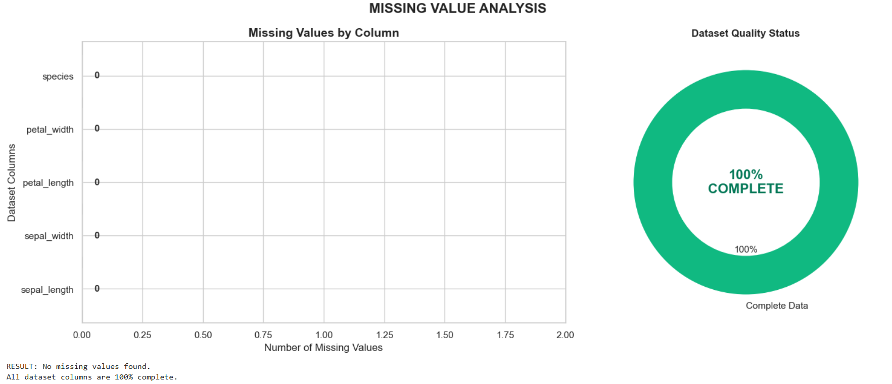
Dataset Shape After Cleaning: (147, 5)

======================================================================
PART 3: INPUT FEATURES AND TARGET IDENTIFIED
======================================================================

Input Features:
sepal_length sepal_width petal_length petal_width
0 5.1 3.5 1.4 0.2
1 4.9 3.0 1.4 0.2
2 4.7 3.2 1.3 0.2
3 4.6 3.1 1.5 0.2
4 5.0 3.6 1.4 0.2

Target Variable:
0 Iris-setosa
1 Iris-setosa
2 Iris-setosa
3 Iris-setosa
4 Iris-setosa
Name: species, dtype: object

Input Shape: (147, 4)
Target Shape: (147,)

Unique Species:
['Iris-setosa' 'Iris-versicolor' 'Iris-virginica']
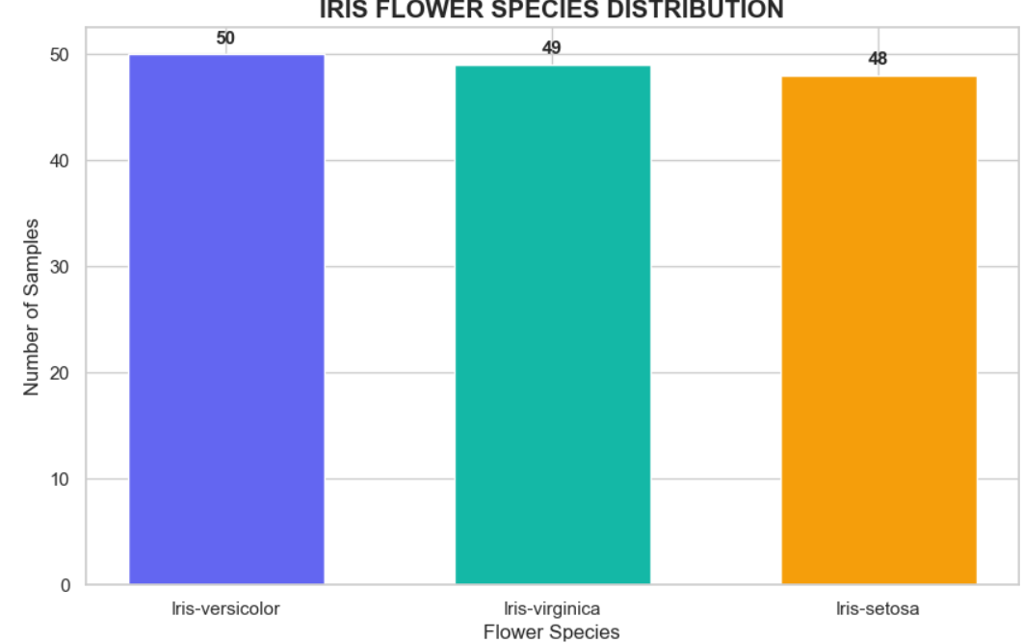
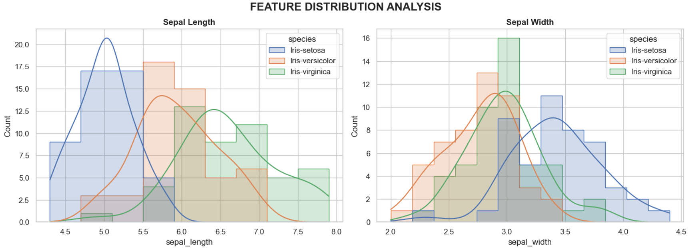
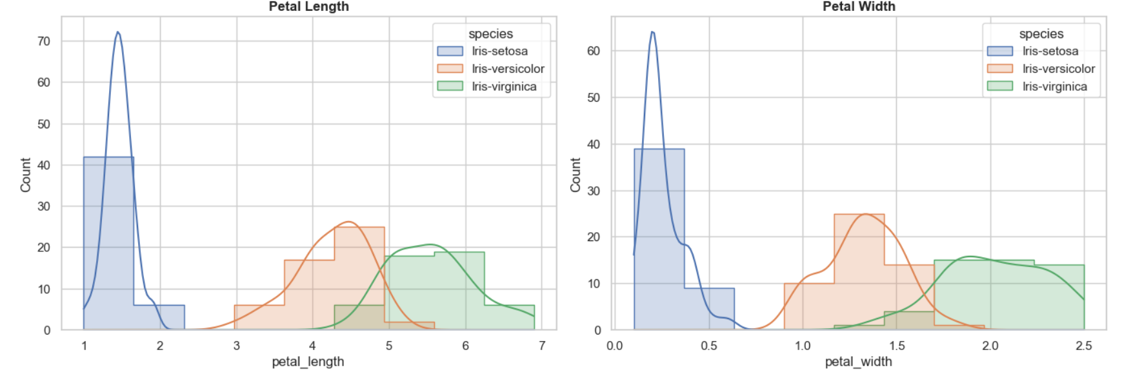
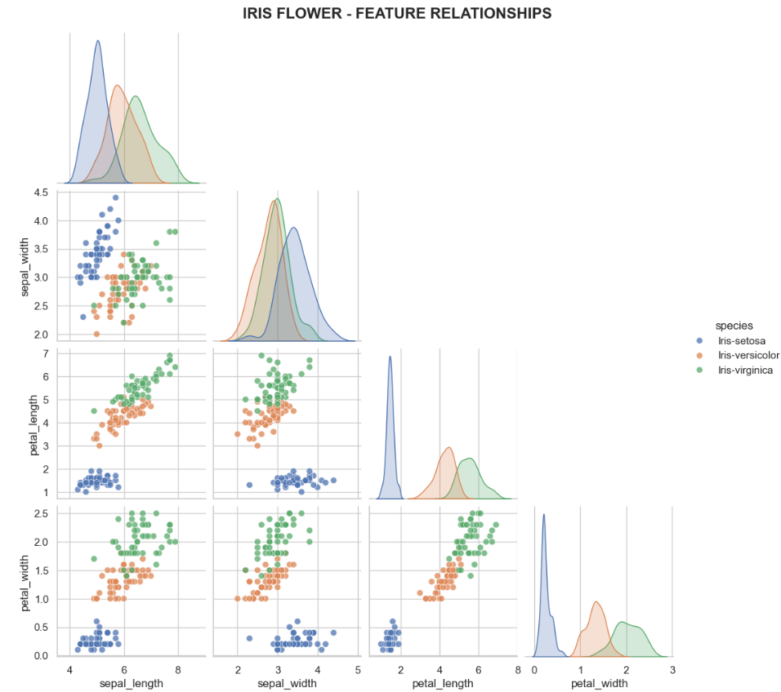
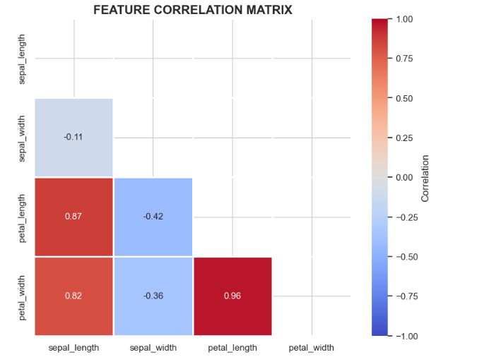 | 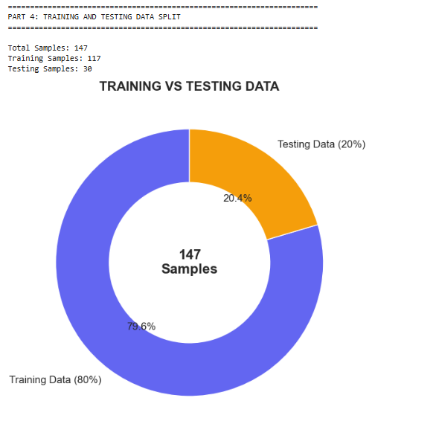

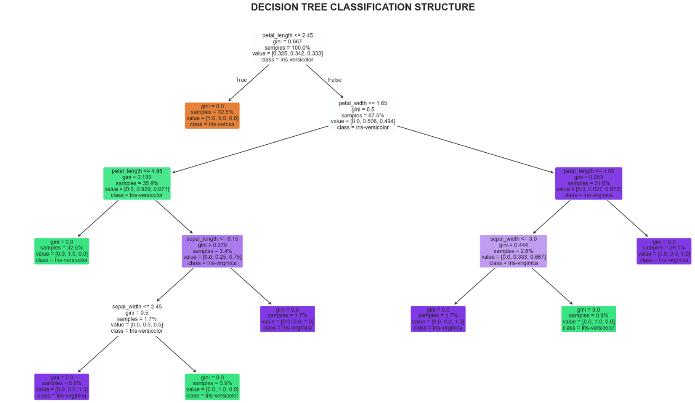 | 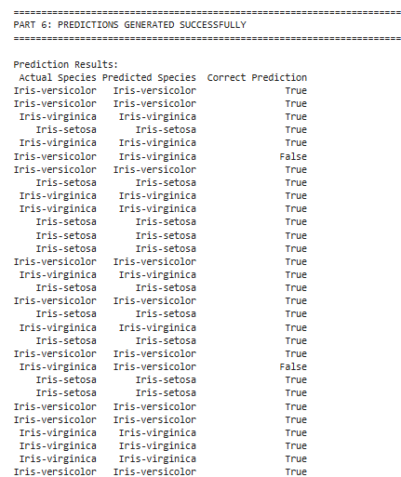

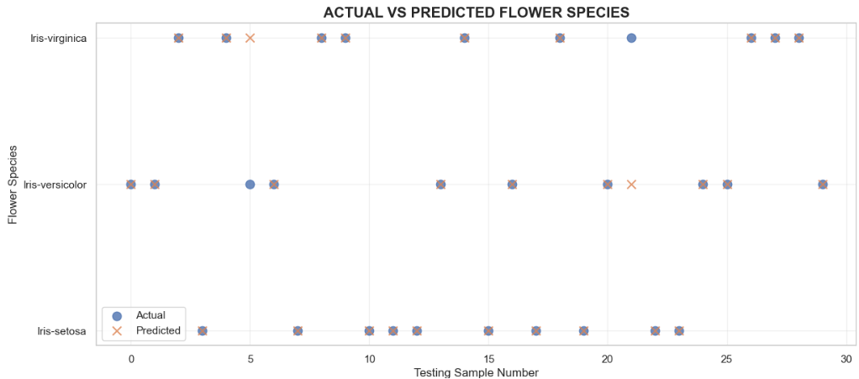 | 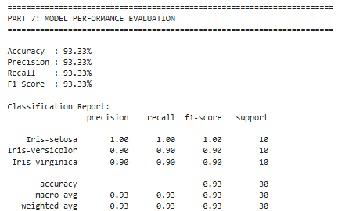

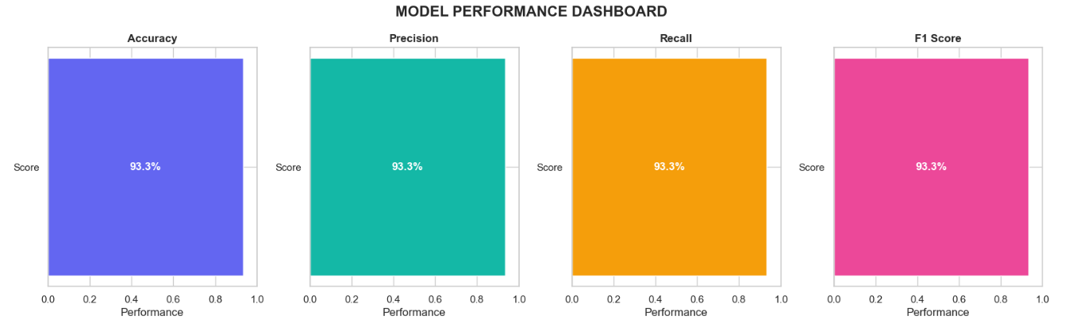
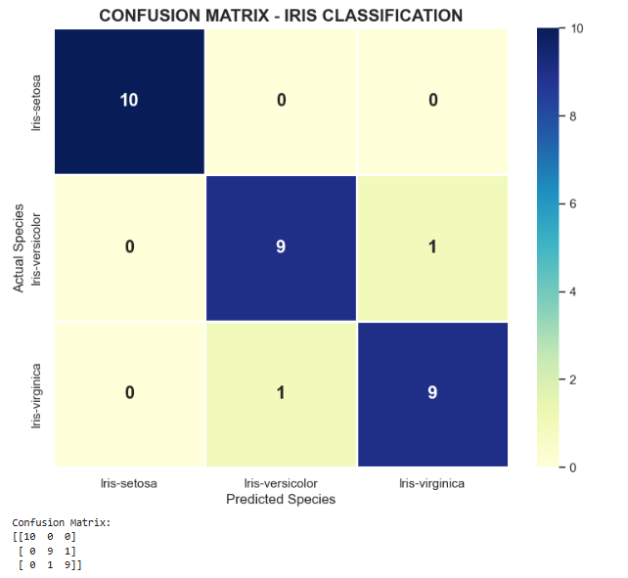 | 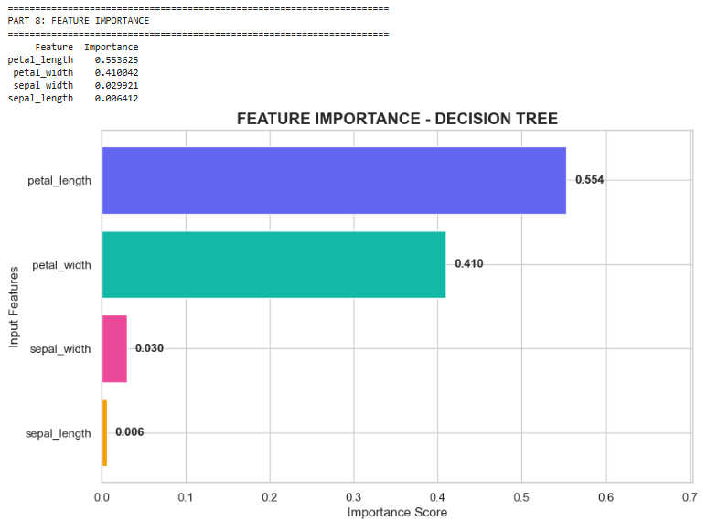

QUESTION:02

===========================================================================
NEON AI LAB | MACHINE LEARNING ANALYTICS
===========================================================================

DATASET FILES FOUND:
Breastcancer.csv
Wine.csv
Diabetes.csv

Loaded successfully: Breastcancer.csv
Shape: (569, 33)

Loaded successfully: Wine.csv
Shape: (178, 14)

Loaded successfully: Diabetes.csv
Shape: (1000, 14)
Breastcancer: target column = 'diagnosis'
Wine: target column = 'class'
Diabetes: target column = 'class'

===========================================================================
PART 6 | DATASET ANALYSIS
===========================================================================

===========================================================================
DATASET: Breastcancer
===========================================================================
Dataset Shape: (569, 33)
Target Column: diagnosis

First Five Records:

 | id | diagnosis | radius_mean | texture_mean | perimeter_mean | area_mean | smoothness_mean | compactness_mean | concavity_mean
0 | 842302 | M | 17.99 | 10.38 | 122.80 | 1001.0 | 0.11840 | 0.27760 | 0.3001
1 | 842517 | M | 20.57 | 17.77 | 132.90 | 1326.0 | 0.08474 | 0.07864 | 0.0869
2 | 84300903 | M | 19.69 | 21.25 | 130.00 | 1203.0 | 0.10960 | 0.15990 | 0.1974
3 | 84348301 | M | 11.42 | 20.38 | 77.58 | 386.1 | 0.14250 | 0.28390 | 0.2414
4 | 84358402 | M | 20.29 | 14.34 | 135.10 | 1297.0 | 0.10030 | 0.13280 | 0.1980

 | concave points_mean | ... | texture_worst | perimeter_worst | area_worst | smoothness_worst | compactness_worst | concavity_worst
0 | 0.14710 | ... | 17.33 | 184.60 | 2019.0 | 0.1622 | 0.6656 | 0.7119
1 | 0.07017 | ... | 23.41 | 158.80 | 1956.0 | 0.1238 | 0.1866 | 0.2416
2 | 0.12790 | ... | 25.53 | 152.50 | 1709.0 | 0.1444 | 0.4245 | 0.4504
3 | 0.10520 | ... | 26.50 | 98.87 | 567.7 | 0.2098 | 0.8663 | 0.6869
4 | 0.10430 | ... | 16.67 | 152.20 | 1575.0 | 0.1374 | 0.2050 | 0.4000

 | concave points_worst | symmetry_worst | fractal_dimension_worst | unnamed: 32
0 | 0.2654 | 0.4601 | 0.11890 | NaN
1 | 0.1860 | 0.2750 | 0.08902 | NaN
2 | 0.2430 | 0.3613 | 0.08758 | NaN
3 | 0.2575 | 0.6638 | 0.17300 | NaN
4 | 0.1625 | 0.2364 | 0.07678 | NaN

Data Types:

 | Data Type |  |  | Data Type
id | int64 |  | compactness_se | float64
diagnosis | object |  | concavity_se | float64
radius_mean | float64 |  | concave points_se | float64
texture_mean | float64 |  | symmetry_se | float64
perimeter_mean | float64 |  | fractal_dimension_se | float64
area_mean | float64 |  | radius_worst | float64
smoothness_mean | float64 |  | texture_worst | float64
compactness_mean | float64 |  | perimeter_worst | float64
concavity_mean | float64 |  | area_worst | float64
concave points_mean | float64 |  | smoothness_worst | float64
symmetry_mean | float64 |  | compactness_worst | float64
fractal_dimension_mean | float64 |  | concavity_worst | float64
radius_se | float64 |  | concave points_worst | float64
texture_se | float64 |  | symmetry_worst | float64
perimeter_se | float64 |  | fractal_dimension_worst | float64
area_se | float64 |  | unnamed: 32 | float64
smoothness_se | float64

Missing Values:

 | Missing Values |  |  | Missing Values
id | 0 |  | compactness_se | 0
diagnosis | 0 |  | concavity_se | 0
radius_mean | 0 |  | concave points_se | 0
texture_mean | 0 |  | symmetry_se | 0
perimeter_mean | 0 |  | fractal_dimension_se | 0
area_mean | 0 |  | radius_worst | 0
smoothness_mean | 0 |  | texture_worst | 0
compactness_mean | 0 |  | perimeter_worst | 0
concavity_mean | 0 |  | area_worst | 0
concave points_mean | 0 |  | smoothness_worst | 0
symmetry_mean | 0 |  | compactness_worst | 0
fractal_dimension_mean | 0 |  | concavity_worst | 0
radius_se | 0 |  | concave points_worst | 0
texture_se | 0 |  | symmetry_worst | 0
perimeter_se | 0 |  | fractal_dimension_worst | 0
area_se | 0 |  | unnamed: 32 | 569
smoothness_se | 0

Statistical Summary:

 | count | unique | top | freq | mean | std | min | 25% | 50% | 75% | max
id | 569.0 | NaN | NaN | NaN | 30371831.432337 | 125020585.612224 | 8670.0 | 869218.0 | 906024.0 | 8813129.0 | 911320502.0
diagnosis | 569 | 2 | B | 357 | NaN | NaN | NaN | NaN | NaN | NaN | NaN
radius_mean | 569.0 | NaN | NaN | NaN | 14.127292 | 3.524049 | 6.981 | 11.7 | 13.37 | 15.78 | 28.11
texture_mean | 569.0 | NaN | NaN | NaN | 19.289649 | 4.301036 | 9.71 | 16.17 | 18.84 | 21.8 | 39.28
perimeter_mean | 569.0 | NaN | NaN | NaN | 91.969033 | 24.298981 | 43.79 | 75.17 | 86.24 | 104.1 | 188.5
area_mean | 569.0 | NaN | NaN | NaN | 654.889104 | 351.914129 | 143.5 | 420.3 | 551.1 | 782.7 | 2501.0
smoothness_mean | 569.0 | NaN | NaN | NaN | 0.09636 | 0.014064 | 0.05263 | 0.08637 | 0.09587 | 0.1053 | 0.1634
compactness_mean | 569.0 | NaN | NaN | NaN | 0.104341 | 0.052813 | 0.01938 | 0.06492 | 0.09263 | 0.1304 | 0.3454
concavity_mean | 569.0 | NaN | NaN | NaN | 0.088799 | 0.07972 | 0.0 | 0.02956 | 0.06154 | 0.1307 | 0.4268
concave points_mean | 569.0 | NaN | NaN | NaN | 0.048919 | 0.038803 | 0.0 | 0.02031 | 0.0335 | 0.074 | 0.2012
symmetry_mean | 569.0 | NaN | NaN | NaN | 0.181162 | 0.027414 | 0.106 | 0.1619 | 0.1792 | 0.1957 | 0.304
fractal_dimension_mean | 569.0 | NaN | NaN | NaN | 0.062798 | 0.00706 | 0.04996 | 0.0577 | 0.06154 | 0.06612 | 0.09744
radius_se | 569.0 | NaN | NaN | NaN | 0.405172 | 0.277313 | 0.1115 | 0.2324 | 0.3242 | 0.4789 | 2.873
texture_se | 569.0 | NaN | NaN | NaN | 1.216853 | 0.551648 | 0.3602 | 0.8339 | 1.108 | 1.474 | 4.885
perimeter_se | 569.0 | NaN | NaN | NaN | 2.866059 | 2.021855 | 0.757 | 1.606 | 2.287 | 3.357 | 21.98
area_se | 569.0 | NaN | NaN | NaN | 40.337079 | 45.491006 | 6.802 | 17.85 | 24.53 | 45.19 | 542.2
smoothness_se | 569.0 | NaN | NaN | NaN | 0.007041 | 0.003003 | 0.001713 | 0.005169 | 0.00638 | 0.008146 | 0.03113
compactness_se | 569.0 | NaN | NaN | NaN | 0.025478 | 0.017908 | 0.002252 | 0.01308 | 0.02045 | 0.03245 | 0.1354
concavity_se | 569.0 | NaN | NaN | NaN | 0.031894 | 0.030186 | 0.0 | 0.01509 | 0.02589 | 0.04205 | 0.396
concave points_se | 569.0 | NaN | NaN | NaN | 0.011796 | 0.00617 | 0.0 | 0.007638 | 0.01093 | 0.01471 | 0.05279
symmetry_se | 569.0 | NaN | NaN | NaN | 0.020542 | 0.008266 | 0.007882 | 0.01516 | 0.01873 | 0.02348 | 0.07895
fractal_dimension_se | 569.0 | NaN | NaN | NaN | 0.003795 | 0.002646 | 0.000895 | 0.002248 | 0.003187 | 0.004558 | 0.02984
radius_worst | 569.0 | NaN | NaN | NaN | 16.26919 | 4.833242 | 7.93 | 13.01 | 14.97 | 18.79 | 36.04
texture_worst | 569.0 | NaN | NaN | NaN | 25.677223 | 6.146258 | 12.02 | 21.08 | 25.41 | 29.72 | 49.54
perimeter_worst | 569.0 | NaN | NaN | NaN | 107.261213 | 33.602542 | 50.41 | 84.11 | 97.66 | 125.4 | 251.2
area_worst | 569.0 | NaN | NaN | NaN | 880.583128 | 569.356993 | 185.2 | 515.3 | 686.5 | 1084.0 | 4254.0
smoothness_worst | 569.0 | NaN | NaN | NaN | 0.132369 | 0.022832 | 0.07117 | 0.1166 | 0.1313 | 0.146 | 0.2226
compactness_worst | 569.0 | NaN | NaN | NaN | 0.254265 | 0.157336 | 0.02729 | 0.1472 | 0.2119 | 0.3391 | 1.058
concavity_worst | 569.0 | NaN | NaN | NaN | 0.272188 | 0.208624 | 0.0 | 0.1145 | 0.2267 | 0.3829 | 1.252
concave points_worst | 569.0 | NaN | NaN | NaN | 0.114606 | 0.065732 | 0.0 | 0.06493 | 0.09993 | 0.1614 | 0.291
symmetry_worst | 569.0 | NaN | NaN | NaN | 0.290076 | 0.061867 | 0.1565 | 0.2504 | 0.2822 | 0.3179 | 0.6638
fractal_dimension_worst | 569.0 | NaN | NaN | NaN | 0.083946 | 0.018061 | 0.05504 | 0.07146 | 0.08004 | 0.09208 | 0.2075
unnamed: 32 | 0.0 | NaN | NaN | NaN | NaN | NaN | NaN | NaN | NaN | NaN | NaN

Target Distribution:

 | Frequency
diagnosis
B | 357
M | 212

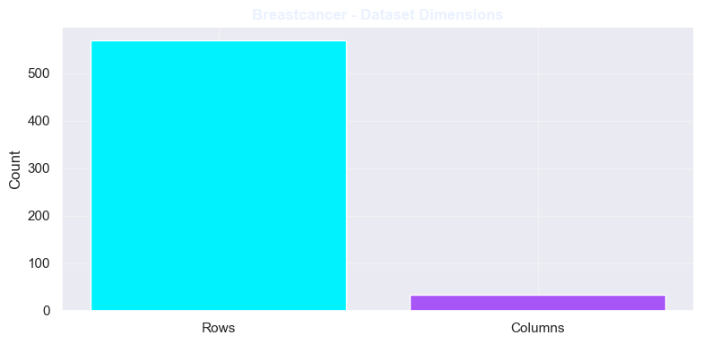 | 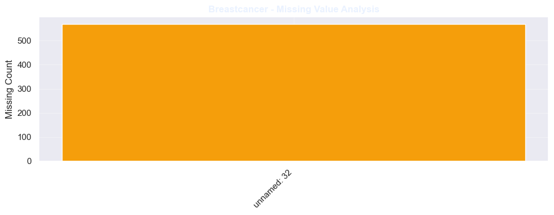 | 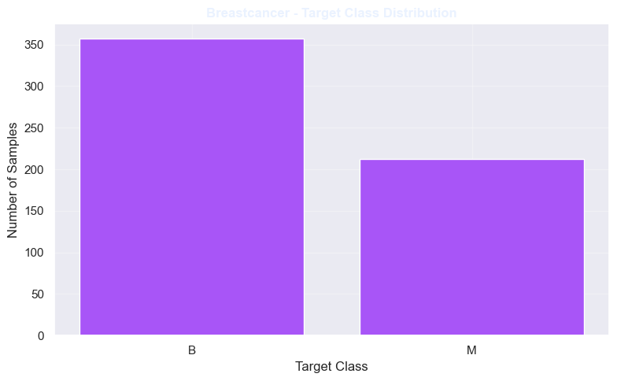

===========================================================================
DATASET: Wine
===========================================================================
Dataset Shape: (178, 14)
Target Column: class

First Five Records:

 | class | alcohol | malic acid | ash | alcalinity of ash | magnesium | total phenols | flavanoids | nonflavanoid phenols | proanthocyanins
0 | 1 | 14.23 | 1.71 | 2.43 | 15.6 | 127 | 2.80 | 3.06 | 0.28 | 2.29
1 | 1 | 13.20 | 1.78 | 2.14 | 11.2 | 100 | 2.65 | 2.76 | 0.26 | 1.28
2 | 1 | 13.16 | 2.36 | 2.67 | 18.6 | 101 | 2.80 | 3.24 | 0.30 | 2.81
3 | 1 | 14.37 | 1.95 | 2.50 | 16.8 | 113 | 3.85 | 3.49 | 0.24 | 2.18
4 | 1 | 13.24 | 2.59 | 2.87 | 21.0 | 118 | 2.80 | 2.69 | 0.39 | 1.82

 | color intensity | hue | od280/od315 of diluted wines | proline
0 | 5.64 | 1.04 | 3.92 | 1065
1 | 4.38 | 1.05 | 3.40 | 1050
2 | 5.68 | 1.03 | 3.17 | 1185
3 | 7.80 | 0.86 | 3.45 | 1480
4 | 4.32 | 1.04 | 2.93 | 735

Data Types:

 | Data Type |  |  | Data Type
class | int64 |  | flavanoids | float64
alcohol | float64 |  | nonflavanoid phenols | float64
malic acid | float64 |  | proanthocyanins | float64
ash | float64 |  | color intensity | float64
alcalinity of ash | float64 |  | hue | float64
magnesium | int64 |  | od280/od315 of diluted wines | float64
total phenols | float64 |  | proline | int64

Missing Values:

 | Missing Values |  |  | Missing Values
class | 0 |  | flavanoids | 0
alcohol | 0 |  | nonflavanoid phenols | 0
malic acid | 0 |  | proanthocyanins | 0
ash | 0 |  | color intensity | 0
alcalinity of ash | 0 |  | hue | 0
magnesium | 0 |  | od280/od315 of diluted wines | 0
total phenols | 0 |  | proline | 0

Statistical Summary:

 | count | mean | std | min | 25% | 50% | 75% | max
class | 178.0 | 1.938202 | 0.775035 | 1.00 | 1.0000 | 2.000 | 3.0000 | 3.00
alcohol | 178.0 | 13.000618 | 0.811827 | 11.03 | 12.3625 | 13.050 | 13.6775 | 14.83
malic acid | 178.0 | 2.336348 | 1.117146 | 0.74 | 1.6025 | 1.865 | 3.0825 | 5.80
ash | 178.0 | 2.366517 | 0.274344 | 1.36 | 2.2100 | 2.360 | 2.5575 | 3.23
alcalinity of ash | 178.0 | 19.494944 | 3.339564 | 10.60 | 17.2000 | 19.500 | 21.5000 | 30.00
magnesium | 178.0 | 99.741573 | 14.282484 | 70.00 | 88.0000 | 98.000 | 107.0000 | 162.00
total phenols | 178.0 | 2.295112 | 0.625851 | 0.98 | 1.7425 | 2.355 | 2.8000 | 3.88
flavanoids | 178.0 | 2.029270 | 0.998859 | 0.34 | 1.2050 | 2.135 | 2.8750 | 5.08
nonflavanoid phenols | 178.0 | 0.361854 | 0.124453 | 0.13 | 0.2700 | 0.340 | 0.4375 | 0.66
proanthocyanins | 178.0 | 1.590899 | 0.572359 | 0.41 | 1.2500 | 1.555 | 1.9500 | 3.58
color intensity | 178.0 | 5.058090 | 2.318286 | 1.28 | 3.2200 | 4.690 | 6.2000 | 13.00
hue | 178.0 | 0.957449 | 0.228572 | 0.48 | 0.7825 | 0.965 | 1.1200 | 1.71
od280/od315 of diluted wines | 178.0 | 2.611685 | 0.709990 | 1.27 | 1.9375 | 2.780 | 3.1700 | 4.00
proline | 178.0 | 746.893258 | 314.907474 | 278.00 | 500.5000 | 673.500 | 985.0000 | 1680.00

Target Distribution:

 | Frequency
class
2 | 71
1 | 59
3 | 48

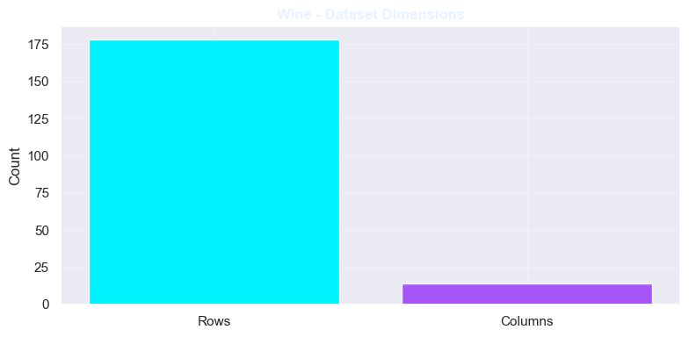 | 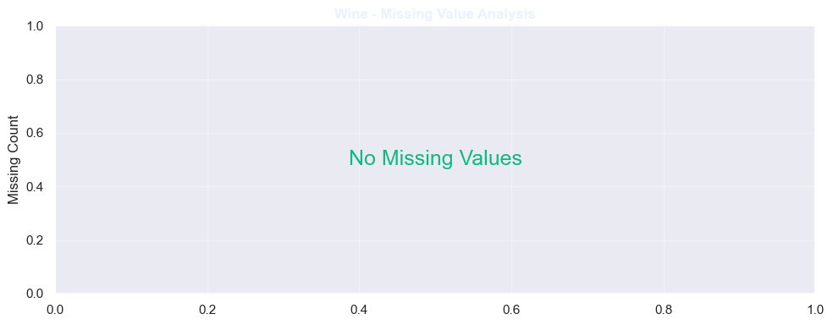 | 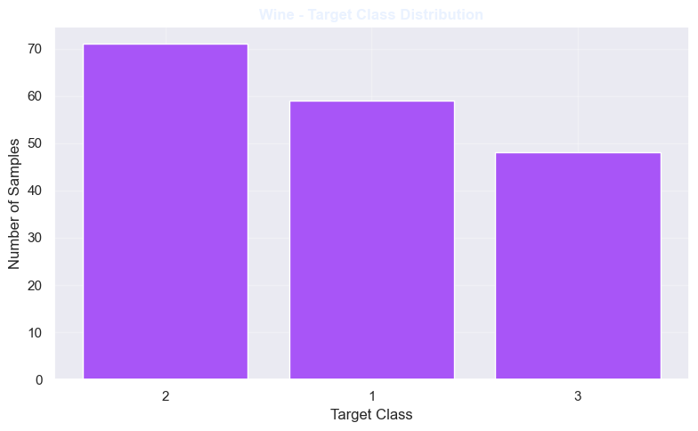

===========================================================================
DATASET: Diabetes
===========================================================================
Dataset Shape: (1000, 14)
Target Column: class

First Five Records:

 | id | no_pation | gender | age | urea | cr | hba1c | chol | tg | hdl | ldl | vldl | bmi | class
0 | 502 | 17975 | F | 50 | 4.7 | 46 | 4.9 | 4.2 | 0.9 | 2.4 | 1.4 | 0.5 | 24.0 | N
1 | 735 | 34221 | M | 26 | 4.5 | 62 | 4.9 | 3.7 | 1.4 | 1.1 | 2.1 | 0.6 | 23.0 | N
2 | 420 | 47975 | F | 50 | 4.7 | 46 | 4.9 | 4.2 | 0.9 | 2.4 | 1.4 | 0.5 | 24.0 | N
3 | 680 | 87656 | F | 50 | 4.7 | 46 | 4.9 | 4.2 | 0.9 | 2.4 | 1.4 | 0.5 | 24.0 | N
4 | 504 | 34223 | M | 33 | 7.1 | 46 | 4.9 | 4.9 | 1.0 | 0.8 | 2.0 | 0.4 | 21.0 | N

Data Types:

 | Data Type |  |  | Data Type
id | int64 |  | chol | float64
no_pation | int64 |  | tg | float64
gender | object |  | hdl | float64
age | int64 |  | ldl | float64
urea | float64 |  | vldl | float64
cr | int64 |  | bmi | float64
hba1c | float64 |  | class | object

Missing Values:

 | Missing Values |  |  | Missing Values
id | 0 |  | chol | 0
no_pation | 0 |  | tg | 0
gender | 0 |  | hdl | 0
age | 0 |  | ldl | 0
urea | 0 |  | vldl | 0
cr | 0 |  | bmi | 0
hba1c | 0 |  | class | 0

Statistical Summary:

 | count | unique | top | freq | mean | std | min | 25% | 50% | 75% | max
id | 1000.0 | NaN | NaN | NaN | 340.5 | 240.397673 | 1.0 | 125.75 | 300.5 | 550.25 | 800.0
no_pation | 1000.0 | NaN | NaN | NaN | 270551.408 | 3380757.821973 | 123.0 | 24063.75 | 34395.5 | 45384.25 | 75435657.0
gender | 1000 | 3 | M | 565 | NaN | NaN | NaN | NaN | NaN | NaN | NaN
age | 1000.0 | NaN | NaN | NaN | 53.528 | 8.799241 | 20.0 | 51.0 | 55.0 | 59.0 | 79.0
urea | 1000.0 | NaN | NaN | NaN | 5.124743 | 2.935165 | 0.5 | 3.7 | 4.6 | 5.7 | 38.9
cr | 1000.0 | NaN | NaN | NaN | 68.943 | 59.984747 | 6.0 | 48.0 | 60.0 | 73.0 | 800.0
hba1c | 1000.0 | NaN | NaN | NaN | 8.28116 | 2.534003 | 0.9 | 6.5 | 8.0 | 10.2 | 16.0
chol | 1000.0 | NaN | NaN | NaN | 4.86282 | 1.301738 | 0.0 | 4.0 | 4.8 | 5.6 | 10.3
tg | 1000.0 | NaN | NaN | NaN | 2.34961 | 1.401176 | 0.3 | 1.5 | 2.0 | 2.9 | 13.8
hdl | 1000.0 | NaN | NaN | NaN | 1.20475 | 0.660414 | 0.2 | 0.9 | 1.1 | 1.3 | 9.9
ldl | 1000.0 | NaN | NaN | NaN | 2.60979 | 1.115102 | 0.3 | 1.8 | 2.5 | 3.3 | 9.9
vldl | 1000.0 | NaN | NaN | NaN | 1.8547 | 3.663599 | 0.1 | 0.7 | 0.9 | 1.5 | 35.0
bmi | 1000.0 | NaN | NaN | NaN | 29.57802 | 4.962388 | 19.0 | 26.0 | 30.0 | 33.0 | 47.75
class | 1000 | 5 | Y | 840 | NaN | NaN | NaN | NaN | NaN | NaN | NaN

Target Distribution:

 | Frequency
class
Y | 844
N | 103
P | 53

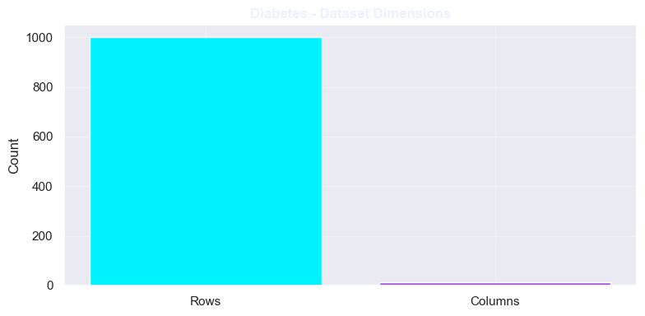 | 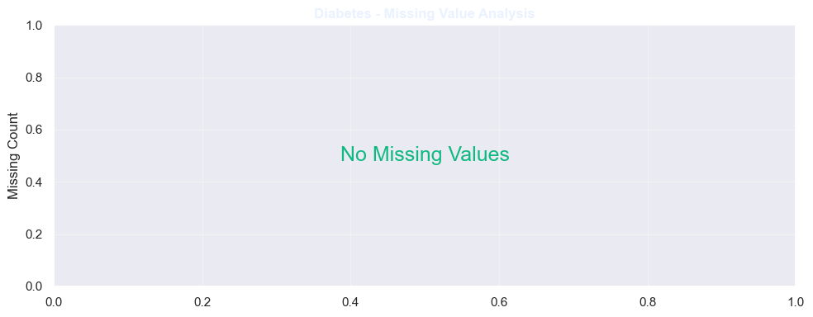 | 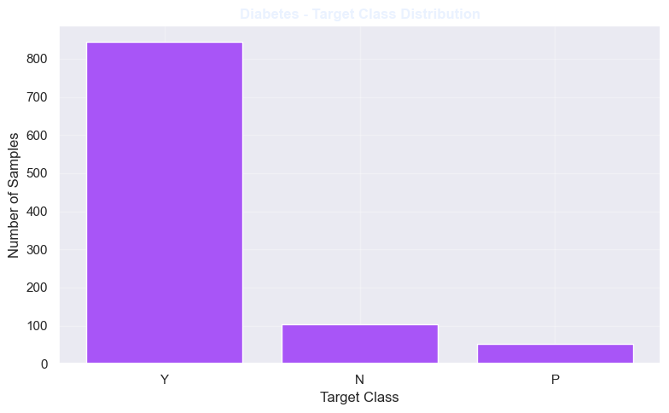

===========================================================================
PART 7 | DATA CLEANING AND PREPROCESSING
===========================================================================

Breastcancer: Duplicate rows removed: 0

PREPROCESSING: Breastcancer
Samples: 569
Features: 30
Target Classes: ['B', 'M']

Cleaned Target Distribution:

 | Frequency
diagnosis
B | 357
M | 212

Removed ID Columns: ['id']
Removed Empty Columns: ['unnamed: 32']
Removed Constant Columns: []

Wine: Duplicate rows removed: 0

PREPROCESSING: Wine
Samples: 178
Features: 13
Target Classes: ['1', '2', '3']

Cleaned Target Distribution:

 | Frequency
class
2 | 71
1 | 59
3 | 48

Removed ID Columns: []
Removed Empty Columns: []
Removed Constant Columns: []

Diabetes: Duplicate rows removed: 0

PREPROCESSING: Diabetes
Samples: 1000
Features: 11
Target Classes: ['N', 'P', 'Y']

Cleaned Target Distribution:

 | Frequency
class
Y | 844
N | 103
P | 53

Removed ID Columns: ['id', 'no_pation']
Removed Empty Columns: []
Removed Constant Columns: []

===========================================================================
PART 8 | DIABETES LABEL CLEANING
===========================================================================
Diabetes classes after whitespace cleaning:

 | Frequency
Y | 844
N | 103
P | 53

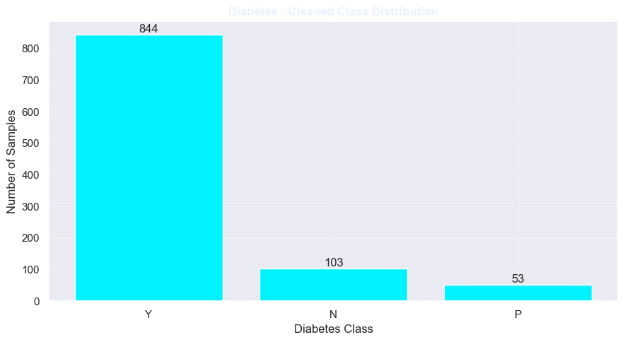
===========================================================================
PART 9 | FEATURE DISTRIBUTION ANALYSIS
===========================================================================

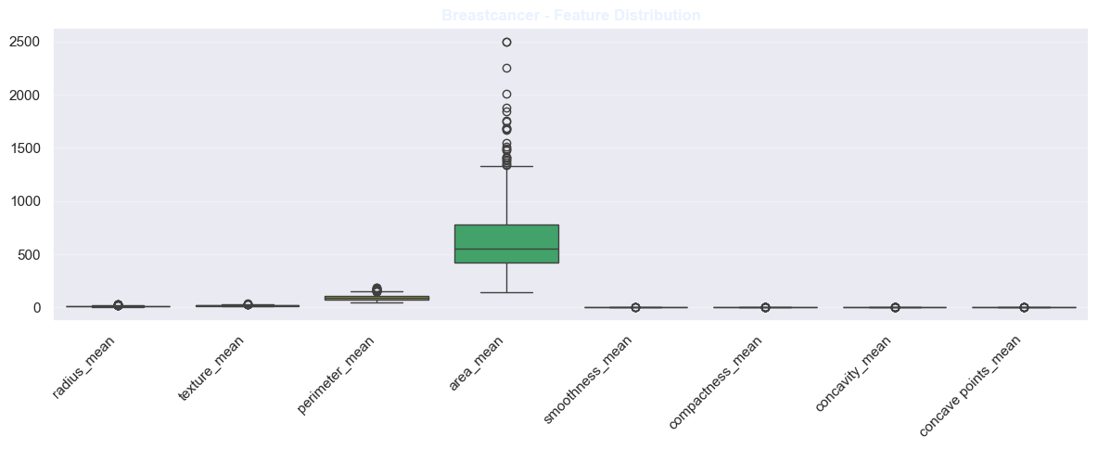 | 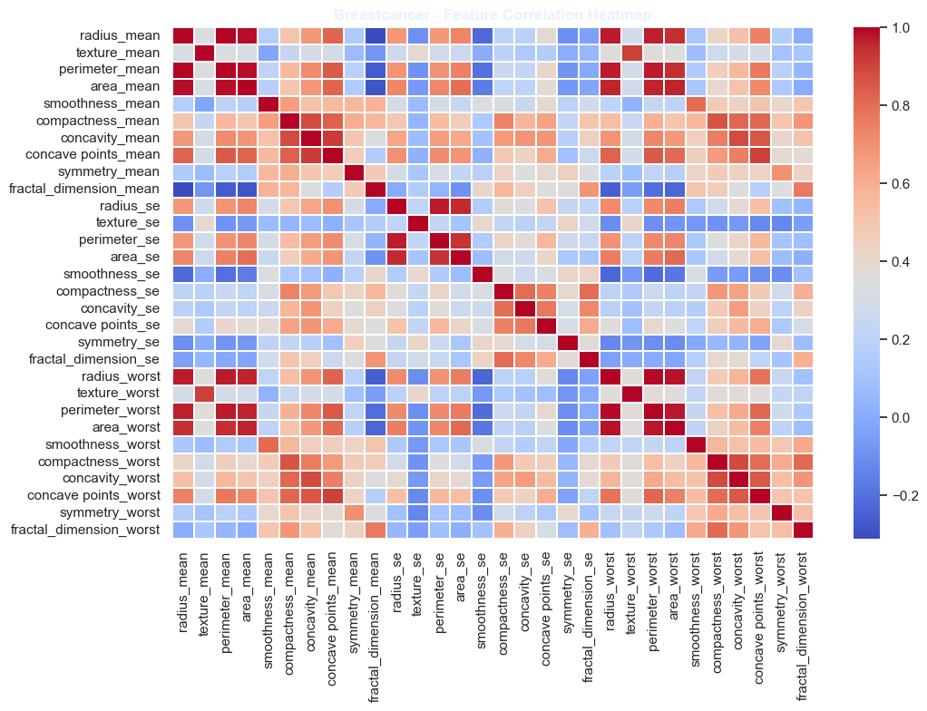 | 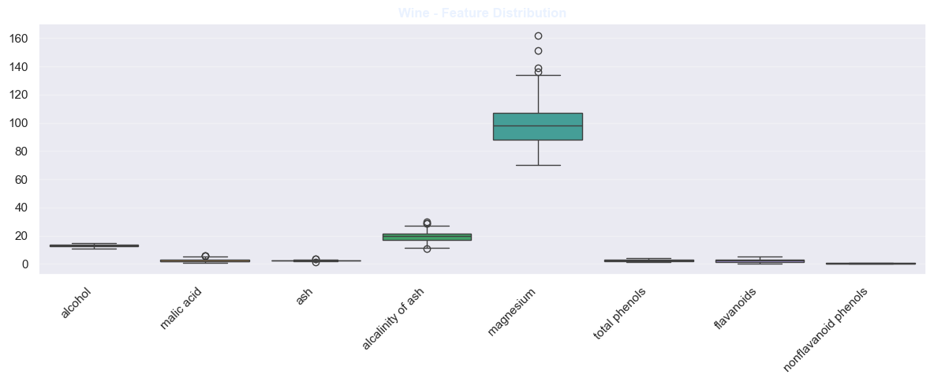
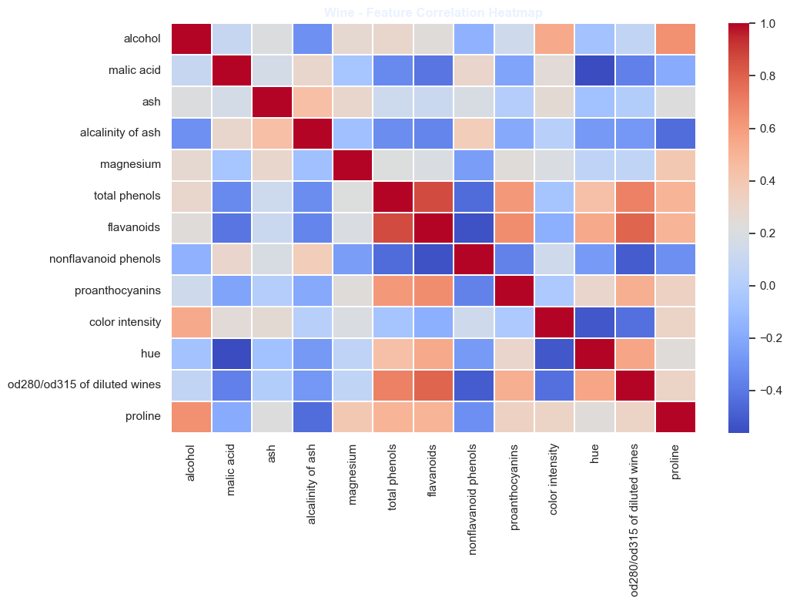 | 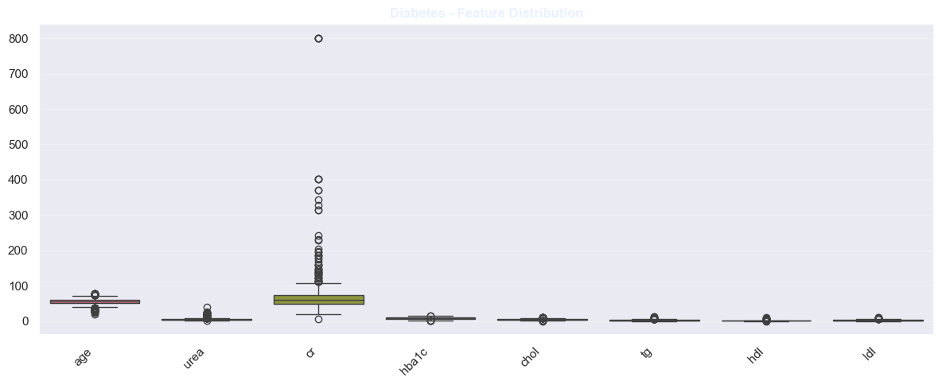 | 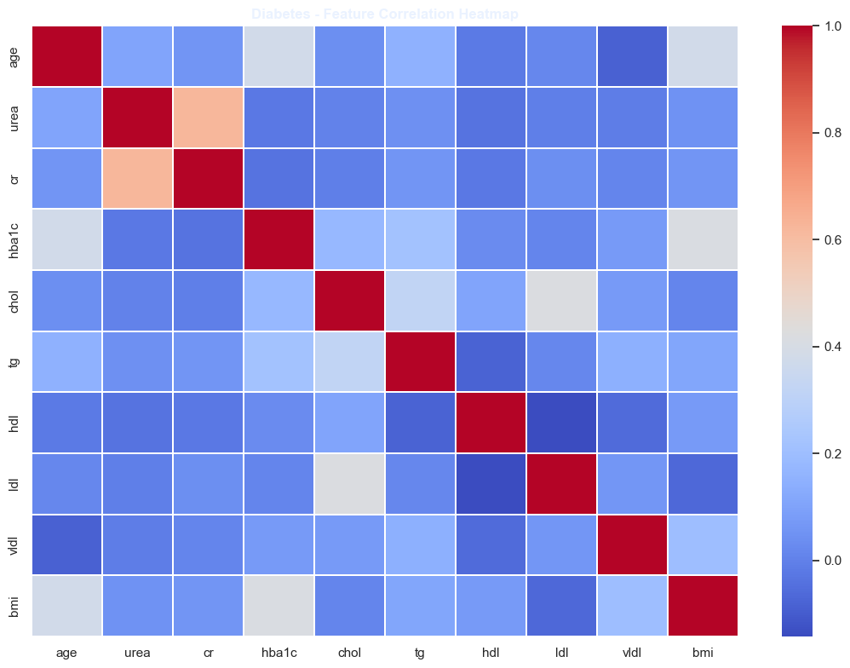

===========================================================================
PART 10 | TRAIN TEST SPLITTING
===========================================================================

===========================================================================
PART 12 | MACHINE LEARNING MODEL CONFIGURATION
===========================================================================

Dataset: Breastcancer
Algorithm: Decision Tree Classifier

Dataset: Wine
Algorithm: Random Forest Classifier

Dataset: Diabetes
Algorithm: Gradient Boosting Classifier

===========================================================================
PART 13 | MODEL TRAINING AND EVALUATION
===========================================================================

Breastcancer
Training Samples: 455
Testing Samples: 114

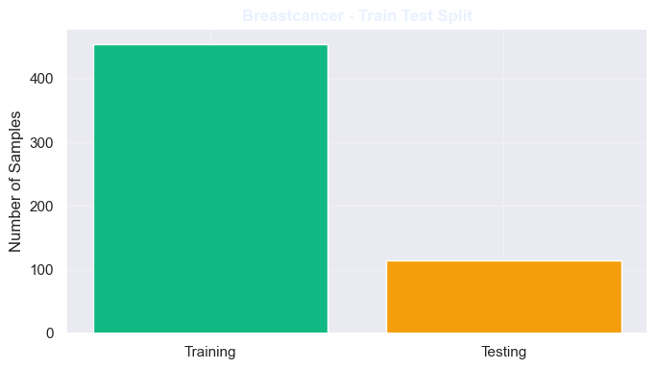
Training: Decision Tree Classifier

MODEL PERFORMANCE
--------------------------------------------------
Accuracy: 0.9211
Precision: 0.9227
Recall: 0.9211
F1 Score: 0.9199

Classification Report:
precision recall f1-score support

B 0.91 0.97 0.94 72
M 0.95 0.83 0.89 42

accuracy 0.92 114
macro avg 0.93 0.90 0.91 114
weighted avg 0.92 0.92 0.92 114

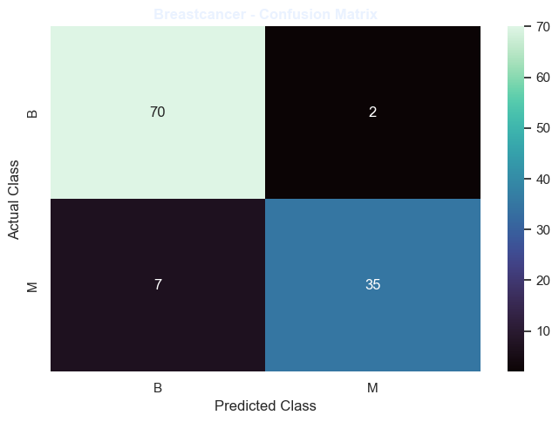 | 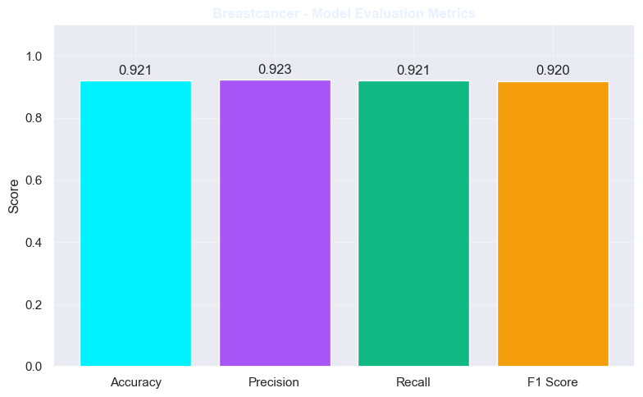

Wine
Training Samples: 142
Testing Samples: 36

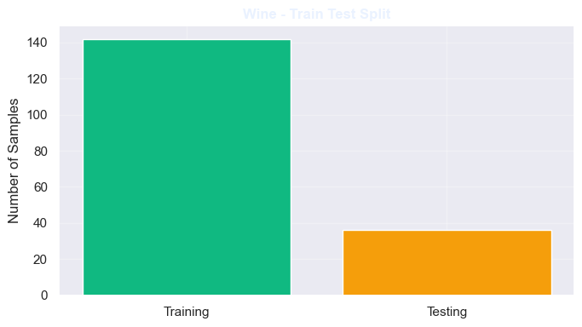
Training: Random Forest Classifier

MODEL PERFORMANCE
--------------------------------------------------
Accuracy: 1.0000
Precision: 1.0000
Recall: 1.0000
F1 Score: 1.0000

Classification Report:
precision recall f1-score support

1 1.00 1.00 1.00 12
2 1.00 1.00 1.00 14
3 1.00 1.00 1.00 10

accuracy 1.00 36
macro avg 1.00 1.00 1.00 36
weighted avg 1.00 1.00 1.00 36

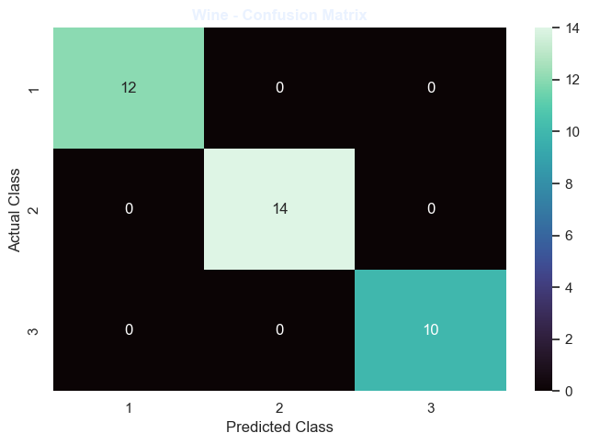 | 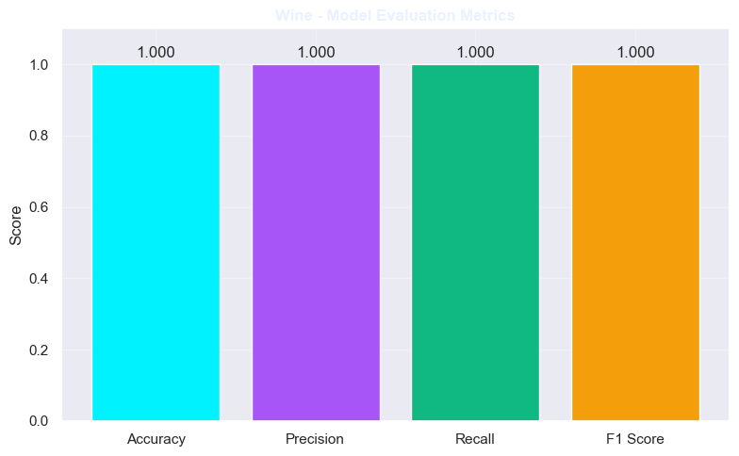

Diabetes
Training Samples: 800
Testing Samples: 200

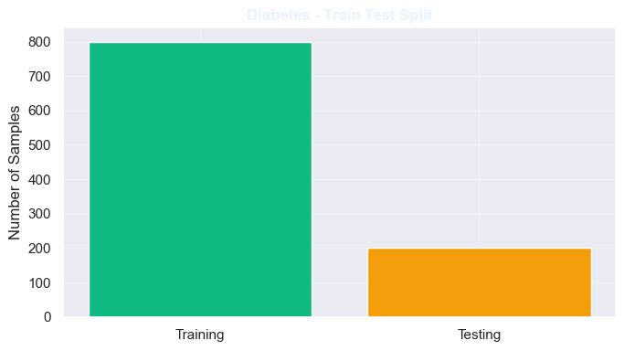
Training: Gradient Boosting Classifier

MODEL PERFORMANCE
--------------------------------------------------
Accuracy: 0.9900
Precision: 0.9901
Recall: 0.9900
F1 Score: 0.9898

Classification Report:
precision recall f1-score support

N 1.00 0.95 0.98 21
P 1.00 0.90 0.95 10
Y 0.99 1.00 0.99 169

accuracy 0.99 200
macro avg 1.00 0.95 0.97 200
weighted avg 0.99 0.99 0.99 200

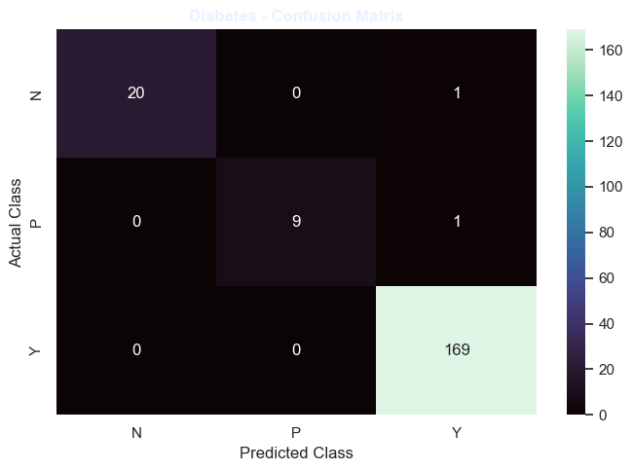 | 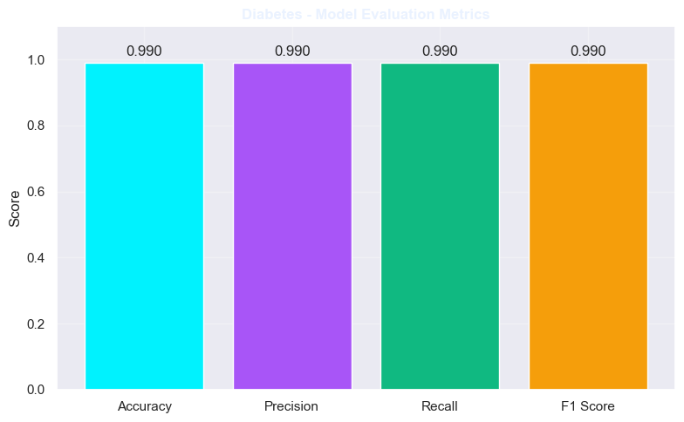

===========================================================================
PART 14 | FEATURE IMPORTANCE ANALYSIS
===========================================================================

Breastcancer - Top 10 Important Features

 | Feature | Importance |  |  | Feature | Importance
22 | numeric__perimeter_worst | 0.778155 |  | 21 | numeric__texture_worst | 0.023217
27 | numeric__concave points_worst | 0.071731 |  | 23 | numeric__area_worst | 0.016536
1 | numeric__texture_mean | 0.030886 |  | 7 | numeric__concave points_mean | 0.014215
24 | numeric__smoothness_worst | 0.026282 |  | 11 | numeric__texture_se | 0.011940
3 | numeric__area_mean | 0.023789 |  | 26 | numeric__concavity_worst | 0.003248

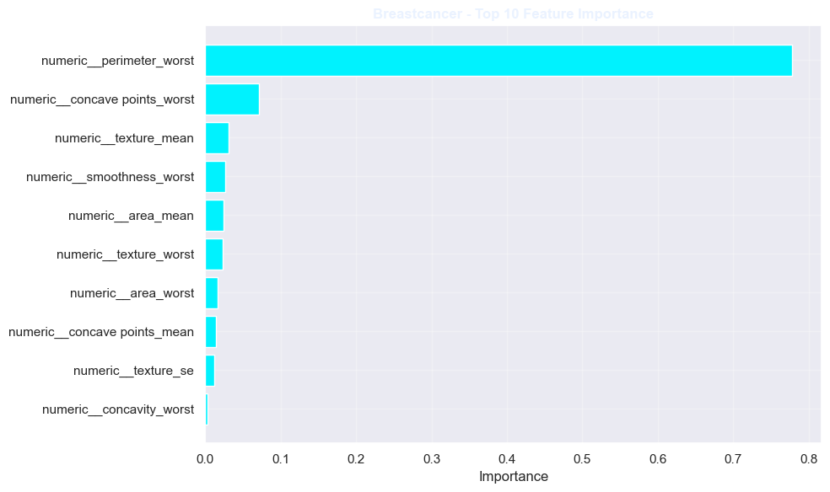
Wine - Top 10 Important Features

 | Feature | Importance |  |  | Feature | Importance
9 | numeric__color intensity | 0.187404 |  | 11 | numeric__od280/od315 of diluted wines | 0.089898
6 | numeric__flavanoids | 0.168373 |  | 5 | numeric__total phenols | 0.051274
12 | numeric__proline | 0.157024 |  | 4 | numeric__magnesium | 0.035210
0 | numeric__alcohol | 0.108171 |  | 1 | numeric__malic acid | 0.030246
10 | numeric__hue | 0.094966 |  | 8 | numeric__proanthocyanins | 0.028266

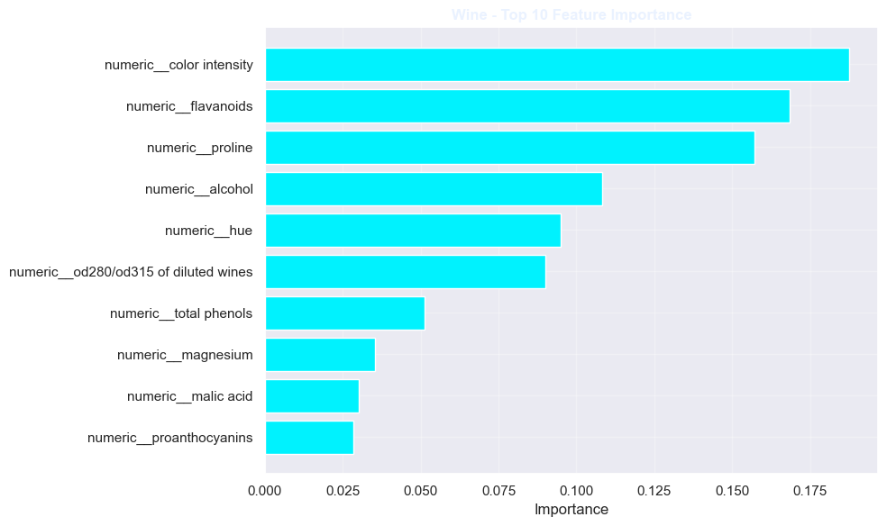
Diabetes - Top 10 Important Features

 | Feature | Importance |  |  | Feature | Importance
3 | numeric__hba1c | 0.499775 |  | 1 | numeric__urea | 0.002676
9 | numeric__bmi | 0.352463 |  | 7 | numeric__ldl | 0.002601
4 | numeric__chol | 0.086944 |  | 8 | numeric__vldl | 0.001743
0 | numeric__age | 0.036275 |  | 6 | numeric__hdl | 0.000348
5 | numeric__tg | 0.017164 |  | 2 | numeric__cr | 0.000010

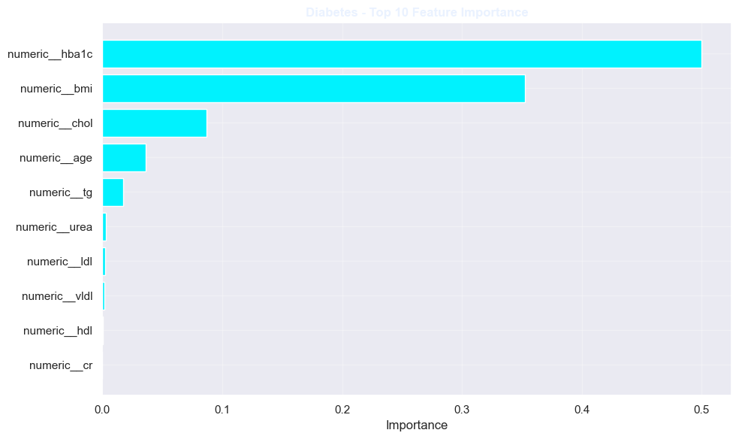
===========================================================================
PART 15 | DECISION TREE STRUCTURE
===========================================================================

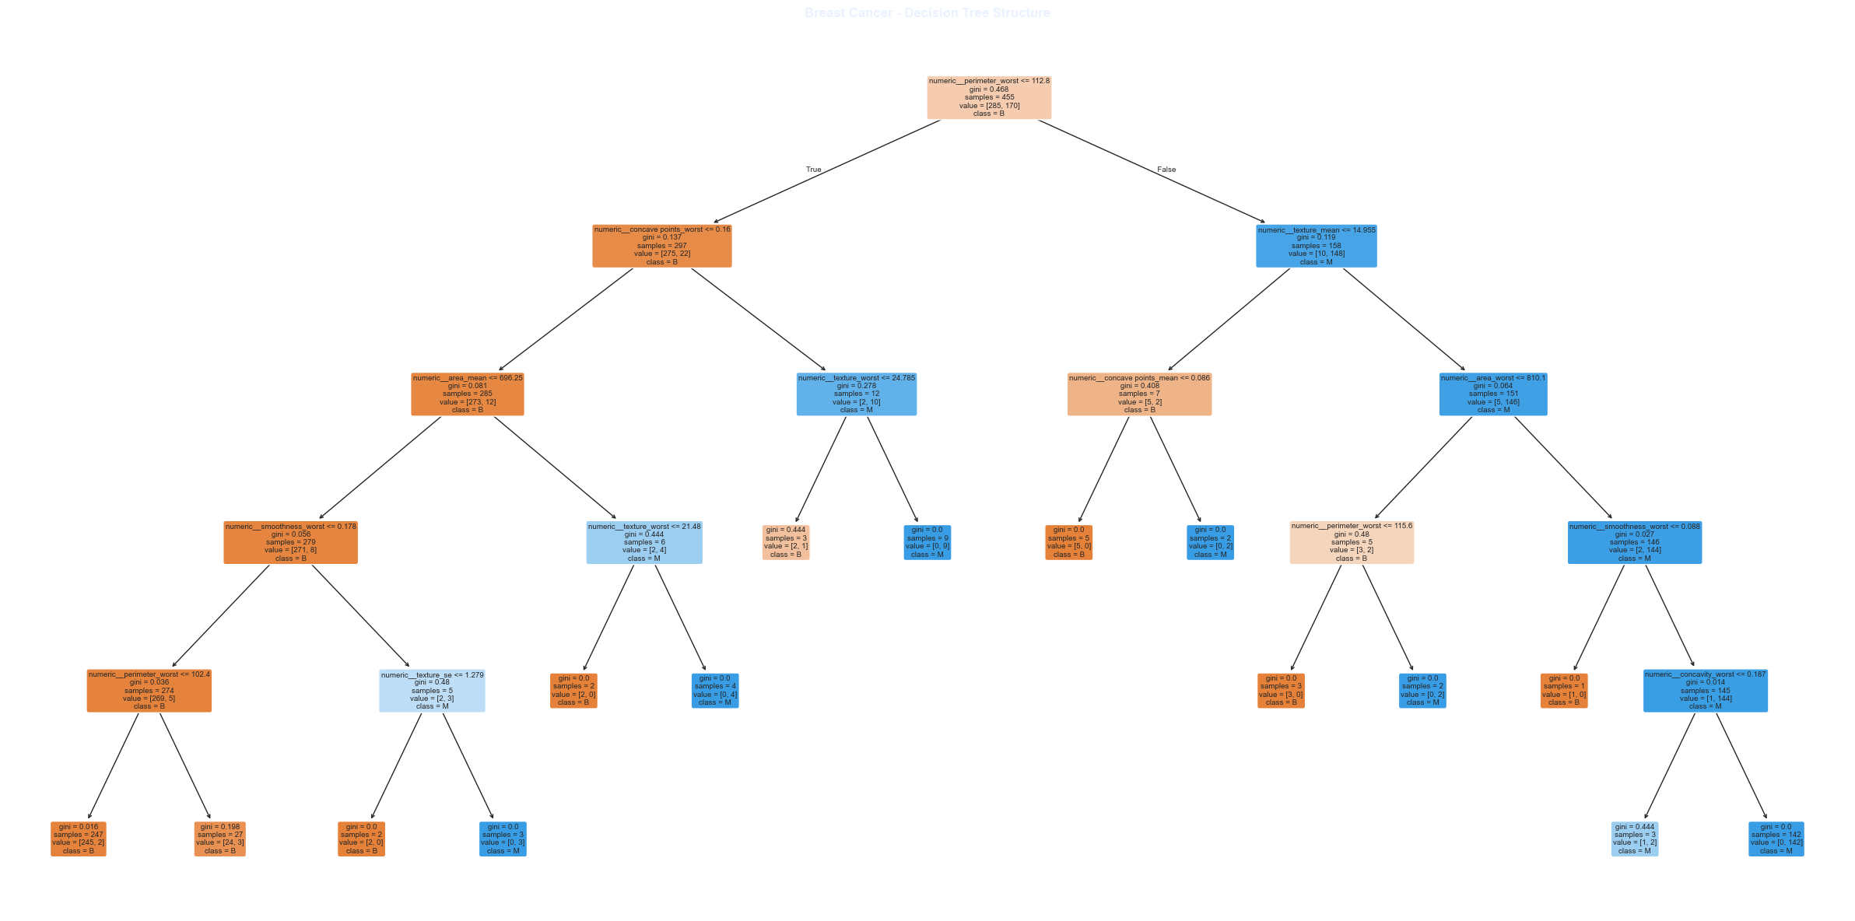
===========================================================================
PART 16 | ROC CURVE ANALYSIS
===========================================================================

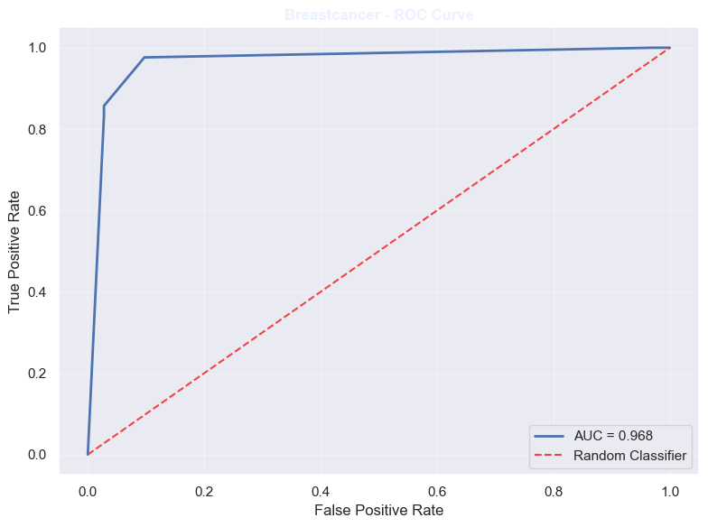 | 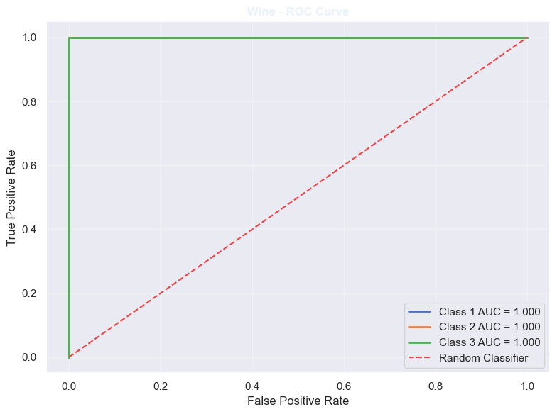 | 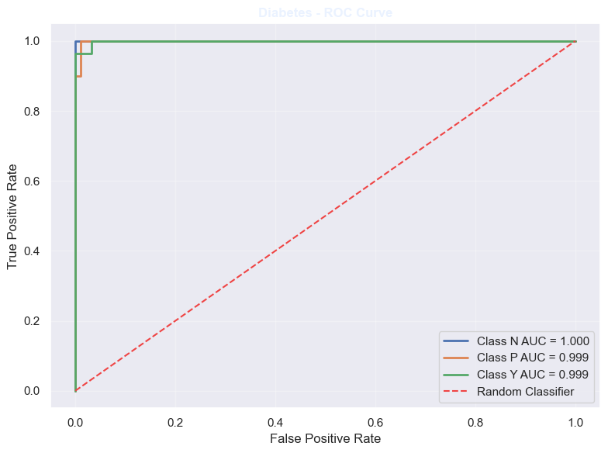

===========================================================================
PART 17 | ACTUAL VS PREDICTED COMPARISON
===========================================================================

Breastcancer - Actual vs Predicted

 | Actual | Predicted |  |  | Actual | Predicted
0 | B | B |  | 8 | B | B
1 | M | M |  | 9 | B | B
2 | B | M |  | 10 | M | M
3 | M | B |  | 11 | B | B
4 | B | B |  | 12 | M | M
5 | B | B |  | 13 | B | B
6 | M | M |  | 14 | B | B
7 | B | B

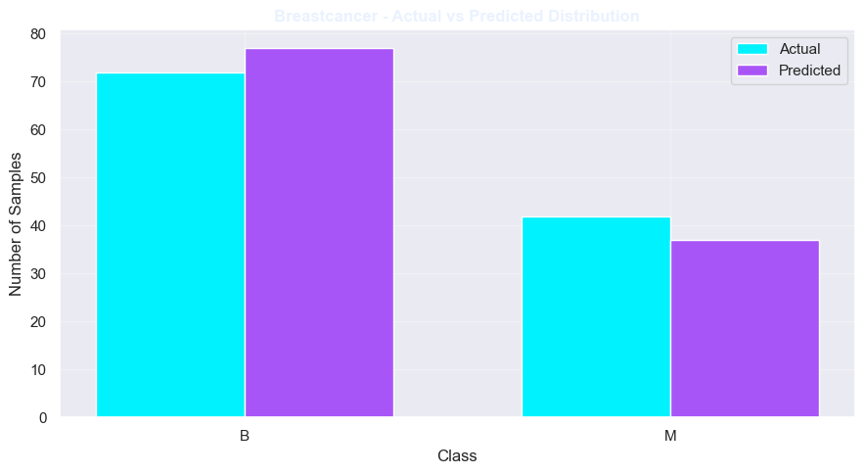
Wine - Actual vs Predicted

 | Actual | Predicted |  |  | Actual | Predicted
0 | 1 | 1 |  | 8 | 2 | 2
1 | 3 | 3 |  | 9 | 3 | 3
2 | 1 | 1 |  | 10 | 2 | 2
3 | 2 | 2 |  | 11 | 3 | 3
4 | 2 | 2 |  | 12 | 1 | 1
5 | 1 | 1 |  | 13 | 3 | 3
6 | 1 | 1 |  | 14 | 1 | 1
7 | 2 | 2

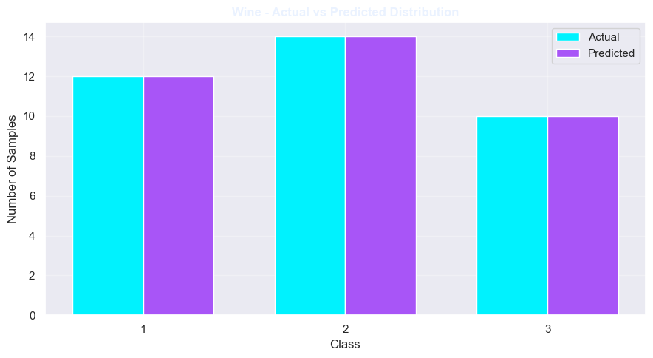
Diabetes - Actual vs Predicted

 | Actual | Predicted |  |  | Actual | Predicted
0 | P | P |  | 8 | Y | Y
1 | N | N |  | 9 | Y | Y
2 | Y | Y |  | 10 | N | N
3 | Y | Y |  | 11 | N | N
4 | N | N |  | 12 | Y | Y
5 | Y | Y |  | 13 | N | N
6 | Y | Y |  | 14 | Y | Y
7 | Y | Y

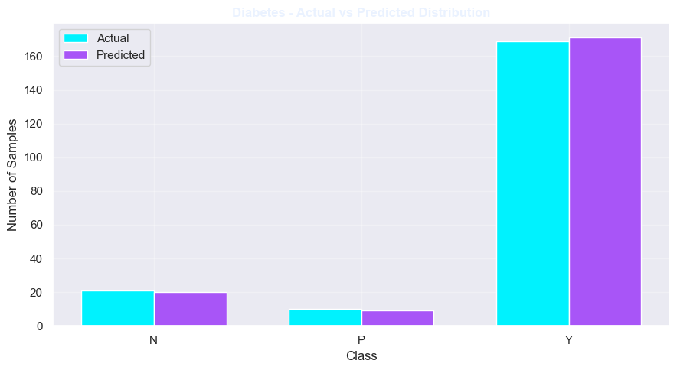
===========================================================================
PART 18 | OVERALL MODEL COMPARISON
===========================================================================

FINAL MODEL PERFORMANCE COMPARISON

 | Accuracy | Precision | Recall | F1 Score
Breastcancer | 0.9211 | 0.9227 | 0.9211 | 0.9199
Wine | 1.0000 | 1.0000 | 1.0000 | 1.0000
Diabetes | 0.9900 | 0.9901 | 0.9900 | 0.9898

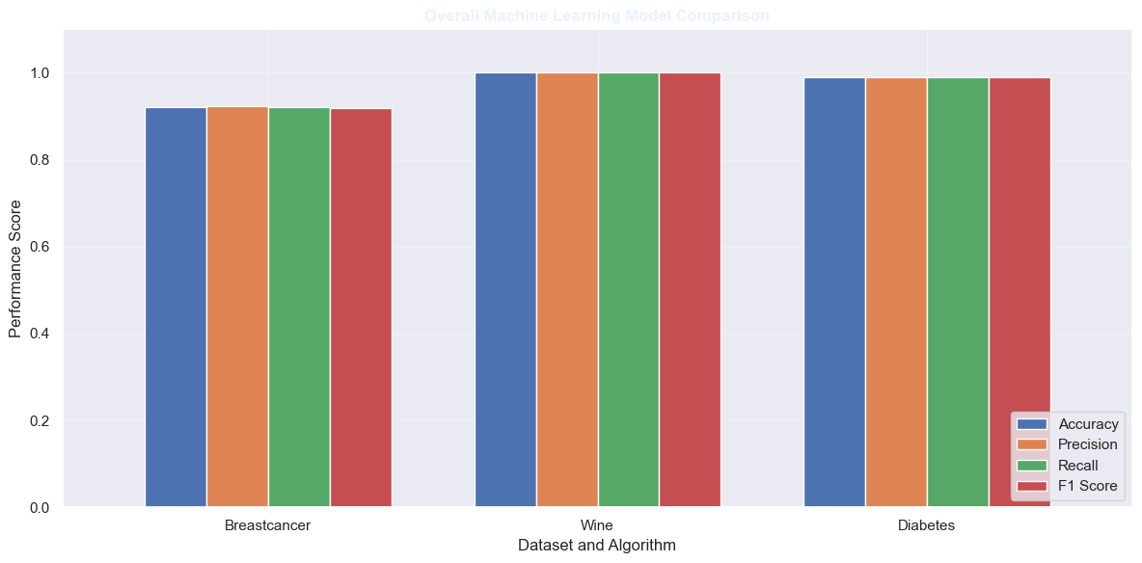
===========================================================================
PART 19 | MODEL PERFORMANCE RADAR CHART
===========================================================================

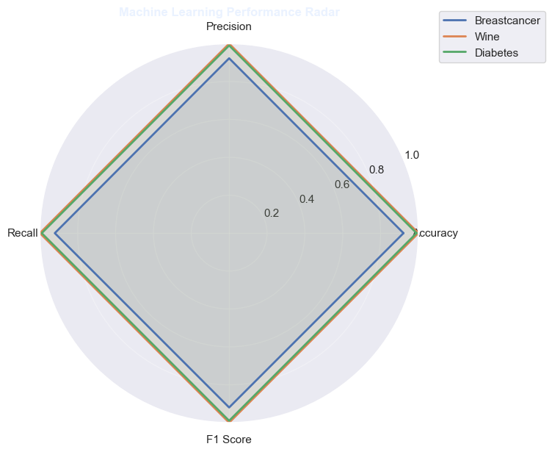
===========================================================================
PART 20 | MODEL PERFORMANCE RANKING
===========================================================================

 | Accuracy | Precision | Recall | F1 Score
Wine | 1.0000 | 1.0000 | 1.0000 | 1.0000
Diabetes | 0.9900 | 0.9901 | 0.9900 | 0.9898
Breastcancer | 0.9211 | 0.9227 | 0.9211 | 0.9199

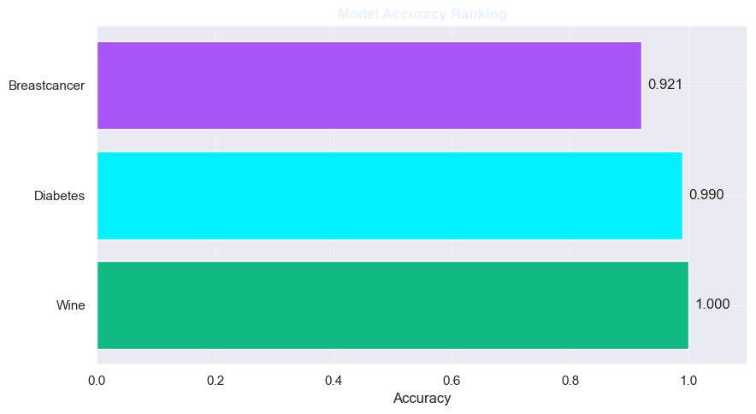
===========================================================================
PART 21 | MODEL STRENGTHS AND LIMITATIONS
===========================================================================

Decision Tree

Strengths:
+ Easy to understand
+ Simple interpretation
+ Handles nonlinear patterns

Limitations:
- Can overfit
- Sensitive to data changes
- May be less stable

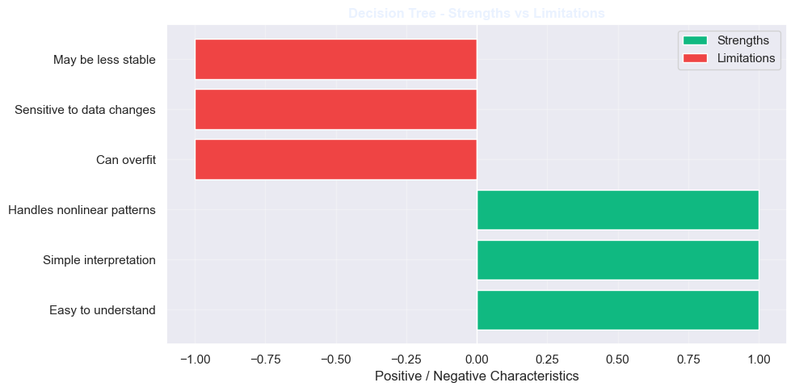
Random Forest

Strengths:
+ Reduces overfitting
+ Uses multiple trees
+ Good general performance

Limitations:
- More computational cost
- Less interpretable
- Requires more memory

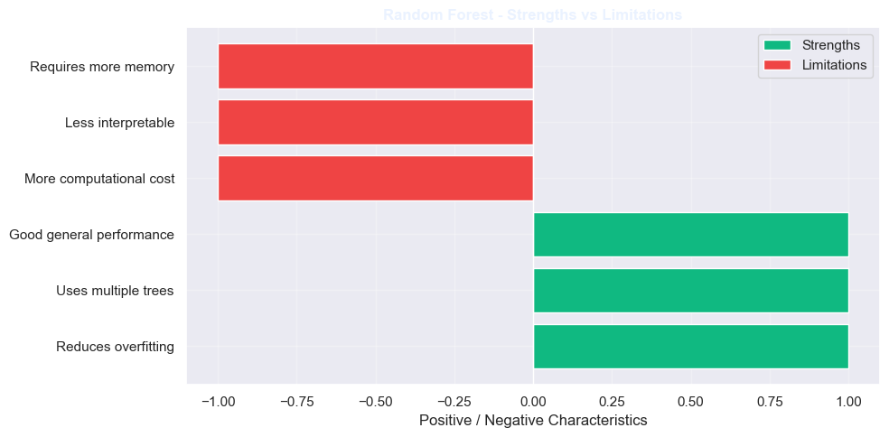
Gradient Boosting

Strengths:
+ Learns complex patterns
+ Improves weak learners
+ Strong predictive ability

Limitations:
- Sensitive to parameters
- Can require longer training
- May overfit without tuning

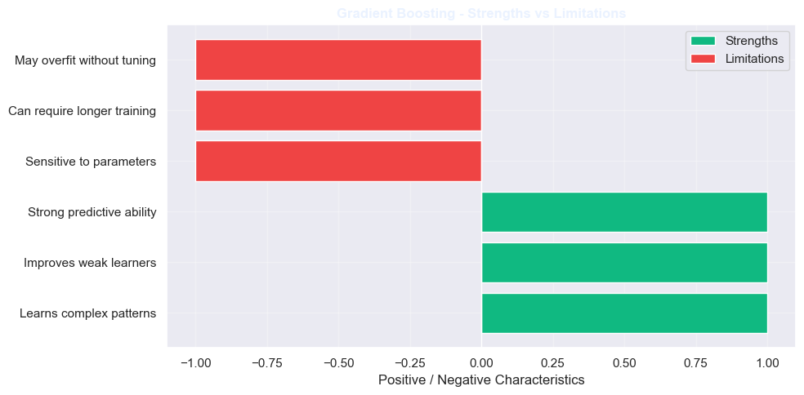
===========================================================================
PART 22 | EVALUATION METRICS EXPLANATION
===========================================================================

Accuracy:
Percentage of all predictions that are correct.

Precision:
Percentage of predicted positive cases that are actually positive.

Recall:
Percentage of actual positive cases correctly identified.

F1 Score:
Harmonic mean of precision and recall.

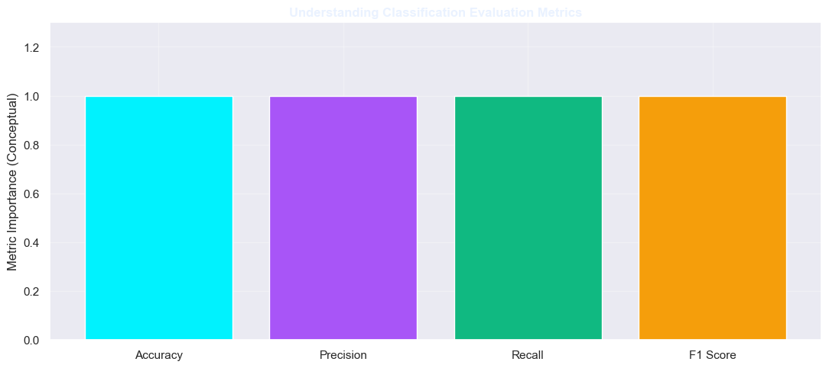
===========================================================================
PART 23 | FINAL RESULTS
===========================================================================

DATASETS AND MODELS:
1. Breast Cancer -> Decision Tree Classifier
2. Wine -> Random Forest Classifier
3. Diabetes -> Gradient Boosting Classifier

FINAL PERFORMANCE:

 | Accuracy | Precision | Recall | F1 Score
Breastcancer | 0.9211 | 0.9227 | 0.9211 | 0.9199
Wine | 1.0000 | 1.0000 | 1.0000 | 1.0000
Diabetes | 0.9900 | 0.9901 | 0.9900 | 0.9898

Best accuracy among the three tested models:
Wine
Accuracy: 1.0000

All datasets processed successfully.
All three models trained and evaluated.

