Dr. A. Q. Khan Institute of Computer Science & Information Technology

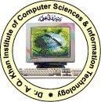

Lab no. 01
Artificial Intelligence (Lab)

Submitted to:
MAM HAJRA
Submitted by:
Tehzeeb (232101006)
Department:
BSCE-7.
Date:
September 21, 2026

Coding/logic | Response | Data processing & visualization | Accuracy | Outcome/Result
04 | 04 | 04 | 04 | 04
LINK: https://github.com/Tehzeb/AI-LAB/blob/main/main.py

Question 1
Practice Python programming fundamentals and Demonstrate by developing and executing Python programs using variables, data types, operators, conditional statements, loops, functions, and lists. Execute the developed programs in a Python environment to verify correct syntax, logical execution, and expected output. Analyze the program logic and execution results to identify and troubleshoot common syntax, logical, and runtime errors. Evaluate the implemented programs to assess how fundamental Python programming concepts provide a foundation for developing Artificial Intelligence and Machine Learning applications.
Task Requirements
1. Create and execute Python programs demonstrating:
o Variables and data types
o Arithmetic, relational, and logical operators
o if-else conditional statements
o for and while loops
o Functions
o Lists and basic list operations
2. Display appropriate input and output for each program.
3. Identify and correct at least one syntax or logical error.
4. Execute the corrected programs and verify the expected results.
5. Document the source code and corresponding outputs.
6. Briefly explain how these Python concepts are used in AI/ML programming.
[CLO- 01, PLO-02, P3 (Practice) , WK4, EC1, EC2 and SDG 9 Rubric (Design ,(Outcome) Points (12)]

ANSWER:
Step 1: Variables and Data Types

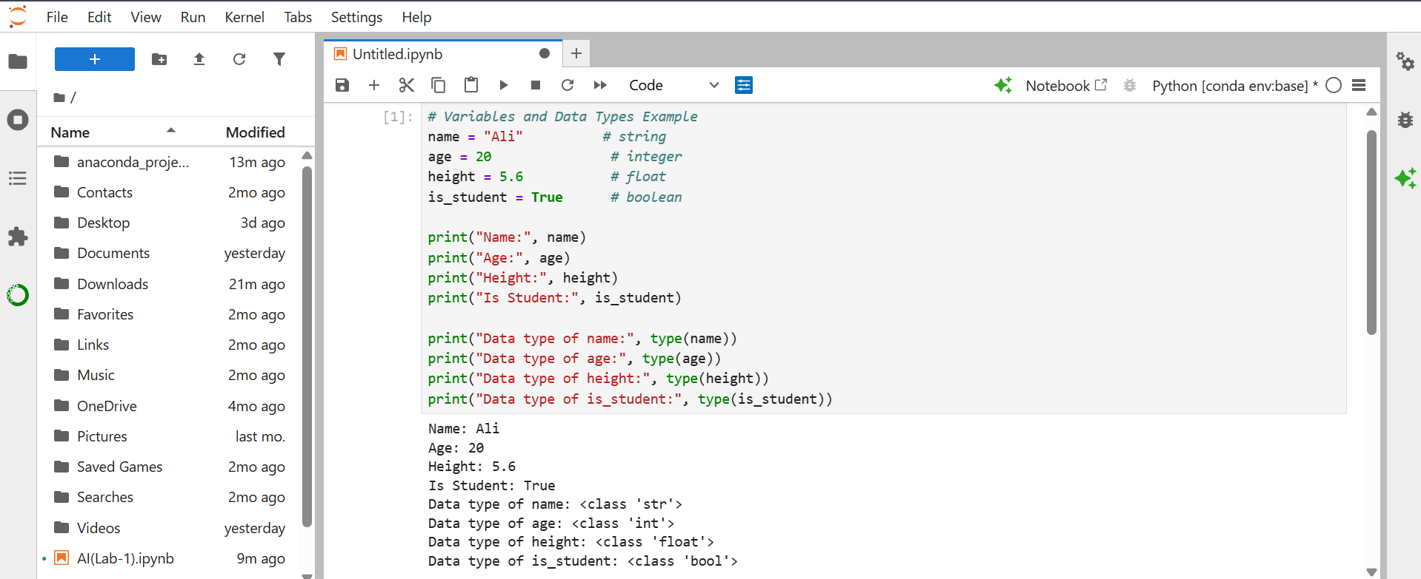
OUTPUT:

Step 2: Arithmetic, Relational, and Logical Operators
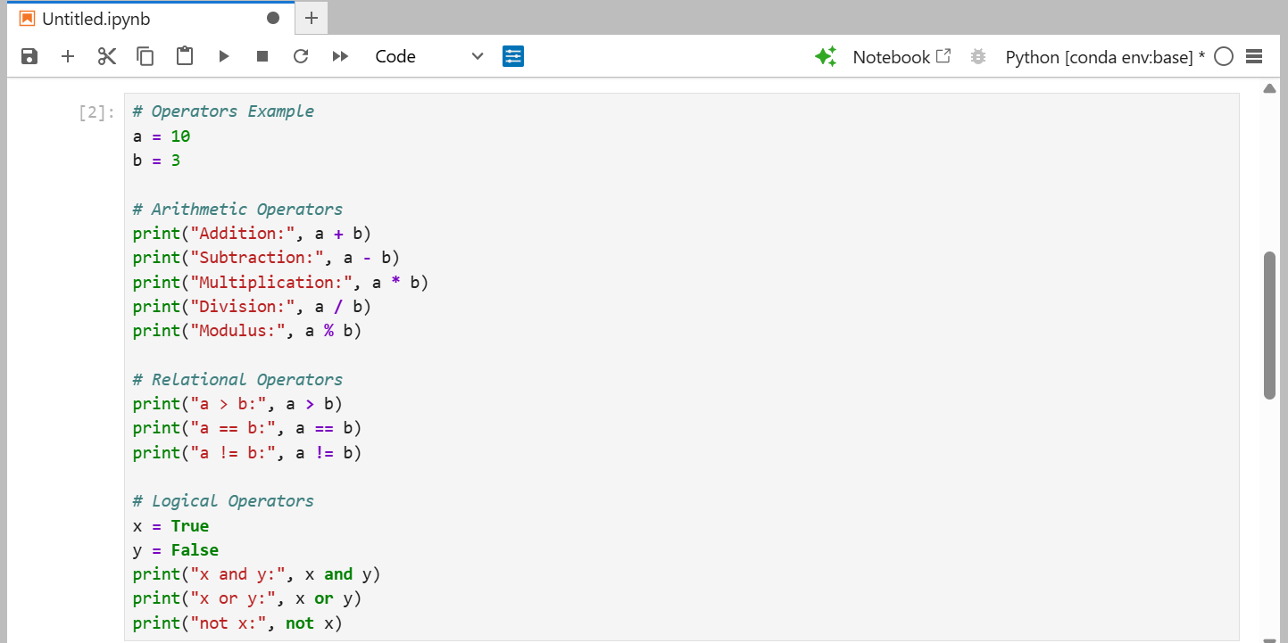
OUTPUT:
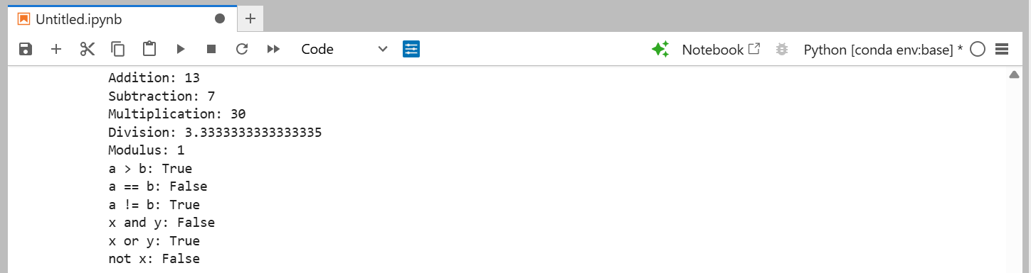
Step 3: if-else Conditional Statement
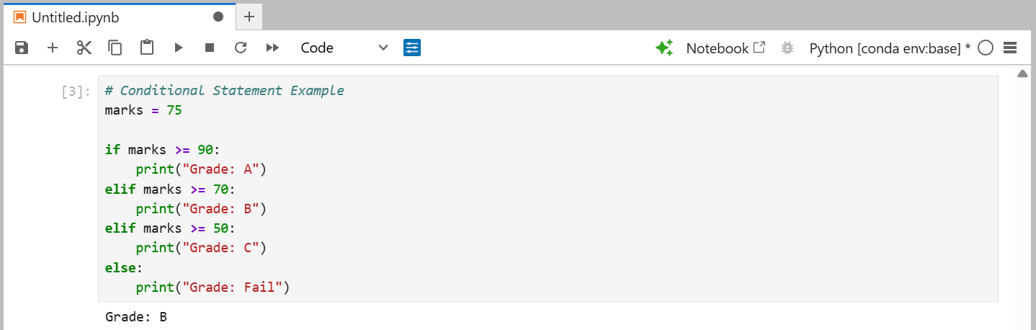

Step 4: for and while Loops
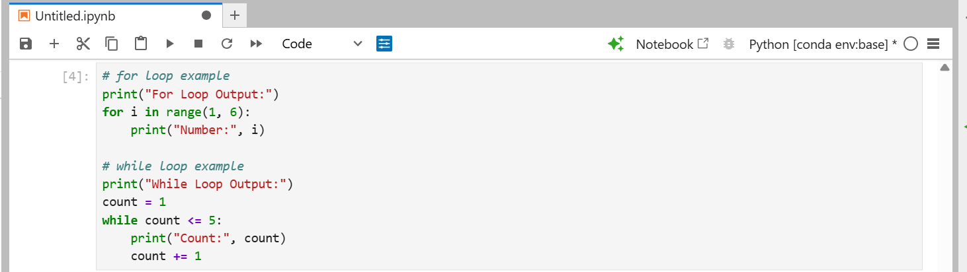
OUTPUT:
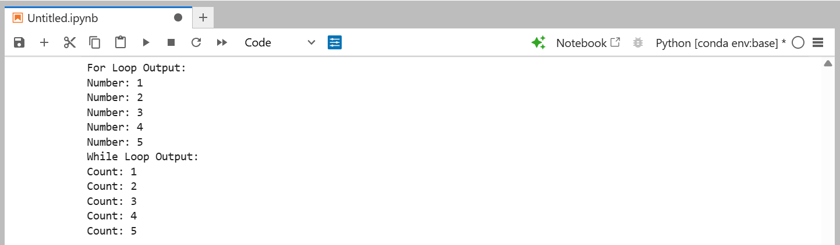
Step 5: Functions
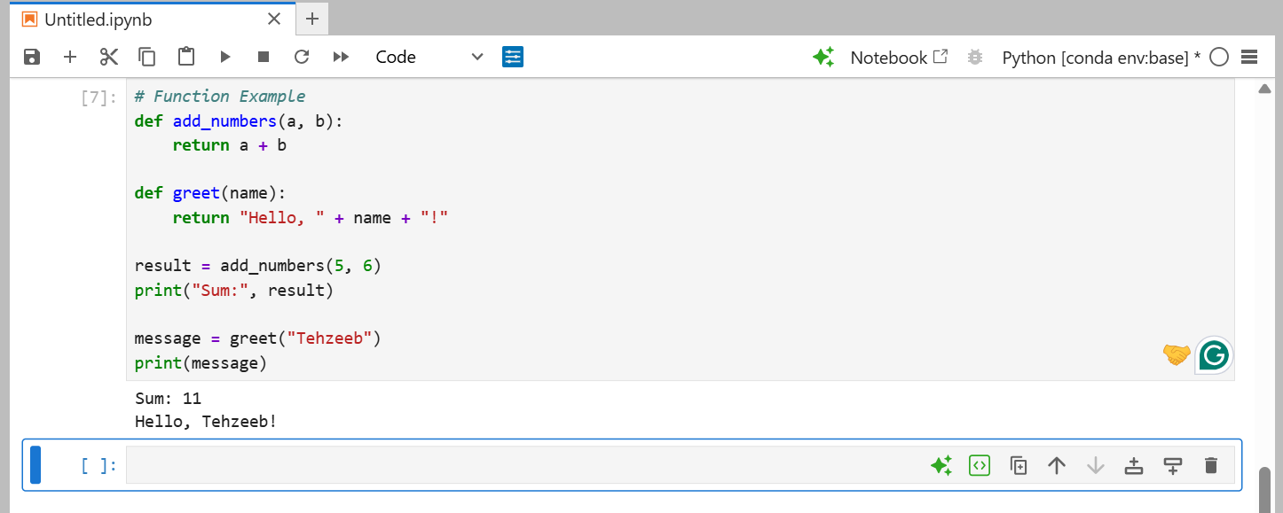

Step 6: Lists and Basic List Operations
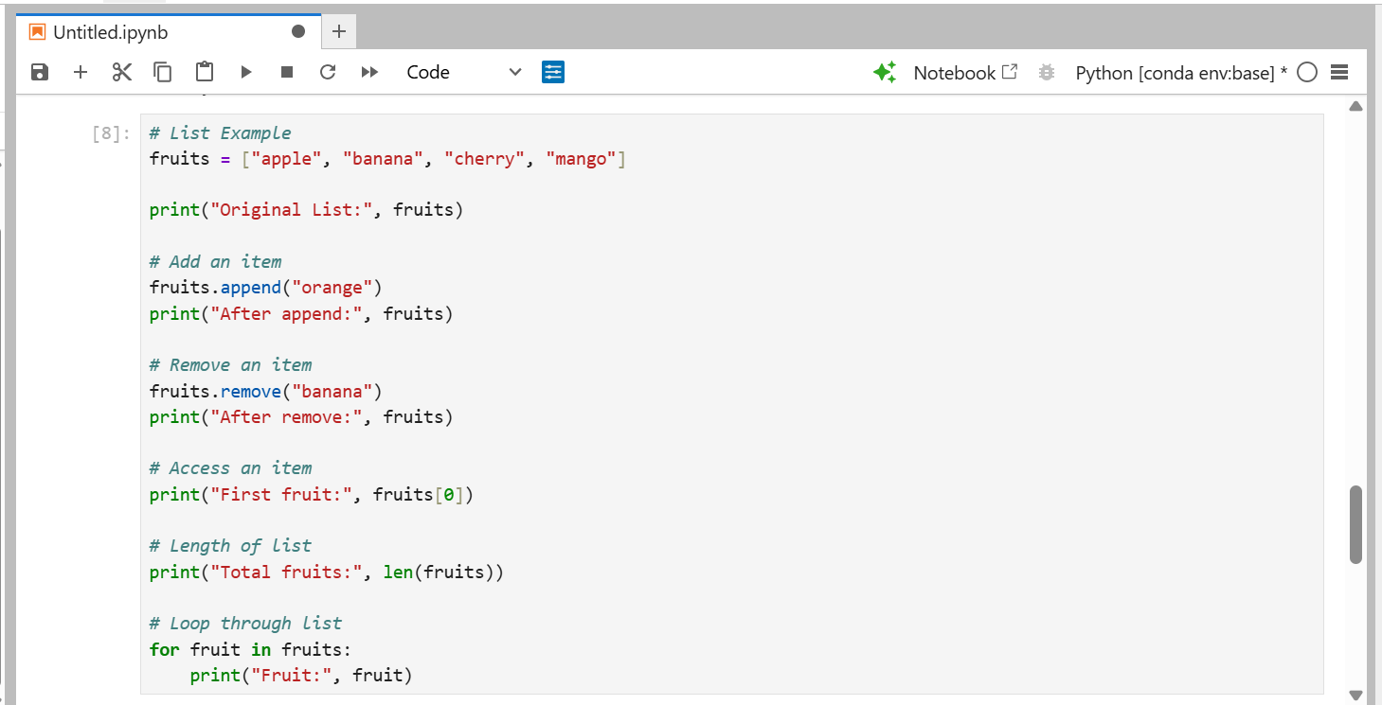
OUTPUT:
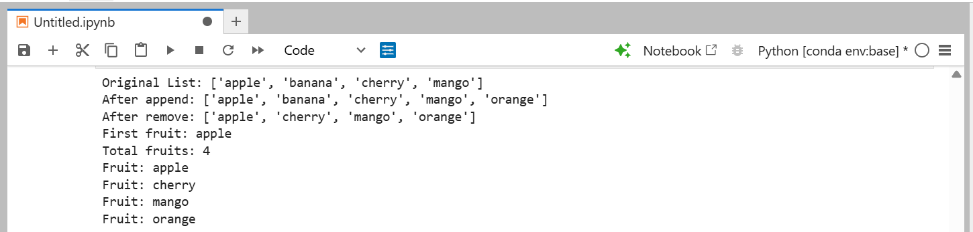
Step 7: Find and Correct an Error (Required by task)
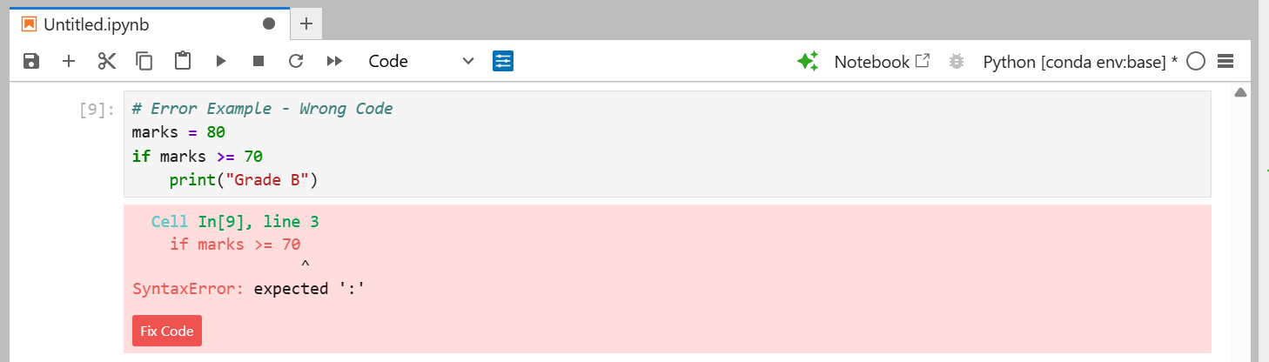
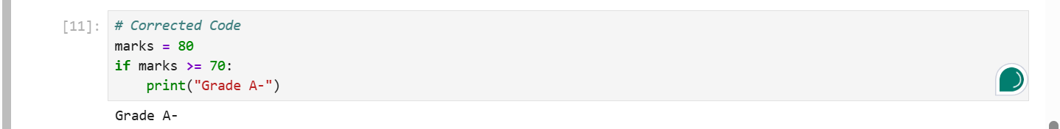
Explanation (AI/ML):
Python fundamentals such as variables, data types, operators, conditional statements, loops, functions, and lists form the base of every AI and Machine Learning program. Variables and data types are used to store data such as images, numbers, and text for training models. Operators and conditional statements help build decision-making logic used in algorithms. Loops are used to repeat training steps or process large datasets. Functions allow AI code to be organized into reusable blocks, such as functions for data cleaning or prediction. Lists are used to store datasets, features, and results, which are later processed using AI/ML libraries like NumPy and Pandas. Overall, mastering these basics is essential before working with advanced AI/ML frameworks.
Question 2
Execute version control and collaborative software development using Git and GitHub and Demonstrate by creating a Python project in Visual Studio Code (VS Code), initializing a local Git repository, connecting it with a GitHub repository, and managing project files through version control. Execute Git operations including add, commit, push, pull, and status to synchronize the local project with the remote GitHub repository. Analyze the interaction between VS Code, Git, and GitHub to understand how source-code changes are tracked and synchronized. Evaluate the version-control workflow by identifying and resolving basic synchronization or repository errors and assessing how GitHub supports organized, collaborative, and maintainable AI software development.
Task Requirements
1. Install and configure Git and VS Code.
2. Create a new Python project in VS Code.
3. Develop and execute a simple Python program.
4. Create a new repository on GitHub.
5. Initialize the local Git repository using VS Code or Git commands.
6. Connect the local repository with the GitHub remote repository.
7. Perform the following Git operations:
o git status
o git add
o git commit
o git push
o git pull
8. Modify the Python program and create a second commit.
9. Push the updated project to GitHub.
10. Verify that the latest project version is available in the GitHub repository.
11. Identify and troubleshoot at least one basic Git or synchronization error.
12. Document the Git commands used along with screenshots of VS Code and GitHub.
13. Explain how version control can support collaborative AI/ML project development.
[CLO- 02, PLO-03, P4 (Execute) (WK5, EC4, and SDG 11) Rubric (Syntax, Logic, Completeness, (Outcome) Points (12)]
ANSWER:
Step 1: Install Git and VS Code
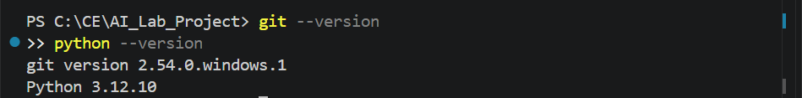
Step 2: Create a New Python Project in VS Code
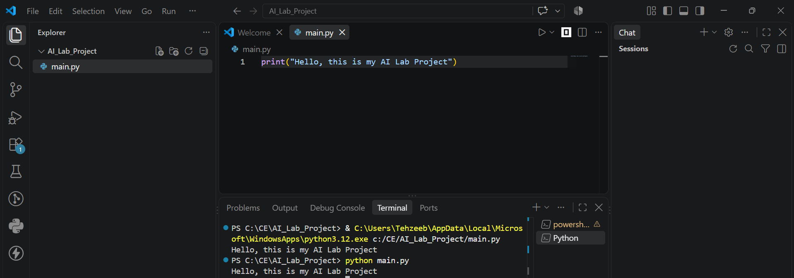
Step 3: Initialize Local Git Repository
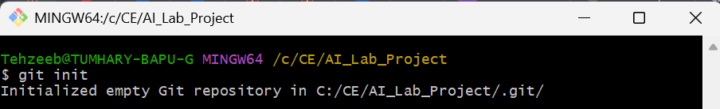
Configure Git (only needed once on your PC)
Step 4: Check Status
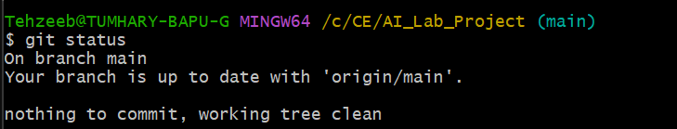
Step 5: Add all files to staging
Step 6: Commit the added files
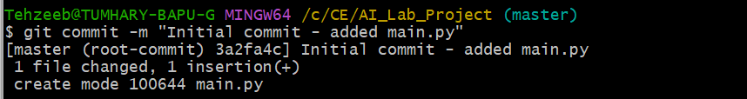
Step 7: Connect Local Repo with GitHub
Step 8: Rename branch to main
Step 9: Push project to GitHub
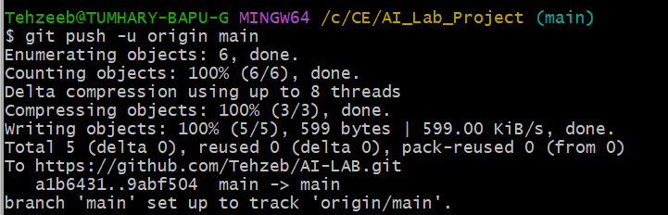

Step 10: Pull (to sync anything from GitHub)
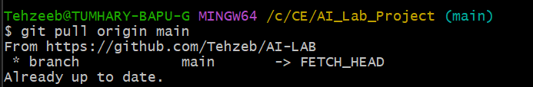
Step 11: Second Commit (after editing main.py)
